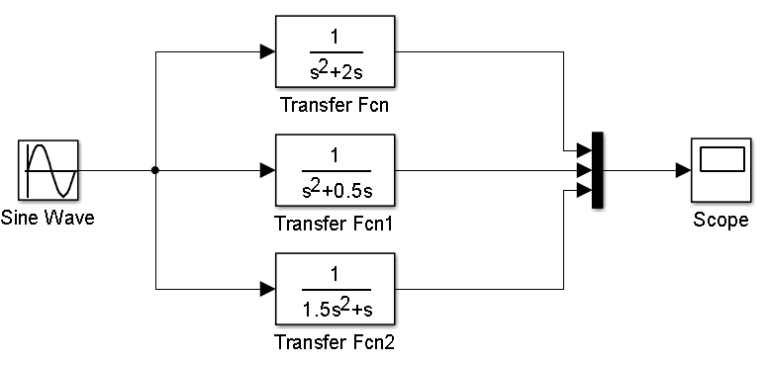

**1d i)**

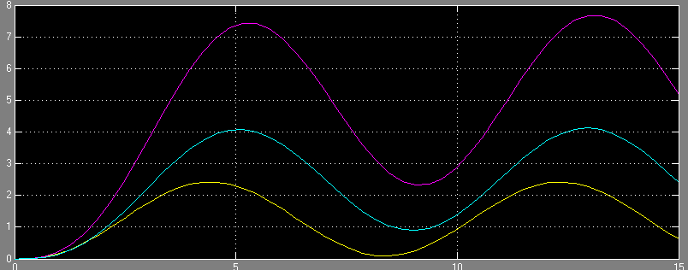

When I applied the input signal x(t)=2sin5t, I observe three responses on the same figure as above

II)

Calculating resonat frequency, resonant peak value, and bandwith

**FOR G1(s);**

>> TF1closed= (TF1/(1+TF1))

TF1closed =

s^2 + 2 s

-------------------------

s^4 + 4 s^3 + 5 s^2 + 2 s

>> n1=[1 2 0]

>> n1=[1 4 5 2 0];

>> [m,ph,w]=bode(n1,d1,w);

>> [peak,i]=max(m)

peak = 1.0000

i = 1

>> resfreq=w(i)

resfreq = 1.0000e-03

**Calculating the bandwith;**

>> x=1;

>> while 20*log10(m(x))>=-3

x=x+1;

end;

>> bw=w(x)

bw = 0.7197

FOR G2(s);

>> TF2closed= (TF2/(1+TF2))

TF2closed =

s^2 + 0.5 s

----------------------------

s^4 + s^3 + 1.25 s^2 + 0.5 s

>> n2 = [1 0.5 0];

>> d2 = [1 1 1.25 0.5 0];

>> [m, ph, w] =bode(n2,d2,w);

>> [peak, i] =max(m)

**peak = 2.0000**

i = 22

>> resfreq=w(i)

**resfreq = 1**

>> bw=w(x)

**bw = 0.7197**

FOR G3(s);

>> TF3closed= (TF3/(1+TF3))

TF3closed =

1.5 s^2 + s

------------------------------

2.25 s^4 + 3 s^3 + 2.5 s^2 + s

>> n3=[1.5 1 0];

>> d3=[2.25 3 2.5 1 0];

>> [m, ph, w] =bode(n3,d3,w);

>> [peak, i] =max(m)

**peak = 1.3272**

i = 21

>> resfreq=w(i)

**resfreq = 0.7197**

>> bw=w(x)

**bw = 0.7197**

The block diagram I used on MATLAB is as below.

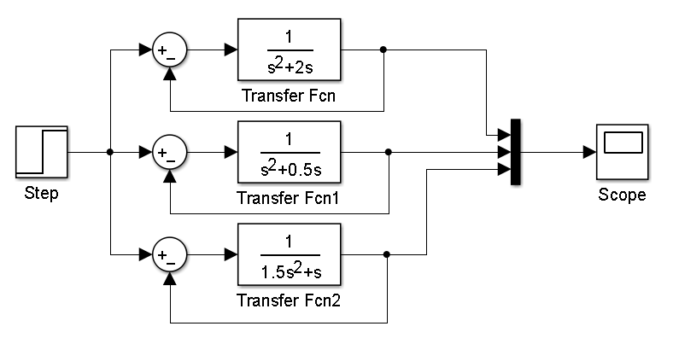

I have plot them in the same figure.

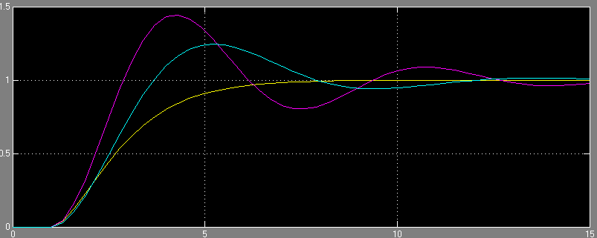

**d) III)**

I have defined G1(s), G2(s) and G3(s) as TF1, TF2 and TF3.

We find the Bode diagram characteristics as below.

>> TF1=tf(1,[1 2 0])

**TF1 =**

1

---------

s^2 + 2 s

Continuous-time transfer function.

>> [Gm Pm Wcg Wcp]=margin(TF1)

Gm = Inf

Pm = 76.3464

>> TF2=tf(1,[1 0.5 0])

**TF2 =**

1

-----------

s^2 + 0.5 s

Continuous-time transfer function.

>> [Gm Pm Wcg Wcp]=margin(TF2)

Gm = Inf

Pm = 28.0202

>> TF3=tf(1,[1.5 1 0])

**TF3 =**

1

-----------

1.5 s^2 + s

Continuous-time transfer function.

>> [Gm Pm Wcg Wcp]=margin(TF3)

Gm = Inf

Pm = 43.8958

ROOT LOCUS OF G1(s);

>> rlocus(TF1)



We can give the formula of Gain Margin as below ;

Gain Margin = (Value of K at the imaginay axes cross over) / (Design Value of K)

As we can see from the root locus, it goes to infinite **so it doesn’t cross imaginary axis**. As a result, we can determine that Gain Margin is going to be infinite and we have seen it also before.

I have found the Phase margin of G3(s) as infinite so adding infinite value to system is not possible