- Question
The hooke jeeves algoritm that we wrote;

syms x1 x2 f(x1,x2)
f(x1,x2)=3*x1^2 - 2*x1*x2 + 4*x1 + x2^2 + 3*x2;
% x1 and x2 are references
x1=0;
x2=0;
firstf=f(x1,x2);
fnew=firstf;

iteration = 4;
h= [1 0.5 0.25 0.125]; % changes of step magnitude

for m= 1: iteration
for i=1:10 % We try for 10 times for the same step magnitude
step=h(m);
if f(x1+step,x2)<f(x1,x2);
fnew=f(x1+step,x2);
x1=x1+step;
elseif f(x1-step,x2)<f(x1,x2);
fnew=f(x1-step,x2);
x1=x1-step;
end
if f(x1,x2+step)<f(x1,x2);
fnew=f(x1,x2+step);
x2=x2+step;
elseif f(x1,x2-step)<f(x1,x2);
fnew=f(x1,x2-step);
x2=x2-step;
end

end

end

x1
x2
result = fnew

The result is as below;
>> q1_a

x1 = -1.7500
x2 = -3.2500

result = -67/8

- Question
First, in order to choose the controller if PI or PD is the best, we have used Simulink and tuning feature.
PI Controller;
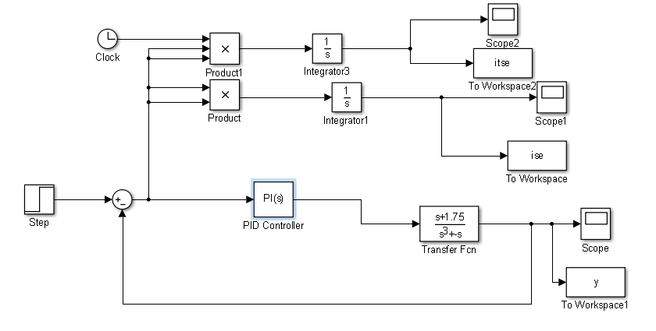
When we used PI controller and used the tuning feature, it has been seen that system can not be stable.
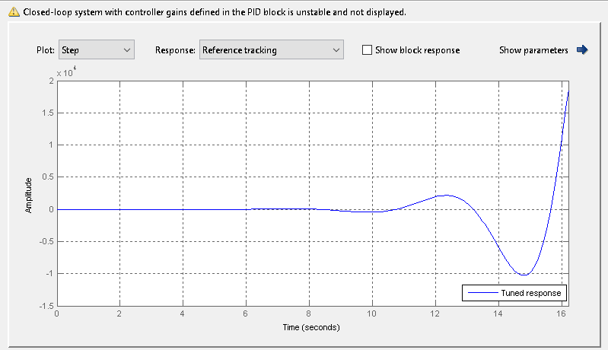
We have seen that also from Mathematica;
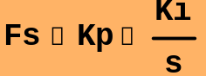
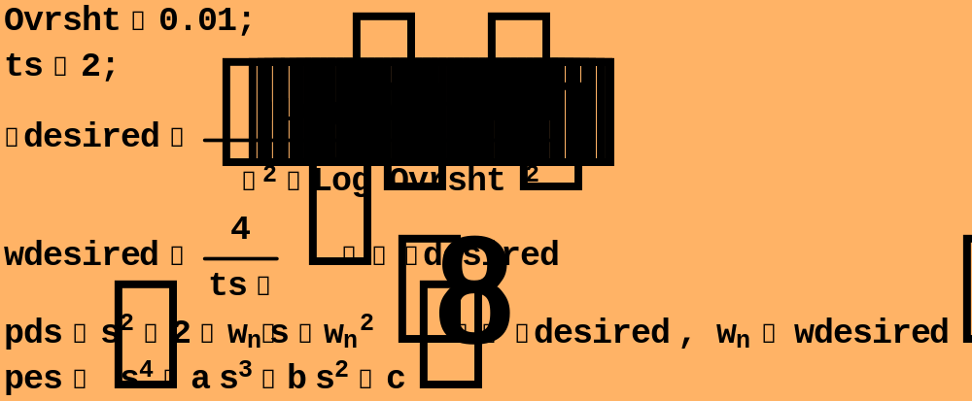
RouthTabulation[pcs]
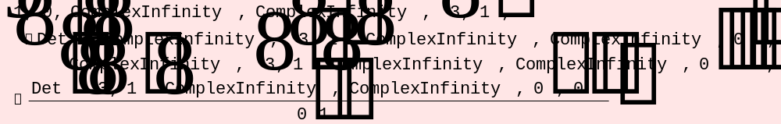
PD Controller;
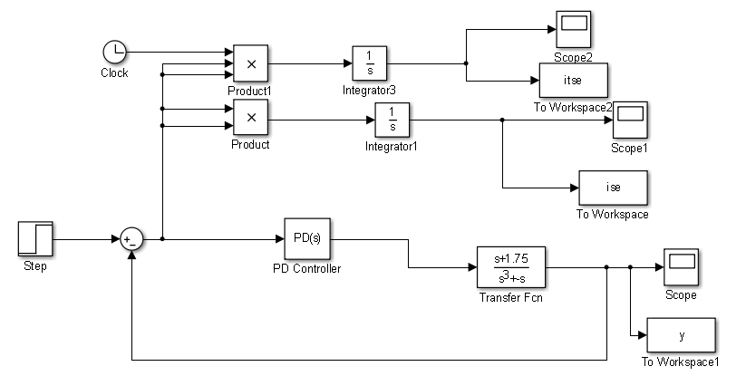
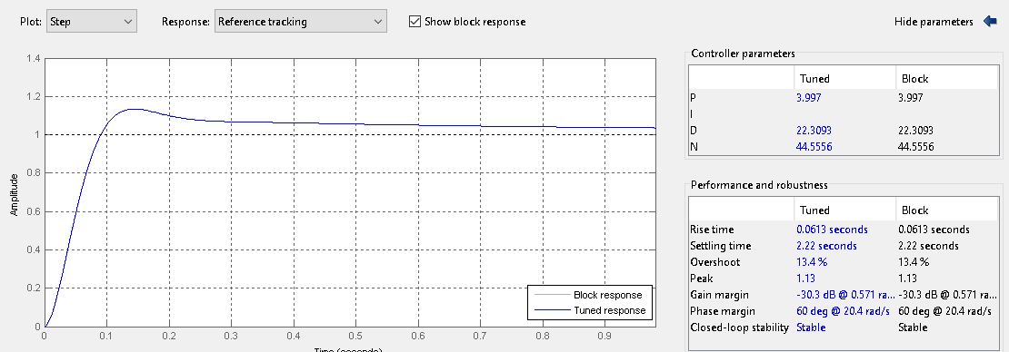
When we used this tuned controller, we looked at the max value of ise which is the error.
>> max(ise)
ans =
0.0381
So, we choose PD controller;
For J1;
We have written a function f to take the ise value from Simulink;
function sonuc = f(Kd_temp, Kp_temp) % This function is used to find the ISE value
global Kp;
global Kd;
Kp = Kp_temp;
Kd = Kd_temp;
sim('q2_a_simulink_PD');
sonuc = ise(end);
end
Below we can see the Simulink block diagrams;
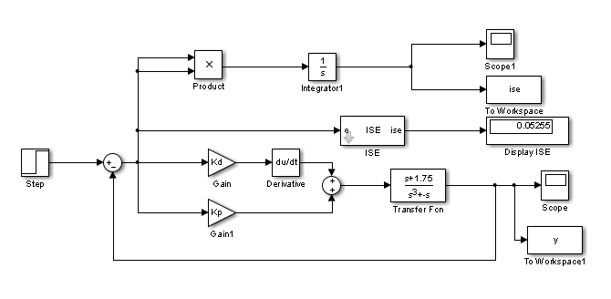
And now it is time to use our hooke jeeves algorithm;

global Kp Kd;
global x1 x2;
syms s;
Kd = input('Kd: ');
Kp = input('Kp: ');

% Hooke Jeeves
% We did not want to change all x1 and x2 from the code
x1=Kd;
x2=Kp;
firstf=f(Kd,Kp);
fnew=firstf;

iteration = 4; % number of step magnitudes
% We declare the step magnitudes as below;
h= [1 0.5 0.25 0.125]; % changes of step magnitude

for m= 1: iteration
for i= 1:1000
step=h(m);
tmp=fnew; % the value before the check
if f(x1+step,x2)<f(x1,x2);
fnew=f(x1+step,x2)
x1=x1+step;
elseif f(x1-step,x2)<f(x1,x2);
fnew=f(x1-step,x2)
x1=x1-step;
end
if f(x1,x2+step)<f(x1,x2);
fnew=f(x1,x2+step)
x2=x2+step;
elseif f(x1,x2-step)<f(x1,x2);
fnew=f(x1,x2-step)
x2=x2-step;
end
if fnew==tmp
break;
end
end

end

Kd=x1
Kp=x2
ise = fnew

The starting point is given as [Kd=2,Kp=1.125]
Kd = 26
Kp = 691.2500
ise = 0.0345
We can see the ISE as 0.0345 from above by hooke jeeves algorithm.
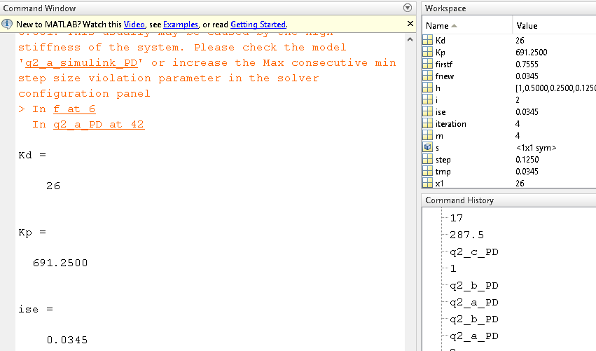
For J2;
We have written a function f to take the itse value from Simulink;
function sonuc = f(Kd_temp, Kp_temp) % This function is used to find the ISE value
global Kp;
global Kd;
Kp = Kp_temp;
Kd = Kd_temp;
sim('q2_b_simulink_PD');
sonuc = itse(end);
end
Below we can see the Simulink block diagrams;
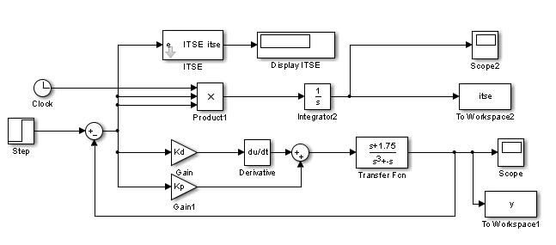
From previous hooke jeeves algorithm, we only written the result as itse.
The starting point is given as [Kd=17,Kp=287.5]
Kd = 15.1250
Kp = 289
itse = 0.0107
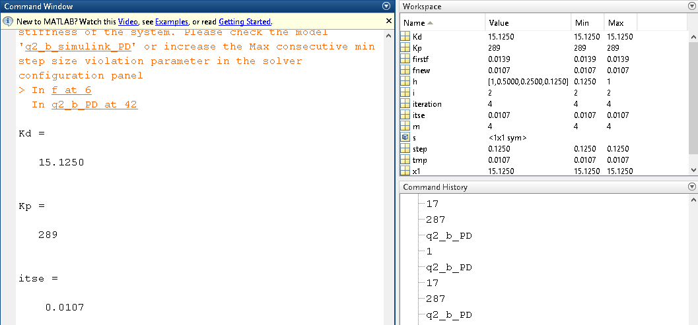

For J3;
We have set the overshoot as the objective function.
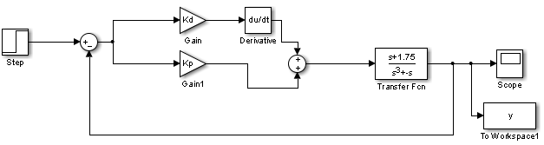
We have set the starting point as Kd=1; Kp=1;
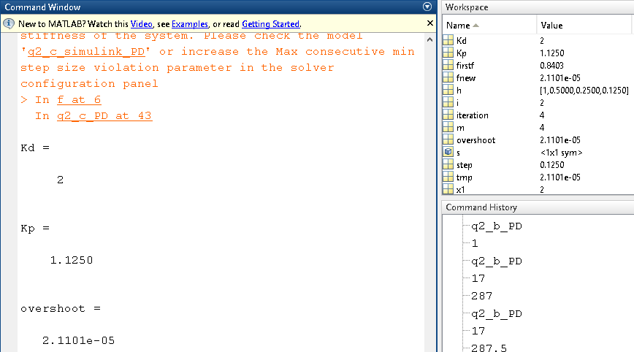
Overshoot is 0.0000211.
Genetic Algorithm;

- Question
Comment
As you can see that the controllers we have found in hooke jeeves algorithm are better controllers.

- Question
For J1;
We have used the same script and same function as question-2, we just added the saturation block in Simulink as below;
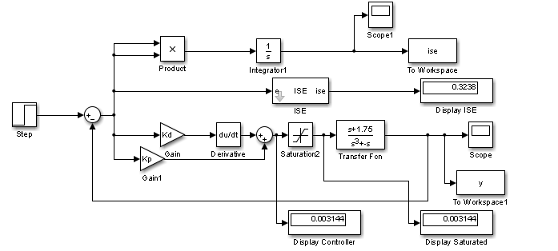
And we determined saturation intervals as 5,-5.
The results were as below;
Kd = 5;
Kp= 12.5;
ise = 0.3238
For J2;
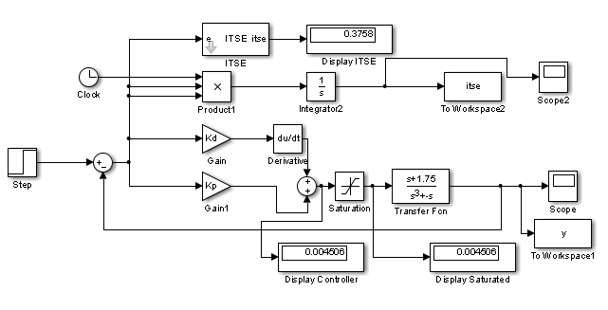
And we determined saturation intervals as 5,-5.
The results were as below;
Kd = 4;
Kp= 9;
ise = 0.3758
For J3;
As we have determined overshoot as objective function, in Simulink, we just need to add the saturation block.
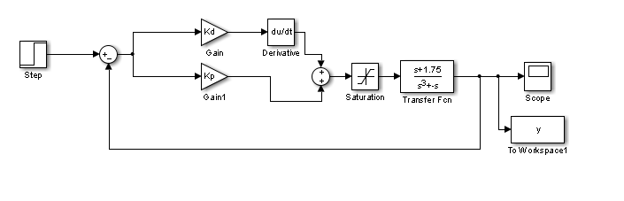
The result;
Kd = 2
Kp = 1.1250
overshoot = 1.1001e-06

- Question
The Controllers we have found in Question-4 are
For J1;
Kd = 5;
Kp = 12.5;
For J2;
Kd=4;
Kp=9;
For J3;
Kd = 2
Kp = 1.1250
Since our system has an integrator(type-1), dead time leads system to infinity.

