# Reasoned Project Plan

# Description of Aim

As a creative project, I plan to analyze The Utopia of Thomas More using Nature Language Processing (NLP) techniques. Utilizing artificial intelligence is useful not only in the field of computers but also in the field of linguists. By way of example, artificial intelligence practices can provide a better understanding of classics by examining them differently than a linguist examines. My motivation of this project is to gain improved understanding of the Utopia using artificial intelligence techniques that have recently become popular. In this course we interpret the Utopia in our point of view, with our feelings, i will show the computers’ understanding, feelings of human language specifically what it understand from Utopia. In addition, after computer examines the text and gives the results it understands, i will seek to answer, what causes can be behind the results and how can we interpret them.

# Indication of Course Project

To begin with, NLP analysis of Utopia will be divided into 2 sections (Syntactic, and Semantic Analysis). Thereafter, entire text will be divided into groups, words belonging to different groups will be examined separately. While the first book of Utopia is going to be examined alone, the second book will be divided into different parts. The reason of is that, Hythloday in first book describes his own memories, yet in the second one he focuses on the Utopia, and Utopia is presented at different topics (their travel, their slaves, their cities, their learning, their military affairs and so on). Even these topics give us clues in terms of syntax analysis.

## 1-Syntactic Analysis

Syntactic analysis will be divided into 3 sections.

* 1. Common Phrases
  2. Frequent words
  3. Frequencies of content words

In this section, i am going to be working with the syntax of sentences, i will be doing syntactic analysis of the Utopia. In this section, most common phrases, most frequent words, frequencies of content words are going to be analyzed.

To do so, Utopia as a text is presented in syntactic way and it needs to be expanded in terms of the meanings underlying this syntax. To elaborate this part with a specific example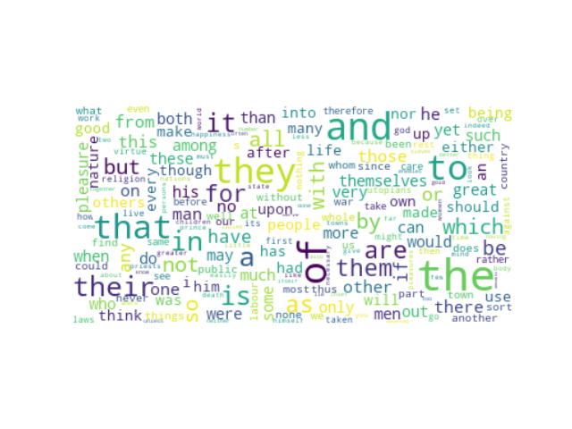

the of and to they that their in a is it are them for as

1422 1055 978 861 835 741 517 509 498 464 440 400 356 348 334

This table stands for the most frequent words in the Second book of the Utopia. When we extract general words e.g. ( "the", "of", "and") an interesting result comes out. The most common frequent words in the Utopia is “they, “their”, and “them”. In my project, i need to expand this information by examining the possible reasons of this outcome.

## 2- Semantic Analysis

Syntactic analysis will be divided into 2 sections.

2-1 Sentiment Analysis

2-2 Consistency Between Topics of Utopia

In the first section, sentiment analysis, the evaluation of the topics in terms of being positive or negative will be analyzed.

In the second section, semantic similarities and differences between parts will be examined and the correctness of Thomas More's claim which is Utopia is not a fiction will be discussed.

To elaborate this part with a specific example, on pg 134.

“*I am sure that whatever may be said of their notions, there is not in the whole world either*

*a better people or a happier government.”*

Here Hythloday, praises Utopia and describes the happiness of the Utopians. I will expand this claim by analyzing the level of happiness of Utopians in text with the help of NLP techniques.

Word Count: 590