**README**

* For question 1 and 2, path to the images can be changed in ***“main.cpp”*.**
* For question 3, path to the dictionary training images and path to the test image can be changed via ***“bow()”*** function in ***“methods.cpp”.***
* Build and run the program.
* Follow the command line instructions.
* Output files are created in the same folder

**EE 576 HW3**

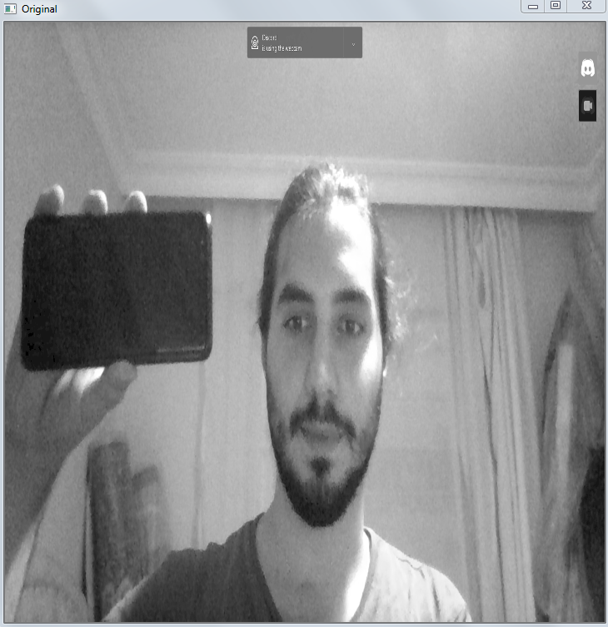 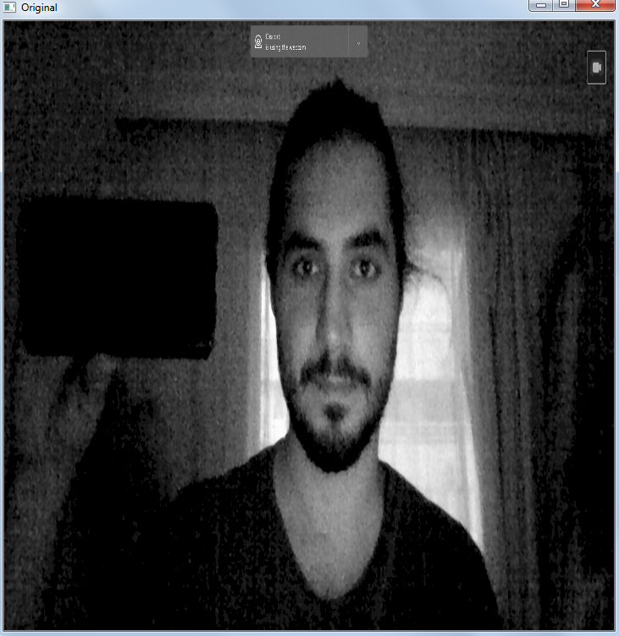

*Original light theme Original dark theme*

**Q1)** For the SIFT method, while dark theme introduces lots of noise, light theme image gave clear and sufficient results for the keypoint detection. Keypoint locations and associated 123 dimensional vectors can be found under *“SIFT.txt”.*

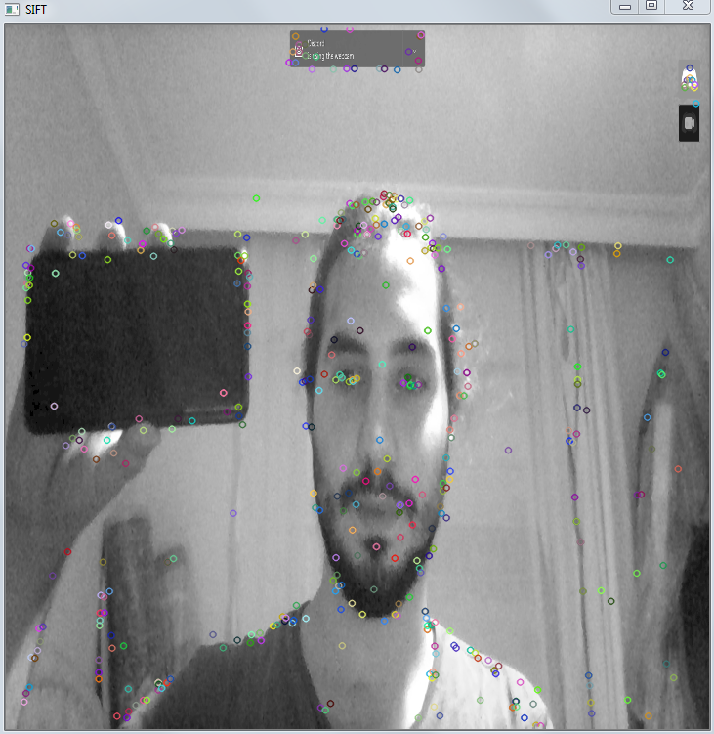 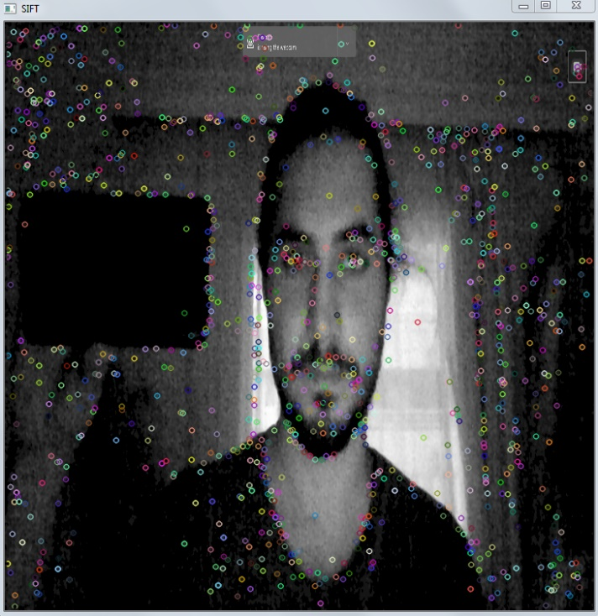

For the Harris, light themed image used 80 as threshold and 140 for the dark themed image. Giving the dark themed image 80 threshold resulted a pure red image which means lots of noise for our corner detector.

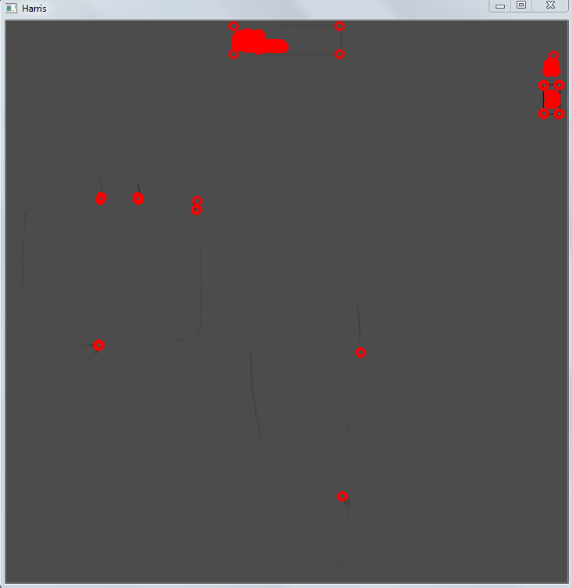 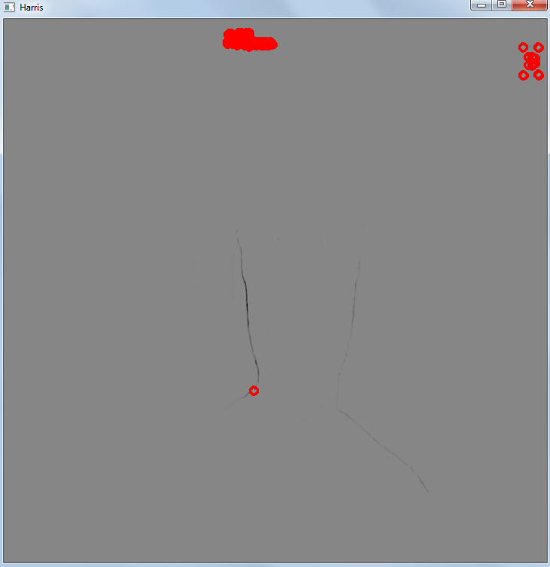

80 threshold light theme 140 threshold dark theme

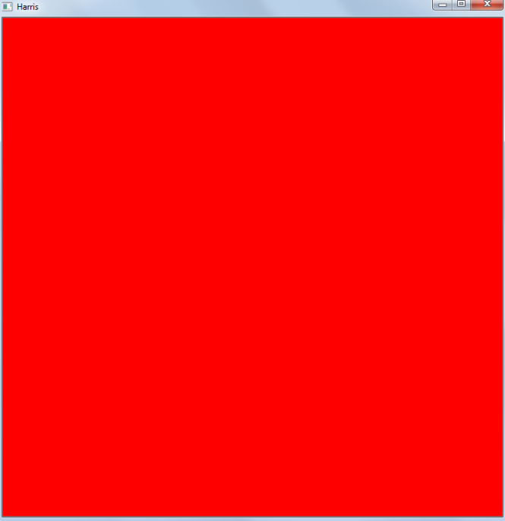

80 threshold dark theme

**Q2)** First edge detection via Canny and later Hough Transform is applied to the both images.

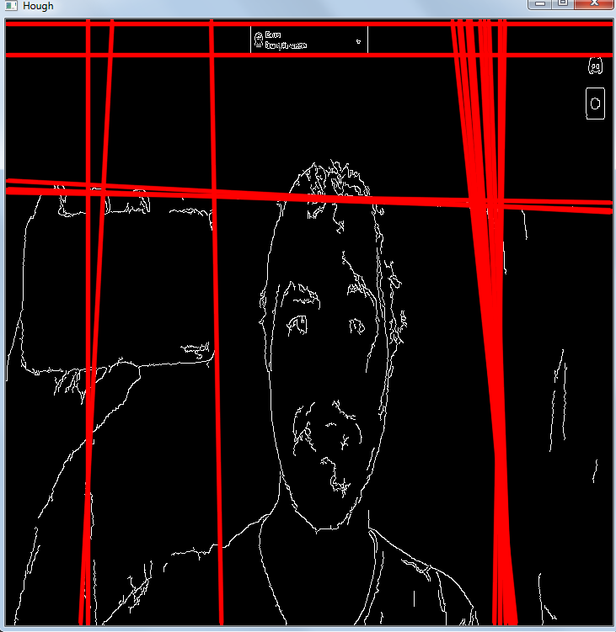 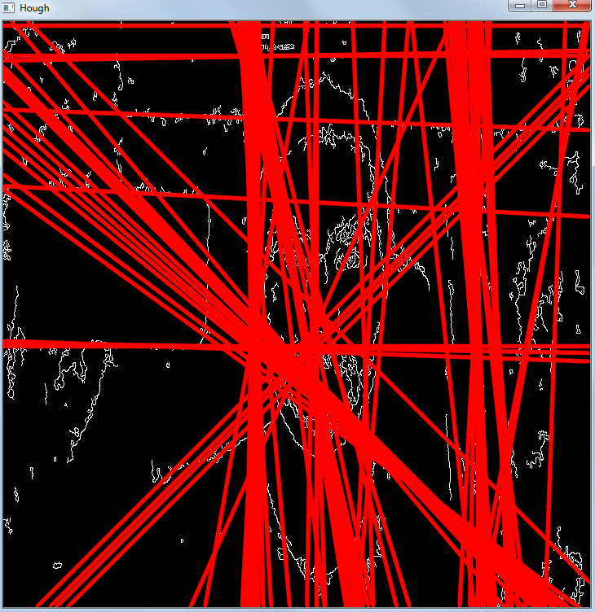

*Hough Transform light theme Hough Transform dark theme*

Resolution 1° and threshold for minimum intersections 100 is selected for Hough Transform. It can be clearly seen from the pictures that Hough transform gives more accurate results for highly illuminated pictures. For the first picture it detected curtain lines, discord video box and some of the phone and carpet lines. Second picture is just too complicated to analyze. Line parameters can be found under *“Hough.txt”* file.

**Q3)** For Box of Words, a 3 class data set has been created. Classes are cars, aeroplanes and bicycles. 17 different pictures for each class is used for vocabulary creation. For easy observation only 3 clusters are used for vocabulary. Created vocabulary can be found under *“vocabulary.yml”* file.

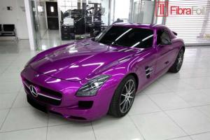 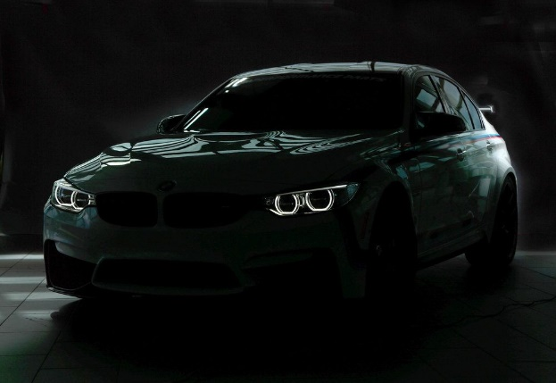

For the car in the light histogram result is: [ 4.63007182e-01, 2.10023880e-01, 3.26968998e-01 ]

For the car in the dark histogram result is: [ 3.23308289e-01, 1.50375947e-01, 5.26315808e-01 ]

It can be seen that this method gives different results for differently illuminated cars but it still clusters them in the same category.

**References**

1. <https://docs.opencv.org/3.4/d9/db0/tutorial_hough_lines.html>
2. <https://www.codeproject.com/Articles/619039/Bag-of-Features-Descriptor-on-SIFT-Features-with-O>
3. <https://docs.opencv.org/3.4/d5/d3c/classcv_1_1xfeatures2d_1_1SIFT.html>
4. <http://isl.ee.boun.edu.tr/courses/ee576/lectures/sunum/featuresPres.pdf>
5. <https://docs.opencv.org/3.4.9/d4/d7d/tutorial_harris_detector.html>