**README**

* You can change the image path from the main file if you desire.
* You can change the harmonic number from the main file in “ellipticFourierDescriptors” function.
* Run the program.
* Continue by pressing *“enter”*.
* Prompt question number as “q1” or “q2”.
* Refer “Segments.txt” for Q1 and “descriptors50/100/150.txt” for Q2.

Note that there are 2 different thresholds in the program “thr” for Q1 and “threshold” for Q2.

**EE 576 HW5**

**Methodology:**

For both questions I used an image binarization technique which evaluates every color in the image one by one. I chose this because even if we label each object in the image using HSV similarity and then 8-neighborhood method in the end “findContours” function only sees the image as 1s and 0s and doesn’t utilizes our different labels for different segments. I used “moments” and “boundingRect” functions for tasks and I fully utilized provided EFD code.

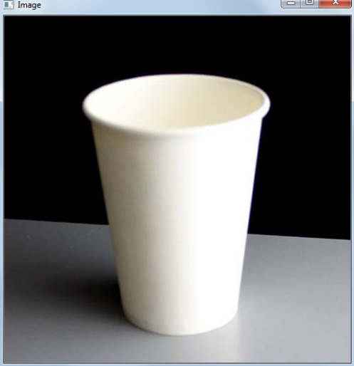 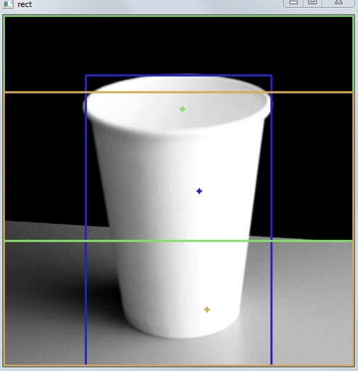

*Object Original Image Segmentation with threshold = 0.1*

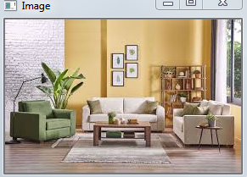 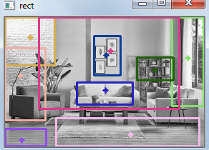

*Object Original Image Segmentation with threshold = 0.01*

For the single object, algorithm detected 3 segments: table, glass and background. It was quite successful in this image. For the scene, it lacks the certain definition of some colors like brown but anyway it detected window, middle wall, left wall, middle couch, bookshelf, lamp, portraits and floor. Certain segments were not detected because of the threshold.

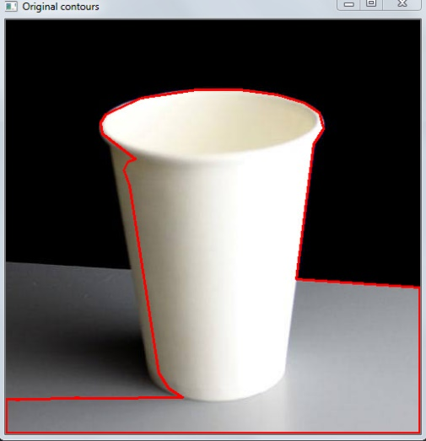 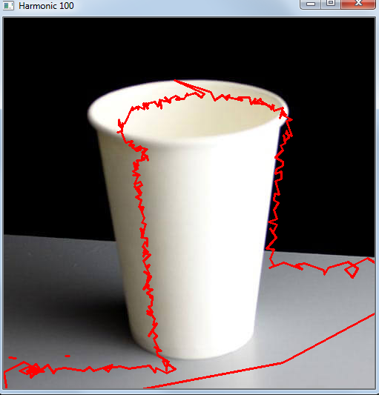

*Original Contours Harmonic 100*

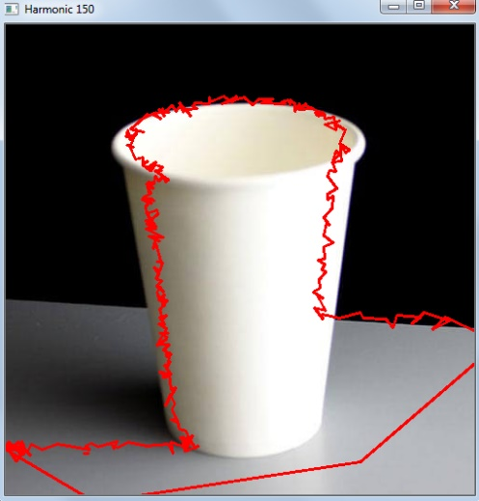 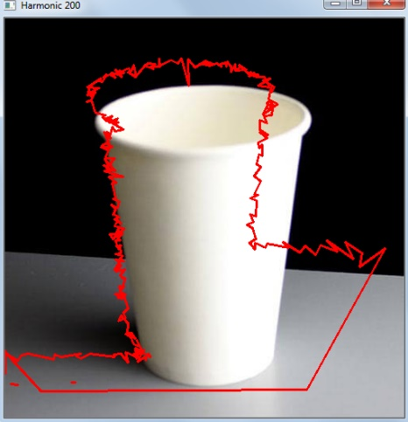

*Harmonic 150**Harmonic 200*

For Q2, we tried 3 different harmonics – low, medium and large. Required harmonic scale was bigger in the scene compared to single object image. We see that ideal harmonic for object image is 150. 200 is overfitted and 100 is not generalized well. For the scene image, in the original contour image there is a unneccessary contour which covers whole image and we see that while it interacts with other contours in low harmonics, it vanishes as we proceed with bigger harmonics.

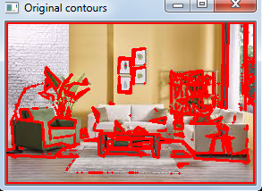 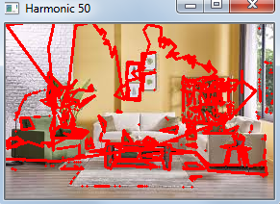

*Original Contours Harmonic 50*

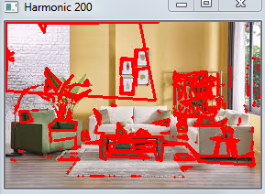 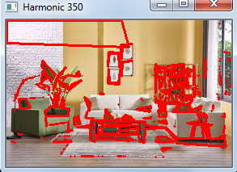

*Harmonic 200 Harmonic 350*

**References**

1. <http://learn.leighcotnoir.com/artspeak/elements-color/hue-value-saturation/hsv8/>
2. <https://docs.opencv.org/3.4/da/d97/tutorial_threshold_inRange.html>
3. <https://docs.opencv.org/2.4/doc/tutorials/imgproc/shapedescriptors/moments/moments.html>
4. <https://docs.opencv.org/3.4/da/d0c/tutorial_bounding_rects_circles.html>
5. Provided EFD code
6. EE576 Homework 4

**Fehmi Ayberk Uçkun**

**2015401009**