**README**

* Run the program.
* First, you need to create a vocabulary. To create it enter process number as “1”. You can access to the created one using “vocabulary.yml”.
* Process Code List:

**1:** Create Vocabulary

**2:** Evaluation of Training Data

**3:** Evaluation of Test Data

* Check the results in “results.txt”
* “train_results.txt” and “test_results.txt” are provided with program to show precalculated results.

**EE 576 HW8**

**Methodology:**

Vocabulary cluster size is increased compared to the previous homework considering scenes might require better histogram representations to perform well. Labeled the bow histograms of the images and with these data and trained OpenCV SVM. One vs All strategy is chosen for this assignment. As explained in the previous homework, the reason behind this decision is implementation feasibility. In one vs all, I trained 5 different classifiers ( 1 for each class) and chose positive samples as the respective class for labeling and took the distances as output. Thresholded them with 3 different thresholds and evaluated the results. One threshold same with hyperplane, one threshold uses higher confidence and the other to let low confidence outputs.

**Results for Train Data**

|  |  |  |  |  |  |
| --- | --- | --- | --- | --- | --- |
| **Threshold = -0.5** | **Place1** | **Place2** | **Place3** | **Lab** | **Park lot** |
| **Precision** | 1 | 1 | 1 | 1 | 1 |
| **Recall** | 0.43 | 1 | 0.85 | 0.78 | 0.91 |

*Every column represents the classifier which trained with positive samples of the respective class name.*

|  |  |  |  |  |  |
| --- | --- | --- | --- | --- | --- |
| **Threshold = 0** | **Place1** | **Place2** | **Place3** | **Lab** | **Park lot** |
| **Precision** | 1 | 1 | 1 | 0.94 | 1 |
| **Recall** | 1 | 1 | 1 | 0.89 | 0.98 |

|  |  |  |  |  |  |
| --- | --- | --- | --- | --- | --- |
| **Threshold = 0.75** | **Place1** | **Place2** | **Place3** | **Lab** | **Park lot** |
| **Precision** | 0.93 | 0.81 | 0.81 | 0.9 | 0.92 |
| **Recall** | 1 | 1 | 1 | 1 | 1 |

Threshold is a trade-off between precision and recall. Large thresholds mean that larger errors are accepted, and false-positives are frequent while small thresholds mean only small errors are accepted and false-negatives are common. We can see that, in our case, increasing threshold values increased the recall rate and decreased the precision rate of the classes. As we can see from the table, increasing threshold from “0” to “.75” increased the performance of “Lab” class while sacrificing the precision of “Place1” and “Place2” classes. This situation can be desired or avoided considering the expected performance criteria. Although, further increasing the threshold resulted in a sharp decrease on the performance of all classes. Also, decreasing the threshold from “0” to “-0.5” increased the precision of “Lab” class at the cost of all classes recall rates. Thus, one must choose the threshold with care.

After the inspection of ROC curves, if we need to choose a best class model it would be “Place2” because it simply has 1 precision and 1 recall both at greater confidence levels (like threshold = -0.5) and zero threshold. But with further examination, we can see its precision decreases more rapidly than other models as we increased the threshold. This means, even though it perfectly separated its positive class from hyperplane, it couldn’t put negative samples to a great distance from hyperplane. The most optimum model is probably “Park Lot” because it both has a great recall at negative threshold and has a great precision at positive threshold. This means hyperplane is perfectly placed in the middle of the positive and negative samples. For the worst models, “Lab” model never reaches the 1 precision – 1 recall performance and “Place1” has a significantly low recall rate at negative threshold, this means it couldn’t differentiate positive samples from negatives with great confidence. Thus, these both models are not preferable. “Place1” is also the model which has least variation in its training data thus this leads to bad results.

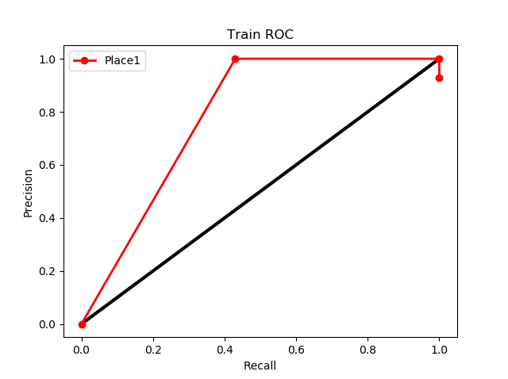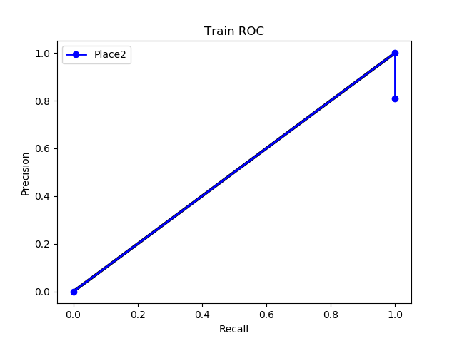

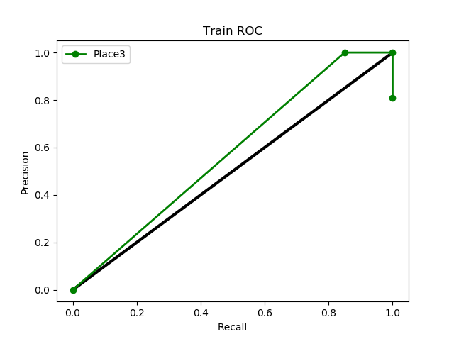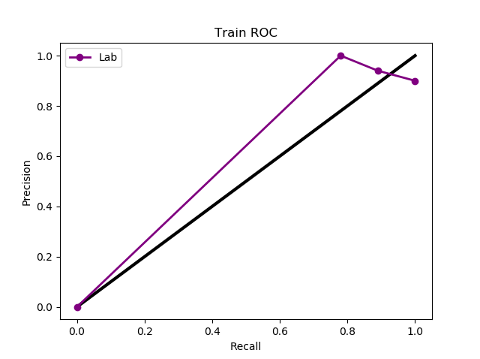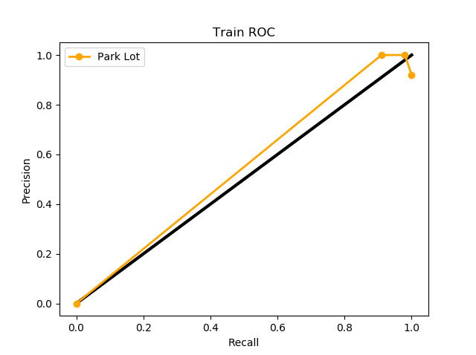

*Graphs-1: ROC curves of 5 classes each sampled at mentioned thresholds for the training data*

**Results for Test Data**

|  |  |  |  |  |  |
| --- | --- | --- | --- | --- | --- |
| **Threshold = -0.5** | **Place1** | **Place2** | **Place3** | **Lab** | **Park lot** |
| **Precision** | 0 | 1 | 1 | 1 | 0.97 |
| **Recall** | 0 | 0.86 | 0.29 | 0.56 | 1 |

*Every column represents the classifier which trained with positive samples of the respective class name.*

|  |  |  |  |  |  |
| --- | --- | --- | --- | --- | --- |
| **Threshold = 0** | **Place1** | **Place2** | **Place3** | **Lab** | **Park lot** |
| **Precision** | 1 | 1 | 1 | 1 | 0.97 |
| **Recall** | 0.83 | 0.86 | 0.71 | 0.89 | 1 |

|  |  |  |  |  |  |
| --- | --- | --- | --- | --- | --- |
| **Threshold = 0.75** | **Place1** | **Place2** | **Place3** | **Lab** | **Park lot** |
| **Precision** | 0.86 | 0.78 | 0.58 | 1 | 0.85 |
| **Recall** | 1 | 1 | 1 | 1 | 1 |

This time we encounter with 0 precision – 0 recall situation for “Place1” model. We already mentioned this model suffers from low confidence rate and this manifest itself greatly at the training data. Also, this time “Place3” performs worse than “Lab” model and greatly misses the optimum precision/recall ratio. Expectedly “Place2” and “Park Lot” both shows great performance with test data. If we compare test results with the training results, we can see an overall worse performance, as expected, but especially on recall rates, that is, how much true-positives we found compared to all positive classes, are worse. That’s because we trained the model with the same training data and its highly unlikely that model will miss any positives at the training data.

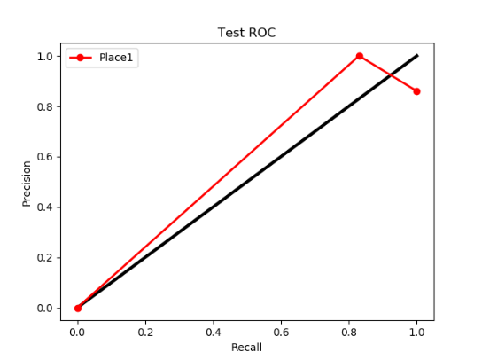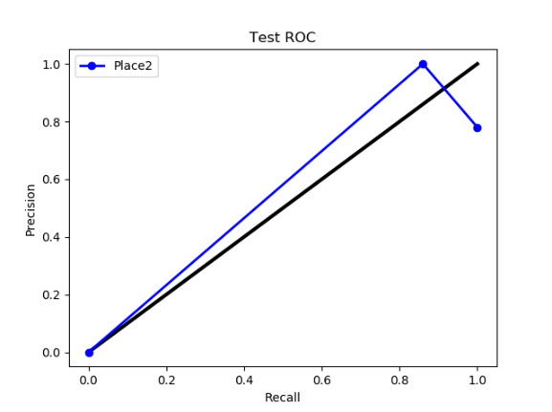

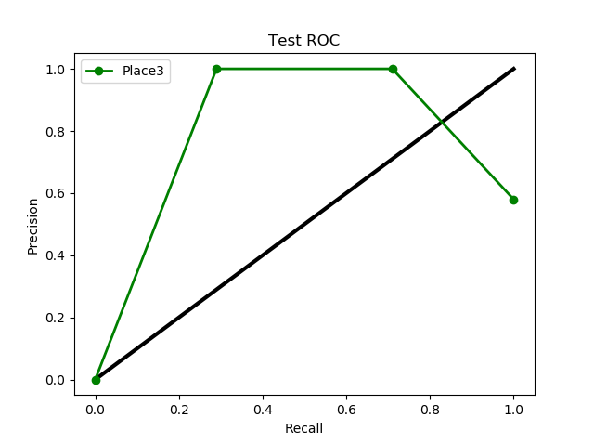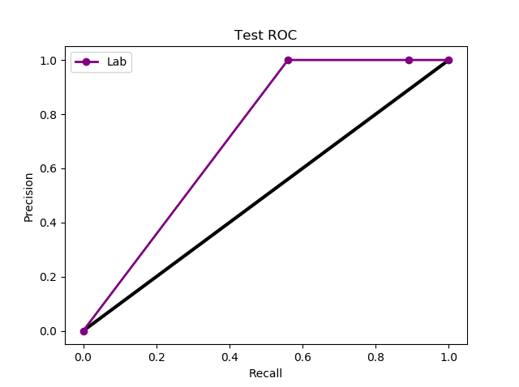

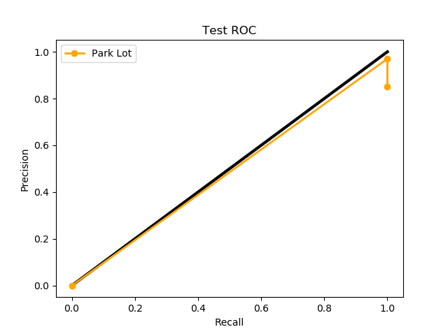

*Graphs-2: ROC curves of 5 classes each sampled at mentioned thresholds for the test data*

**References**

1. EE576 Homework 6
2. EE576 Homework 7

**Fehmi Ayberk Uçkun**

**2015401009**