**README**

* Run the program.
* Choose the Optical Flow type you want to use as specified in parenthesis. *(dense or sparse)*
* Choose the dataset you want to use as specified in parenthesis. *(human or car)*
* You will see the vector field corresponding the movement between the two consecutive frame in the screen both on a blank image and superimposed on the original gray image.
* You can press “p” any moment, after selecting the image window, to stop the image flow. For the Sparse Optical Flow, pressing “p” will also show the tracked feature list of the current frame in the command window.
* You can press “q” to quit.

**EE 576 HW9**

**Methodology:**

For this assignment, I used Farneback algorithm for dense optical flow and Lucas-Kanade method for sparse optical flow considering these are the suggested APIs in OpenCV. As output, I showed the resulting vector field of two consecutive images in the screen. For sparse optical flow, I used “goodFeaturesToTrack” function to find the Harris features of every frame and then only the best 100 features are tracked between two images.

**Dense Optical Flow**

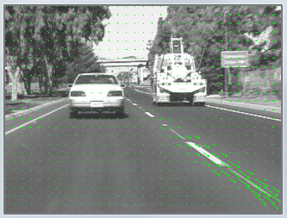 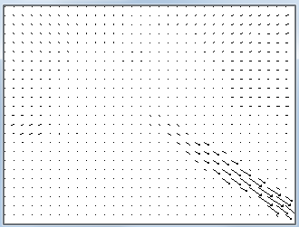

*Dense Optical Flow vector field on car dataset*

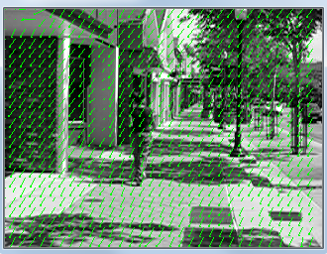 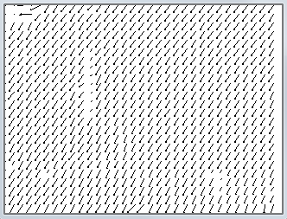

*Dense Optical Flow vector field on human dataset*

For the car dataset, camera is moving with the car it’s attached to thus we expect a movement of the image pixels towards outside of the image. Our algorithm detects movement mainly on the road tracks and at the surrounding trees. This makes sense because other cars are also moving with the camera thus, they are relatively stable.

For the human dataset, we can see all pixels move along the same way that’s because camera is significantly unstable and moves with every step of the camera holder. This causes camera movement to dominate other objects relative movement. To recover from this situation, an affine transformation can be applied to the consecutive images.

**Sparse Optical Flow**

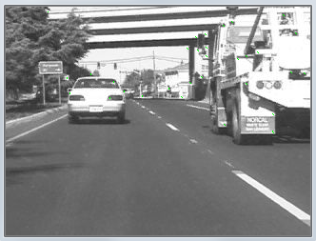 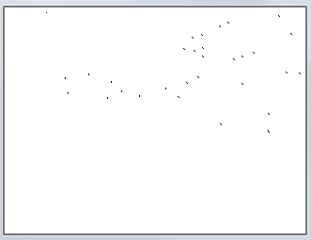

*Sparse Optical Flow vector field on car dataset*

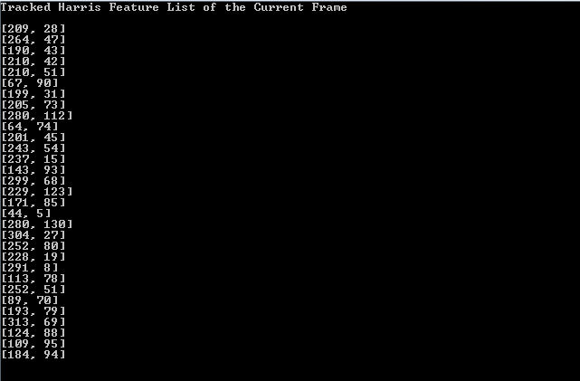

*Tracked Harris Feature List of the above frame*

If we compare the results of the dense and sparse optical flow, the obvious one is sparse optical flow doesn’t really recognize every movement. For the car dataset, Harris features (corners) are on the cars. We already mentioned, other cars are relatively stationery with respect to the camera movement. As it happens in real life, the background is needed to be recognized to be moving but because all the corners are on the dominant objects of the image (mainly cars), sparse optical flow failed to detect the movement and only showed the slow movement of the cars.

For the human dataset, again camera movement dominated the scene and all the corners detected as moving in reverse of the camera direction. This is a bad dataset thus results are not satisfactory and comparable.

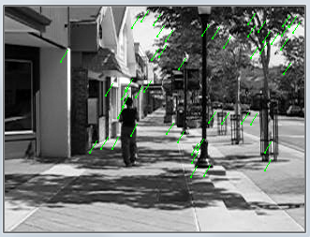 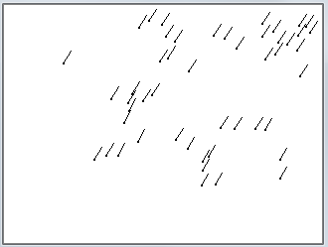

*Sparse Optical Flow vector field on human dataset*

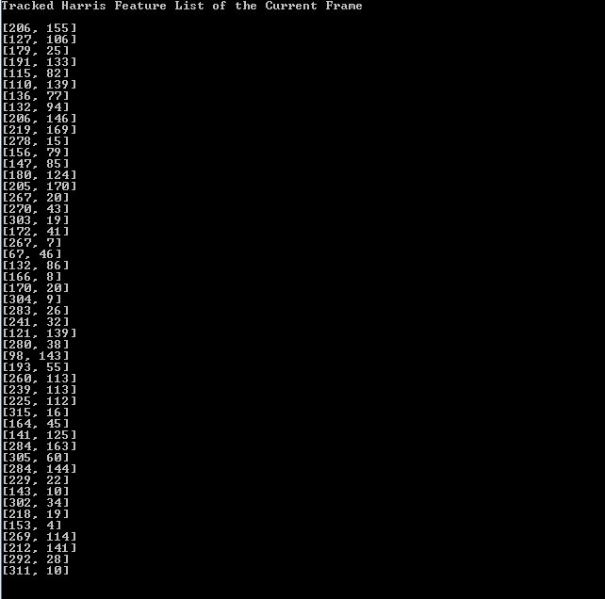

*Tracked Harris Feature List of the above frame*

For the bonus question, I believe we can apply segmentation using optical flow. If we consider car dataset, segmenting similar movements together, we can detect the background, road tracks and the cars by applying a carefully selected threshold. However, this is not always easy as it happens in the human dataset. We cannot apply any segmentation in that dataset.

**References**

1. EE576 Homework 2
2. <https://opencv-python-tutroals.readthedocs.io/en/latest/py_tutorials/py_video/py_lucas_kanade/py_lucas_kanade.html>

**Fehmi Ayberk Uçkun**

**2015401009**