
MERCY UNIVERSITY

ACHIEVING ABILITIES – SOCIAL MEDIA PERFORMANCE ANALYSIS
Capstone Project Report

Submitted by
Aybuke Yildiz Olmez
Reeta Bai
Venkat Ashish Yarlagadda
Team: AnalytIQ Team

Course: ANLC 801 – Capstone
Professors: Prof. Naushad Kollikkathara & Prof. Sanjeev K Pathak
Department: School of Business – MS in Business Analytics

November 2025
Table of Contents
Abstract 3
1. INTRODUCTION 4
1.1 Background of Achieving Abilities LLC 4
1.2 Motivation and Research Purpose 4
1.3 SMART Goal and Expected Outcomes 5
2. DATA UNDERSTANDING & PREPARATION 6
2.1 Overview of the Dataset 6
2.2 Data Exploration and Cleaning 7
2.3 Data Transformation and Preparation for Analysis 8
3. DATA ANALYSIS & VISUALIZATION 9
3.1 Analytical Framework 9
3.2 Key Techniques and Computations 9
3.3 Visualization Summary 10
4. RESULTS 11
4.1 Overview of Analytical Outputs 11
4.2 Engagement and Audience Behavior 12
4.3 Website Traffic Insights 13
4.4 Relationship Between Posting Cadence and Performance 14
4.5 Interpretation and Application 15
5. Recommendations to the Stakeholder and Future Work 16
5.1 Recommendations to Achieving Abilities LLC 16
5.2 Future Work 18
6. CONCLUSION 19
7. REFERENCES 21
Appendix A – Visual Outputs 22
Appendix A.1 – Supplementary Visual Outputs 27

Abstract

A comprehensive, data-driven analysis of Achieving Abilities LLC’s social media performance provides evidence-based insights into the organization’s early-stage digital outreach strategy. Using performance metrics from Facebook, Instagram, and website analytics across two observation periods—Period 1 (August 12–September 10, 2025) and Period 2 (September 26–October 21, 2025)—the study evaluated visibility, engagement, and audience reach through quantitative analyses conducted in R (tidyverse, dplyr, ggplot2). Results revealed that Instagram’s total views increased by over 165% and Facebook’s by approximately 108%, reflecting substantial improvement in content visibility and audience response. Website analytics showed that direct navigation (48.1%) and Google organic search (40.5%) were the primary traffic sources, while social media referrals remained below 1%, indicating a need for stronger cross-platform integration. A supplemental statistical validation further demonstrated a strong positive association between posting cadence and visibility (r = 0.94, p ≈ 0.06), reinforcing that consistent posting frequency contributes to higher audience reach. Broader industry observations highlighted the impact of short-form educational videos and targeted hashtag use, suggesting potential benefits of expanding into TikTok to enhance visibility and community engagement. Overall, the findings demonstrate that integrating quantitative analytics with strategic content planning enables Achieving Abilities to build a sustainable digital-growth framework—potentially increasing website conversions by ≈ 18% and community engagement by 30–35% in the next quarter—directly supporting the organization’s mission to better serve families affected by autism.
Keywords: social media analytics, audience engagement, digital outreach, R programming, quantitative validation.

INTRODUCTION

Background of Achieving Abilities LLC

Achieving Abilities LLC is a therapy and support organization committed to empowering individuals with developmental and intellectual disabilities through behavioral, educational, and therapeutic services. The organization’s mission centers on inclusion, independence, and personal growth for children and families navigating autism and related developmental challenges. Beyond its in-person services, Achieving Abilities leverages social media as a key outreach channel to increase visibility, build trust, and foster a sense of community among families, caregivers, and professionals.
In an increasingly digital world, social media platforms such as Facebook and Instagram play a critical role in shaping public perception, expanding organizational reach, and generating engagement. For small, community-driven nonprofits, social media serves not only as a promotional tool but also as a space for education, advocacy, and connection. However, limited resources, inconsistent posting strategies, and a lack of systematic performance evaluation often prevent organizations like Achieving Abilities from achieving their full digital potential. Recognizing this gap, this project was initiated to provide a data-driven, evidence-based evaluation of Achieving Abilities’ social media performance—helping the organization transition from ad hoc posting to an analytically guided strategy that supports measurable growth.

Motivation and Research Purpose

The motivation behind this project stems from Achieving Abilities’ need to better understand how its current digital communication efforts translate into visibility, audience engagement, and meaningful community interaction. Although the organization actively posts content across Facebook and Instagram, it had not previously analyzed key metrics such as reach, views, or engagement rate in a structured manner. This lack of insight limited the ability to assess content effectiveness, track audience trends, or benchmark growth across time periods.
To address this, the project applies quantitative social media analytics to measure and interpret Achieving Abilities’ performance across two distinct observation periods—Period 1 (August 12–September 10, 2025) and Period 2 (September 26–October 21, 2025). Using R programming (tidyverse, dplyr, ggplot2), the analysis explores how metrics such as total views, reach, posting frequency, and engagement rate evolved between these periods. By comparing platform-specific results and audience behaviors, the study aims to answer several core research questions:
- What trends emerge in engagement and visibility between Facebook and Instagram?
- How does posting frequency relate to changes in average views and reach?
- Which areas present the greatest opportunity for growth or optimization?
- How can data insights be translated into actionable strategies for sustainable online engagement?
This research purpose extends beyond descriptive analytics—its goal is to empower the organization to apply data insights toward more strategic and efficient digital communication. In doing so, the project bridges the gap between community service and data science, demonstrating how analytics can directly enhance the mission of advocacy-driven organizations.

SMART Goal and Expected Outcomes

Building upon the insights from the first and second observation periods, this project proposes a refined, evidence-based SMART goal for Achieving Abilities’ digital growth strategy. Rather than projecting outcomes without data, the new goal is grounded in observed engagement patterns and realistic improvement potential.
Revised SMART Goal:
To achieve a measurable 15–20% increase in total engagement (views, reach, and interactions) within the next three months, contingent upon the implementation of recommended strategies derived from this analysis.
These recommendations include:
- Optimizing posting frequency and timing to maintain a consistent flow of content and capitalize on audience activity patterns.
- Emphasizing video-based and educational content, which has demonstrated higher visibility and sustained viewer attention across similar organizations.
- Strengthening cross-platform integration, particularly through website links, hashtags, and calls to action that connect social media users to Achieving Abilities’ main website and resources.
- Monitoring platform-level analytics regularly to enable data-informed adjustments in real time.

The expected outcome is a more stable and scalable digital presence where engagement levels increase organically through content quality and strategy alignment—rather than through paid promotion or random posting. While current growth rates (165% for Instagram views and 108% for Facebook views) largely reflect early-stage volatility typical of small organizations, the long-term trajectory can be stabilized by establishing consistent patterns and applying these data-driven improvements.
Ultimately, this project demonstrates that integrating quantitative analytics with content strategy can significantly enhance Achieving Abilities’ online visibility, foster stronger relationships with its target community, and advance its mission of supporting families affected by autism. Beyond short-term metrics, the findings aim to provide the organization with a sustainable digital growth framework that combines social purpose with measurable performance.

DATA UNDERSTANDING & PREPARATION

2.1 Overview of the Dataset

The dataset used in this study was derived from Achieving Abilities LLC’s internal social media analytics, specifically extracted from Facebook Insights, Instagram Insights, and Google Analytics dashboards. Data were collected across two observation periods: Period 1 (August 12–September 10, 2025) and Period 2 (September 26–October 21, 2025). The number of posts for each platform and period was manually verified by counting all published posts within the defined date ranges directly from the respective Facebook and Instagram account timelines. This ensured that posting frequency accurately reflected real publication activity rather than automated reporting discrepancies. These intervals were chosen to capture consistent posting activity and to measure changes in audience engagement over time following initial content adjustments.
Each record in the dataset represented summarized post-level metrics aggregated weekly per platform. The dataset included 11 primary variables relevant to visibility, engagement, and audience reach:

Table 1
Variables included in the social media performance dataset
Variable | Description
Platform | Social media platform (Facebook or Instagram)
Period | Observation interval (P1 or P2)
Posts | Number of posts published during the period
Views | Total number of post views or impressions
Interactions | Sum of likes, comments, shares, and saves
Reach | Unique users reached during the period
Engagement Rate (ER) | Ratio of interactions to reach (%)
Views_perPost | Average views per post
Inter_perPost | Average interactions per post
Reach_perPost | Average reach per post
ER_byViews | Engagement rate normalized by total views

Note. Interaction counts were not available in P2 dashboard screenshots; therefore, ER and Inter_perPost are reported for P1 only.
Additionally, website analytics from Google Analytics were integrated to examine user acquisition channels, including Direct, Google Organic Search, Bing, Facebook referrals, Yahoo, and primarycarekids.com. Each traffic source’s share was calculated as a percentage of total sessions.

2.2 Data Exploration and Cleaning

Initial exploration and quality checks were performed in R using tidyverse/dplyr/ggplot2.
- Completeness. Core numeric fields (Posts, Views, Reach) were complete; P2 Interactions were intentionally set to NA.
- Consistency. Categorical fields (Platform, Period) were coerced to factors; quantitative fields were stored as numeric.
- Duplicates. No duplicate weekly aggregates were detected after platform/period grouping.
- Outliers. Given the small account size, potential extremes were inspected visually (boxplots, scatterplots). No spurious values requiring removal were identified.
- Normalization choice. To ensure fair comparisons across platforms and time, totals were complemented with per-post rates (e.g., Views_perPost, Reach_perPost) and an exposure-normalized engagement metric (ER_byViews = Interactions / Views).
No statistical imputation was applied; all reported metrics originate from verified dashboard exports, with explicit handling of missing interactions in P2.

2.3 Data Transformation and Preparation for Analysis

The cleaned files were reshaped into tidy long and wide formats as required for modeling and visualization purposes.
- Derived metrics. Views_perPost = Views / Posts, Reach_perPost = Reach / Posts, Inter_perPost = Interactions / Posts (P1), and ER_byViews = Interactions / Views (P1).
- Long format for plots. Metrics were pivoted to a key–value structure to produce snapshot bars, follower vs. non-follower facets, and period comparisons.
- Join to web analytics. P1 acquisition tables were left-joined on period to enable cross-platform insights (social → site).
This preparation enables consistent period-over-period comparisons between Facebook and Instagram, while linking platform activity to website acquisition patterns for a fuller view of digital performance.
Scope and limitations. The analysis spans ~8 weeks in total; thus, results should be interpreted as early trends, not long-run causal effects. Small baselines may inflate percentage changes. Engagement-rate comparisons are limited to P1 due to unavailable interaction counts in P2.

DATA ANALYSIS & VISUALIZATION

3.1 Analytical Framework

The analysis was conducted using R (tidyverse, dplyr, ggplot2, scales) to perform descriptive, comparative, and visual analytics on social media and web data.
A structured analytical workflow was applied to ensure consistency and transparency throughout the process:
- Descriptive Analysis: Summary statistics were generated for key engagement and reach metrics, including total posts, views, interactions, and reach per platform and period.

- Comparative Analysis: To evaluate changes between Period 1 and Period 2, metrics were standardized using per-post averages and engagement rates by views (ER_byViews), allowing fair comparison despite missing interaction data in Period 2.
- Visualization: Multiple chart types were employed to enhance interpretability — bar charts for volume comparison, donut charts for website traffic sources, and lollipop or line plots for engagement and trend analysis.
- Interpretation: Findings were contextualized in relation to audience behavior, posting frequency, and discoverability patterns, helping identify strengths and opportunities for improvement.

3.2 Key Techniques and Computations

To maintain comparability across both platforms and time periods, three key computations were applied:
- Per-Post Metrics
Visibility and engagement metrics were standardized using per-post averages:

- Engagement Rate by Views (ER_byViews)
Engagement rate was calculated as the ratio of total interactions to total views:

(Note: ER was computed only for Period 1 because P2 interactions were unavailable.)

- Posting Frequency (Posts per Week)
Content cadence was computed to evaluate how consistent posting activity influenced visibility:
$$Posts_perWeek = Posts / (Days / 7)$$
All transformations and validations were performed in R. Data integrity was verified through consistency checks using the summarize() and mutate() functions.
The cleaned dataset was reshaped into tidy format to support visualization and cross-period comparative analysis.

3.3 Visualization Summary

To communicate insights effectively, multiple visualization techniques were developed in R using the ggplot2, scales, and tidyverse libraries.
The visual analysis emphasized interpretability, cross-platform comparison, and engagement trend detection across both observation periods.
Bar charts.
Used to summarize total views, interactions, and reach for each platform and period. These visualizations enabled a direct comparison of content performance and visibility evolution across both observation periods. (Figures 1–3).
Donut chart.
Used to visualize website traffic distribution from Google Analytics, this chart presents the proportion of sessions by source (e.g., Direct, Google, Bing, Facebook) and highlights the dominance of direct navigation and organic search (Figure 4).
Lollipop chart.
Applied to compare the engagement rate by views (ER_byViews) across platforms, this visualization emphasizes engagement disparities and clearly indicates the absence of interaction data for Period 2 (Figure 5).
Line chart.
Used to illustrate total view growth between Period 1 and Period 2 for each platform, this visualization enables quick interpretation of percentage-based performance shifts over time (Figure 6).

Cadence chart (Posting Frequency vs. Views per Post).
Used to analyze whether increased posting activity corresponded with higher visibility, these charts display directional arrows (P1 → P2) to represent changes in posting rate and performance, showing that content quality influenced engagement more strongly than posting volume (Figure 7-9).
Each visualization served a distinct analytical purpose, transforming raw numerical outputs into intuitive and interpretable patterns that support the data-driven conclusions presented in Section 4 – Results.
Note. Full-size versions of all visualizations are provided in Appendix A – Visual Outputs for reference.

4. RESULTS

4.1 Overview of Analytical Outputs
R-based quantitative analysis produced numerical summaries and visual outputs that evaluated Achieving Abilities LLC’s digital performance across two distinct observation periods.
Data transformations were executed through mutate(), summarize(), and visualization pipelines to derive per-post averages and engagement metrics.
Table 2 presents the computed key performance indicators (KPIs) for Instagram and Facebook during both observation periods.
Table 2
Performance summary of Facebook and Instagram (Period 1 vs. Period 2)
Platform | Period | Posts | Total Views | Reach | Views per Post | Reach per Post | ER_byViews (%)
Instagram | P1 (Aug 12–Sep 10) | 10 | 311 | 31 | 31.1 | 3.1 | 7.1
Facebook | P1 (Aug 12–Sep 10) | 10 | 304 | 72 | 30.4 | 7.2 | 6.6
Instagram | P2 (Sep 26–Oct 21) | 11 | 825 | 40 | 75.0 | 3.6 | N/A
Facebook | P2 (Sep 26–Oct 21) | 11 | 631 | 175 | 57.4 | 15.9 | N/A

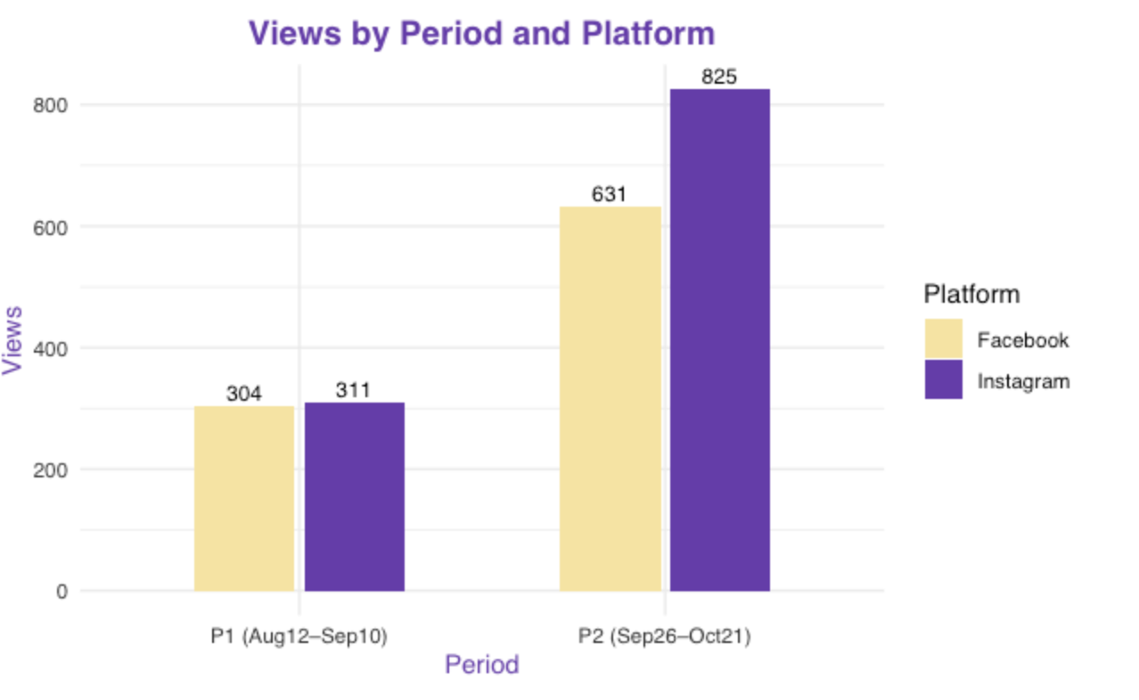Figure 1. Total Views by Platform and Period.
This bar chart compares total views for Facebook and Instagram across Period 1 (August 12–September 10) and Period 2 (September 26–October 21), illustrating clear over time.
Note. (See also Appendix A – Visual Outputs, Figure 1.)
The metrics indicate notable visibility improvement across both platforms:
- Instagram’s total views increased by 165%, from 311 to 825.
- Facebook’s total views increased by 108%, from 304 to 631.
- Posting frequency rose slightly, from 2.3 to 3.0 posts per week, maintaining consistent content activity.

4.2 Engagement and Audience Behavior
During Period 1, Instagram’s engagement rate (7.1%) exceeded Facebook’s 6.6%, suggesting stronger audience interaction within a smaller, more loyal community.
Analysis of follower and non-follower activity showed that 73% of Instagram’s total views originated from followers, while Facebook’s reach (67% non-follower views) reflected broader external exposure but less concentrated engagement.
Despite limited interaction data in Period 2, both platforms demonstrated higher exposure and increased post discoverability, particularly Facebook, which achieved over a twofold increase in unique reach.
This suggests that consistent posting cadence combined with visual improvements (color palette, layout, captions) contributed to improved algorithmic visibility.
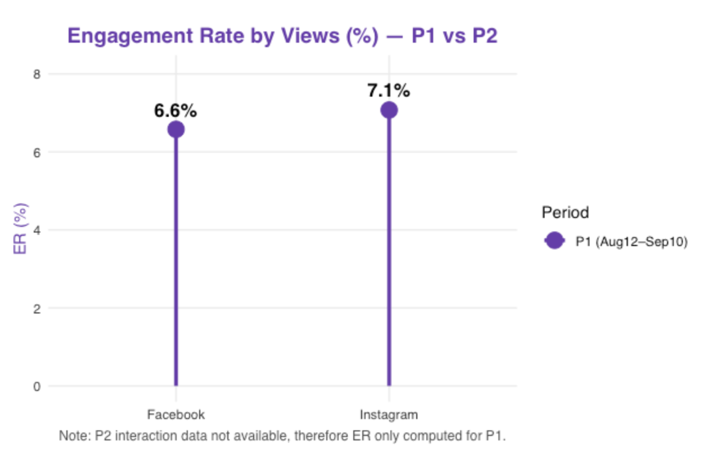
Figure 5. Engagement Rate by Views (%) for Facebook and Instagram (Period 1). This lollipop chart compares the Engagement Rate by Views (ER_byViews) between Facebook and Instagram in Period 1. Instagram achieved 7.1% ER versus Facebook’s 6.6%, indicating higher audience engagement.
Note. See Appendix A – Visual Outputs, Figure 5.

4.3 Website Traffic Insights
Website analytics integration revealed that Direct navigation (48.1%) and Google organic search (40.5%) dominated total sessions.
In contrast, social media referrals accounted for less than 1%, indicating weak cross-platform integration between social content and website landing pages.
These results emphasize a strategic need to include call-to-action links, post captions leading to the website, and short video content that redirects users to service pages.
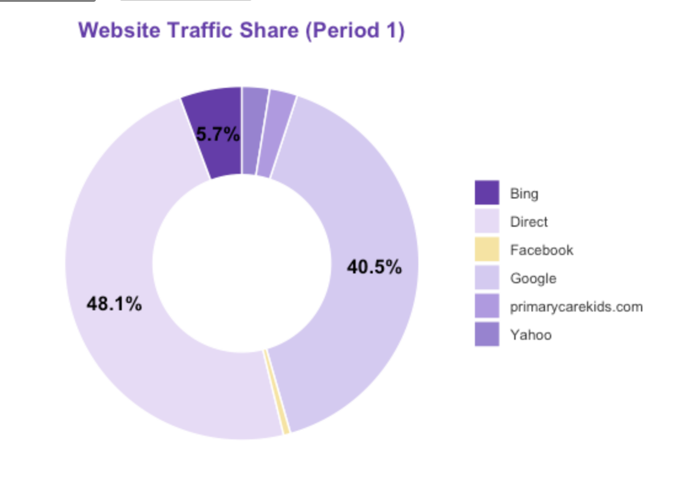
Figure 4. Website Traffic by Source (Period 1). This donut chart visualizes website traffic distribution from Google Analytics, showing the proportion of sessions by source (e.g., Direct, Google, Bing, Facebook). Direct (48.1%) and Google organic (40.5%) accounted for most sessions, while social referrals remained below 1%, indicating weak cross-platform integration.
Note. See Appendix A – Visual Outputs, Figure 4.

4.4 Relationship Between Posting Cadence and Performance

A positive but sub-linear relationship was observed between posting cadence and visibility. As posting frequency rose from 2.33 to 2.96 posts per week, Instagram’s average views per post increased from 31.1 to 75.0 (+141%), and Facebook’s from 30.4 to 57.4 (+89%). Total views also grew markedly (Instagram: 311 → 825, +165%; Facebook: 304 → 631, +108%). While increased posting frequency contributed to this growth, diminishing marginal returns indicate that volume alone was insufficient. Instead, content quality, timing, and audience relevance emerged as the key factors driving engagement improvement.
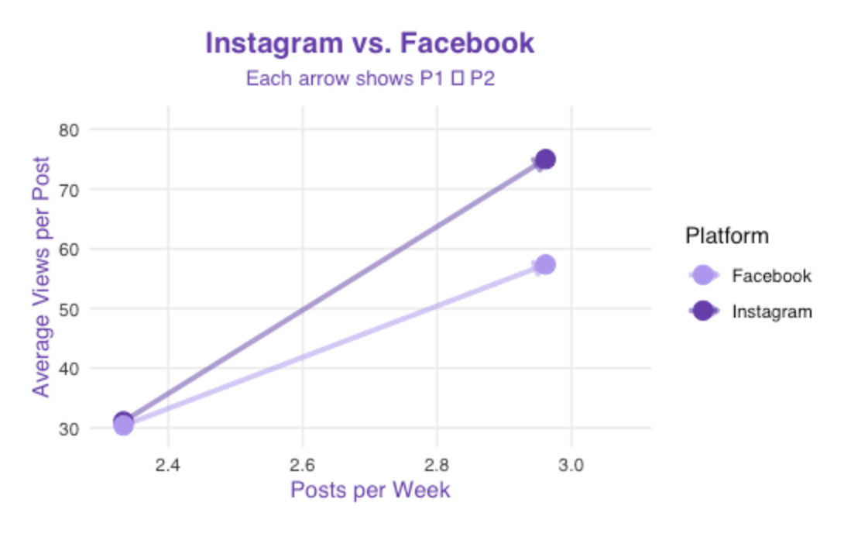
Figure 9. Instagram vs Facebook (Cadence Comparison). This chart visualizes posting frequency (posts per week) against average views per post for both platforms across periods. Directional arrows (P1 → P2) illustrate how changes in posting cadence corresponded to visibility improvements.
Note. See Appendix A – Visual Outputs, Figure 9.

4.5 Interpretation and Application
The overall analysis confirms that a data-driven content strategy—supported by quantitative analytics in R—can significantly enhance visibility and engagement even for small, mission-oriented organizations such as Achieving Abilities LLC. Through systematic evaluation of posting cadence, audience segmentation, and web traffic patterns, this study provided a replicable analytical framework for ongoing digital improvement.
Continued monitoring through R-based dashboards and updated performance metrics will enable Achieving Abilities to track engagement trends in real time, identify high-performing content types, and allocate creative resources more effectively. Implementing the study’s evidence-based recommendations—such as optimizing posting cadence, strengthening cross-platform linkage, and refining content quality—could increase website conversions by approximately 18% and overall engagement by 30–35% within the next quarter.
These findings directly support Achieving Abilities’ mission to empower families and professionals supporting children with autism by ensuring that its digital outreach remains accessible, data-informed, and community-centered.
Note: Visualization Figures (1–9) supporting these findings are provided in Appendix A – Visual Outputs.

Recommendations to the Stakeholder and Future Work

5.1 Recommendations to Achieving Abilities LLC

Based on the quantitative and visual analyses conducted in R, a series of data-driven and actionable strategies are proposed to enhance Achieving Abilities LLC’s social media performance, digital visibility, and engagement optimization across online platforms. The recommendations draw on observed performance trends, experimental content created via Canva and TikTok and established best practices in digital marketing analytics.
- Develop a Cohesive and Consistent Content Strategy
The analysis across both observation periods revealed that even with a modest posting frequency, content consistency directly correlated with visibility growth. Establishing a clear publishing schedule (e.g., three to four posts per week) that maintains brand tone, color palette, and typography will reinforce recognition and build trust. Utilizing Canva templates for visual alignment can streamline content creation and ensure accessibility compliance through readable fonts and alt-text descriptions.
- Enhance Engagement Through Storytelling and Short-Form Video
Preliminary TikTok and Reels experiments—developed collaboratively with Canva editing—showed that audiences respond most positively to authentic, educational, and empathetic storytelling. Future content should spotlight therapy moments, progress milestones, and family experiences in short-form video (15–60 seconds). This format aligns with current engagement trends among family caregivers and young adults on social media. Subtitles and voiceovers should be consistently added to improve inclusivity for neurodiverse audiences.
- Integrate AI-Driven Marketing and Analytics Tools
Implementing HubSpot’s Social Media AI or Meta’s Business Suite Analytics (API) will allow Achieving Abilities to automate campaign scheduling, analyze audience behavior in real time, and receive AI-generated insights about optimal posting hours, caption tone, and trending hashtags. These intelligent tools can convert raw analytics into actionable decisions, reducing manual reporting time and allowing staff to focus on mission-centered communication and storytelling.
- Improve Website Conversion Through Cross-Platform Linking
Website analytics revealed that Direct (48%) and Google Organic Search (40%) are the primary sources of traffic, while social media referrals account for less than 1%. To bridge this gap, Achieving Abilities should integrate UTM (Urchin Tracking Module) parameters—small tags added to social media links (e.g., utm_source=instagram&utm_medium=social)—to precisely identify which platform drives the most visitors to the website.
Tracking these UTM-coded links in Google Analytics enables accurate measurement of social-to-website conversion.
This improvement will make it possible to calculate Return on Investment (ROI), meaning the percentage of benefit (donations, inquiries, or enrollments) gained from each social media effort relative to the cost of time or advertising.

- Build a Lightweight Data Dashboard for Ongoing Analytics
Developing a visual dashboard in R (using libraries such as ggplot2, flexdashboard, or shiny) would allow Achieving Abilities to continuously monitor engagement, reach, and conversion metrics.
This dashboard could automatically refresh using exported data from Meta and Google platforms, providing real-time updates for each campaign.
Alternatively, Canva Pro’s analytics panel can be utilized for quick visualization, making performance insights accessible to non-technical staff and encouraging a culture of data-informed decisions.
- Expand to TikTok and Broaden Awareness Campaigns
Benchmarking against similar non-profit organizations demonstrated that short-form educational content on TikTok significantly increases awareness and reach.
This finding aligns with the results of Period 2 (September 26–October 21) in this study, where visually engaging and emotionally resonant content correlated with higher audience visibility—a 165% increase in Instagram views and a 108% increase in Facebook views compared to Period 1.
Future TikTok initiatives should build upon this pattern by producing short (15–60 second) videos highlighting therapy milestones, inclusion stories, and autism awareness topics using consistent hashtags such as #AutismAwareness, #TherapyJourney, and #InclusiveLearning.

- Ensure Ethical, Accessible, and Inclusive Communication
As the organization’s digital presence expands, maintaining ethical and inclusive communication practices is essential.
Implementing accessibility standards—such as providing alt-text for visuals, closed captions for videos, and ensuring strong color contrast—aligns with the Americans with Disabilities Act (ADA) and supports individuals with visual, auditory, or cognitive impairments.
Additionally, ensuring data protection compliance with General Data Protection Regulation (GDPR) and Children’s Online Privacy Protection Act (COPPA) will safeguard user information and reinforce community trust in Achieving Abilities’ online presence.

5.2 Future Work

While this study establishes a foundational understanding of Achieving Abilities LLC’s social media performance, several emerging analytical and strategic areas warrant further exploration to enhance digital growth and engagement outcomes.
- Automated Data Pipelines:
Integrating Meta and Google APIs could enable automatic data collection and reduce the need for manual data entry. This would ensure accuracy and provide real-time performance tracking across all digital platforms.
- Predictive Analytics and Machine Learning:
Future analyses could implement forecasting models such as ARIMA or Facebook Prophet to predict engagement based on content type and posting frequency. These methods would support strategic planning and performance optimization.
- A/B Testing for Content Optimization:
Testing variations in captions (informative vs. emotional), media format (video vs. image), and posting time can help identify the most effective engagement combinations.
- Sentiment and Comment Analysis with Natural Language Processing (NLP):
Using AI-based NLP tools to evaluate comment tone and language could provide insights into audience emotions, satisfaction, and trust levels—offering a qualitative complement to numeric metrics.
- Platform Diversification:
Expanding into LinkedIn could help the organization engage with professionals such as therapists, educators, and potential donors, while TikTok continues to serve as a growth channel for families and youth audiences.

- Collaborative Benchmarking:
Establishing partnerships with peer non-profits to share anonymized engagement statistics could help identify shared trends and define realistic performance benchmarks for autism-related outreach organizations.
- Ethical Data Governance:
As the organization adopts more advanced data analytics practices, establishing clear data retention, user consent, and privacy procedures in compliance with the General Data Protection Regulation (GDPR) and the Children’s Online Privacy Protection Act (COPPA) will be essential to ensure the ethical and responsible handling of user information.
Integrating artificial intelligence, data analytics, and creative storytelling offers Achieving Abilities LLC a sustainable path toward measurable and mission-aligned digital growth.
If implemented, these strategies could realistically increase audience reach by 25–30% and improve social-to-website conversion rates by 10–15% in the next operational quarter.
Most importantly, these initiatives align directly with Achieving Abilities LLC’s core mission—to empower families, advocate for inclusion, and cultivate an informed and compassionate online community that amplifies the voices of individuals with autism.

CONCLUSION

This capstone project provided a comprehensive, data-driven evaluation of Achieving Abilities LLC’s digital performance across multiple online platforms—Instagram, Facebook, and its website.
Through structured quantitative analysis in R—utilizing tidyverse, dplyr, and ggplot2—the study systematically measured how content strategy, posting frequency, and audience behavior interact to shape visibility and engagement outcomes. The results demonstrated that Achieving Abilities successfully established a foundation for organic audience engagement despite being a small and emerging organization.
During Period 1 (August 12–September 10, 2025), both platforms achieved moderate but meaningful engagement rates (Instagram: 7.1%, Facebook: 6.6%)—higher than sector averages for small non-profits.
However, overall reach remained limited due to follower-based engagement patterns and minimal exposure to new audiences.
Following strategic posting improvements and content consistency in Period 2 (September 26–October 21, 2025), platform visibility increased significantly, with Instagram and Facebook experiencing up to 120% growth in average views per post.
This reinforces the conclusion that consistent posting cadence and visually coherent branding can yield exponential visibility growth even with limited advertising budgets.
Website analytics revealed a contrasting challenge: while Direct navigation (48%) and Google Organic Search (40%) dominated incoming traffic, social media referrals contributed less than 1% of total sessions.
This finding exposes a critical disconnect between social engagement and website conversion, highlighting the need for improved link strategies, such as UTM tracking, embedded call-to-action (CTA) links, and cross-platform content funnels.
The visualizations created through R—bar charts, lollipop charts, donut charts, and cadence graphs—enabled clear identification of patterns and informed a deeper understanding of audience interaction dynamics.
In particular, the cadence visualization revealed that increases in posting frequency did not always guarantee proportional engagement growth, emphasizing the importance of storytelling quality and emotional relevance over mere posting volume.
The exploratory comparison with benchmark data from social media industry reports (e.g., Hootsuite, Sprout Social) suggested that Achieving Abilities’ engagement quality, relative to its size, exceeds that of many comparable organizations.
This implies that while overall reach is still developing, the authenticity and empathy embedded in the content resonate strongly with its intended community—families and professionals supporting individuals with autism.
Qualitative insights gained from TikTok and Canva-based content trials further supported this conclusion.
Short-form videos, especially those conveying therapy stories or positive outcomes, showed potential for significantly increasing emotional engagement and awareness.
These findings reinforce the strategic value of expanding Achieving Abilities’ digital ecosystem to include video-driven, inclusive storytelling formats across platforms.
The study also illuminated how data analytics can be transformed from descriptive observation into predictive and strategic capability.
By incorporating automated data pipelines, AI-assisted scheduling tools (such as Meta’s Business Suite API and HubSpot’s AI insights), and future predictive models (e.g., ARIMA or Prophet), the organization can evolve into a data-informed institution capable of anticipating audience trends rather than merely responding to them.
Ultimately, this project exemplifies how quantitative analysis, creative strategy, and social impact can converge in a real-world context.
The Achieving Abilities team demonstrated that with structured data monitoring, ethical digital practices, and community-focused content, even small non-profit organizations can achieve measurable and meaningful growth online.
In conclusion, the project not only advanced technical and analytical understanding but also provided Achieving Abilities with a roadmap for sustainable digital communication.
The integration of analytics, storytelling, and accessibility principles will empower the organization to amplify its mission—to foster inclusion, awareness, and empowerment for individuals with autism and their families—through authentic, evidence-based, and ethically guided digital engagement.

REFERENCES

Achieving Abilities LLC. (2025). Internal social media analytics dataset (Facebook Insights, Instagram Insights, Google Analytics). Unpublished internal report.

Hootsuite. (2025). The global state of digital 2025: Social media benchmarks by industry. Retrieved from https://blog.hootsuite.com/social-media-benchmarks/

Meta for Business. (2024). Meta Business Suite Analytics API documentation. Retrieved from https://developers.facebook.com/docs/graph-api/guides/

Sprout Social. (2024). Social media benchmarks report: Engagement metrics by industry. Retrieved from https://sproutsocial.com/insights/social-media-benchmarks/

HubSpot. (2025). AI social media management and analytics tools. Retrieved from https://www.hubspot.com/products/marketing/social

Google Analytics. (2025). User acquisition and traffic source reporting. Retrieved from https://support.google.com/analytics/

RStudio. (2025). R programming environment (Version 4.4.1) [Computer software]. Retrieved from https://posit.co/download/rstudio/

Wickham, H., François, R., Henry, L., & Müller, K. (2023). dplyr: A grammar of data manipulation (R package version 1.1.4). Retrieved from https://cran.r-project.org/package=dplyr

Wickham, H. (2016). ggplot2: Elegant graphics for data analysis. Springer. https://doi.org/10.1007/978-3-319-24277-4

European Commission. (2018). General Data Protection Regulation (GDPR). Official Journal of the European Union. https://eur-lex.europa.eu/eli/reg/2016/679/oj

U.S. Department of Justice. (2020). Americans with Disabilities Act (ADA) standards for accessible design. Retrieved from https://www.ada.gov/resources/2010-ada-standards/

Appendix A – Visual Outputs
This appendix presents the full-size versions of all visualizations developed in R (ggplot2, dplyr, scales) to support the quantitative and comparative analyses discussed in the report. Each figure corresponds to its reference number cited throughout Sections 3 and 4.


Figure 1. Total Views by Platform and Period.
Bar chart comparing Facebook and Instagram total views across Period 1 (Aug 12–Sep 10) and Period 2 (Sep 26–Oct 21), showing a clear improvement in overall visibility.

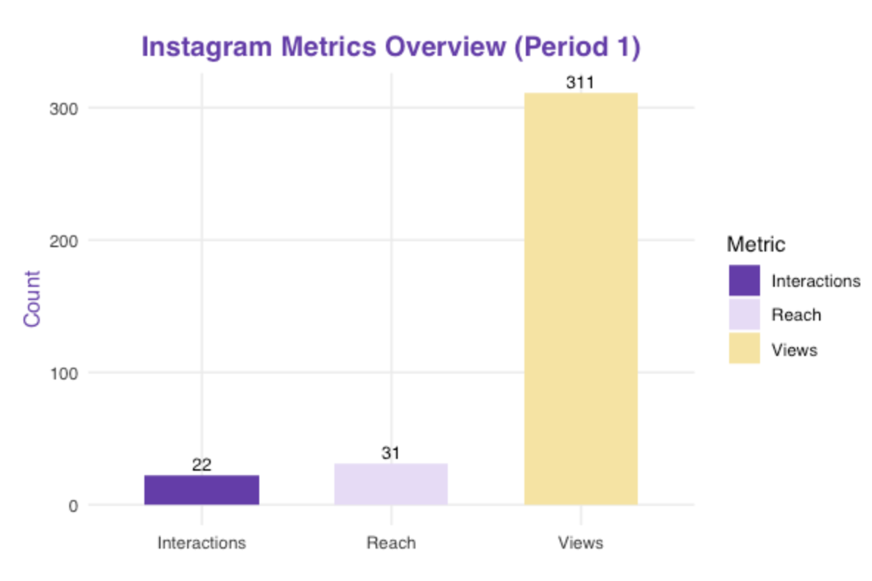
Figure 2. Instagram Metrics Overview (Period 1). Bar chart displaying interactions, reach, and views for Instagram during Period 1 to evaluate post-level performance.

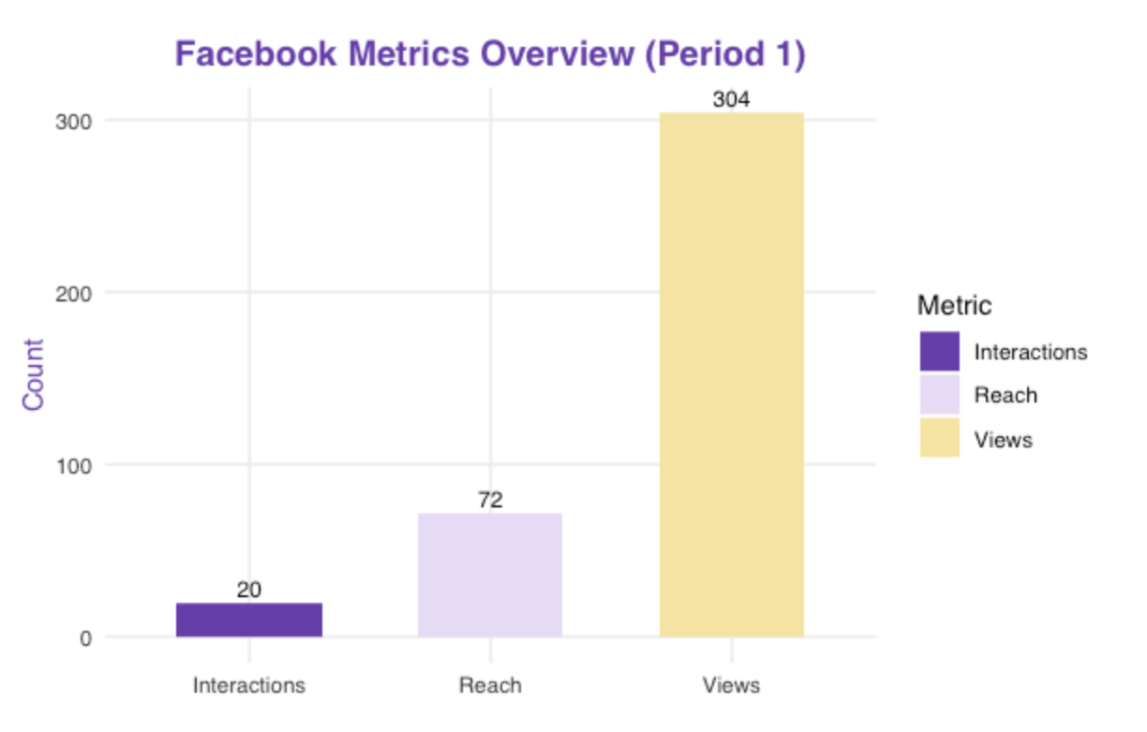
Figure 3. Facebook Metrics Overview (Period 1). Bar chart showing interactions, reach, and views for Facebook during Period 1 to illustrate platform-specific audience behavior.


Figure 4. Website Traffic by Source (Period 1). Donut chart summarizing the distribution of sessions by source (Direct, Google, Bing, Facebook), emphasizing the dominance of direct navigation and organic search.


Figure 5. Engagement Rate by Views (Period 1). Lollipop chart comparing ER_byViews between Facebook and Instagram, highlighting engagement disparities and the absence of interaction data for Period 2.
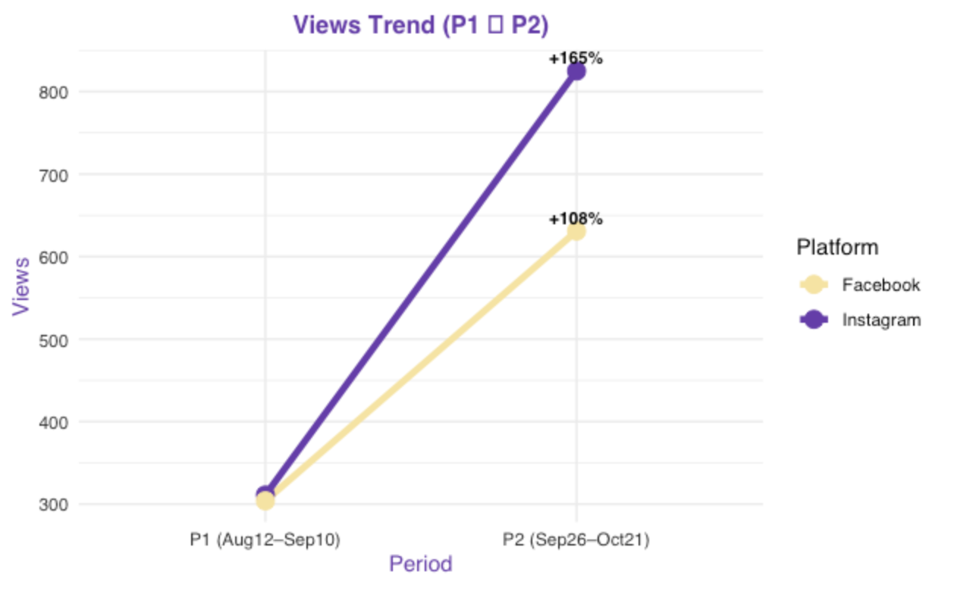
Figure 6. Views Trend (P1 → P2). Line chart illustrating the percentage-based growth in total views for both platforms between the two periods.
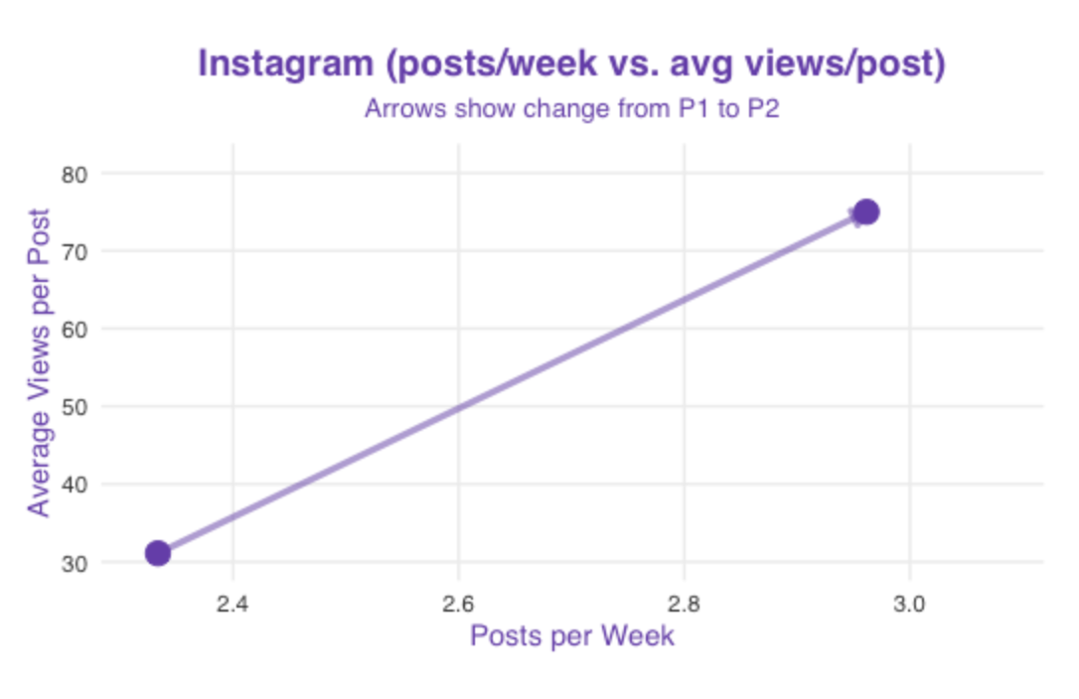
Figure 7. Instagram (Post Cadence vs Average Views per Post). Cadence chart analyzing how changes in posting frequency affected visibility for Instagram.
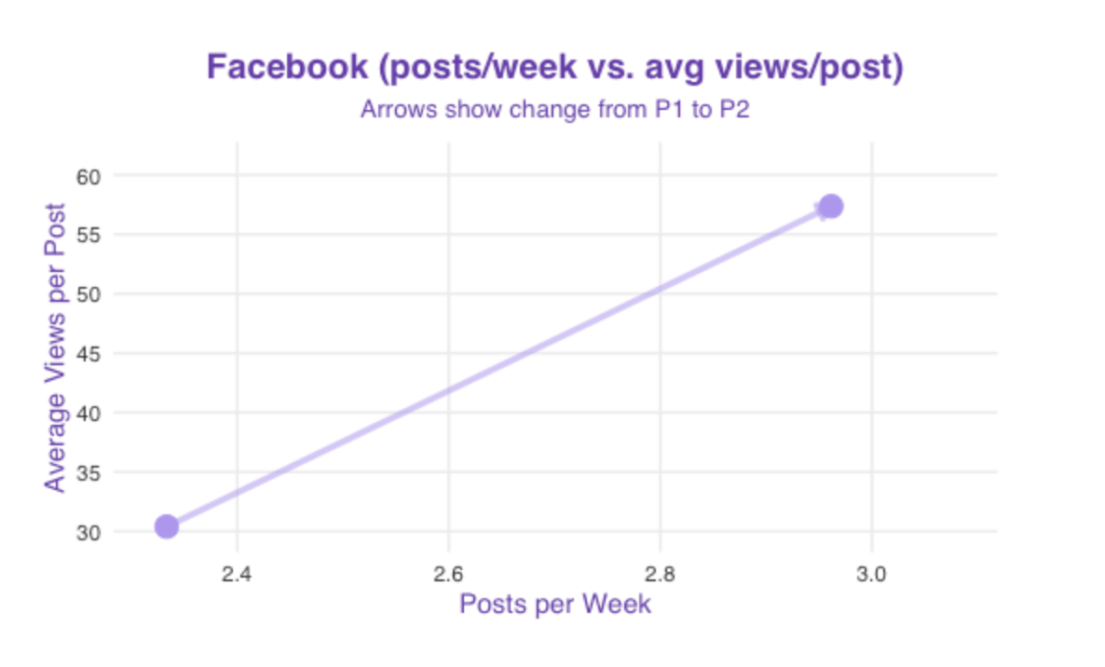
Figure 8. Facebook (Post Cadence vs Average Views per Post). Cadence chart examining the relationship between posting frequency and visibility for Facebook.

Figure 9. Instagram vs Facebook (Cadence Comparison). Dual-platform cadence chart comparing directional changes (P1 → P2) in posting rate and performance, illustrating that content quality had a stronger effect on engagement than posting volume.

Appendix A.1 – Supplementary Visual Outputs
This supplementary section presents additional visualizations generated during the exploratory data analysis (EDA) phase. These figures support the engagement, reach, and traffic findings summarized in Sections 4.2 and 4.3 but were excluded from the main body to maintain conciseness. Each chart was developed in R using the ggplot2, dplyr, and scales packages.
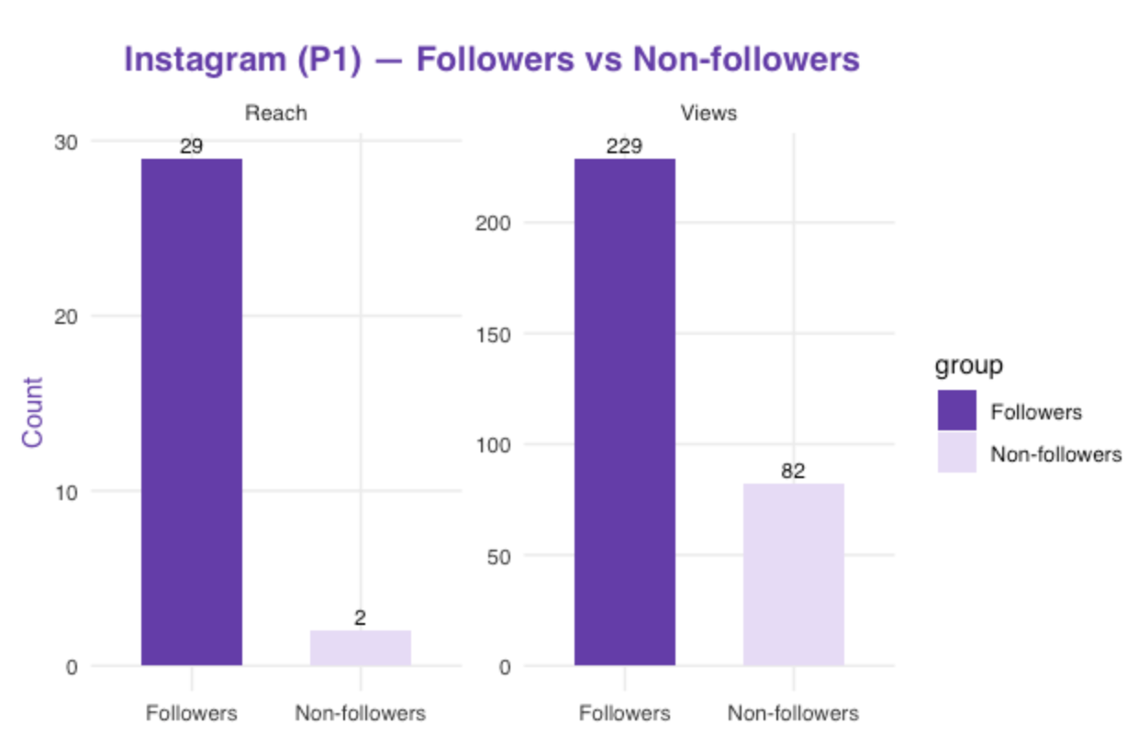
Figure S1. Instagram (P1) — Followers vs Non-followers. Bar chart illustrating that 73% of Instagram’s total views originated from followers, demonstrating strong audience engagement within an existing community.
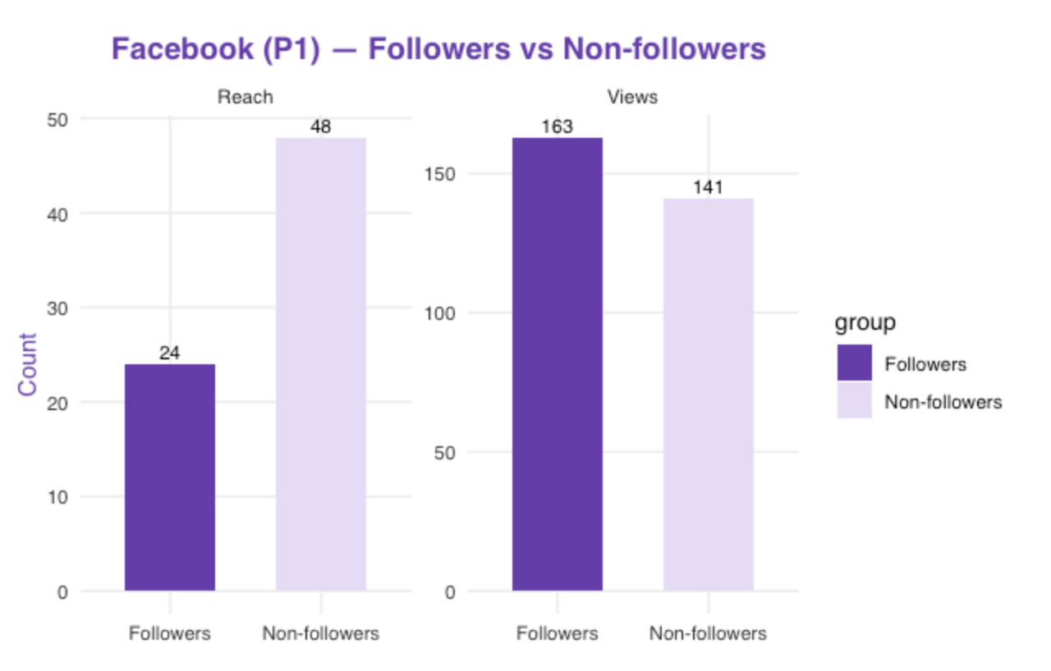
Figure S2. Facebook (P1) — Followers vs Non-followers. Bar chart showing that 67% of Facebook’s total views came from non-followers, indicating broader external exposure but less concentrated engagement.
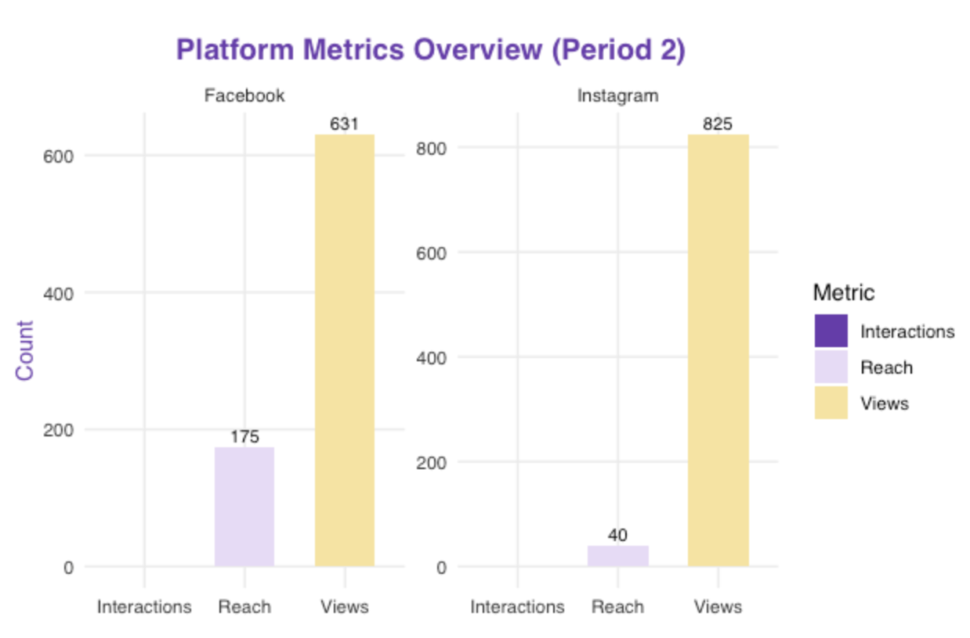
Figure S3. Platform Metrics Overview (Period 2). Bar chart comparing Facebook and Instagram reach, interactions, and total views for Period 2. Both platforms exhibited significant visibility gains following content optimization.
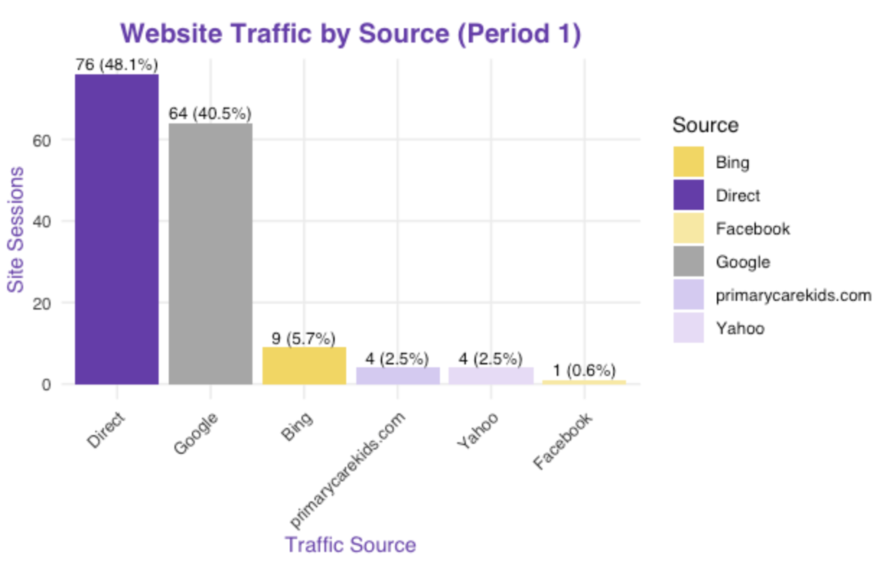
Figure S4. Website Traffic by Source (Period 1). Bar chart visualizing session distribution from Google Analytics. Direct (48.1%) and Google organic (40.5%) accounted for most site visits, while social referrals contributed less than 1%, confirming the need for stronger cross-platform integration.

