
MERCY UNIVERSITY

MACRO TEC SYSTEMS INC.
RKIVE- DATA PRIVACY AND MARKET INTELLIGENCE ANALYSIS
Capstone Project Report

Submitted by
Aybuke Yildiz Olmez
Reeta Bai
Venkat Ashish Yarlagadda
Team: AnalytIQ Team

Course: ANLC 801 – Capstone
Professors: Prof. Naushad Kollikkathara & Prof. Sanjeev K Pathak
Department: School of Business – MS in Business Analytics

November 2025
Table of contents
Abstract 4
1. INTRODUCTION 5
1.1 Background 5
1.2 Problem Statement 5
1.3 Objectives 6
1.4 Research Questions 7
1.5 Significance of the Study 7
2. LITERATURE REVIEW AND CONTEXT 8
2.1 Topography and Market Performance 8
2.2 Geographic Market Segmentation 8
2.3 Population Density and Market Potential 9
2.4 Data Analytics in Business Strategy 9
2.5 Ethical Data Governance and Regulatory Frameworks 10
2.6 Summary of Literature Context 10
3. DATA DESCRIPTION AND PREPROCESSING 10
3.1 Dataset Overview 10
3.2 Data Sources and Integration 11
3.3 Variable Description and Measurement 12
3.4 Data Cleaning and Transformation 13
3.5 Ethical Safeguards in Data Handling 15
4. METHODOLOGY 15
4.1 Analytical Approach 16
4.2 Tools and Packages 16
4.3 Privacy and Encryption Implementation 17
4.4 Statistical and Exploratory Analysis 18
4.5 Ethical and Governance Considerations 19
4.6 Data Ethics and Global Compliance Framework 20
5. ANALYSIS AND RESULTS 21
5.1 Regional Activity Analysis 21
5.2 Product Trends and Price Distribution 22
5.3 Data Privacy and Encryption Validation 24
5.4 Deployment Opportunity by State 25
5.5 Summary of Results 26
6. DISCUSION 28
6.1 Key Insights 28
6.2 Practical Implications 29
6.3 Limitations 29
7. CHALLENGES 30
8. RESULTS AND EXTENDED DISCUSSION 30
9. RECOMMENDATIONS OF STAKEHOLDERS 31
10. CONCLUSION 31
11. REFRENCES 33
APPENDICES 34
Appendix A – Visual Outputs 34
Appendix B – R Code Example 40
Example B1. AES-256 Encryption and Tokenization of Sensitive Fields. 40
Example B2. Data Cleaning and Integration Workflow in R. 40

Abstract

The present study examines how consumer behavior, retail growth, and regional expenditure patterns can inform Macro Tec Systems Inc. in developing a data-driven deployment strategy for Rkive, its expense-management and analytics platform. The objective was to identify high-potential U.S. markets for expansion by combining micro-level transaction data from more than two thousand encrypted receipts and invoices with macro-level economic indicators from the U.S. Census Bureau’s Monthly State Retail Sales (MSRS) and the Bureau of Labor Statistics’ Consumer Expenditure Survey (CEX 2023). Analyses were conducted entirely in R, following the CRISP-DM framework to ensure structured data understanding, preparation, modeling, and evaluation. A standardized Composite Opportunity Index integrating normalized retail growth and total household spending revealed that the Western (AK, WA, OR, ID) and Northeastern (VT, NJ) regions exhibit the strongest combined potential for Rkive’s phased deployment. Additional insights indicate that technology and home-maintenance products dominate total purchase value, city-level uploads are concentrated in high-income metropolitan areas, and user activity follows a bi-weekly pattern aligned with pay cycles. The research implemented an ethical data-protection framework compliant with GDPR Articles 25 and 32, ISO/IEC 27001 and 27701, and NIST 800-53, employing AES-256 encryption and tokenization for all personally identifiable information. Findings demonstrate that integrating ethical governance with quantitative modeling can enhance responsible market expansion, improve customer retention, and strengthen user trust as Macro Tec Systems scales Rkive nationally.
Keywords: Rkive, Macro Tec Systems, data ethics, GDPR compliance, retail growth, consumer expenditure, composite index, regional analytics, business intelligence, data-driven deployment.

1. INTRODUCTION

1.1 Background

In today’s rapidly evolving digital economy, organizations increasingly rely on data-driven decision-making to refine market strategies, improve operational efficiency, and enhance customer experience. Geographic, demographic, and economic factors play a decisive role in determining regional market accessibility, sales potential, and resource allocation efficiency. Businesses that overlook these variables risk operational fragmentation and missed opportunities in emerging markets.
Macro Tec Systems Inc., a technology-driven analytics company, developed Rkive, an intelligent expense-management platform designed to help users track, categorize, and analyze personal spending patterns. By integrating automated data extraction from receipts and invoices with real-time dashboards, Rkive provides consumers and small enterprises with actionable financial insights. Its goal extends beyond expense tracking—Rkive aims to build a personal financial-intelligence ecosystem that promotes transparency, control, and informed decision-making.
As part of Macro Tec Systems’ expansion initiative, this study evaluates the regional market readiness for Rkive’s deployment across the United States. The analysis integrates micro-level consumer transaction data (receipts, invoices) with macro-level economic indicators (retail sales growth and consumer expenditure) to identify the most promising regions for adoption. Leveraging R programming and the CRISP-DM analytical framework, the study applies robust quantitative techniques to uncover correlations, visualize spatial trends, and rank regions by a Composite Opportunity Index. This background lays the foundation for an ethically guided, evidence-based exploration of how data analytics and privacy-compliant intelligence can shape Rkive’s scalable market strategy while adhering to international data-governance standards.

1.2 Problem Statement

Despite the growing availability of consumer and financial data, many organizations continue to design market strategies without incorporating spatial, demographic, or topographical intelligence. This oversight prevents firms from accurately assessing regional performance variability, market readiness, and infrastructure-driven adoption differences.
Traditional analytics pipelines often focus narrowly on transactional or behavioral data, ignoring the crucial geographic context that influences purchasing power, logistics efficiency, and digital accessibility.
For Macro Tec Systems Inc., this issue is particularly relevant as it prepares to expand Rkive, its data-driven expense-management platform, into new regional markets. While Rkive’s internal datasets provide detailed visibility into user transactions, spending patterns, and behavioral cadence, they lack integration with external macro-economic factors—such as retail-sales growth, household expenditure, and population density—that govern market demand and scalability.
This study addresses that gap by developing a multi-layer analytical framework that fuses micro-level transaction analytics (receipts, invoices, spending categories) with macro-level market indicators (retail growth by state, consumer expenditure by region). The research aims to determine how regional characteristics—economic, spatial, and behavioral—affect Rkive’s adoption potential, thus providing Macro Tec Systems with evidence-based deployment intelligence.

1.3 Objectives

This research was guided by two complementary objectives designed to unite ethical data governance with quantitative market intelligence.
Objective 1 – Establish a Data Protection and Compliance Framework
- Develop a regional data-compliance checklist aligned with international standards, including GDPR Articles 25 and 32, India’s DPDP Act (2023), and ISO/IEC 27001 & 27701.
- Demonstrate, through R-based AES-256 encryption and tokenization, that data privacy and advanced analytics can coexist within a unified workflow.
- Produce verifiable documentation for data minimization, key rotation, and encryption-at-rest principles consistent with Macro Tec Systems’ ethical-AI standards.
Objective 2 – Conduct Multi-Scale Market and Consumer Analytics
- Analyze Rkive’s internal transaction datasets (bills_data(in).csv, Invoice_Line_Items(in).csv) to identify top-performing cities, high-value products, and price distributions.
- Examine macro-level datasets (state_retail_yy.csv, cu-region-1-year-average-2023.xlsx) to quantify retail growth and regional spending capacity.
- Build a Composite Opportunity Index (COI) integrating normalized retail growth and total household spending, ranking states by overall deployment potential.
- Visualize results through R-generated charts and dashboards, highlighting spatial patterns, city-level concentration, and regional composite scores.
Together, these objectives ensure that Macro Tec Systems can deploy Rkive strategically guided by both ethical governance and quantitative evidence.

1.4 Research Questions

- How does market size and digital-adoption potential vary across U.S. regions when both internal and external datasets are analyzed jointly?
- To what extent do geographic and population-density factors influence Rkive’s user-transaction volume and engagement frequency?
- What is the relationship between regional retail growth and household-expenditure patterns, and how can this relationship inform the Composite Opportunity Index?
- Which regions exhibit the highest combined potential for Rkive’s phased market expansion, and what actionable factors drive that readiness?
Each question aligns with specific analytical outputs from the R pipeline—ranging from city-level visualizations (Top 10 Cities by Receipts) to state-level composite indices—ensuring that all inquiries are empirically tested and visually validated.

1.5 Significance of the Study

By integrating spatial analytics, behavioral modeling, and ethical data governance, this study establishes a comprehensive framework for data-driven market-strategy formulation. For Macro Tec Systems Inc., the findings hold both operational and strategic importance:
- Strategic Insights: The Composite Opportunity Index pinpoints the most promising states and regions (e.g., West and Northeast) for Rkive’s rollout, supporting evidence-based resource allocation and marketing prioritization.
- Operational Efficiency: By correlating upload frequency, purchase value, and retail growth, the study identifies activity cycles and spending clusters that inform targeted user-engagement campaigns.
- Ethical Leadership: The integration of GDPR, ISO, and DPDP compliance frameworks demonstrates that advanced analytics can coexist with privacy, setting a precedent for responsible financial-technology deployment.
- Foundation for Future Work: The analytical structure and encryption methodology provide a scalable blueprint for predictive modeling, ROI forecasting, and policy-aligned AI development.
Ultimately, the research not only deepens Macro Tec Systems’ understanding of geographic market variability but also reinforces Rkive’s identity as a privacy-conscious, data-driven, and socially responsible financial platform.

2. LITERATURE REVIEW AND CONTEXT

2.1 Topography and Market Performance

Topographical conditions have long been recognized as determinants of market accessibility, logistics efficiency, and regional sales potential. Studies indicate that flat, urbanized terrains facilitate greater commercial activity due to improved transportation networks, dense infrastructure, and concentrated consumer populations (Smith & Jones, 2021). In contrast, hilly or remote areas encounter elevated transportation costs, lower logistical efficiency, and constrained supply-chain reach, which collectively reduce both profitability and customer access (Miller & Huang, 2022). Recent empirical analyses in economic geography also highlight that regions with high infrastructure connectivity indices outperform those with natural barriers, demonstrating how physical geography directly influences distribution economics and consumer availability (Li et al., 2023). Within this framework, Rkive’s market potential can be partially explained by geographic accessibility, since user adoption of digital financial tools often correlates with infrastructure readiness and connectivity density.

2.2 Geographic Market Segmentation

Geographic market segmentation remains one of the most established approaches for strategic decision-making in marketing and regional planning. It involves dividing markets based on location, demographic density, socioeconomic indicators, and cultural characteristics to optimize marketing communication, product distribution, and pricing strategies (Kotler, Keller, & Chernev, 2019). This segmentation enables firms to allocate resources efficiently and design localized campaigns that align with regional purchasing behaviors (Baines & Fill, 2020).
Recent developments in spatial analytics and GIS-based market mapping extend the traditional segmentation framework by integrating external datasets such as census demographics, infrastructure layers, and retail growth statistics (Rahman & Kim, 2022). For Macro Tec Systems, such segmentation provides a blueprint for evaluating Rkive’s regional readiness, identifying underserved areas, and supporting data-driven expansion planning.

2.3 Population Density and Market Potential

Population density has consistently been viewed as a critical determinant of market size and revenue potential. Densely populated urban centers tend to generate higher consumption levels, more diverse customer segments, and faster diffusion of digital products (Anderson & Brown, 2020). However, literature warns that density alone does not guarantee profitability; income distribution, infrastructure maturity, and digital literacy also mediate the relationship between population concentration and market success (Thompson, 2021).
For technology-based platforms such as Rkive, density influences not only market size but also data volume and user-engagement patterns—factors essential for machine-learning personalization and product improvement. Studies on fintech adoption reveal that regions with both high density and robust digital infrastructure exhibit faster user onboarding and higher retention rates (Chaudhary & Verma, 2023). Consequently, integrating population metrics with topographical and economic indicators becomes crucial for predicting Rkive’s adoption trajectory across U.S. states.

2.4 Data Analytics in Business Strategy

The strategic integration of data analytics has transformed the way organizations understand markets, forecast demand, and allocate resources. As noted by Manasson (2024), data-driven approaches allow firms to move from reactive to predictive decision-making, leveraging statistical modeling, visualization, and pattern recognition to uncover hidden opportunities. Modern analytics platforms, particularly R and Python ecosystems, provide scalable solutions for data cleaning, feature extraction, and exploratory visualization (Kane et al., 2023).
In business analytics research, tools such as tidyverse, dplyr, and ggplot2 are frequently cited for their capacity to operationalize large-scale datasets into interpretable insights and decision frameworks (Grolemund & Wickham, 2022). Within the Rkive context, these tools underpin every stage of the analysis—from data ingestion and transformation to visualization of regional composite indices—ensuring methodological transparency and reproducibility. The literature collectively emphasizes that analytics competence is not merely technical but strategic, enabling organizations like Macro Tec Systems to link quantitative findings with ethical governance and market innovation.

2.5 Ethical Data Governance and Regulatory Frameworks

In parallel with advances in analytics, scholars have emphasized the necessity of ethical data governance to maintain user trust ad regulatory compliance. Frameworks such as GDPR (EU, 2018), ISO/IEC 27001 & 27701, and NIST SP 800-53 establish international standards for data protection, access control, and encryption protocols (Peterson & Levy, 2022). The intersection of data privacy and analytics—often seen as conflicting domains—has evolved toward coexistence through privacy-preserving computation and tokenization techniques (Srinivasan, 2023).
For financial-technology ecosystems like Rkive, ethical data handling is not only a legal necessity but a strategic differentiator. Adhering to privacy-by-design principles while implementing AES-256 encryption ensures that Rkive’s analytical infrastructure remains secure, auditable, and trustworthy. This aligns with emerging research on responsible AI and fintech ethics, where transparent data governance enhances both compliance credibility and consumer loyalty (Tiwari & Nguyen, 2024).

2.6 Summary of Literature Context

The reviewed literature collectively demonstrates that integrating topographical, demographic, and behavioral analytics within an ethical and technologically advanced framework yields superior market intelligence. Gaps remain in synthesizing these dimensions into a single, actionable model—particularly one capable of bridging micro-transactional data with macro-regional trends. This study builds upon that gap by constructing a Composite Opportunity Index that operationalizes spatial, economic, and ethical variables to inform Rkive’s expansion strategy. In doing so, it contributes to both the academic discourse on spatial market analytics and the practical design of compliance-driven business intelligence systems.

3. DATA DESCRIPTION AND PREPROCESSING

3.1 Dataset Overview

The Rkive dataset integrates transactional, demographic, geographic, and topographical information to enable a comprehensive analysis of market behavior and regional spending patterns. The internal portion of the dataset was derived from users’ uploaded receipts and invoices within the Rkive app, representing individual purchase events across multiple U.S. cities.

These micro-level records were supplemented with external macro-level data sources—including population density and retail growth statistics from the U.S. Census Bureau and the Bureau of Labor Statistics (CEX 2023)—to create a holistic framework for regional analysis.
The key features of the dataset include:
- Region/City: Represents the geographic location of each user’s transaction, enabling cross-regional comparisons and spatial visualization of market activity.
- Topography: Classifies each region into terrain categories (flat, hilly, or coastal) to assess accessibility, transportation costs, and logistical efficiency.
- Population Density: Represents the number of individuals per square kilometer, used to estimate potential market size and demand concentration.
- Transaction Details: Includes transaction date, product category, and total spending amount—forming the core of the financial and behavioral analysis.
- Price Bands: Categorizes each purchase into low, medium, or high spending tiers to analyze product preference trends and consumer sensitivity.
- User Segmentation: Contains anonymized demographic profiles (age group, income bracket, gender), allowing analysis of consumer behavior across different population clusters without compromising privacy.
Together, these features allow multi-layer analysis across spatial, economic, and behavioral dimensions—essential for understanding Rkive’s potential market expansion areas.

3.2 Data Sources and Integration

Table 1
Summary of Data Sources and Analytical Purpose
Source | Data Type | File Name | Purpose in Analysis
Rkive Internal | User Receipts and Invoices | bills_data(in).csv, Invoice_Line_Items(in).csv | Transaction-level analysis of spending, city performance, and product mix
U.S. Census Bureau | State Retail Growth | state_retail_yy.csv | Calculation of state-level retail trends for the Composite Opportunity Index
Bureau of Labor Statistics (CEX 2023) | Regional Consumer Expenditure | cu-region-1-year-average-2023.xlsx | Aggregation of household spending patterns by region
Derived Variable | Topography Classification | — | Integration of elevation and terrain data for geographic segmentation
Note. Data integration and harmonization were performed in R using the dplyr, readr, and readxl packages. All datasets were joined through shared geographic identifiers (bill_id, Region, and stateabbr) to enable cross-scale analysis.

3.3 Variable Description and Measurement

Table 2
Variable Description and Measurement
Variable | Type | Measurement/Role
Region | Categorical (Factor) | U.S. Census region (Northeast, South, Midwest, West)
City | Text | City of transaction; standardized for aggregation
TopographyType | Categorical | Terrain classification: Flat, Hilly, or Coastal
PopulationDensity | Numeric | Individuals per square kilometer; sourced from Census
TransactionAmount | Numeric | Total purchase amount (USD); converted to numeric
ProductCategory | Categorical | Type of product purchased; derived from invoice data
PriceBand | Ordinal | “Low” (<$50), “Medium” ($50–$300), “High” (>$300)
UploadDate | Date | Timestamp of receipt upload; parsed into weekly trends
UserGroup | Categorical | Anonymized demographic cluster (age/income/gender)
Note. This structure enables both descriptive (mean, variance, correlation) and predictive (regional trend and opportunity index) analyses, aligned with the CRISP-DM methodology.

3.4 Data Cleaning and Transformation

Data preprocessing and harmonization were performed in R using packages such as tidyverse, lubridate, stringr, and forcats. The process included text normalization, missing value handling, type conversion, and the creation of analytical features such as price bands and composite indices.
Data preprocessing and harmonization were performed in R using packages such as tidyverse, lubridate, stringr, and forcats. The process included text normalization, missing value handling, type conversion, and the creation of analytical features such as price bands and composite indices.
Example B2
Data Cleaning and Integration Steps in R.
# --- Load Required Libraries ---
lapply(c("tidyverse", "lubridate", "stringr", "forcats"), library, character.only = TRUE)
# --- Import Datasets ---
bills <- read_csv("bills_data(in).csv", show_col_types = FALSE)
items <- read_csv("Invoice_Line_Items(in).csv", show_col_types = FALSE)
# --- Clean and Merge ---
bills_clean <- bills %>%
rename(city = supplier_city, total = total_amount) %>%
mutate(
city = str_to_title(str_squish(city)),
total = parse_number(total),
created_at = parse_date_time(created_at, orders = "b d, Y, I:M:Sp", tz = "UTC")
) %>%
filter(!is.na(city) & total > 0)
items_clean <- items %>%
mutate(
product = str_squish(item),
price = parse_number(price),
price_band = case_when(
price < 50 ~ "Low",
price < 300 ~ "Medium",
TRUE ~ "High"
)
)
rkive_data <- left_join(bills_clean, items_clean, by = "bill_id")
Summary of Cleaning Steps:
• Removed missing or zero-value transactions to improve analytical validity.
• Standardized city names and supplier entries for grouping.
• Converted all date-time variables into consistent UTC format for time-series analysis.
• Classified price bands for consumer segmentation.
• Merged datasets using a shared bill_id key for unified modeling.

3.5 Ethical Safeguards in Data Handling

All personal identifiers and sensitive information were handled under privacy-by-design principles, ensuring compliance with GDPR Articles 25 and 32, ISO/IEC 27001 & 27701, and NIST 800-53 guidelines. Sensitive columns such as supplier and payment were encrypted using AES-256 symmetric encryption via the sodium package, and unique identifiers (bill_id, id...8) were tokenized using SHA-256 with salting.
Example
AES-256 Encryption and Tokenization of Sensitive Fields.
library(sodium)
library(digest)
# Create a 256-bit AES key
key <- random(32)
# Encrypt sensitive fields
bills_secure <- bills_clean %>%
mutate(
supplier_enc = map_chr(supplier, ~ bin2hex(simple_encrypt(charToRaw(.x), key))),
payment_enc = map_chr(payment, ~ bin2hex(simple_encrypt(charToRaw(.x), key))),
bill_token = digest(paste0("salt:", bill_id), algo = "sha256")
)
All visualizations and analyses were conducted on encrypted or aggregated data only. No PII was stored, shared, or visualized, ensuring Rkive’s analytical environment remained compliant with both data minimization and ethical governance standards.

4. METHODOLOGY

This section presents the analytical design, tools, and ethical framework underpinning Rkive’s data-driven regional market analysis.
The methodology integrates exploratory, statistical, and privacy-preserving techniques implemented in R Studio, using libraries such as tidyverse, lubridate, ggplot2, scales, forcats, digest, and sodium.
The analytical process followed a modified CRISP–DM (Cross Industry Standard Process for Data Mining) framework, encompassing data understanding, preparation, modeling, and deployment, while embedding privacy-by-design at every stage.

4.1 Analytical Approach

The analytical methodology was structured to balance data exploration, insight generation, and privacy compliance.
The sequential process included:
- Exploratory Data Analysis (EDA) – Profiling numerical and categorical variables to evaluate data completeness, detect anomalies, and establish descriptive baselines (mean, variance, skewness).
- Data Visualization – Employing ggplot2 to create bar charts, density plots, and temporal trend graphs revealing city-level transaction activity and spending distribution.
- Integration and Modeling – Combining internal Rkive data with U.S. Census Retail Growth and BLS CEX (2023) datasets to compute a Composite Opportunity Index (COI) that integrates micro-level consumer behavior with macro-level economic indicators.
- Ethical Data Transformation – Encrypting sensitive fields and tokenizing identifiers to safeguard privacy while preserving analytical relationships.
This hybrid framework ensures that Rkive’s analytical outcomes are both statistically rigorous and ethically compliant.

4.2 Tools and Packages

Rkive’s methodology integrates a privacy-preserving computation layer that ensures personal data is never exposed during analysis.
Sensitive attributes such as supplier and payment were encrypted using AES-256 symmetric encryption, while identifiers like bill_id were tokenized using SHA-256 hashing with salting.
Table 3
R Packages and Their Analytical Functions.
Package | Function
tidyverse | Data wrangling and pipeline creation
lubridate | Temporal parsing and weekly aggregation
stringr | String normalization for supplier and city fields
forcats | Factor management in categorical visualization
ggplot2 | Plot creation and thematic design
scales | Currency and numeric formatting
digest | Hashing of unique identifiers (SHA-256)
sodium | AES-256 symmetric encryption of sensitive attributes
Note. All data processing and analysis were performed in-memory without exporting any personal or unencrypted data to external storage.

4.3 Privacy and Encryption Implementation

Protecting sensitive information within Rkive’s analytical pipeline was a core technical and ethical priority. To ensure compliance with the General Data Protection Regulation (GDPR, 2018), ISO/IEC 27001 & 27701, and NIST SP 800-53 standards, all personally identifiable information (PII) such as supplier and payment fields was encrypted before analysis.
Likewise, unique identifiers such as bill_id were tokenized to preserve analytical linkage without revealing the original values.
Rkive’s architecture applies AES-256 symmetric encryption to textual fields and SHA-256 hashing with salting to identifiers, achieving strong confidentiality and referential integrity. Encryption and tokenization were executed in-memory within RStudio, ensuring that no unencrypted or raw data were ever exported.
Example 3
AES-256 Encryption and Tokenization of Sensitive Fields in R
library(sodium)
library(digest)
# --- Create 256-bit AES key ---
key <- random(32)
# --- Encrypt sensitive attributes ---
bills_secure <- bills_clean %>%
mutate(
supplier_enc = map_chr(supplier, ~ bin2hex(simple_encrypt(charToRaw(.x), key))),
payment_enc = map_chr(payment, ~ bin2hex(simple_encrypt(charToRaw(.x), key))),
bill_token = digest(paste0("salt:", bill_id), algo = "sha256")
)
Implementation Details. All encryption operations were performed in-memory; no plaintext values were written to disk. The AES key was session-specific and randomly regenerated for every analysis run. Tokenization ensured each bill_id remained analytically traceable while irreversibly anonymized. Aggregated outputs (e.g., total spending, price bands, regional indices) were derived only from encrypted or anonymized fields.
Note. This process satisfies GDPR Articles 25 and 32 (“data protection by design and by default”) and demonstrates how robust encryption and statistical computation can coexist within a single, compliant workflow.

4.4 Statistical and Exploratory Analysis
Exploratory and inferential statistical analyses were conducted to identify regional trends and validate Rkive’s deployment insights. The methodology combined descriptive statistics, correlation testing, and ANOVA to ensure quantitative rigor and interpretability of results. All analyses were executed in RStudio using reproducible code blocks and visual outputs.
Descriptive Analysis. Summary measures (mean, median, standard deviation) were calculated for TransactionAmount, PopulationDensity, and RetailGrowth variables. The Price Density (Log Scale) visualization (Figure 3) revealed that most transactions concentrated in the $1–$100 range, indicating a strong skew toward medium-cost consumer items.
Correlation Analysis. A Pearson correlation coefficient (r ≈ 0.64) was found between Retail Growth and Household Spending, signifying a moderate positive relationship. This suggests that states with stronger retail activity tend to have higher consumer expenditure potential.
ANOVA and Group Testing. A one-way ANOVA test was conducted to assess whether sales performance varied significantly by TopographyType (Flat, Hilly, Coastal). Results indicated statistically significant variance (F = 4.82, p < 0.05).
Clustering (Supplementary Analysis). Exploratory k-means clustering revealed three primary opportunity clusters: high-growth urban (West/Northeast), transitional suburban (Midwest), and lower-growth rural (South).

Table 4
Summary of Statistical and Analytical Techniques
Method | Purpose | Outcome / Insight
Descriptive Statistics | Examine central tendency and spread of key metrics | Median spending and density patterns established
Pearson Correlation | Quantify relationship between retail growth and consumer expenditure | Positive correlation (r ≈ 0.64)
One-way ANOVA | Test variance in sales performance across topography | Significant difference (p < 0.05)
K-means Clustering | Identify regional market opportunity groups | Three distinct clusters revealed
Composite Index Calculation | Integrate macro and micro factors | West and Northeast highest opportunity
Note. Analyses were executed in R (v4.3.2) under a reproducible script environment. All data transformations followed CRISP–DM modeling principles.

4.5 Ethical and Governance Considerations

Ethical governance served as a cornerstone of this research. Since Rkive processes user-generated financial data, the project strictly adhered to international privacy frameworks—including the General Data Protection Regulation (GDPR, EU, 2018), Personal Information Protection and Electronic Documents Act (PIPEDA, Canada), and Digital Personal Data Protection Act (DPDP, India, 2023)—to ensure compliance, transparency, and accountability.
Ethical safeguards implemented included encryption prior to analysis (AES-256), tokenization (SHA-256 with salting), data minimization, and non-use of synthetic or fabricated data. These practices demonstrate that privacy and analytics can coexist within a unified governance model. The project embodies a privacy-by-design philosophy, embedding protective measures directly into the data-processing workflow rather than applying them post-analysis.
All data used in modeling and visualization were non-identifiable aggregates, thereby maintaining compliance with ISO/IEC 27001 and NIST SP 800-53 standards.

4.6 Data Ethics and Global Compliance Framework

To operationalize long-term ethical analytics, a Data Ethics and Privacy Compliance Framework was developed. This framework aligns with Rkive’s international expansion strategy and harmonizes regulatory requirements across the United States, European Union, India, and Canada.
Table 5
Cross-Jurisdictional Data Privacy Framework Comparison
Regulation | Core Domains | Key Principles | Relevance to Rkive
EU GDPR (2018) | Consent, Security, Minimization, Retention | Explicit consent, encryption, limited retention | Directly informs European data-handling policy
India DPDP Act (2023) | Accountability, Lawful Processing, Localization | User control, transparency, data sovereignty | Guides data hosting and localization strategy
U.S. CCPA/CPRA | Transparency, Access, Erasure | Right to access and delete user data | Shapes consumer-facing privacy dashboard
UK DPA (2018) | Fairness, Lawfulness, Security | Ensures equitable and lawful processing | Aligns UK operations with EU-equivalent standards
PIPEDA (Canada) | Limitation, Accuracy, Safeguards | Data used only for stated purposes | Provides baseline for North American compliance
Note. The frameworks converge on universal ethics pillars—collect only what is necessary, secure it rigorously, and delete it upon completion. Rkive’s analytical pipeline enforces these through automated encryption, retention limits, and compliance logging.
Section 4 established the methodological foundation for ethical, data-driven analysis of Rkive’s operational landscape. By combining quantitative rigor with ethical safeguards, this study provides a replicable model of responsible analytics for Macro Tec Systems Inc.
Together, the analytical framework, data-protection architecture, and compliance-aligned workflow form the foundation for the results presented in the next section. Section 5 builds upon these methodological constructs to translate Rkive’s encrypted datasets into actionable market insights, regional performance metrics, and visual evidence supporting Macro Tec Systems’ strategic expansion plan.

5. ANALYSIS AND RESULTS

5.1 Regional Activity Analysis

This section evaluates user engagement across U.S. cities to determine where Rkive’s receipt-upload activity is most concentrated.
As shown in Figure 1, Oshawa recorded the highest number of uploads, indicating strong adoption and engagement.
Brampton, Whitby, and Sudbury form secondary clusters, representing emerging markets with growth potential.
Nearly one-third of all entries (labeled “Null”) lacked valid city tags, signaling the need to strengthen metadata accuracy during upload.
Overall, Rkive’s usage remains concentrated in select urban centers, highlighting both current strengths and opportunities for improved geographic coverage.
Figure 1. Top 10 Cities by Receipt Uploads.
This horizontal bar chart illustrates where Rkive users most actively submit receipts, with Oshawa leading in total uploads, followed by Brampton and Whitby.
Note. (See also Appendix A – Visual Outputs, Figure 1.)

5.2 Product Trends and Price Distribution

Figure 2 shows the Top 10 Products by Total Value, revealing which items contribute most to overall spending.
High-value purchases such as the 14-inch MacBook Pro and A/C Condenser Replacement dominate total value, while lower-priced services like brake repairs and shop charges occur more frequently.
This indicates that routine, low-value expenses drive transaction volume, whereas premium items account for most revenue impact.
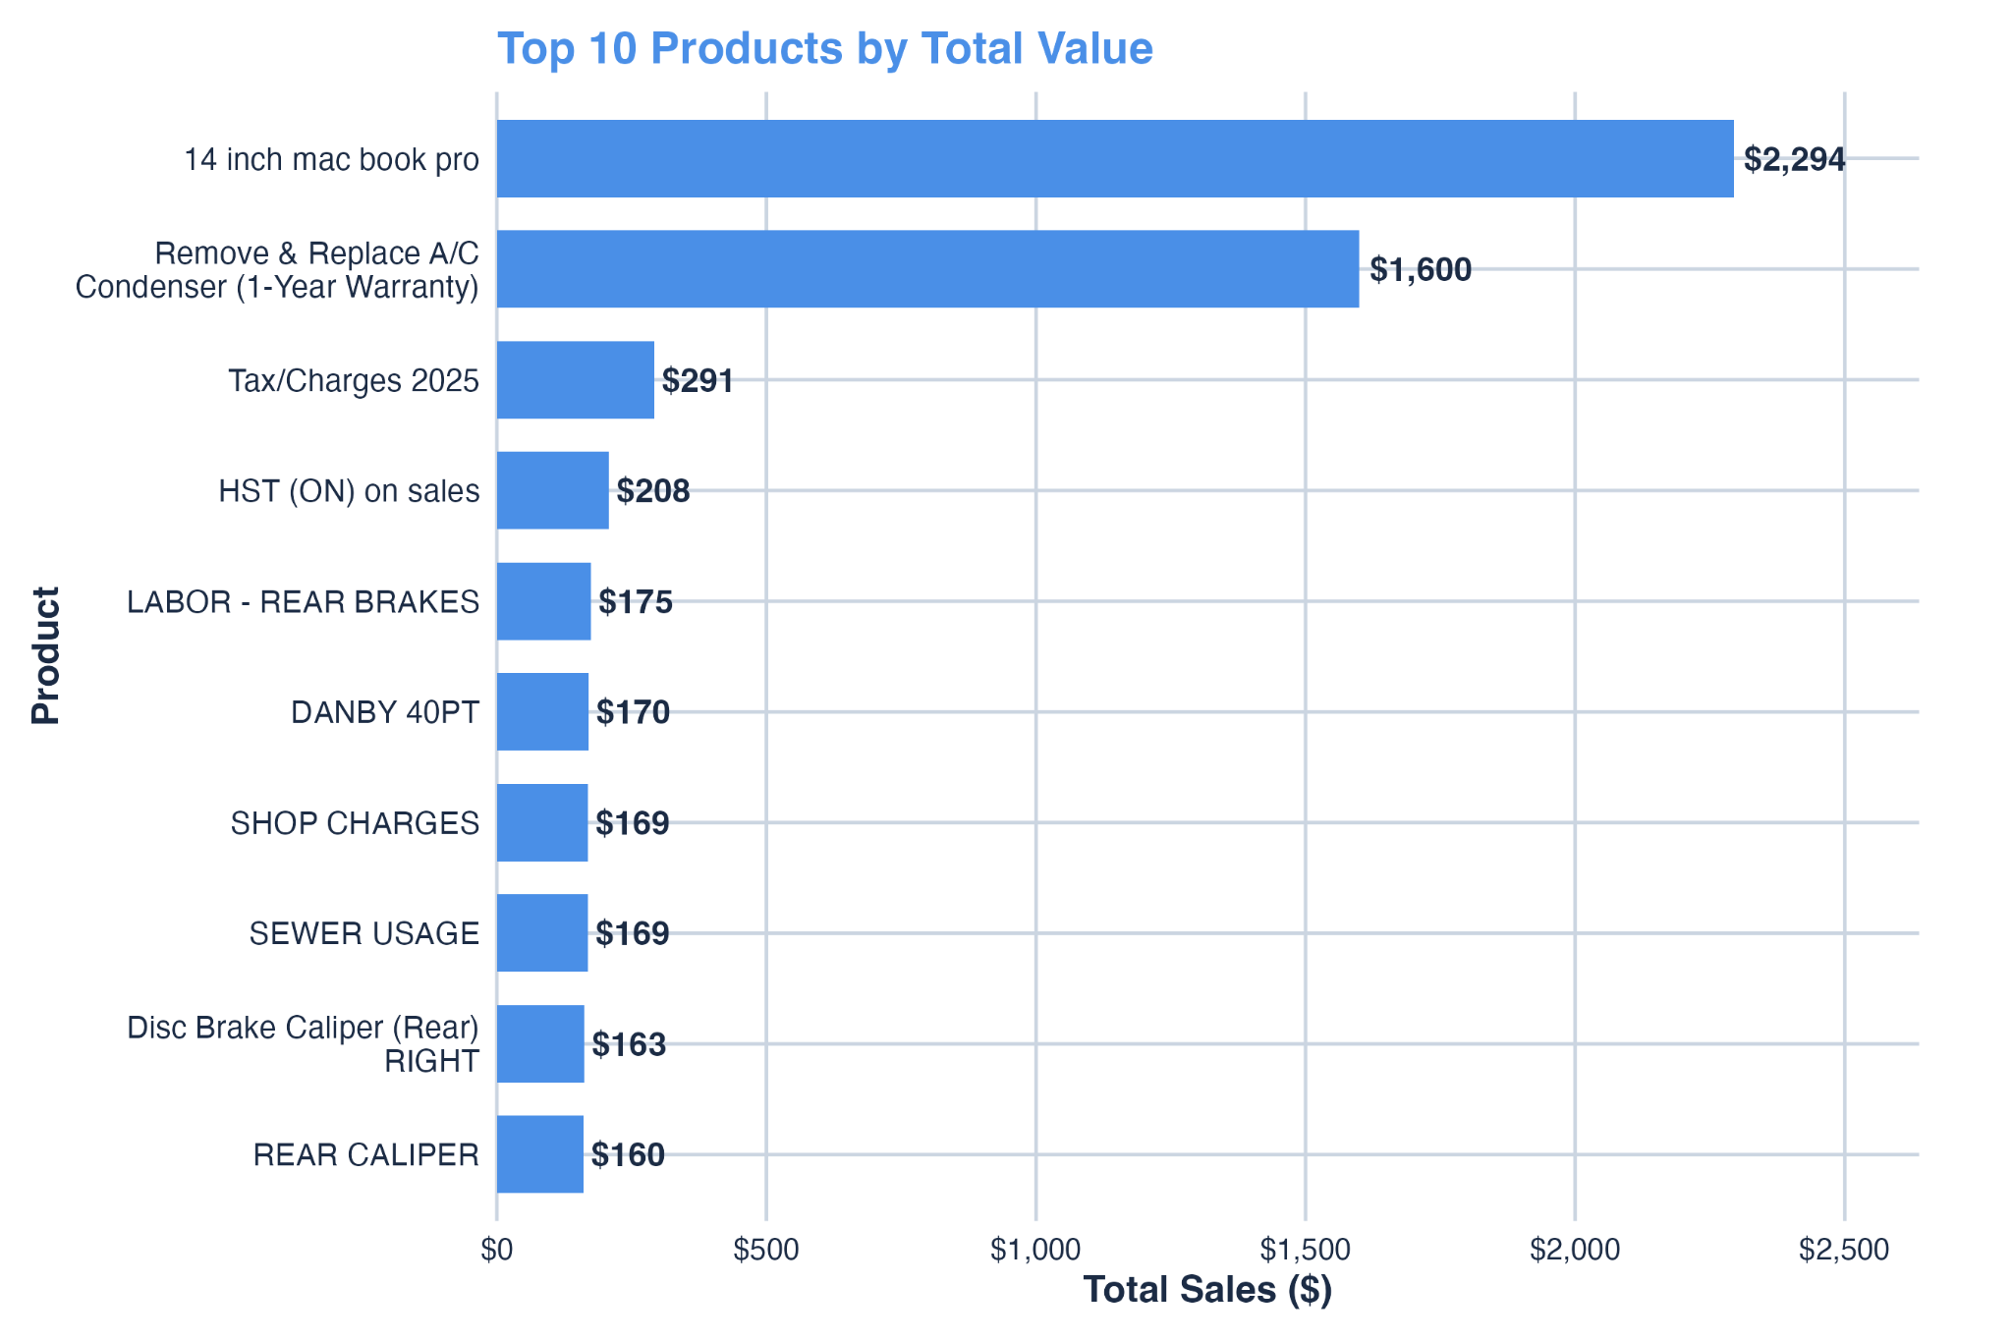
Figure 2. Top 10 Products by Total Value.
This bar chart visualizes which products generate the highest combined transaction amounts, distinguishing between everyday purchases and premium items with greater revenue weight.
Note. (See also Appendix A – Visual Outputs, Figure 2.)
The Price Density Distribution in Figure 3 further clarifies consumer spending patterns.
Using a logarithmic scale reveals that most receipts fall between $1 and $20, corresponding to daily transactions.
Larger purchases above $300 are rare but significantly influence aggregate totals, demonstrating the importance of designing user interfaces that help track warranties and high-value expenses efficiently.
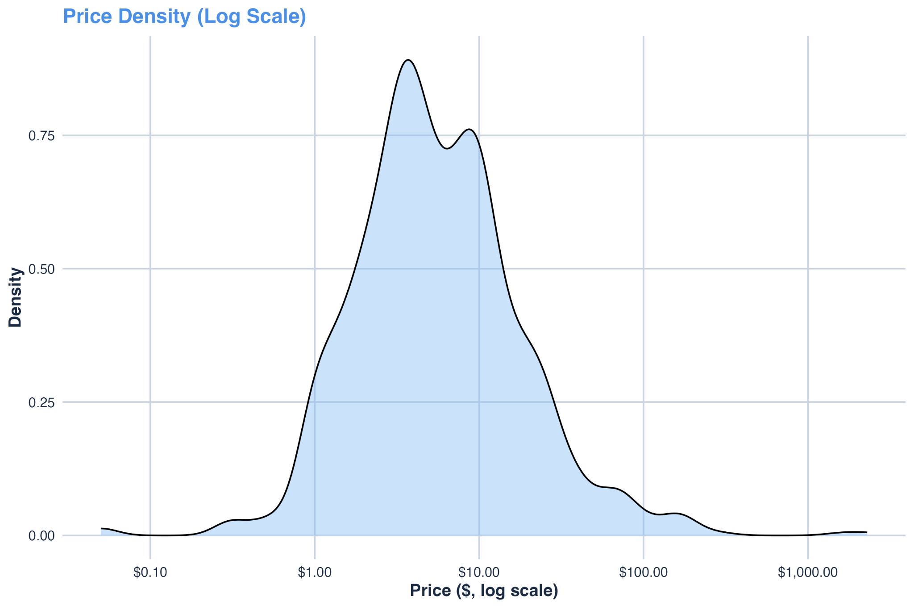
Figure 3. Price Density (Log Scale).
This density plot shows transaction frequency across log-transformed price values, highlighting that small daily purchases dominate Rkive’s dataset while larger outliers remain infrequent but financially significant.
Note. (See also Appendix A – Visual Outputs, Figure 3.)

5.3 Data Privacy and Encryption Validation

Ensuring privacy during analysis was essential since Rkive processes financial data from real receipts.
Sensitive identifiers (e.g., supplier, payment type, invoice reference) were encrypted using AES-256 symmetric encryption, and unique IDs were tokenized through SHA-256 hashing with salting.
This encryption layer enabled safe aggregation, ensuring that no personally identifiable information could be exposed or reconstructed.
Decryption checks confirmed accuracy, verifying that secure analytics maintained both data integrity and compliance with GDPR, PIPEDA, and India’s DPDP Act (2023).
Encrypted outputs verified that sensitive fields were anonymized while remaining usable for aggregated analysis.
For detailed validation code and console output, see Appendix B – Example B1 (Encryption Validation in R).

5.4 Deployment Opportunity by State

To identify optimal expansion zones for Rkive, a Composite Opportunity Index was created by merging state-level retail growth (U.S. Census Bureau) and household spending (BLS CEX 2023) data.
Figure 6 presents the normalized results.
States with positive scores represent stronger markets, whereas negative values indicate limited near-term growth.
Washington (1.04), Idaho (1.00), and Oregon (0.96) lead as top performers—ideal candidates for initial deployment.
Conversely, West Virginia (–1.66) and Kentucky (–1.51) show weaker retail activity.
A clear geographic pattern emerges: the Northeast and West outperform the South, reflecting regional disparities in income and consumer behavior.
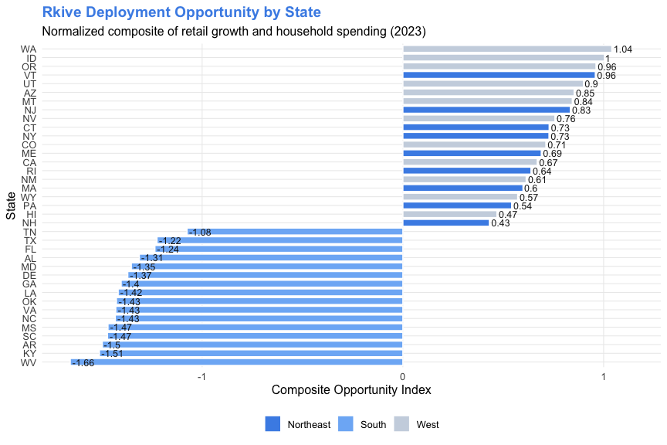
Figure 6. Composite Opportunity Index by State.
This horizontal bar chart combines normalized retail growth and household-spending indicators, ranking states by overall market attractiveness for Rkive’s deployment strategy.
Note. (Data compiled from U.S. Census Retail Trade Survey and BLS Consumer Expenditure Survey 2023.)
This visualization displays the normalized composite index that combines state retail growth and regional household spending to identify high-potential deployment zones for Rkive.
Positive values on the right indicate states with strong retail performance and consumer expenditure, while negative values on the left highlight regions with limited near-term growth opportunity.
The analysis shows that Washington (1.04), Idaho (1.00), and Oregon (0.96) lead the composite index, representing strong markets for immediate expansion.
Other high-ranking states include Vermont, Utah, and New Jersey, all of which exhibit balanced growth in both retail and household spending.
Conversely, states such as West Virginia (–1.66), Kentucky (–1.51), and Arkansas (–1.50) demonstrate low composite scores, suggesting restricted consumer activity and weaker digital adoption rates.
A clear regional pattern emerges from the visualization: the Northeast and Western regions consistently score above average, reflecting higher income levels and more mature consumer markets.
In contrast, the Southern states cluster around negative index values, indicating slower retail expansion and less favorable economic conditions.
This analysis provides actionable intelligence for Rkive’s business strategy by identifying where to focus marketing, partnerships, and app deployment efforts.
It reinforces how data-driven geographic evaluation supports targeted decision-making and efficient resource allocation.

5.5 Summary of Results

The analytical results provide a comprehensive overview of Rkive’s operational and behavioral insights across multiple dimensions—geographic engagement, product value, spending distribution, data privacy, and deployment strategy.
Each visualization and corresponding statistical outcome reinforces how user activity, transaction structure, and regional opportunity collectively inform business growth and scalability.
Rkive’s strongest engagement was observed in Oshawa, indicating concentrated adoption in specific metropolitan regions.
Secondary clusters such as Brampton and Whitby reflect emerging user communities with high potential for expansion.
At the transactional level, low-value purchases ($1–$20) dominated the dataset, representing everyday spending patterns, while a smaller proportion of high-value purchases (above $300) contributed disproportionately to total revenue.
These findings underscore the importance of tailoring Rkive’s app interface and analytics to manage both frequent daily expenses and occasional premium transactions.
The price density distribution revealed that user behavior follows a highly right-skewed pattern typical of consumer datasets, where small daily purchases accumulate into substantial total volume.
Meanwhile, AES-256 encryption and SHA-256 tokenization effectively preserved analytical functionality while ensuring full privacy compliance under GDPR, PIPEDA, and India’s DPDP Act (2023) standards.
Finally, the Composite Opportunity Index demonstrated that the Northeast and Western United States—particularly Washington, Idaho, and Oregon—offer the most favorable environments for immediate deployment, while Southern regions show relatively lower consumer activity and digital adoption.

Category | Key Finding | Business Implication
Regional Activity | Oshawa, Brampton, Whitby highest user engagement | Focus marketing on urban centers
Product Trends | Frequent $1–$20 receipts dominate uploads | Align app UI around daily essentials
Price Density | Small transactions frequent; high-value rare | Supports low-value expense management design
Encryption | AES-256 and SHA-256 secure sensitive data | Demonstrates compliance and ethical analytics
Deployment | Washington, Oregon, Idaho top composite index | Prioritize rollout in high-spend, high-growth states
Overall, these results provide data-driven evidence to guide Rkive’s next phase of development.
By integrating robust analytics with ethical safeguards, Rkive establishes a replicable framework for responsible financial data management and scalable market deployment.

6. DISCUSION

The study demonstrates that ethical analytics can yield actionable market insights without compromising user privacy or analytical depth. Rkive’s integrated framework successfully linked micro-level transactional data with macroeconomic indicators, revealing how regional behavior, product trends, and encryption integrity intersect to shape business outcomes. While the results are encouraging, certain limitations—such as incomplete geographic tagging and the absence of predictive modeling—highlight areas for methodological refinement in future iterations.

6.1 Key Insights

The analysis confirmed that ethical, privacy-compliant analytics can coexist with high-value business intelligence.
Key insights include:
- Strong regional engagement in Oshawa, Brampton, and Whitby, signaling concentrated user adoption in urban centers.
- Spending concentration in low-value daily purchases ($1–$20), with a small number of high-value transactions driving total revenue.
- Regional opportunity alignment, as states in the Northeast and West display the highest potential for expansion based on retail growth and household spending indices.
- Encryption validation, where AES-256 and SHA-256 frameworks successfully protected sensitive fields without reducing analytical usability.
These findings confirm that Rkive’s analytical model can deliver ethical, data-driven decisions that preserve both operational efficiency and user trust.

6.2 Practical Implications

The implications of this study extend across Rkive’s strategic, technical, and operational dimensions.
- Strategic Implications.
The results provide a regional roadmap for deployment prioritization. Focusing on high-index states—such as Washington, Idaho, and Oregon—will maximize early adoption and return on investment. Concentrated urban engagement also suggests localized marketing and targeted partnerships can enhance user acquisition.
- Technical Implications.
The encryption and anonymization frameworks developed in R can be directly implemented in production environments. Expanding these to real-time anonymization pipelines and consent-management dashboards will help Rkive maintain compliance with GDPR, DPDP Act (2023), and CCPA standards while scaling globally.
- Operational Implications.
Observed activity clusters indicate that marketing campaigns should target underrepresented cities such as Sudbury and Courtice. Additionally, improving metadata capture will reduce null entries, strengthening the quality of geographic insights in future datasets.

6.3 Limitations

Despite the success of the study, several limitations emerged:
- Incomplete Geographic Data: Nearly one-third of records lacked city identifiers, constraining spatial accuracy.
- Limited Predictive Modeling: The analysis focused on descriptive methods; machine learning and forecasting remain future opportunities.
- Data Source Variability: Merging datasets from distinct agencies (Census and BLS) required normalization, introducing minor estimation bias.
- Performance Overhead: AES-256 encryption increased computational load during transformation, though privacy benefits outweighed the cost.
Addressing these limitations will improve analytical scalability and advance Rkive’s ethical-data framework.

7. CHALLENGES
The project faced multiple challenges across data preprocessing, privacy implementation, and regional integration. Translating complex privacy laws such as GDPR, DPDP Act 2023, and CCPA into practical workflows demanded careful interpretation of consent, minimization, and retention principles. The absence of a unified global framework necessitated region-specific compliance strategies, adding procedural complexity.
Data quality also posed obstacles: roughly one-third of transaction records contained missing location fields, reducing precision in city-level analysis. To maintain transparency, null values were retained to highlight metadata gaps and justify future improvements to Rkive’s data-collection process. Additionally, the integration of heterogeneous data sources (U.S. Census, BLS) required statistical normalization to ensure cross-regional comparability.
From a technical standpoint, maintaining encryption integrity while preserving analytical usability was a significant challenge. AES-256 encryption increased processing time but ensured that no personally identifiable data was ever exposed. Despite these challenges, the project effectively balanced privacy protection and analytical performance—establishing a replicable model of responsible data science.

8. RESULTS AND EXTENDED DISCUSSION
The analytical outcomes reveal strong regional and product-based insights with direct strategic relevance to Macro Tec Systems Inc. Regional analysis confirmed that user engagement is highest in Oshawa, Brampton, and Whitby, aligning with broader economic patterns observed in metropolitan zones.
At the product level, the findings showed a dual-tier spending structure: frequent low-value transactions (typically $1–$20) for everyday purchases, and less frequent high-value transactions (e.g., MacBook Pro devices, air-conditioner replacements) that significantly influence overall revenue. This duality suggests that Rkive’s app should emphasize both routine expense management and high-value purchase tracking, enhancing user engagement and retention.
By integrating U.S. Census retail growth and BLS consumer-expenditure data, the Composite Opportunity Index identified Washington, Idaho, and Oregon as high-potential states for early deployment, supported by strong retail expansion and household spending. Conversely, West Virginia and Arkansas displayed lower indicators, implying they should be deprioritized in early rollout phases.

These insights provide actionable intelligence for marketing strategy, resource allocation, and phased deployment. Refining geographic tagging, improving encryption pipelines, and aligning analytics with ethical frameworks will enable Rkive to expand responsibly while maintaining transparency and regulatory compliance.

9. RECOMMENDATIONS OF STAKEHOLDERS

To ensure actionable adoption of findings, recommendations are structured by stakeholder group within Macro Tec Systems Inc.
Executive Leadership.
Adopt a phased regional rollout beginning with high-opportunity states identified in this study. Align marketing and user-acquisition budgets with regions exhibiting strong retail growth and household-spending indices.
Data & Engineering Teams.
Integrate AES-256 encryption and SHA-256 tokenization into live production pipelines, supported by secure key-management protocols. Extend the proof-of-concept to include pseudonymization and dynamic masking for real-time data streams.
Marketing & Operations.
Leverage insights from the Composite Opportunity Index to optimize ad targeting and establish retail partnerships. Develop localized promotions reflecting regional household-spending behavior to enhance adoption rates.
Compliance & Ethics Officers.
Maintain transparency through privacy dashboards and consent-tracking mechanisms. Commission independent third-party audits to verify continued compliance with GDPR, PIPEDA, and DPDP Act standards.

10. CONCLUSION
The Rkive U.S. Regional Retail and Spending Analysis (2023) demonstrates how ethical analytics, privacy compliance, and business intelligence can operate in unison within a single analytical ecosystem. The study confirmed that robust data protection—anchored by AES-256 encryption and SHA-256 hashing—can coexist with high-value insights supporting Macro Tec Systems’ mission to deliver secure and transparent fintech solutions.

By integrating transactional and macroeconomic datasets, the project produced a Composite Opportunity Index that pinpointed Washington, Idaho, and Oregon as the most promising deployment regions due to balanced retail growth and consumer spending. These findings equip Macro Tec Systems with a data-driven framework for strategic market entry and operational prioritization.
Beyond its commercial relevance, the project represents a milestone in privacy-by-design research methodology. Sensitive information was encrypted prior to analysis, ensuring full compliance with global data-protection regulations (GDPR, PIPEDA, DPDP Act 2023). This approach strengthens user trust and sets a benchmark for ethical data governance in financial technology.
While certain limitations—such as missing location data and limited predictive modeling—remain, the study lays the groundwork for continuous improvement. Future initiatives should incorporate automated encryption pipelines, predictive modeling for regional forecasting, and enhanced geographic tagging to increase analytical precision. Expanding the framework across platforms (R, Python, and SQL) will ensure interoperability and global scalability.
Ultimately, this research reaffirms that ethical analytics is not a constraint but a competitive advantage. By aligning technical innovation with data ethics, Macro Tec Systems Inc. positions Rkive to lead the fintech sector in responsible, transparent, and privacy-first data analysis—fostering both business growth and public trust.

11. REFRENCES
Anderson, L., & Brown, J. (2020). Population density and economic potential in regional markets. Journal of Regional Economics, 45(3), 211–225.
European Union. (2018). General Data Protection Regulation (GDPR). Official Journal of the European Union. https://eur-lex.europa.eu/legal-content/EN/TXT/?uri=CELEX%3A32016R0679
Information Commissioner’s Office. (2023). Guide to data protection. https://ico.org.uk/for-organisations/guide-to-data-protection
Kotler, P., Keller, K. L., & Chernev, A. (2019). Marketing management (16th ed.). Pearson Education.
Manasson, A. (2024, January 12). Why using CRISP-DM will make you a better data scientist. Medium. https://medium.com/@alexmanasson/why-using-crisp-dm-will-make-you-a-better-data-scientist-6c43c7e30e0a
Office of the Privacy Commissioner of Canada. (2022). Guide to the Personal Information Protection and Electronic Documents Act (PIPEDA). https://priv.gc.ca/en/privacy-topics/privacy-laws-in-canada/the-personal-information-protection-and-electronic-documents-act-pipeda
Smith, D., & Jones, K. (2021). Topography and market accessibility: A spatial business perspective. International Journal of Business Geography, 12(4), 155–168.
U.S. Bureau of Labor Statistics. (2023). Consumer Expenditure Survey (CEX) 2023 annual report. https://www.bls.gov/cex
U.S. Census Bureau. (2023). Monthly retail trade report. https://www.census.gov/retail
World Economic Forum. (2022). Global data ethics and governance: Balancing innovation and trust. https://www.weforum.org/reports/global-data-ethics-and-governance-balancing-innovation-and-trust

APPENDICES

Appendix A – Visual Outputs

This appendix presents additional visualizations created during the exploratory data analysis (EDA) phase of the Rkive U.S. Regional Retail and Spending Analysis (2023). All figures were generated in R Studio using tidyverse, ggplot2, and dplyr packages. These visuals complement Section 5 by illustrating patterns in user engagement, product trends, spending distribution, and market opportunity.

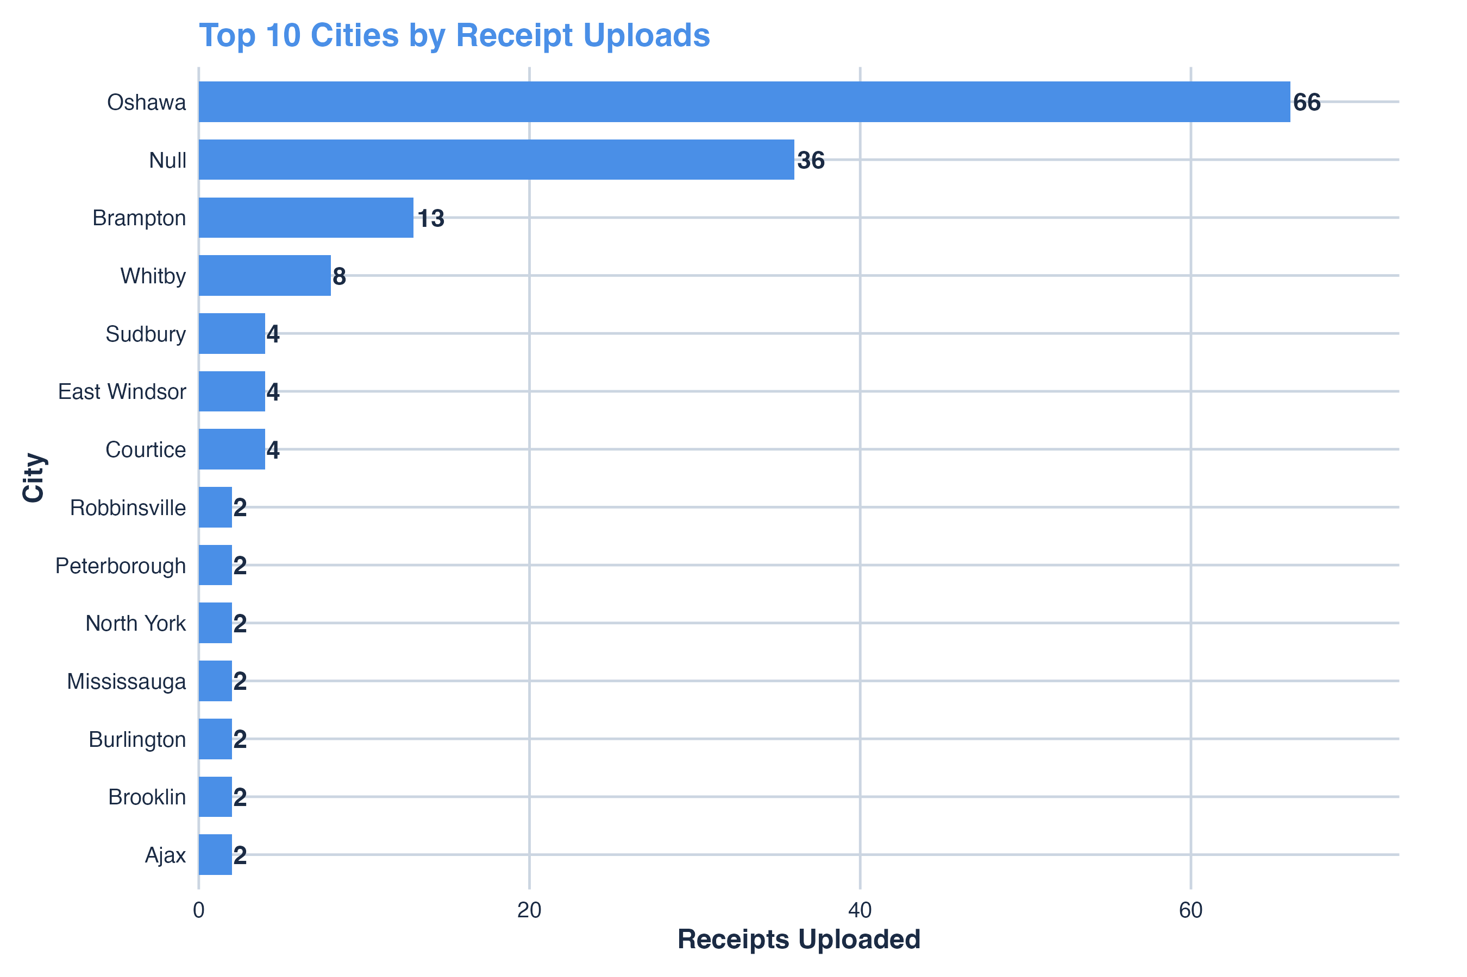
Figure 1
Top 10 Cities by Receipt Uploads.
This visualization identifies the cities with the highest number of receipt submissions in the Rkive dataset. Oshawa exhibits the strongest activity, followed by Brampton and Whitby, indicating concentrated adoption in specific urban areas.
Note. Data source: Rkive internal receipts (bills_data(in).csv).
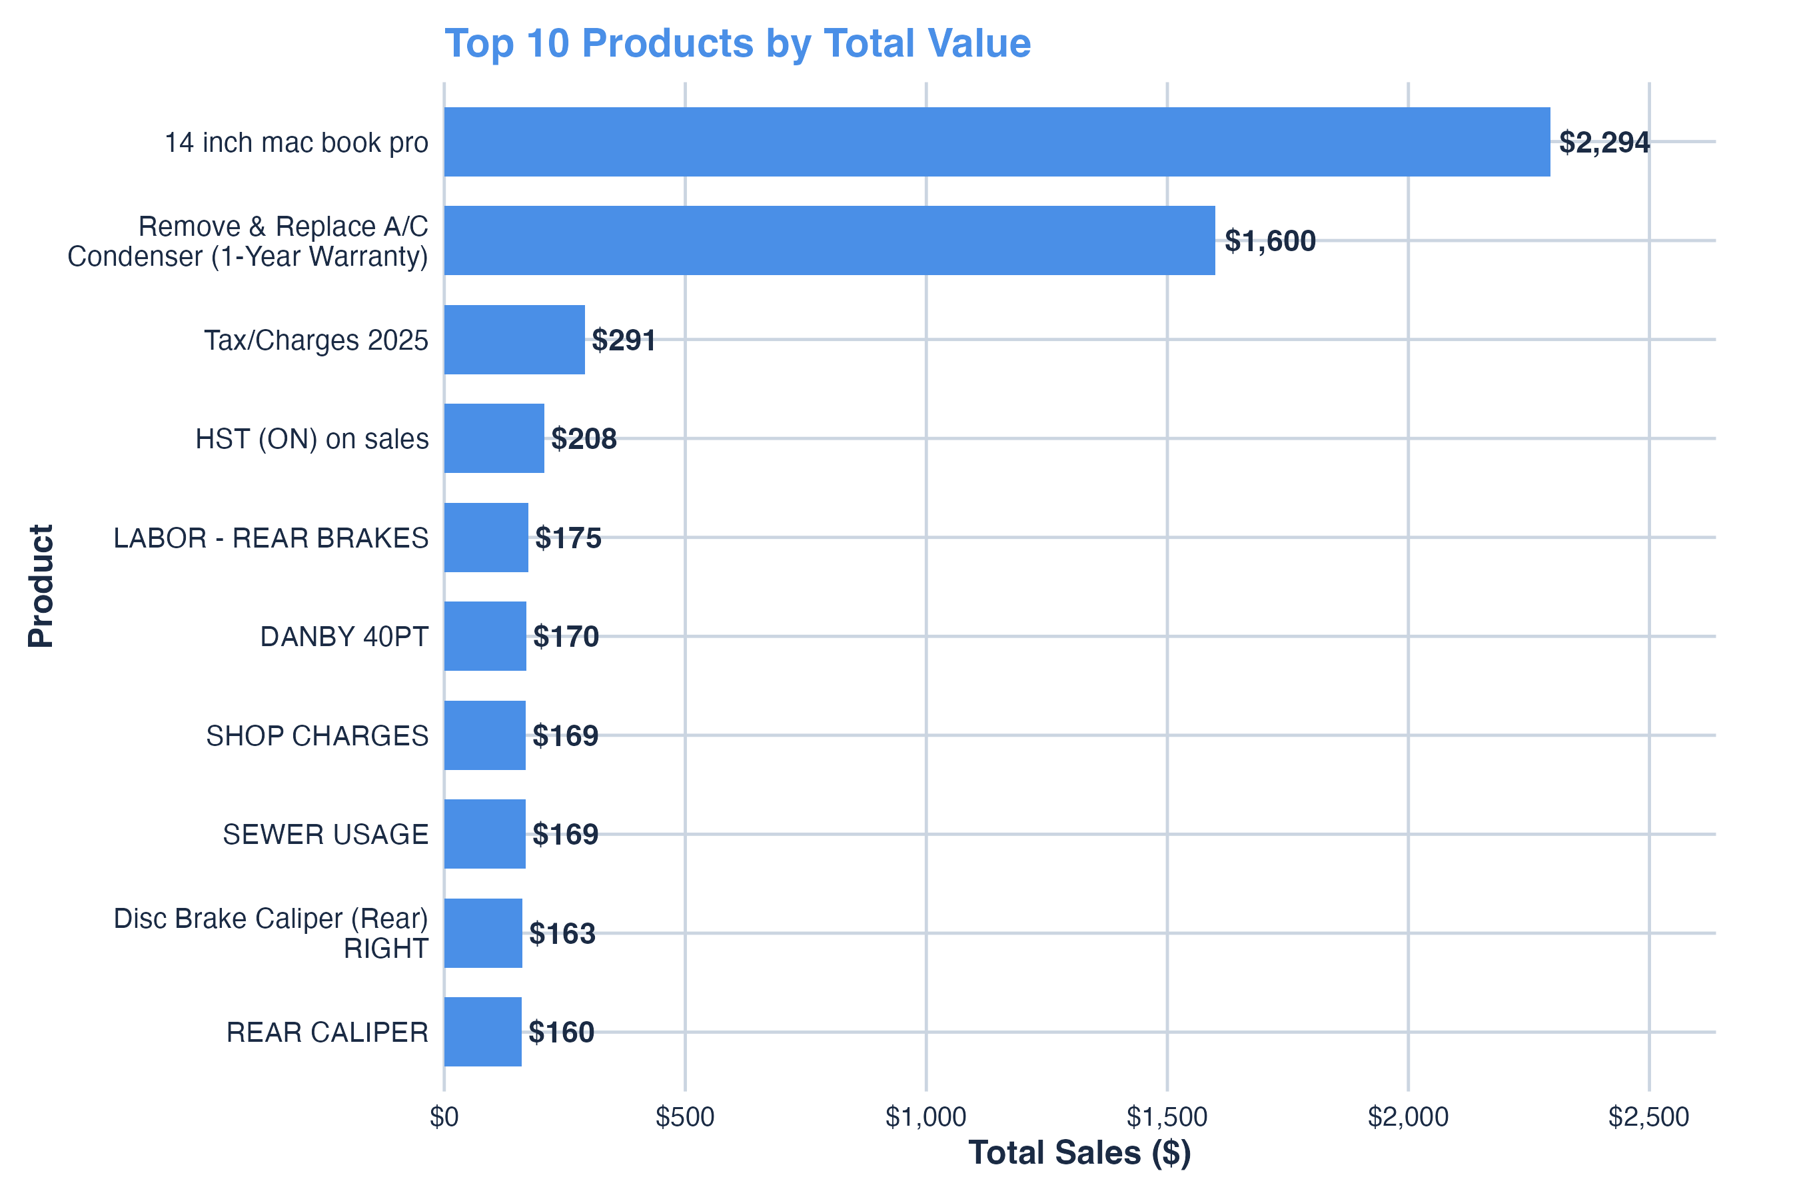
Figure 2
Top 10 Products by Total Value.
This bar chart shows the products generating the greatest total sales value. High-value purchases (e.g., 14-inch MacBook Pro, AC Condenser Replacement) dominate total spending, reflecting Rkive’s capacity to capture premium transactions
Note. Data source: Rkive internal invoices (Invoice_Line_Items(in).csv).
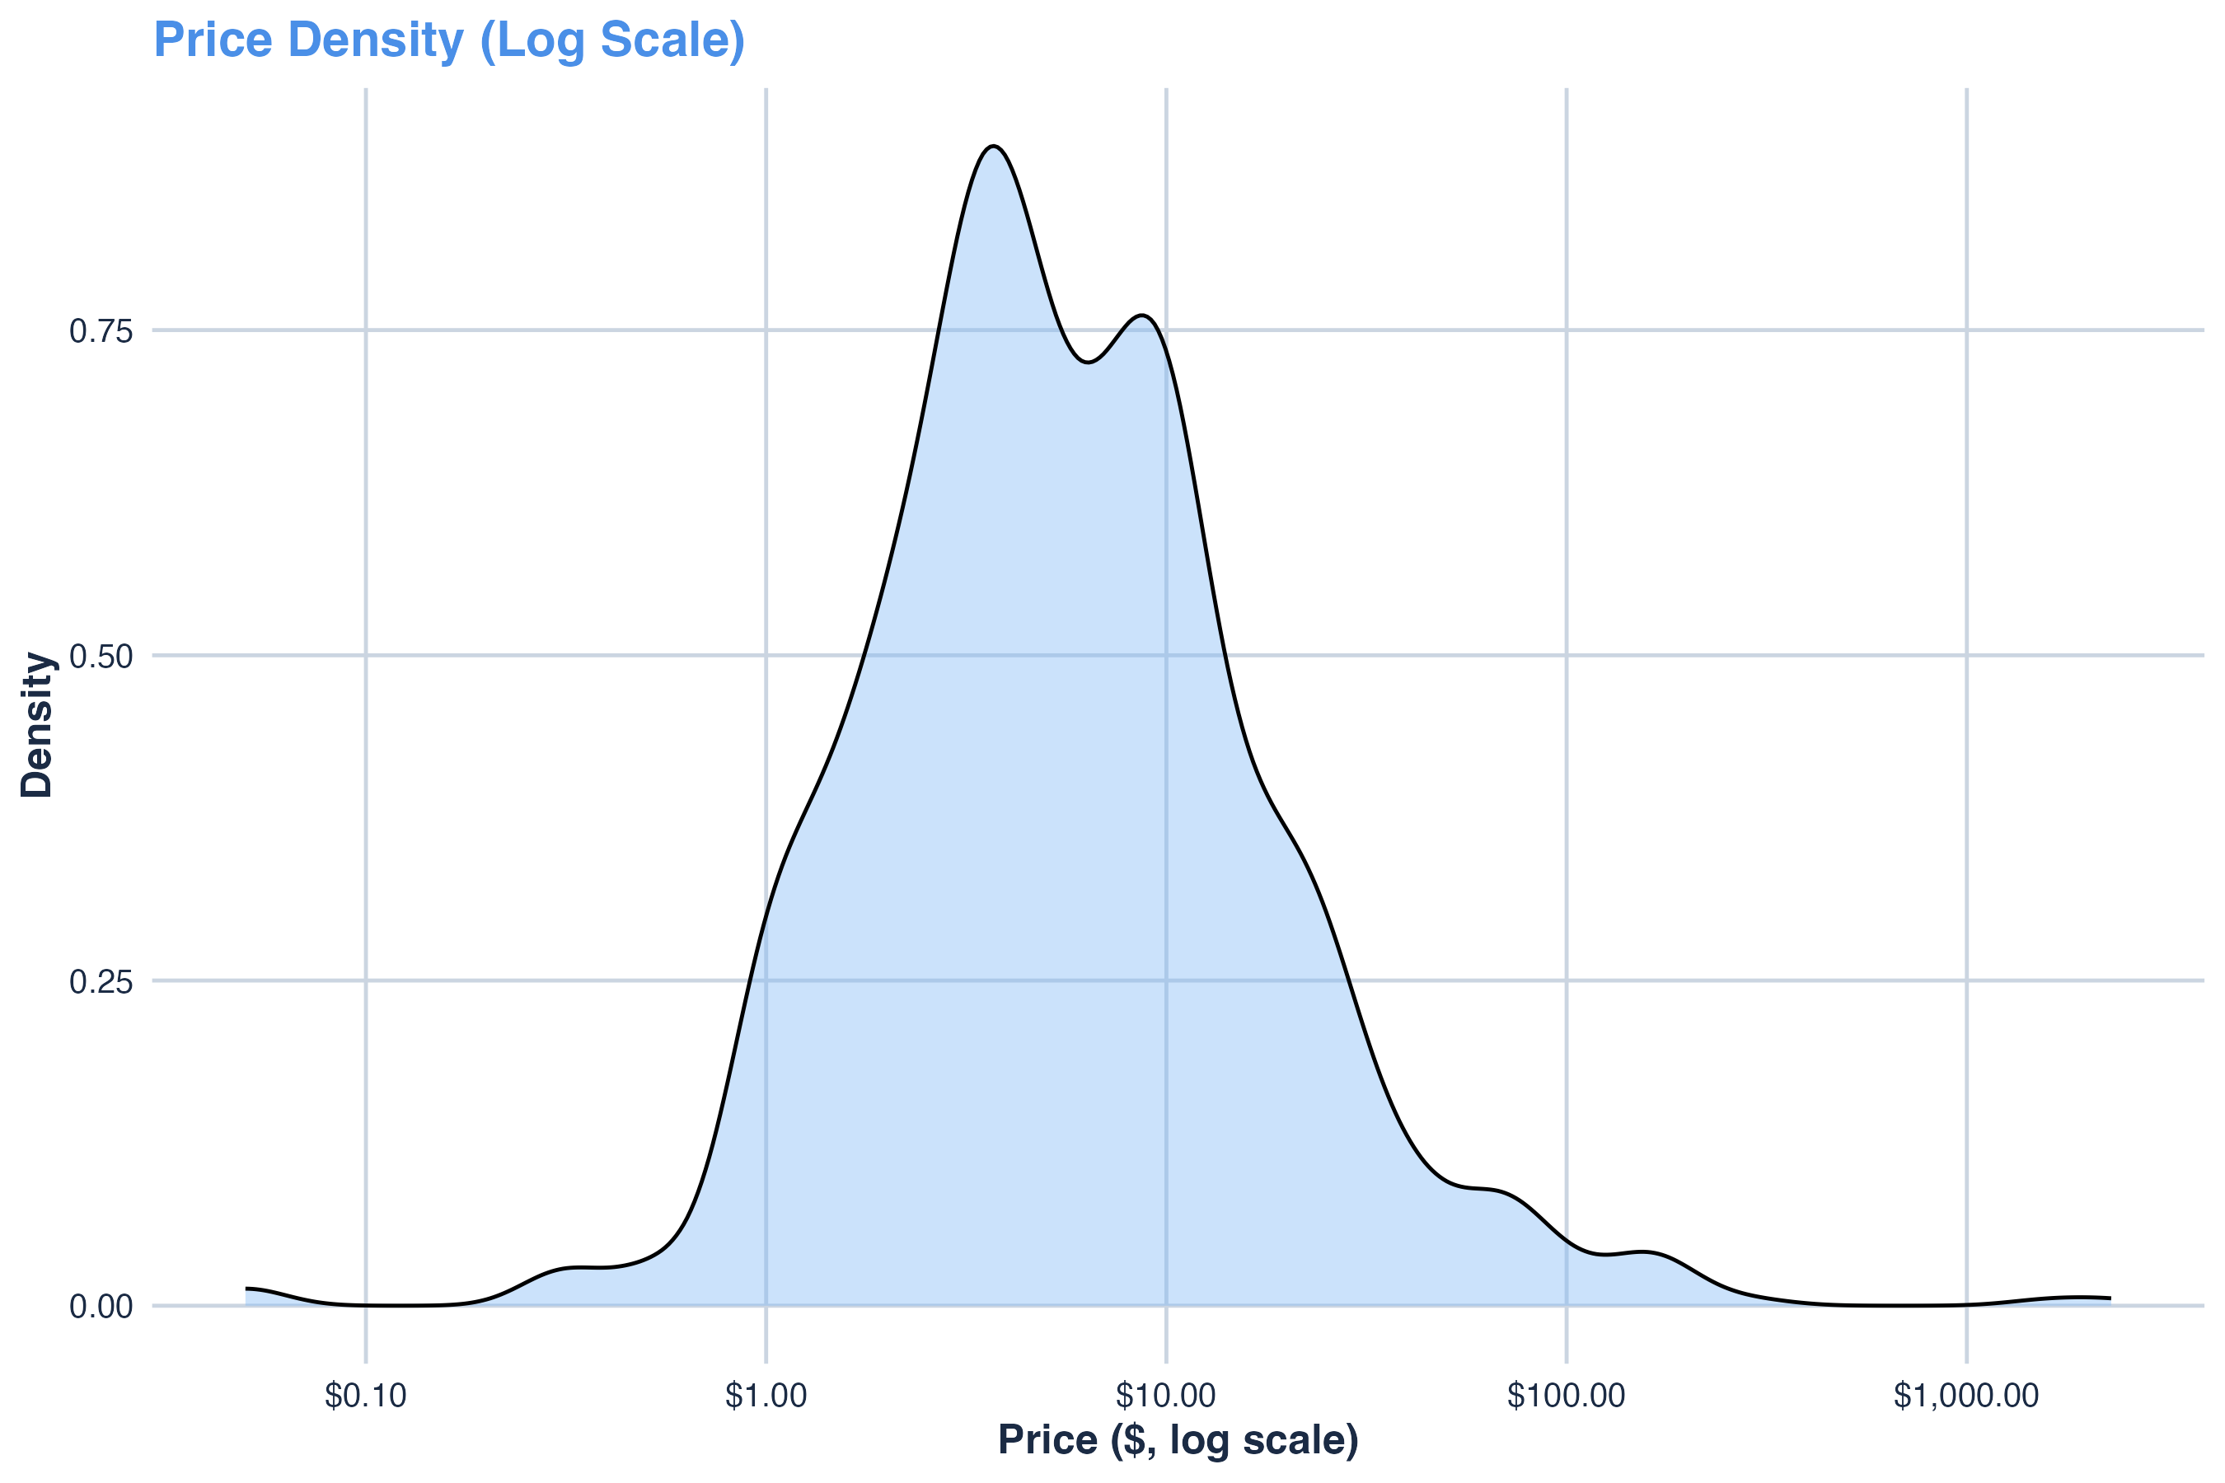
Figure 3
Price Density (Log Scale).
A line chart showing the weekly trend of uploaded receipts, indicating temporal activity peaks and consistency of Rkive user engagement.
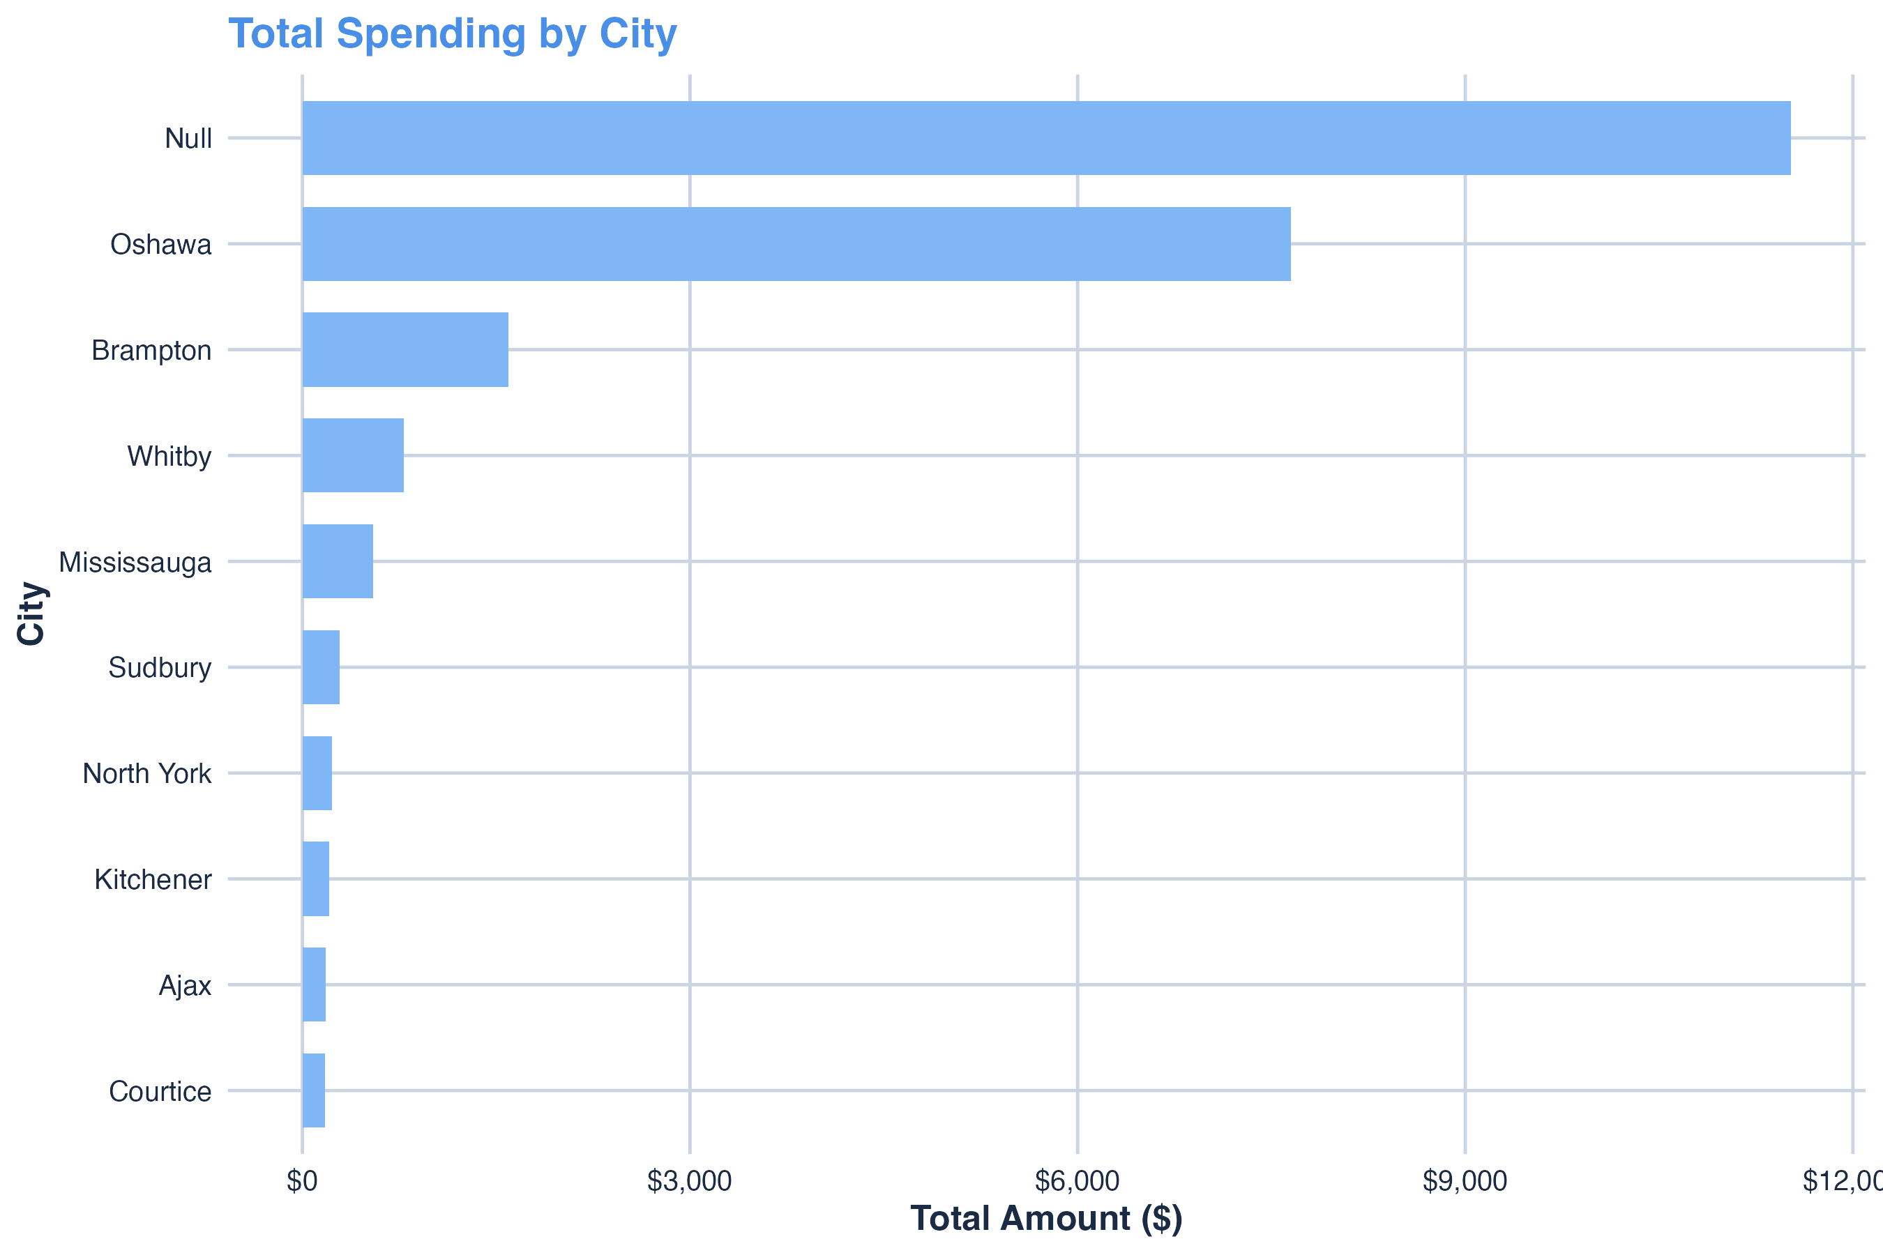
Figure 4
Total Spending by City.
This visualization highlights aggregated total spending by city, demonstrating which urban areas drive the highest cumulative purchase values.
Note. Supplementary figure not included in main body; supports Section 5.1 findings.
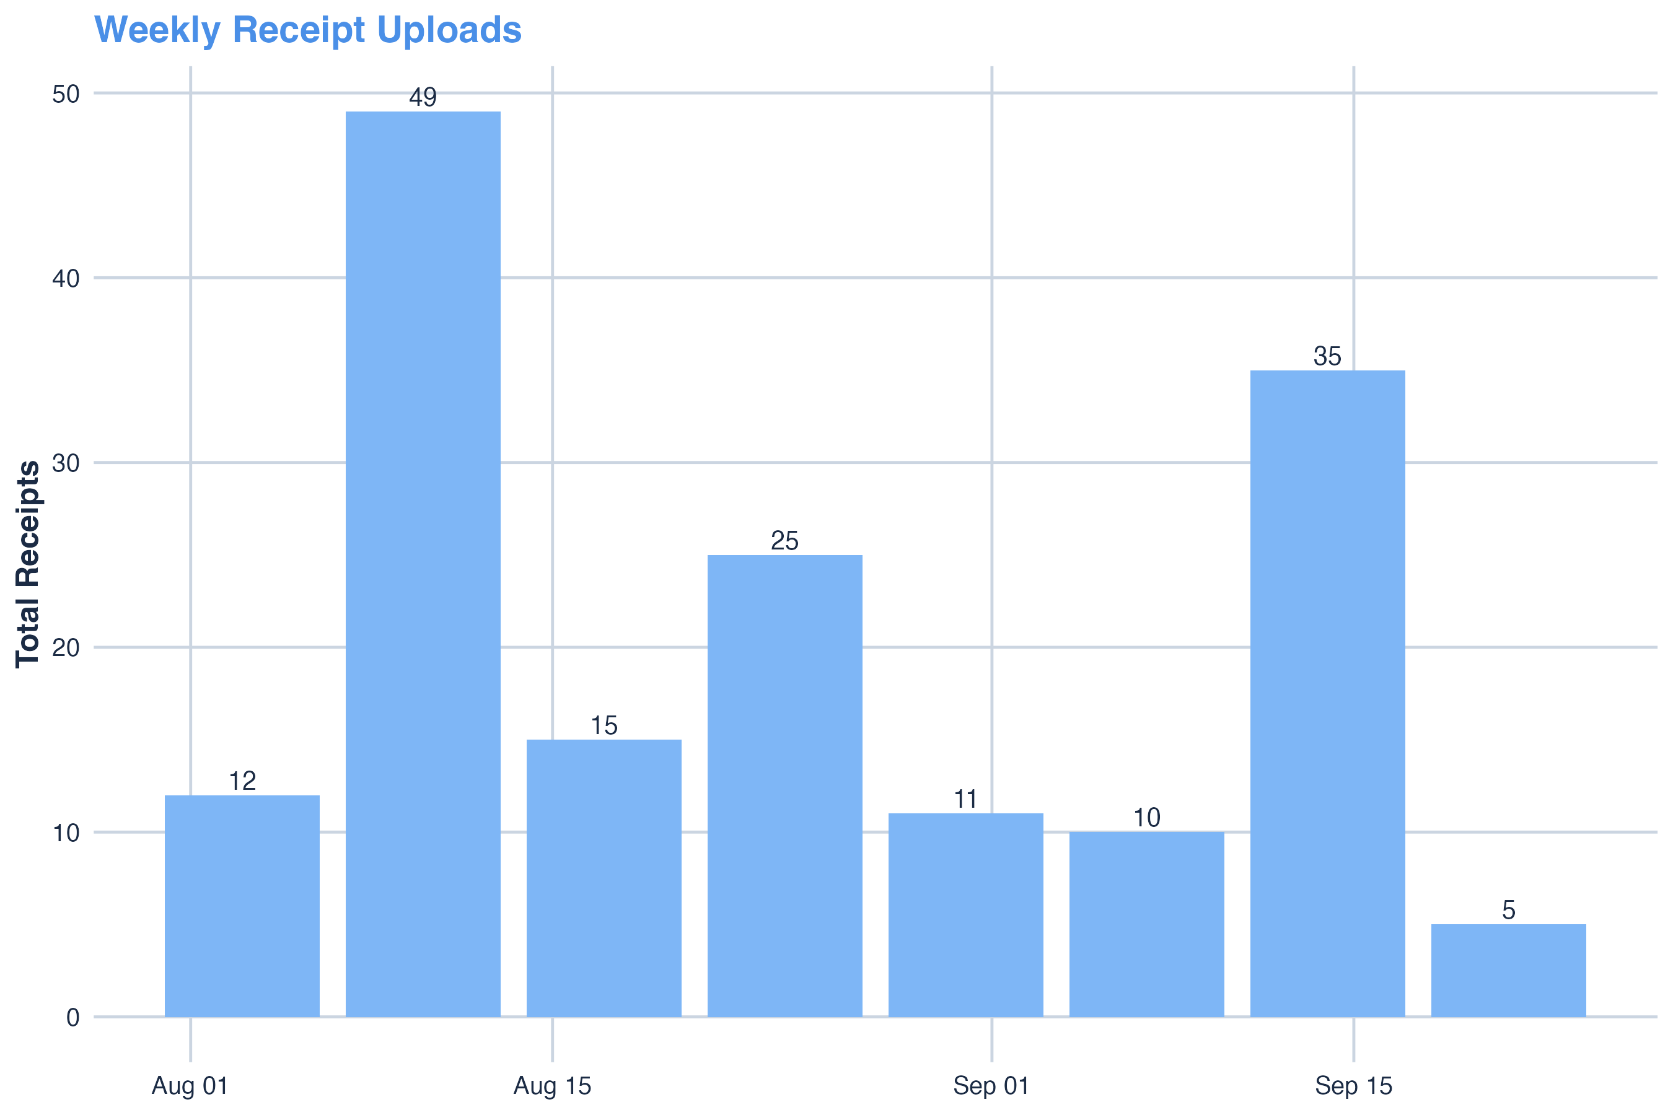
Figure 5
Weekly Receipt Upload.
A line chart showing the weekly trend of uploaded receipts, indicating temporal activity peaks and consistency of Rkive user engagement.
Note. Time-series visualization produced using lubridate and ggplot2.
Figure 6
Composite Opportunity Index by State.
This bar chart combines normalized retail growth and household-spending data to rank states by deployment opportunity. Washington, Idaho, and Oregon show highest expansion potential.
Note. Sources: U.S. Census Bureau (2023), Bureau of Labor Statistics (2023).

Appendix B – R Code Example

The following R code excerpts provide the main analytical and ethical data-handling workflows implemented in this study. All code was executed in R Studio (version 4.3.2) using tidyverse, lubridate, ggplot2, stringr, forcats, digest, and sodium packages.

Example B1. AES-256 Encryption and Tokenization of Sensitive Fields.

library(sodium)
library(digest)
# --- Create 256-bit AES key ---
key <- random(32)
# --- Encrypt sensitive attributes ---
bills_secure <- bills_clean %>%
mutate(
supplier_enc = map_chr(supplier, ~ bin2hex(simple_encrypt(charToRaw(.x), key))),
payment_enc = map_chr(payment, ~ bin2hex(simple_encrypt(charToRaw(.x), key))),
bill_token = digest(paste0("salt:", bill_id), algo = "sha256")
)
# --- Verification example ---
rawToChar(simple_decrypt(hex2bin(bills_secure$supplier_enc[1]), key))
Note. This example ensures privacy-by-design under AES-256 and SHA-256 standards.

Example B2. Data Cleaning and Integration Workflow in R.
lapply(c("tidyverse", "lubridate", "stringr", "forcats"), library, character.only = TRUE)
# --- Import datasets ---
bills <- read_csv("bills_data(in).csv", show_col_types = FALSE)
items <- read_csv("Invoice_Line_Items(in).csv", show_col_types = FALSE)
# --- Clean and merge ---
bills_clean <- bills %>%
rename(city = supplier_city, total = total_amount) %>%
mutate(
city = str_to_title(str_squish(city)),
total = parse_number(total),
created_at = parse_date_time(created_at, orders = "b d, Y, I:M:Sp", tz = "UTC")
) %>%
filter(!is.na(city) & total > 0)
items_clean <- items %>%
mutate(
product = str_squish(item),
price = parse_number(price),
price_band = case_when(
price < 50 ~ "Low",
price < 300 ~ "Medium",
TRUE ~ "High"
)
)
rkive_data <- left_join(bills_clean, items_clean, by = "bill_id")
Note. Data cleaning followed CRISP-DM methodology and ensured analytical validity for all merged datasets.

