**Project : BookHub**

1. Ideation :

* Benchmarking :

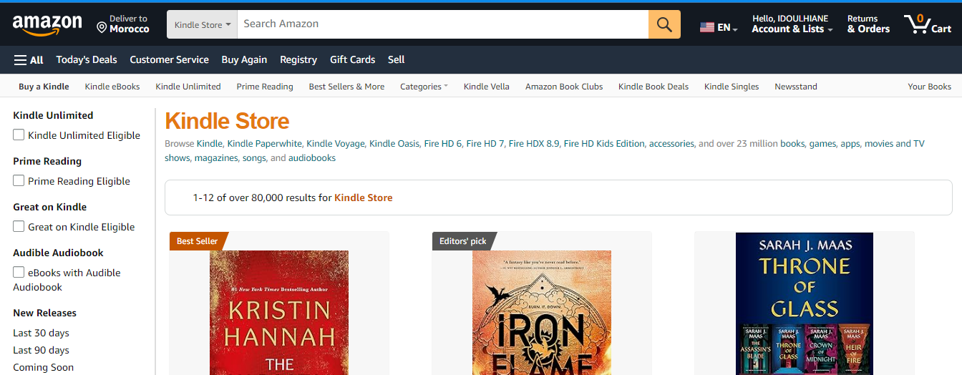Amazon Kindle :

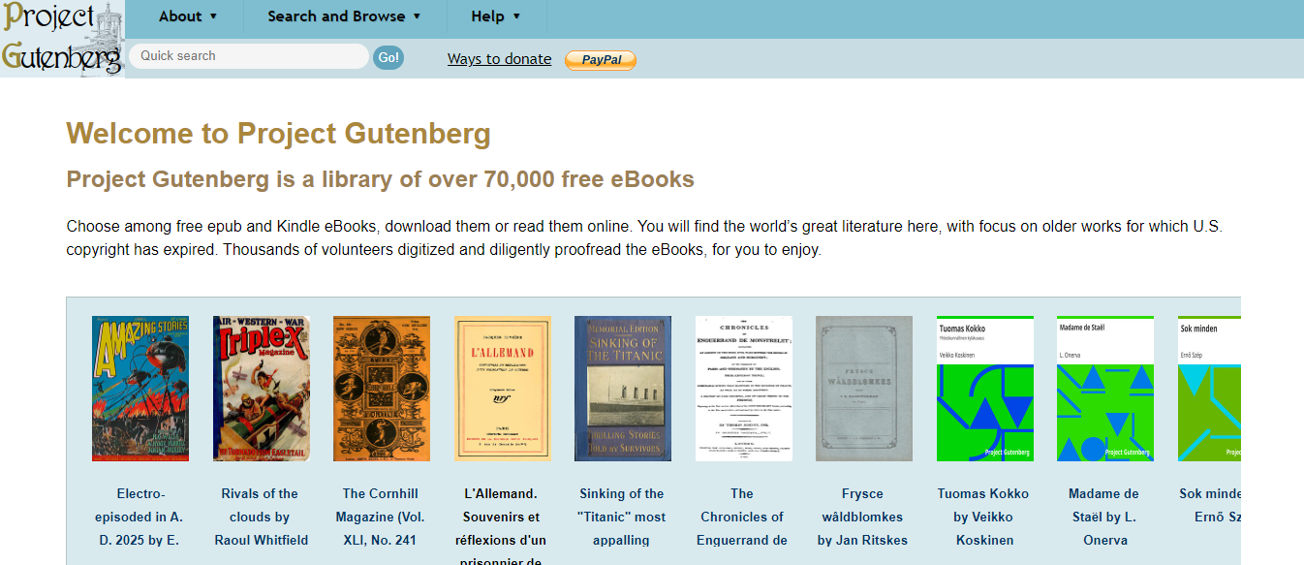Gutenberg :

Kobo.com :

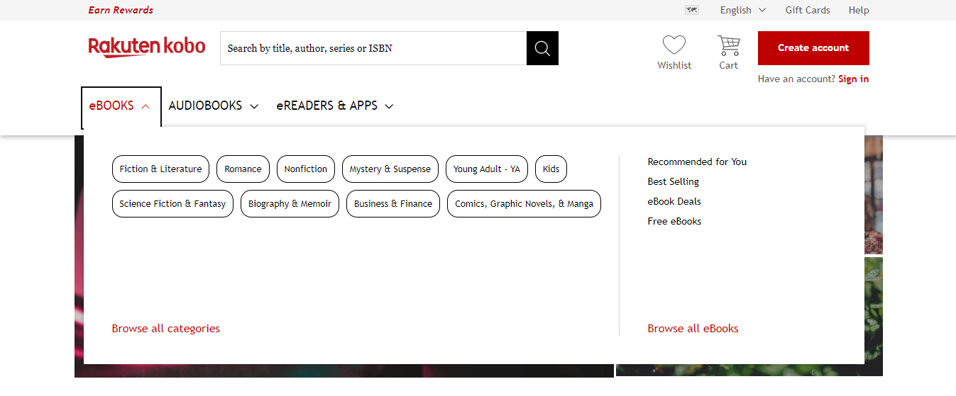

* Persona + Userflow + Prototypage :

<https://www.figma.com/proto/vSjSvo3vVbdmDYURQbP1rW/BookHub?node-id=0-1&t=HJTjGcivEQNS8zfY-1> (A télécharger et à mettre en pièce jointe)

Homepage content:

-Welcome image

-Welcome message

-User Stories

About Us content:

-overall idea

-the how/ testimonials

-authors, publishers and book marketers

-join us

-media ressources

-connect with us

Shelf page:

-categories

🡪books

Image + title + author + a pop-up at the top of the page with the description of the selected book

Contact page:

-heading(message)

-A form

1. Lancement/Planification :

* Répartition des tâches :

Header : KAOUTAR

Body : ALAE et AYOUB

Footer : YOUNES

* Nombres des pages : 4

-Home

-Shelf

-About us

-Contact

* Functionnalities :

-Header&Footer:

Header:

Sign in & sign up a hoover animation.

Logo header is a quick link to homepage.

Quick links to homepage- about us- shelf- contact.

Footer:

Logo footer is a quick link to homepage.

Quick links to homepage- about us- shelf- contact.

Follow us: Facebook, Instagram, Twitter and their icons.

-Body:

*Homepage:

Dynamic welcome

User Stories (dynamic slide)

*About:

Quick links in the paragraph to the “how” and testimonials.

*Shelf:

Hoover animation.

Button (see books).

🡪book-category:

Animation on click with a description pop-up.

*Contact:

Fill a form: Mail, subject, how can we help.

“Envoyer” Button.