HW02 REPORT

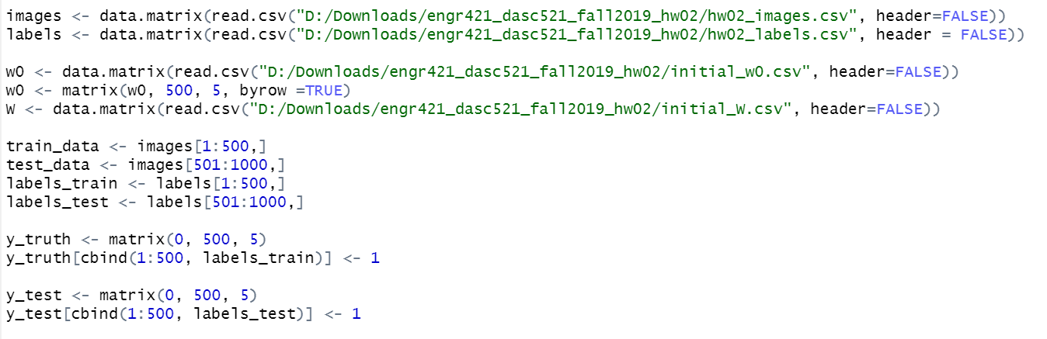In HW02, I implemented discrimination by regression algorithm using sigmoid function for given multiclass classification problem. As a first step, I split images data (1000x784 matrix) to 500x784 train_data matrix taking the first half of the images. I put other half of the images to a test_data which is 500x784 matrix. After splitting data, I put W and w0 parameters in a matrix where W is a 784x5 matrix and w0 is a 500x5 matrix. I split labels data into labels_train and labels_test with the same way that I used for images data. I put labels_train and labels_test in a matrix according to their corresponding images with below function:

After that, I implemented sigmoid function as shown below:

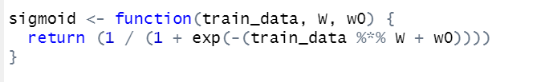

Since sigmoid function exists in between 0 and 1, for predicting probabilities as an output, it is useful for our model.

As a next step, I calculated gradient_W and gradient_w0 according to textbook section 10.8 as shown below:

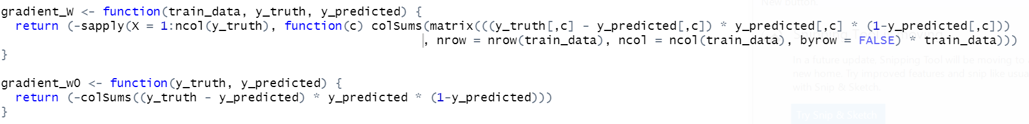

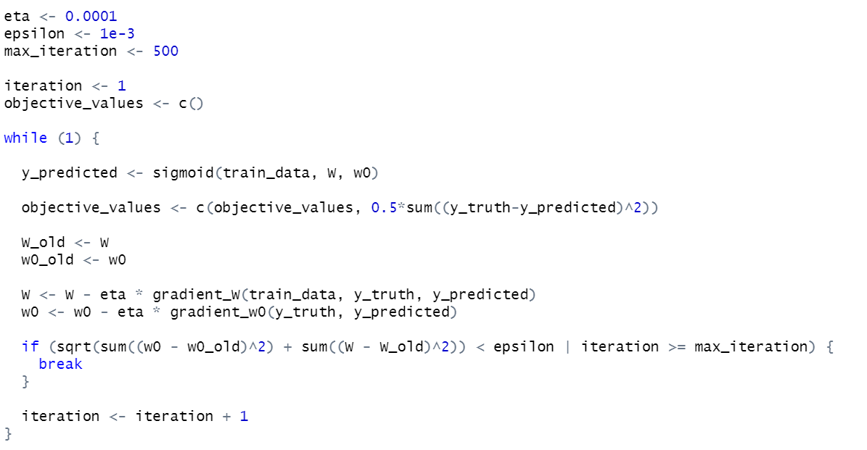After setting epsilon, eta and max_iteration values according to homework specifications, start updating W and w0 parameters in while loop as shown below:

I plot the error vs iteration graph as shown below:

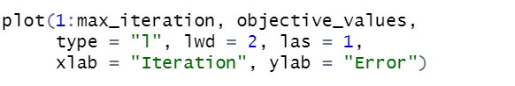

I calculated the confusion matrix for train_data as shown below:

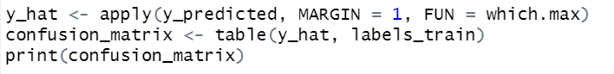

After applying sigmoid function to test_data, I calculated confusion matrix with updated W and w0 as shown below:

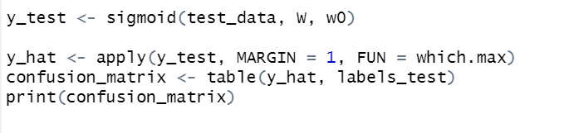

The reason that we are applying sigmoid function also to the test_data is to provide unbiased evaluation of a final model fit on the training data set.