Akdeniz University
2018-2019, Spring
CSE366 Introduction to Image Processing

Homework 1- Basic Image Operations

For this homework I chose to use Python as programming language, and I worked in online python notebook Jupyter. Codes and screenshotes are all attached down below.

- Write a function that returns value of a pixel entered

%matplotlib inline
from skimage.io import imread, imsave, imshow
img = imread('https://stepik.org/media/attachments/lesson/58180/tiger-gray.png')

def get_val(x, y, z):
v =img[x, y, z]
print(v)

x = int(input("x ="))
y = int(input("y ="))
z = int(input("z ="))

get_val(x, y, z)
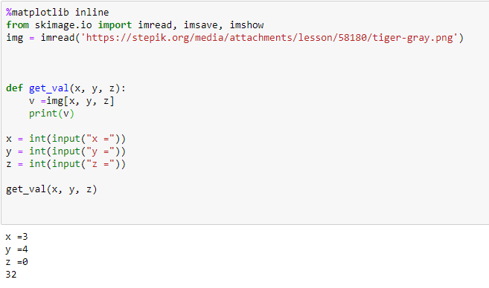

- Write a function that sets value of a pixel entered

%matplotlib inline
from skimage.io import imread, imsave, imshow
img = imread('https://stepik.org/media/attachments/lesson/58180/tiger-gray.png')

def get_val(x, y, z):
v =img[x, y, z]
print(v)
def set_val(x, y, z, val):
v = img[x, y, z] = val
print(v)

x = int(input("x ="))
y = int(input("y ="))
z = int(input("z ="))
val = int(input("val ="))

set_val(x, y, z, val)

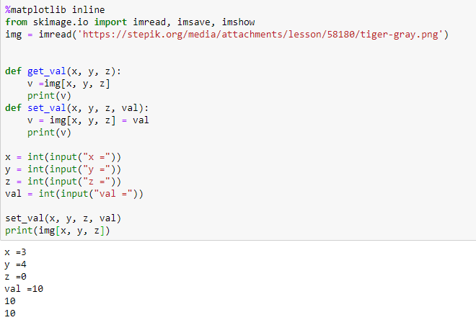

Print in the end of the code is used in order to check whether the value was entered.

- Write a function that creates a copy of a image:

%matplotlib inline
from skimage.io import imread, imsave, imshow
img = imread('https://stepik.org/media/attachments/lesson/58180/tiger-gray.png')
def copy_pic(img):
img_copy = img.copy()
copy_pic(img)
imshow(img_copy)

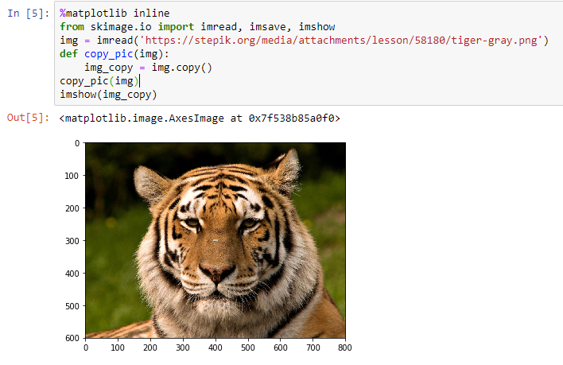

- Write a function that turns rgb image to grayscale using relative luminance formula

Formula = 0.21 R + 0.72 G + 0.07 B.

%matplotlib inline
from skimage.io import imread, imshow, imsave
import numpy as np
import matplotlib.pyplot as plt
import matplotlib.image as mpimg

def rgb_to_gray(img):
grayImage = np.zeros(img.shape)
R = np.array(img[:, :, 0])
G = np.array(img[:, :, 1])
B = np.array(img[:, :, 2])

R = (R *.21)
G = (G *.72)
B = (B *.07)

Avg = (R+G+B)
grayImage = img

for i in range(3):
grayImage[:,:,i] = Avg

return grayImage

image = mpimg.imread("https://stepik.org/media/attachments/lesson/58180/tiger-color.png")
grayImage = rgb_to_gray(image)
plt.imshow(grayImage)
plt.show()

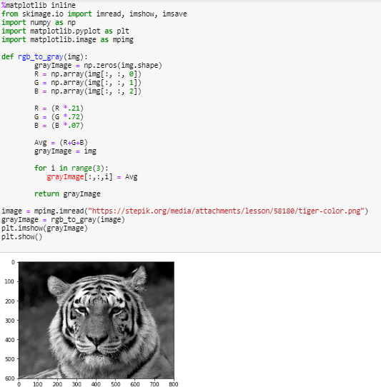

- Write a function that shifts pixel values. It should add v value ​ to every pixel in channel c​ in the image

%matplotlib inline
from skimage.io import imread, imshow, imsave
import numpy as np
import matplotlib.pyplot as plt
import matplotlib.image as mpimg

def shift_pix_val(img, channel, value):
shifted_pic = np.zeros(img.shape)
R = np.array(img[:, :, 0])
G = np.array(img[:, :, 1])
B = np.array(img[:, :, 2])

if channel == 0:
R = (R + value)
if channel == 1:
G = (G + value)
if channel == 2:
B = (B + value)

pic = (R+G+B)
shifted_pic = img

for i in range(3):
shifted_pic[:,:,i] = pic

return shifted_pic

image = mpimg.imread("https://stepik.org/media/attachments/lesson/58180/tiger-color.png")
channel = int(input("channel ="))
value = int(input("value ="))
shifted_pic = shift_pix_val(image, channel, value)
plt.imshow(shifted_pic)
plt.show()
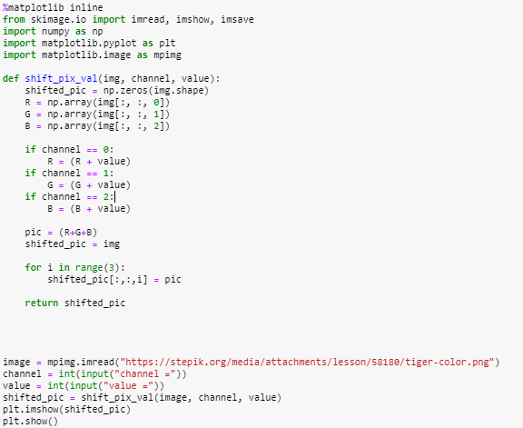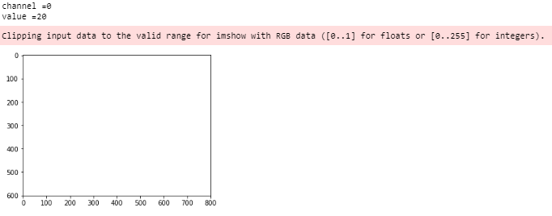

As expected out of range error appears.

- There should be a problem after adding some constant values to pixels. Solve it with sol function.

%matplotlib inline
from skimage.io import imread, imshow, imsave
import numpy as np
import matplotlib.pyplot as plt
import matplotlib.image as mpimg

def sol(img, channel, value):
shifted_pic = np.zeros(img.shape)
R = np.array(img[:, :, 0])
G = np.array(img[:, :, 1])
B = np.array(img[:, :, 2])

if channel == 0:
if R + value >= 255:
R = 255
elif channel == 0 and R + value <= 0:
R = 0
else:
R = (R + value)

if channel == 1:
if G + value >= 255:
G = 255
elif G + value <= 0:
G = 0
else:
G = (G + value)

if channel == 2:
if B + value >= 255:
B = 255
elif B + value <= 0:
B = 0
else:
B = (B + value)

pic = (R+G+B)
shifted_pic = img

for i in range(3):
shifted_pic[:,:,i] = pic

return shifted_pic

image = mpimg.imread("https://stepik.org/media/attachments/lesson/58180/tiger-color.png")
channel = int(input("channel ="))
value = int(input("value ="))
shifted_pic = sol(image, channel, value)
plt.imshow(shifted_pic)
plt.show()
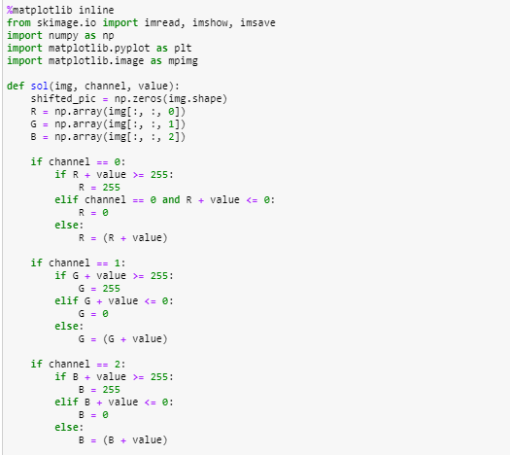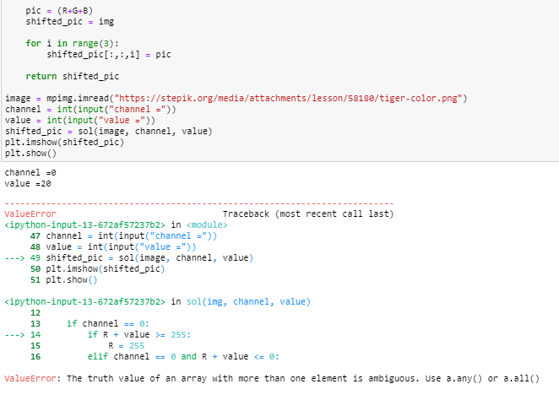

I tried to write a required solution method but unfortunately I didn’t manage to do it.

