Akdeniz University
2018-2019, Spring
CSE366 Introduction to Image Processing

Homework 3- Some Noises

Salt and Pepper Noise

import numpy as np
import random
import cv2

def sp_noise(image,prob):

output = np.zeros(image.shape,np.uint8)
thres = 1 - prob
for i in range(image.shape[0]):
for j in range(image.shape[1]):
rdn = random.random()
if rdn < prob:
output[i][j] = 0
elif rdn > thres:
output[i][j] = 255
else:
output[i][j] = image[i][j]
return output

image = cv2.imread('kermitbnw.jpg',0)
noise_img = sp_noise(image,0.05)
cv2.imwrite('sp_noise.jpg', noise_img)

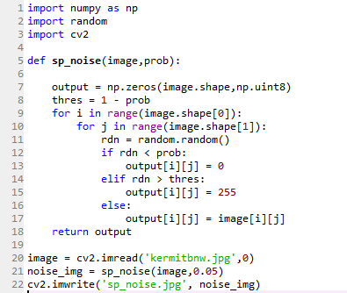

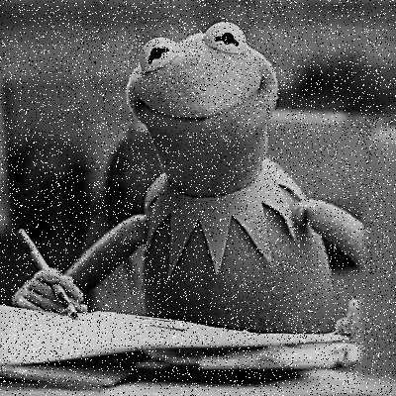

Get Rid of Salt & Pepper Noise

import cv2

im = cv2.imread('sp_noise.jpg',0)
median_blur= cv2.medianBlur(im, 3)
cv2.imshow('sp_noise.jpg', im)
cv2.imshow('median_blur', median_blur)

cv2.waitKey()
cv2.destroyAllWindows()
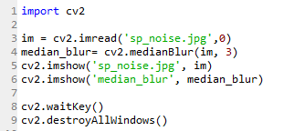
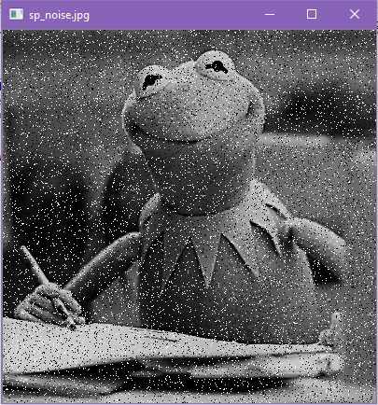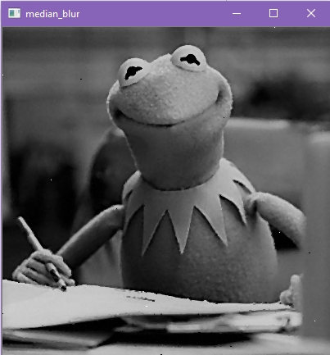

Add Gaussian Noise

import numpy as np
import os
import cv2
from skimage.io import imread, imsave, imshow

def gauss_noise(image):

row,col,ch= image.shape
mean = 0
var = 0.1
sigma = var**0.5
gauss = np.random.normal(mean,sigma,(row,col,ch))
gauss = gauss.reshape(row,col,ch)
noisy = image + gauss
return noisy

image = cv2.imread('teletubbies-joy-division-black-and-white.jpg')
noise_img = gauss_noise(image)
cv2.imwrite('gauss_n.jpg', noise_img)

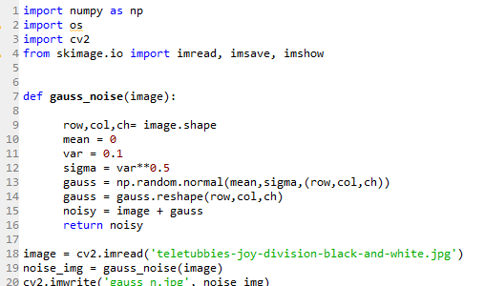
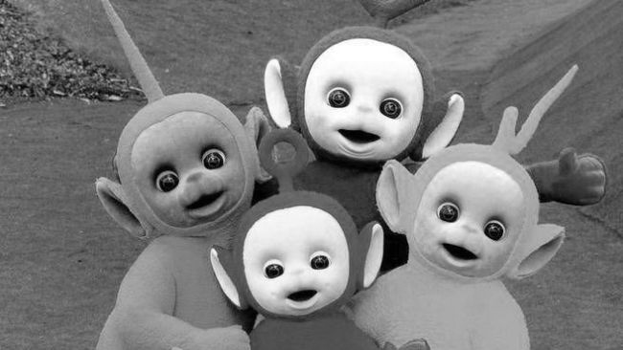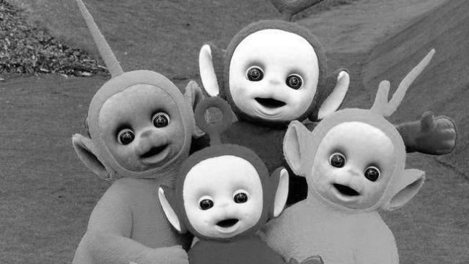

I don’t know what I did wrong these images turned out the same, and I just gave up, sorry.

Get Rid of Gaussian Noise

import numpy as np
import cv2
from matplotlib import pyplot as plt
img = cv2.imread('additivegaussiannoise_large.jpg')

dst = cv2.fastNlMeansDenoisingColored(img,None,10,10,7,21)
plt.subplot(121),plt.imshow(img)
plt.subplot(122),plt.imshow(dst)
plt.show()
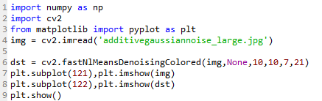
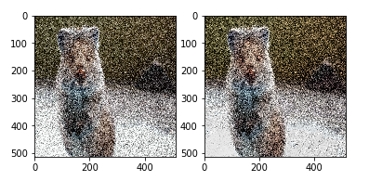

Fourier Transform, Add Periodic Noise, Remove Periodic Noise

import cv2
import numpy as np
from matplotlib import pyplot as plt

img = cv2.imread("teletubbies-joy-division-black-and-white.jpg", cv2.IMREAD_GRAYSCALE)

f = np.fft.fft2(img)
fshift = np.fft.fftshift(f)
magnitude_spectrum0 = 20*np.log(np.abs(fshift))
magnitude_spectrum0 = np.asarray(magnitude_spectrum0, dtype=np.uint8)

dft = cv2.dft(np.float32(img),flags = cv2.DFT_COMPLEX_OUTPUT)
dft_shift = np.fft.fftshift(dft)

magnitude_spectrum = 20*np.log(cv2.magnitude(dft_shift[:,:,0],dft_shift[:,:,1]))

rows, cols = img.shape
crow,ccol = rows/2 , cols/2

mask = np.zeros((rows,cols,2),np.uint8)
mask[int(crow-0):int(crow+750), int(ccol-0):int(ccol+750)] = 1

fshift = dft_shift*mask
f_ishift = np.fft.ifftshift(fshift)
img_back = cv2.idft(f_ishift)
img_back = cv2.magnitude(img_back[:,:,0],img_back[:,:,1])

mask2 = np.zeros((rows,cols,2),np.uint8)
mask2[int(crow-30):int(crow+30), int(ccol-30):int(ccol+30)] = 1

fshift2 = dft_shift*mask2
f_ishift2 = np.fft.ifftshift(fshift2)
img_back2 = cv2.idft(f_ishift2)
img_back2 = cv2.magnitude(img_back2[:,:,0],img_back2[:,:,1])

mag_spectrum = [img, img_back,magnitude_spectrum0,img_back2]
filter_name = ['input image', 'Periodic Noise', 'FFT','Remove Periodic Noise']
for i in range(4):
plt.subplot(2,3,i+1),plt.imshow(mag_spectrum[i],cmap = 'gray')
plt.title(filter_name[i]), plt.xticks([]), plt.yticks([])
plt.show()
