Hello Mr. CEO,

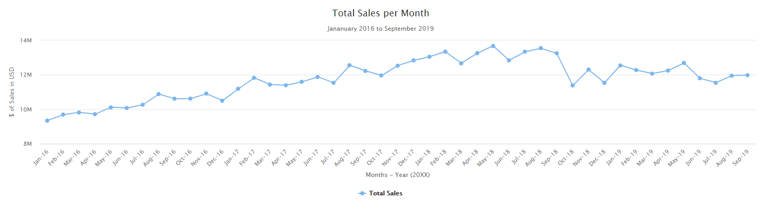I hope you are doing well with your work in Milan. I have brought to you some analysis regarding the past two years of sales data.

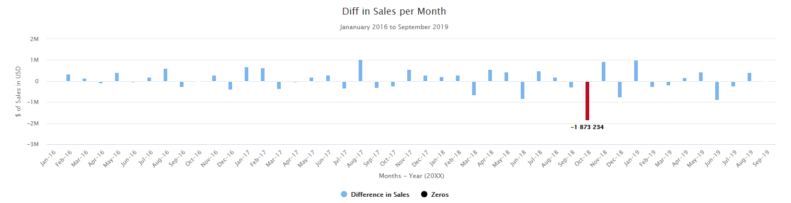Regarding your concern with Burger King’s ‘Impossible Burger,’ it did affect our sales very negatively. November of 2018 proved to have shown the largest drop in sales that we have ever experienced by a large margin. Sales in the months following months have not recovered since. Though our numbers are not decreasing, they have stagnated in comparison to our constant growth preceding the month of Burger King’s release.

As such, I propose that McDonalds also produce and market our own vegetarian burger. I believe that this will revive our numbers and bring in more customers. With the growing trend of consumers being more health conscious and interested in environmental security, I believe that this move will bring back our customers lost and bring in new customers as well.

Regarding other areas of data. Regional sales proved to show little to no real trends.

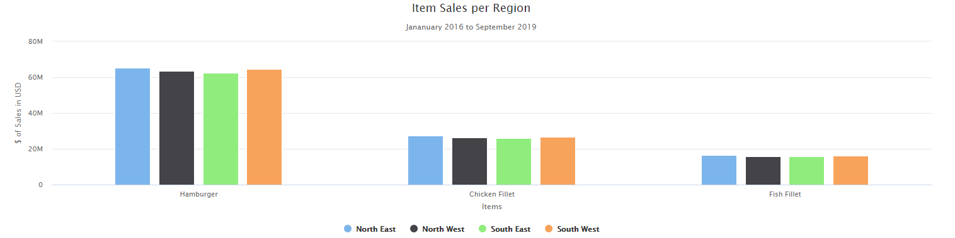

Every item within each region showed constant sales with no clear bias for any item in any region.

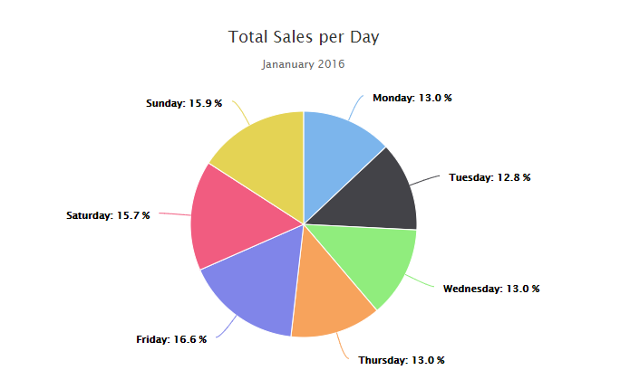In addition, looking at daily data from January of 2016.

We do see a slight increase in sales during the weekend in comparison to the weekdays, which is natural as people would be more willing to eat fast food during their days off.

Thank you for your time and consideration and all you have done for our company!