Codebook for finalgirls

Autogenerated data summary from dataMaid

2018-12-12 18:04:54

# Data report overview

The dataset examined has the following dimensions:

|  |  |
| --- | --- |
| Feature | Result |
| Number of observations | 15266 |
| Number of variables | 5 |

# Codebook summary table

|  |  |  |  |  |  |
| --- | --- | --- | --- | --- | --- |
| Label | Variable | Class | # unique values | Missing | Description |
|  | **Name** | factor | 15266 | 0.00 % |  |
|  | **Gender** | factor | 1 | 0.00 % |  |
|  | **Count15** | integer | 961 | 0.00 % |  |
|  | **Count16** | integer | 951 | 0.00 % |  |
|  | **Total** | integer | 1300 | 0.00 % |  |

# Variable list

## Name

* The variable is a key (distinct values for each observation).

## Gender

* The variable only takes one (non-missing) value: "F". The variable contains 0 % missing observations.

## Count15

|  |  |
| --- | --- |
| Feature | Result |
| Variable type | integer |
| Number of missing obs. | 0 (0 %) |
| Number of unique values | 961 |
| Median | 15 |
| 1st and 3rd quartiles | 8; 40 |
| Min. and max. | 5; 20415 |

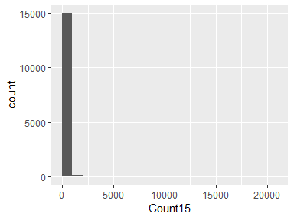

## Count16

|  |  |
| --- | --- |
| Feature | Result |
| Variable type | integer |
| Number of missing obs. | 0 (0 %) |
| Number of unique values | 951 |
| Median | 15 |
| 1st and 3rd quartiles | 8; 40 |
| Min. and max. | 5; 19414 |

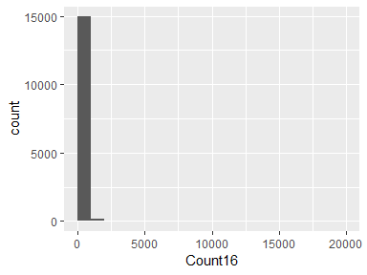

## Total

|  |  |
| --- | --- |
| Feature | Result |
| Variable type | integer |
| Number of missing obs. | 0 (0 %) |
| Number of unique values | 1300 |
| Median | 30 |
| 1st and 3rd quartiles | 17; 79 |
| Min. and max. | 10; 39829 |

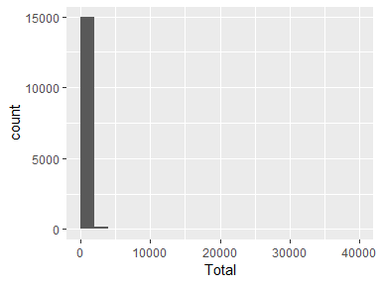

Report generation information:

* Created by aydare (username: ayoad).
* Report creation time: Wed Dec 12 2018 18:04:55
* Report was run from directory: C:/Users/ayoad/Documents
* dataMaid v1.2.0 [Pkg: 2018-10-03 from CRAN (R 3.4.4)]
* R version 3.4.3 (2017-11-30).
* Platform: x86_64-w64-mingw32/x64 (64-bit)(Windows >= 8 x64 (build 9200)).
* Function call: makeDataReport(data = finalgirls, mode = c("summarize", "visualize", "check"), smartNum = FALSE, file = "codebook_finalgirls.Rmd", checks = list(character = "showAllFactorLevels", factor = "showAllFactorLevels", labelled = "showAllFactorLevels", haven_labelled = "showAllFactorLevels", numeric = NULL, integer = NULL, logical = NULL, Date = NULL), listChecks = FALSE, maxProbVals = Inf, codebook = TRUE, reportTitle = "Codebook for finalgirls")