API Reference
REST API Documentation

Audience: Frontend developers, integration engineers, and API consumers

NGX Trading Bot

Overview
The NGX Trading Bot exposes a REST API on port 8080 for dashboard consumption, backtest management, and system control. All responses are JSON. No authentication is currently required (designed for local/private network access).
Base URL: http://localhost:8080

Endpoint Map
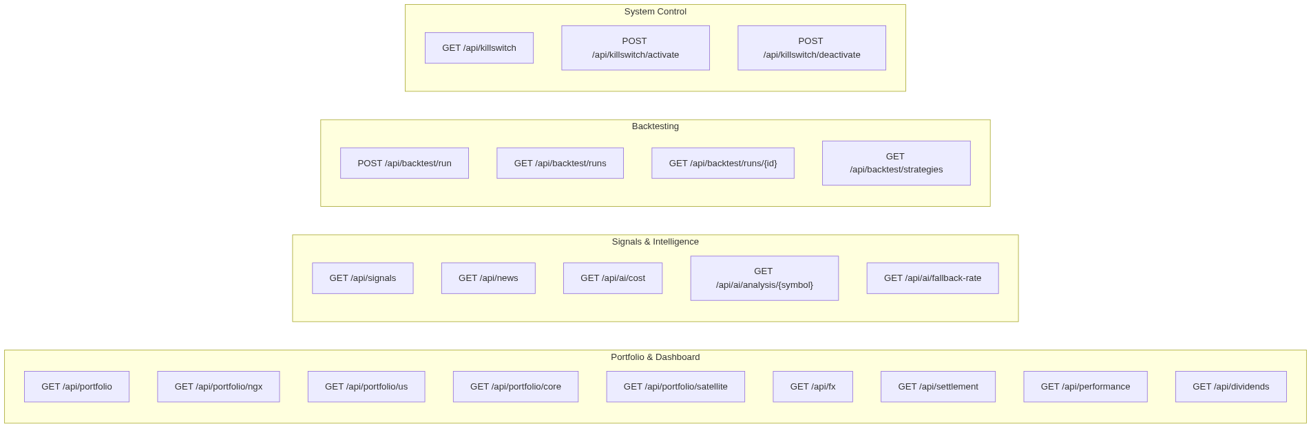
Figure 1: Endpoint Map

Portfolio & Dashboard

GET /api/portfolio
Returns consolidated portfolio overview across both markets.
Response:
json
{
"totalValueNgn": 5250000.00,
"ngxValue": 3750000.00,
"usValueUsd": 1200.00,
"fxRate": 1250.00,
"openPositions": 7,
"byMarket": { "NGX": 3750000.00, "US": 1200.00 },
"byPool": { "CORE": 4000000.00, "SATELLITE": 1250000.00 },
"killSwitchActive": false
}

GET /api/portfolio/ngx
Returns NGX-only portfolio with positions and available cash.
Response:
json
{
"market": "NGX",
"currency": "NGN",
"totalValue": 3750000.00,
"positions": [...],
"positionCount": 5,
"availableCash": 850000.00
}

GET /api/portfolio/us
Returns US-only portfolio.
Response:
json
{
"market": "US",
"currency": "USD",
"totalValue": 1200.00,
"positions": [...],
"availableCash": 150.00
}

GET /api/portfolio/core
Returns all open CORE pool positions.
Response:
json
[Position objects]

GET /api/portfolio/satellite
Returns all open SATELLITE pool positions.
Response:
json
[Position objects]

GET /api/fx
Returns FX rate information (broker vs. market).
Response:
json
{
"brokerRate": 1250.00,
"marketRate": 1245.00,
"spreadPct": 0.40
}

GET /api/settlement
Returns settlement cash ledger for both markets.
Response:
json
{
"ngx": { "availableCash": 850000.00, "settlingCash": 120000.00 },
"us": { "availableCash": 150.00, "settlingCash": 0.00 }
}

GET /api/performance
Returns portfolio performance metrics.
Response:
json
{
"snapshotDate": "2026-02-23",
"totalValue": 5250000.00,
"dailyPnl": 65000.00,
"dailyPnlPct": 1.25,
"unrealizedPnlByMarket": { "NGX": 45000, "US": 20000 },
"openPositionCount": 7
}

GET /api/dividends
Returns all tracked dividend events.
Response:
json
[DividendEvent objects]

Signals & Intelligence

GET /api/signals
Returns today's trade signals. Optional filter: ?market=NGX or ?market=US
json
[
{
"symbol": "ZENITHBANK.XNSA",
"side": "BUY",
"strategy": "MomentumBreakout",
"confidenceScore": 78.5,
"entryPrice": 48.00,
"stopLoss": 45.00,
"targetPrice": 54.00
}
]

GET /api/news
Returns news items from the last 7 days.

GET /api/ai/cost
Returns AI usage cost tracking.
json
{
"date": "2026-02-23",
"dailyCostUsd": 1.25,
"monthlyCostUsd": 42.50,
"budgetExceeded": false
}

GET /api/ai/analysis/{symbol}
Returns AI analysis records for a stock from the last 30 days.

Backtesting

POST /api/backtest/run
Triggers async backtest. Returns 202 Accepted.
Request body:
json
{
"strategyName": "MomentumBreakout",
"market": "NGX",
"startDate": "2025-02-01",
"endDate": "2026-02-01",
"initialCapital": 5000000.00
}

GET /api/backtest/runs
Returns all backtest runs. Optional filters: ?strategy=X&market=NGX

GET /api/backtest/runs/{id}
Returns a single backtest run by ID. 404 if not found.

GET /api/backtest/runs/{id}/trades
Returns simulated trades within a backtest run.

GET /api/backtest/runs/{id}/equity-curve
Returns equity curve data points for a backtest run.

GET /api/backtest/strategies
Returns all registered strategies with name, market, pool, and enabled status.

System Control

GET /api/killswitch
Returns kill switch status.
json
{
"active": false,
"reason": null,
"activatedAt": null
}

POST /api/killswitch/activate
Activates kill switch. Sends urgent WhatsApp + Telegram notification.
json
Request: { "reason": "Manual halt" }
Response: { "status": "activated", "reason": "Manual halt" }

POST /api/killswitch/deactivate
Deactivates kill switch, allowing trading to resume.

POST /api/reconcile
Triggers manual reconciliation of positions and cash vs. broker.
json
{
"portfolioMatch": true,
"ngxCashMatch": true,
"usCashMatch": true,
"allClear": true
}

Webhooks

POST /api/webhooks/whatsapp/message
Receives incoming WhatsApp messages from WAHA for trade approvals (YES/NO).
Always returns 200 OK. Non-approval messages are ignored.

Health & Monitoring
Endpoint | Description
GET /actuator/health | Application health (returns "UP")
GET /actuator/info | Application info
GET /actuator/metrics | Spring Boot metrics
GET /actuator/flyway | Flyway migration status

Request Flow
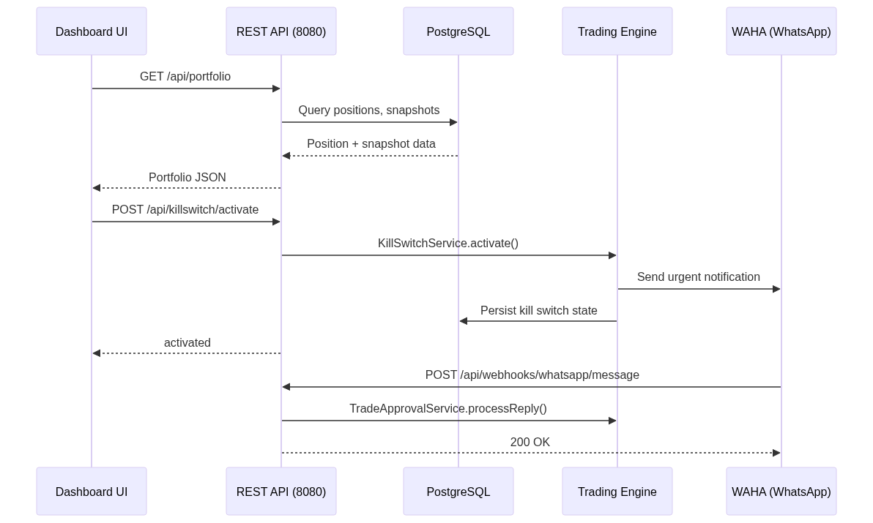
Figure 2: API Request Flow

