Business Overview
Executive Summary & Market Position

Audience: Business stakeholders, management, and non-technical decision makers

NGX Trading Bot

Executive Summary
The NGX Trading Bot is an autonomous software system that trades stocks on the Nigerian Stock Exchange (NGX) and US equity markets through the Trove/Meritrade brokerage platform. It eliminates the need for manual broker interaction by using browser automation technology to log in, place orders, and manage a portfolio — just as a human trader would, but faster, more disciplined, and available during every second of market hours.

Problem Statement
Nigerian brokers provide no trading APIs. Unlike developed markets where algorithmic trading is standard, the NGX ecosystem requires traders to manually log into web portals, navigate dashboards, and click through multi-step order forms.
Challenge | Impact
Speed | Manual order entry takes minutes. In a 4.5-hour window (10:00-14:30 WAT), delays cost money.
Discipline | Human traders deviate from strategy under pressure — chasing losses, holding too long.
Coverage | A single person cannot monitor 50+ stocks, 6 news sources, and execute orders simultaneously.
Errors | Manual data entry leads to wrong quantities, wrong prices, and missed opportunities.

The Solution
The NGX Trading Bot acts as an autonomous digital trader that sees, thinks, decides, acts, and reports:
Figure 1: Solution Flow — Sees, Thinks, Decides, Acts, Reports

Key Capabilities

Autonomous Broker Interaction
- Logs into Trove/Meritrade without human intervention
- Handles OTP verification automatically via Gmail or WhatsApp
- Reads portfolio holdings and cash balances from broker dashboard
- Places LIMIT orders only (never market orders, for price protection)

10 Trading Strategies
Strategy | Focus
Momentum Breakout | Volume spikes + price breakouts on NGX
ETF NAV Arbitrage | Buy ETFs trading below net asset value
Dollar-Cost Averaging | Monthly systematic buying
Dividend Accumulation | High-yield NGX and US stocks
Value Accumulation | Fundamentally undervalued NGX stocks
Sector Rotation | Rotate into strongest NGX sectors
Pension Flow Overlay | Follow pension fund capital flows
US Earnings Momentum | Trade post-earnings moves on US stocks
US ETF Rotation | Monthly sector ETF rotation (US)
Currency Hedge | Gold/USD positions during Naira weakness

Risk Management
Every trade must pass ALL of these checks — no exceptions:
Rule | Limit | Purpose
Max risk per trade | 2% of portfolio | No single trade can cause large losses
Max single position | 15% (20% for core) | Prevents overconcentration
Max sector exposure | 40% of portfolio | Diversification across sectors
Min cash reserve | 20% of portfolio | Always maintain liquidity
Max open positions | 10 | Manageable position count
Min avg daily volume | 10,000 shares | Ensures stock is liquid
Max volume participation | 10% of daily volume | Avoids market impact

Safety Layers
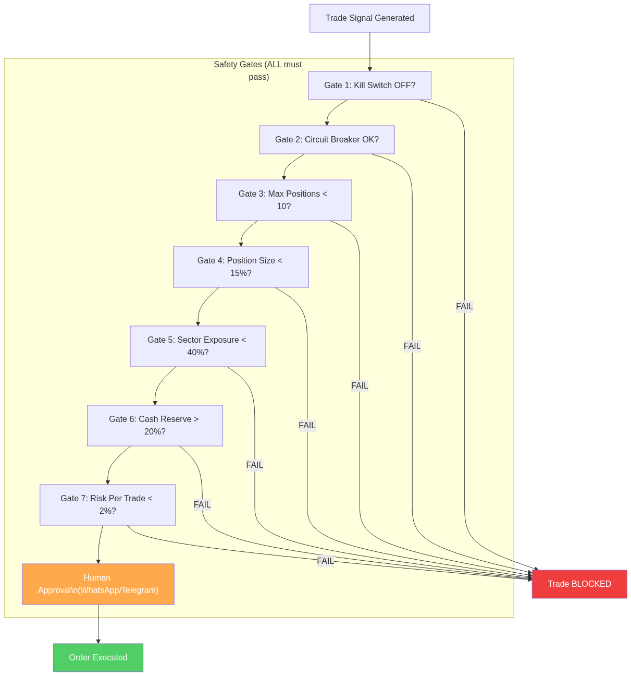
Figure 2: 7-Gate Safety System

Circuit Breakers: 5% daily loss halts trading for the day. 10% weekly loss halts until Monday.
Kill Switch: Instant manual override to halt all trading with one command. Sends urgent notification.

Market Coverage

NGX (Nigerian Stock Exchange)
Large caps: Zenith Bank, GTCO, Access Corp, UBA, Dangote Cement, Seplat, MTNN. ETFs: Stanbic ETF30, VetGrif30, MerGrowth, MerValue, SiamletETF40, NewGold. Market hours: 10:00-14:30 WAT. Settlement: T+2. Daily price limit: +/-10%.

US Equities (via Trove)
ETFs: VOO, SCHD, BND, GLD, VXUS, VNQ. Individual US stocks for earnings momentum. Settlement: T+1.

Competitive Advantages
- First-mover in NGX automation: No known competitors offer autonomous trading for the Nigerian market.
- No API dependency: Browser automation works regardless of broker API availability.
- AI-enhanced analysis: Claude AI for sophisticated news and earnings analysis.
- Settlement-aware cash management: Tracks settled vs. unsettled cash (T+2 NGX, T+1 US).
- Dual-market support: Trades both NGX and US equities through a single platform.
- News intelligence: Scrapes 6 sources and classifies events by market impact.

Current Status
Phase | Status | Details
Phase 1: Infrastructure | Complete | Autonomous login, OTP, 10 strategies, risk engine, notifications, AI, news, backtesting, 30 migrations, 181+ tests
Phase 2: Live Trading | Next | Live order execution, portfolio sync, P&L tracking, account verification
Phase 3: Scale | Future | Multi-broker support, mobile dashboard, walk-forward optimization

