Deployment Guide
Production Deployment & Operations

Audience: DevOps engineers and system administrators

NGX Trading Bot

Architecture Overview
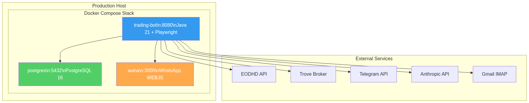
Figure 1: Production Architecture

Prerequisites
Requirement | Minimum | Recommended
OS | Ubuntu 22.04 / Debian 12 | Ubuntu 24.04 LTS
Docker | 24.0+ | Latest stable
Docker Compose | v2.20+ | Latest stable
RAM | 4 GB | 8 GB
Disk | 20 GB | 50 GB
CPU | 2 cores | 4 cores

Required Outbound Access
Service | Domain | Port
EODHD | eodhd.com | 443
Trove Broker | app.trovefinance.com | 443
Telegram API | api.telegram.org | 443
Anthropic API | api.anthropic.com | 443
Gmail IMAP | imap.gmail.com | 993
WhatsApp Web | web.whatsapp.com | 443

Environment Configuration
Create a .env file in the project root. Never commit this file to version control.
bash
# Database
DB_USERNAME=trader
DB_PASSWORD=<strong-password>
# Market Data
EODHD_API_KEY=<your-key>
# Broker
MERITRADE_USERNAME=<your-email>
MERITRADE_PASSWORD=<your-password>
# WhatsApp
WHATSAPP_CHAT_ID=<phone>@c.us
WAHA_API_KEY=<your-key>
# Telegram
TELEGRAM_BOT_TOKEN=<your-token>
TELEGRAM_CHAT_ID=<your-chat-id>
# AI (Optional)
AI_ENABLED=true
AI_API_KEY=<your-anthropic-key>

Deployment Steps

Step 1: Clone and Configure
bash
git clone <repository-url> trading-bot
cd trading-bot
cp .env.example .env
nano .env

Step 2: Build and Start
bash
docker compose up -d --build
docker compose ps

Step 3: Configure WhatsApp (WAHA)
1. Open http://<host>:3000 in a browser
2. Scan the QR code with WhatsApp mobile (Settings > Linked Devices)
3. Wait for session to establish (status: WORKING)

Step 4: Verify Health
bash
curl http://localhost:8080/actuator/health
# Expected: {"status":"UP"}

Startup Sequence
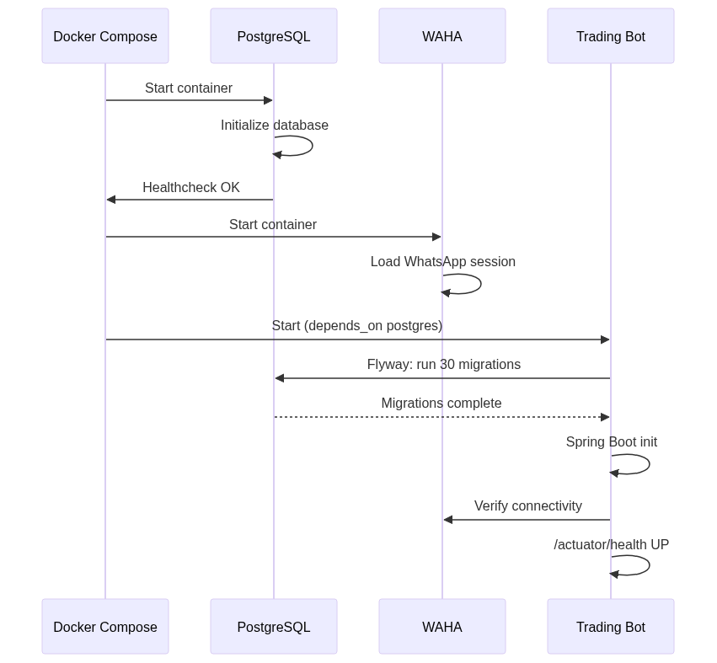
Figure 2: Startup Sequence

Docker Compose Services

trading-bot
Setting | Value
Base image | mcr.microsoft.com/playwright/java:v1.41.0-jammy
JDK | Eclipse Temurin 21
Port | 8080
Spring Profile | prod
JVM flags | G1GC, heap dump on OOM
User | trader (non-root)
Health check | curl /actuator/health every 30s

postgres
Setting | Value
Image | postgres:16-alpine
Database | ngx_trading
Health check | pg_isready every 10s
Volume | postgres_data

waha
Setting | Value
Image | devlikeapro/waha:latest
Engine | WEBJS
Port | 3000
Volume | waha_data (sessions)

Production Configuration
The prod profile (application-prod.yml) applies these overrides:
Setting | Dev | Prod | Reason
meritrade.headless | true | true | No GUI in production
meritrade.slow-mo-ms | 500 | 300 | Faster automation
screenshot-retention-hours | 72 | 48 | Less disk usage
hikari.maximum-pool-size | 10 | 15 | Handle concurrent load
server.shutdown | (default) | graceful | Clean shutdown
logging.file.name | (console) | /app/logs/trading-bot.log | File logging
log max-file-size | (default) | 50MB | Prevents log bloat
log max-history | (default) | 30 | 30-day retention

Monitoring

Health Checks
bash
curl -s http://localhost:8080/actuator/health | jq .
curl -s http://localhost:8080/actuator/flyway | jq .

Key Log Patterns
Pattern | Meaning | Severity
KillSwitch ACTIVATED | Trading halted | CRITICAL
Circuit breaker tripped | Loss limit hit | HIGH
Order status: UNCERTAIN | Execution failed | HIGH
OTP timeout | OTP not received | MEDIUM
Budget exceeded | AI spending limit | LOW
Scraper failed | News source unreachable | LOW

Dashboard Queries
bash
# Portfolio value
curl -s http://localhost:8080/api/portfolio | jq '.totalValueNgn'
# Kill switch status
curl -s http://localhost:8080/api/killswitch | jq '.'
# AI budget
curl -s http://localhost:8080/api/ai/cost | jq '.'

Backup & Recovery

Database Backup
bash
# Manual backup
docker exec ngx-postgres pg_dump -U trader -d ngx_trading > backup.sql
# Compressed backup
docker exec ngx-postgres pg_dump -U trader -d ngx_trading | gzip > backup.sql.gz

Automated Daily Backup (Cron)
bash
# Add to crontab
0 3 * * * docker exec ngx-postgres pg_dump -U trader -d ngx_trading | gzip > /backups/ngx_$(date +%Y%m%d).sql.gz
0 4 * * * find /backups -name '*.sql.gz' -mtime +30 -delete

Restore
bash
docker compose stop trading-bot
cat backup.sql | docker exec -i ngx-postgres psql -U trader -d ngx_trading
docker compose start trading-bot

Maintenance

Updating the Application
bash
git pull origin main
docker compose up -d --build trading-bot
curl -s http://localhost:8080/actuator/health | jq '.status'
Flyway migrations run automatically on startup. New migrations apply when the updated container starts.

Troubleshooting

Bot Won't Start
Check: docker logs ngx-trading-bot
Common causes: PostgreSQL not ready, missing .env vars, Flyway migration failure, port 8080 in use.

WhatsApp Not Working
Check: curl http://localhost:3000/api/sessions
Fix: Restart WAHA and re-scan QR code.

OTP Failures
Check: docker logs ngx-trading-bot | grep -i otp
Common: Gmail App Password expired, WAHA session disconnected.

Database Connection
Check: docker exec ngx-postgres pg_isready -U trader -d ngx_trading

Emergency Kill Switch
bash
# Activate immediately
curl -X POST http://localhost:8080/api/killswitch/activate \
-H "Content-Type: application/json" \
-d '{"reason": "Emergency manual halt"}'
# Verify
curl -s http://localhost:8080/api/killswitch | jq .
# Deactivate when ready
curl -X POST http://localhost:8080/api/killswitch/deactivate

Security Checklist
- .env file has restricted permissions (chmod 600 .env)
- .env is in .gitignore (never committed)
- PostgreSQL password is strong and unique
- WAHA API key is set (not default)
- Bot runs as non-root user (trader) inside container
- Ports 5432 and 3000 NOT exposed to public internet
- Port 8080 restricted to trusted networks or behind reverse proxy
- Gmail uses App Password (not main password)
- Telegram bot token not shared publicly
- Regular database backups configured and tested

