Developer Guide
Technical Architecture & Setup

Audience: Software engineers onboarding or contributing

NGX Trading Bot

Architecture Overview
The NGX Trading Bot is a Spring Boot 3.3 application (Java 17) that autonomously trades stocks on the Nigerian Stock Exchange (NGX) and US equity markets through the Trove/Meritrade brokerage platform. It uses Playwright-Java for browser automation, WAHA for WhatsApp notifications, and PostgreSQL 16 for persistence.
Component | Technology | Purpose
Runtime | Java 17, Spring Boot 3.3.6 | Application framework
Database | PostgreSQL 16 + Flyway | Persistence + schema migrations
Browser Automation | Playwright-Java 1.49.0 | Meritrade broker interaction
WhatsApp | WAHA (Docker) | Primary notification channel
Telegram | Bot API | Fallback notification channel
Market Data | EODHD API | OHLCV bars + fundamentals
AI Analysis | Claude API (Anthropic) | News sentiment + earnings analysis
Web Scraping | Jsoup | News from 6 sources
Build | Maven | Dependency management + build

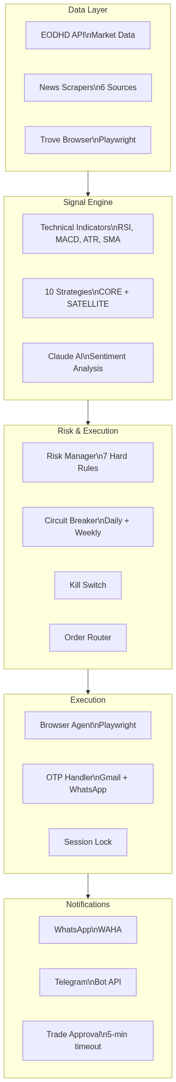
Figure 1: System Architecture

Module Breakdown
Module | Responsibility
common | Shared models (TradeSide, SignalStrength, TradeSignal), exceptions (KillSwitchActiveException), base entities
data | EODHD API client, OHLCV bar entity/repository, market data fetching
signal | RSI, MACD, ATR, SMA/EMA calculators, CompositeSignalScorer, TradeSignal generation
strategy | 10 trading strategies, Strategy interface, StrategyPool (CORE/SATELLITE), StrategyMarket (NGX/US/BOTH)
risk | RiskManager (5 checks), CircuitBreaker (daily/weekly), SettlementCashTracker (T+2 NGX, T+1 US), Position/PortfolioSnapshot entities
execution | OrderRouter, TroveBrowserAgent (Playwright), BrokerGateway, OtpHandler + EmailOtpReader, KillSwitchService, BrowserSessionLock, OrderRecoveryService
notification | NotificationRouter (WhatsApp + Telegram), MessageFormatter, TradeApprovalService, WhatsAppWebhookController
news | 6 scrapers (BusinessDay, Nairametrics, SeekingAlpha, Reuters, CBN, NGX), NewsEventClassifier, EventImpactRules
ai | Claude API client, AiCostTracker, budget enforcement ($5/day, $100/month), deep analysis triggers
discovery | Stock screener (EODHD), watchlist management, observation pipeline, promotion/demotion policies
longterm | DCA scheduling, dividend tracking + reinvestment, portfolio rebalancing (quarterly, 10% drift)
backtest | BacktestRunner, SimulatedOrderExecutor, PerformanceAnalyzer (Sharpe, drawdown, win rate)
dashboard | REST API controllers (29 endpoints), PortfolioReconciler, CashReconciler, FxRateReconciler
config | PlaywrightConfig, *Properties classes, YAML-driven configuration
scheduling | Cron jobs for market hours, settlement processing, screenshot cleanup

Deployment Architecture
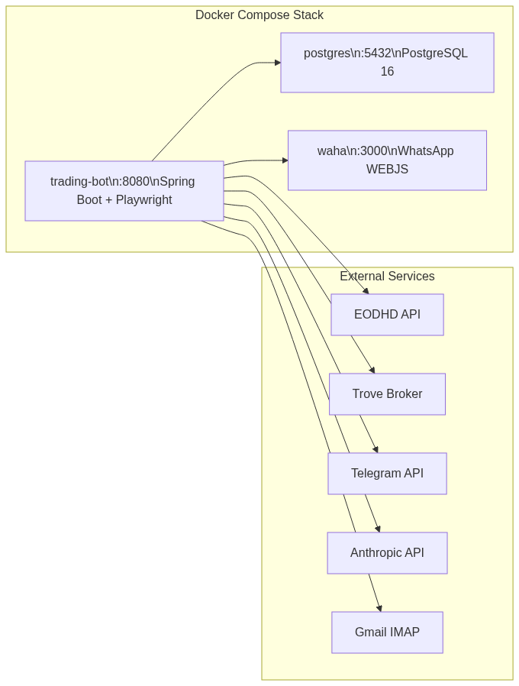
Figure 2: Deployment Architecture

Trade Execution Sequence
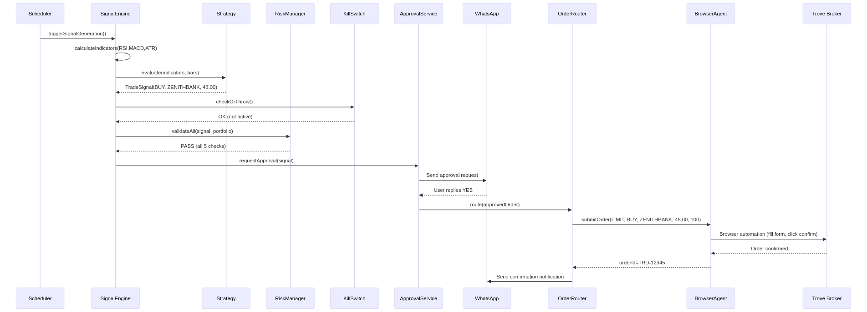
Figure 3: Trade Execution Sequence

Database
30 Flyway migrations in src/main/resources/db/migration/ (V1 through V30):
Migration | Table(s) Created
V1 | ohlcv_bars
V2 | etf_valuations
V3 | trade_orders
V4 | positions
V5 | portfolio_snapshots
V6 | corporate_actions
V7 | market_indices
V8 | watchlist_stocks
V9 | trade_signals
V10 | notification_log
V11 | kill_switch_state
V12 | approval_requests
V13 | news_items
V14 | broker_sessions
V15 | risk_events
V16 | circuit_breaker_log
V17 | sector_mapping
V18 | system_config
V19 | updated_at triggers
V20 | Seed watchlist stocks
V21 | ai_analysis, ai_cost_ledger
V22 | News event columns
V23 | discovered_stocks
V24 | discovery_events
V25 | core_holdings
V26 | dca_plans
V27 | dividend_events
V28 | rebalance_actions
V29 | Pool/market/currency on positions
V30 | backtest_runs, backtest_trades, equity_curve_points

Entity Relationship Diagram
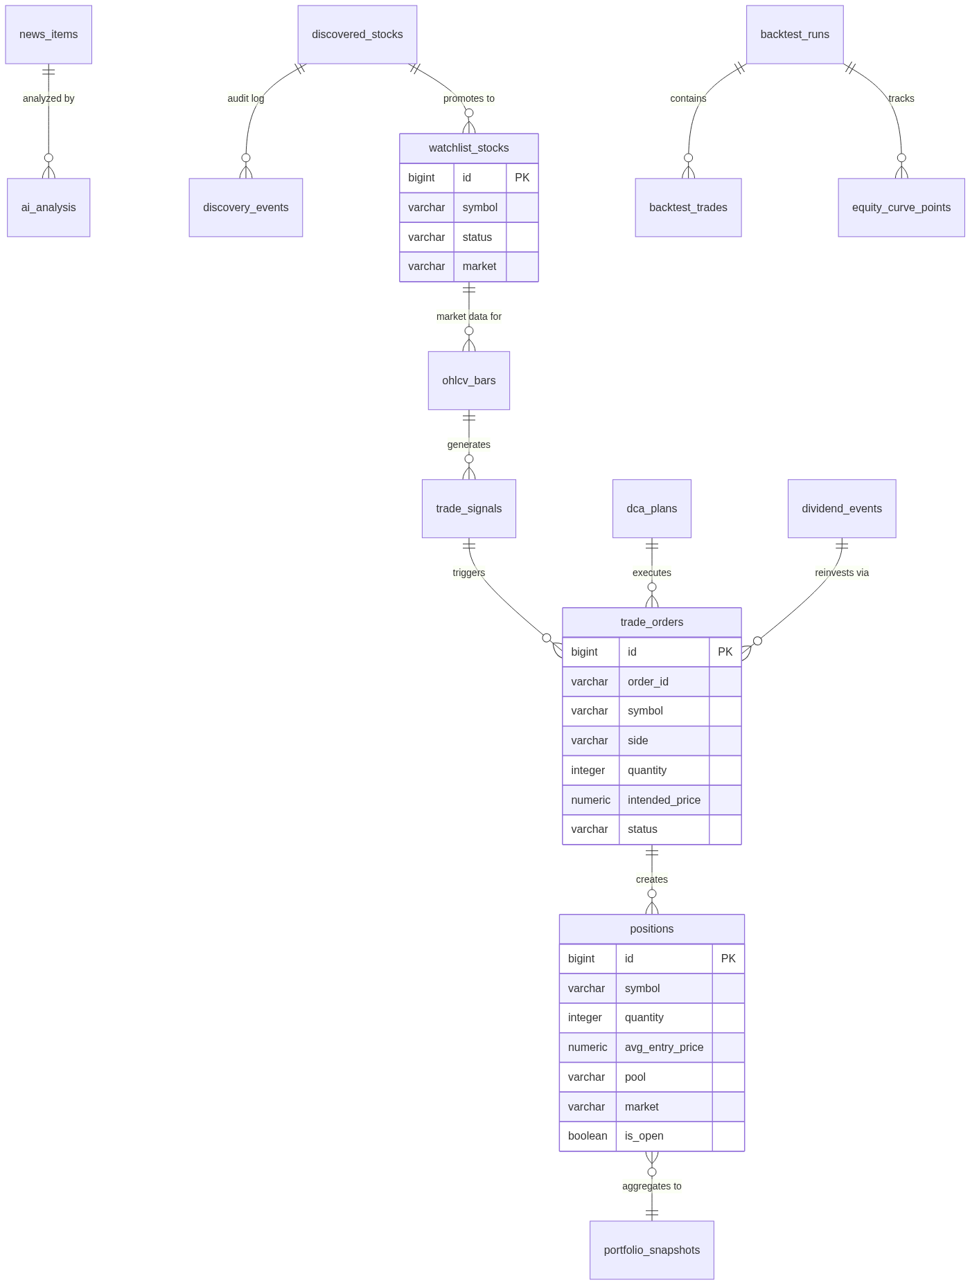
Figure 4: Entity Relationship Diagram

Local Development Setup

Prerequisites
Requirement | Version
Java | 17+ (Temurin recommended)
Maven | 3.9+
PostgreSQL | 16 (via Docker)
Docker + Docker Compose | v2.20+
Node.js | Not required (no frontend)

Setup Steps
1. Clone the repository and configure environment variables:
bash
cp .env.example .env
# Edit .env with your API keys and credentials
2. Start infrastructure services:
bash
docker compose up -d postgres waha
3. Scan WhatsApp QR code at http://localhost:3000
4. Build and run:
bash
mvn clean compile
mvn spring-boot:run

Configuration Guide
All configuration lives in application.yml with profile overrides:
Profile | File | Use
(default) | application.yml | Local development
prod | application-prod.yml | Docker production deployment
integration | application-integration.yml | Integration test environment

Key Configuration Sections
Section | Controls
trading | Market hours, timezone, watchlist symbols
risk | All 7 risk thresholds (percentages stored as decimals)
meritrade | Broker URL, credentials, CSS selectors for Playwright
otp | Gmail IMAP settings for OTP reading
notification | WhatsApp (WAHA) + Telegram config
ai | Claude API, model selection, budget limits ($5/day, $100/month)
discovery | Screener thresholds, watchlist sizing
longterm | DCA budgets, dividend reinvestment, rebalance rules
strategies | Per-strategy enable/disable + parameters

Coding Conventions
Rule | Convention
Monetary values | BigDecimal — never double or float
Trade dates | LocalDate
Timestamps | ZonedDateTime with ZoneId.of("Africa/Lagos")
Dependency injection | Constructor injection only (no field @Autowired)
Scheduled tasks | zone = "Africa/Lagos" on all @Scheduled
Orders | LIMIT only — never market orders
Percentages | Stored as decimals in config (2.0 = 2%)
Boilerplate | Lombok (@RequiredArgsConstructor, @Slf4j, @Builder, @Data)

Common Commands
Command | Purpose
mvn clean compile | Build the project
mvn test | Run unit tests only
mvn verify -Pintegration | Run integration tests
mvn spring-boot:run | Run locally
docker compose up -d | Full stack (bot + postgres + waha)
docker compose up -d postgres waha | Infrastructure only
docker compose logs -f trading-bot | Follow bot logs

