NGX Trading Bot
Investor Pitch

Audience: Investors, accelerators, and pitch competitions

NGX Trading Bot

The Problem
Nigeria's stock market (NGX) has a market capitalization of over $50 billion and is one of Africa's largest exchanges. Yet retail investors face a frustrating reality:
- Zero API access — Nigerian brokers offer no programmatic trading APIs. Every order must be placed manually.
- 4.5-hour trading window — The NGX is open 10:00-14:30 WAT. Miss a signal, miss the opportunity.
- Manual, error-prone execution — 10+ manual steps per trade: login, navigate, enter details, handle OTP.
- No automation tools exist — While developed markets have dozens of algo platforms, Nigeria has none.
- Growing retail participation — NGX retail accounts are growing, but tools remain primitive.

The Solution

Manual Trading vs. NGX Trading Bot
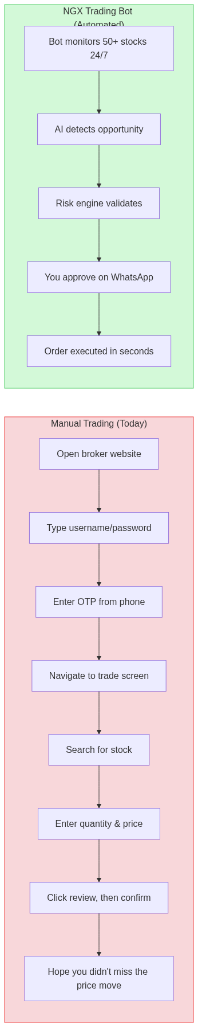
Before vs. After: Manual Trading vs. NGX Trading Bot
An AI-powered autonomous trading bot that sees, thinks, and acts like a human trader — but faster, more disciplined, and never misses market hours.

How It Works
Stage | Components | Purpose
1. DATA | EODHD Market Data, 6 News Sources, Broker Portfolio | Collect real-time information
2. ANALYSIS | RSI, MACD, ATR + AI Sentiment + Fundamental Screens | Generate insights from data
3. DECISION | 10 Strategies + Signal Scoring + Risk Validation | Determine optimal trade actions
4. EXECUTION | Browser Automation (Playwright) + Auto-Login + Auto-OTP | Execute LIMIT orders
5. ALERT | WhatsApp + Telegram + Human Approval for Big Trades | Keep you informed and in control

Market Opportunity
- NGX market cap: ~$50B+ with growing daily trading volumes
- Retail growth: Increasing year-over-year, driven by fintech awareness
- Automation gap: Zero existing solutions for automated NGX trading
- Dual-market access: Trove enables both NGX and US equities from one platform
- Emerging market alpha: Less efficient markets offer greater systematic opportunities
- Regulatory tailwind: NGX actively modernizing infrastructure

Technology Moat

1. Browser Automation Bypasses API Absence
Where others see a blocker (no APIs), we see a solved problem. Playwright-based automation mimics human interaction, working with any broker UI regardless of API availability.

2. Zero-Touch OTP Handling
Our bot reads OTP codes from Gmail (IMAP) and WhatsApp (WAHA), entering them automatically. No human needs to be present to verify login.

3. AI-Enhanced Signal Analysis
Claude AI analyzes news from 6 sources, interprets earnings reports, and detects insider trading patterns. Automatic escalation to deeper analysis for high-impact events.

4. Settlement-Aware Cash Management
Independently tracks settled vs. unsettled cash across both markets (T+2 NGX, T+1 US), preventing the bot from spending money that hasn't settled.

5. Configurable Without Code Changes
Every strategy, risk parameter, and UI selector is configurable via YAML. Broker UI changes = config file update, not code deployment.

Traction
Working prototype with proven infrastructure:
- Autonomous login + OTP handling (Gmail + WhatsApp)
- 10 trading strategies implemented and tested
- 7-rule risk management engine with circuit breakers
- Real-time WhatsApp and Telegram notifications
- AI analysis integration with budget controls
- News intelligence from 6 sources
- Backtesting engine with historical data
- Dashboard REST API (29 endpoints)
- 181+ unit tests passing
- 11 integration test steps validating the full pipeline
- 30 database migrations for a production-ready schema
- Dual-market support: NGX and US equities

Revenue Model
Model | Description | Target
SaaS Subscription | Monthly/annual access to the trading bot platform | Retail investors, HNWIs
Performance Fees | Percentage of profits above a benchmark | Managed account clients
White-Label | Licensed to Nigerian brokerages as a value-add | Meristem, Stanbic IBTC, CSCS participants
Data & Analytics | NGX market intelligence, sentiment, signal feeds | Institutional investors, asset managers

Team
[Placeholder — Add team member bios, relevant experience, and LinkedIn profiles]

The Ask
[Placeholder — Customize based on your fundraising stage and needs]
Potential use of funds:
- Complete live trading integration and deploy to production
- Onboard first 100 beta users with managed accounts
- Build mobile dashboard for portfolio monitoring
- Expand to additional Nigerian brokerages
- Hire quantitative analyst and full-stack engineer

Contact
[Placeholder — Add your email, phone, website, and GitHub repository link]

