Product Specification
Feature Inventory & Roadmap

Audience: Product managers, designers, and project planners

NGX Trading Bot

Product Vision
A fully autonomous trading system for emerging market equities, starting with the Nigerian Stock Exchange (NGX) and expanding to US equities via Trove's dual-market platform. The system replaces manual broker interaction with intelligent automation — analyzing data, generating signals, managing risk, executing trades, and reporting results with zero human intervention during normal operation.

Feature Inventory

Core Trading Engine
Feature | Status | Description
Signal generation pipeline | Done | Technical + fundamental indicators scored into signals
Technical indicators | Done | RSI, MACD, ATR, SMA/EMA, volume analysis
Fundamental signals | Done | NAV discount, dividend proximity, PenCom eligibility
Composite signal scoring | Done | Weighted multi-indicator scoring
Strategy evaluation | Done | 10 strategies with CORE/SATELLITE pool classification
Strategy enable/disable | Done | Per-strategy YAML toggle
Market hours enforcement | Done | Hard-coded 10:00-14:30 WAT check
Order routing | Done | Signal -> risk check -> approval -> execution pipeline

Trading Strategies
Strategy | Status | Market | Pool
Momentum Breakout | Done | NGX | SATELLITE
ETF NAV Arbitrage | Done | NGX | SATELLITE
Dollar-Cost Averaging | Done | BOTH | CORE
Dividend Accumulation | Done | BOTH | CORE
Value Accumulation | Done | NGX | CORE
Sector Rotation | Done | NGX | SATELLITE
Pension Flow Overlay | Done | NGX | SATELLITE
US Earnings Momentum | Done | US | SATELLITE
US ETF Rotation | Done | US | SATELLITE
Currency Hedge | Done | BOTH | CORE

Broker Integration
Feature | Status | Description
Playwright browser automation | Done | Chromium-based browser control
Trove login automation | Done | Navigate to login, fill credentials, submit
OTP via WhatsApp | Done | Bot requests OTP, user replies via WhatsApp
OTP via Gmail IMAP | Done | Auto-reads OTP from Trove emails
Portfolio scraping | Done | Reads holdings and quantities from broker
Cash balance reading | Done | Reads available cash from broker
FX rate reading | Done | Reads USD/NGN rate from broker
Screenshot capture | Done | Saves browser state at key moments
Order submission | In Progress | submitOrder() implemented, pending live wiring
Order status checking | Done | Reads order status from broker
Browser session management | Done | Session lock, max hours, auto-relogin
CSS selector configuration | Done | All UI selectors configurable via YAML

Risk Management
Feature | Status | Description
Risk per trade (2%) | Done | Validates max portfolio risk per trade
Single position (15%/20%) | Done | Pool-aware: 15% satellite, 20% core
Sector exposure (40%) | Done | Cross-position sector aggregation
Cash reserve (20%) | Done | Ensures liquidity
Max open positions (10) | Done | Hard cap on concurrent positions
Volume participation (10%) | Done | Prevents market impact
Daily circuit breaker (5%) | Done | Halts on 5% daily loss
Weekly circuit breaker (10%) | Done | Halts until Monday on 10% weekly loss
Kill switch | Done | Manual emergency halt with notification
Settlement cash tracking | Done | T+2 NGX, T+1 US
Order recovery | Done | UNCERTAIN status + kill switch on failure
Stop-loss monitoring | Done | Monitors positions against stop levels
Position sizing | Done | Optimal quantity given risk constraints

Notifications
Feature | Status | Description
WhatsApp via WAHA | Done | Primary channel
Telegram Bot API | Done | Fallback channel with rich formatting
Message formatting | Done | Structured signal/portfolio/alert templates
Trade approval flow | Done | Human-in-the-loop with 5-min timeout
OTP request/response | Done | Bidirectional WhatsApp for OTP
Webhook receiver | Done | WAHA POSTs to /api/webhooks/whatsapp/message
Urgent notifications | Done | Kill switch, circuit breaker, failures

AI Integration
Feature | Status | Description
Claude API client | Done | Sends prompts to Anthropic API
News sentiment analysis | Done | BULLISH/BEARISH/NEUTRAL with confidence
Earnings analysis | Done | EPS/revenue surprise assessment
Cross-article synthesis | Done | Correlates themes across sources
Cost tracking | Done | Per-call cost + daily/monthly totals
Budget enforcement | Done | $5/day, $100/month limits
Deep analysis triggers | Done | Auto-upgrade to stronger model for key events
Graceful fallback | Done | Continues without AI when unavailable

News Intelligence
Feature | Status | Description
BusinessDay scraper | Done | Nigerian business news
Nairametrics scraper | Done | Nigerian financial news
SeekingAlpha scraper | Done | US market analysis (may be blocked)
Reuters RSS | Done | International financial RSS
CBN Press scraper | Done | Central Bank of Nigeria releases
NGX Bulletin parser | Done | Exchange announcements
Event classification | Done | Categorizes by event type
Impact scoring | Done | Rates by market impact severity
URL deduplication | Done | Prevents duplicate processing

Stock Discovery
Feature | Status | Description
EODHD screener | Done | Screens NGX stocks by fundamentals
Watchlist management | Done | Max 30 active, max 20 observation
Candidate evaluation | Done | Fundamental scoring
Promotion/demotion policies | Done | Rules for tier movement
Observation period | Done | 14-day evaluation
Demotion cooldown | Done | 90-day cooldown

Long-Term Portfolio
Feature | Status | Description
DCA scheduling | Done | Monthly: NGX day 5, US day 10
DCA budgets | Done | NGN 150K/month NGX, $300/month US
Dividend tracking | Done | Ex-date monitoring with 7-day alerts
Dividend reinvestment | Done | Auto-reinvest into same stock
Portfolio rebalancing | Done | Quarterly with 10% drift threshold
Target allocation | Done | 14 positions across NGX + US

Backtesting
Feature | Status | Description
Backtest runner | Done | Strategies against historical data
Simulated executor | Done | Fill simulation with slippage
Performance analyzer | Done | Sharpe, drawdown, win rate
Equity curve | Done | Point-by-point tracking
Results persistence | Done | Stored in PostgreSQL
REST API | Done | Trigger and view via API

User Flows

Signal-to-Execution Flow
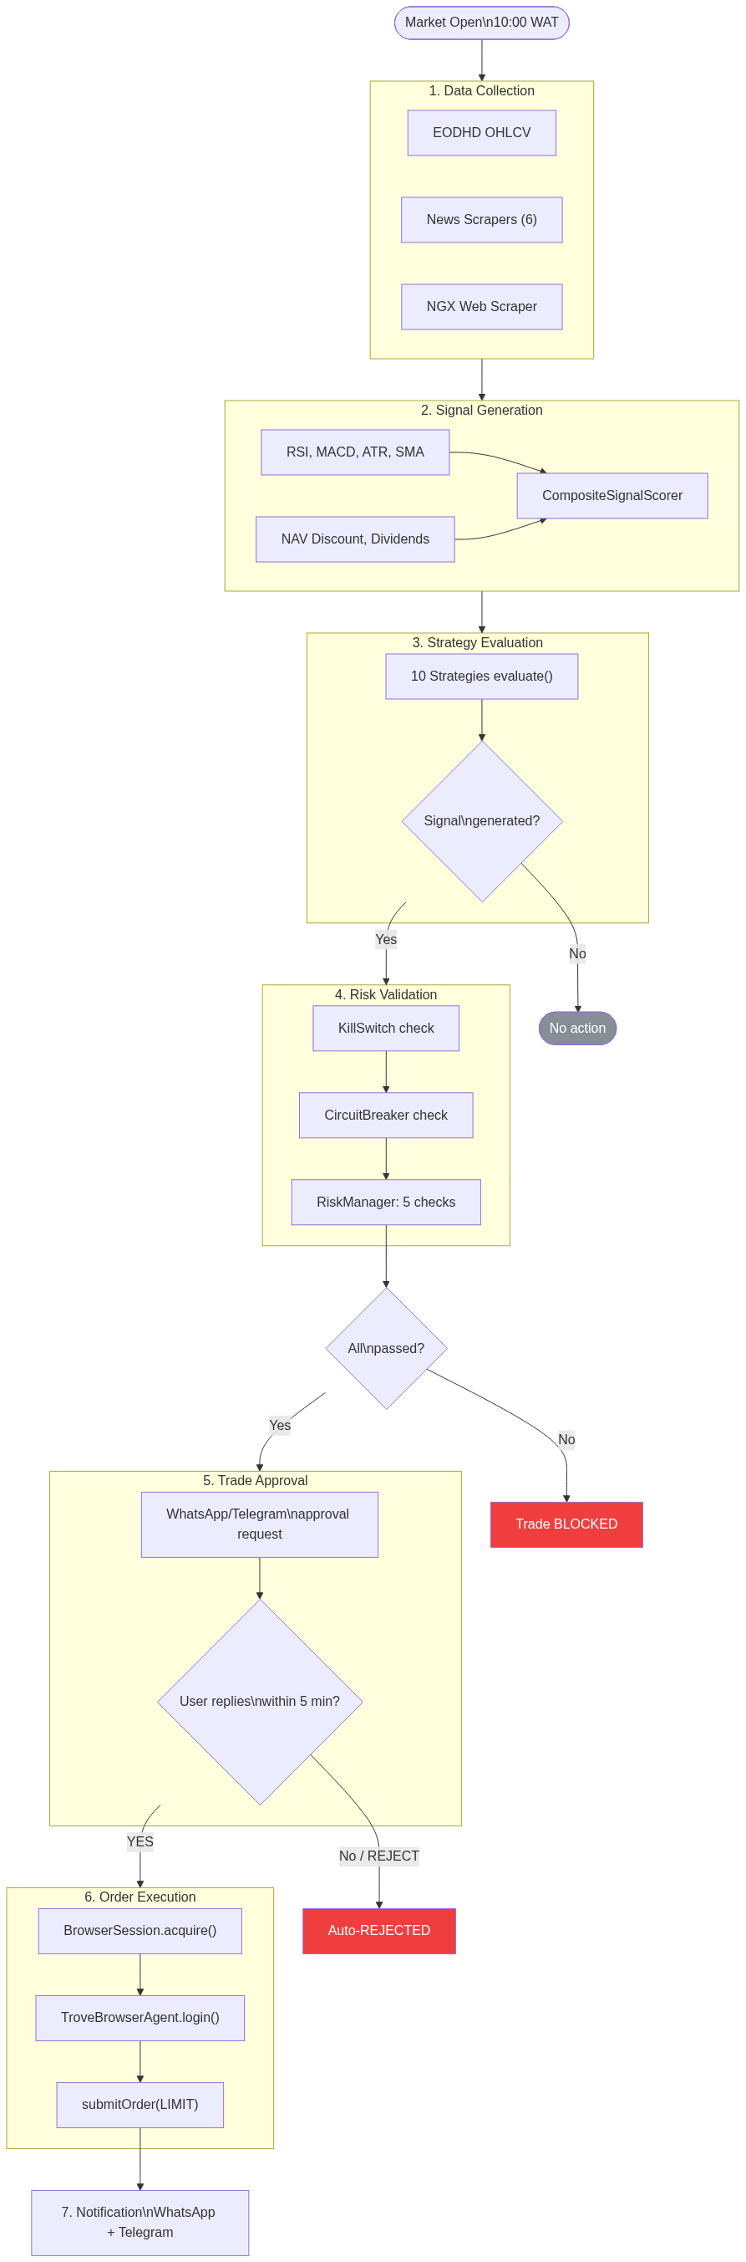
Figure 1: Signal-to-Execution Pipeline

Order State Machine
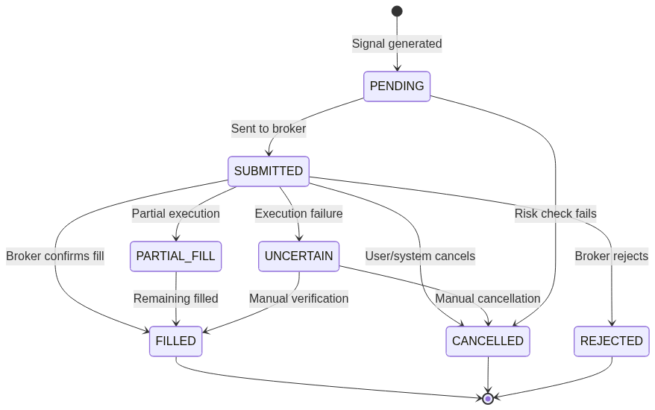
Figure 2: Order State Machine

Watchlist State Machine
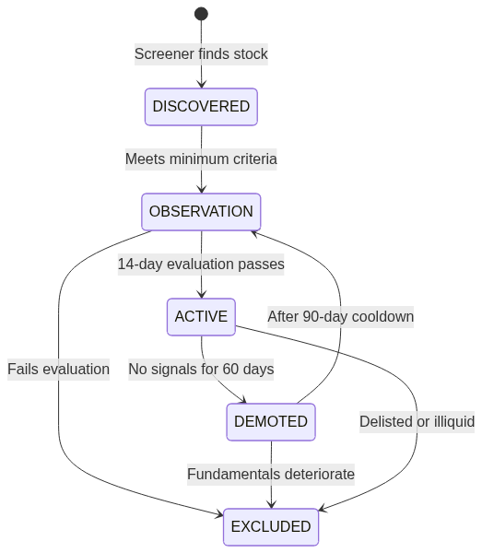
Figure 3: Watchlist State Machine

Data Model
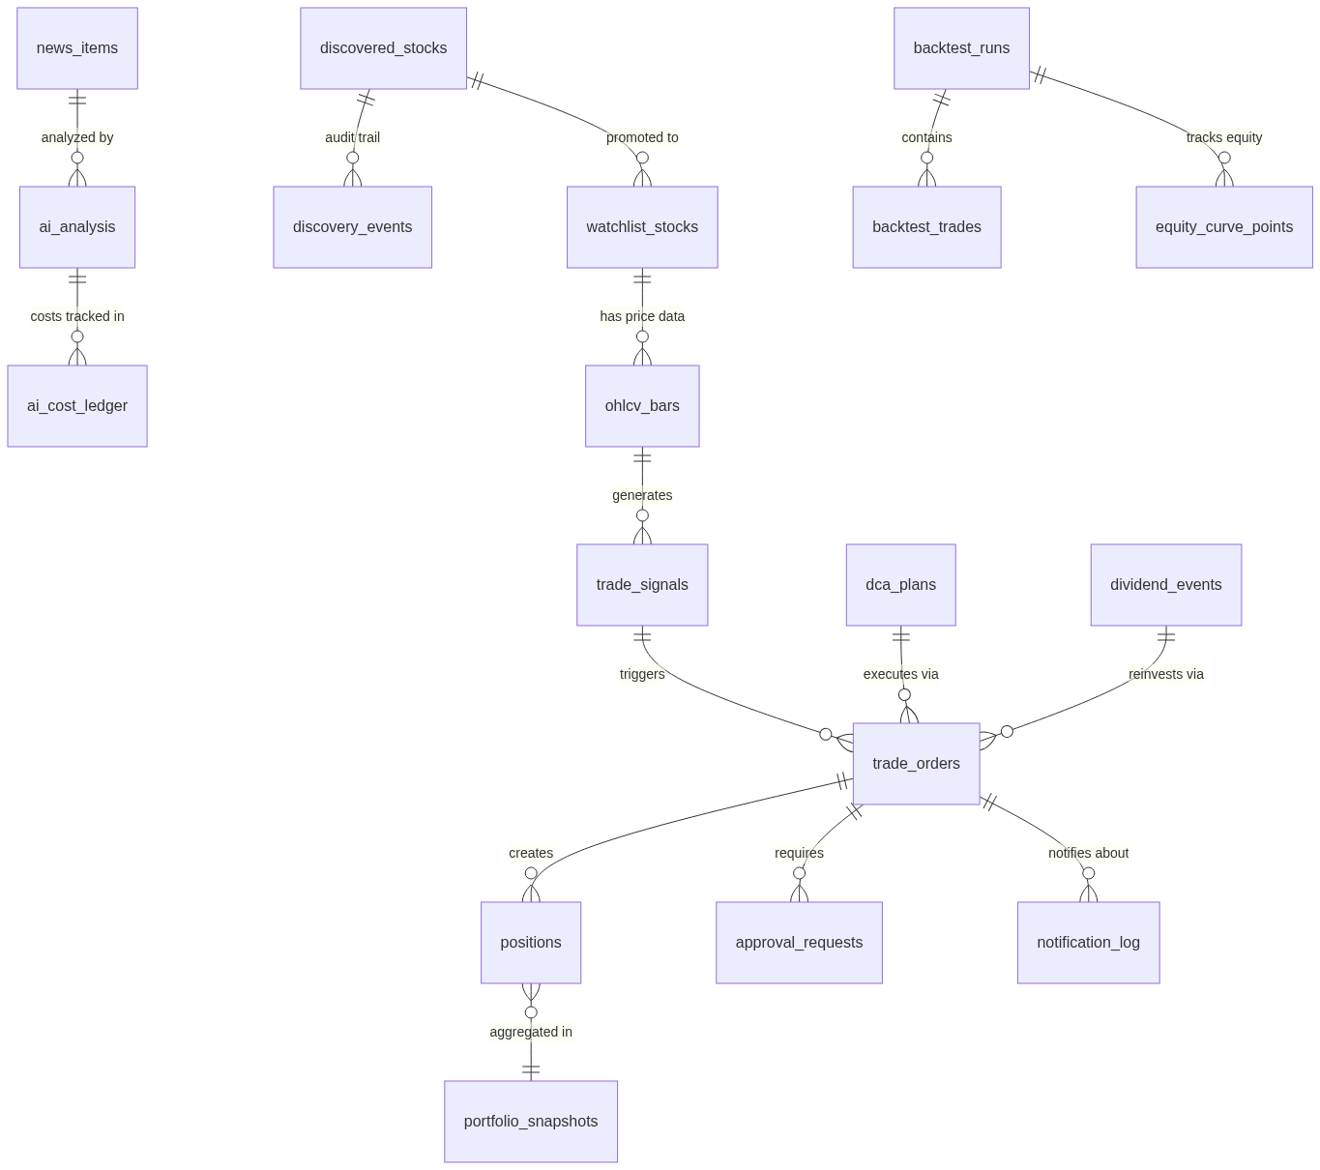
Figure 4: Entity Relationship Diagram

Roadmap
Phase | Status | Key Deliverables
Phase 1: Infrastructure & Intelligence | Complete | 30 migrations, 10 strategies, risk engine, browser automation, OTP, notifications, AI, news, backtesting, 181+ tests
Phase 2: Live Trading | Next | Wire submitOrder() for production, real-time portfolio sync, P&L tracking, Trove account verification
Phase 3: Scale & Optimize | Future | Multi-broker support, mobile dashboard, walk-forward optimization, ML signal enhancement

Success Metrics
Metric | Target | Measurement
OTP success rate | > 95% | OTP attempts vs. successful verifications
Risk rule compliance | 100% | Zero trades with failed risk checks
Notification latency | < 5 seconds | Signal to WhatsApp/Telegram delivery
Unit test pass rate | 100% | mvn test green on every commit
Integration test pass rate | > 90% | Steps 01-11 (some depend on external services)
Kill switch response | < 1 second | Activation to trading halt
Backtest Sharpe | > 0.5 | 1-year historical backtest
Uptime (market hours) | > 99% | 10:00-14:30 WAT availability

