QA Guide
Test Architecture & Coverage

Audience: QA engineers testing the NGX Trading Bot

NGX Trading Bot

Test Architecture
Tier | Framework | Count | Runner | Tag
Unit Tests | JUnit 5 + Mockito + AssertJ | ~181 methods | Maven Surefire | (none)
Integration Tests | JUnit 5 + Spring Boot Test | 11 step files | Maven Failsafe | @Tag("integration")

Unit tests use H2 in-memory database and mocked dependencies. Integration tests hit real PostgreSQL, real EODHD API, real WAHA, and real Trove browser.

Test Pyramid
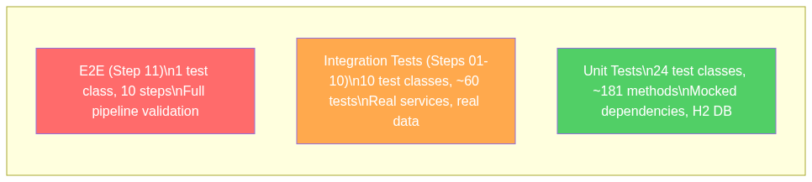
Figure 1: Test Pyramid

Integration Test Dependency Flow
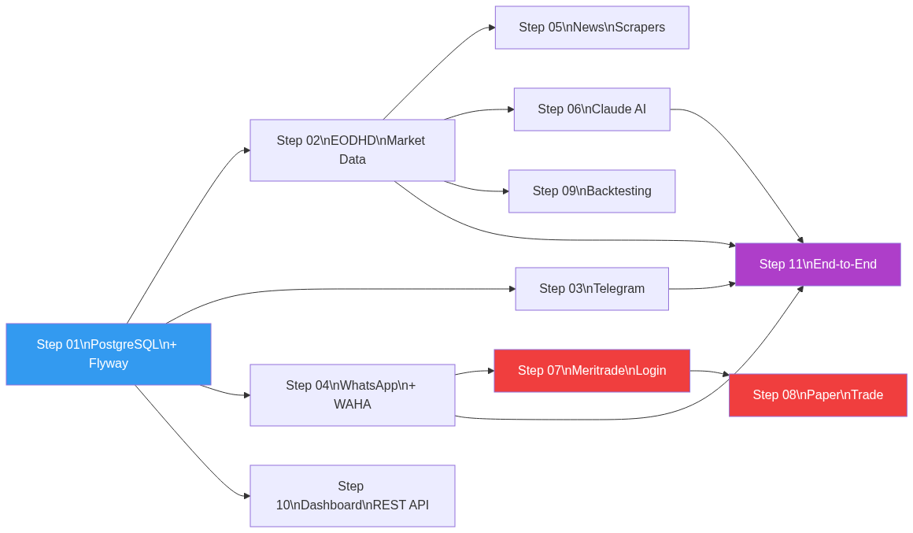
Figure 2: Integration Test Dependencies (Blue=infra, Red=browser, Purple=full pipeline)

Unit Test Coverage
24 test classes covering all critical modules:

Risk & Safety
Class | What It Tests
RiskManagerTest | All 5 risk checks: max positions, single position size, sector exposure, cash reserve, risk per trade
CircuitBreakerTest | Daily 5% loss trigger, weekly 10% loss trigger, reset behavior
SettlementCashTrackerTest | T+2 NGX settlement, T+1 US settlement, overspend prevention, cross-market isolation

Execution
Class | What It Tests
OrderRouterTest | Kill switch check before routing, risk validation, broker gateway delegation
EndToEndFlowTest | 5 nested classes: KillSwitch, Settlement, OrderRecovery, OtpFlow, BrowserLock, CrossMarket

Strategies
Class | What It Tests
MomentumBreakoutStrategyTest | Volume spike detection, RSI range filtering, SMA breakout signals
EtfNavArbitrageStrategyTest | NAV discount entry, premium exit, extreme premium handling

Signals & Indicators
Class | What It Tests
RsiCalculatorTest | RSI(14) calculation accuracy, edge cases
MacdCalculatorTest | MACD line, signal line, histogram values
NavDiscountCalculatorTest | NAV discount/premium percentage calculation

Notifications
Class | What It Tests
MessageFormatterTest | Trade signal formatting, portfolio summary formatting
TradeApprovalServiceTest | Approval flow, timeout behavior, default REJECT

News
Class | What It Tests
EventImpactRulesTest | Event type to impact mapping
NewsEventClassifierTest | Headline classification into event types

Long-term
Class | What It Tests
DcaExecutorTest | Monthly DCA execution logic, budget calculations
DividendTrackerTest | Ex-date tracking, alert generation
PortfolioRebalancerTest | Drift detection, rebalance action generation

Backtest
Class | What It Tests
PerformanceAnalyzerTest | Sharpe ratio, max drawdown, win rate calculations
SimulatedOrderExecutorTest | Simulated fill logic with slippage

Data & Discovery
Class | What It Tests
EodhdApiClientTest | API response parsing, OHLCV bar construction
WatchlistManagerTest | Watchlist add/remove, size limits, promotion/demotion

Integration Test Steps

Step 01: PostgreSQL + Flyway
Class: Step01_PostgresFlywayIT — Validates: Database infrastructure
Test | Assertion | Details
1.1 | PostgreSQL connection alive | Connection valid, product is PostgreSQL
1.2 | Flyway ran all migrations | flyway_schema_history >= 30 successful entries
1.3 | All expected tables exist | 27 expected tables present in public schema
1.4 | ohlcv_bars schema correct | Columns: id, symbol, trade_date, open/high/low/close, volume
1.5 | trade_orders schema correct | Columns: id, order_id, symbol, side, quantity, price, status
1.6 | No failed migrations | Zero rows with success = false
1.7 | Seed data exists | watchlist_stocks has > 0 rows (from V20)

Step 02: EODHD Market Data
Class: Step02_EodhdApiIT — Validates: Market data ingestion
Test | Assertion | Details
2.1 | API key configured | EODHD_API_KEY is not blank
2.2 | Fetch ZENITHBANK OHLCV | Returns bars with positive close price and volume
2.3 | Fetch GTCO OHLCV | Returns recent bars with positive close
2.4 | Fetch fundamentals | Returns data (skipped on free-tier)
2.5 | Screener returns candidates | Returns NGX stocks (skipped on free tier)
2.6 | OHLCV persists to DB | All bars have dataSource = "EODHD"
2.7 | Values are reasonable | High >= Low, Low <= Close <= High

Step 03: Telegram
Class: Step03_TelegramIT — Validates: Telegram notifications
Test | Assertion | Details
3.1 | Credentials configured | Bot token and chat ID not blank
3.2 | Plain text message | Sends without throwing
3.3 | Formatted trade signal | Rich formatted message sends
3.4 | Long message | Portfolio summary under 4096 char limit

Step 04: WhatsApp via WAHA
Class: Step04_WhatsAppIT — Validates: WhatsApp notification + OTP
Test | Assertion | Details
4.1 | Chat ID configured | Contains @c.us format
4.2 | WAHA running | /api/sessions returns response
4.3 | Plain text message | Sends without throwing
4.4 | Formatted trade alert | Sends trade signal format
4.5 | OTP handler state | No pending OTPs, max retries = 3
4.6 | Webhook endpoint | WhatsAppWebhookController bean loaded

Step 05: News Scrapers
Class: Step05_ScrapersIT — Validates: News scraping from 6 sources
Test | Assertion | Details
5a | BusinessDay | Deduplicates by URL
5b | Nairametrics | Same dedup behavior
5c | SeekingAlpha | Often blocked (403 expected) — soft pass
5d | Reuters RSS | Feed URL may change — soft pass
5e | CBN Press | Website may change — soft pass
5f | NGX Price List + ASI Index | May need JS rendering — soft pass

Step 06: Claude AI
Class: Step06_ClaudeAiIT — Validates: AI analysis integration
Test | Assertion | Details
6.1 | AI configured | AI_ENABLED=true, API key set
6.2 | News analysis prompt | Returns response with content + tokens
6.3 | Cost tracker | Records cost, daily/monthly totals
6.4 | Budget check | Budget not exceeded after test call
6.5 | Structured analysis | Response contains JSON-like structure

Step 07: Meritrade Login
Class: Step07_MeritradeLoginIT — Validates: Browser automation login
Test | Assertion | Details
7.1 | Credentials configured | Username and password not blank
7.2 | Login succeeds | Session active, screenshot exists
7.3 | Portfolio holdings | Returns Map (may be empty)
7.4 | Available cash | Returns BigDecimal >= 0
7.5 | FX rate | Returns USD/NGN rate (soft pass)
7.6 | Dashboard screenshot | Screenshot file exists on disk

Step 08: Paper Trade
Class: Step08_PaperTradeIT — Validates: Real order submission (1 share)
Test | Assertion | Details
8.1 | Session active | Broker session ready
8.2 | Submit BUY LIMIT | Order ID returned for TRANSCORP at NGN 5.00
8.3 | Persist to DB | TradeOrder saved with ID
8.4 | Send notification | Telegram notification sent
8.5 | Check order status | Status is not blank
8.6 | Verify in DB | Order found in database

Step 09: Backtesting
Class: Step09_BacktestIT — Validates: Backtesting engine
Test | Assertion | Details
9.1 | Fetch historical data | 5 stocks, all have bars
9.2 | List strategies | At least 1 strategy registered
9.3 | Run backtest | BacktestRun returned with metrics
9.4 | Results persist | Rows in backtest_runs and backtest_trades
9.5 | Metrics reasonable | Max drawdown <= 0, win rate 0-100%

Step 10: Dashboard REST API
Class: Step10_DashboardIT — Validates: REST API endpoints
Test | Assertion | Details
10.1-14 | All 14 endpoints return 200 OK | /api/portfolio, /fx, /settlement, /performance, /signals, /news, /ai/cost, /discovery/active, /discovery/candidates, /backtest/runs, /backtest/strategies, /actuator/health, /killswitch, /dividends

Step 11: End-to-End Pipeline
Class: Step11_EndToEndIT — Validates: Full signal-to-notification pipeline
Test | Assertion | Details
E2E 1/10 | Fetch 3 months OHLCV | ZENITHBANK data loaded
E2E 2/10 | Calculate indicators | RSI(14) and MACD computed
E2E 3/10 | Scrape news | BusinessDay articles fetched
E2E 4/10 | AI analysis | News + market data analyzed
E2E 5/10 | Generate signal | Mock BUY signal created
E2E 6/10 | Safety checks | Kill switch OFF, circuit breakers OK
E2E 7/10 | Approval request | Sent via Telegram
E2E 8/10 | Simulate approval | Auto-approved
E2E 9/10 | Record trade | Saved to PostgreSQL
E2E 10/10 | Send confirmation | Telegram + WhatsApp notified

Running Tests
Command | What Runs
mvn test | Unit tests only (excludes integration)
mvn verify -Pintegration | Integration tests only
mvn verify -Pintegration -Dtest="Step01_PostgresFlywayIT" | Single integration step

Manual Testing Checklist

Login Flow
- Bot navigates to https://app.trovefinance.com/login
- Email and password fields are filled
- Login button is clicked
- If OTP screen appears, bot sends WhatsApp/email prompt
- OTP is entered and verified
- Dashboard loads (verify via screenshot in ./screenshots/)

Kill Switch
- Activate kill switch via KillSwitchService.activate(reason)
- Verify all trading halts immediately
- Verify urgent WhatsApp/Telegram notification sent
- Deactivate and verify trading resumes

Known Limitations
1. Portfolio selectors need real account with positions to validate
2. submitOrder() not yet fully wired for production
3. Trove requires account verification before trading is enabled
4. SeekingAlpha scraper frequently blocked by anti-bot (403 expected)
5. RSS feed URLs may change without notice
6. EODHD free tier: fundamentals/screener require paid plan

