Cron Jobs Reference
Scheduled Task Architecture & Documentation

Audience: Engineering Team, DevOps, QA

NGX Trading Bot

Table of Contents
Right-click and select Update Field to generate Table of Contents

Executive Summary
The NGX Trading Bot operates 24 scheduled tasks across 14 Java classes organized into 6 functional modules. All cron-based tasks use the Africa/Lagos timezone (WAT, UTC+1).

Scheduling Patterns
Pattern | Count | Details
Cron-based | 23 | Time/day-specific triggers
fixedDelay | 1 | AiAnalysisScheduler.processUnanalyzedArticles (15 min)

Category Breakdown
Category | Schedulers | Jobs
Data Collection | 2 | 7
Analysis | 1 | 2
Signal | 1 | 2
Discovery | 1 | 3
Long-term | 4 | 4
Risk | 3 | 4
Execution | 2 | 2

All scheduled times are in WAT (West Africa Time, UTC+1). The bot does NOT trade outside 10:00-14:30 WAT for NGX.

Master Job Inventory
Complete inventory of all scheduled tasks sorted by execution time.
# | Scheduler | Method | Schedule | Time (WAT) | Days | Category | Purpose
1 | DataCollectionScheduler | preMarketNewsScan | 0 0 9 * * MON-FRI | 09:00 | Mon-Fri | Data Collection | Scans financial RSS feeds for pre-market news
2 | DataCollectionScheduler | pullEodhdData | 0 0 15 * * MON-FRI | 15:00 | Mon-Fri | Data Collection | Fetches 5-day OHLCV bars from EODHD for all watchlist symbols
3 | DataCollectionScheduler | scrapeNgxBackup | 0 5 15 * * MON-FRI | 15:05 | Mon-Fri | Data Collection | Backup: scrapes NGX website for daily prices and ASI index
4 | DataCollectionScheduler | scrapeEtfNavs | 0 0 16 * * MON-FRI | 16:00 | Mon-Fri | Data Collection | Scrapes ETF Net Asset Values from fund manager sites
5 | NewsScraperScheduler | earlyMorningNewsScan | 0 0 8 * * MON-FRI | 08:00 | Mon-Fri | Data Collection | Pre-market news scan via all 5 web scrapers
6 | NewsScraperScheduler | midDayNewsScan | 0 30 12 * * MON-FRI | 12:30 | Mon-Fri | Data Collection | Mid-day news refresh via all 5 web scrapers
7 | NewsScraperScheduler | afterMarketNewsScan | 0 0 17 * * MON-FRI | 17:00 | Mon-Fri | Data Collection | After-market scan: 5 web scrapers + NGX bulletin parser
8 | AiAnalysisScheduler | processUnanalyzedArticles | fixedDelay=900000 | Every 15m | Always | Analysis | Batch-analyzes unprocessed news via Claude API
9 | AiAnalysisScheduler | crossArticleSynthesis | 0 0 21 * * MON-FRI | 21:00 | Mon-Fri | Analysis | Synthesizes consensus from multiple articles per symbol
10 | SignalGenerationScheduler | generateNgxSignals | 0 15 15 * * MON-FRI | 15:15 | Mon-Fri | Signal | Generates NGX trade signals from all non-US strategies
11 | SignalGenerationScheduler | generateUsSignals | 0 30 21 * * MON-FRI | 21:30 | Mon-Fri | Signal | Generates US trade signals from US+dual-market strategies
12 | DiscoveryScheduler | weeklyScreenerScan | 0 0 6 * * SUN | 06:00 | Sunday | Discovery | Weekly EODHD screener scan for new NGX candidates
13 | DiscoveryScheduler | dailyObservationCheck | 0 0 20 * * MON-FRI | 20:00 | Mon-Fri | Discovery | Evaluates OBSERVATION stocks for promotion criteria
14 | DiscoveryScheduler | dailyDemotionCheck | 0 30 20 * * MON-FRI | 20:30 | Mon-Fri | Discovery | Checks PROMOTED stocks for demotion conditions
15 | DcaScheduler | checkAndExecuteDca | 0 15 10 * * * | 10:15 | Daily | Long-term | Checks if today is DCA day, executes for NGX and/or US
16 | DividendCheckScheduler | weeklyDividendCheck | 0 0 9 * * MON | 09:00 | Monday | Long-term | Checks upcoming ex-dates and processes reinvestments
17 | FundamentalUpdateScheduler | weeklyFundamentalUpdate | 0 0 20 * * SUN | 20:00 | Sunday | Long-term | Refreshes fundamental scores for all core holdings
18 | RebalanceScheduler | quarterlyRebalanceCheck | 0 0 15 1 1,4,7,10 * | 15:00 | 1st of Jan/Apr/Jul/Oct | Long-term | Quarterly portfolio rebalance if drift exceeds threshold
19 | CircuitBreaker | periodicCircuitCheck | 0 */10 10-22 * * MON-FRI | Every 10m (10:00-22:00) | Mon-Fri | Risk | Checks daily/weekly/cross-market loss thresholds
20 | SettlementCashTracker | dailySettlementProcessing | 0 0 9 * * MON-FRI | 09:00 | Mon-Fri | Risk | Processes T+2/T+1 settlements, moves to available cash
21 | StopLossMonitor | monitorNgxStops | 0 */5 10-14 * * MON-FRI | Every 5m (10:00-14:00) | Mon-Fri | Risk | Checks NGX positions (.XNSA) against stop-loss levels
22 | StopLossMonitor | monitorUsStops | 0 */5 15-21 * * MON-FRI | Every 5m (15:00-21:00) | Mon-Fri | Risk | Checks US positions against stop-loss levels
23 | PortfolioReconciler | dailyReconciliation | 0 30 9 * * MON-FRI | 09:30 | Mon-Fri | Execution | Reconciles DB positions vs broker holdings; kill switch on mismatch
24 | CashReconciler | dailyCashReconciliation | 0 35 9 * * MON-FRI | 09:35 | Mon-Fri | Execution | Reconciles internal cash vs broker balance; kill switch on mismatch

Daily Execution Timeline
Visual timeline of all scheduled tasks across a typical trading day.

Weekday Morning (06:00-14:30 WAT)
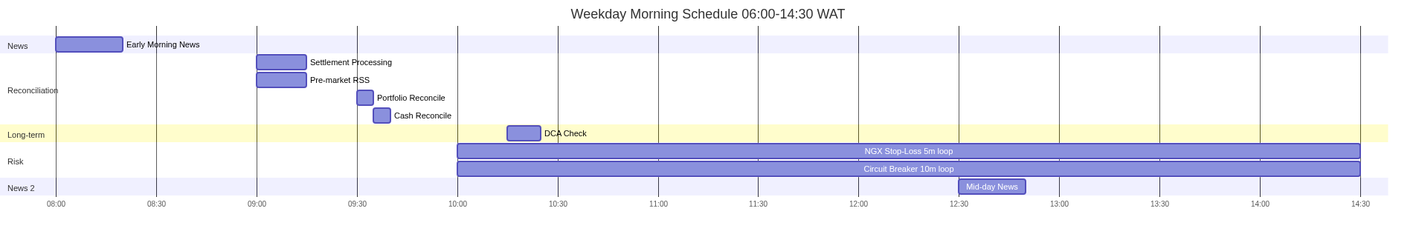
Morning schedule: reconciliation, news, risk monitoring

Weekday Afternoon-Evening (14:30-22:00 WAT)
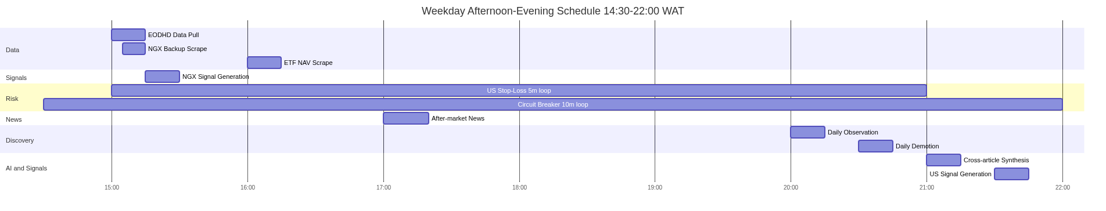
Afternoon/evening: data pull, signals, discovery, AI

Weekend & Weekly Jobs
Weekend: Sunday screener + fundamentals, Monday dividends

Quarterly job (RebalanceScheduler) runs on 1st of Jan/Apr/Jul/Oct at 15:00 WAT.

5. Data Collection Scheduler
Foundation of the data pipeline. Collects OHLCV price bars from EODHD API, scrapes NGX website as backup, fetches ETF NAVs, and scans RSS feeds for financial news.
File: src/main/java/com/ngxbot/data/scheduler/DataCollectionScheduler.java

Dependencies
Type | Name | Purpose
Client | EodhdApiClient | EODHD REST API for OHLCV data
Scraper | NgxWebScraper | NGX website backup price scraper
Scraper | EtfNavScraper | ETF NAV scraper from fund managers
Scraper | NewsRssScraper | Financial news RSS feed parser
Config | TradingProperties | Watchlist symbols and config

Database Tables
Table | Access | Notes
ohlcv_bar | WRITE
news_item | WRITE
market_index | WRITE
etf_valuation | WRITE

preMarketNewsScan()
Schedule: 0 0 9 * * MON-FRI | Time: 09:00 | Days: Mon-Fri
Scans financial RSS feeds for pre-market news

pullEodhdData()
Schedule: 0 0 15 * * MON-FRI | Time: 15:00 | Days: Mon-Fri
Fetches 5-day OHLCV bars from EODHD for all watchlist symbols

scrapeNgxBackup()
Schedule: 0 5 15 * * MON-FRI | Time: 15:05 | Days: Mon-Fri
Backup: scrapes NGX website for daily prices and ASI index

scrapeEtfNavs()
Schedule: 0 0 16 * * MON-FRI | Time: 16:00 | Days: Mon-Fri
Scrapes ETF Net Asset Values from fund manager sites

Execution Flow
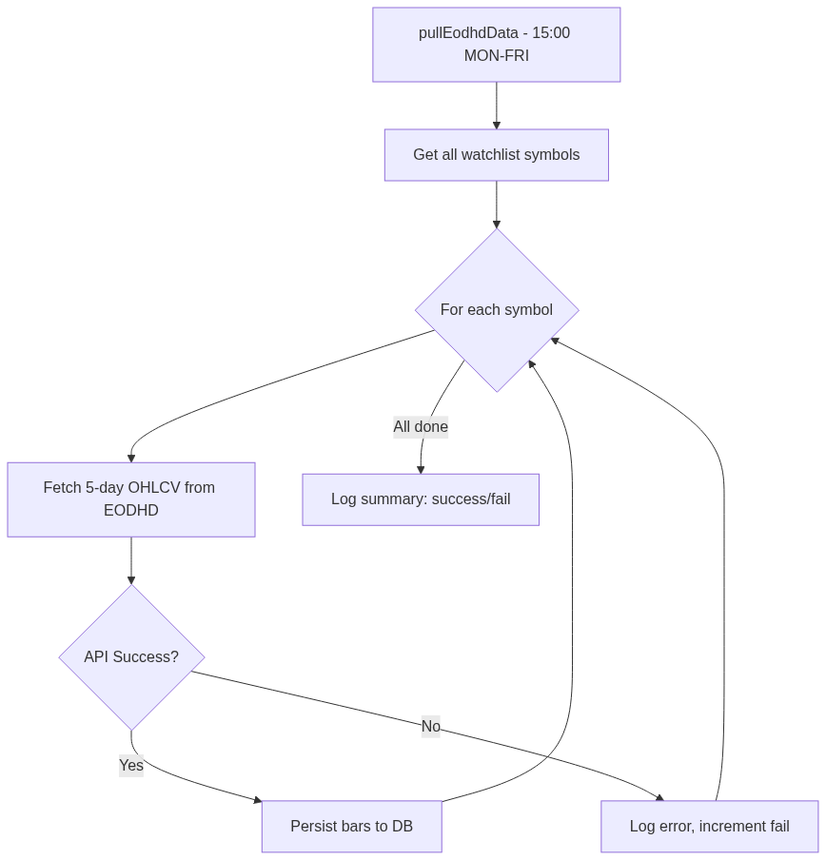
Data Collection Scheduler - primary job flow
────────────────────────────────────────────────────────────

6. News Scraper Scheduler
Runs 5 web scrapers (Nairametrics, BusinessDay, Reuters RSS, SeekingAlpha, CBN Press) three times daily, plus NGX bulletin parsing in the after-market scan.
File: src/main/java/com/ngxbot/news/scraper/NewsScraperScheduler.java

Dependencies
Type | Name | Purpose
Scraper | NairametricsScraper | Nairametrics news scraper
Scraper | BusinessDayScraper | BusinessDay news scraper
Scraper | ReutersRssScraper | Reuters RSS feed scraper
Scraper | SeekingAlphaScraper | SeekingAlpha news scraper
Scraper | CbnPressScraper | CBN press release scraper
Parser | NgxBulletinParser | NGX daily bulletin parser

Database Tables
Table | Access | Notes
news_item | WRITE

earlyMorningNewsScan()
Schedule: 0 0 8 * * MON-FRI | Time: 08:00 | Days: Mon-Fri
Pre-market news scan via all 5 web scrapers

midDayNewsScan()
Schedule: 0 30 12 * * MON-FRI | Time: 12:30 | Days: Mon-Fri
Mid-day news refresh via all 5 web scrapers

afterMarketNewsScan()
Schedule: 0 0 17 * * MON-FRI | Time: 17:00 | Days: Mon-Fri
After-market scan: 5 web scrapers + NGX bulletin parser

Execution Flow
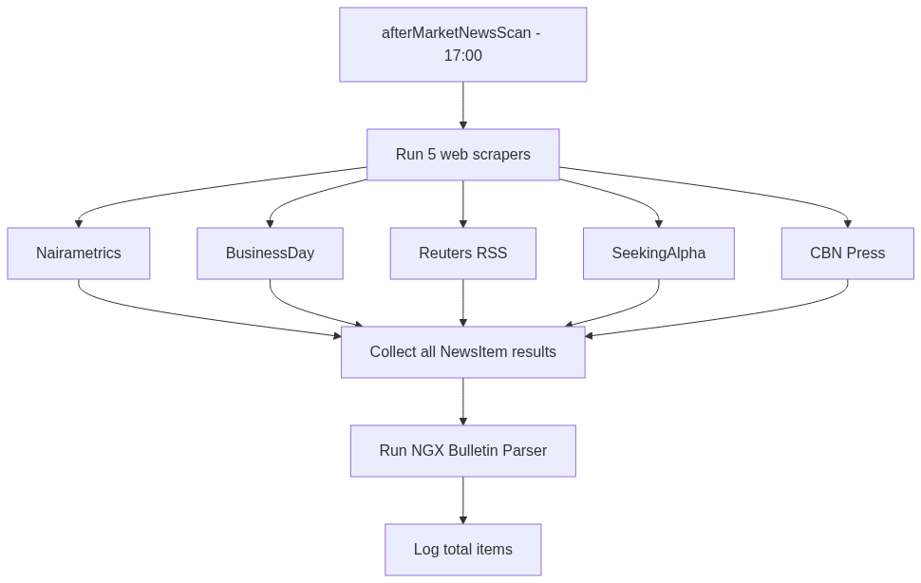
News Scraper Scheduler - primary job flow
────────────────────────────────────────────────────────────

7. AI Analysis Scheduler
Processes unanalyzed news articles via Claude API in batches (every 15 min), and runs cross-article sentiment synthesis daily.
File: src/main/java/com/ngxbot/ai/scheduler/AiAnalysisScheduler.java

Dependencies
Type | Name | Purpose
Service | AiNewsAnalyzer | Claude API article analyzer
Service | AiCrossArticleSynthesizer | Multi-article synthesis
Repo | NewsItemRepository | Unprocessed news query
Repo | AiAnalysisRepository | AI results persistence
Service | AiCostTracker | API spending budget tracker
Config | AiProperties | AI module config

Database Tables
Table | Access | Notes
news_item | READ
ai_analysis | READ
ai_cost_ledger | READ

processUnanalyzedArticles()
Schedule: fixedDelay=900000 | Time: Every 15m | Days: Always
Batch-analyzes unprocessed news via Claude API

crossArticleSynthesis()
Schedule: 0 0 21 * * MON-FRI | Time: 21:00 | Days: Mon-Fri
Synthesizes consensus from multiple articles per symbol

Execution Flow
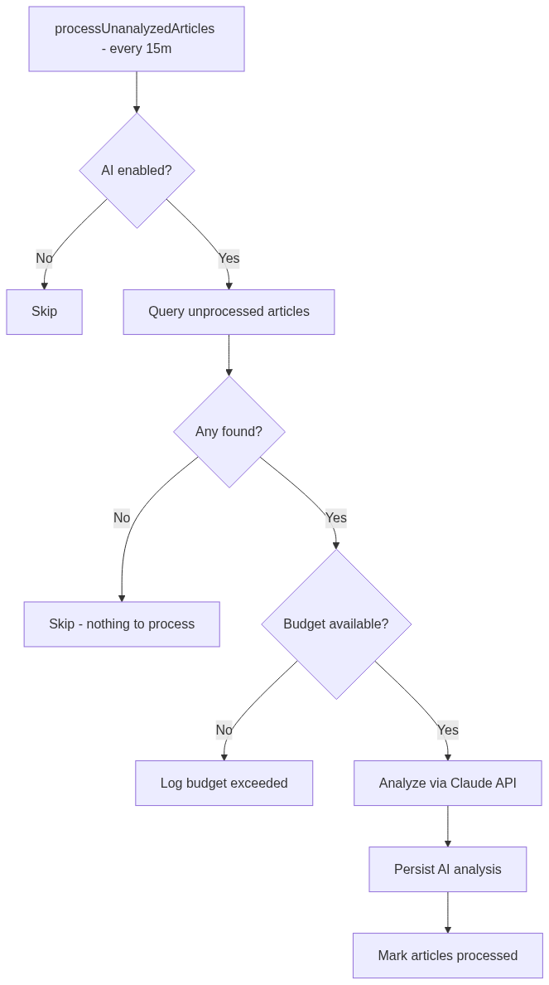
AI Analysis Scheduler - primary job flow
────────────────────────────────────────────────────────────

8. Signal Generation Scheduler
Generates trade signals by running composite scoring across all strategies. NGX signals at 15:15 (after EODHD pull), US at 21:30.
File: src/main/java/com/ngxbot/signal/SignalGenerationScheduler.java

Dependencies
Type | Name | Purpose
Service | CompositeSignalScorer | Multi-strategy signal scorer
Repo | TradeSignalRepository | Signal persistence
Util | ObjectMapper | JSON serialization

Database Tables
Table | Access | Notes
ohlcv_bar | READ
position | READ
ai_analysis | READ
trade_signal | WRITE

generateNgxSignals()
Schedule: 0 15 15 * * MON-FRI | Time: 15:15 | Days: Mon-Fri
Generates NGX trade signals from all non-US strategies

generateUsSignals()
Schedule: 0 30 21 * * MON-FRI | Time: 21:30 | Days: Mon-Fri
Generates US trade signals from US+dual-market strategies

Execution Flow
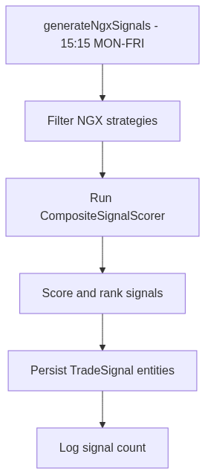
Signal Generation Scheduler - primary job flow
────────────────────────────────────────────────────────────

9. Discovery Scheduler
Manages the stock discovery pipeline: weekly EODHD screening, daily observation evaluation, and daily demotion checks.
File: src/main/java/com/ngxbot/discovery/scheduler/DiscoveryScheduler.java

Dependencies
Type | Name | Purpose
Client | EodhdScreenerClient | EODHD stock screener
Service | CandidateEvaluator | Candidate scoring
Policy | PromotionPolicy | OBSERVATION to PROMOTED rules
Policy | DemotionPolicy | PROMOTED to DEMOTED rules
Repo | DiscoveredStockRepository | Discovery persistence
Config | DiscoveryProperties | Module config
Service | WatchlistManager | Watchlist updates

Database Tables
Table | Access | Notes
discovered_stock | READ
discovery_event | WRITE

weeklyScreenerScan()
Schedule: 0 0 6 * * SUN | Time: 06:00 | Days: Sunday
Weekly EODHD screener scan for new NGX candidates

dailyObservationCheck()
Schedule: 0 0 20 * * MON-FRI | Time: 20:00 | Days: Mon-Fri
Evaluates OBSERVATION stocks for promotion criteria

dailyDemotionCheck()
Schedule: 0 30 20 * * MON-FRI | Time: 20:30 | Days: Mon-Fri
Checks PROMOTED stocks for demotion conditions

Execution Flow
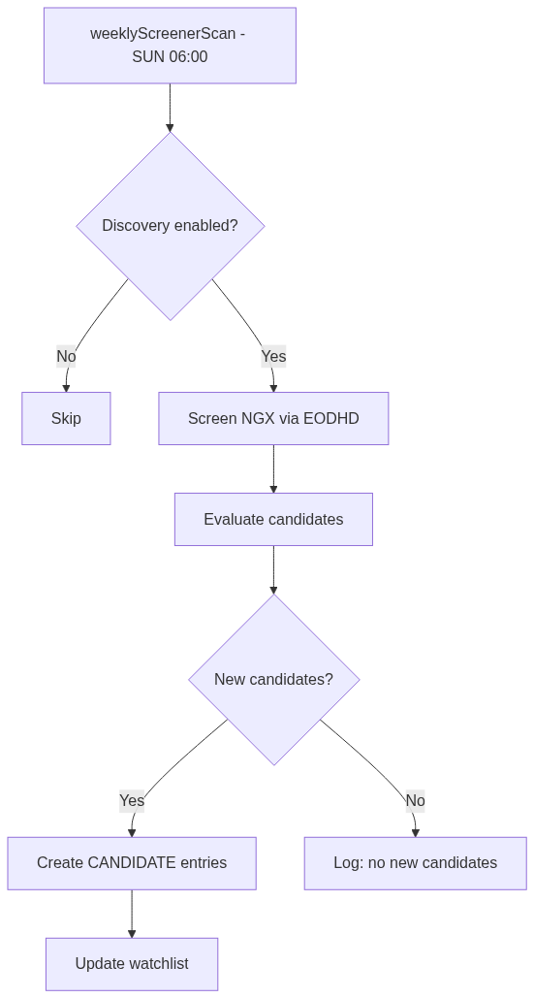
Discovery Scheduler - primary job flow
────────────────────────────────────────────────────────────

10. DCA Scheduler
Dollar-cost averaging executor. Runs daily at 10:15 AM, checks if today is a configured DCA day, and executes for NGX/US markets.
File: src/main/java/com/ngxbot/longterm/scheduler/DcaScheduler.java

Dependencies
Type | Name | Purpose
Service | DcaExecutor | DCA order execution
Config | LongtermProperties | DCA config (days, amounts)

checkAndExecuteDca()
Schedule: 0 15 10 * * * | Time: 10:15 | Days: Daily
Checks if today is DCA day, executes for NGX and/or US

Execution Flow
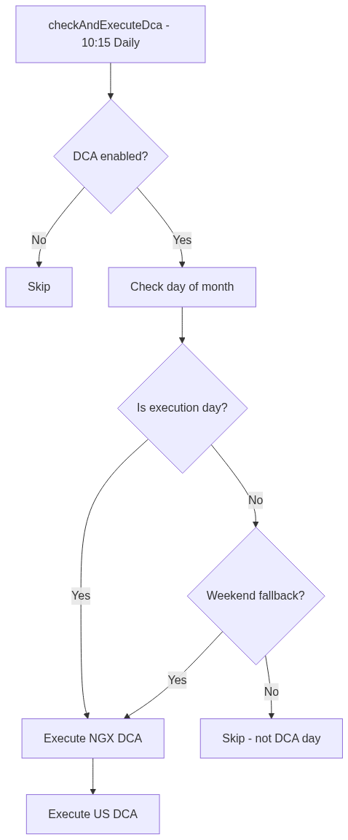
DCA Scheduler - primary job flow
────────────────────────────────────────────────────────────

11. Dividend Check Scheduler
Weekly Monday check for upcoming ex-dividend dates within alert window, and processes pending dividend reinvestments.
File: src/main/java/com/ngxbot/longterm/scheduler/DividendCheckScheduler.java

Dependencies
Type | Name | Purpose
Service | DividendTracker | Ex-date tracking
Service | DividendReinvestmentService | Reinvestment execution
Config | LongtermProperties | Dividend config

Database Tables
Table | Access | Notes
dividend_event | READ

weeklyDividendCheck()
Schedule: 0 0 9 * * MON | Time: 09:00 | Days: Monday
Checks upcoming ex-dates and processes reinvestments

Execution Flow
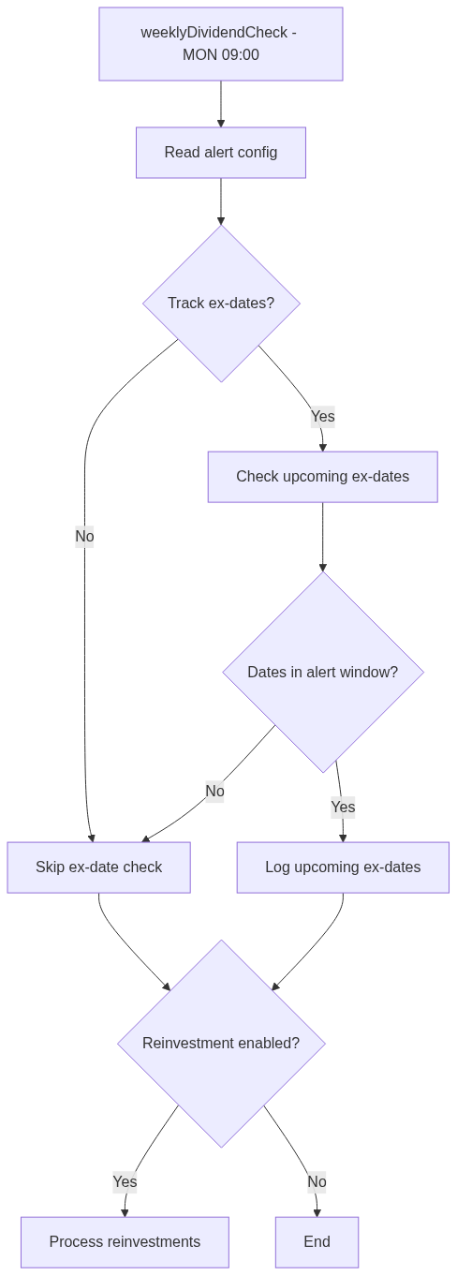
Dividend Check Scheduler - primary job flow
────────────────────────────────────────────────────────────

12. Fundamental Update Scheduler
Weekly Sunday refresh of fundamental scores for all core holdings (NGX + US) via the FundamentalScreener.
File: src/main/java/com/ngxbot/longterm/scheduler/FundamentalUpdateScheduler.java

Dependencies
Type | Name | Purpose
Service | FundamentalScreener | Fundamental scoring engine
Service | CorePortfolioManager | Core holdings manager

Database Tables
Table | Access | Notes
core_holding | READ

weeklyFundamentalUpdate()
Schedule: 0 0 20 * * SUN | Time: 20:00 | Days: Sunday
Refreshes fundamental scores for all core holdings

Execution Flow
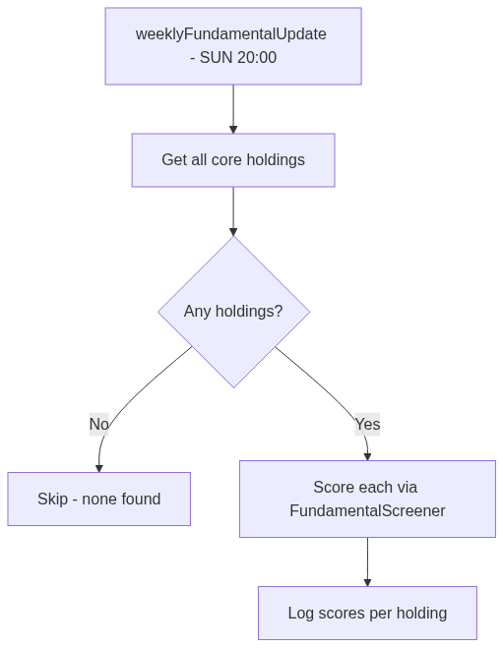
Fundamental Update Scheduler - primary job flow
────────────────────────────────────────────────────────────

13. Rebalance Scheduler
Quarterly rebalance on 1st of Jan/Apr/Jul/Oct at 15:00. Refreshes market values, calculates drift, generates rebalance actions.
File: src/main/java/com/ngxbot/longterm/scheduler/RebalanceScheduler.java

Dependencies
Type | Name | Purpose
Service | PortfolioRebalancer | Rebalance action generator
Service | CorePortfolioManager | Market value refresh
Config | LongtermProperties | Rebalance config

Database Tables
Table | Access | Notes
core_holding | READ
rebalance_action | WRITE

quarterlyRebalanceCheck()
Schedule: 0 0 15 1 1,4,7,10 * | Time: 15:00 | Days: 1st of Jan/Apr/Jul/Oct
Quarterly portfolio rebalance if drift exceeds threshold

Execution Flow
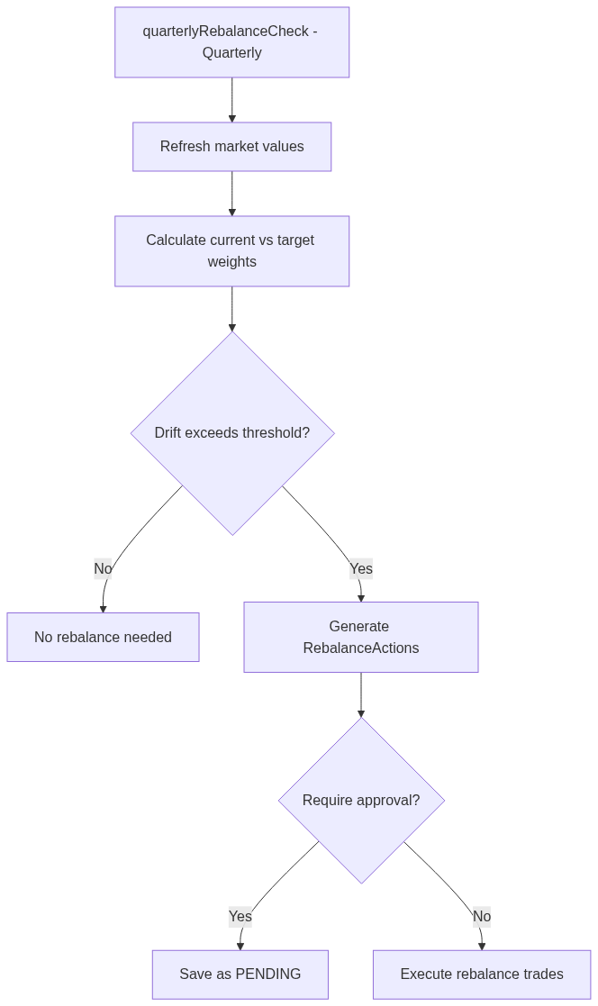
Rebalance Scheduler - primary job flow
────────────────────────────────────────────────────────────

14. Circuit Breaker
Monitors portfolio P&L every 10 minutes during combined trading hours. Halts SATELLITE trading on excessive losses. CORE pool unaffected.
File: src/main/java/com/ngxbot/risk/service/CircuitBreaker.java

Dependencies
Type | Name | Purpose
Config | RiskProperties | Loss thresholds
Repo | PortfolioSnapshotRepository | P&L snapshot data

Database Tables
Table | Access | Notes
portfolio_snapshot | READ

periodicCircuitCheck()
Schedule: 0 */10 10-22 * * MON-FRI | Time: Every 10m (10:00-22:00) | Days: Mon-Fri
Checks daily/weekly/cross-market loss thresholds

Execution Flow
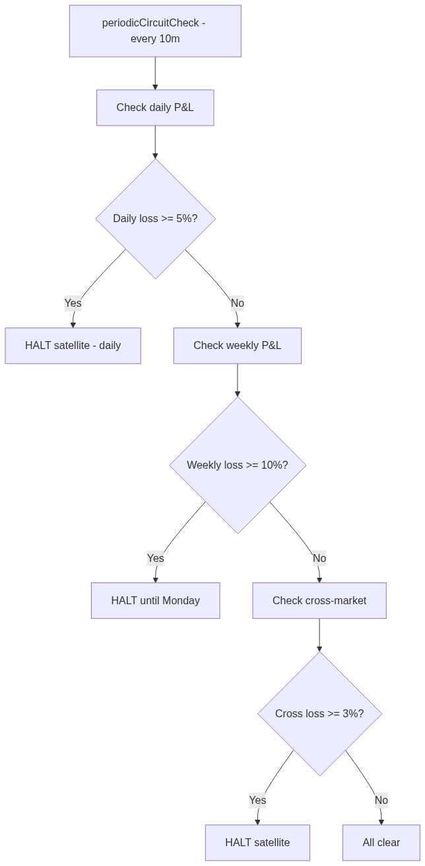
Circuit Breaker - primary job flow
────────────────────────────────────────────────────────────

15. Settlement Cash Tracker
Daily settlement processing at 9:00 AM. Moves settled amounts from settling pool to available cash (T+2 NGX, T+1 US). In-memory ledger.
File: src/main/java/com/ngxbot/risk/service/SettlementCashTracker.java

dailySettlementProcessing()
Schedule: 0 0 9 * * MON-FRI | Time: 09:00 | Days: Mon-Fri
Processes T+2/T+1 settlements, moves to available cash

Execution Flow
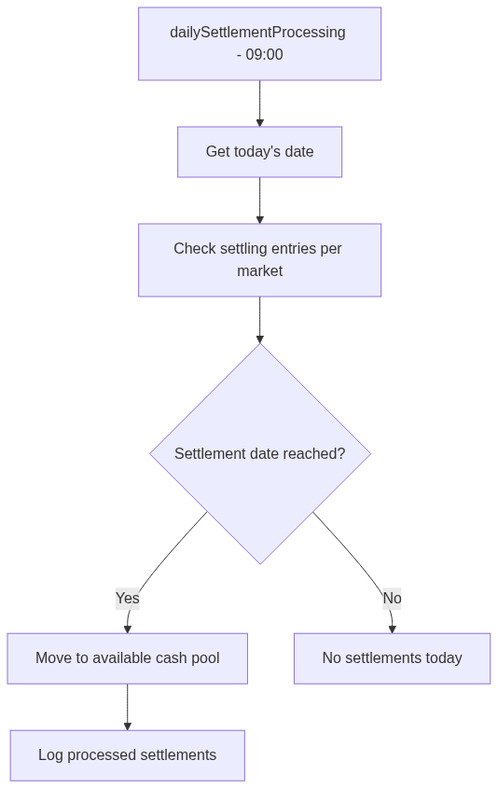
Settlement Cash Tracker - primary job flow
────────────────────────────────────────────────────────────

16. Stop-Loss Monitor
Monitors open positions every 5 minutes during market hours. NGX positions during 10:00-14:00, US positions during 15:00-21:00.
File: src/main/java/com/ngxbot/risk/service/StopLossMonitor.java

Dependencies
Type | Name | Purpose
Repo | PositionRepository | Open position queries
Repo | OhlcvRepository | Latest price data

Database Tables
Table | Access | Notes
position | READ
ohlcv_bar | READ

monitorNgxStops()
Schedule: 0 */5 10-14 * * MON-FRI | Time: Every 5m (10:00-14:00) | Days: Mon-Fri
Checks NGX positions (.XNSA) against stop-loss levels

monitorUsStops()
Schedule: 0 */5 15-21 * * MON-FRI | Time: Every 5m (15:00-21:00) | Days: Mon-Fri
Checks US positions against stop-loss levels

Execution Flow
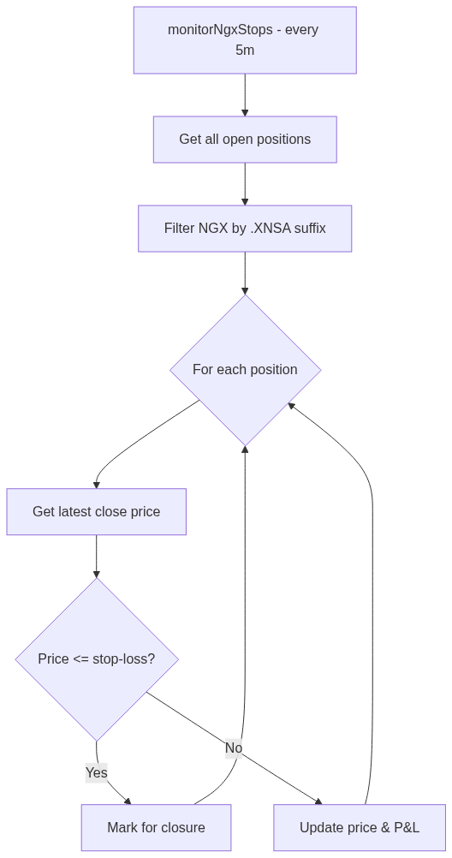
Stop-Loss Monitor - primary job flow
────────────────────────────────────────────────────────────

17. Portfolio Reconciler
Pre-market position reconciliation at 9:30 AM. Compares DB positions against broker holdings. Activates kill switch on mismatch.
File: src/main/java/com/ngxbot/execution/service/PortfolioReconciler.java

Dependencies
Type | Name | Purpose
Repo | PositionRepository | DB position data
Service | KillSwitchService | Kill switch activation
Service | NotificationRouter | Urgent alert routing
Gateway | BrokerGateway | Broker portfolio query

Database Tables
Table | Access | Notes
position | READ

WARNING: This scheduler can ACTIVATE the kill switch, halting ALL trading.

dailyReconciliation()
Schedule: 0 30 9 * * MON-FRI | Time: 09:30 | Days: Mon-Fri
Reconciles DB positions vs broker holdings; kill switch on mismatch

Execution Flow
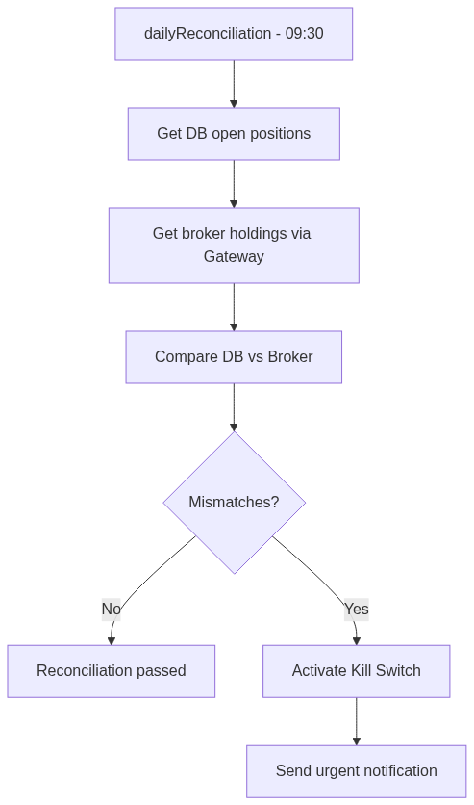
Portfolio Reconciler - primary job flow
────────────────────────────────────────────────────────────

18. Cash Reconciler
Pre-market cash reconciliation at 9:35 AM. Compares internal cash ledger against broker's actual balance. Kill switch on >2% mismatch.
File: src/main/java/com/ngxbot/execution/service/CashReconciler.java

Dependencies
Type | Name | Purpose
Service | SettlementCashTracker | Internal cash ledger
Service | KillSwitchService | Kill switch activation
Service | NotificationRouter | Urgent alert routing
Gateway | BrokerGateway | Broker cash balance query

WARNING: This scheduler can ACTIVATE the kill switch, halting ALL trading.

dailyCashReconciliation()
Schedule: 0 35 9 * * MON-FRI | Time: 09:35 | Days: Mon-Fri
Reconciles internal cash vs broker balance; kill switch on mismatch

Execution Flow
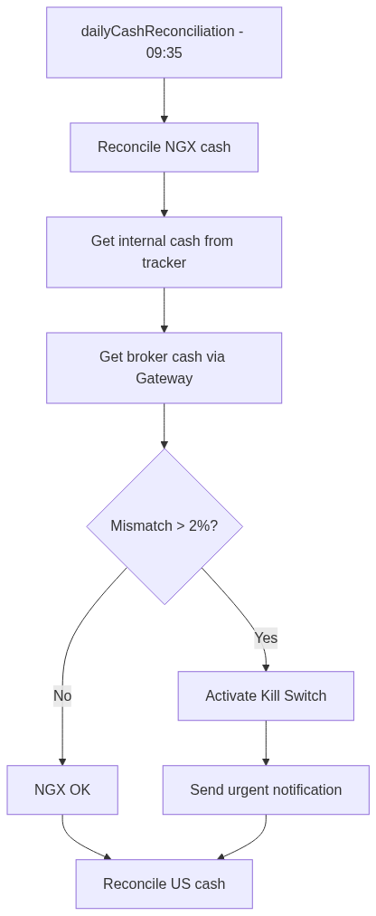
Cash Reconciler - primary job flow
────────────────────────────────────────────────────────────

19. Inter-Module Data Flow
Data flows through a pipeline: Collection gathers raw data, Analysis extracts insights, Signal Generation produces trade decisions, and Risk Management gates execution.
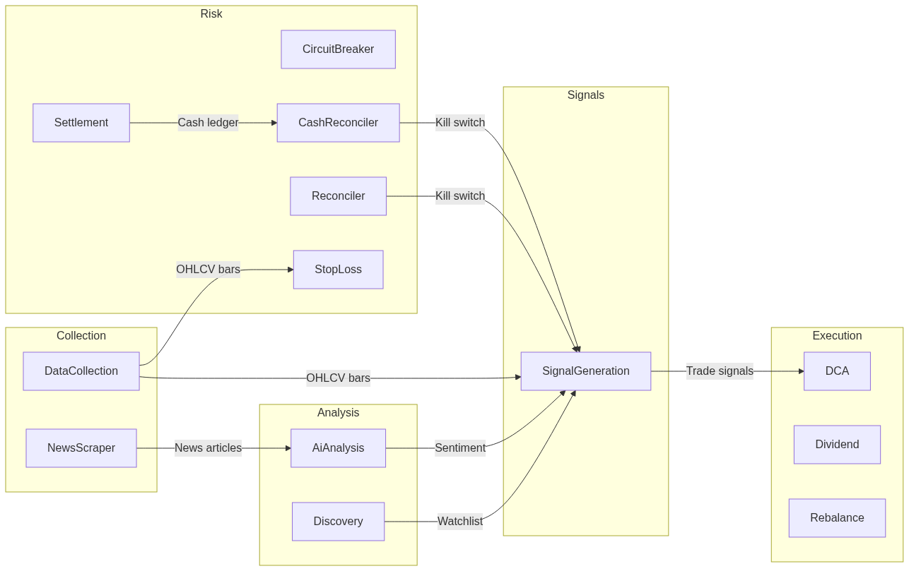
Cross-module data flow pipeline

Data Flow Details
Source Job | Data Object | Consumer Job
DataCollection.pullEodhdData | ohlcv_bar records | SignalGeneration, StopLossMonitor
DataCollection.preMarketNewsScan | news_item records | AiAnalysis
NewsScraper (3 scans) | news_item records | AiAnalysis
AiAnalysis.processUnanalyzed | ai_analysis (sentiment) | SignalGeneration
AiAnalysis.crossArticle | synthesis summaries | SignalGeneration
Discovery.weeklyScreener | discovered_stock (CANDIDATE) | Discovery.observation
Discovery.observation | discovered_stock (PROMOTED) | SignalGeneration
SignalGeneration (NGX/US) | trade_signal entities | Execution layer
SettlementCashTracker | CashLedger (available) | CashReconciler
PortfolioReconciler | Kill switch activation | All execution

20. Shared Service Dependency Graph
Several critical services are shared across schedulers. KillSwitchService and NotificationRouter are the most cross-cutting dependencies.
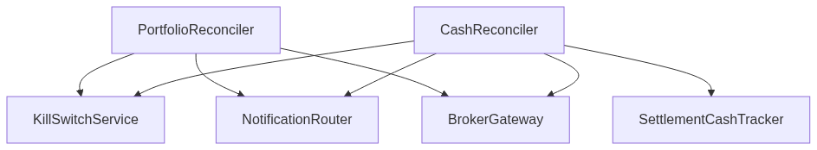
Shared service dependency graph

Shared Service Usage
Shared Service | Used By
KillSwitchService | PortfolioReconciler, CashReconciler
NotificationRouter | PortfolioReconciler, CashReconciler
BrokerGateway | PortfolioReconciler, CashReconciler
SettlementCashTracker | CashReconciler (reads ledger), Execution layer (records trades)
PositionRepository | PortfolioReconciler, StopLossMonitor
OhlcvRepository | StopLossMonitor, SignalGeneration (indirect)
CompositeSignalScorer | SignalGenerationScheduler
AiCostTracker | AiAnalysisScheduler (budget gating)

21. Risk & Safety Architecture
The trading bot implements multiple safety layers: kill switch for hard stops, circuit breakers for loss limits, and settlement tracking for cash management.

Kill Switch Interaction
Only PortfolioReconciler and CashReconciler can activate the kill switch. Once active, ALL trading halts until manual deactivation.
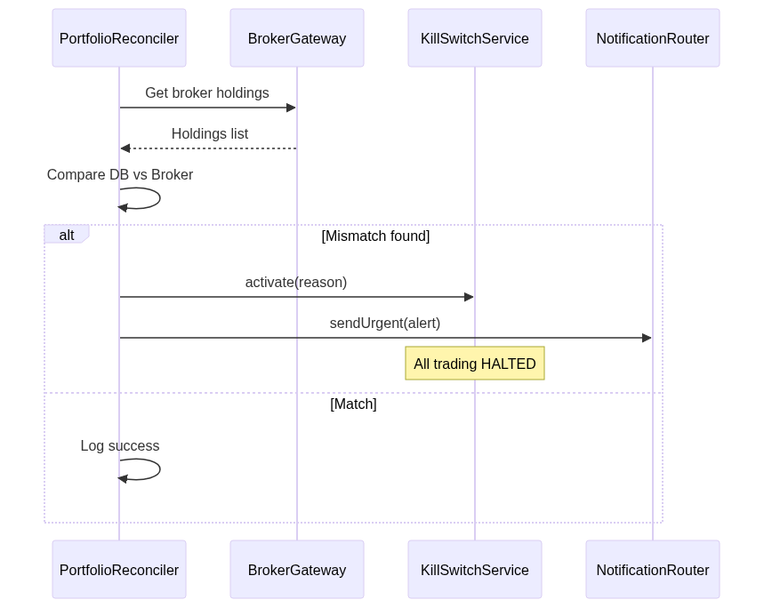
Kill switch activation sequence

Settlement Cash Flow
Sales enter a settling pool. NGX settles T+2, US settles T+1. SettlementCashTracker processes at 09:00 daily.
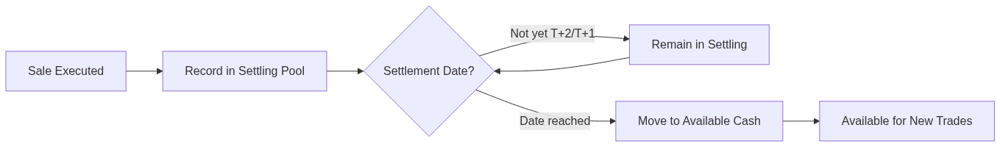
Settlement flow: sale to available cash

Signal-to-Execution Pipeline
Trade signals must pass through kill switch and circuit breaker checks before reaching the order router.
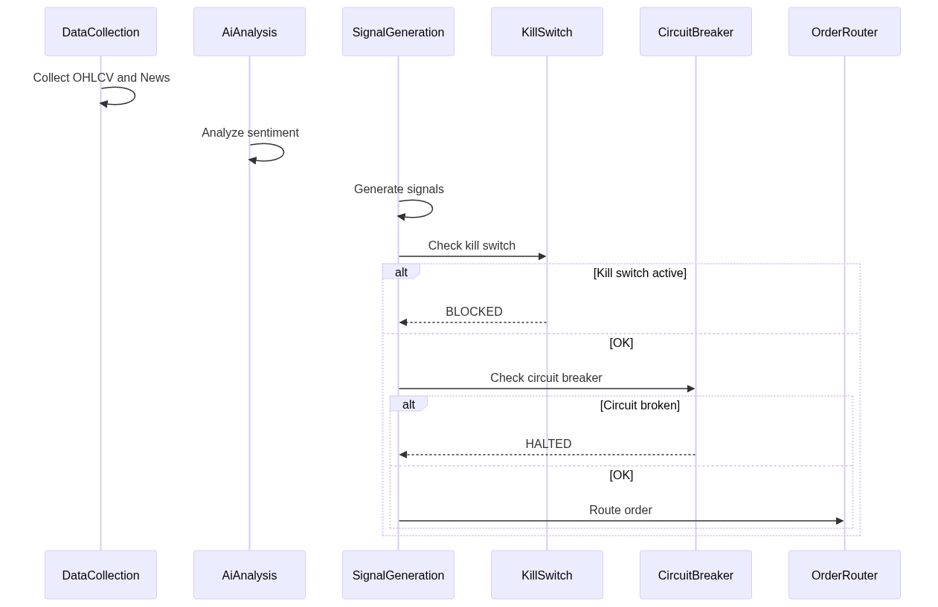
Signal to execution sequence

Discovery Lifecycle
Discovered stocks progress through states: CANDIDATE (new), OBSERVATION (promising), PROMOTED (active), DEMOTED (cooldown).
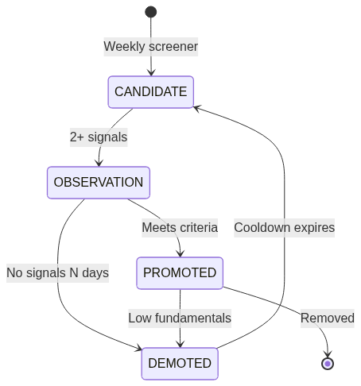
Stock discovery state machine

22. Schedule Reference Card
Compact reference of all scheduled tasks sorted by execution time.
Time (WAT) | Days | Scheduler | Method | Category
06:00 | Sunday | Discovery | weeklyScreenerScan | Discovery
08:00 | Mon-Fri | NewsScraper | earlyMorningNewsScan | Data Collection
09:00 | Mon-Fri | DataCollection | preMarketNewsScan | Data Collection
09:00 | Monday | DividendCheck | weeklyDividendCheck | Long-term
09:00 | Mon-Fri | SettlementCashTracker | dailySettlementProcessing | Risk
09:30 | Mon-Fri | PortfolioReconciler | dailyReconciliation | Execution
09:35 | Mon-Fri | CashReconciler | dailyCashReconciliation | Execution
10:15 | Daily | Dca | checkAndExecuteDca | Long-term
12:30 | Mon-Fri | NewsScraper | midDayNewsScan | Data Collection
15:00 | Mon-Fri | DataCollection | pullEodhdData | Data Collection
15:00 | 1st of Jan/Apr/Jul/Oct | Rebalance | quarterlyRebalanceCheck | Long-term
15:05 | Mon-Fri | DataCollection | scrapeNgxBackup | Data Collection
15:15 | Mon-Fri | SignalGeneration | generateNgxSignals | Signal
16:00 | Mon-Fri | DataCollection | scrapeEtfNavs | Data Collection
17:00 | Mon-Fri | NewsScraper | afterMarketNewsScan | Data Collection
20:00 | Mon-Fri | Discovery | dailyObservationCheck | Discovery
20:00 | Sunday | FundamentalUpdate | weeklyFundamentalUpdate | Long-term
20:30 | Mon-Fri | Discovery | dailyDemotionCheck | Discovery
21:00 | Mon-Fri | AiAnalysis | crossArticleSynthesis | Analysis
21:30 | Mon-Fri | SignalGeneration | generateUsSignals | Signal
Every 10m (10:00-22:00) | Mon-Fri | CircuitBreaker | periodicCircuitCheck | Risk
Every 15m | Always | AiAnalysis | processUnanalyzedArticles | Analysis
Every 5m (10:00-14:00) | Mon-Fri | StopLossMonitor | monitorNgxStops | Risk
Every 5m (15:00-21:00) | Mon-Fri | StopLossMonitor | monitorUsStops | Risk

Total: 24 scheduled tasks across 14 classes in 6 modules.

