

**494 Senior Project Report**

**SKIN CANCER DIAGNOSIS WITH DEEP LEARNING**

**TEMA**

|  |  |
| --- | --- |
| **Team Members :** | **Tuğba GÜL, Elif KUBİLAY,**  **Alp AYDEMİR, Mustafa SÜTCÜ** |

|  |  |
| --- | --- |
| **Supervisor** | **: Dr. Öğ. Üyesi Güzin TİRKEŞ**  **09.03.2022** |

**TABLE OF CONTENTS**

ABSTRACT 1

2. LITERATURE REVIEW 4

3. REQUIREMENTS 8

**3.1 Overall Description** 8

**3.1.1 Product Perspective** 8

**3.1.2 User Classes And Characteristics** 8

**3.1.3 Operating Environment** 8

**3.1.4. Design And Implementation Constraints** 8

**3.1.5. Assumptions** 8

**3.2. Specific Requirements** 9

**3.2.1 External Interface Requirements** 9

**3.2.2. Functional Requirements** 9

**3.2.3. Non-functional Requirements** 9

4. DESIGN 11

**4.1 Overview** 11

**4.1.2 Purpose** 11

**4.2 Software Methodology** 11

**4.3 System Architecture** 12

**4.4 Use Case Diagram** 13

**4.5 Use Case Documents** 14

**4.5.1Upload Photography** 14

**4.6 Collaboration Diagrams** 15

**4.6.1Uploading images to the system** 15

**4.7 Deployment Diagram** 15

**4.7.1 Uploading Images To The System** 16

**4.8 ER Diagram** 17

**4.9 User Interfaces** 17

**4.9.1 User Uploads Photography** 17

**4.9.2 User Upload By Taking A Photography** 18

**4.10 Budget** 19

**4.11. Project Milestones and Timeline** 19

5. TESTING 19

6. EVALUATION 26

8.CONCLUSION 30

9. REFERENCES 31

**LIST OF FIGURES**

**Figure 1:** Comparison Of C4net With Other Representatives..………………………….........5

**Figure2:** Agile Methodology Cycle……………………………………………………….…..9

**Figure3:** System Architecture……………………………………………………………......10

**Figure4:** Use Case Diagram……………………………………………………………..…...11

**Figure5:** Collaboration Diagram……………………………………………………………..12

**Figure6:** Deployment Diagram……………………………………………………………....12

**Figure7:** Er Diagram Of The System……………………………………………………..…14

**Figure8:** Loading Page Of User İnterface………………………………………………..…..15

**Figure9:** User Interface Prediction Page……………………………………………………..15

**Figure10:** Project Timeline and Milestone…………………………………………………..17

**LIST OF TABLES**

**Table 1:** Literature Comparison …………………………………………………….…….…3

**Table 2:** Classification Performance Metrics……………………………………………..…..5

**Table 3:** Photograph Specialists Of Uploading The System………………………….……..11

**Table 4:** The Format Properties Of The Photo……………………………………………....13

**Table 5:** The Properties Of Dataset………………………………………………….……...13

**Table 6:** Total Budget Table For Employees Of The Project………………………………..16

# **ABSTRACT**

Skin cancer is a type of cancer that is frequently diagnosed across the world. It occurs as a result of factors such as exposure to ultraviolet (UV) rays, less pigmentation on the skin, aging, gender, genetic predisposition, exposure to particular chemicals like arsenic, exposure to radiation therapy, weak immune system, long-term UV light treatment. Cancer appears when a cell divides uncontrollably. Skin cancer is caused by the formation of tumors as a result of mutations in DNA. There are two types of melanoma known as benign and malignant. The benign tumor has a low rate of spread and is not cancerous. The malignant tumor is formed by the abnormal development and division of cells in the body and does not have stable symptoms. Early diagnosis of malignant tumors is not easy for dermatologists. [1] The first step in the diagnosis of skin cancers is a doctor's examination. Afterward, a biopsy is applied to determine the type of cancer and its spreading. Accurate and early diagnosis of melanoma may increase the probability of successful treatment[ 2]. However, diagnostic schemes such as the ABCD rule [3] or the 7-point checklist [4], which physicians commonly use for lesion diagnosis, do not give accurate results every time because they involve human interpretation and subjectivity [5]. The recent emergence of deep learning on the purpose of medical imaging may help physicians make better decisions in diagnosing a disease. At the same time it has contributed also the development of technical diagnostic systems related to medical imaging. In our project, our plan is to create a program based on a deep learning method in classifying a dermoscopic image containing a skin lesion as malignant or benign. The proposed solution is built around convolutional neural network architecture and uses a cancer learning paradigm. For the web-based software created in this research, Python and Deep Learning Algorithm CNN was used in the background.

1. **INTRODUCTION**

According to the world cancer statistics of the World Health Organization- International Agency for Research on Cancer (IARC) 2020, there are 1.2 million cases of non-melanoma skin cancer worldwide. [6] As the environmental pollution increases day by day and the ozone layer gets thinner, people's exposure to UV rays has increased due to the amount and effect of UV rays coming to our world. In this case, it directly contributed to the increase in skin cancer cases, because UV rays and solarium devices are the leading factors that cause skin cancer. In addition, skin diseases are not only caused by UV rays but also by a fungal infection, bacteria, allergies, viruses, etc. When all factors are taken into consideration, skin cancer has a very threatening feature worldwide. With the development of medical technology, laser, and photonics-based devices are used in the diagnosis of skin cancer. However, treatment with laser photonic devices is currently limited and considered as quite expensive. It is also very difficult to diagnose skin cancer correctly. Recently, deep learning algorithms have emerged to achieve much better performance in different tasks. This learning method, which is also used in the diagnosis of cancers such as lung, breast, brain has been used especially in the diagnosis of skin cancer or skin diseases, and successful results have been obtained. It has created an automatic dermatological scanning system. Deep learning methodologies are used in these systems, whose aim is to get faster and more accurate results. Deep learning is a type of machine learning that uses neural networks to enable digital systems to learn and make decisions based on unstructured, unlabeled data. [7]. Artificial intelligence systems are trained in order to examine the information which they receive from the data, recognize the patterns, offer suggestions based on the patterns which they have learned, and adapt. Deep learning, which includes neural networks and similar machine learning, is more widely used than traditional learning methods. When it is considered that the deep learning methods are used in the field of health; Bioinformatics; Cancer diagnosis, Gene selection and classification of Denoising auto-encoders, Deep belief networks, and Deep neural networks methods are used for gene diversity detection, Tissue classification, Organ segmentation, Cell clustering, Internal bleeding detection, and Tumor detection, which are the fields of Medical Imaging Applications. Convolutional deep belief networks, Convolutional neural networks, Denoising auto-encoders, Deep neural networks are the methods. In addition, disease prediction, human behavior monitoring, data mining are medical informatics applications in which deep learning methods are used [8]. Deep learning methods used in medical informatics applications can be listed as Deep belief networks, Convolutional neural networks, recursive neural networks, Convolutional deep belief networks, Deep neural networks.

In our project, we’ve proposed a method based on processing image in order to detect skin cancer, which is included in the field of medical informatics application and bioinformatics. This method takes a digital image of the affected skin area, then uses image analysis to determine the type of disease. Our proposed approach is simple, fast, and doesn’t require any expensive equipment other than a computer. The approach works on the inputs of a color image. Then it resizes the image to bring out features by using the pre-trained convolutional neural network. Finally, the results are displayed to the user, including the type.

# **LITERATURE REVIEW**

In the literature research which we did for our project, we had the opportunity to examine the projects developed on this subject before us. We examined the methods and algorithms used in the studies. In our research from general to specific, we continued our research by examining the projects related to other cancer types and focused on skin cancer. In this section, we discuss on the similarities and differences between the studies in the articles we have examined in the literature and our studies. We present how previous studies have guided us.

We reviewed studies using the following datasets in our research on skin cancer. In the table below, we have given the name, link, class number, dataset size, and presence of noise of the datasets.



Table 1 **–** *Literature Comparison*

The size and diversity of the data set to increase the classification performance. This is why; we chose the skin-cancer-malignant-vs-benign dataset among the datasets we examined. The deep learning method has also been used for the detection of other cancer types. For breast cancer diagnosis, Chen, Xu, Wong, Wong, & Liu presented a model for automatic glaucoma diagnosis using the deep learning technique CNN method in their study. The proposed model architecture includes six learned layers: four CNN layers and two fully connected layers. It was tested on ORIGIN and SCES datasets. The accuracy rate was found as 88% through this method [9]. Ma J. et al. used CNN to distinguish thyroid nodules from ultrasound images more accurately, inasmuch as, the heterogeneouses and backgrounds on thyroid images make detection of nodules more difficult on images. CNN used sections of benign and malignant thyroid images as input and produced segmentation probability maps as output. The experimental results showed that the recommended method’s performance is quite well in detection of nodule and CNN can identify nodules accurately and influentially [10] We are studying on the detection of skin cancer in our project. There are many studies and methods in the literature to identify and classify skin cancers. Deep learning and classical machine learning are among these methods. Classifying skin cancers through classical machine learning methods generally consists of four steps. These steps are respectively; preprocessing of image, segmentation of lesion, bringing out features from the lesion, learning and classifying these features. Deep Learning (DL) models have been successfully applied in many fields including medical image classification, and have begun to replace machine learning methods[11] Deep learning architectures can classify through learning from the representative data. “The basis of deep learning is consisted by artificial neural networks. Deep learning architectures can operate on many data by learning from the representative data. That’s why; they have more hidden layers than traditional artificial neural networks”[12]. The most remarkable one of DL models is Convolutional Neural Networks (CNN). CNN is commonly used for image recognition problems because of its classification performance. There are many CNN models in the literature; “C4net, AlexNet, GoogLeNet, VGGNet, and ResNet are remarkable CNN models. Evaluation of the classifiers in the studies according to their features indicated on Table 3:

AlexNet: Average classification accuracy was obtained as 93.93% with 150 cycles (epoch), 10-fold cross-validation.

GoogLeNet: Average classification accuracy was obtained as 94.95% with 150 cycles (epoch), 10-fold cross-validation.

VGGNet: Average classification accuracy was obtained as 94.85% with 150 cycles (epoch), 10-fold cross-validation.

ResNet: Average classification accuracy was obtained as 92.96% with 150 cycles (epoch), 10-fold cross-validation

C4Net: Average classification accuracy was obtained as 96.94% achieved with 150 cycles (epoch), 10-fold cross-validation”[13]

|  |  |  |
| --- | --- | --- |
| Criteria | Formula | Description |
| Accuracy |  | Overall effectiveness of a classifier |
| Sensitivity |  | Effectiveness of a classifier to identify positive labels. Also called true positive rate |
| Specificity |  | How effectively classifier identifies negative labels. Also called true negative rate |
| Precision |  | Class agreement of the data labels with the positive labels given by the classifier |

Table 2 : *Classification Performance Metrics*

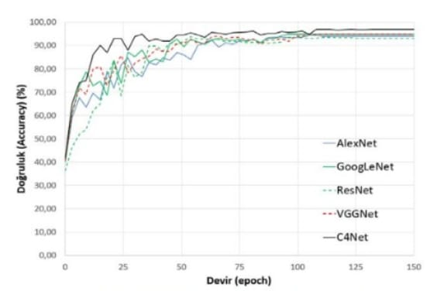

Figure 1*: Comparison Of C4net With Other Representatives*

An automated and reliable computer-aided diagnosis (Computer-Aided Diagnosis, CAD) system to recognize skin cancer is an important assessment tool that provides dermatologists with a second opinion to support their decisions and help them. In the study of Codella et al., the support vector machine was used as a classifier and the accuracy was obtained as 88.8% [14], Matsunaga et al. used data of 1444 additional images in their study. They obtained 82.8% accuracy and value of area under the curve(AUC) as 95.8% in the classification of melanoma using the deep convolutional neural network (CNN) structure as a classifier.[15], Guo and Yang used Multi-channel ResNet deep neural network architecture in their study. They achieved 82.4% accuracy and 91.7% AUC performance in their studies[16], and Chen et al. designed a multitasking structure for the classification process. The structure they designed is composed of two parts as the segmentation network, and the classification network. They achieved 80.1% accuracy through the classification performance of this structure [17]. Using deep learning methods in the diagnosis of cancer is a successful method in accordance with the knowledges in the articles that we have reviewed. We’re also going to use deep learning (DL) in our project for the diagnosis of skin cancer.

# **3. REQUIREMENTS**

In this section we describe the functional and non-functional requirements of our project in detail and descriptively. Our aim is to make a correct plan in the project development process and to spend our project process efficiently.

## **3.1 Overall Description**

### **3.1.1 Product Perspective**

We aim to facilitate the diagnosis of skin cancer when we complete our project. Therefore, we don’t want the program developed by us to be confusing for users. This is why; we are developing a system being used easily. In our interface the user will upload a photo of the area having potential cancer risk to the system and learn the answer whether it is cancerous or non-cancerous through high accuracy estimation.

### **3.1.2 User Classes And Characteristics**

The system gives a result about that it is cancer or not for potential melanoma whose photo is uploades according to similarity rate.

### **3.1.3 Operating Environment**

The software is a web application that uses client-server interaction via HTML and javascript.

### **3.1.4. Design And Implementation Constraints**

-This software is web-based and runs on all operating systems.

-Our system can work without any internet connection.

-Photos uploaded to the system are evaluated as cancerous or non-cancerous and added to the database.

### **3.1.5. Assumptions**

-While creating the program, Keras, NumPy, TensorFlow, pillow libraries were used.

-Pre-trained data was used in our model.

- To use the Python language in the training of the model has been approved.

-The latest version of the software program Python 3.10.2 is used.

-Using HTML and javascript on the interface is considered as a good component.

## **3.2. Specific** **Requirements**

### **3.2.1 External Interface Requirements**

#### **3.2.1.1. Hardware Interfaces**

-Our project has been developed with deep learning technology. Devices to work in the system must work with GPU.

#### **3.2.1.2. Communication Interface**

-Our web application connects via HTTP.

-Our software has been trained with Keras and TensorFlow.

-The trained model has been written in python.

-The user uploads the photo to the page and gets the result.

#### **3.2.1.3. User Interface**

-Usage is quite simple.

-The user takes a photo of the area with potential cancer risk and uploads it to the system.

#### **3.2.1.4. Software Interfaces**

-Keras and TensorFlow are used.

### **3.2.2. Functional Requirements**

-User must log in the system

-The user must upload a photo of the possible disease area of ​​his skin to the system.

-The system must detect and scan the photo

-The system must tell the user whether the uploaded photo carries a cancer risk.

### **3.2.3. Non-functional** **Requirements**

#### **3.2.3.1. Performance Requirements**

-The user can see the results in a few seconds after uploading/taking the photo.

#### **3.2.3.2. Availability**

-The system is opened for using along 24 hours in a day, 365 days in a year.

**3.2.3.3 Usability**

-The system can work online and offline

-The system supports different network protocols.

-It provides easy usage through its simple structure.

#### **3.2.3.4. Reliability**

Photos uploaded by the user are going to be designed within the framework of the law on the protection of personal rights by preventing sharing with third parties except of the patient and doctor.

# **4. DESIGN**

## **4.1 Overview**

This document contains software design descriptions for "Image Classification" CNN project. This document provides a general description of the project design in details related to how the project should be built.

**4.1.1 Scope**

The project is an Image Classifier using CNN technology. It is designed as a web application and does not have a web page version. It can be used only for diagnosis of skin cancer among cancer types.

**4.1.2 Purpose**

The purpose of this study is to explain the software system structured to provide the requirements of artificial intelligence created for the diagnosis of skin cancer. This document is intended for all project stakeholders, and it is not limited to software developers, project managers, system administrators, and customers.

## **4.2 Software Methodology**

In this project we used the agile method as a software development method. The purpose of using this method is to present our project with a team spirit and to direct our project in accordance with changing needs and requests, to make iterative plans instead of detailed plans and processes, to respond the change instead of following a plan, to be able to adapt quickly to changing conditions, to provide individual interactions rather than processes and tools, to ensure sustainable quality because planning and execution match each other. Team members must constantly make decisions, share ideas, and we must cooperate with the project team. That’s why; we follow the agile method steps. It is indicated on Figure 2.

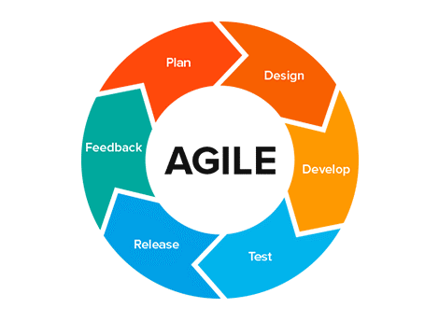

Figure 2 *Agile methodology cycle*

## **4.3 System Architecture**

Our skin cancer diagnosis system, which we created by using deep learning consists of some stages. Firstly, there should be a viewing page for the user to login. The view page was created by using html and JavaScript codes, and the python software language was used to make the prediction of the machine. In addition, the algorithm which we use and is inspired by our literature searches, is the CNN algorithm. The working logic is as follows; The user JPEG of a photograph of the suspected tissue on the skin. Uploads to the system in format. The captured image is processed within a few seconds for analysis. It makes an estimation, either malignant or benign, and the estimation is displayed on the user's screen.

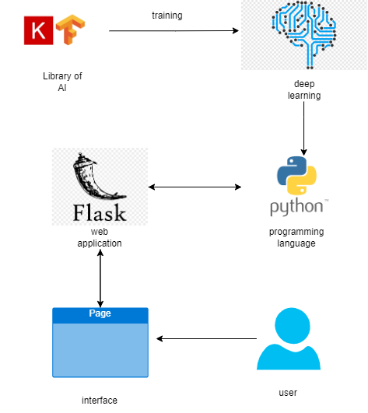

Figure 3*: System Architecture*

## **4.4 Use Case Diagram**

Unified Modeling Language, which its use case diagrams are used in modeling software and other systems, is one of the 14 diagrams of UML.[9] In this section our purpose is to view the whole picture from the user's point of view with the correct determination of our necessities. The roles and actors of the system created for the diagnosis of skin cancer are shown in the figure below. Our actor was defined as the “user” who will use the system. The roles of the user are to log in the system, upload the photo in the desired format, and view the result.

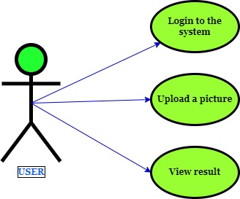

Figure4 : *Use Case Diagram*

## **4.5 Use Case Documents**

### **4.5.1Upload Photography**

|  |  |
| --- | --- |
| **Description:** | This use case contains scenarios and other details for user registration into the application. |
| **Actors:** | User |
| **Use Case ID:** | USECASE1 |
| **Use Case Name:** | Upload a picture |
| **Prerequisites:** | User entering this application |
| **Main Success**  **Scenario:** | 1-)The user selects a picture  2-) User uploads images. |
| **Final Conditions:** | 1-)The user has uploaded the picture.  2-) The picture has been displayed on the screen. |

Table 3 : *Photograph Specialists Of Uploading The System*

## **4.6 Collaboration Diagrams**

### **4.6.1Uploading images to the system**

Communication diagram that conveys the dynamic relations between classes in a system via messages is a behavior diagram.[10] The following colloboration diagram is used in our system.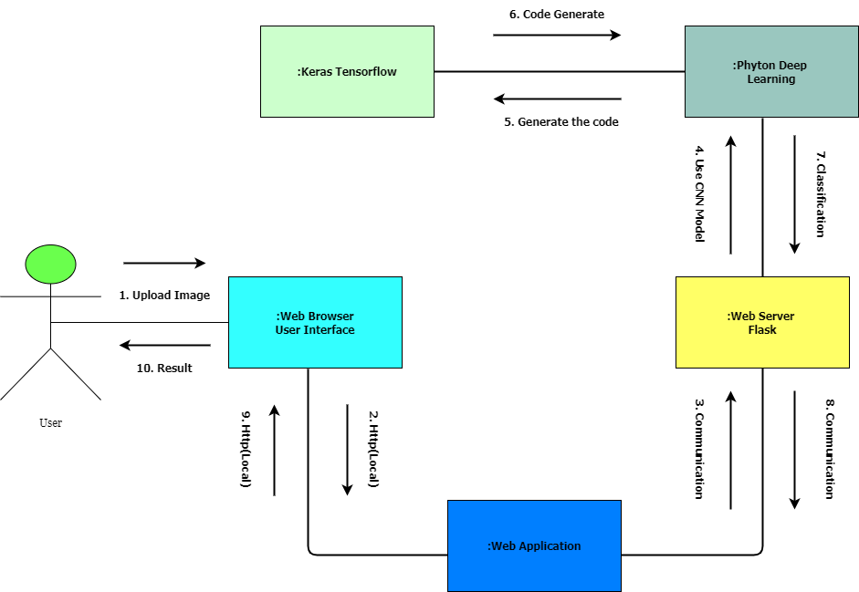

Figure 5: *Collaboration Diagram*

## **4.7 Deployment Diagram**

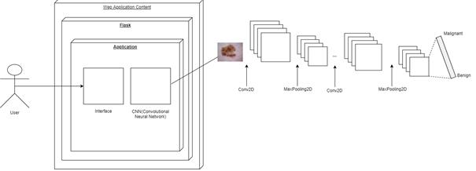

Figure 6: *Deployment Diagram*

### **4.7.1 Uploading Images To The System**

The format properties of the photo to be uploaded to the system are given in the table below.

|  |  |
| --- | --- |
|  | Format : JPEG |
| Dimensions: 224x224 |
| Width: 224px  Height :224px |
| Horizontal Resolution: 96dpi |
| Vertical Resolution : 96 dpi |
| Size: 6.12 KB (6,272 bytes) |
| Size On Disk: 8.00 KB (8,192 bytes) |

Table 4: *The Format Properties Of The Photo*

|  |  |
| --- | --- |
| Dataset Name | skin-cancer-malignant-vs-benign |
| Dataset Link | https://www.kaggle.com/datasets/ehabibrahim758/skincancermalignantvsbenign?select=data |
| Number of Classes | 2 |
| Class Distribution | Equal |
| Dataset Size | 170 MB |

Table 5: *The Properties Of Dataset*

## **4.8 ER Diagram**

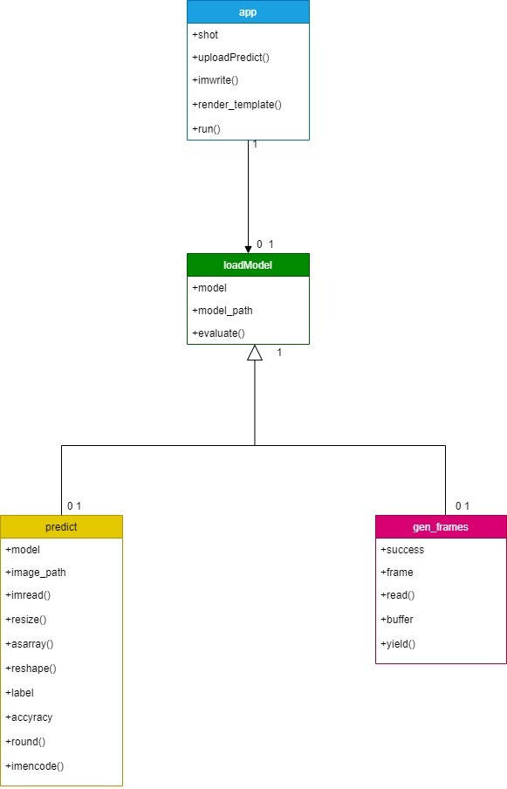

Figure 7*: Er Diagram Of System*

## **4.9 User Interfaces**

### **4.9.1 User Uploads Photography**

In the user interface for the user to upload the image to the system; User takes a photo of the lesion with a high resolution tool, saves it and uploads it to the area specified below. Selected file button is used for the upload process.

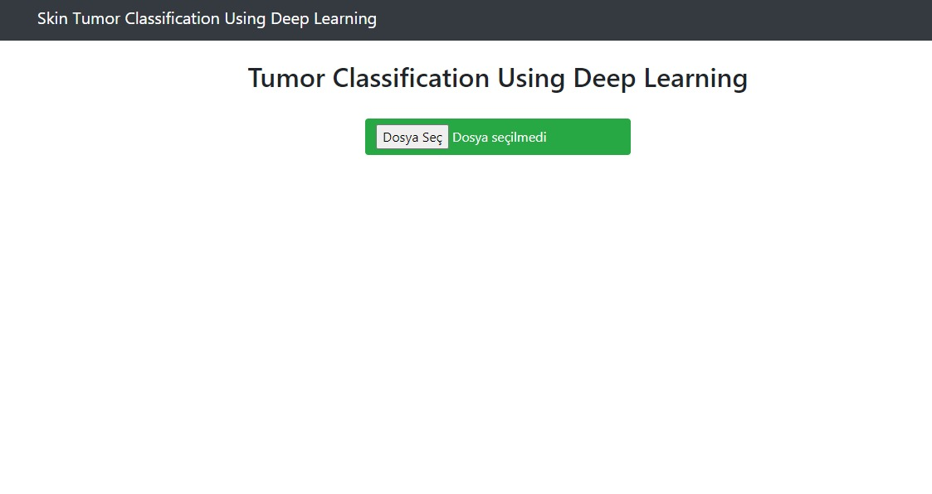

Figure 8: *Loading Page Of User İnterface*

### **4.9.2 User Upload By Taking A Photography**

The imaged lesion is displayed as a photograph on the screen. When the user presses the guess button, a guess appears on the screen. Machine indicates that lesion is benign/malignant

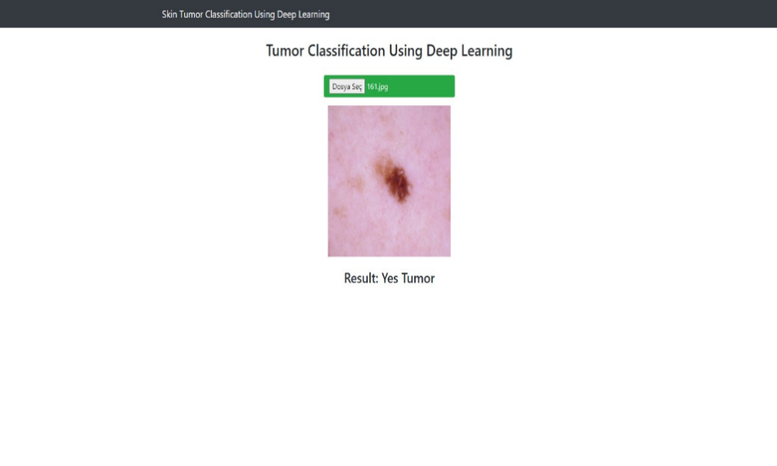

Figure 9 : *User Interface Prediction Page*

## **4.10 Budget**

One of the most important elements in the software development process is budget planning. Estimating the cost is required in project management to complete the project. Visual Studio Code was used to design and code the interface. The tables displaying the cost of our project are as follows. In addition to our table, Visual Studio Code costs 3.232 TL.

|  |  |  |  |  |
| --- | --- | --- | --- | --- |
| **EmployeeRole** | **NumberOfEmployees** | **Monthly Fee** | **Working Month per Person** | **Total** |
| ProjectManager | 1 | 13000₺ | 4 | 52000₺ |
| Architecture Designer | 1 | 13000₺ | 4 | 52000₺ |
| Software Developer | 4 | 8000₺ | 4 | 128000₺ |
| UI Designer | 1 | 6500₺ | 4 | 26000₺ |
| Software Analyst | 1 | 6000₺ | 4 | 24000₺ |
| Reporting Officer | 1 | 5800₺ | 4 | 23200₺ |
| Testing | 1 | 5800₺ | 4 | 23200₺ |
| Computer gpu | 1 | 15000₺ | - | - |

**Table 6:** Total Budget Table For Employees Of The Project

## **4.11. Project Milestones and Timeline**

Figure 10: *Project Timeline and Milestone*

# 

# **5. TESTING**

mainTrain.py

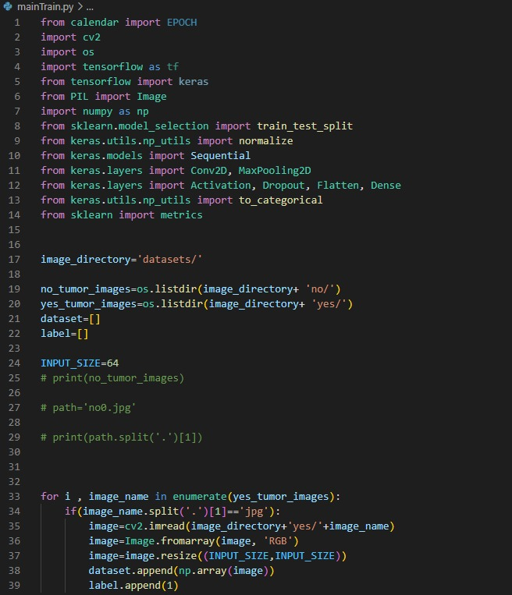

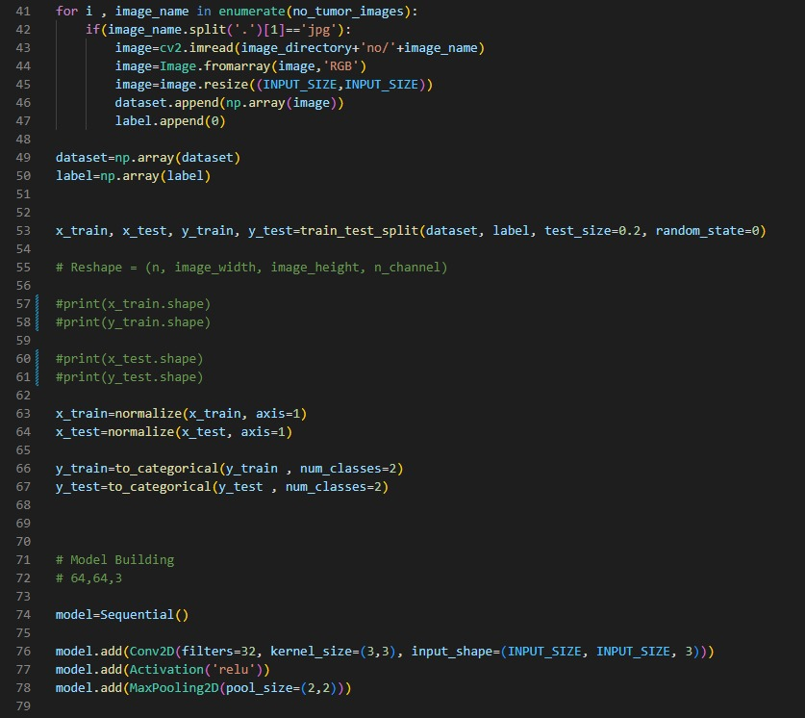

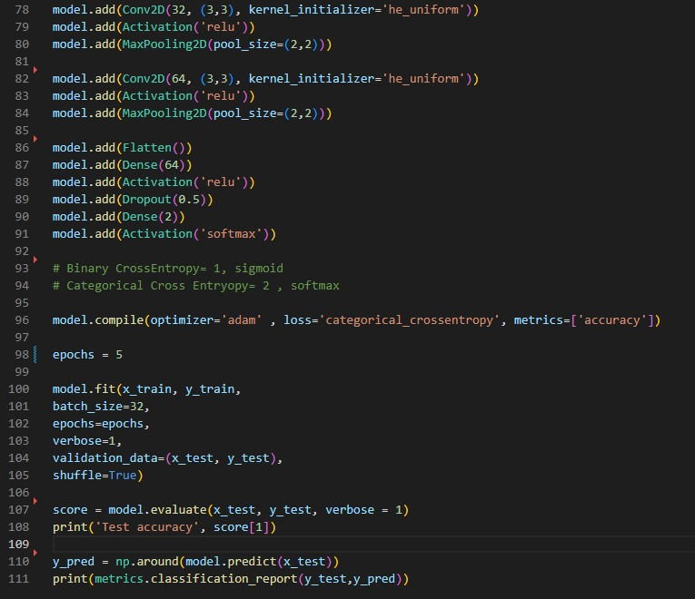

mainTest.py

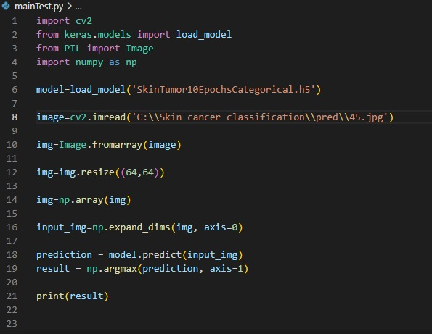

App.py

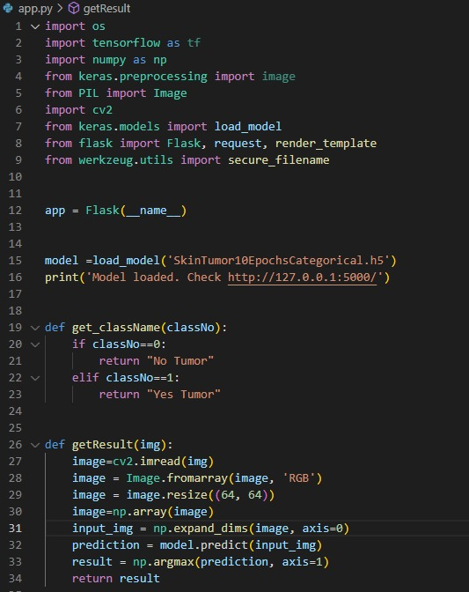

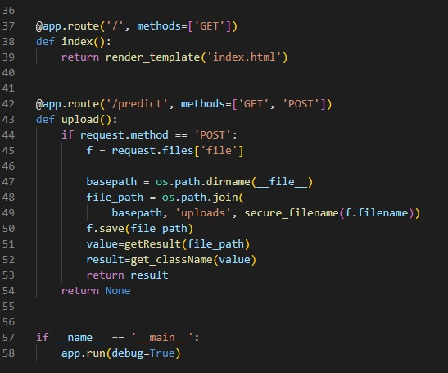

newjs.js

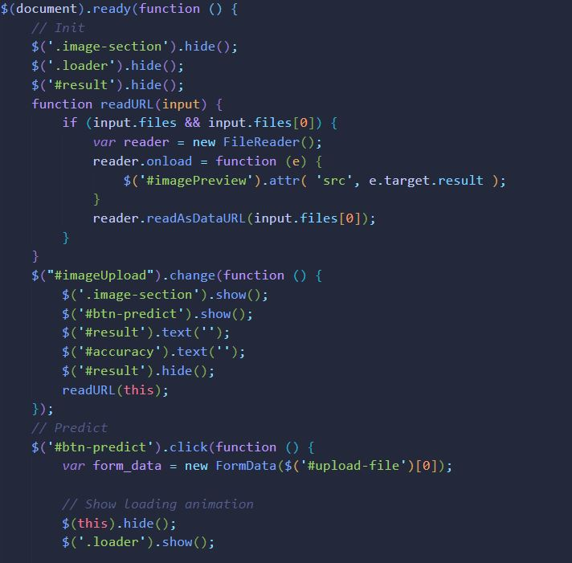

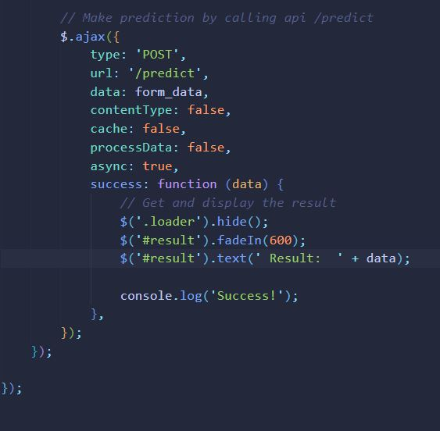

İmport.html

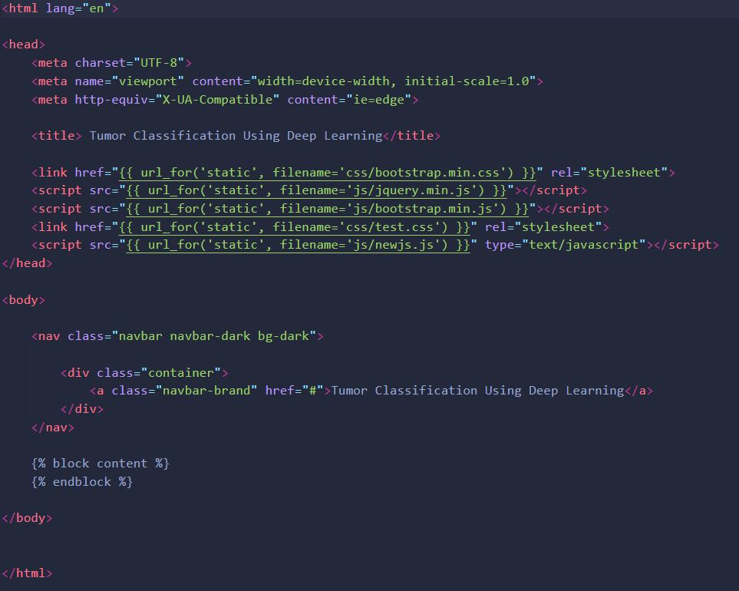

İndex.html

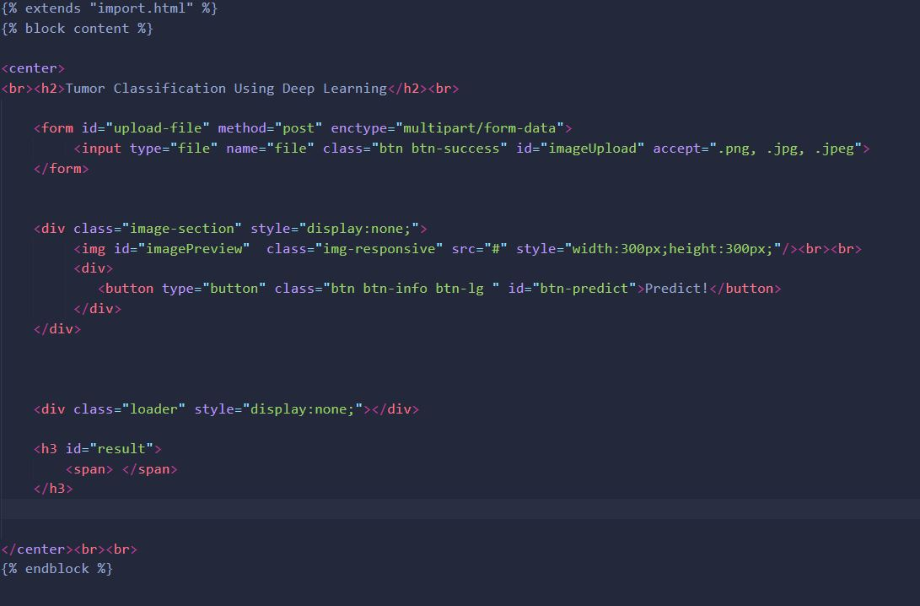

test.css

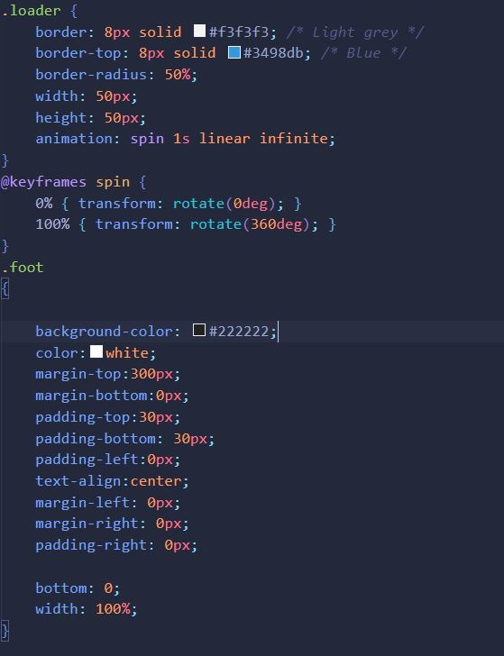

|  |  |  |  |  |
| --- | --- | --- | --- | --- |
| TEST DATASET | Accuracy | F1 | Precision | Recall |
| Synthetic1 | 0.7746 | 0.8234 | 0.7534 | 0.9043 |
| Synthetic2 | 0.7345 | 0.7264 | 0.8464 | 0.6354 |
| Real3 | 0.7611 | 0.7553 | 0.8834 | 0.6532 |
| Real4 | 0.7878 | 0.8265 | 0.7865 | 0.8776 |

* Performance metrics when the CNN is trained using combined dataset.

|  |  |  |  |  |  |
| --- | --- | --- | --- | --- | --- |
| Train Datasets | Test Datasets | | | | |
| Synthetic1 | Synthetic2 | Real3 | Real4 | Real5 |
| Synthetic1 | 0.7910 | 0.0719 | 0.0570 | 0.3004 | 0.0020 |
| Synthetic2 | 0.7244 | 0.7910 | 0.7532 | 0.7001 | 0.7123 |
| Real3 | 0.5305 | 0.8045 | 0.8232 | 0.7345 | 0.8483 |
| Real4 | 0.7402 | 0.8032 | 0.7690 | 0.8844 | 0.8021 |
| Real5 | 0.8434 | 0.4034 | 0.2643 | 0.4323 | 0.7345 |

F1 values of the models trained and tested with dataset.

**6. EVALUATION**

**Topic**

* The system has been developed as a series of releases or increments with stakeholders involved in release specification and evaluation. It analyzes the photographic images at hand, classifies them according to the state in which it is ill or not and makes strong predictions.
* Documentation is used as little as possible and it is mostly focused on code in the process.
* The interface we developed can be used easily. It is user friendly.

**Performance**

* The user-friendly interface is designed to be simple and understandable, loading the image and getting a response is very fast. The code running in the background responds quickly.

**Usability**

* One of our goals is to make the system easy to be used by the user and to arrange it in a way that minimizes user errors. The buttons in the interface created by us are designed as very simple and easy to use.
* As the usage of the system increases, the performance of the user will increase and the errors arising from the usage of the system will decrease in comparison with the first use.

**Deployment**

* The created system cannot be accessed without an internet connection.
* The program that we designed only for windows operating system needs to be rearranged in order to use it in another operating system.

**Maintenance**

* It is prepared for all users with Windows operating system and any internet browser.
* All necessary algorithms are provided to users.

**Backup & Recovery**

* The data entered to predict the system is kept in the background in the program.

**Security**

* Only photos are uploaded to the system. None of personal information about the patient is required.
* Backups of the uploaded images are not kept, only the user accesses the image in the process that the machine will guess.
* HTTP protocol is valid.

**7. IMPACT OF THE PROJECT & COMPLIANCE WITH THE CONSTRAINTS**

**7.1. Project Milestones**

Before we developed our project, we knew that there were constraints that we might encounter, while determining the constraints in addition to cost, time and scope constraints, we determined quality, user satisfaction and available resource constraints. We have demonstrated all our constraints in a table below.

(NA: It means there is no item.)

|  |  |  |
| --- | --- | --- |
|  | **ECONOMIC FACTORS** | |
| **EXPENDITURES** |  | |
| COMPUTER | Personal computers of team members are used during the development and preparing report of the software. | |
| OTHER DEVICES | NA | |
| PERIPHERALS | NA | |
| INTERNET CONNECTION | During the study period, each team member has used her/his own Internet connection. | |
| SOFTWARE | Python Flask is used for user interface in Microsoft Visual Studio. Windows is used as operating system. | |
| SUPPORT MATERIAL | Some Articles on Google | |
| HUMAN RESOURCES | Human resources of the study consist of a team that includes 4 members. | |
| OTHER | NA | |
|  | | **FUNDING SOURCES** |
| UNIVERSITYRESOURCES | | NA |
| PROJECT SUPPORT | | NA |
| INDUSTRY | | NA |
| SELF-FUNDED | | NA |
| OTHER | | NA |
|  | | **OTHER CONSTRAINTS** |
| MEMORY | | It is used on the user's own personal computer and the programs to run it take up space. |
| RUNTIME EFFICIENCY | | Runtime efficiency constraints are met because the software has affordable level data. |
|  | | **MANAGERIAL** |
| SCHEDULE | | The time is allocated for the study is 18 weeks, all tasks are done properly on time. There is no problem in terms of scheduling. |

**7.2.** **Impact of the Project**

We developed our project with the academicians of Atılım University ISE/CMPE department. The compliance of our project with ethical rules within the scope of social, health and environmental issues was discussed. The necessary information is provided in the table below.

(NA: It means there is no item.)

|  |  |
| --- | --- |
| **Professional/Ethical Issues** | |
| **ETHICS/IT Law** | |
| Copyright in copying multimedia (sound, video, text) | NA |
| Use of licensed software | Visual Studio Code |
| Data Privacy | NA |
| Use of patented products/ideas | NA |
| IT Laws in Turkey (5661 and others) | There is no situation that violates any law locally or nationally |
| IT Laws – International | There is no situation that violates any law locally or nationally |
| Plagiarism | There is no similarity in code and reports. |
| **PROFESSIONAL** | |
| Sustainability (use of Licensed and/or open-source code) | Use open-source application |
| Maintenance | The system does not need maintenance at certain intervals, but this situation may change according to user demand. |
| Liability | The project manager is responsible for errors in the code. |
| Financial impact/Manufacturability | NA |
| Sustainability (use of Licensed and/or open-source code) | NA |
| **SOCIAL/POLITICAL/ ENVIRONMENTAL** | |
| Political impact | It is a skin cancer analysis system. Provides early diagnosis for the user. |
| Impact on health | NA |
| Gambling | NA |
| Pornography | Anyone can access the system |
| Equal Access/equity | NA |
| Environmental impacts (energy, carbon  footprint and so on) | NA |
| Technology acceptance & Human/Business psychology | NA |
| Security issues | NA |
| **PROFESSIONAL (CODES, STANDARDS, FRAMEWORKS)** | |
| IEEE | NA |
| ISO | NA |
| ANSI | NA |
| TSE | NA |
| ITIL/COBIT | NA |
| OTHER | APA style is used to prepare the report. |

# 

# **8.CONCLUSION**

The objective of this senior project is to develop an application for the diagnosis of skin cancer that enables the dermatologist to strengthen the malignant/benign prediction of the skin lesion. Before starting to develop our project, a comprehensive literature review was carried out and previous similar studies were reviewed. A top-down approach was adopted in our research, starting with the general title of cancer diagnosis and narrowing it down to skin cancer diagnosis. After getting enough information, our app was created.

A computer with features that support the artificial intelligence program is sufficient for usining the application.. In our system, which can be used quite easily, a photo of the area where the lesion is located is taken and uploaded to the system, and the machine is asked to estimate the JPEG of the photo to be considered here. Format is uploaded to the system. While creating our system, a method based on image processing was used. While making our skin cancer classification, we studied on the dataset prepared for this purpose. 2109 images were used for training the system. 528 images were used for test. It means that we use 80% of our data set from Kaggle for training and 20% for testing. As you can see in the test part of our project, our accuracy rates are approximately 0.8011.

Some technical information about our project; It is a web application that uses client-server interaction via HTML and javascript. We used Keras, NumPy, TensorFlow, Pillow and OpenCV libraries while creating the program. We used Python software language for web-based software in Visual Studio Code. We used also CNN, a deep learning algorithm. Devices in the system must work with GPU. We used Flask as web framework in our project.

Through the development of technology and the increasing interest in information technologies in the coming days, it seems possible to diagnose many types of cancer in a shorter time and with less effort. We believe that the use of artificial intelligence in treatment-related processes has a very complex process and our project and similar projects should be developed much more in order to make a decision.

# **9. REFERENCES**

[1] Borges, A. L., Nicoletti, S., Dufrechou, L. and Centanni, A. N., "Dermatoscopy in the Public Health Environment" Dermatology in Public Health Environments, Springer International Publishing Switzerland, 2018

[2] Yılmaz.F, Edizkan.R “,Improvement of Skin Cancer Detection Performance Using Deep Learning Technique”, Elektrik Elektronik Mühendisli÷i Mühendislik Mimarlık Fakültesi Eskişehir, Türkiye, February 22,2021

[3] Stolz, W., Reimann, A. and Cognetta, A. B., "ABCD rule of dermatoscopy: a new practical method for early recognition of malignant melanoma" Eur. J. Dermatol., 4:521-527, 1994

[4] Argenziano, G., Fabbrocini, G., Carli, P., De Giorgi, V., Sammarco, E. and Delfino, M., "Epiluminescence microscopy for the diagnosis of doubtful melanocytic skin lesions: comparison of the ABCD rule of dermatoscopy and a new 7-point checklist based on pattern analysis" Archives of Dermatology, 134(12): 1563-1570, 1998.

[5] Fleming, Matthew G., vd., "Techniques for a structural analysis of dermatoscopic imagery" Computerized medical imaging and graphics, 22(5): 375-389, 1998

[6 ] <https://www.cancerresearchuk.org/about-cancer/skin-cancer/about-skin-cancer>

[7] <https://azure.microsoft.com/tr-tr/overview/what-is-deep-learning/>

[8] <https://dergipark.org.tr/en/download/article-file/773628>

[9] X. Chen, Y. Xu, D. W. K. Wong, T. Y. Wong ve J. Liu, «Glaucoma detection based on deep convolutional neural network,» %1 içinde 37th Annual International Conference of the IEEE Engineering in Medicine and Biology Society (EMBC), 2015

[10] Ma, J., Wu, F., Jiang, T. A., Zhao, Q., ve Kong, D. (2017). Ultrasound image-based thyroid nodule automatic segmentation using convolutional neural networks. International journal of computer assisted radiology and surgery, 12(11), 1895-1910. Doi: 10.1007/s11548-017-1649-7

[11] Yıldız, Oktay (2019). “Melanoma detection from dermoscopy images with deep learning methods: A comprehensive study”, Journal of the Faculty of Engineering and Architecture of Gazi University 34:4 2241-2260

[12] Ergün, Erhan (2021). “DERİN ÖĞRENME İLE ARTIRILMIŞ GÖRÜNTÜ SETİ ÜZERİNDEN CİLT KANSERİ TESPİTİ”, Black Sea Journal of Engineering and Science doi: 10.34248/bsengineering.938520

[13] Codella NCF, Gutman D, Celebi ME, Helba B, Marchetti MA, Dusza SW, et al. Skin lesion analysis toward melanoma detection: A challenge at the 2017 International symposium on biomedical imaging [ISBI], hosted by the international skin imaging collaboration [ISIC]. In: Internation Symposium Biomedecal Imaging. Washington, D.C 2018-April:p.168–172.

[14] Matsunaga K, Hamada A, Minagawa A, Koga H. Image Classification of Melanoma, Nevus and Seborrheic Keratosis by Deep Neural Network Ensemble. 2017;2–5. <http://arxiv.org/abs/1703.03108>

[15] Guo S, Yang Z. Multi-Channel-ResNet: An integration framework towards skin lesion analysis. Informatics in Medicine Unlocked. 2018;12:67–74.

[16] Chen S, Wang Z, Shi J, Liu B, Yu N. A multi-task framework with feature passing module for skin lesion classification and segmentation. In: 2018 IEEE 15th International Symposium on Biomedical Imaging (ISBI). Washington, D.C. April 4-7, 2018.p.1126-1129