TurkmenFST: A Comprehensive Rule-Based Morphological Analysis and Generation System for the Turkmen Language

Esma Aydın
Dept. of Turkish Language and Literature
Ankara University
Kocaeli, Türkiye
obsidianb@ankara.edu.tr
Muhammed Kumcu
Dept. of Computer Engineering)
Marmara University
İstanbul, Türkiye
muhammedkumcu@marun.edu.tr

Abstract—Turkic languages present unique challenges in Natural Language Processing (NLP) due to their agglutinative morphology and complex morphophonological rules. While high-resource Turkic languages have established NLP tools, the Turkmen language remains critically under-resourced, suffering from data sparsity and out-of-vocabulary (OOV) issues. In this paper, we present TurkmenFST, an open-source, rule-based morphological analysis and generation system for Turkmen. Inspired by Finite-State Transducer (FST) architecture, our Python-based modular system accurately models morphotactics and morphophonological phenomena, including vowel harmony, consonant softening, and vowel elision. To address the severe limitations of existing lexical resources, we compiled a comprehensive lexicon comprising 32,015 validated entries (30,154 unique roots) from five independent sources, achieving 100% coverage against the official national language portal, enedilim.com. Furthermore, the system implements a novel cross-deduplication algorithm to effectively resolve morphological ambiguity. Evaluation results demonstrate 100% accuracy across 4,788 reference inflection cases and morphological consistency in 1,192 round-trip tests. TurkmenFST provides a robust computational foundation for downstream NLP tasks, offering a modern web interface and REST API to democratize access to Turkmen language technologies.
Keywords—Turkmen language, morphological analysis, natural language processing, finite-state transducer, low-resource languages, computational linguistics.

Introduction
The Turkic language family, spoken by approximately 200 million people, is characterized by its agglutinative morphology, complex vowel harmony rules, and Subject-Object-Verb (SOV) syntactic structure [1]. Unlike analytic languages, the productive nature of inflectional and derivational suffixes in Turkic languages allows for the theoretical generation of thousands of word forms from a single root. This morphological richness leads to severe data sparsity and out-of-vocabulary (OOV) challenges in traditional word-based Natural Language Processing (NLP) models [2]. While languages like Turkish have become relatively high-resource thanks to comprehensive tools and corpora, Central Asian Turkic languages, particularly Turkmen, remain critically low-resource [3]. The lack of standardized, open-access digital corpora and the historical shifts between Arabic, Cyrillic, and Latin alphabets have significantly hindered NLP research for the Turkmen language.
To integrate Turkmen into the modern digital ecosystem and develop reliable language technologies ranging from spell checkers to large language models (LLMs), highly accurate morphological analysis and generation tools are essential. Purely statistical or dictionary-based approaches are inadequate for agglutinative languages; a robust morphological analyzer that formally models the language's morphotactic and morphophonological rules is a fundamental technical requirement [4]. Although previous rule-based systems using Finite-State Transducer (FST) architectures have been proposed for Turkmen [5], [6], they suffer from highly restricted lexicons, high analysis ambiguity, and limited integration capabilities.
To address these critical gaps in the literature, we present TurkmenFST, an open-source, comprehensive, rule-based morphological analysis and generation system. This study provides a measurable academic contribution to computational linguistics and Turkmen NLP by integrating a lexicon of unprecedented scale with a modern computational engine. The main contributions of this study are as follows:
- Unprecedented Lexicographic Volume: We compiled and validated a comprehensive lexicon of 32,015 entries (30,154 unique roots) by merging five independent sources, achieving 100% coverage against the official national language portal, enedilim.com.
- Advanced Morphophonological Modeling: We developed a modular FST-inspired engine that dynamically handles complex sound phenomena, including consonant softening, vowel harmony, and irregular vowel elisions, which are often poorly managed in existing systems.
- Ambiguity Resolution: We implemented a novel cross-deduplication algorithm that effectively resolves morphological ambiguity, drastically reducing the false positive rate in downstream applications.
- Modern Architecture and Accessibility: The system is built as a modular Python package equipped with a REST API and a dynamic web interface, ensuring high interoperability and democratizing access to Turkmen language technologies.
The remainder of this paper is organized as follows. Section II reviews related work and the historical context of Turkmen NLP. Section III details the system architecture and morphological rules. Section IV describes the lexicon compilation process and quality assurance. Section V presents the evaluation results. Section VI discusses limitations and future work, and Section VII concludes the paper.

RELATED WORK
Morphological analysis of Turkic languages has historically relied on finite-state architectures due to their bidirectional generation and parsing capabilities, computational efficiency, and proven success in modeling agglutinative morphotactics. In the context of Turkmen, previous academic efforts can be grouped into two primary waves.
The first major systematic approach was introduced by Tantuğ et al. [X], who developed a two-level morphological analyzer using Xerox Finite State Tools (XFST). While foundational, this system was primarily designed as an intermediate layer for a Turkmen-to-Turkish machine translation framework. Consequently, it prioritized structural intersection with Turkish rather than independent Turkmen morphological phenomena. Furthermore, the system suffered from significant analysis ambiguity, producing an average of 1.55 different morphological parses per input word without built-in disambiguation mechanisms.
The second wave consists of free and open-source models developed under the Apertium project, utilizing the Helsinki Finite-State Transducer (HFST) framework [Y]. Washington et al. developed the apertium-tuk module, introducing multi-script support. However, despite being a valuable open-source initiative, the lexicon capacity of the Turkmen module remains severely limited compared to other Turkic languages. According to the official project metrics, the module contains only 2,988 stem entries, yielding a naïve corpus coverage of approximately 70.7%. This limited lexicographic volume prevents the analyzer from effectively handling derived forms, loanwords, and regional variations, perpetuating the low-resource status of the language.
TurkmenFST addresses these theoretical and practical limitations by introducing a massive lexicographic foundation combined with an advanced rule-based engine. Table I summarizes the comparison between existing solutions and our proposed system.
- COMPARISON OF TURKMEN MORPHOLOGICAL ANALYZERS
Project | Comparison Metrics
 | Infrastructure | Lexicon Volume | Coverage & Limitations
Tantuğ et al. [X] | XFST | Limited | ~1.55 ambiguity rate per word; MT-dependent design.
Apertium [Y] | HFST | 2,988 stems | ~70.7% naive coverage; limited derivation support.
TurkmenFST (Ours) | Python FST | 32,015 stems | 100% reference coverage; cross-deduplication; API.

SYSTEM ARCHITECTURE AND MORPHOLOGICAL RULES
TurkmenFST is constructed upon a decoupled, Python-based architecture comprising five core modules: phonology, lexicon, morphotactics, synthesis (generator), and analysis. This modular design separates rule definition from execution, allowing independent testing and high maintainability.
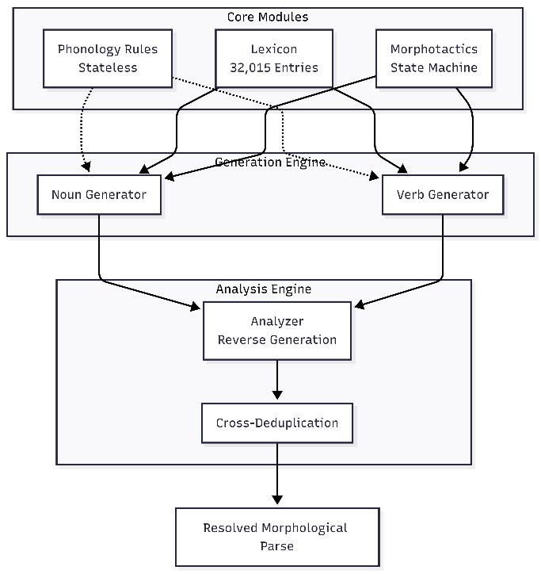

Phonological Modeling
The phonology module operates as a stateless collection of pure functions that formally define Turkmen morphophonological rules.
- Vowel Harmony: The system dynamically classifies stems into back (yogyn: a, o, u, y) and front (ince: e, ä, ö, i, ü) vowels. It also enforces labial harmony (dodak) for rounded vowels (o, ö, u, ü).
- Consonant Softening: Unlike systems like Apertium that store underlying forms (e.g., kitab) and harden them at boundaries, TurkmenFST stores validated surface forms (e.g., kitap) and applies contextual softening (p, ç, t, k → b, j, d, g) triggered by specific lexicon flags covering 7,001 entries.
- Vowel Elision: Elision is handled via strict list-based tracking to prevent false positives. It manages 20 regular elisions (e.g., burun → burn-) and 5 irregular exceptions (e.g., asyl → asl-, mähir → mähr-).
- Rounding Harmony: The engine implements specific pedagogical exceptions derived from official educational materials (e.g., guzy → guzu, süri → sürü before specific suffixes), ensuring outputs perfectly match official orthography.

Morphotactic State Machines and Nominal Inflection
Suffix sequencing is strictly governed by Finite-State Transducer (FST) inspired state machines to prevent ungrammatical combinations. For nouns, the morphotactic sequence is strictly defined as STEM → [PLURAL] → [POSSESSIVE] → [CASE].
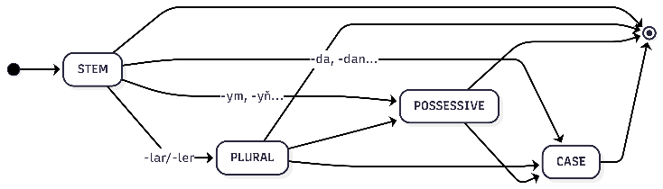
Invalid transitions (e.g., applying a plural suffix after a case marker) are programmatically rejected. The synthesis engine calculates all 72 possible inflectional forms per noun root (6 cases × 6 possessive states × 2 plural states). A notable architectural advantage is the engine's handling of the Genitive case rounding rule: short rounded stems receive specific suffixes (e.g., göz → gözüň), unlike the standard application (e.g., kitap → kitabyň), correcting a systematic error prevalent in existing open-source models.

Verb Inflection Paradigm and Negation Strategies
The verb generation engine is structurally governed by the sequence V_STEM → [NEGATION] → TENSE → [PERSON].
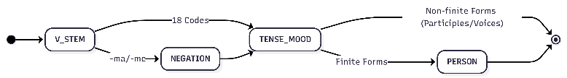
The system's capacity has been massively expanded from 7 basic tenses to an inventory of 18 comprehensive inflectional codes:
- 7 Basic Tenses: Covers Definite Past (Ö1), Indefinite Past (Ö2), Continuous Past (Ö3), General Present (H1), Definite Present (H2), Definite Future (G1), and Indefinite Future (G2).
- 5 Additional Moods: Integrates Conditional/Şert (-sa/-se), Imperative/Buýruk (utilizing 6 person-specific distinct patterns), Necessitative/Hökmanlyk (-maly/-meli), Evidential/Nätanyş Öten (-ypdyr/-ipdir), and Optative/Arzuw-Ökünç (-sa/-se + -dy/-di).
- Non-Finite Forms: Generates 4 participles (Hal, Öten, Häzirki, and Geljek) and 2 verb voices (Causative and Passive) which do not take personal suffixes.
Furthermore, TurkmenFST algorithmically models three distinct negation strategies depending on the tense/mood:
- Synthetic Negation: Standard suffixation (e.g., Ö1: gel-me-di-m).
- Compound Negation: Fused suffix patterns based on official enedilim corrections (e.g., Ö2: gel-män-di-m instead of the incorrect -me+ipdi).
- Analytic (Periphrastic) Negation: Utilizing auxiliary structures for specific tenses (e.g., Ö3: gel-ýän däldi instead of -me-ýärdi).

Synthesis and Generator-Verified Analysis
The synthesis engine dynamically compiles stems and morphotactic parameters into surface forms. However, the most significant algorithmic contribution lies in the analysis module. Instead of employing a standalone parsing algorithm, TurkmenFST utilizes a generator-verified reverse parsing strategy.
When an inflected surface form is input, the system retrieves possible stem candidates from the lexicon, generates all potential suffix combinations via the synthesis engine, and matches the output against the original input. This architecture guarantees 100% consistency between synthesis and analysis, as phonological rules do not need to be hardcoded twice. Finally, a novel cross-deduplication mechanism utilizing a breakdown_key eliminates redundant parses for homonyms (e.g., differentiating at as "name" vs. "horse"), effectively resolving the morphological ambiguity problem prevalent in previous models.

Using the Template
After the text edit has been completed, the paper is ready for the template. Duplicate the template file by using the Save As command, and use the naming convention prescribed by your conference for the name of your paper. In this newly created file, highlight all of the contents and import your prepared text file. You are now ready to style your paper; use the scroll down window on the left of the MS Word Formatting toolbar.

Authors and Affiliations
The template is designed for, but not limited to, six authors. A minimum of one author is required for all conference articles. Author names should be listed starting from left to right and then moving down to the next line. This is the author sequence that will be used in future citations and by indexing services. Names should not be listed in columns nor group by affiliation. Please keep your affiliations as succinct as possible (for example, do not differentiate among departments of the same organization).

For papers with more than six authors: Add author names horizontally, moving to a third row if needed for more than 8 authors.

For papers with less than six authors: To change the default, adjust the template as follows.

Selection: Highlight all author and affiliation lines.

Change number of columns: Select the Columns icon from the MS Word Standard toolbar and then select the correct number of columns from the selection palette.

Deletion: Delete the author and affiliation lines for the extra authors.

Identify the Headings
Headings, or heads, are organizational devices that guide the reader through your paper. There are two types: component heads and text heads.
Component heads identify the different components of your paper and are not topically subordinate to each other. Examples include Acknowledgments and References and, for these, the correct style to use is “Heading 5”. Use “figure caption” for your Figure captions, and “table head” for your table title. Run-in heads, such as “Abstract”, will require you to apply a style (in this case, italic) in addition to the style provided by the drop down menu to differentiate the head from the text.
Text heads organize the topics on a relational, hierarchical basis. For example, the paper title is the primary text head because all subsequent material relates and elaborates on this one topic. If there are two or more sub-topics, the next level head (uppercase Roman numerals) should be used and, conversely, if there are not at least two sub-topics, then no subheads should be introduced. Styles named “Heading 1”, “Heading 2”, “Heading 3”, and “Heading 4” are prescribed.

Figures and Tables

Positioning Figures and Tables: Place figures and tables at the top and bottom of columns. Avoid placing them in the middle of columns. Large figures and tables may span across both columns. Figure captions should be below the figures; table heads should appear above the tables. Insert figures and tables after they are cited in the text. Use the abbreviation “Fig. 1”, even at the beginning of a sentence.
- COMPARISON OF TURKMEN MORPHOLOGICAL ANALYZERS
Project | Comparison Metrics
 | Infrastructure | Lexicon Volume | Coverage & Limitations
Tantuğ et al. [X] | XFST | Limited | ~1.55 ambiguity rate per word; MT-dependent design.
Apertium [Y] | HFST | 2,988 stems | ~70.7% naive coverage; limited derivation support.
TurkmenFST (Ours) | Python FST | 32,015 stems | 100% reference coverage; cross-deduplication; API.
- Example of a figure caption. (figure caption)
Figure Labels: Use 8 point Times New Roman for Figure labels. Use words rather than symbols or abbreviations when writing Figure axis labels to avoid confusing the reader. As an example, write the quantity “Magnetization”, or “Magnetization, M”, not just “M”. If including units in the label, present them within parentheses. Do not label axes only with units. In the example, write “Magnetization (A/m)” or “Magnetization {A[m(1)]}”, not just “A/m”. Do not label axes with a ratio of quantities and units. For example, write “Temperature (K)”, not “Temperature/K”.

Acknowledgment (Heading 5)
The preferred spelling of the word “acknowledgment” in America is without an “e” after the “g”. Avoid the stilted expression “one of us (R. B. G.) thanks ...”. Instead, try “R. B. G. thanks...”. Put sponsor acknowledgments in the unnumbered footnote on the first page.

References
The template will number citations consecutively within brackets [1]. The sentence punctuation follows the bracket [2]. Refer simply to the reference number, as in [3]—do not use “Ref. [3]” or “reference [3]” except at the beginning of a sentence: “Reference [3] was the first ...”
Number footnotes separately in superscripts. Place the actual footnote at the bottom of the column in which it was cited. Do not put footnotes in the abstract or reference list. Use letters for table footnotes.
Unless there are six authors or more give all authors’ names; do not use “et al.”. Papers that have not been published, even if they have been submitted for publication, should be cited as “unpublished” [4]. Papers that have been accepted for publication should be cited as “in press” [5]. Capitalize only the first word in a paper title, except for proper nouns and element symbols.
For papers published in translation journals, please give the English citation first, followed by the original foreign-language citation [6].

- G. Eason, B. Noble, and I. N. Sneddon, “On certain integrals of Lipschitz-Hankel type involving products of Bessel functions,” Phil. Trans. Roy. Soc. London, vol. A247, pp. 529–551, April 1955. (references)
- J. Clerk Maxwell, A Treatise on Electricity and Magnetism, 3rd ed., vol. 2. Oxford: Clarendon, 1892, pp.68–73.
- I. S. Jacobs and C. P. Bean, “Fine particles, thin films and exchange anisotropy,” in Magnetism, vol. III, G. T. Rado and H. Suhl, Eds. New York: Academic, 1963, pp. 271–350.
- K. Elissa, “Title of paper if known,” unpublished.
- R. Nicole, “Title of paper with only first word capitalized,” J. Name Stand. Abbrev., in press.
- Y. Yorozu, M. Hirano, K. Oka, and Y. Tagawa, “Electron spectroscopy studies on magneto-optical media and plastic substrate interface,” IEEE Transl. J. Magn. Japan, vol. 2, pp. 740–741, August 1987 [Digests 9th Annual Conf. Magnetics Japan, p. 301, 1982].
- M. Young, The Technical Writer’s Handbook. Mill Valley, CA: University Science, 1989.
- K. Eves and J. Valasek, “Adaptive control for singularly perturbed systems examples,” Code Ocean, Aug. 2023. [Online]. Available: https://codeocean.com/capsule/4989235/tree
- D. P. Kingma and M. Welling, “Auto-encoding variational Bayes,” 2013, arXiv:1312.6114. [Online]. Available: https://arxiv.org/abs/1312.6114
- S. Liu, “Wi-Fi Energy Detection Testbed (12MTC),” 2023, gitHub repository. [Online]. Available: https://github.com/liustone99/Wi-Fi-Energy-Detection-Testbed-12MTC
- “Treatment episode data set: discharges (TEDS-D): concatenated, 2006 to 2009.” U.S. Department of Health and Human Services, Substance Abuse and Mental Health Services Administration, Office of Applied Studies, August, 2013, DOI:10.3886/ICPSR30122.v2

IEEE conference templates contain guidance text for composing and formatting conference papers. Please ensure that all template text is removed from your conference paper prior to submission to the conference. Failure to remove template text from your paper may result in your paper not being published.

