Summary
- Go to https://simplenewsvendorgameclient.onrender.com/
- Enter nickname
- Enter admin key (admin123)
- Start game
- Wait for people to arrive- do not worry, they can join during the 1st round without any loss, or you can restart if there exist a lot of people who were slow to enter.
- For each round
  - Select parameters:
    - Distribution related parameters
    - Costs and profits
- Click to set parameters button
- Start round
- Wait for a bit, so that students can enter the values
- End round
- There will be changes to the leaderboard, people will see realized demand. Wait for everyone to monitor the last changes
- You can still set the parameters during above step
- Again, set parameters, start round and end round
- When the game ends, you can either click to one more turn or end game
  - If you go with one more turn, you can play for one more turn. When it finishes, you’ll be redirected to the leaderboard, but still there will be an option to play one more turn. Regardless of how many turns you played.
  - If you decide to end the game, make sure that all game related processes are complete, you’ll not be going to check the leaderboard again.
- When the game ends you are redirected to initial screen, everything is cleaned

Detailed process

How Standard Game Proceeds

- Go to https://simplenewsvendorgameclient.onrender.com/

Following QR is usable:


- Create active game as admin

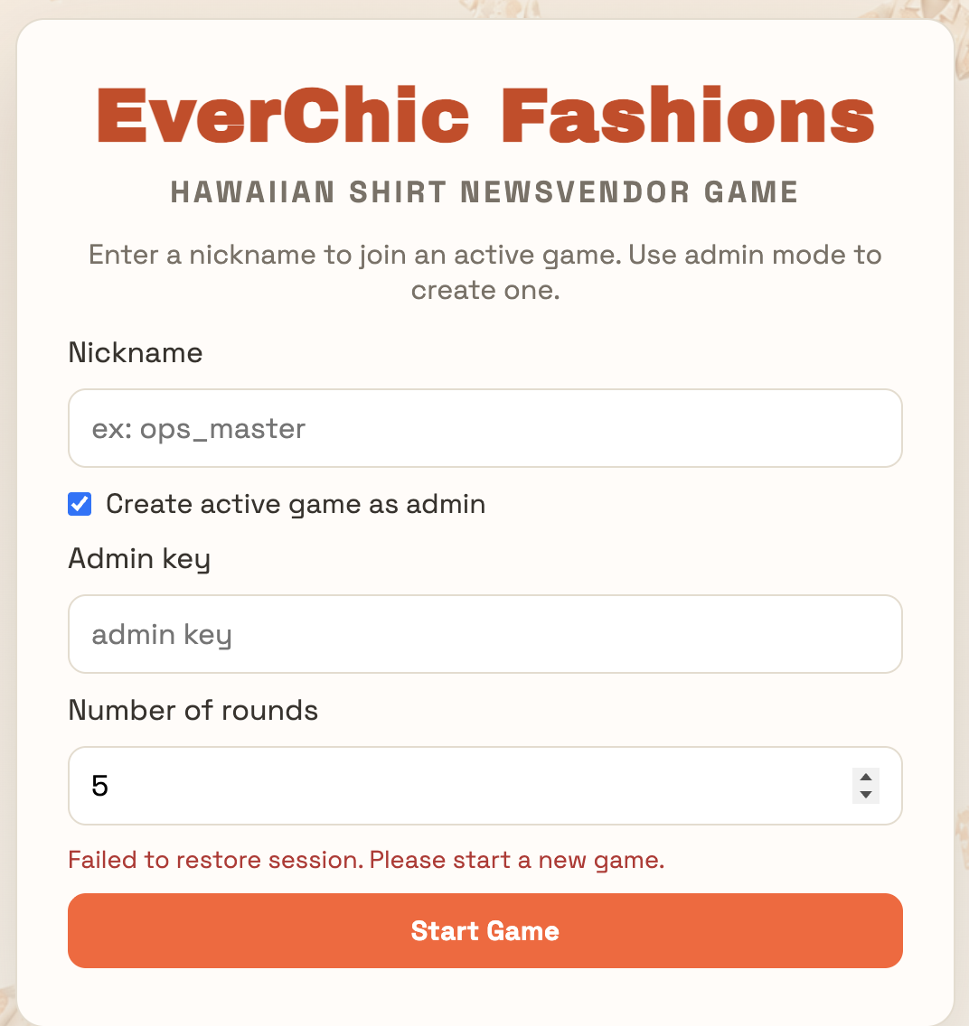

- Enter nickname, enter admin key (admin123) and select number of rounds.
Now Start Game

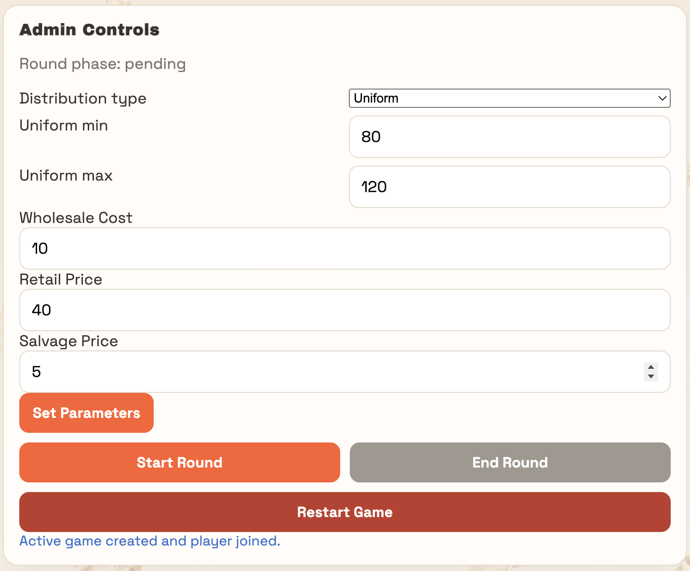
- General admin screen

For each turn:

- Set parameters

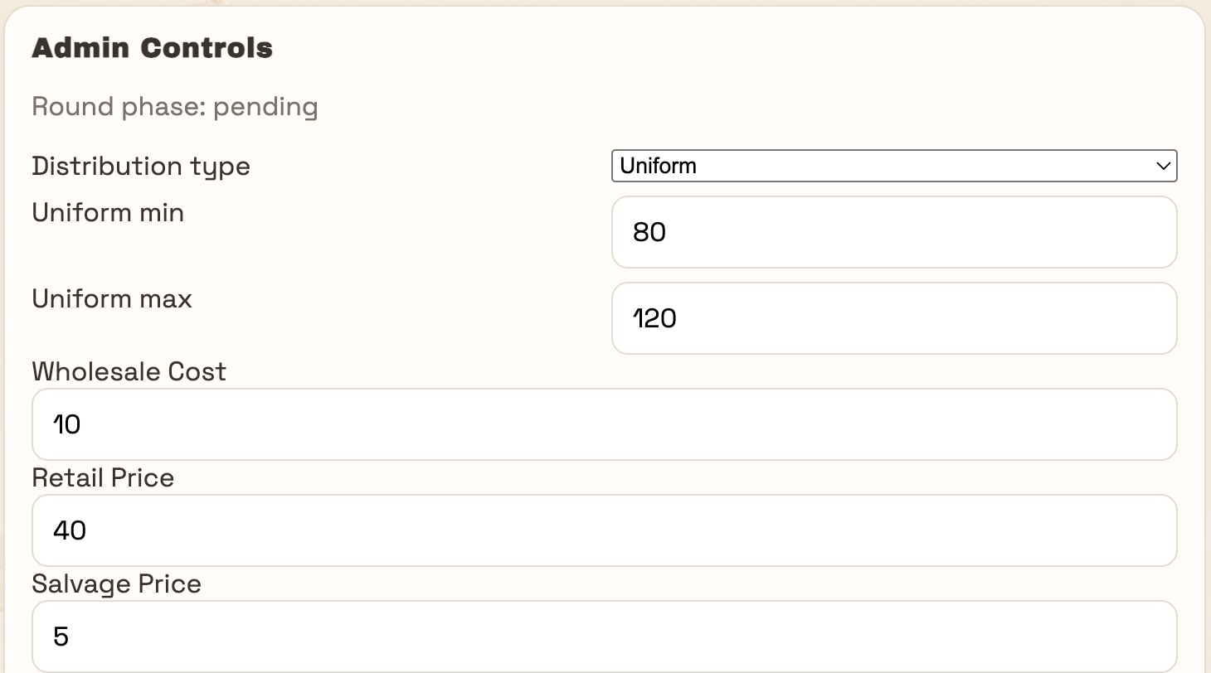

Not forget to click “Set Parameters”


- Start round
- Wait for people to enter their answers
-> During a round, people can still join the game without any problems.
- End round
General game process continues as this.

How game ends:
- People see their last rounds
- They can wait for 15 seconds or directly go to leaderboard
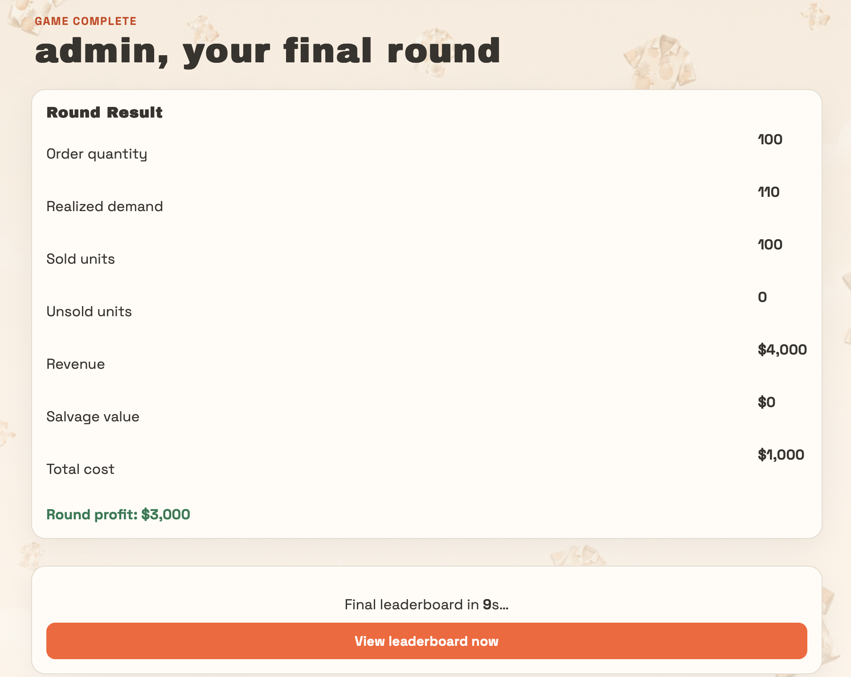

The button below finishes the game (only exists in the leaderboard screen), for everyone. Results will not be visible after clicking here.


Only admin can do that

Notes & Handling Potential Problems
- If there are late comers:
Late comers are not assigned with a value for the rounds that they have not played. If you want to restart the game.

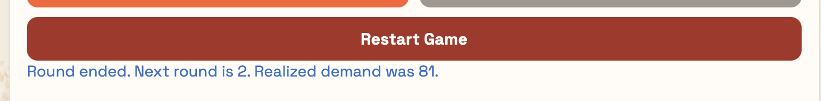

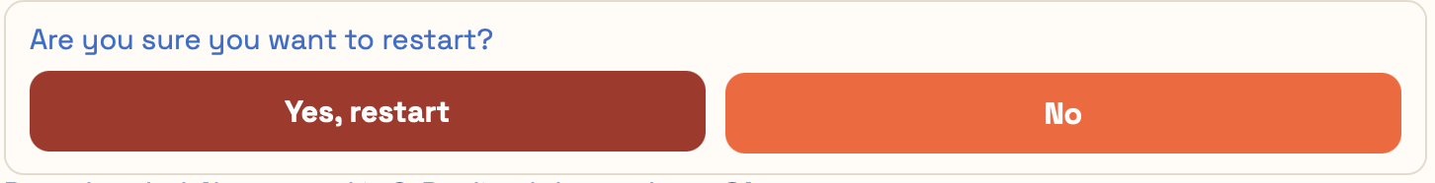

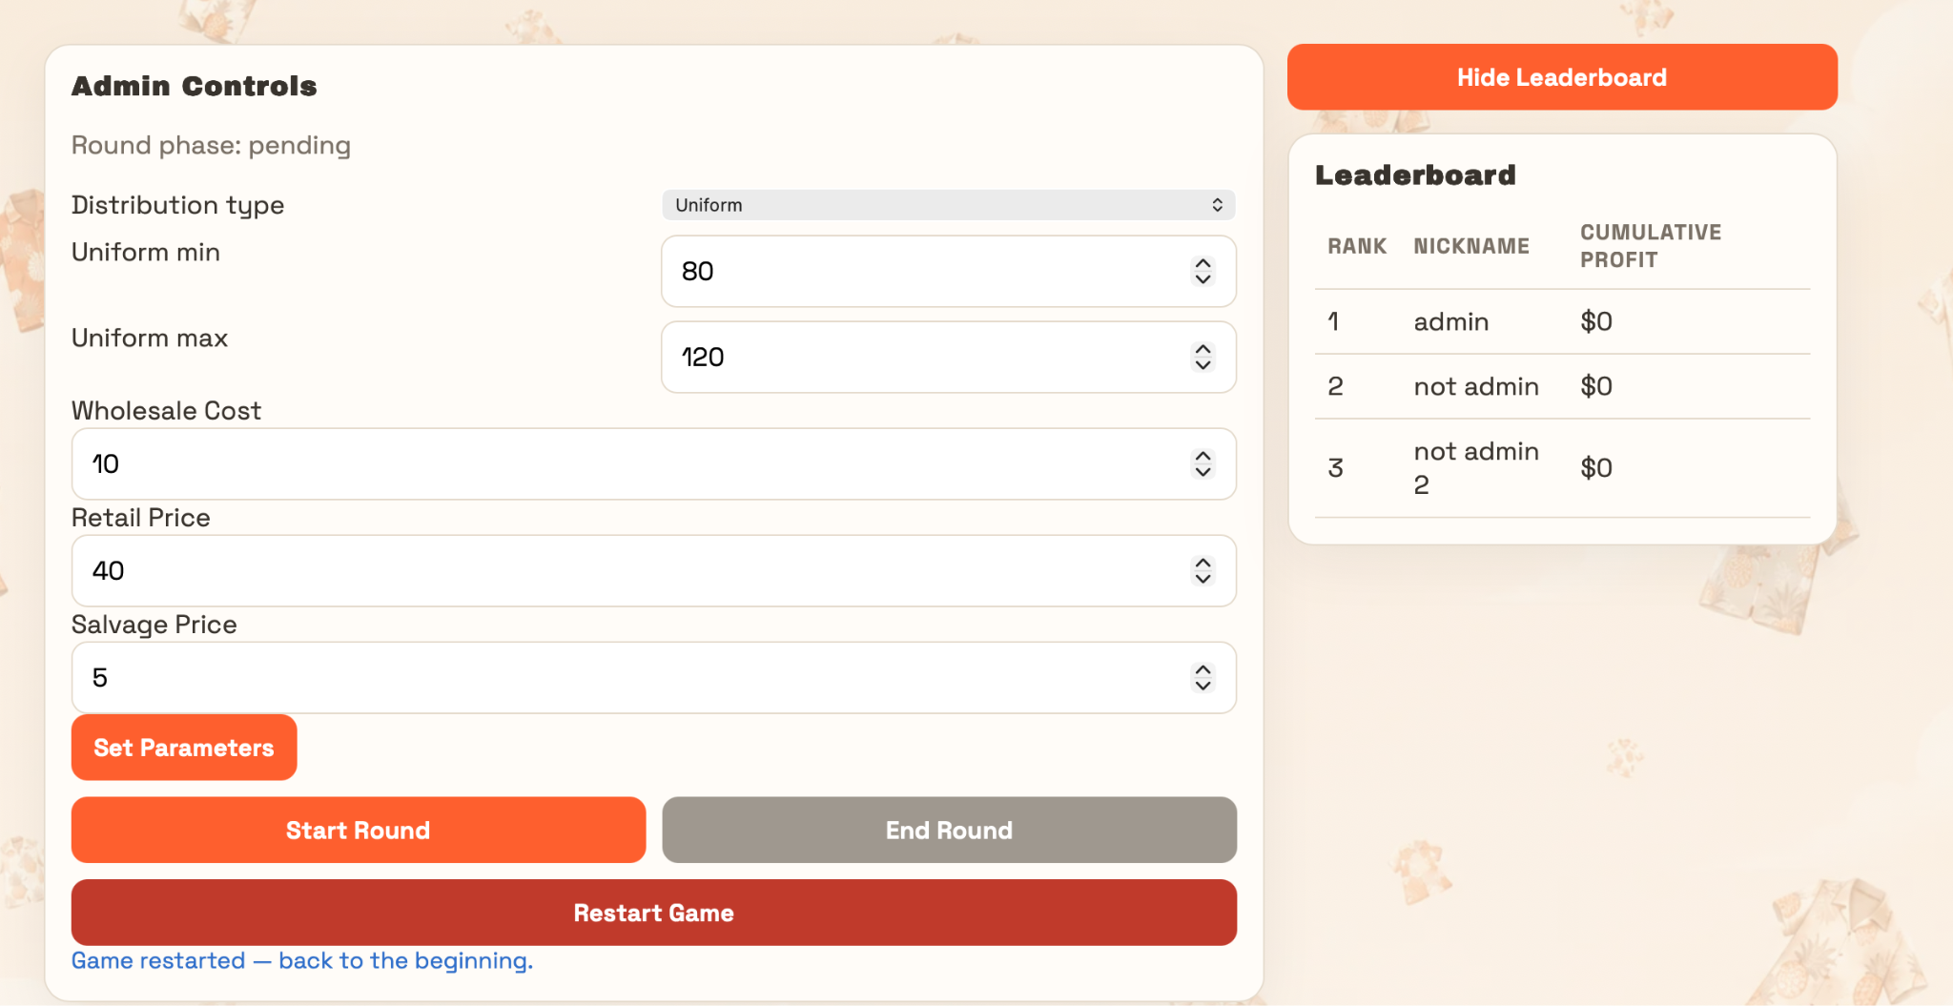

After a restart scores set back to zero. Anyone in the initial game redirected to the new one.

- If you want to play for more rounds after the end

In the last leaderboard screen, only for the admin, there exists an option for playing for another round. This can be used repetitively, after each finish, only increases 1 by 1.
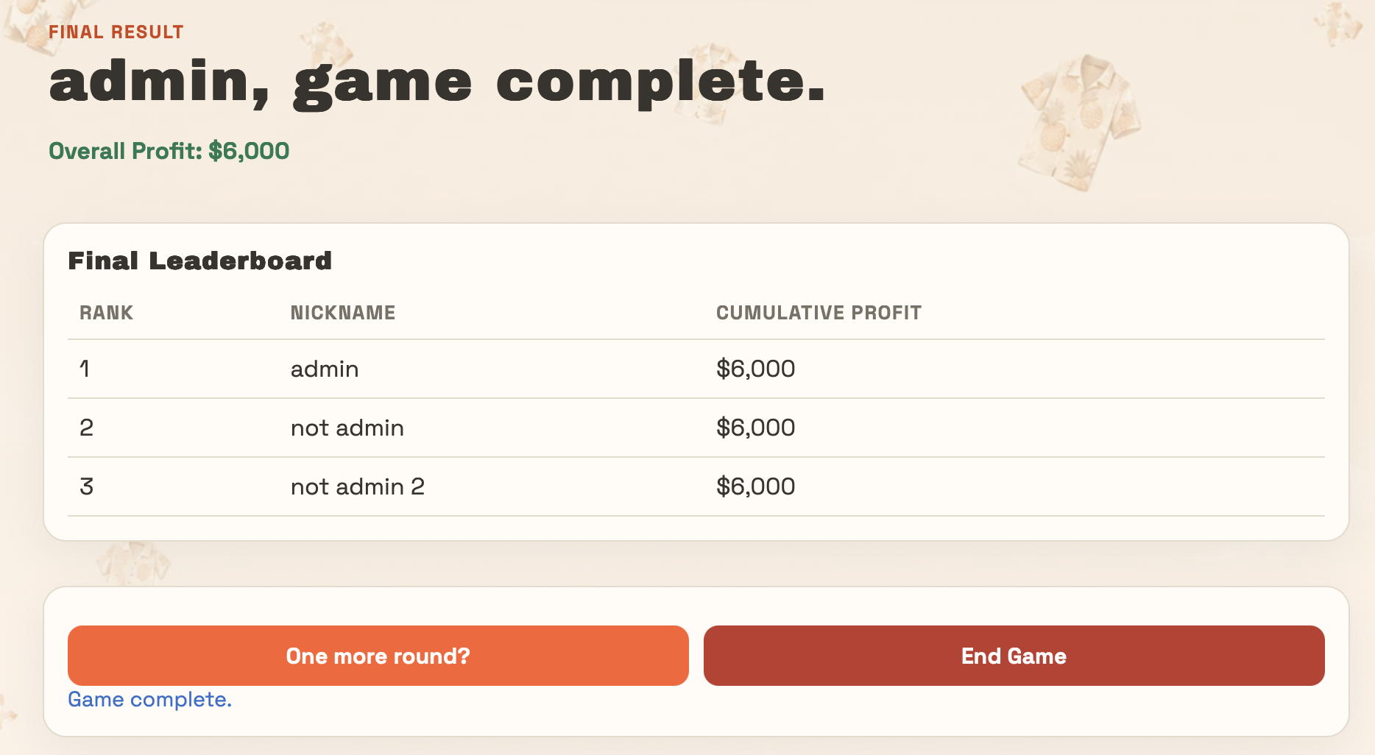
The game continues where you left of round number is increased by one.


