Chapter 1 : Introduction

1. Background of Wind Energy Harvesting

Like many developments in technology, modern wind energy utilization by means of wind turbines started 40 years ago due to search for alternative energy sources except oil, whose deficiency and high prices were a global crisis issue. At first times of development, countries excluding Denmark tried to produce these wind turbines by experiences used in aerospace technology which has very high power ratings of MWs. After the understanding of the fact that produced turbines were bulky and inefficient in terms of reasonable cost of energy and required different technology than aeroplanes motors, all governments started follow Denmarks' path. Denmark started the wind turbine technology by developing small wind turbines first and encouraged the individiuals and small companies.Today, more than 40 per cent of Denmark’s energy supply comes from wind power and the plan is to reach 50 per cent by 2020, as set out in the 2012 Energy Act.Total wind energy capacity in Denmark was 4,890 MW by the end of 2014, 3,620 MW onshore and 1,271 MW offshore[[1]](http://denmark.dk/en/green-living/wind-energy/). Denmark has some of most important wind energy manufacturers worldwide such as [Vestas](https://www.vestas.com/) and [Bonus Energy A/S-lately was acquired by Siemens](http://www.energy.siemens.com/hq/en/renewable-energy/wind-power/). Global annual installed wind capacity between 2001-2016 and global cumulative installed wind capacity between same period is given Figures 1 and 2, respectively.

Wind turbine is an important issue for renewable energy. Especially for the last decade its technology is substantially matured. According to [[2]](http://ieeexplore.ieee.org/xpl/articleDetails.jsp?arnumber=6216474) the global installed utility scale wind power was 197 GW at the end of 2010 (an increase of 24.1%) while the globalmarket for small wind turbines (SWTs) grew by only 4%.

Wind turbine generators dominating the markets nowadays have 300-800 kW power output capacity in average.But the challenges and trends are toward to 1 MW per turbine thanks to promising concepts such as direct-drive[3].

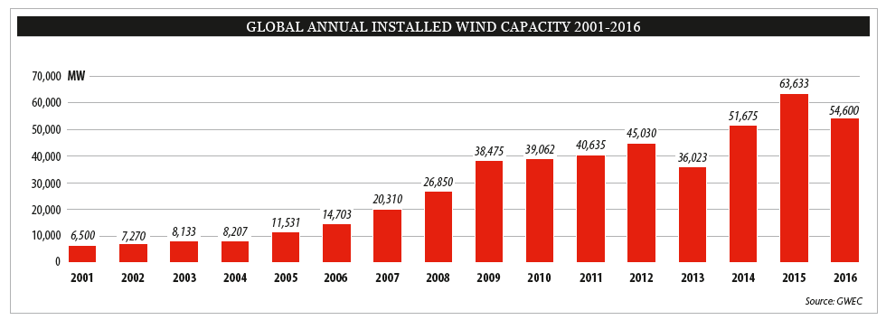

Figure 1. Global annual installed wind capacity 2001-2016 (GWEC report-2016)

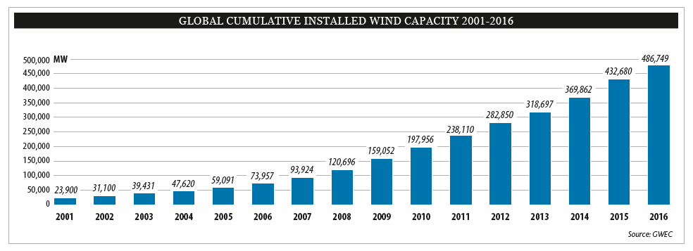

Figure 2. Global cumulative installed wind capacity 2001-2016 (GWEC report-2016)

Increase in utilization of wind energy in Turkey is very similar to global trends. Turkey has nearly stable increase rate of installation rate of wind power plants for past 5 years. Figure 3 below shows the variation of cumulative installations for wind power plants in Turkey. Figure 4 shows the global statistics of top 10 new installed capacity between January-December 2016.

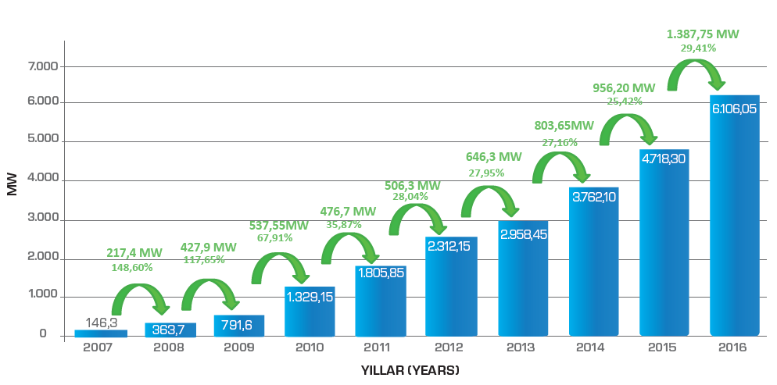

Figure 3. Cumulative installations for wind power plants in Turkey (TUREB-Turkish Wind Energy Statistics Report/January 2017)

The cost per swept area is used rather than just the cost of the turbines or cost per rated power since the swept area gives a better indication of the total energy that can be generated by the turbine than the rated power given by the manufacturer. Besides that, when designing and investing a wind power stations,3 main properties which are necessary to validate are given as follows:

* Low cost
* long-lasting
* Low service requirement

These are called L3 conditions[1]

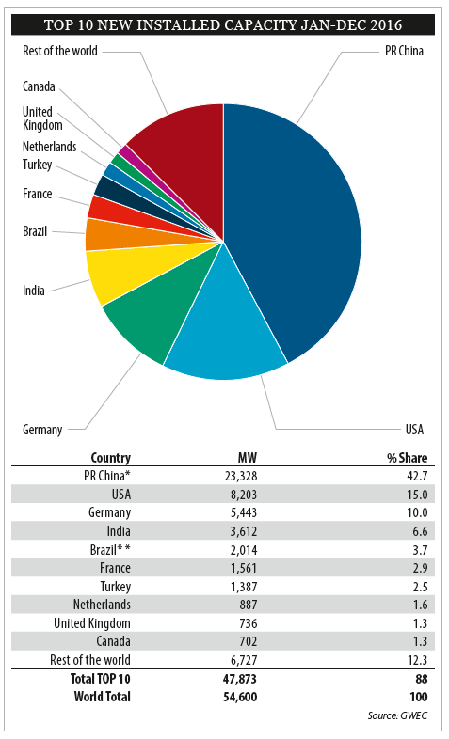

Figure 4. Top 10 new installed WPP(Wind Power Plant) capacity between January-December 2016 (GWEC report-2016)

Small wind turbines(there is no certain definition about the scale but we can assume that for kw scale ones) can be categorized in two types:

* Horizontal axis wind turbines (HAWT)
* Vertical axis wind turbines (VAWT)

In general, the efficiency of small wind turbines is low compared with large wind turbines.

Another important issue is the speed control of these turbines. At this point two main control techniques are exist: furling control and pitch control .

There are no standards about what wind speed manufacturers should give the output power of their turbine (rated power). Therefore, there are some differences between the manufacturer's plate values and actual measured values.

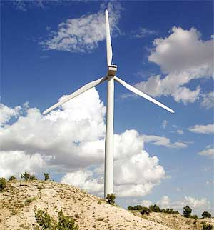 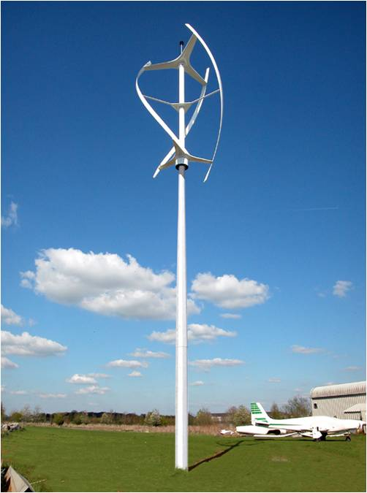

*Horizontal axis wind turbine Vertical axis wind turbine*

**References**

[1] Kuik, G. A. M. van, J Peinke, R Nijssen, D Lekou, J Mann, JN Sørensen, C Ferreira, et al. 2016. Long-term research challenges in wind energy – a research agenda by the European Academy of Wind Energy. Wind Energy Science 1, no. 1: 1-39. <http://www.wind-energ-sci.net/1/1/2016/>.

[2] Ani, S. O., Polinder, H., and Ferreira, J. A. (2013). Comparison of energy yield of small wind turbines in low wind speed areas. IEEE Transactions on Sustainable Energy 4, 42-49.

[3] Lampola, P. DIRECTLY DRIVEN , GRID ­ CONNECTED SURFACE ­ MOUNTED PERMANENT ­ MAGNET WIND GENERATOR. 1-6 (2015)