**CHAPTER 2: REVIEW OF WIND ENERGY CONVERSION (WEC) SYSTEMS**

In this chapter, detailed survey of wind energy fundamentals and general overview of wind energy conversion systems will be summarized. To accomplish this, this chapter is divided into four main parts. In first part, wind turbine power equations and wind equations will be given and discussed. This data especially used in wind turbine investment calculations and wind potential estimation techniques. In next part, current wind turbine systems will be classified and evaluated according to their mechanical and electrical aspects. Then three main flux orientations in PM based systems will be shown and explained. Finally, importance of modularity in wind energy conversion systems and axial flux advantages and disadvantages will be evaluated.

1. **Power Equations**

The available shaft power (output power) P from a wind turbine can be expressed as a function of the wind speed as follows :

$P=\frac{1}{2}ρ_{air}C_{p}(λ,β)πr^{2}v^{3}$ (1)

where,

$ρ_{air}$ is the mass density of air

$C_{p}\left(λ,β\right)$ is the power coefficient, a function of the tip speed ratio λ and the pitch angle β

$r$ is radius of the turbine blade

$v$ is the wind velocity

**Power Coefficient ($C_{p}\left(λ,β\right)$)**

Power coefficient, sometimes called performance coefficient, is basically can be defined as the ratio between captured wind power by the wind turbine and the available input power of the wind. Therefore it tells us how efficiently we utilize the wind turbine. Its value is sometimes taken from look up tables or can be assumed by nonlinear computations[3]. Since physical limitations are exist in nature such as friction and other mechanical losses, maximum value of the power coefficient *Cp* is lower than theoretical maximum of Betz, which is about 59%. Betz limit will be explained detailed in following parts.

In [[1](http://ieeexplore.ieee.org/stamp/stamp.jsp?tp=&arnumber=6226866&isnumber=6331663)] Power coefficient is defined as a nonlinear function of TSR(λ) and pitch angle(β)  as follows,

$C_{P}\left(λ,β\right)=C_{1}\left(\frac{C_{2}}{λ_{i}}-C_{3}β-C_{3}\right)e^{\frac{{-C}_{5}}{λ_{i}}}+C_{6}λ$ (2)

where,

$\frac{1}{λ_{i}}=\frac{1}{λ+0.08β}-\frac{0.035}{β^{3}+1}$ (3)

These coefficients shown above depend on the turbine characteristics. In [6], authors searched for common used variable values. According to this work, most used values in literature for these *Ci* variables are given in Table 1. As can be seen from table, most values for same variable are very similar, therefore values in third column (ref. [9]-[17]) can be assumed valid for related calculations. Nominal power of the wind turbine generator is achieved by proper control algorithms. For this purpose, maximum value of the Cp is can be obtained by employing optimal set of pitch angle(β) and tip speed ratio[30].

*Table 1. Coefficients of Power Coefficient Cp ()*

|  |  |  |  |  |  |  |  |  |
| --- | --- | --- | --- | --- | --- | --- | --- | --- |
| Ref.no  Coef. | [7] | [8] | [9]-[17] | [18]-[23] | [24] | [25]-[26] | [27]-[28] | [29] |
| *C0* | 0.5 | 0.5 | 0.5176 | 0.22 | 0.5 | 0.73 | 0.44 | 1 |
| *C1* | 116 | 116 | 116 | 116 | 72.5 | 151 | 124.99 | 110 |
| *C2* | -0.4 | -0.4 | -0.4 | -0.4 | -0.4 | -0.58 | -0.4 | -0.04 |
| *C3* | 0 | 0 | 0 | 0 | 0 | -0.002 | 0 | -0.002 |
| *C4* | - | 0 | 0 | 0 | 0 | 2.14 | - | 2.2 |
| *C5* | -5 | -5 | -5 | -5 | -5 | -13.2 | -6.94 | -9.6 |
| *C6* | -21 | -21 | -21 | -12.5 | -13.125 | -18.4 | -17.05 | -18.4 |
| *C7* | 0 | 0 | 0.0068 | 0 | 0 | 0 | 0 | 0 |

**Tip Speed Ratio-TSR (λ)**

Tip speed ratio  (TSR) is defined as a ratio of linear tip speed of turbine blade to speed of the wind. This ratio is very useful when designing a wind turbine. Optimal TSR is desired to obtain maximum power from wind as much as possible.

$$λ=\frac{Rω_{M}}{V}$$

where,

*V* is the wind speed

*wm*  is the rotational rotor speed

*R* is the rotor radius

TSR is a kind of measurement of how speedy turbine blades and shaft rotate. Therefore high TSR is aimed when designing a wind turbine. This topic is very important because of the efficiency issues. If turbine blades turns too slow then incoming air to the turbine is not used efficiently (natural result of Betz limit). If turbine blades turns too fast, blades act like a solid wall to the turbine and then efficiency decreases again. Besides, high TSR has several other disadvantages. Edge parts of blades rotating at very high speeds are subjected to faster erosion due environmental factors like sand or dust particles. This effect can be seen in Figure 1. Also high rotational speed of blades result in audible noise and vibration. To avoid bad consequences (low efficiency, physical breakdown) of turbulence issue, choosing optimal TSR is really important. Each wind turbine has unique value of TSR regardless of the generator topology used in manufacture [32].

Approximate optimal TSR’s for a system[33]:

for TSR value ~6-7 Number of blades=2

for TSR value ~5-6 Number of blades=3

for TSR value ~2-3 Number of blades=5

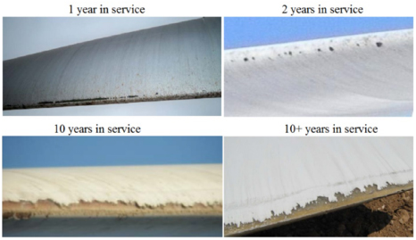

Figure 1. Leading edge erosion effect on wind turbine blades[31]

**Betz Limit**

Theoretically, maximum 59% (approximately 16/27) of energy carried by the wind can be extracted by an ideal wind turbine. This result is concluded by German physicist Albert Betz in 1919. This limitation is valid for both vertical and horizontal axis wind turbines. Maximum value of performance coefficient (*Cp*) is limited by Betz criterion. Generally imperfections in blade manufacture reduces the actual energy yield of the turbine less than the useable energy. Therefore value of *Cp* is generally less than 0.59. As mention before previous parts, there is a relationship between TSR and *Cp* and this correlation is limited by Betz as can be seen in Figure 2 which is depicted for two bladed systems. Minimum wind speed that is needed to start to rotate the turbines' blade is cut-in wind speed while cut-out speed is the maximum speed of wind that turbine is allowed to continue operation.

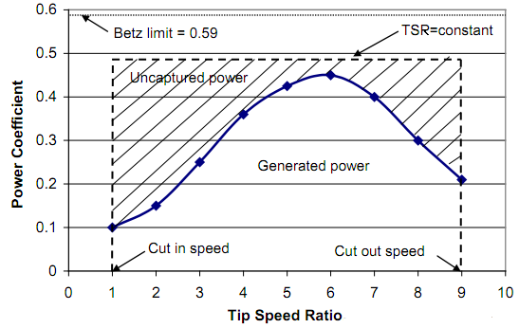

Figure 2. TSR and Power coefficient relation between cut-in and cut-out speeds, respectively for two bladed wind turbine [34]

**Wind profile and distributions**

Time dependent nature of the wind determines the production scheme of the WECs(Wind Energy Conversion Systems). There are some approaches for estimate the wind profile at given place. Wind profile at any given area is generally measured 10 meters above the ground level and estimated by 1/7 “Power Profile Law” as given follows[3] :

$$\frac{v}{v_{0}}={(\frac{h}{h_{0}})}^{α(v_{0}{,h}_{0})}$$

where,

*v* is desired wind speed,

*v0* is reference wind speed,

*h* is the desired height,

*h0* is the reference height

*α* value in the equation above can be calculated as follows[3],

$$α\left(v_{0, }h_{0}\right)=\frac{0.37-0.088\ln{(v_{0})}}{1-0.088\ln{(\frac{h}{h_{0}})}}$$

this value is used approximately as "1/7" in calculations.

In [3], authors mentioned about wind profile estimation techniques based on different computational methods. Light Detection and Ranging, Adaptive Neuro-fuzzy interference system and particle filter based methods are main methods introduced among these estimation techniques.

Weibull distribution is used to determine the wind speed distribution and gives an indication of what percentage of time a certain wind speed occurs in a given site. This indication is need because of the probabilistic nature of wind. Weibull distribution function is given as follows:

$$f\left(v\right)=\frac{k}{s}{(\frac{v}{s})}^{(k-1)}e^{{-(\frac{v}{s})}^{k}}$$

where,

*v* is the wind speed

*k* is the shape parameter

*s* is the scale parameter

Another similar distribution function to obtain wind profile is Rayleigh distributions. In this distribution, main difference is using constant value of 2 for shape parameter *k*. According to [35] both distributions show similar performance when analyzing and predicting wind data. IEC 61400 standard which is specialized for design requirements of wind turbine, mentions Rayleigh and Weibull distributions as most common [36].

Determining wind speed profile of a given site by using Weibull distribution is useful together with the power curve of turbine, when calculating energy yield over a time. Therefore energy yield over a period of time T can be defined with the help of Weibull distribution as follows,

$$E_{y}=T\int{P(v)f(v)dv}$$

where,

*Ey* is the energy yield

*P* is the generated power

*f(v)* is the Weibull function

*T* is 8760 hours (1 year)

1. **Current Wind Turbine Systems**

In this part, generators are categorized according to their mechanical and electrical properties. In mechanical categorization, drivetrain approach is considered. In electrical categorization, most used generator types in WECs, induction and synchronous generators are considered in terms of wind turbine point of view. Reaching megawatts of power capability per turbine, generator technology gaining more attention than its past. Therefore its design is the main focus point of both this study and current research activities on this area.

1. **Mechanical Aspects**

Wind turbines can be categorized based on mechanical construction (or drivetrain) as “geared drive” and “direct drive”. Both concepts are explained in detailed below.

**Geared Drive**

In this type of generator, turbine blades with hub structure connected to shaft of the generator via a gear-box, which increases the rotational speed of the low-speed shaft. Gear ratio is a measure of relationship between output and input speeds of dynamic system. Drivetrain of a VSCF (variable speed constant frequency) turbine generally consists of blades, low and high speed shafts, gear-box and generator. Gearbox in a wind turbine system is responsible of transmission of aerodynamic power from turbine to the generator shaft. Turbine shaft can be referred as low speed shaft while generator shaft is referred as high speed shaft. In Figure 3 , a representation of geared drivetrain of wind turbine generator can be seen.

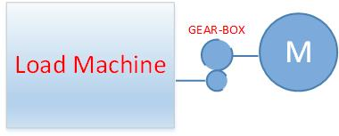

Figure 3. Schematic of geared drivetrain

**Direct Drive**

Main purposes of the Direct-drive(Ddrive) concept for wind turbines are;increasing energy yield,reducing gearbox failures and lower maintenence problems. There are two types of DD namely, rotational and linear direct drives. Due to tip speed limitation they are operating at low speeds which is a important advantage. But according to the formula:

$$P=T.ω_{m}$$

Torque must be increase inverse proportional to decrease of angular speed. To do that when scaling up the turbine sizes, amount of material is increased in order to maintain the air-gap against deflection forces between stator and rotor parts. This means DDrive machines are heavier than other types of machines. Torque/volume and torque/mass parameters are important during the design of the generator system. In some designs[2] ratio of axial lenght to airgap diameter, K is optimized.

More material also means extra cost which is big disadvantage for this type of generators.

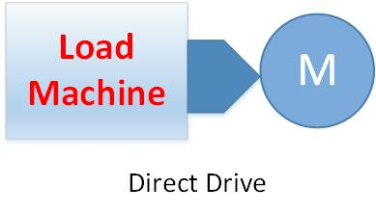

**Drivetrain modelling**

Drivetrain can be modelled single-mass or two mass model according to application[3]. If the system response to transients and other stability issues are the main focus of the analyze, two mass model is employed[3]. Two mass model of the drivetrain system is given as follows,

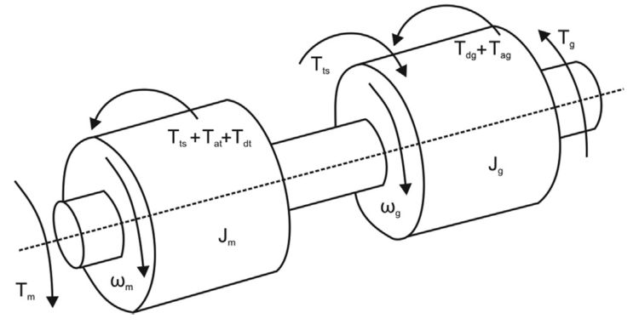

*2 mass model of the drivetrain*

**Note:** mass with the m indice denotes turbine moment of inertia and other mass with "g" indice denotes generator moment of inertia.

Equations for angular speeds at the both end of the two-mass model are as follows[4],

$$\frac{d_{ω_{m}}}{dt}=\frac{1}{J_{m}}(T_{m}-T_{dt}-T_{at}-T_{ts})$$

$$\frac{{dω}_{g}}{dt}=\frac{1}{J_{g}}(T_{ts}-T_{dg}-T_{ag}-T_{g})$$

where,  
  
Jm is moment of inertia of blades and hub  
  
Tm is mechanical torque,  
  
Tdt is resistant torque in the wind turbine bearing  
  
Tat is resistant torque in the hub and blades   
  
Jg is moment of inertia of rotor of the generator  
  
Tg is electrical torque,  
  
Tdg is resistant torque in generator bearing  
  
Tag is resistant torque for airflow in generator   
  
Tts is torsional stifness torque

1. **Electrical Aspects**

There are two main type of generators in this section: Induction Generators and Synchronous Generators.

i) Induction Generators

-Squirrel Cage Induction Generator(SCIG)

- Wound Rotor Induction Generator(WRIG)

- Doubly fed Induction Generators(DFIG)

ii) Synchronous Generators

- Wound rotor Synchronous Generators(WRSG)

- Permanent Magnet Synchronous Generators(PMSG)

**Squirrel Cage Induction Generator(SCIG)**

This type of machine can be used with both fixed(Danish concept) and variable speed. Robustness, stable operation, lower maintanence makes SCIG preferable in WECs. But in order to get more efficient operation SCIG should be constructed with low number of poles because high number of poles contruction becomes a drawback for SCIG. Thefore gear-boxes are generally used with SCIGs.

Capacitor banks and Static Synchronous Compensators(STATCOM) are commonly used for reactive power compensation with SCIGs. Additionally, STATCOMs used for active and reactive power flow control for variable speed applications of SCIGs.

In variable speed applications of SCIG back-to-back voltage source converters(VSCs) are employed in order to meet grid codes[25]. Schematic diagram of a this type WEC is given below.

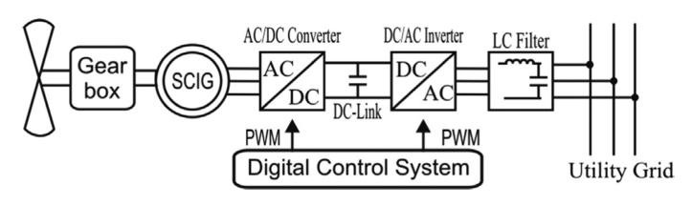

*SCIG with back-to-back VSC converter*

Danish concept is known for fixed speed operation and can be applied to SCIG . Generator speed is determined according to grid electrical frequency.Circuit schematic and Danish-concept turbine is given below.

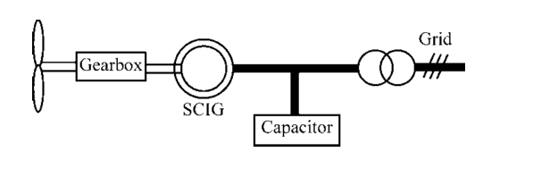

*SCIG with Danish concept*

**Wound Rotor Induction Generator(WRIG)**

These type of generators are used for variable speed applications, thus there will be dynamic slip control[3].This control is applied by connecting electronically controlled resistor blocks to rotor of the generator. Slip denotes the relation between the rotor speed and synchronous speed and is given by the formula as follows,

$$s=\frac{N_{s}-N_{r}}{N_{s}}$$

where,

s is the slip  
  
Ns is synchronous speed  
  
Nr is rotor speed

Also there exists shunt capacitors connected to line for compensation purposes.Typical WRIG schematic diagram with these capacitors is shown below.

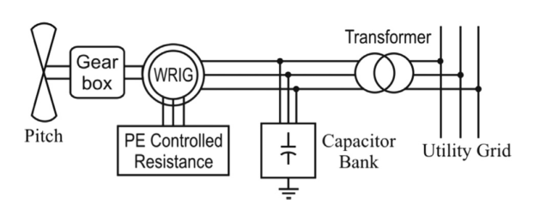

*WRIG schematic diagram*

**Doubly-fed Induction Generators(DFIG)**

Among these generator types, doubly-fed induction generator system with 3 stage gearbox (DFIG-3G) is the most common configuration at present [5]. Although it consists more complicated power electronic control, it can control active and reactive power flow from to control within supply side or rotor side. Stator is connected to grid via transformer while rotor connected to grid via power electronic converter blocks. Sometimes second PGSC(parallel grid side converter) is used parallel with dc-link in order to control unbalanced conditions better. This kind of configuration of DFIG is shown in figure below.

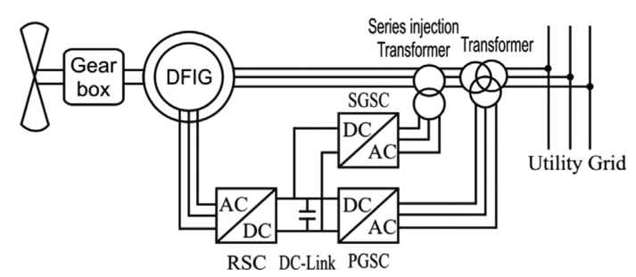

*DFIG configuration with double GSC*

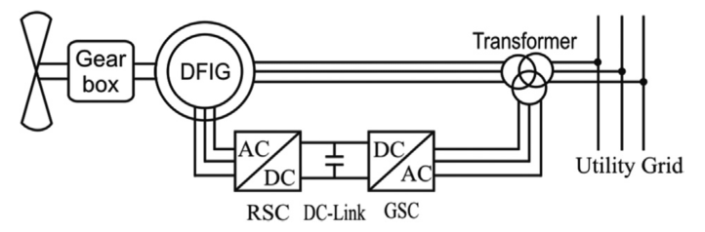

*Conventional grid connected DFIG*

**Wound rotor Synchronous Generators(WRSG)**

This type of SG can be operated with variable speed applications with suitable grid connected power electronic block and proper vector control algorithm. Schematic diagram of WRSG is given below. Additionally, this machine type has cost advantage since no PM exists for field.

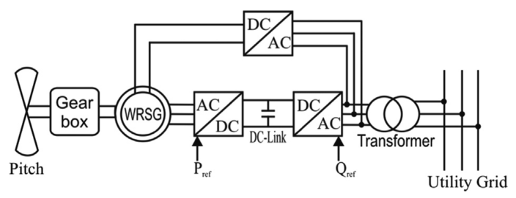

*WRIG-Wound rotor Synchronous Generator grid connection*

**Permanent Magnet Synchronous Generators(PMSG)**

In this thesis work, Direct drive PMSG is chosen for the design. It becomes very popular especially for last decade because of its high energy yield, improved reliability, efficiency and low maintanence. Reliability can be increased by developing modular and fault tolerant PMSG. These days capacity of PMSG wind turbines increased up to 8 MW.

Conventional PMSG are connected to the grid via back-to-back converters as shown below in figures. This type of generator can be connected with diode front end system too.

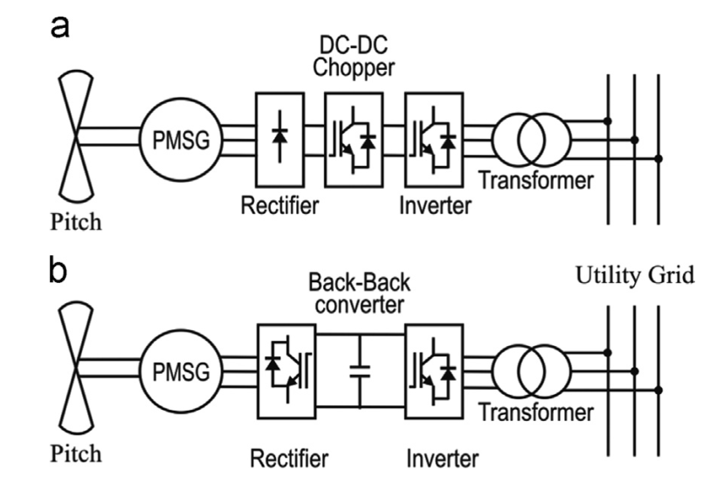

*PMSG based WECs a)diode front end system b)back to back converter system*

1. **Flux Orientations in PM based systems**

One of the important options in design of the machine is magnetic flux path directions. Current technology in this topic can be classied as three main subgroups as follows:

* Radial flux (path of the magnetic flux is perpendicular to the direction of the rotor shaft)
* Axial flux (path of the magnetic flux is perpendicular to the radial direction of the rotor shaft)
* Transverse flux (path of the magnetic flux is perpendicular to the direction of the rotor rotation)

1. **Importance of modularity in WEC systems**

Modular construction of electrical machines aims to get easy assemble and disassemble operations during maintain and repair conditions. This concept also allows each module can work individually thus better fault-tolerance.By this modular structure technique, identical machines can be stacked in order to increase power output. These stacked generator sets can be grouped in parallel fashion, thus overall reliability of overall system increases.

**References**

[1] Y. Xia, K. H. Ahmed and B. W. Williams, "Wind Turbine Power Coefficient Analysis of a New Maximum Power Point Tracking Technique," in IEEE Transactions on Industrial Electronics, vol. 60, no. 3, pp. 1122-1132, March 2013.

[2] S. Engström and S. Lindgren, “Design of NewGen direct-drive generator for demonstration in a 3.5 MW wind turbine”, EWEC (European Wind Energy Conference & Exhibition, Milan, Italy, May 7-10 2007.

[3] O. P. Mahela, A. G. Shaik, Renewable and Sustainable Energy Reviews 57, 260-281 (2016).

[4] R. Melício, V.M.F. Mendes, J.P.S. Catalão, Fractional-order control and simulation of wind energy systems with PMSG/full-power converter topology, Energy Conversion and Management, Volume 51, Issue 6, June 2010, Pages 1250-1258, ISSN 0196-8904, <http://dx.doi.org/10.1016/j.enconman.2009.12.036>.

[5] Xu Yang; Patterson, D.; Hudgins, J., "Permanent magnet generator design and control for large wind turbines," in Power Electronics and Machines in Wind Applications (PEMWA), 2012 IEEE , vol., no., pp.1-5, 16-18 July 2012.

[6] V. Reyes, J. J. Rodríguez, O. Carranza and R. Ortega, "Review of mathematical models of both the power coefficient and the torque coefficient in wind turbines," 2015 IEEE 24th International Symposium on Industrial Electronics (ISIE), Buzios, 2015, pp. 1458-1463.  
doi: 10.1109/ISIE.2015.7281688.

[7] Janakiraman, S. Kotti, R. and Shireen, W., “Adaptive sensorless maximum power point tracking control for PMSG wind energy conversion systems”, paper P 1-41 Workshop on Control and modeling for Power Electronics (COMPEL), 2014.

[8] Kaur, J. and Khajuria, S., “Implementation of pitch control of wind turbine using Simulink (Matlab)”, International Journal of Advanced Research in Computer Engineering & Technology, Volume 1, 2012.

[9] Aguayo, J. Cotorogea, M. y Ovando, R. II., Emulation of a low power wind turbine with a DC motor in Matlab/Simulink, Power Electronics Specialists Conference, 2007.

[10] Cao, R. Lu, L. Xie, Z. Zhang, X. and Yang, S., “A dynamic wind turbine simulator of the wind turbine generator system”, International Conference on Intelligent System design and engineering application, 2012.

[11] Jin, Z. and Ma, Xiao. , “Semi-definite programming for power output control in a wind energy conversion system”, IEEE Transactions on sustainable energy, vol. 5, no.2, April, 2014.

[12] Aree, P. and Lhaksup, S., “Dynamic simulation of self-excited Induction Generator feeding motor load using matlab/Simulink”, 11th International Conference on Electrical Engineering/Electronics, Computer, Telecommunications and Information Technology (ECTICON), publisher IEEE, 2014.

[13] Duman, S. Altas, I.H. Yorukeren, N. and Sharaf, A.M., “A novel FACTS based on modulated power filter compensator for wind-grid energy systems”, IEEE 5th International Symposium on Power Electronics for Distributed Generation Systems (PEDG), Published IEEE, 2014.

[14] Cultura, A. B. and Salameh, Z. M., “Modeling and simulation of a wind turbine-generator system”, IEEE Power and Energy Society General Meeting, 2011 Published IEEE 2011, San Diego, CA.

[15] Yi, Guo. Hosseini, S.H. Jiang, J.N. Choon Yik Tang and Ramakumar, R.G., “Voltage/Pitch control for maximization and regulation of active/reactive powers in wind turbines with uncertainties”, 49th IEEE Conference on Decision and Control (CDC), Published IEEE, 2010, pp: 3956 – 3963, Atlanta, GA.

[16] Hamane, B. Doumbia, M.L. Bouhamida, M. and Benghanem, M., “Control of wind turbine based on DFIG using Fuzzy-PI and sliding mode controllers”, Ninth International Conference on Ecological Vehicles and Renewable Energies (EVER), 2014, Pp:1 – 8, Monte- Carlo, IEEE.

[17] Yi Guo. Hosseini, S.H. Choon Yik Tang and Jiang, J.N., “An approximate model of wind turbine control systems for wind farm power control”, 2011 IEEE Power and Energy Society, pp: 1 – 7, San Diego, CA.

[18] Gao, F. Lv, Y. and Xui, D., “Hybrid automaton modeling and global control of wind turbine generator”, Proceedings of Seventh International Conference on Machine Learning and Cybernetics, Kunming, 2008.

[19] Bagh, S.K. Samuel, P. Sharma, R. and Banerjee, S., “Emulation of static and dynamic characteristics of a wind turbine using Matlab/Simulink”, Power, 2nd International Conference on Control and Embedded Systems (ICPCES), 2012, Pp:1 – 6, Allahabad.

[20] Ming Yin , Gengyin Li , Ming Zhou and Chengyong Zhao, “Modeling of the wind turbine with a permanent magnet synchronous generator for integration”, IEEE Power Engineering Society General Meeting, Pp:1 – 6, Tampa, FL, 2007.

[21] Qiaoming Shi ; Gang Wang ; Lijun Fu ; Lei Yuan and He Huang, “State-space averaging model of wind turbine with PMSG and its virtual inertia control”, IECON 2013 - 39th Annual Conference of the IEEE Industrial Electronics Society, Pp: 1880 – 1886, Vienna 2013.

[22] Junfei Chen ; Hongbin Wu ; Ming Sun and Weinan Jiang, “Modeling and simulation of directly driven wind turbine with permanent magnet synchronous generator”, IEEE Innovative Smart Grid Technologies - Asia (ISGT Asia), Pp:1 – 5, Tianjin, 2012.

[23] Jie Chen and Dongxiang Jiang, “Study on modeling and simulation of non-grid-connected wind turbine”, WNWEC 2009 World Non-Grid- Connected Wind Power and Energy Conference, Pp:1 – 5, Nanjing, 2009.

[24] Llano, D. McMahon, R. and Tatlow, M., “Control algorithms for permanent magnet generators evaluated on a wind turbine emulator test-ring”, 7th IET International Conference on Power Electronics, Manchester, 2014.

[25] Cai, X. Shi, G. Wang, Z. Yao, L. and Zhu, M., “Generalized average model of DC wind turbine with consideration of electromechanical transients”, IECON 2013 - 39th Annual Conference of the IEEE, Vienna, 2013.

[26] Boukettaya, G. ; Naifar, O. and Ouali, A., “A vector control of a cascaded doubly fed induction generator for a wind energy conversion system”, 11th International Multi-Conference on Systems, Signals & Devices (SSD), Pp:1 - 7, Barcelona, 2014.

[27] Bustos, G. Milla, F. Saez, D. Vargas, L. S. Zareipour, H. and Nuñez, A., “Comparison of fixed speed wind turbines models: a case study”, IECON 2012 - 38th Annual Conference on IEEE, Montreal, QC, 2012.

[28] Ahmed, D. ; Karim, F. and Ahmad, A., “Design and modeling of lowspeed axial flux permanent magnet generator for wind based microgeneration systems, International Conference on Robotics and Emerging Allied Technologies in Engineering (iCREATE), Pp: 51 – 57, Islamabad, 2014

[29] Ahmad, A. Ahmed and D. Karim, F., “Design and modeling of lowspeed axial flux permanent magnet generator for wind based microgeneration systems”, 2014 International Conference on Robotics and Emerging Allied Technologies in Engineering (iCREATE), Islamabad, Pakistan, 2014.

[30] <http://www.cwpc.cn/cwpp/files/7313/9823/7381/Technology_Wind_Turbine_Design_Guidelines_for_Design_of_Wind_Turbines.pdf>

[31] M H Keegan et al 2013 J. Phys. D: Appl. Phys. **46** 383001

[32] Rossouw, Francois Gerhardus, “Analysis and Design of Axial Flux Permanent Magnet Wind Generator System for Direct Battery Charging Applications” ,MS Thesis, 2009.

[33] <https://www.windynation.com/jzv/inf/tip-speed-ratio-how-calculate-and-apply-tsr-blade-selection>

[34] Magdi Ragheb and Adam M. Ragheb (2011). Wind Turbines Theory - The Betz Equation and Optimal Rotor Tip Speed Ratio, Fundamental and Advanced Topics in Wind Power, Dr. Rupp Carriveau (Ed.), InTech, DOI: 10.5772/21398. Available from: <https://www.intechopen.com/books/fundamental-and-advanced-topics-in-wind-power/wind-turbines-theory-the-betz-equation-and-optimal-rotor-tip-speed-ratio>

[35] S.H. Pishgar-Komleh, A. Keyhani, P. Sefeedpari, Wind speed and power density analysis based on Weibull and Rayleigh distributions (a case study: Firouzkooh county of Iran), Renewable and Sustainable Energy Reviews, Volume 42, February 2015, Pages 313-322, ISSN 1364-0321, <http://doi.org/10.1016/j.rser.2014.10.028>.

[36] <http://www.ae.metu.edu.tr/~ae462/12/IEC%2061400-1.pdf>