# **CHAPTER 2**

# **REVIEW OF WIND ENERGY CONVERSION (WEC) SYSTEMS**

In previous chapter, background of wind energy conversion systems is introduced and related wind energy statistics are summarized and tabulated. In this chapter, detailed survey of wind energy fundamentals and general overview of wind energy conversion systems will be summarized. To accomplish this, this chapter is divided into five main parts. In first part, wind turbine power equations and key parameters during the selection of system will be given and discussed. This data especially used in wind turbine investment calculations and wind potential estimation techniques. Then challenges in wind energy conversion systems will be introduced and common problems will be addressed. In next part, current wind turbine systems will be classified and evaluated according to their mechanical and electrical aspects. Then three main flux orientations in PM based systems will be shown and explained. Finally, importance of modularity in wind energy conversion systems and axial flux advantages and disadvantages will be evaluated. Also in this last part, reasons for choosing direct drive axial flux permanent magnet concept will be explained.

## Power Equations and Parameters

The available shaft power (output power) *P* from a wind turbine can be expressed as a function of the wind speed as follows :

$P=\frac{1}{2}ρ_{air}C_{p}(λ,β)πr^{2}v^{3}$ (1)

where , $ρ_{air}$ is the mass density of air , $C_{p}$ is the power coefficient which is a function of the tip speed ratio λ and the pitch angle β, $r$ is radius of the turbine blade and $v$ is the wind velocity. Power coefficient, sometimes called performance coefficient, is basically can be defined as the ratio between captured wind power by the wind turbine and the available input power of the wind. Therefore it tells us how efficiently we utilize the wind turbine. Its value is sometimes taken from look up tables or can be assumed by nonlinear computations [3]. Since physical limitations are exist in nature such as friction and other mechanical losses, maximum value of the power coefficient *Cp* is lower than theoretical maximum of Betz, which is about 59%. In [[1](http://ieeexplore.ieee.org/stamp/stamp.jsp?tp=&arnumber=6226866&isnumber=6331663)] Power coefficient is defined as a nonlinear function of TSR (λ) and pitch angle (β)  as follows,

$C_{P}\left(λ,β\right)=C_{1}\left(\frac{C_{2}}{λ_{i}}-C_{3}β-C_{3}\right)e^{\frac{{-C}_{5}}{λ_{i}}}+C_{6}λ$ (2)

where,

$\frac{1}{λ_{i}}=\frac{1}{λ+0.08β}-\frac{0.035}{β^{3}+1}$ (3)

These coefficients shown above depend on the turbine physical characteristics. Investigation of these values is out of scope of this thesis. Tip speed ratio  (TSR) is defined as a ratio of linear tip speed of turbine blade to speed of the wind as shown in (4). This ratio is very useful when designing a wind turbine. Optimal TSR is desired to obtain maximum power from wind as much as possible.

$λ=\frac{Rω_{M}}{v}$ (4)

where,  *v* is the wind speed, *wm*  is the rotational rotor speed and *R* is the rotor radius. TSR is a kind of measurement of how speedy turbine blades and shaft rotate. Therefore high TSR is aimed when designing a wind turbine. Although TSR calculations will not be actively utilized in this thesis work, this topic is very important because of the efficiency issues. If turbine blades revolves too slow then incoming air to the turbine is not used efficiently as natural result of Betz limit. If turbine blades revolves too fast, blades act like a solid wall to the turbine and then efficiency decreases again. Besides, high TSR has several other disadvantages. Edge parts of blades rotating at very high speeds are subjected to faster erosion due environmental factors like sand or dust particles. Also high rotational speed of blades result in audible noise and vibration. To avoid bad consequences (low efficiency, physical breakdown) of turbulence issue, choosing optimal TSR is really important. Each wind turbine has unique value of TSR regardless of the generator topology used in manufacture [32]. Approximate optimal TSR for a conventional three blade wind turbine system is given as 5~6 in [33].

Theoretically, maximum 59% (approximately 16/27) of energy carried by the wind can be extracted by an ideal wind turbine. This result is concluded by German physicist Albert Betz in 1919. This limitation is valid for both vertical and horizontal axis wind turbines. Maximum value of performance coefficient (*Cp*) is limited by Betz criterion. Generally imperfections in blade manufacture reduces the actual energy yield of the turbine less than the useable energy. Therefore value of *Cp* is generally less than 0.59.

Minimum wind speed that is needed to start to rotate the turbines' blade is cut-in wind speed while cut-out speed is the maximum speed of wind that turbine is allowed to continue operation. Time dependent nature of the wind determines the production scheme of the WECs. There are some approaches for estimate the wind profile at given place. Wind profile at any given area is generally measured 10 meters above the ground level and estimated by 1/7 “Power Profile Law” as given follows [3] :

(5)

where, *v* is desired wind speed, *v0* is reference wind speed, *h* is the desired height, *h0* is the reference height *α* value in the equation above can be calculated as follows [3],

(6)

this value is used approximately as "1/7" in calculations.

Weibull distribution is used to determine the wind speed distribution and gives an indication of what percentage of time a certain wind speed occurs in a given site. This indication is needed because of the probabilistic nature of wind. Weibull distribution and Rayleigh distributions are used to estimate and analyze wind speed distribution. IEC 61400 standard which is specialized for design requirements of wind turbine, mentions Rayleigh and Weibull distributions as most common distributions for wind profile [36].

## Challenges in WEC Systems

Main focus and effort during the design and implementation of wind turbines is to reach more efficient and cost effective solutions hence reduce the cost of delivered energy. This issue can be considered as a key parameter. Therefore, every detail about machine design, grid connection and other technical trend parameters have to fulfill this economical objective.

As the power scales of wind turbine increases, penetration of these energy sources into electrical grid becomes inevitable. Demand side management techniques and different storage technologies such as flywheels and batteries are developed for grid connection and disturbance support such as short term fluctuations. This integration dictates wind turbines to conform the grid codes in which quality and requirements of power plants described in terms of frequency and voltage support. Therefore modern wind turbines with high power capacities have to keep connected and support grid in terms of voltage regulation and reactive power during the disturbances. This ability is also called low voltage ride through(LVRT) capability.

Another important challenge about wind turbines is modularity and reliability. Reliability is related to failure rates of different part of wind turbine. Thus performance of component of wind turbine determines the reliability of the wind turbine. Especially for offshore wind turbines where access for repair and maintenance is difficult, improving reliability becomes more important key parameters during the design [39]. For example mechanical parts which have high withstand ability for humidity is preferable for offshore wind turbines. Failure rates and corresponding downtimes for different parts of generator are obtained in [39] and given in Figure 1. According to this statistics based on collected data it can be concluded that main failures and longest downtimes result from gearboxes and electrical systems.

As a rule of thumb in generator design it’s important to avoid gearbox because of its moving parts and need for periodic maintenance. Drivetrain of a VSCF (variable speed constant frequency) turbine generally consists of blades, low and high speed shafts, gear-box and generator. Turbine shaft can be referred as low speed shaft while generator shaft is referred as high speed shaft. Gearbox in a wind turbine system is responsible of transmission of aerodynamic power from turbine to the generator shaft. In geared type of generator, turbine blades with hub structure connected to shaft of the generator via a gear-box, which increases the rotational speed of the low-speed shaft. Gearbox allows generator to operate at high speeds, therefore smaller diameters can be used with same amount of torque needs. Gear ratio is a measure of relationship between output and input speeds of dynamic system. Drawings of nacelles of two commercial wind turbines which are geared and gearless are given in Figure 2 and Figure 3 respectively.

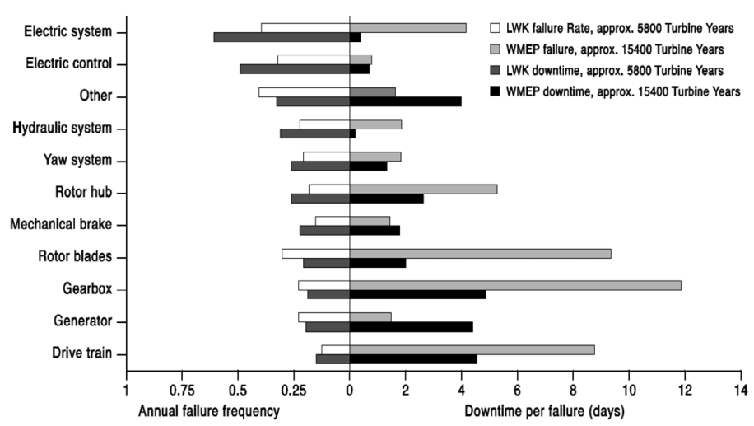

Figure-1. Failure frequency and downtime for different part of wind turbine [39]

Gearbox system is the main source of mechanical faults and losses in wind turbine systems. Also, it’s necessary to make periodic lubrication and maintenance for gearbox components in order to avoid an unexpected failure. Environmental drawback of the gearbox is audible noise created by mechanical parts [40]. Because of these reasons, manufacturers and designers start to develop gearless drive systems for wind turbines from early 1990s. However, geared systems still offer cheaper solutions than large diameter direct drive systems [37].

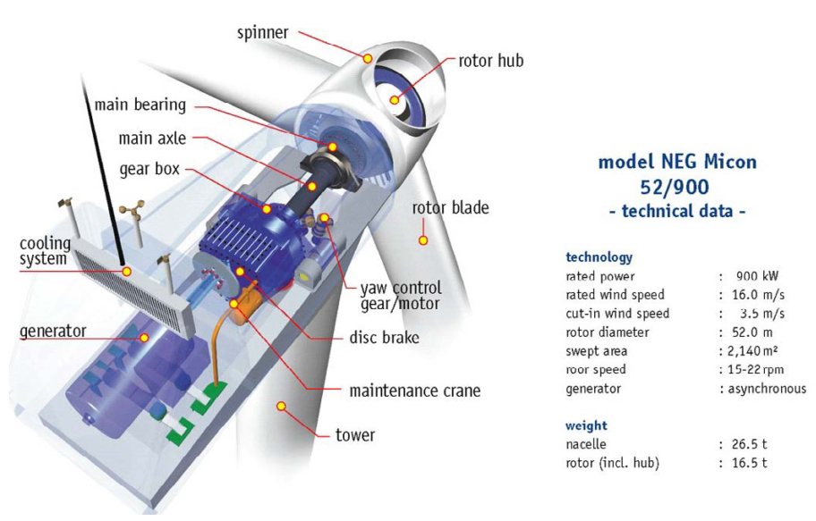

Figure-2. NEG Micon wind turbine with gearbox [39]

As the name refers, in direct drive generators gearbox and all bearing structures are eliminated. Therefore, turbine blades and generator are connected on same shaft rotating at low speed. With this eliminated gearbox and other mechanical structures, direct drive systems offer lower maintenance cost and increased efficiency and reliability. Main purposes of the direct-drive concept for wind turbines are; increasing energy yield, reducing gearbox failures and lower maintenance problems. There are two types of direct-drive namely, rotational and linear direct drives. But, linear direct drives are out of the scope of this thesis. In electrical generator design, one of the main criterion is torque. Due to tip speed limitation and natural result of gearless topology, direct drive wind turbine generators operate at low speed. Relationship between power and torque according formula which defines the output power of generator:

(7)

where, *P* is the output power, *T* is the torque and *wm* is the mechanical speed of the shaft. Torque must be increase inverse proportional to decrease of angular speed in direct drive generators. According to [38], electromagnetic torque of an axial flux permanent magnet machine is proportional to outer diameter as shown in (9). In some designs ratio of axial length to air gap diameter, *k* is optimized [2].

(8)

To do that when scaling up the turbine sizes, amount of material is increased in order to maintain the air-gap against deflection forces between stator and rotor parts. This means direct drive machines are heavier and larger in diameter size rather than other types of machines in order to produce same amount of power. More material also means extra cost which is a big disadvantage for this type of generators. Torque per volume and torque per mass parameters are important during the design of the generator system. Direct drive axial flux type permanent magnet machines are advantageous in torque to volume ratio among other machine topologies while torque per mass values are not much attractive. Torque per volume advantage is due to shorter axial length and compact structure rather than radial flux counterpart. Torque per mass disadvantage is related to large diameter is a penalty of this type of generators. Because of reasons aforementioned above, trend is going through the high torque direct drive generators as it eliminates gearbox losses and minimizes maintenance and repair cost hence increases overall efficiency and reliability of the system.

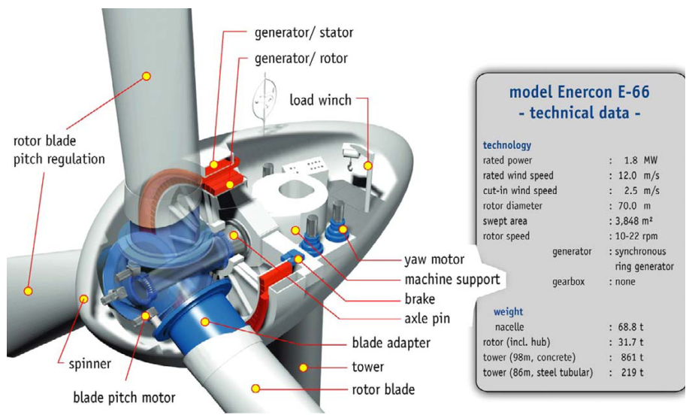

Figure-3. Enercon wind turbine without gearbox [39]

Modularity on the other hand, is related to availability of at least fractional parts of mechanical or electrical structure of generator during the failure periods. With the rapidly increased power levels of 5 MW and above, nowadays trend is going through the modular multi-level power electronics for converters of wind turbine generators. As in the proposed generator in this study, permanent magnets (PMs) are preferred instead of bulky and inefficient field windings. Mechanical modularity can be considered as operating parallel machines instead of one bulky generator, hence redundancy and overall efficiency is increased. In this study axially stacked parallel generator with direct drive concept is preferred because of this reliability view.

Challenges for increasing efficiency of wind turbines as control point of view can be considered as fault monitoring and diagnostic, forecast error and predictive controls. Especially with the Industry 4.0 trend, forecast errors and predictive control methods are gaining more attention than ever with the help of the high capacity digital signal processors and big data analysis techniques.



## Current Wind Turbine Systems

In this part, generators are categorized according to their mechanical and electrical properties. In mechanical categorization, drivetrain approach is considered ie. drivetrain includes gearbox or not. In electrical categorization, most used generator types in WECs namely induction and synchronous generators are considered in terms of wind turbine point of view. Thus, main approach in this part when describing their properties is based on whether they are induction or synchronous generators. Wind turbines are mainly categorized in the literature according to their revolution speeds which are fixed speed, limited variable speed or variable speed. Among them, variable speed configuration is the most used one because it’s more grid-supportive in terms of frequency converter it provides [41]. Reaching megawatts of power capability per turbine, generator technology gaining more attention than its past. Therefore its design is the main focus point of both this study and current research activities on this area.

## Induction Generators

## Squirrel Cage Induction Generators (SCIG)

This type of generator can be used with both fixed (also known as Danish Concept) and variable speed. However, SCIGs are commonly used for constant speed operation. Most common configuration of this generator consists of three stage gearbox connected to SCIG and compensating capacitors [39]. Generator speed is determined according to grid electrical frequency. Sometimes soft-starter can be used after the generator for smoother grid connection [42]. This type of SCIG is given in Figure 4.

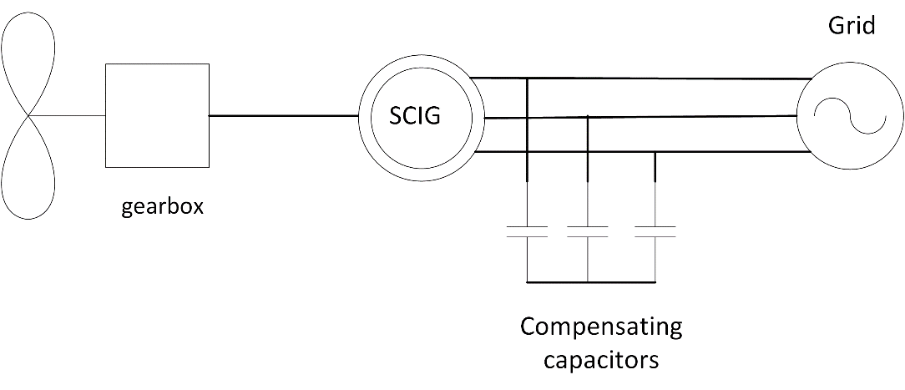

Figure-4. SCIG wind turbine schematic

Robustness, off-the-shelf parts, lower investment costs, stable operation and lower maintenance makes SCIG preferable in WECs. But in order to get more efficient operation SCIG should be constructed with low number of poles because high number of poles construction becomes a mechanical drawback for SCIG. Therefore gear-boxes are generally used with SCIGs. Due to fixed speed operation above rated wind speeds, limited output power is another drawback of this system. Lack of power electronic unit results in poor capability of reactive power control and voltage level problems. Need for magnetizing current in order to create magnetic field for stator, makes induction generator reactive power-dependent. Capacitor banks and Static Synchronous Compensators (STATCOM) are commonly used for reactive power compensation with SCIGs. Wind speed fluctuations and tower-shadow effect directly converted in torque dips and fatigue loads on turbine sub-mechanical systems.

In variable speed applications of SCIG back-to-back voltage source converters (VSCs) are employed in order to meet the grid codes [3]. Schematic diagram of this type WEC is given in Figure 5. Generator given in Figure 2 was also a constant speed SCIG namely, Danish Concept.

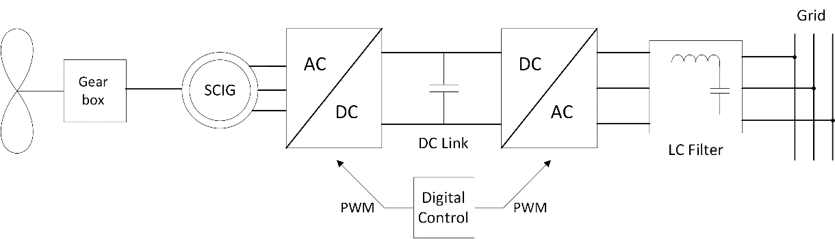

Figure-5. SCIG with back-to-back VSC converter [3]

## Wound Rotor Induction Generators (WRIG)

Wound rotor induction generators are also known as the Optislip concept and have been applied by Vestas since 1990s [42]. These type of generators are used for limited variable speed applications, thus there will be dynamic slip control [3].This control is applied by connecting electronically controlled resistor blocks to rotor of the generator. Mechanical loads are reduced in this type of configuration because of controllable speed. Slip denotes the relation between the rotor speed and synchronous speed and is given by the formula as follows,

(9)

where, s is the slip, Ns is synchronous speed, Nr is rotor speed. Higher slip magnitudes indicate higher power losses on rotor connected resistors hence lower efficiency. Gearbox in this system can be multiple stage just as the SCIG case. Also there exists shunt capacitors connected to line for compensation purposes.

Typical WRIG schematic diagram with these capacitors is shown in Figure 6. It can be concluded that main advantage of this concept is limited variable speed operation ability due to resistors connected series with power electronic converter. Main disadvantage of WRIG is lower efficiency due to heat losses on resistors while increasing variable speed range.

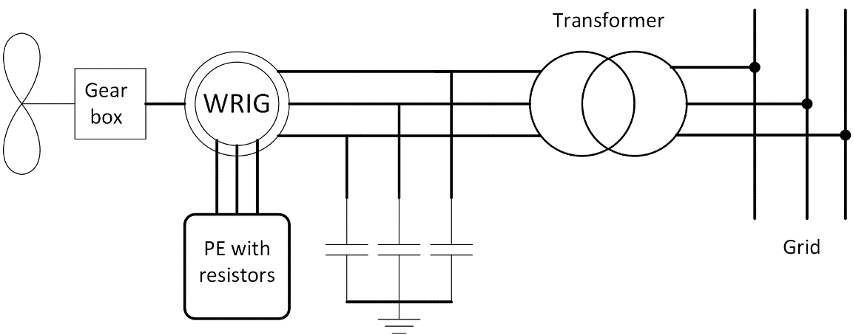

Figure-6. WRIG schematic diagram

Vestas V80 wind turbine has the output power of 2 MW and utilizes WRIG technology. An image of this wind turbine is given in Figure 7.

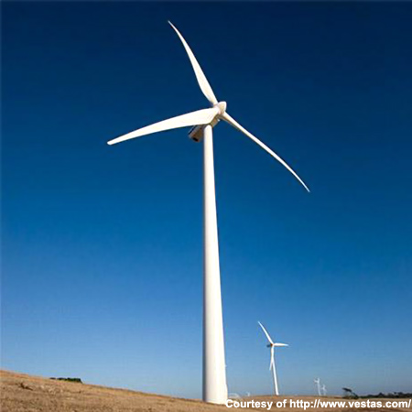

Figure-7. Vestas V80 wound rotor induction generator(Courtesy of Vestas) [43]

## Doubly-fed Induction Generator (DFIG)

Among these generator types, doubly-fed induction generator system with 3 stage gearbox (DFIG-3G) is the most common configuration at present [5]. Although it consists more complicated power electronic control, it can control active and reactive power flow within supply side or rotor side. Stator is connected to grid via transformer while rotor connected to grid via power electronic converter blocks. This power electronic converter is rated at fraction (usually between 20-30%) of generator power [44], therefore these converters are called as partial scale converter. Main objective of this power electronic block is to adjust speed range and grid reactive power support. Sometimes second PGSC (parallel grid side converter) is used parallel with dc-link in order to control unbalanced conditions better. Both kind of configuration of DFIG from basic to complex are shown in Figure 8 and Figure 9, respectively.

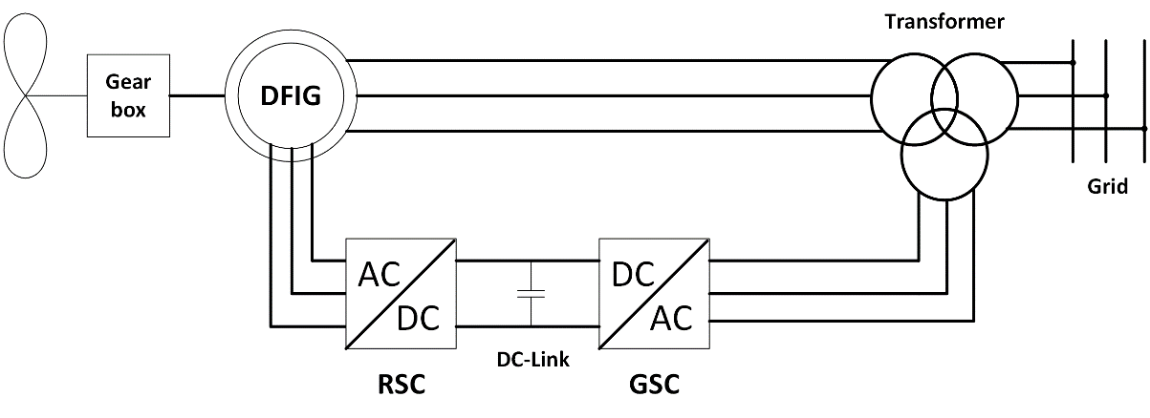

Figure-8. Conventional grid connected DFIG, RSC: Rotor side converter, GSC: Grid side converter

Slip rings and multistage gearbox are disadvantages of this generator. DFIGs are not suitable for direct drive because of efficiency problems. As mentioned before, as machine rotational speed decreases, torque must be increase in order to produce same amount of power. Therefore generator size should be increased. However, as the diameter of DFIG increases airgap also increase and magnetizing current increases. Higher magnetizing current means lower efficiency. Stator of the DFIG is directly connected to grid, thus possible active and reactive power support can be realized via partial scale converter of rotor. Back-to-back converter seen in Figure 8 can used with crowbar in order limit the current and provide fault handling capacity [44].

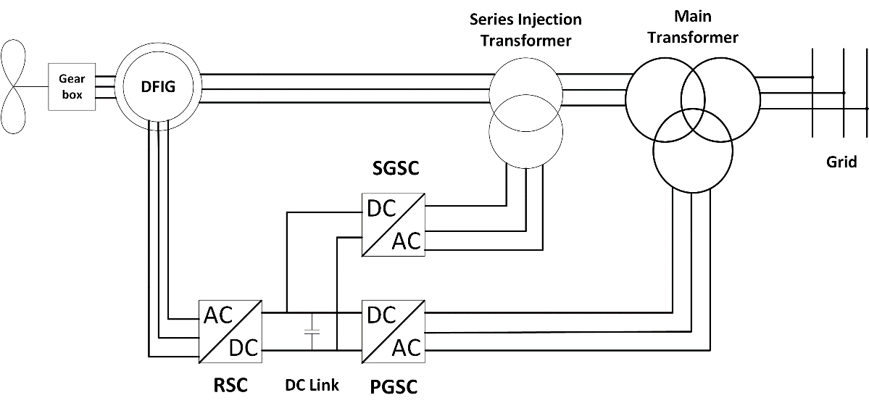

Figure-9. DFIG configuration with double GSC, SGSC: Series grid side converter, PGSC: Parallel grid side converter

A commercial DFIG wind turbine Nordex N131/3600 is given Figure 10. It’s rated at 3.6 MW and has 3 stage gear-box.

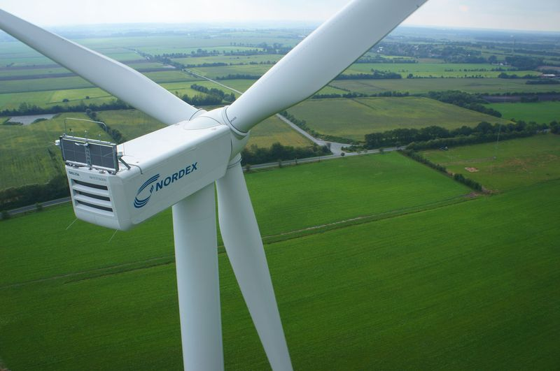

Figure-10. NORDEX N131 [courtesy of NORDEX]

Variable speed operation and efficient converter with active/reactive power control rather than WRIG, low price, easy off-the-shelf availability are main advantages of DFIG. Dependency on gearbox, complex power electronic and fractional scale adjustable reactive power control, slip rings, high stator peak torques during fault conditions, weak LVRT capability than synchronous generators with full-scale converters are main disadvantages of this type of wind turbine generators. Especially with the increasing importance of grid integration, it’s expected that DFIGs will become less preferable.

## Synchronous Generators

## Wound Rotor Synchronous Generators

Synchronous generators for wind turbines connected to grid via full scale power electronic converters. In WRSG additional partial scale converter is used for rotor DC excitation for required field [44]. Therefore WRSGs are also called as electrically excited synchronous generators (EESG). Rotor of synchronous generator can be excited permanent magnets (PM) also, but this type of generator will be described in next subsection. One of the most prominent manufacturer of WRSG is Enercon. In Figure 11, one of the gearless Enercon wind turbine can be seen. WRSG of this commercial wind turbine has 4.2 MW of output power and rotor diameter of 127 meters. One of the main advantages of this concept is that WRSG can be operated with variable speed applications with suitable grid connected power electronic block and proper vector control algorithm. Additionally, this machine type has cost advantage since no PM exists for field. Power converter losses and high prices of converter are main disadvantages of full-scale converter. But, it can provide wide control ability of wind turbine generator [42]. It can be either geared or direct-driven. However, direct-driven concept is more popular due to elimination of gearbox losses and reduced audible noise. It’s manufactured in large size and number of poles, therefore EESG can be heavy and expensive solution. Schematic diagram of WRSG is given in Figure 12 with gearbox depicted with dashed lines in order to show it’s optional for EESG.

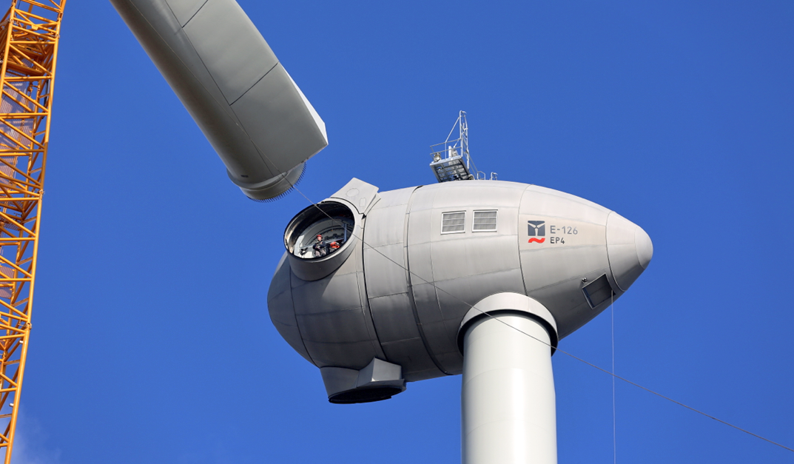

Figure-11. Enercon E-126 EP4, 4.2 MW wind turbine during the installation [45]

As a good alternative for PM excited synchronous generator, popularity of EESG depends on the PM prices. It can be said that reduction in magnet prices and disadvantages aforementioned above cause EESG less preferable against permanent magnet synchronous generators.

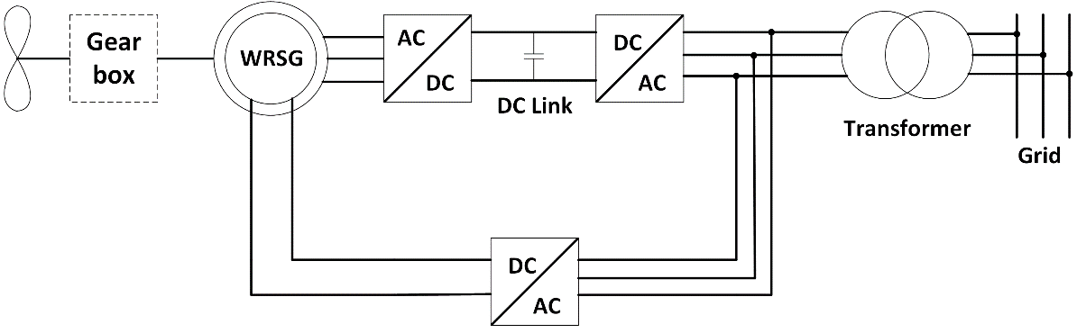

Figure-12. WRSG-Wound rotor Synchronous Generator grid connection

## Permanent Magnet Synchronous Generators

In this thesis work, Direct drive PMSG is chosen for the design. It becomes very popular especially for last decade because of its high energy yield, improved reliability, efficiency and low maintenance. Reliability can be increased by developing modular and fault tolerant PMSG. These days capacity of PMSG wind turbines increased up to 8 MW.

Conventional PMSG are connected to the grid via back-to-back converters as shown below in figures. This type of generator can be connected with diode front end system also.

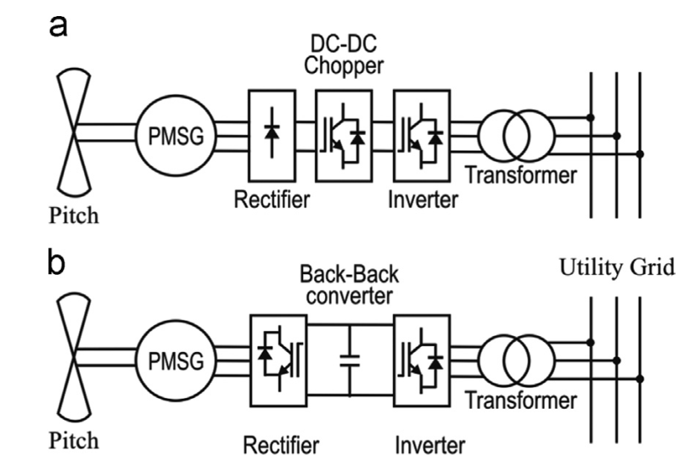

*PMSG based WECs a)diode front end system b)back to back converter system*

Vestas commercial 3.45 MW wind turbine with PMSG technology is given below.

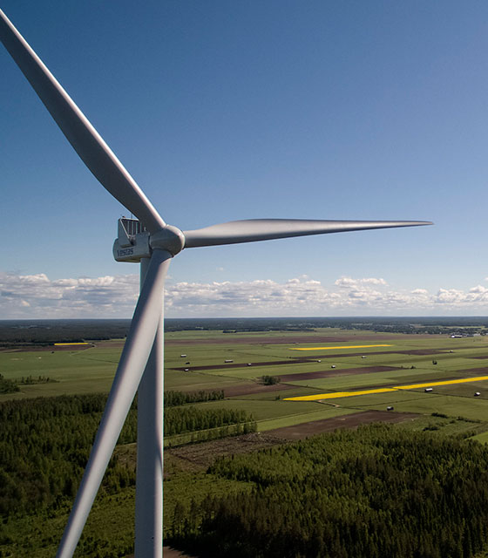

## Flux Orientations in PM based Systems

## Importance of Modularity in WEC Systems and AFPM

**REFERENCES**

[1] Y. Xia, K. H. Ahmed and B. W. Williams, "Wind Turbine Power Coefficient Analysis of a New Maximum Power Point Tracking Technique," in IEEE Transactions on Industrial Electronics, vol. 60, no. 3, pp. 1122-1132, March 2013.

[2] S. Engström and S. Lindgren, “Design of NewGen direct-drive generator for demonstration in a 3.5 MW wind turbine”, EWEC (European Wind Energy Conference & Exhibition, Milan, Italy, May 7-10 2007.

[3] O. P. Mahela, A. G. Shaik, Renewable and Sustainable Energy Reviews 57, 260-281 (2016).

[4] R. Melício, V.M.F. Mendes, J.P.S. Catalão, Fractional-order control and simulation of wind energy systems with PMSG/full-power converter topology, Energy Conversion and Management, Volume 51, Issue 6, June 2010, Pages 1250-1258, ISSN 0196-8904, <http://dx.doi.org/10.1016/j.enconman.2009.12.036>.

[5] Xu Yang; Patterson, D.; Hudgins, J., "Permanent magnet generator design and control for large wind turbines," in Power Electronics and Machines in Wind Applications (PEMWA), 2012 IEEE , vol., no., pp.1-5, 16-18 July 2012.

[6] V. Reyes, J. J. Rodríguez, O. Carranza and R. Ortega, "Review of mathematical models of both the power coefficient and the torque coefficient in wind turbines," 2015 IEEE 24th International Symposium on Industrial Electronics (ISIE), Buzios, 2015, pp. 1458-1463.  
doi: 10.1109/ISIE.2015.7281688.

[7] Janakiraman, S. Kotti, R. and Shireen, W., “Adaptive sensorless maximum power point tracking control for PMSG wind energy conversion systems”, paper P 1-41 Workshop on Control and modeling for Power Electronics (COMPEL), 2014.

[8] Kaur, J. and Khajuria, S., “Implementation of pitch control of wind turbine using Simulink (Matlab)”, International Journal of Advanced Research in Computer Engineering & Technology, Volume 1, 2012.

[9] Aguayo, J. Cotorogea, M. y Ovando, R. II., Emulation of a low power wind turbine with a DC motor in Matlab/Simulink, Power Electronics Specialists Conference, 2007.

[10] Cao, R. Lu, L. Xie, Z. Zhang, X. and Yang, S., “A dynamic wind turbine simulator of the wind turbine generator system”, International Conference on Intelligent System design and engineering application, 2012.

[11] Jin, Z. and Ma, Xiao. , “Semi-definite programming for power output control in a wind energy conversion system”, IEEE Transactions on sustainable energy, vol. 5, no.2, April, 2014.

[12] Aree, P. and Lhaksup, S., “Dynamic simulation of self-excited Induction Generator feeding motor load using matlab/Simulink”, 11th International Conference on Electrical Engineering/Electronics, Computer, Telecommunications and Information Technology (ECTICON), publisher IEEE, 2014.

[13] Duman, S. Altas, I.H. Yorukeren, N. and Sharaf, A.M., “A novel FACTS based on modulated power filter compensator for wind-grid energy systems”, IEEE 5th International Symposium on Power Electronics for Distributed Generation Systems (PEDG), Published IEEE, 2014.

[14] Cultura, A. B. and Salameh, Z. M., “Modeling and simulation of a wind turbine-generator system”, IEEE Power and Energy Society General Meeting, 2011 Published IEEE 2011, San Diego, CA.

[15] Yi, Guo. Hosseini, S.H. Jiang, J.N. Choon Yik Tang and Ramakumar, R.G., “Voltage/Pitch control for maximization and regulation of active/reactive powers in wind turbines with uncertainties”, 49th IEEE Conference on Decision and Control (CDC), Published IEEE, 2010, pp: 3956 – 3963, Atlanta, GA.

[16] Hamane, B. Doumbia, M.L. Bouhamida, M. and Benghanem, M., “Control of wind turbine based on DFIG using Fuzzy-PI and sliding mode controllers”, Ninth International Conference on Ecological Vehicles and Renewable Energies (EVER), 2014, Pp:1 – 8, Monte- Carlo, IEEE.

[17] Yi Guo. Hosseini, S.H. Choon Yik Tang and Jiang, J.N., “An approximate model of wind turbine control systems for wind farm power control”, 2011 IEEE Power and Energy Society, pp: 1 – 7, San Diego, CA.

[18] Gao, F. Lv, Y. and Xui, D., “Hybrid automaton modeling and global control of wind turbine generator”, Proceedings of Seventh International Conference on Machine Learning and Cybernetics, Kunming, 2008.

[19] Bagh, S.K. Samuel, P. Sharma, R. and Banerjee, S., “Emulation of static and dynamic characteristics of a wind turbine using Matlab/Simulink”, Power, 2nd International Conference on Control and Embedded Systems (ICPCES), 2012, Pp:1 – 6, Allahabad.

[20] Ming Yin , Gengyin Li , Ming Zhou and Chengyong Zhao, “Modeling of the wind turbine with a permanent magnet synchronous generator for integration”, IEEE Power Engineering Society General Meeting, Pp:1 – 6, Tampa, FL, 2007.

[21] Qiaoming Shi ; Gang Wang ; Lijun Fu ; Lei Yuan and He Huang, “State-space averaging model of wind turbine with PMSG and its virtual inertia control”, IECON 2013 - 39th Annual Conference of the IEEE Industrial Electronics Society, Pp: 1880 – 1886, Vienna 2013.

[22] Junfei Chen ; Hongbin Wu ; Ming Sun and Weinan Jiang, “Modeling and simulation of directly driven wind turbine with permanent magnet synchronous generator”, IEEE Innovative Smart Grid Technologies - Asia (ISGT Asia), Pp:1 – 5, Tianjin, 2012.

[23] Jie Chen and Dongxiang Jiang, “Study on modeling and simulation of non-grid-connected wind turbine”, WNWEC 2009 World Non-Grid- Connected Wind Power and Energy Conference, Pp:1 – 5, Nanjing, 2009.

[24] Llano, D. McMahon, R. and Tatlow, M., “Control algorithms for permanent magnet generators evaluated on a wind turbine emulator test-ring”, 7th IET International Conference on Power Electronics, Manchester, 2014.

[25] BOS

[26] Boukettaya, G. ; Naifar, O. and Ouali, A., “A vector control of a cascaded doubly fed induction generator for a wind energy conversion system”, 11th International Multi-Conference on Systems, Signals & Devices (SSD), Pp:1 - 7, Barcelona, 2014.

[27] Bustos, G. Milla, F. Saez, D. Vargas, L. S. Zareipour, H. and Nuñez, A., “Comparison of fixed speed wind turbines models: a case study”, IECON 2012 - 38th Annual Conference on IEEE, Montreal, QC, 2012.

[28] Ahmed, D. ; Karim, F. and Ahmad, A., “Design and modeling of lowspeed axial flux permanent magnet generator for wind based microgeneration systems, International Conference on Robotics and Emerging Allied Technologies in Engineering (iCREATE), Pp: 51 – 57, Islamabad, 2014

[29] Ahmad, A. Ahmed and D. Karim, F., “Design and modeling of lowspeed axial flux permanent magnet generator for wind based microgeneration systems”, 2014 International Conference on Robotics and Emerging Allied Technologies in Engineering (iCREATE), Islamabad, Pakistan, 2014.

[30] <http://www.cwpc.cn/cwpp/files/7313/9823/7381/Technology_Wind_Turbine_Design_Guidelines_for_Design_of_Wind_Turbines.pdf>

[31] M H Keegan et al 2013 J. Phys. D: Appl. Phys. **46** 383001

[32] Rossouw, Francois Gerhardus, “Analysis and Design of Axial Flux Permanent Magnet Wind Generator System for Direct Battery Charging Applications” ,MS Thesis, 2009.

[33] <https://www.windynation.com/jzv/inf/tip-speed-ratio-how-calculate-and-apply-tsr-blade-selection>

[34] Magdi Ragheb and Adam M. Ragheb (2011). Wind Turbines Theory - The Betz Equation and Optimal Rotor Tip Speed Ratio, Fundamental and Advanced Topics in Wind Power, Dr. Rupp Carriveau (Ed.), InTech, DOI: 10.5772/21398. Available from: <https://www.intechopen.com/books/fundamental-and-advanced-topics-in-wind-power/wind-turbines-theory-the-betz-equation-and-optimal-rotor-tip-speed-ratio>

[35] S.H. Pishgar-Komleh, A. Keyhani, P. Sefeedpari, Wind speed and power density analysis based on Weibull and Rayleigh distributions (a case study: Firouzkooh county of Iran), Renewable and Sustainable Energy Reviews, Volume 42, February 2015, Pages 313-322, ISSN 1364-0321, <http://doi.org/10.1016/j.rser.2014.10.028>.

[36] <http://www.ae.metu.edu.tr/~ae462/12/IEC%2061400-1.pdf>

[37] H. Polinder, F. F. A. van der Pijl, G. J. de Vilder and P. J. Tavner, "Comparison of direct-drive and geared generator concepts for wind turbines," in IEEE Transactions on Energy Conversion, vol. 21, no. 3, pp. 725-733, Sept. 2006.

[38] J.F. Gieras, R. Wang, M. J. Kamper, Axial Flux Permanent Magnet Brushless Machines, Second Edition.

[39] H. Polinder, "Overview of and trends in wind turbine generator systems," 2011 IEEE Power and Energy Society General Meeting, San Diego, CA, 2011, pp. 1-8. doi: 10.1109/PES.2011.6039342

[40] Reza MS thesis

[41] Guidelines for design of wind turbines, DNV,Second Edition

[42] H. Li and Z. Chen, "Overview of different wind generator systems and their comparisons," in IET Renewable Power Generation, vol. 2, no. 2, pp. 123-138, June 2008. doi: 10.1049/iet-rpg:20070044

[43] <http://www.powertechnology.com/projects/scrobysands/scrobysands3.html>

[44] M. Liserre, R. Cardenas, M. Molinas and J. Rodriguez, "Overview of Multi-MW Wind Turbines and Wind Parks," in IEEE Transactions on Industrial Electronics, vol. 58, no. 4, pp. 1081-1095, April 2011. doi:10.1109/TIE.2010.2103910

[45] <http://www.enercon.de/fileadmin/_processed_/csm_titel_ep4_1d94c9e268.png>

[46]