# **CHAPTER 3**

# **DESIGN OF PROPOSED GENERATOR**

In previous chapters, background about wind energy conversion systems and detailed overview of most used generator types are given. Then, challenges of modern wind turbine systems and fundamental equations are discussed. In chapter 2, direct drive axial flux permanent magnet generator is chosen for design in this thesis study because of its lower mechanical losses due to eliminated gearbox, high torque per volume and axial length advantages thanks to selected axial flux permanent magnet synchronous machine topology. In this chapter, electrical and mechanical design parameters of axial flux permanent magnet generator will be described. To do this, analytical design equations of proposed generator are given in the following sub-sections. These design equations will be used in following chapters for genetic algorithm optimization and electromagnetic design. Finally, a comparison of electromagnetic FEA and analytical calculation for given dimensions of proposed generator will be given to ensure the accuracy of the finite element analysis technique.

## Mechanical and Electrical Parameters

In previous chapter, it’s decided to use axial flux permanent magnet synchronous machine. In this machine, inner air-cored stator and outer rotor surface mounted permanent magnets will be used. General overview of proposed generator is given in Figure 1. In this figure, three axially stacked generator blocks are given. However, this image includes only 4 poles of proposed system. Permanent magnets are shown with blue and red colors, showing the direction of magnetization. Concentrated windings are shown with green colors. C-shaped steel rotor discs are shown with gray colors.

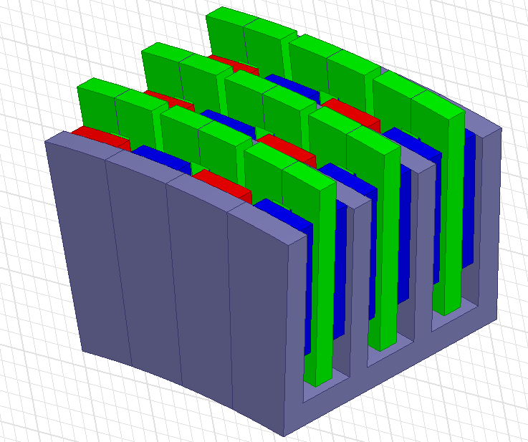

Figure-1. Proposed AFPM generator

## Fundamental Equations

Per-phase equivalent circuit and phasor representation of synchronous machine is given Figure 2 and Figure 3, respectively. Output rms phase voltage (terminal voltage) of a typical synchronous machine is calculated as follows,

(1)

where, *Eph,rms*is the induced emf rms value, *Zph,rms* is the phase impedence under steady state temperature and is the rms phase current.

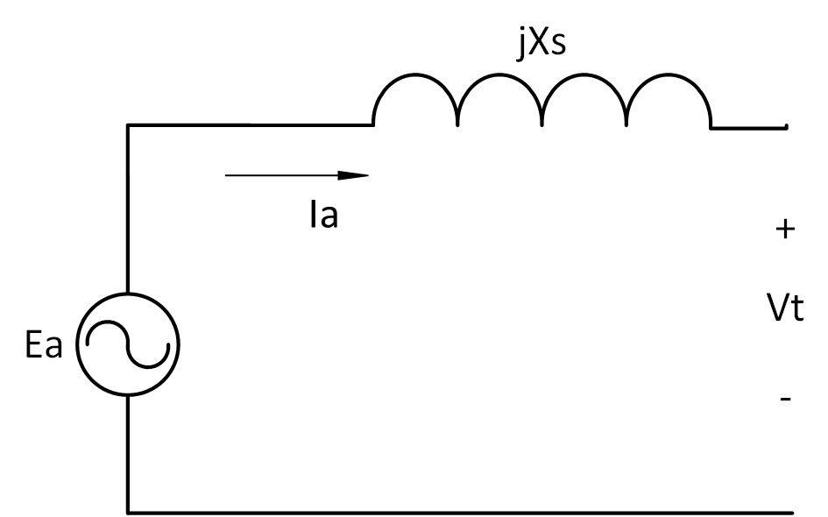

Figure-2. Equivalent circuit of the synchronous machine where Ea is the induced emf, Ia is the phase current, Xs is the synchronous reactance and Vt is the phase voltage[1]

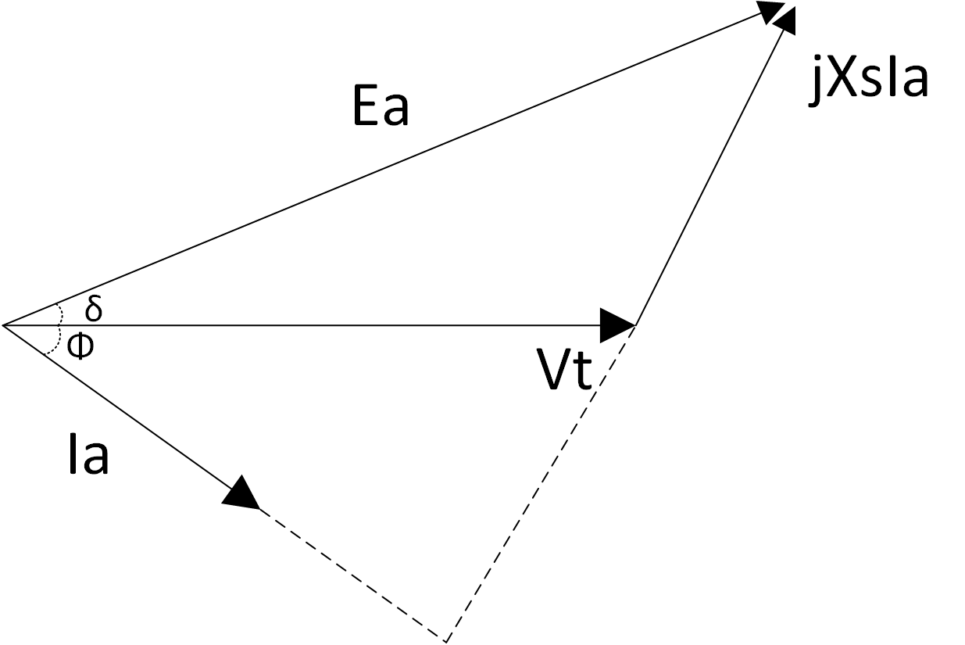

Figure 3. Phasor diagram of synchronous machine where δ is the load angle, Φ is the power factor angle

*Eph,rms* is calculated as follow,

(2)

(3)

Where *e* is the induced emf in one turn of conductor, *Nt* is the number of turns, *Ns* is the number of coils in series.

Phase voltage peak and rms values according phasor diagram given in Figure-3, are calculated as follows,

 (4)

 (5)

where  and  are phase resistance (which is relatively small than reactance) and phase reactance, respectively. Induced emf *e* in one turn of coil is calculated as follows,

 (6)

where  is the peak flux linkage,  is the pole pitch and *v* is the airgap linear speed. Peak flux linkage is calculated for the proposed generator as follows,

 (7)

where  is the leakage coefficient, ro and ri are the outer and inner radius of rotor respectively,  and  are the outer and inner length ratios of the coil pitch and width of the winding, respectively, Np is the number of poles. Leakage coefficient  can be taken as constant of 0.95. First harmonic value of the air-gap flux density *Bag* is given as follows,

(8)

where is the magnet pitch-to-pole pitch ratio and is the flux density in the airgap. Airgap linear speed *v* can be calculated as follows,

 ()

where  is the mean radius and  is the mechanical speed in rad/s. This mechanical speed is calculated as follows,

 ()

where *n* is the rotational speed in rpm. Since proposed machine is a synchronous generator, frequency of the machine is defined as follows,

 ()

## Geometrical parameters

Length ratios  and  given in (5) are calculated as follows,

 (9)

 (10)

 (11)

where is the difference between two distances.  and  are shown in Figure 4. Pole pitch  value in (6) can be calculated as follows,

 (12)

Coil pitch  which is used in (7), can be calculated as follows,

 (22)

Width of the winding value *tw* is calculated as follows,

 (21)

Outside radius *ro* and inside radius *r*i are given as follows,

 (13)

 (14)

where  is the mean airgap radius and *l*m is the axial length of the magnet.

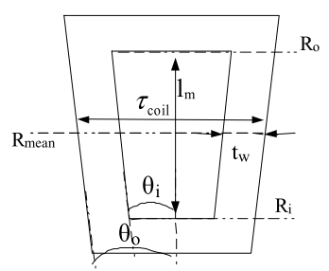

Figure 4. C-core coil with inner and outer length ratios[2]

Magnet pitch-to-pole pitch ratio is also referred as pole shoe arc-to-pole pitch ratio in [3] and can be calculated for our design as follows,

 (15)

This ratio can be taken as variable between 0.65 and 0.85. In our design it’s used as 0.75. Lower values of this variable leads to lower utilization of permanent magnets, hence higher values are preferred. Steel-to-steel distance *lss* can be calculated as follows,

 ()

In this equation *hm* is the height of the magnet, *lmm* is the magnet-to-magnet distance. C-shaped core is given in Figure 4 with related distances. Magnet-to-magnet distance can be calculated as follows,

 ()

where  is the height of the winding and *g* is the airgap clearance.

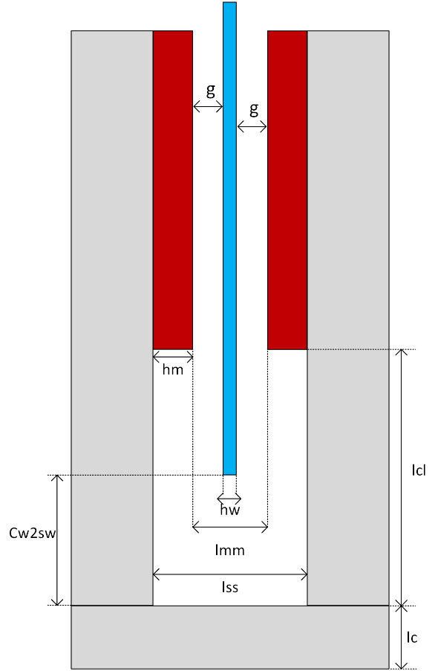

Figure 4. C-shaped core with defined distances. Gray: steel core, Red: Permanent magnets, Blue: stator windings

Steel web thickness *lc* is defined as the steel thickness at the bottom part of the C-shaped core and shown also in Figure 4. Magnet-to-steel web clearance *lcl* is the distance between steel web and magnet bottom edge part and shown in Figure 4 and calculated as follows,

 ()

where  is the distance between winding and steel web. Groove distance is the clearance defined as the length magnet buried in steel core limb. Since this value will be negligible small groove distance can be taken as zero and it can be assumed that magnets are smoothly surface mounted on the C-cores without any gap. Circumferential distance between the C-cores, ie. inter-module clearance called as spacer gap will be evaluated in the optimization part. Web pole pitch  is calculated as follows,

 ()

where  is the steel web radius and calculated as follows,

 ()

where  is the inner radius of the generator and calculated as given below,

 ()

Outer radius of the generator is calculated as follows,

 ()

In Figure 5, counter view of the one pole of the generator core limb diagram with different radius distances defined above is given.



Figure 5. Counter view of one pole of the generator core limb with different radius values and pitches; *wm*: magnet width, : pole pitch, *lc*: steel web thickness

Magnet width distance *wm* can be calculated as follows,

 ()

Stator outer diameter is calculated as follows,

 ()

* Structural Deflection

Structural deflection is related to mechanical stability. C cores try to close against each other and result in deflection in the air gap clearance. Main reason of this deflection is strong magnetic force between magnets in the area of airgap clearance. Ratio of this deflection with respect to airgap clearance is significant parameter in terms of structural modelling of the generator. It’s desired to keep this ratio below 10% in our design. To model the structural deflection, beam model is employed. Normally C cores are exist on the web module. Therefore, length of the beam  is limited as sum of the magnet length  and magnet to steel web clearance. Right hand side of the beam is modelled as stationary wall to show the steel web part. Beam model is given in Figure 6.



Figure 6. a) Beam model for the C core deflection. b) Model for uniformly distributed load (udl-*w*) is applied at a=0 c) Model for uniformly distributed load (udl-*w*) is applied at limited *a* units along the beam.

Normal stress *q* due to airgap flux density is calculated as follows,

 ()

Uniformly distributed load (udl-*w*) is calculated as follows,

 ()

Total deflection *y* is calculated by summing the two sub-models as shown in Figure 6. First sub-model demonstrates the deflection *y1* when a=0 and the second one demonstrates the deflection *y2* when a=. As mentioned before, beam length is calculated as follows,

 ()

Two beam deflections (*y1* and *y2*) and resulting total deflection *y* are calculated as follows,

 for  ()

 for  ()

 ()

where E and I are Young’s Modulus of steel and second moment of inertia, respectively. Young’s Modulus is taken as constant as 200x109 Pa for structural steel. Second moment of inertia is calculated as follows,

 ()

Ratio of deflection with respect to airgap, which shouldn’t be exceed 10%, is calculated as follows,

 ()

## Phase turns, phase resistance & inductance and flux densities

Peak and rms values of the total current per phase can be calculated as follows,

 (16)

 (17)

where  and  are peak and rms values of the phase current respectively,  is the current in one coil,  is the number of parallel coils.  value is calculated as follows,

 (18)

where *J* is the current density and  is the cross-sectional area of the conductor. Current density value can be selected before the design process as a constant. Cross-sectional area of the conductor, namely  can be calculated as follows,

 (19)

In this equation  is stand for effective window area of the conductors and calculated as follows,

 (20)

where *hw* is height of the winding, *tw* is the width of the winding and *kfill* is the fill factor for the winding coils. Conductor diameter *dcond* is calculated based of conductor area value as given below,

 in mm ()

Ratio of (4/3) used in equation (22) is a natural result of the structure of the selected axial flux PMSG and will be used in related calculation as constant.

Resistance of one coil is calculated as follows,

 (23)

where  is resistivity for copper conductor, *lt* is the mean turn length for a coil and calculated as given in (24).

 (24)

where  ,  and  are end, middle and structural parts of the coil, respectively. These lengths are calculated as follows,

 (25)

 (26)

 (27)

Resistance per phase value is based on resistance per coil and calculated as follows,

 (28)

Resistance value given in (28) was calculated without thermal effects. Resistance value including thermal effects can be calculated as follows.

 (29)

where  is the temperature coefficient of copper and  is the temperature difference between ambient and desired operating temperature. Phase reactance  value is calculated as follows,

 (30)

where  is the angular frequency,  is the inductance of a coil. Angular frequency and inductance of a coil are calculated as follows,

 ()

 () ()

where  is the flux linked by coil, *lss* is the C-core steel-to-steel distance. Phase impedence *Zph* can be calculated using phase resistance and reactance values as follows,

 ()

In order to find essential fluxes and flux densities of proposed generator, flux paths and reluctance networks should be defined first. As mentioned earlier it’s assumed that no leakage flux exist in the generator, therefore design parameters will be defined accordingly.

* **Thermal Considerations**

Cooling of the machine is chosen as forced air cooling. Therefore, we can determine a proper current density value at 100o C temperature. Then, calculation of the temperature rise  can be done as follows,

 ()

 can be assumed as 20o C . Other constant and reference values will be explained in the next chapter.

* **Reluctances**

Reluctances and flux paths are shown in side and top view of the cores in Figure 6 and Figure 7, respectively. Airgap reluctance of the machine is calculated as follows,

 ()

Steel reluctance can be evaluated as two parts, namely Part A and Part C, as given in Figure 6. These specific reluctances and resulting total steel reluctance are calculated as follows,

 ()

 ()

 ()

where , and  are thickness of outer limb, permeability of free space and permeability of steel, respectively. Reluctance of spacer is calculated as follows,

 ()

where and c are inner limb thickness and spacer distance between modules, respectively. However, gap between modules (*c*) can be omitted. Because it’s negligible small in reality. PM reluctance consists of two parts : magnet itself reluctance and reluctance exist on the steel region. PM reluctance *SPM* is calculated as follows,

 ()

where  is the permeability of the permanent magnet material. All the permeability values of different material of generator will be taken as constant during the optimization. As can be seen on Figure 6 and Figure 7, permanent magnets are MMF source for the magnetic circuit. This MMF value provided by the magnets, can be calculated as follows,

 ()

where  is the remanent flux density of the selected permanent magnet material.



Figure 6. Side view of the C-core for reluctances and flux paths



Figure 7. Top view of the C-cores for reluctances and flux paths

* **Flux and flux densities**

In order to define fluxes and flux densities, magnetic circuit should be analysed in terms of reluctance network via Kirchoff’s voltage and current laws.

Once we assume there is no leakage flux, we can say that flux that crosses the airgap is same as the flux that PM generates. Therefore, node equations at point A in Figure 7 can be written as follows,

 ()

 ()

For the loop B, following equations can be derived

 ()

Since we assume  , then



 (1)

where, , ,  and  are spacer flux, steel flux, permanent magnet flux and airgap flux, respectively. ,  ,  and  are spacer top and bottom reluctances, permanent magnet top and bottom reluctances, respectively. Similar equations can be derived for the loop C as seen on Figure 6.

 ()

 (2)

If we combine (1) and (2) together we get,



To solve this matrice problem left hand side of the equation should be multiplied by the inverse of the reluctance matrice exist on the right hand side,



According to equation above, flux values are calculated as follows,

 ()

 ()

 ()

In the equation above spacer and magnet reluctances are separated into two component which are top (T subscript) and bottom (B subscript) part of the path due to different cross sections of geometry. However, difference of top and bottom components of these reluctances are negligible small. Therefore, it can be assumed as same, ie. top and bottom part reluctances are equal for the simplicity of the calculations. Finally, fluxes are calculated as follows,

 ()

 ()

 ()

Flux densities are calculated based on above flux equaions as follows,

For air-gap flux density,

 ()

For spacer flux density,

 ()

For steel flux density,

 ()

## Volume and mass Equations

Total mass of the generator consists of two main categories. These are :

* Active mass
* Steel mass
* Copper mass
* Permanent magnet mass
* Structural mass
* Shaft
* Stator cylinder structure
* Rotor torque structure
* Steel band
* Epoxy

Active mass includes the materials which affects the electromagnetic performance of the machine directly while structural mass components are generally provided mechanical stability to generator via non-magnetic materials.

* Active mass calculation

Total steel mass  consists of three main parts: outer limb mass, inner limb mass and web mass. These are calculated as follows,

 ()

where , , , ,  and  are mass of outer limb, number of outer limbs in machine, mass of inner limb, number of inner limbs of machine, mass of steel web and number of steel web part, respectively. Mass of each components are calculated as follows,

 ()

 ()

 ()

where  and  are mass density of the steel and height of steel web, respectively. Height of the steel web can be calculated as follows,

 ()

Until now, mass components of the steel material have been calculated. However, these values are valid for only single layer. In order to include number of parallel machines into calculation, number of layers of each component should be multiplied with related mass of steel. A sample view of 3-stage (number of parallel machine is three) axially stacked generator is given in Figure 8. As it can be seen on this figure, number of outer limbs is always two regardless of the stack number of generators. Number of inner limb is always one less than that of the stack number. Number of steel web is same as number of stacks. Number of permanent magnets  is always double that of the stack number.



Figure 8. Proposed axial flux PM generator side view with three axial stacks[2]

Total magnet mass  is calculated as follows,

 ()

where  and  are mass density of permanent magnet material and total number of permanent magnet layers in generator, respectively. Total copper mass is calculated as follows,

 ()

where  and  are mass density of copper and number of parallel stacks in the generator, respectively.

* Structural mass calculation

Total structural mass of the generator can be defined as the sum of the shaft mass, stator torque structure mass, rotor torque structure mass, steel band mass and epoxy resin mass.

Shaft can be modelled as a hollow cylinder. Therefore total shaft mass can be calculated as follows,

 ()

where  ,  and  are shaft outer radius, shaft inner radius and shaft length, respectively. For the convenience, shaft length is selected as the 5/4 times that of the machine total axial length. Total axial length of the machine () is calculated as follows,

 ()

 ()

Total stator mass consist of a stator cylinder mass  and two times of the stator torque arm structure mass  . This mass can be calculated as follows,

 ()

Stator cylinder provides supportive mechanism to the stator windings and mass of this structure  can be calculated as follows,

 ()

Stator torque arm structure holds the stator cylinder mechanism stable and consists of torque arms. These arms are formed of rectangle steel hollow bars as can be seen on Figure 9. Stator torque arm structure mass is calculated as follows,

 ()

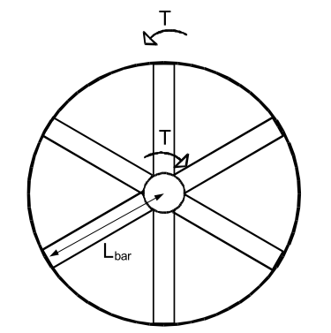

Figure 9. Torque arm structure with 6 arms[2]

where  and  are the number of stator torque arms and length of stator torque arms, respectively. Length of bar is generally half of the stator outer diameter of the machine. *b, d, bi, and di* are the cross-sectional distances of steel hollow bars. Constants used in the calculations of these values should be suitable in terms of hollow bar view and have very low effect on resulting mass. These lengths are shown in Figure 10 can calculated as follows,



Figure 10. Steel hollow bar dimensions

 ()

 ()

 ()

 ()

Duty of rotor torque arms is to maintain stability to C-shaped cores of rotor. Total mass of rotor torque arms () is calculated in a very similar way that of stator torque arm calculation:

 ()

where  and  are number of rotor torque arms and length of the rotor torque arm, respectively. Calculations and definitions for steel hollow torque arms for rotor are same as stator torque arm calculations. Therefore, Figure 9 and Figure 10 are valid for rotor torque arm structure. Length of rotor torque arm bar is equal to web radius . It can be optional to use supporting steel discs instead of rotor torque arms as shown in Figure 8. However, torque arm is selected for rotor support in our design due to its simple equations.

Function of the steel band is to give mechanical support to coils and fix them to the stator structure. A sample steel band used in proposed generator is given in Figure 11. Total steel band mass is calculated as follows,

 ()

where  and  are the height and width of the steel band, respectively. These sizing values of the steel band can be determined during optimization.

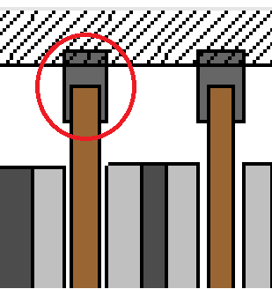

Figure 11. Steel band

Epoxy is used to fill the free space around coils and to give mechanical support and insulation for winding[4]. Its total mass  in our proposed design is calculated as follows,

 ()

where  and  are the mass density of epoxy resin and pitch of the coil former. Main duty of the coil former is the give mechanical support to the coils from inner side[4]. Representation of sample trapezoidal winding with distances including the pitch of the coil former is given in Figure 12. Mean pitch of the coil former  can be calculated as follows,

 ()

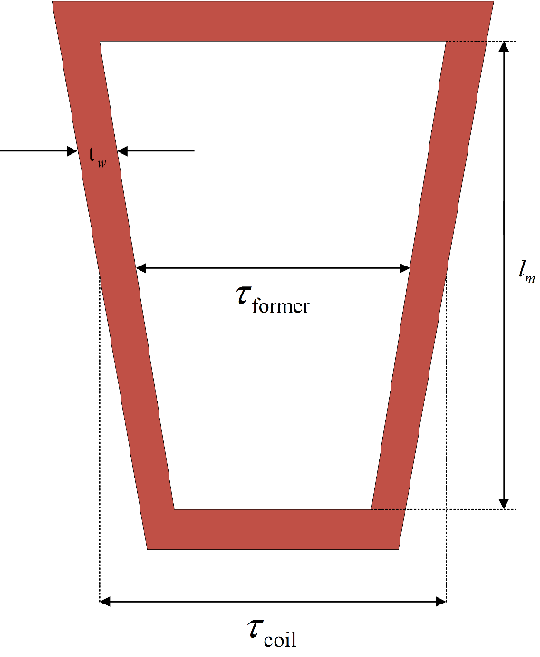

Figure 12. Trapezoidal winding distances

## Losses

Total energy loss in the generator is sum of the core losses and the copper losses.

 ()

Copper losses  are calculated as follows,

 ()

Core losses consist of eddy losses both on coils and magnet surface. These losses are calculates as given below,

 ()

 ()

 ()

where ,  are coil and magnet components of eddy loss respectively,  and  are thickness and height of the copper conductor respectively, *Bag* is the airgap flux density without leakage flux assumption, *keddy* is the eddy loss coefficient used in calculating magnet surface eddy loss, *Nc* is the number of coils. These variables are calculated as follows,

 ()

Number of coils per phase (*Nc,ph*) is calculated by dividing *Nc* value by 3. Number of coils in series (*Ns*) is calculated as follows,

 ()

Thickness and height of the copper values are calculated as follows,

 ()

 ()

In the equations above, ,  and  are height of the coil, thickness of the coil and thickness of the insulation material, respectively. These parameters are calculated as follows,

 ()

 ()

where  and  are thickness of epoxy and number of turns per strand, respectively. Epoxy thickness value can be taken as constant during the design process. Number of turns per strand value is calculated as follows,

 ()

where  is the number of strand and taken as 1 in our design. Coil area including the insulation part is calculated as follows,

 ()

Insulation area per coil  and insulation thickness  are calculated based on coil area as given below,

 ()

 ()

## Power and Efficiency

Total output electrical power of the generator is given as follows,

 (31)

Efficiency of the generator is calculated as follows,

 (32)

## Electromagnetic FEA vs analytical evaluation for sample dimensions

**References**

[1] B. S. Guru and H. R. Hiziroglu, “Electric Machinery and Transformers,” *Oxford Univ. Press*, p. 741, 2001.

[2] O. Keysan, A. S. McDonald, and M. Mueller, “Integrated Design and Optimization of a Direct Drive Axial Flux Permanent Magnet Generator for a Tidal Turbine,” in *International Conference on Renewable Energies and Power Quality - ICREPQ’10*, 2010.

[3] J. F. Gieras and M. Wing, *Permanent Magnet Motor Technology: design and applications*, vol. 113. 2002.

[4] J. F. Gieras, R.-J. Wang, and M. J. Kamper, *Axial Flux Permanent Magnet Brushless Machines*, vol. 3 ed. Dordrecht: Springer Netherlands, 2008.