# **CHAPTER 3**

# **DESIGN OF THE PROPOSED GENERATOR**

In the previous chapters, background information about wind energy conversion systems and detailed overview of the most used generator types are presented. Then, challenges of modern wind turbine systems and fundamental equations are discussed. Direct drive axial flux permanent magnet generator is chosen for the design in this thesis study because of its lower mechanical losses due to eliminated gearbox, high torque per volume and axial length advantages[1], [2]. In this chapter, electrical and mechanical design parameters of axial flux permanent magnet generators will be described. In order to do this, analytical design equations of proposed generator are presented in the following sub-sections. Finally, a result comparison of electromagnetic FEA and analytical calculation for a sample 50 kW generator will be presented to ensure the accuracy of the finite element analysis simulations. Analytic design equations described in this chapter are coded in MATLAB and then used in genetic algorithm optimization, which will be discussed in the next chapter.

## Mechanical and Electrical Parameters

In this section, main electrical and mechanical parameter calculations of the proposed AFPM generator will be presented. In order to achieve an integrated understanding, dimensions and related drawings of the generator will be shown first. Then, magnetic circuit parameters including the airgap flux density and induced emf of the design will be described. Finally, structural and thermal design notes will be presented.

## Dimensions of the proposed AFPM generator

In axial flux permanent magnet synchronous generator, inner air-cored stator and outer rotor surface mounted permanent magnets will be used. General overview of proposed generator is given in Fig. 3-1. In this figure, three axially stacked generator blocks are presented. However, this figure includes only 4 poles section of the proposed system, for the sake of simplicity.

There is a (4/3) ratio between coil pitch and pole pitch in order to achieve maximum flux linkage. Since flux linked by the coil is related to induced voltage[3], [4], choosing optimum value of the pitch ratio has a high importance in electrical machine design. Induced voltage variation of a coil according to different coil pitch/pole pitch ratios, is shown in Fig.3-2 . As it can be seen from this figure, 4/3 ratio has the highest induced voltage rating. This type of configuration is also used for modularity in our design.

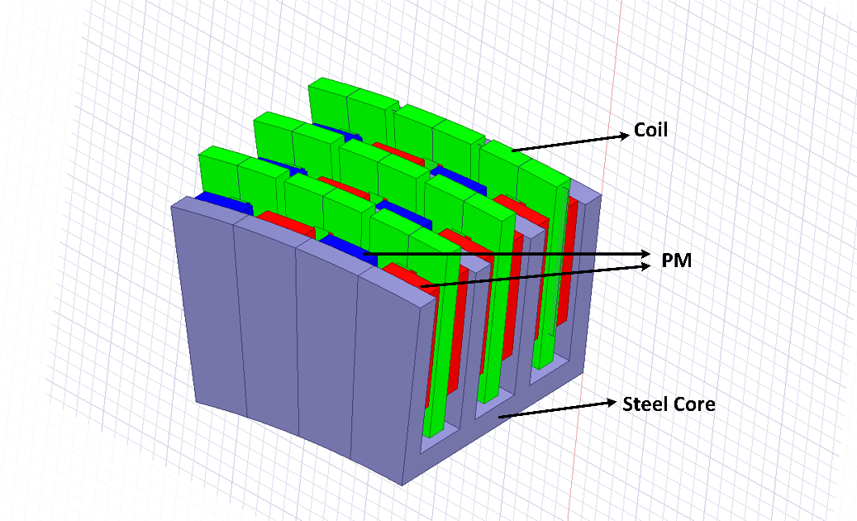

Fig. 3-1. 4-pole section of the proposed axial flux PM generator

Main dimensions of the proposed AFPM generator are presented with their descriptions in Table 3-1, Table 3-2 and Table 3-3. These dimensions are shown on the machine drawing from different view angles in Fig.3-3, Fig.3-4 and Fig.3-5, respectively.

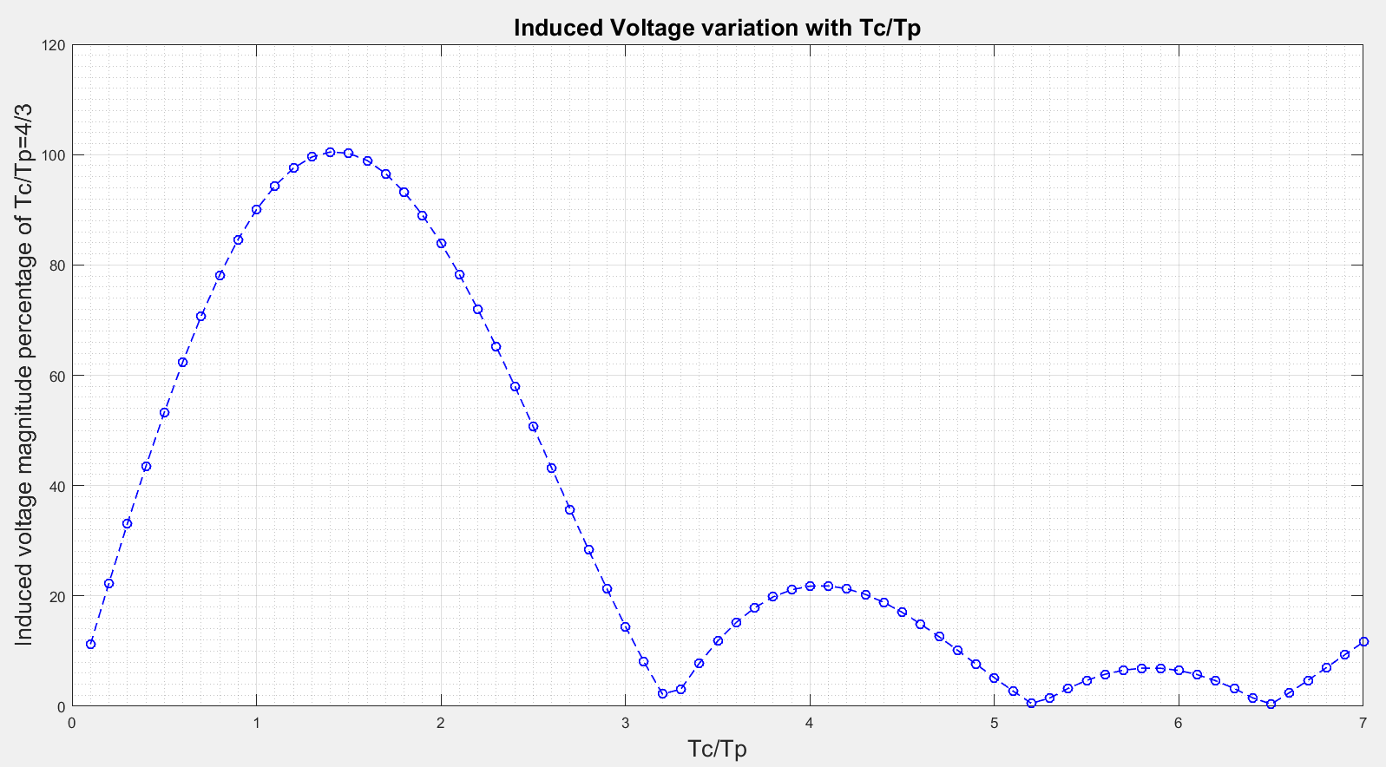

Fig. 3-2. Induced voltage variation with respect to different / ratios []

In Fig.3-3, dimensions for the side view of the proposed AFPM are shown. These parameter definitions are presented in Table 3-1.

Table 3-1. Dimension of the proposed AFPM generator at side view

|  |  |
| --- | --- |
| **Dimension** | **Description** |
|  | Airgap clearance |
|  | Coil to steel-web clearance |
|  | Magnet to steel-web clearance |
|  | Height of the winding |
|  | Height of the magnet |
|  | Magnet-to-magnet distance |
|  | Steel-to-steel distance |
|  | Steel web thickness |
|  | Length of the magnet |
|  | Thickness of winding |
|  | Coil pitch |
|  | Coil thickness/coil pitch ratio |

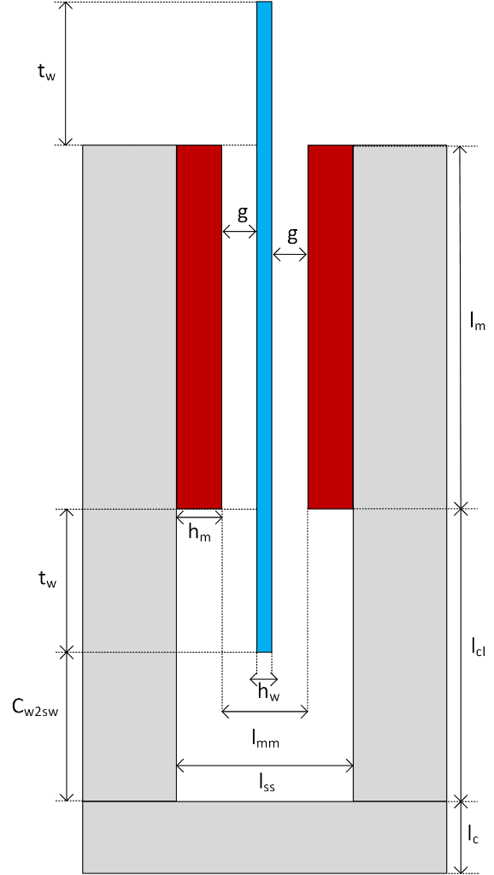

Fig 3-3. C-shaped core side view with defined dimensions in Table 3-1.

Width(thickness) of the winding value *tw* is calculated by the help of the coil pitch ratio  as follows,

 (3-18)

 is the distance between coil and steel web. This value is used in the optimization algorithm as a constant. However, selection of proper distance is important for design considerations. Value of the coil thickness/pitch ratio  is determined by using optimization. In Fig.3-4, dimensions for the counter view of the one pole of the proposed generator are shown. These parameter definitions are presented in Table 3-2.

Table 3-2. Dimension of the proposed AFPM generator pole at counter view

|  |  |
| --- | --- |
| **Dimension** | **Description** |
|  | Pole pitch |
|  | Outer radius |
|  | Inner radius |
|  | Mean radius |
|  | Web radius |
|  | Width of the magnet |
|  | Number of poles |
|  | Web pole pitch |

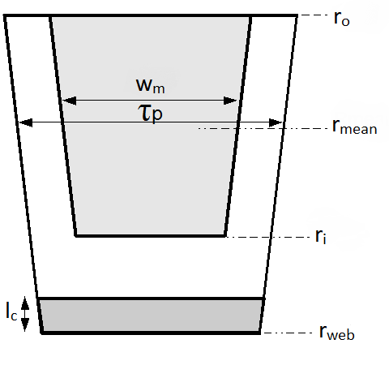

Fig. 3-4. Counter view of one pole of the generator core limb[5]

Pole pitch  distance can be calculated as follows [6],

 (3-16)

Mean radius  and magnet length  are determined by the optimization in our study. Outer radius *ro* and inner radius *r*i lengths are calculated by using magnet length and generator mean radius values as follows,

 (3-19)

 (3-20)

In this study, groove distance is taken as zero and it is assumed that magnets are smoothly surface mounted on the C-cores without any gap. Circumferential distance between the two successive C-cores, namely spacer gap is also assumed as zero. Web pole pitch  is calculated as follows,

 (3-25)

Magnet width distance (magnet pitch) *wm* can be calculated by using magnet pitch-to-pole pitch ratio  as follows,

 (3-27)

Magnet pitch-to-pole pitch ratio  is also referred as pole shoe arc-to-pole pitch ratio in [7] and can be described for our design as follows,

 (3-21)

Lower values of this variable leads to lower utilization of permanent magnets, hence higher values are preferred. However, much higher values of  results in increased leakage flux between permanent magnets thus decreasing the airgap flux density and machine electromagnetic performance[6], [8]. Therefore, value of this ratio is determined by using optimization. Leakage flux phenomenon is depicted in Fig. 3-5 in order to show the effect of higher . Stator outer diameter is important during the design because it should be limited for specific application and determines the main properties of a generator together with the parameter of axial length. Stator outer diameter is calculated as follows,

 (3-28)

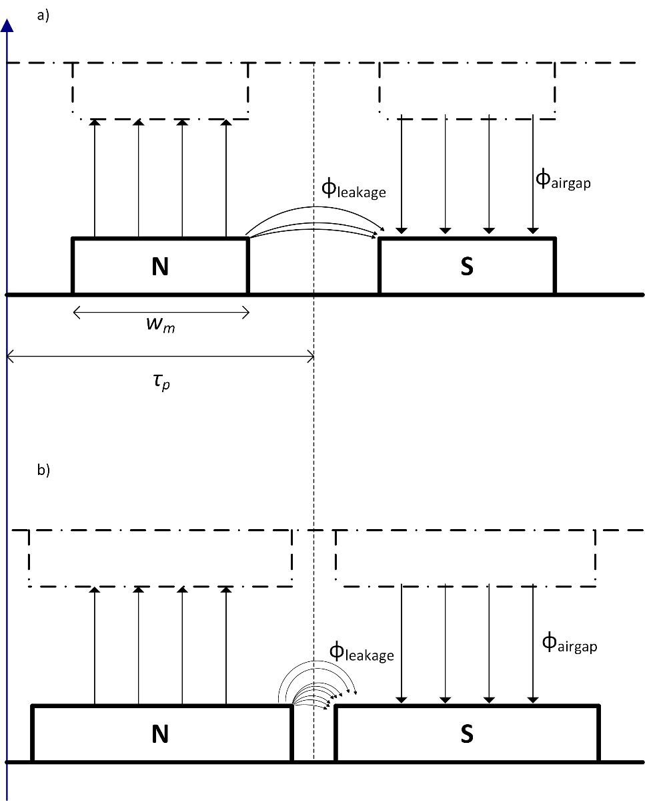

Fig. 3-5. Effect of higher  in terms of leakage flux from the top view of the generator. a) shows lower ratios of  with lower leakage flux. b) Ratio of  is increased thus leakage flux increases and lowering the effective airgap flux density.

In Fig.3-6, dimensions for the C-core coil of the proposed generator are shown. These parameter definitions are presented in Table 3-3.

Table 3-2. Dimension of the proposed AFPM generator pole at counter view

|  |  |
| --- | --- |
| **Dimension** | **Description** |
|  | Inner length ratio |
|  | Outer length ratio |
|  | Length ratio difference which corresponds to thickness of the winding |

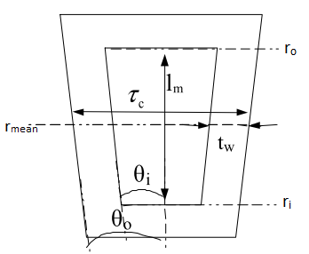

Fig. 3-6. C-core coil with inner and outer length ratios[5]

Length ratios  and  showed in figure above, are calculated as follows,

 (3-13)

 (3-14)

 (3-15)

where is the difference between two ratios. These length ratios are utilized to define the coil segments in radian and used in the flux linkage calculation. These calculations will be presented in the following subsections.

## Electromagnetic Design

In this section electromagnetic design stages of the proposed AFPM generator will be described. In order to do this, first magnetic network of the machine will be presented. Then induced emf and related flux density calculations will be summarized.

* **Magnetic Circuit**

In order to find essential fluxes and flux densities of the proposed generator, flux paths and reluctance network should be defined first [9]. It’s assumed that leakage flux exists in the generator in order to calculate the parameters and analyze the generator more accurately. Therefore, flux paths and equations will be defined accordingly. Reluctances and flux paths are shown in side and top view of the c-cores in Fig. 3-7 and Fig. 3-9, respectively.

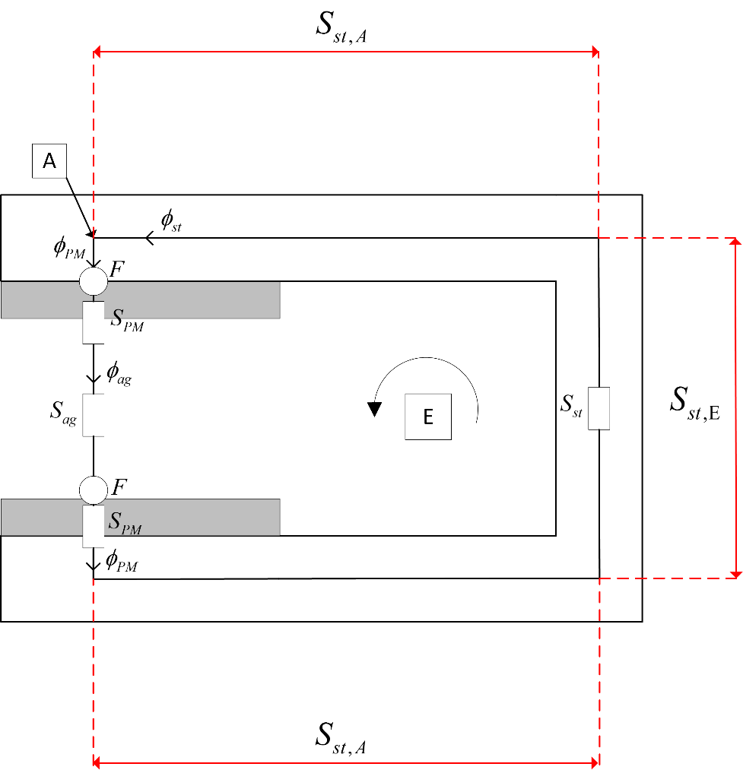

Fig. 3-7. Side view of the C-core for reluctances and flux paths[10]

Airgap reluctance  of the machine is calculated as follows[9],

 (3-56)

where  is the permeability of air. Steel reluctance  can be evaluated as two parts, namely Part A and Part E, depicted in Fig. 3-7. These specific reluctances and resulting total steel reluctance are calculated as follows[9],

 (3-57)

 (3-58)

 (3-59)

where  and  are thickness of outer limb and permeability of steel, respectively. Outer () and inner () limb thickness values are determined according to optimization process, which will be described in the next chapter. Reluctance of spacer is calculated as follows,

 (3-60)

Defined spacer reluctance above corresponds to inter-module steel part of core [9]. Reluctance value of the inter-module gap is omitted because gap distance is assumed as zero, as mentioned before. PM reluctance consists of two parts: magnet’s self reluctance and reluctance of the steel region. These two parts are shown in Fig. 3-8.

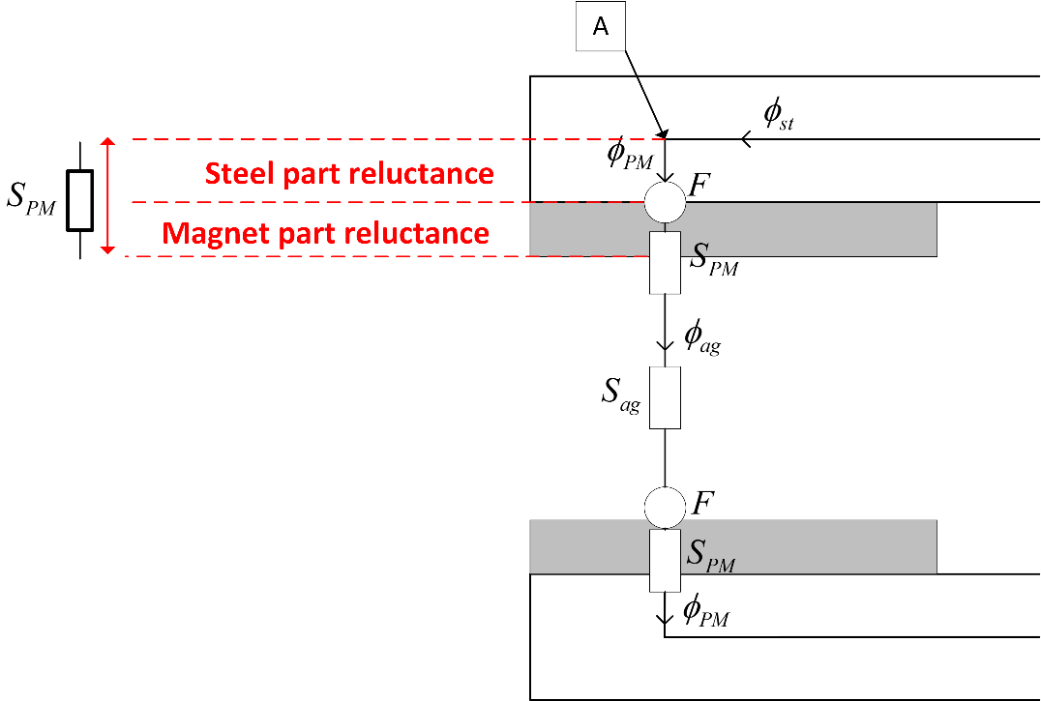

Fig. 3-8. Permanent magnet reluctance components

PM reluctance *SPM* is calculated as follows [9],

 (3-61)

where  is the permeability of the permanent magnet material. Leakage fluxes in this study are assumed for magnet-magnet leakage direction. Top view of the C-cores showing the fluxes and flux paths including the mentioned leakage reluctances, is given in Fig. 3-9.

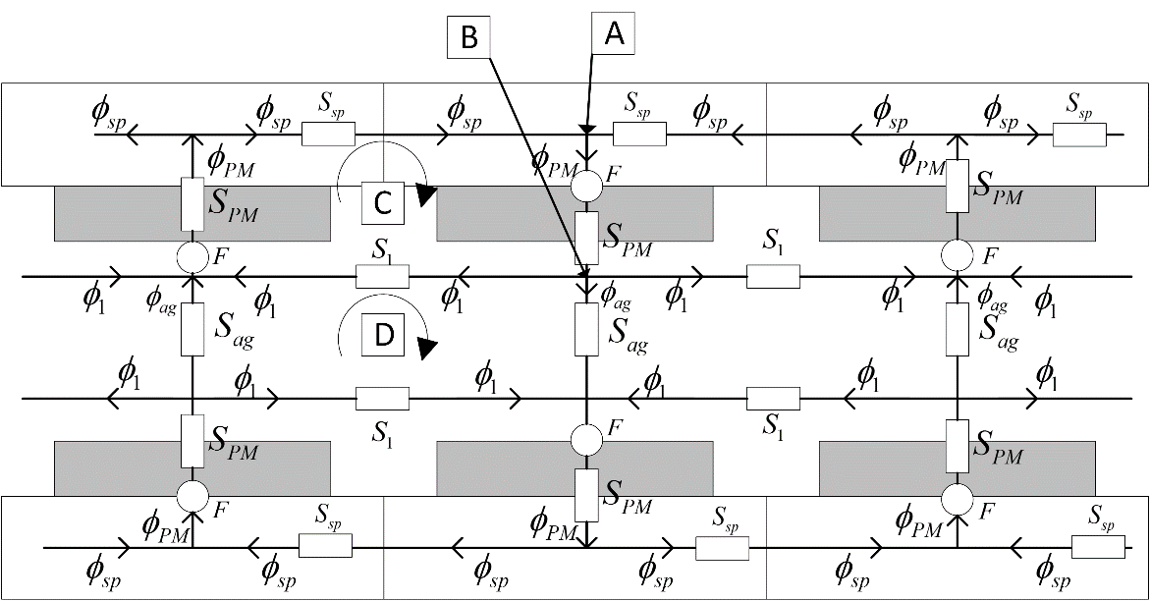

Fig. 3-9. Top view of the C-cores for reluctances and flux paths included leakage effect[9]

Leakage path reluctance *S1* has two components. These components are shown in Fig. 3-10. According to this figure, leakage reluctance component  corresponds to gap regions facing the magnets in axial direction while reluctance component  corresponds to gap region between magnets in circumferential direction. It is assumed that flux generated by the magnets entering and leaving the magnets in axial direction. Therefore, leakage flux calculations on the side faces of magnets are unnecessary.

As can be seen on Fig. 3-8 and Fig. 3-9, permanent magnets are the main MMF source for the magnetic equivalent circuit. This MMF value provided by the permanent magnets, can be calculated as follows[9],

 (3-65)

where  is the remanent flux density of the permanent magnet. Remanent flux density value is taken as 1.4 T for the selected grade N50 rare-earth magnet [11].

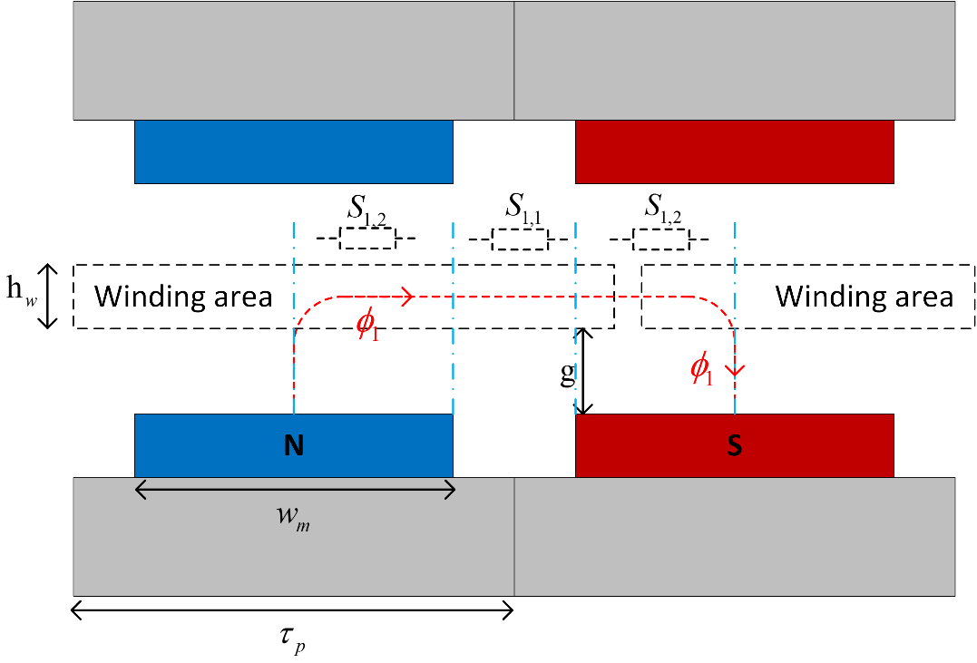

Fig. 3-10. Leakage reluctance network

These reluctance components and resulting reluctance *S1* are calculated as follows,

 (3-64)

 (3-62)

 (3-63) In order to define fluxes and flux densities, magnetic circuit should be analysed in terms of reluctance network. Node equations at point A in Fig. 3-7 and Fig. 3-9 can be written as follows,

 (3-66)

Equation at node B in Fig. 3-9,

 (3-67)

For the loop C in Fig. 3-9,

 (3-68)

For the loop D in Fig. 3-9,

 (3-69)

For the loop E in Fig. 3-7,

 (3-70)

from Eq. (3-67) and Eq. (3-69) ,

 (3-71)

 (3-72)

From Eq. (3-66) ,

 (3-73)

 (3-74)

From Eq. (3-68) ,

 (3-75)

From Eq. (3-70) ,

 (3-76)

where, , ,  and  are spacer flux, steel flux, permanent magnet flux and airgap flux, respectively. Left and right hand sides of the Eq. (3-75) and Eq. (3-76) can be defined as MMF matrix, reluctance matrix and flux matrix.

Reluctance matrix according to combined form of loop equations given in Eq. (3-75) and Eq. (3-76) ,

 (3-xx)

Flux and MMF matrixes are defined according to combined form of reluctance given in Eq. (3-xx) as follows,

 (3-xx)

To obtain the required flux values, inverse of the reluctance matrix should be multiplied with the MMF matrix. Therefore, resulting flux values are calculated as follows,

 (3-78)

Steel flux  is calculated according to Eq. (3-74). Airgap and spacer flux densities are calculated based on above flux equations as follows[9],

For air-gap flux density,

 (3-79)

For spacer flux density,

 (3-80)

For steel flux density,

 (3-81)

* **Electrical Parameters**

Since the proposed machine is a synchronous generator, electrical frequency of the machine is defined as follows [12],

 (3-12)

where *n* is the rotational speed in rpm. Mechanical speed  (rad/s) is calculated as follows,

 (3-11)

Airgap linear speed *v* (m/s)can be calculated as follows,

 (3-10)

In analytical design calculations, it is assumed that flux density in the airgap has a square waveform nature. Therefore, calculated analytical airgap flux density in previous sections, is the flat-top value of mentioned square wave. However, in reality this flux density waveforms are sinusoidal rather than square wave due to magnet shapes and leakage flux. Thus, peak value of the fundamental frequency component of the square waveform is utilized in calculations of flux linkage and induced emf [4]. In the next chapter, peak values of the fundamental component of airgap flux density in analytical calculation and finite element analysis will be compared. In Fig. 3-11, mentioned square waveform of analytical calculation and sinusoidal fundamental component of airgap flux density are shown. As can be seen from this figure, width of the square wave is related to magnet pitch-to-pole pitch ratio .

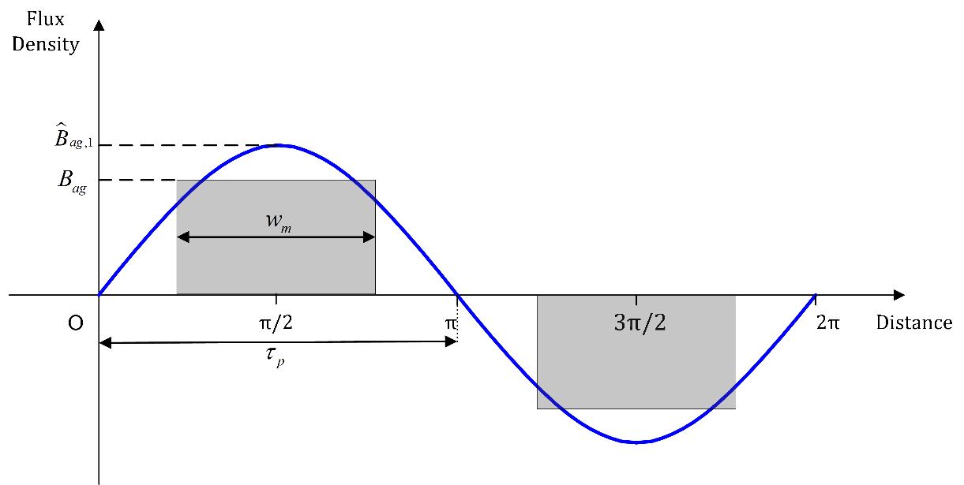

Fig. 3-11. Calculated airgap flux density square waveform(gray) and its sinusoidal fundamental frequency component(red)

Peak value of the fundamental harmonic value of the air-gap flux density *Bag* is given as follows [4],

 (3-9)

Peak flux linkage is calculated for the proposed generator as follows [5], [13],

 (3-8)

Leakage coefficient  is selected as constant of 0.96. This value is determined according to comparison of induced emf results between analytical calculations and FEA. Induced emf *e* in one turn of coil is calculated according to Faraday’s Law by using linked peak flux as follows [5], [13],

 (3-7)

where  is the peak flux linkage,  is the pole pitch and *v* is the airgap linear speed. Approximate per-phase equivalent circuit and phasor representation of synchronous machine are given Fig. 3-12 and Fig. 3-13, respectively. Output rms phase voltage (terminal voltage) of a typical synchronous machine is calculated as follows [12],

 (3-1)

where,  is the induced emf rms value,  is the per phase synchronous reactance under steady state temperature and  is the rms phase current.

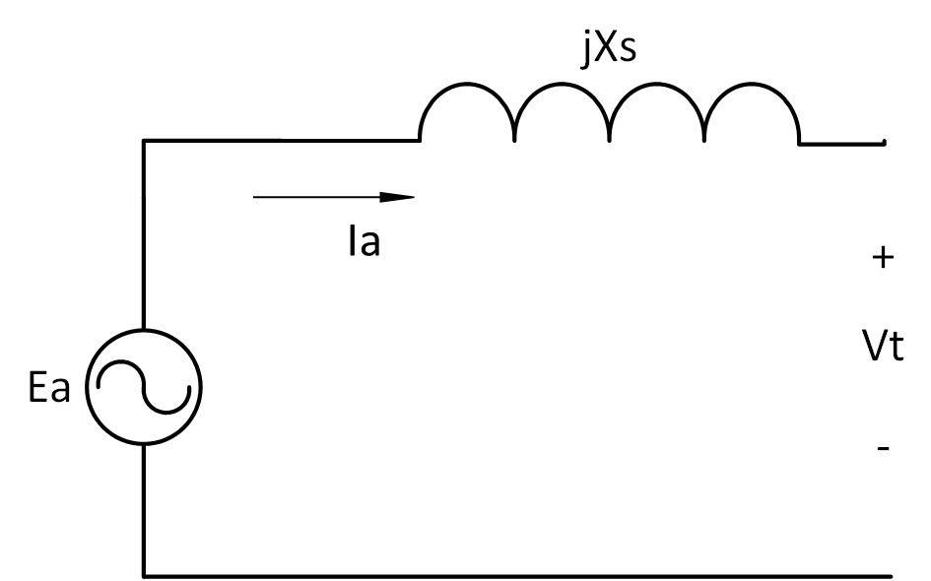

Fig. 3-12. Equivalent circuit of the synchronous machine where *Ea* is the induced emf, *Ia* is the phase current, *Xs* is the synchronous reactance and *Vt* is the phase terminal voltage[12]

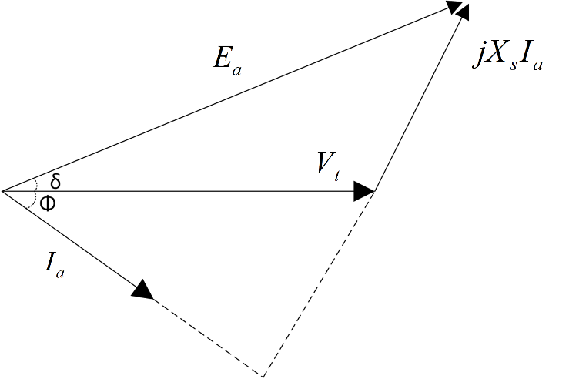

Fig. 3-13. Phasor diagram of synchronous machine where *δ* is the load angle, *Φ* is the power factor angle

 can be calculated as follows,

 (3-3)

where *Ns* is the number of coils in series. Phase voltage rms value according phasor diagram given in Fig. 3-13, is calculated as follows,

 (3-5)

where  and  are phase resistance (which is relatively small than reactance) and phase reactance, respectively. Power factor is assumed as unity in our design. Therefore, power factor angle  is equal to zero. Because, a vector controlled power electronic stage is considered for the converter part. However, power electronic converter design is out of the scope of this thesis. Load angle  is calculated at every rotation speed in the optimization design code according to trigonometric equation given below,

 (3-6)

Effective window area of the conductors  is related with the conductor dimensions and fill factor of the design. This area value is utilized in current and resistance calculations. In Fig. 3-14, schematic representation the of the conductor in cross-sectional window of the winding is given. Effective window area can be expressed as follows,

 (3-41)

where *kfill* is the fill factor for the winding coils. Fill factor can be taken as constant between 0.7 and 0.8 during optimization process due to concentrated air cored windings in our design.

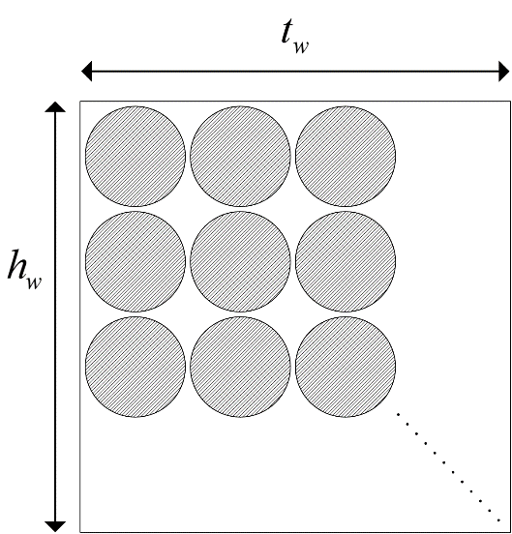

Fig. 3-14. Positions of the conductors in the winding from top view. Shaded regions represent the effective window area.

Current in one coil branch value can be expressed as follows,

 (3-39)

where *J* is the current density in A/mm2 and  is the cross-sectional area of a conductor. Current density value can be selected before the design process as a constant. However, this value is optimized in our design according to operating conditions. More detailed information about this process can be found in the next chapter. Rms value of the total current per phase () can be calculated as follows,

 (3-38)

Mean turn length for a coil *lt* is calculated as given in Eq. (3-44).

 (3-44)

where  ,  and  are lengths defined for end part, middle part and structural part of the coil, respectively. These lengths are calculated as follows,

 (3-45)

 (3-46)

 (3-47)

Resistance of one coil is calculated as follows,

 (3-43)

where  is resistivity coefficient of copper conductor. Resistance per phase value is based on resistance per coil branch and calculated as follows,

 (3-48)

Resistance value given in Eq. (3-48) was calculated without thermal effects. Resistance value including thermal effects can be calculated as follows.

 (3-49)

where  is the temperature coefficient of copper and  is the temperature difference between ambient and expected operating temperature. Angular frequency and inductance of a coil are calculated as follows,

 (3-51)

 (3-52)

where  is the flux linked by coil. Inductance value of the coil can be calculated as follows [12], [13],

 (3-53)

Phase reactance  value is calculated as follows,

 (3-50)

Phase impedance *Zph* can be calculated using phase resistance and reactance values as follows,

 (3-54)

## Structural Deflection

Structural deflection is related to mechanical stability. Since proposed design has air-cored stator, there will be no attraction force between stator and rotor [10]. However, C cores try to close the airgap against each other and result in deflection in the air gap clearance. Main reason of this deflection is strong magnetic attraction forces between magnets in the air gap clearance. Ratio of this deflection with respect to airgap clearance is significant parameter in terms of structural modelling of the generator [9]. This type of deflection is shown in Fig. 3-15. In literature, air gap deflection is generally allowed between 10-20% [9], [14]–[16]. It is desired to keep this ratio below reasonable ratio of 10% in our design.

To model the structural deflection at 2D, beam model is employed [17]. Normally C cores are exist on the web module. Therefore, length of the beam  is limited as sum of the magnet length  and magnet to steel web clearance. Right hand side of the beam is modelled as stationary wall to show the steel web part. Beam model is given in Fig. 3-7. Normal stress *q* due to airgap flux density is calculated with Maxwell stress tensor as follows[5],

 (3-29)

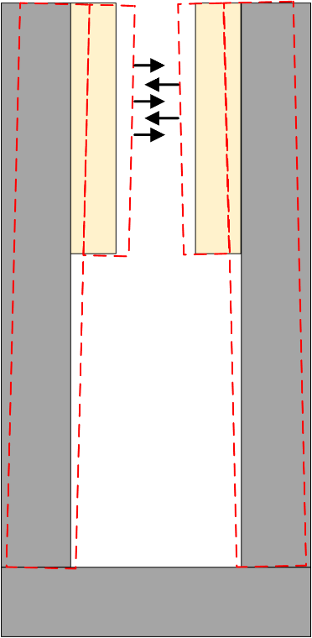

Fig. 3-15. C-core deflection due to attraction forces, deflected cores shown with red dashed lines



Fig. 3-7. a) Beam model for the C core deflection. b) Model for uniformly distributed load () is applied at *a=0* c) Model for uniformly distributed load () is applied at limited *a* units along the beam. [9]

Uniformly distributed load  is calculated as follows,

 (3-30)

Total deflection *y* is calculated by summing the two sub-models as shown in Fig. 3-7. First sub-model demonstrates the deflection *y1* when a=0 and the second one demonstrates the deflection *y2* when *a*=. As mentioned before, beam length is calculated as follows,

 (3-31)

Two beam deflections (*y1* and *y2*) and resulting total deflection *y* are calculated as follows [18],

 for  (3-32)

 for  (3-33)

 (3-34)

where *E* and *I* are the Young’s Modulus of steel and the second moment of inertia of steel cross-section, respectively. Young’s Modulus is taken as constant as 200x109 Pa for structural steel. Second moment of inertia is calculated as follows,

 (3-35)

## Thermal Considerations

Main heat resources in proposed generator are copper losses of the windings and eddy losses. However, eddy losses are relatively very low with respect to copper losses because of low speed and low electrical frequency operation [5]. Therefore, current density control is the main focus of this design. When insulation class of windings (F class-155oC [19]) and operational thermal limits of permanent magnets (N50H-type magnet-120oC [20]) are taken into account, forced cooling methods are more reasonable rather than natural cooling methods for such a MW-level generator. Cooling of the machine is chosen as forced air cooling in order to improve electrical loading performance. Additionally, forced air cooing improves the magnet thermal performance and prevents them from demagnetization at extreme conditions such as short circuit faults [21]. In this study, thermal network of the machine is neglected. However, this disadvantage is compensated by forcing the optimization algorithm to converge for higher efficiency ratings. Therefore, we can determine a reference current density (A/mm2) value at 100o C operating temperature according to chosen cooling technique. Then, calculation of the temperature rise for windings  can be found by using a rational relationship between “I2R” losses and current density as follows,

 (3-55)

where reference current density  is selected as 7A/mm2 [22]–[24].Resulting operating temperature can be found by summing the temperature rise value given above and ambient temperature , which can be assumed as 20o C. In the optimization process, operating temperature value is calculated at every different operating speed and respective current density values. Other constant and reference values will be explained in the next chapter.

## Volume and mass Equations

Total mass of the generator consists of two main categories. These are :

* Active mass
* Steel mass
* Copper mass
* Permanent magnet mass
* Structural mass
* Shaft
* Stator cylinder structure
* Rotor torque structure
* Steel band
* Epoxy

Active mass includes the materials which affect the electromagnetic performance of the machine directly while structural mass components generally provided mechanical stability to generator via non-magnetic materials.

## Active mass calculation

Total steel mass  consists of three main parts: outer limb mass, inner limb mass and web mass. These mass values are calculated as follows,

 (3-82)

where , , , ,  and  are mass of outer limb, number of outer limbs in machine, mass of inner limb, number of inner limbs in machine, mass of steel web and number of steel web part in machine, respectively. Mass of each components are calculated as follows,

 (3-83)

 (3-84)

 (3-85)

where  and  are mass density of the steel and height of steel web, respectively. Height of the steel web can be calculated as follows,

 (3-86)

Until now, mass components of the steel material have been calculated. However, these values are valid for only single layer. In order to include number of parallel machines into calculation, number of layers of each component should be multiplied with related single layer mass of component as given in Eq. (3-82). A sample view of 3-stage (number of parallel machine is three) axially stacked generator is given in Fig. 3-10. As it can be seen on this figure, number of outer limbs is always two regardless of the stack number of generators. Number of inner limb is always one less than that of the stack number. Number of steel web is same as number of stacks. Number of permanent magnets  is always double that of the stack number.



Fig. 3-10. Proposed axial flux PM generator side view with three axial stacks[5]

Total magnet mass  is calculated as follows,

 (3-87)

where  and  are mass density of permanent magnet material and total number of permanent magnet layers in generator, respectively. Total copper mass is calculated as follows,

 (3-88)

where  and  are mass density of copper and number of parallel stacks in the generator, respectively.

## Structural mass calculation

Total structural mass of the generator can be defined as the sum of the shaft mass, stator torque structure mass, rotor torque structure mass, steel band mass and epoxy resin mass.

Shaft can be modelled as a hollow cylinder. Therefore total shaft mass can be calculated as follows,

 (3-89)

where  ,  and  are shaft outer radius, shaft inner radius and shaft length, respectively. Shaft cylinder inner and outer radius values are used as constant in the optimization process. For the convenience, shaft length is selected as the 5/4 times that of the machine total axial length. Total axial length of the machine () is calculated as follows,

 (3-90)

 (3-91)

Total stator mass consist of a stator cylinder mass  and two times of the stator torque arm structure mass  . Formula of this mass is given as follows,

 (3-92)

Stator cylinder provides supportive mechanism to the stator windings and mass of this structure  can be calculated as follows,

 (3-93)

Stator torque structure holds the stator cylinder mechanism stable and consists of torque arms. These arms are formed of rectangle steel hollow bars as can be seen on Fig. 3-11. Stator torque arm structure mass is calculated as follows,

 (3-94)

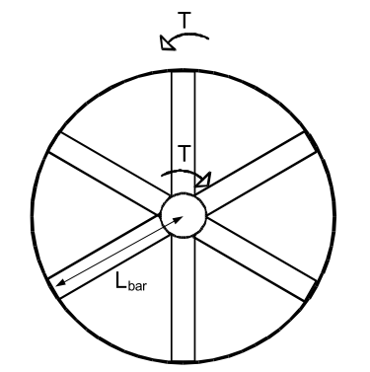

Fig. 3-11. Torque arm structure with 6 arms[5]

where  and  are the number of stator torque arms in a single structure and length of stator torque arms, respectively. Length of bar is generally half of the stator outer diameter of the machine. *b, d, bi,* and *di* are the cross-sectional distances of steel hollow bars. Constants used in the calculations of these values should be suitable in terms of hollow bar view and have very low effect on resulting mass. These lengths are shown in Fig. 3-12 and can be calculated as follows,



Fig. 3-12. Top view of steel hollow bar dimensions

 (3-95)

 (3-96)

 (3-97)

 (3-98)

Duty of rotor torque arms is to maintain stability to C-shaped cores of rotor. Total mass of rotor torque arms () is calculated in a very similar way that of stator torque arm calculation:

 (3-99)

where  and  are number of rotor torque arms and length of the rotor torque arm, respectively. Calculations and definitions for steel hollow torque arms for rotor are same as stator torque arm calculations. Therefore, Fig. 3-11 and Fig. 3-12 are valid for rotor torque arm structure. Length of rotor torque arm bar is equal to web radius . It can be optional to use supporting steel discs instead of rotor torque arms as shown in Fig. 3-10. However, torque arm is selected for rotor support in our design due to its simple design equations. In our proposed design 8 rotor bars and 6 stator bars is used.

Function of the steel band is to give mechanical support to coils and fix them to the stator structure. A sample steel band used in proposed generator is given in Fig. 3-13. Total steel band mass is calculated as follows,

 (3-100)

where  and  are the height and width of the steel band, respectively. These sizing values of the steel band can be determined during optimization.

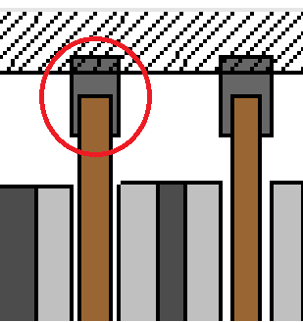

Fig. 3-13. Steel band

Epoxy resin is used to fill the free space around coils and to give mechanical support and insulation for winding[25]. Its total mass  in our proposed design is calculated as follows,

 (3-101)

where  and  are the mass density of epoxy resin and pitch of the coil former. Main duty of the coil former is the give mechanical support to the coils from inner side[25]. Representation of sample trapezoidal winding with distances including the pitch of the coil former is given in Fig. 3- 14. A commercial coil former which has open slots structure, is given in [26]. Mean pitch of the coil former  can be calculated as follows,

 (3-102)

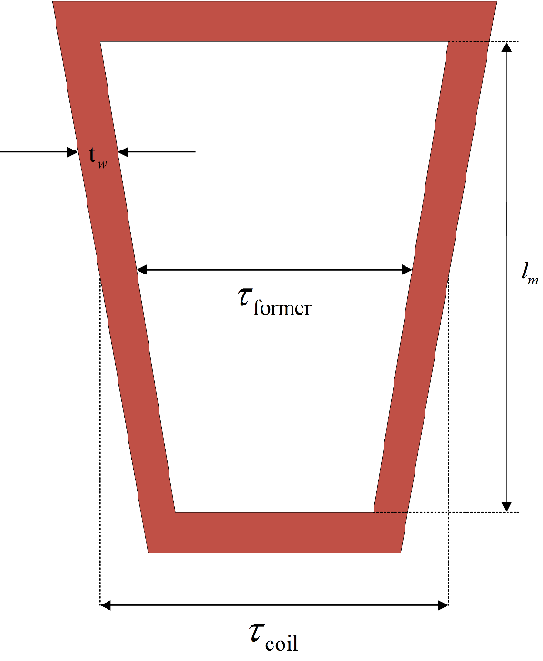

Fig. 3-14. Trapezoidal winding distances

## Losses

Total energy loss in the generator is sum of the core losses and the copper losses.

 (3-103)

Copper losses  are calculated as follows,

 (3-104)

Core losses  consist of eddy losses both on coils and magnet surface. These losses are calculated as given below,

 (3-105)

 (3-106)

 (3-107)

where ,  are coil and magnet components of eddy current losses, respectively.  and  are thickness and height of the copper conductor, respectively. *Bag* is the airgap flux density, *keddy* is the eddy loss coefficient used in calculating magnet surface eddy loss, *Nc* is the number of coils. Eddy loss coefficient is taken as constant of 57.65 W/m2 for rated speed(12 rpm) and it will be changed during the optimization according to operating frequency of generator. These variables are calculated as follows,

 (3-108)

Number of coils per phase (*Nc,ph*) is calculated by dividing *Nc* value by 3. Number of coils in series (*Ns*) is calculated as follows,

 (3-109)

Thickness and height of the copper values are calculated as follows,

 (3-110)

 (3-111)

In the equations above, ,  and  are height of the coil, thickness of the coil and thickness of the insulation material, respectively. Thickness of insulation is controlled during the design optimization. Height and thickness of the coil can be calculated as follows,

 (3-112)

 (3-113)

where  and  are thickness of epoxy and number of turns per strand, respectively. Epoxy thickness value can be taken as constant (1 mm) during the design process. Number of turns per strand value is calculated as follows,

 (3-114)

where  is the number of strand and taken as 1 in our design. Coil area including the insulation part is calculated as follows,

 (3-115)

Insulation area per coil  and insulation thickness  are calculated based on the coil area as given below,

 (3-116)

 (3-117)

## Power and Efficiency

Total output electrical power of the generator is given as follows,

 (3-118)

Efficiency of the generator is calculated as follows,

 (3-119)

## Electromagnetic FEA vs analytical evaluation for sample dimensions

In electrical machine design, airgap magnetic flux density is a key parameter to estimate. Because the airgap magnetic flux density affects the induced emf on stator windings via airgap flux calculations. Besides, airgap flux affects the core magnetic saturation characteristics. Hence core dimensions should be determined properly for normal flux distributions among the machine structure. Due to the reasons aforementioned above, it’s important to calculate the airgap flux density parameter correctly before machine production. Finite element modelling and analysis techniques are preferred especially when the machine geometry is hard to model and calculate analytically. In this subsection, some of the machine analytic equations described earlier in this chapter and the finite element modelling results will be compared in order to verify the design equations and techniques used in this thesis. Finite element modelling results are obtained from Ansys Maxwell 3D FEA analysis software.

To verify the design equations and techniques used in this study, airgap flux density and induced emf per phase values are chosen for the comparison. For this purpose, a 50 kW sample generator design is considered and evaluated in the optimization problem. Detailed information about optimization parameters and optimization process will be given in the next chapter. However, essential design parameters of the 50kW sample generator, which are achieved by the genetic algorithm optimization, are given in the Table 3-1.

Table 3-1. Optimized design parameters of the sample 50 kW generator

|  |  |
| --- | --- |
| **Parameter** | **Value** |
| Voltage per phase | 977.2 V |
| Induced emf per phase rms (*Eph,rms*) | 1058.1 V |
| Induced emf per phase peak () | 1496.4 V |
| Number of turns (*Nt*) | 146 |
| Number of poles (*Np*) | 96 |
| Output power (-per stack) | 15,396 W |
| Phase current () | 5.3 A |
| Phase resistance () | 14.92 Ω |
| Mean radius () | 0.7 m |
| Airgap clearance (*g*) | 2 mm |
| Rotational speed () | 60 rpm |
| Current density (*J*) | 4.03 A/mm2 |
| Outer limb thickness () | 15 mm |
| Inner limb thickness () | 14 mm |
| Steel web clearance (*lc*) | 16 mm |
| Fundamental airgap flux density peak value () | 0.671 T |
| Height of the winding () | 13 mm |
| Winding thickness/Coil pitch ratio  () | 0.369 |
| Fill factor (*kfill*) | 0.65 |
| Height of the magnet (*hm*) | 10 mm |
| Length of the magnet (*l*m) | 87 mm |
| Magnet pitch-to-pole pitch ratio () | 0.76 |
| Number of parallel branches () | 1 |
| Number of parallel machines () | 3 |
| Efficiency () | 92.38 % |
| Total mass (active + structural) | 1024 kg |

Peak value of the fundamental harmonic of the airgap flux density is calculated according to Eq. (3-9). As it can be seen on the Table (3-1), this value is calculated as 0.67 T in our optimization process by using genetic algorithms. In the finite element analysis side, this peak flux density value is found as 0.65 T. For simplicity of the analysis 4 pole symmetric model is used in the analysis. Airgap flux density vector variation is recorded along the line which is shown in Fig. 3-15. This sinusoidal variation is shown in Fig. 3-16. As can be seen from the figures, peak value of the flux density is 0.65 T. Therefore it can be said that analytic equation results and finite element analysis results show good agreement in terms of airgap flux density.

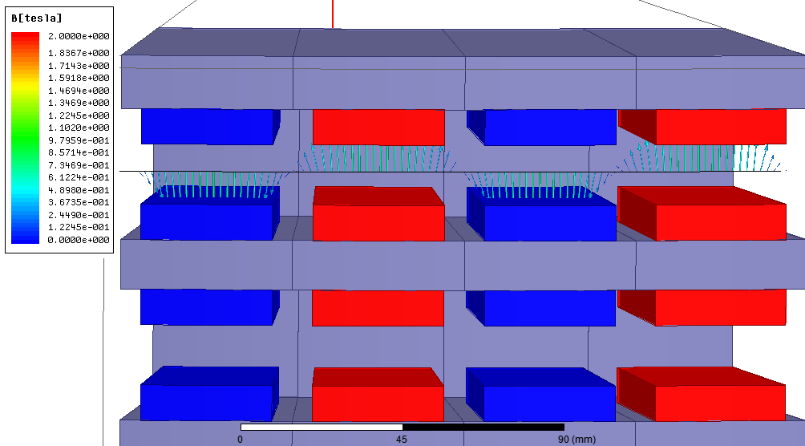

Fig. 3-15. Airgap flux density vectors for the sample 50 kW design



Fig. 3-16. Airgap flux density graph for the sample 50 kW design

Sinusoidal flux density variation induces sinusoidal voltages on windings. In our analytical design equations, induced emf (peak) per phase is calculated via Eq. (3-2) – Eq. (3-7) . As it can be seen on Table (3-1) this value is calculated as 1496.4 V. Induced emf per phase peak value of the finite element analysis is given in Fig. 3-17. This graph is obtained for three phase at rated speed of 60 rpm. All three phases are balanced(120o phase difference) in time domain and they all have peak magnitude of nearly 1600 V. Therefore it can be said that analytic equation results and finite element analysis results show good agreement in terms of induced emf.



Fig. 3-17. Induced emf per phase graph for the sample 50 kW design

## Conclusion

In this chapter, analytical design equations of the proposed AFPM generator are described. For this purpose, chapter is divided into two main sections. In the first section mechanical and electrical parameters of the proposed generator are covered with related graphics and mathematical expressions. These design equations are mainly consist of ; fundamental generator equations, geometrical and structural equations, phase turns, resistance and flux density equations, thermal equations, reluctance network and related equations, volume and mass equations and finally power and efficiency calculations. During the design of the proposed generator leakage fluxes are taken into consideration. Unity power factor is assumed for the phasor equations. These design equations are very important as their results will be used in the optimization process and finite element design. In the second section of the chapter, comparison of the results of the design equations and the finite element analysis is given for a sample 50 kW AFPM generator in order to verify the design method followed in this thesis study. For this purpose, airgap flux density and induced emf per phase parameters are chosen since they’ve been used widely in the design of electrical machines as key parameters [12]. It is concluded that the results of the analytical equations and the results of the finite element analysis are in good agreement. Therefore, these analytical equations can be used in the optimization for the proposed AFPM generator.

**References**

[1] M. Cheng and Y. Zhu, “The state of the art of wind energy conversion systems and technologies: A review,” *Energy Convers. Manag.*, vol. 88, pp. 332–347, 2014.

[2] R. Zeinali, “DESIGN AND OPTIMZIATION OF HIGH TORQUE DENSITY GENERATOR,” *MS thesis*, no. September, 2016.

[3] D. J. Bang, H. Polinder, G. Shrestha, and J. A. Ferreira, “Promising direct-drive generator system for large wind turbines,” *EPE J. (European Power Electron. Drives Journal)*, vol. 18, no. 3, pp. 7–13, 2008.

[4] A. E. Fitzgerald, *Electric machinery*, vol. 319, no. 4. 1985.

[5] O. Keysan, A. S. McDonald, and M. Mueller, “Integrated Design and Optimization of a Direct Drive Axial Flux Permanent Magnet Generator for a Tidal Turbine,” in *International Conference on Renewable Energies and Power Quality - ICREPQ’10*, 2010.

[6] A. Parviainen, M. Niemelä, and J. Pyrhönen, “Modeling of axial flux permanent-magnet machines,” *IEEE Trans. Ind. Appl.*, vol. 40, no. 5, pp. 1333–1340, 2004.

[7] J. F. Gieras and M. Wing, *Permanent Magnet Motor Technology: design and applications*, vol. 113. 2002.

[8] T. F. Chan and L. L. Lai, “An axial-flux permanent-magnet synchronous generator for a direct-coupled wind-turbine system,” *IEEE Trans. Energy Convers.*, vol. 22, no. 1, pp. 86–94, 2007.

[9] A. S. McDonald, “Structural analysis of low speed, high torque electrical generators for direct drive renewable energy converters,” University of Edinburgh, UK, 2008.

[10] O. Keysan, A. S. McDonald, and M. Mueller, “A direct drive permanent magnet generator design for a tidal current turbine(SeaGen),” *2011 IEEE Int. Electr. Mach. Drives Conf. IEMDC 2011*, pp. 224–229, 2011.

[11] “Sintered Neodymium Iron Boron (NdFeB) Magnets.” [Online]. Available: http://www.eclipsemagnetics.com/media/wysiwyg/brochures/neodymium_grades_data.pdf. [Accessed: 09-Aug-2017].

[12] B. S. Guru and H. R. Hiziroglu, “Electric Machinery and Transformers,” *Oxford Univ. Press*, p. 741, 2001.

[13] J. R. Bumby and R. Martin, “Axial-flux permanent-magnet air-cored generator for small-scale wind turbines,” *IEE Proc. - Electr. Power Appl.*, vol. 152, no. 5, pp. 1065–1075, 2005.

[14] H. Polinder, D. Bang, A. S. Mcdonald, and M. A. Mueller, “10 MW Wind Turbine Direct-Drive Generator Design with Pitch or Active Speed Stall Control,” pp. 1390–1395, 2007.

[15] A. S. McDonald, M. Mueller, and H. Polinder, “Structural mass in direct-drive permanent magnet electrical generators,” *IET Renew. Power Gener.*, vol. 2, no. 1, p. 3, 2008.

[16] M. A. Mueller, A. S. McDonald, and D. E. Macpherson, “Structural analysis of low-speed axial-flux permanent-magnet machines,” *IEE Proceedings-Electric Power Appl.*, vol. 152, no. 6, pp. 1417–1426, 2005.

[17] C. Rans, S. Teixeira, and D. Freitas, “Bending Deflection – Macaulay Step Functions.” [Online]. Available: https://ocw.tudelft.nl/wp-content/uploads/Deflection-via-step-functions.pdf. [Accessed: 16-Aug-2017].

[18] R. J. Roark, W. C. Young, and R. Plunkett, *Formulas for Stress and Strain*, vol. 43, no. 3. 1976.

[19] “NEMA Insulation Classes.” [Online]. Available: http://www.engineeringtoolbox.com/nema-insulation-classes-d_734.html. [Accessed: 27-Sep-2017].

[20] “Neodymium Magnets | Arnold Magnetic Technologies.” [Online]. Available: http://www.arnoldmagnetics.com/en-us/Products/Neodymium-Magnets. [Accessed: 27-Sep-2017].

[21] V. Ruuskanen, *Design Aspects of Megawatt-Range Direct-Driven Permanent Magnet*. 2011.

[22] a. Parviainen, M. Niemela, J. Pyrhonen, and J. Mantere, “Performance comparison between low-speed axial-flux and radial-flux permanent-magnet machines including mechanical constraints,” *IEEE Int. Conf. Electr. Mach. Drives, 2005.*, pp. 1695–1702, 2005.

[23] A. Parviainen, *Design of Axial-Flux Permanent-Magnet Low-Speed Machines and Performance Comparison between Radial-Flux and Axial-Flux Machines*. 2005.

[24] J. Braid, A. van Zyl, and C. Landy, “Design, analysis and development of a multistage axial-flux permanent magnet synchronous machine,” *Africon Conf. Africa, 2002. IEEE AFRICON. 6th*, vol. 2, pp. 675–680, 2002.

[25] J. F. Gieras, R.-J. Wang, and M. J. Kamper, *Axial Flux Permanent Magnet Brushless Machines*, vol. 3 ed. Dordrecht: Springer Netherlands, 2008.

[26] “Miles Platts - E1080701GN6NAT.” [Online]. Available: http://www.milesplatts.co.uk/product/e1080701/e1080701gn6nat. [Accessed: 16-Aug-2017].