# **CHAPTER 5**

# **FEA VERIFICATION**

## Introduction

In the previous chapter, optimization procedure of the proposed AFPM generator was described and required design parameters were determined and presented by using genetic algorithm optimization. As a principle in electrical machine design, it is important to verify the design in terms of electromagnetic and electrical performance before the production [1], [2]. For this purpose, modern analysis techniques and computer programs are used. In this chapter, design parameters of the optimized generator will be used in the 3D FEA modelling and analysis in order to verify the electromagnetic and electrical performance of the proposed AFPM generator. ANSYS Maxwell® is employed during the 3D finite element analyses. Analysis configurations of the magnetostatic, no-load transient and full load transient simulations will be presented in the following subsections. As mentioned in Chapter-3, air gap flux density and no-load induced emf values are investigated during the analyses. In addition, full load analysis of the proposed AFPM generator is made in order to calculate the coefficient of eddy losses acting on the permanent magnets. Related graphs and simulation results will be given in the following subsections. At the end of the chapter, comparison of the optimization results of analytical design and the 3D FEA analysis will be given for the proposed AFPM generator with related error rates. Another comparison will be made between commercial MW level wind turbines and the proposed AFPM wind turbine generator.

## Magnetostatic Analysis

In the finite element computation environment, magnetostatic analyses are done in order to estimate the electromagnetic behaviour of the electromechanical systems under static conditions, i.e. no-motion. For our study, magnetostatic analysis is applied to proposed generator model in order to calculate air gap flux density and flux path in the machine.

## Magnetostatic FEA Configurations

In the modelling stage of the generator in ANSYS Maxwell, 1/54 symmetrical model is employed. Therefore excessive mesh computation and analysis time can be saved. In Fig. 5-1, mesh plot of the magnetostatic model is given.

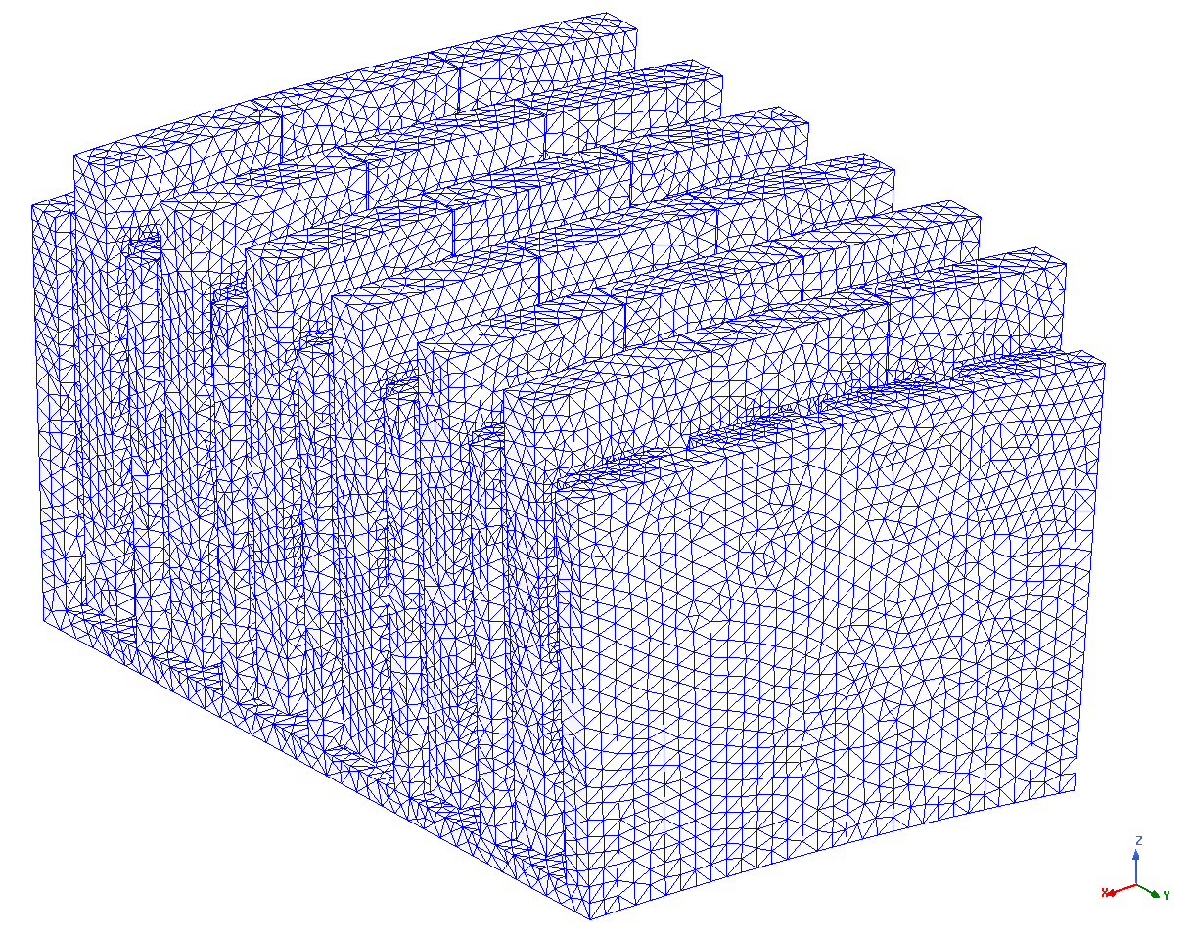

Fig. 5-1. Magnetostatic model mesh plot

Magnetostatic analysis setup configurations and mesh size configurations are given in Table 5-1.

Table 5-1. Magnetostatic FEA Configurations

|  |  |
| --- | --- |
| **Property** | **Value** |
| Mesh size | 25 mm |
| Percent error | 0.5 |
| Maximum number of passes | 15 |
| Refinement Per Pass | 30% |

## Air gap Flux Density verification

In this section, air gap flux density value of the proposed generator is investigated and compared with the analytically calculated air gap flux density value in order to verify the proposed 5MW 12 rpm design. In Fig. 5-2, air gap flux density values with respect to position in the air gap between magnets are depicted.

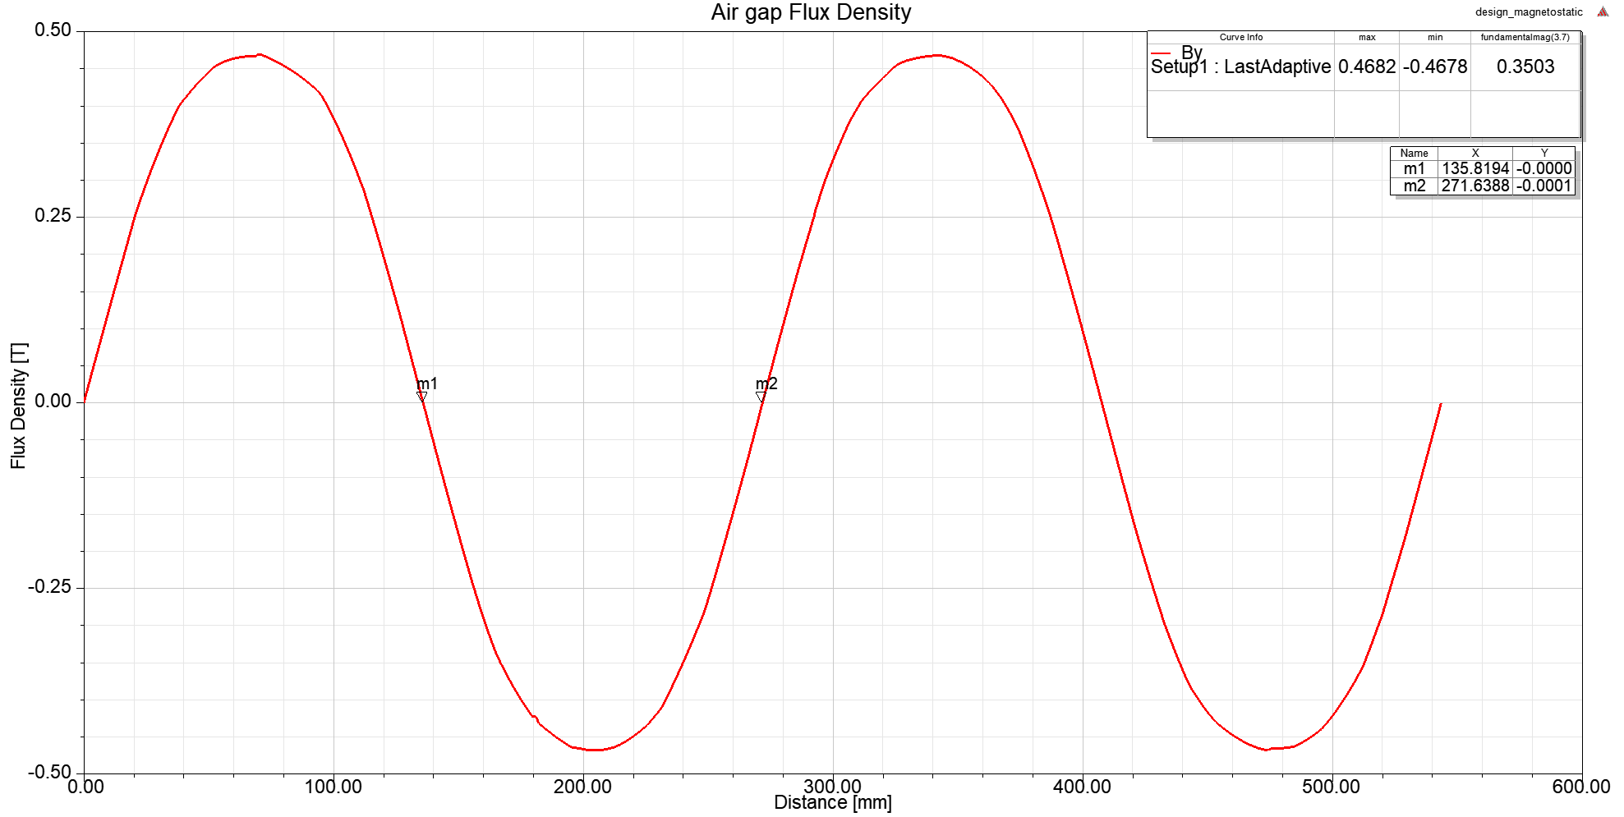

Fig. 5-2. Air gap flux density graph from FEA

According to these FEA results, air gap flux density characteristics of the proposed design and comparison with analytical calculation results are summarized in Table 5-2. In Fig. 5-3, variation of the air gap flux density together with analytical and FEA results are shown. Black labeled flux density is the calculated flux density value with a flat-top value of 0.453 T while red and blue labels show the analytically calculated fundamental harmonic peak air gap flux density and FEA results, respectively.

Table 5-2. Comparison of the analytical and FEA results for the air gap flux density

|  |  |  |  |
| --- | --- | --- | --- |
| **Property** | **FEA Value (T)** | **Analytical Value (T)** | **Error** |
| Air gap flux density -peak | 0.468 | 0.453 (flat-top) | 3.2% |
| Air gap flux density fundamental-peak | 0.494 | 0.510 | 3.2% |

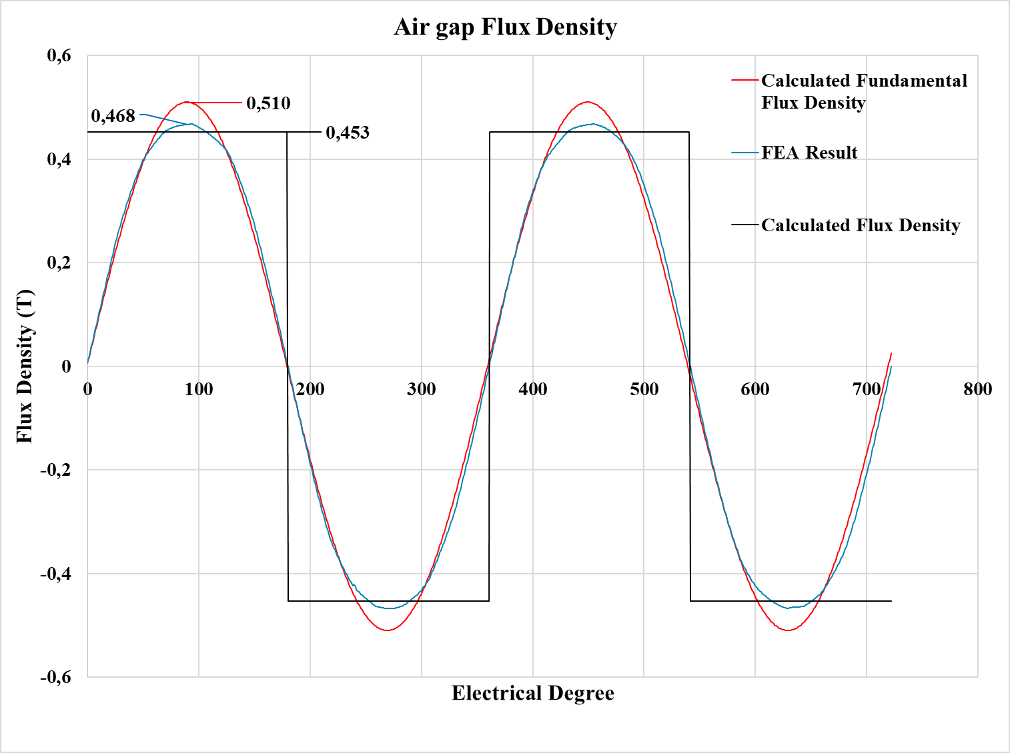

Fig. 5-3. Airgap flux density graph with analytical results for the 5 MW design.

As mentioned in previous chapters, air gap flux density value is a critical value that has to be verified before the production stage of the electrical machine. It can be seen from the Table 5-2 and Fig.5-3 that analytically calculated values and finite element analysis results of the air gap flux density of proposed AFPM generator are in good agreement and related error values are reasonable. Small difference between FEA results and analytically calculated flux density is due to leakage fluxes that can not be calculated by the analytical method in this study. In Fig. 5-4, top view of the flux density vectors is shown around the poles and air gaps. In Fig. 5-5, flux density distribution over the steel core parts is shown.

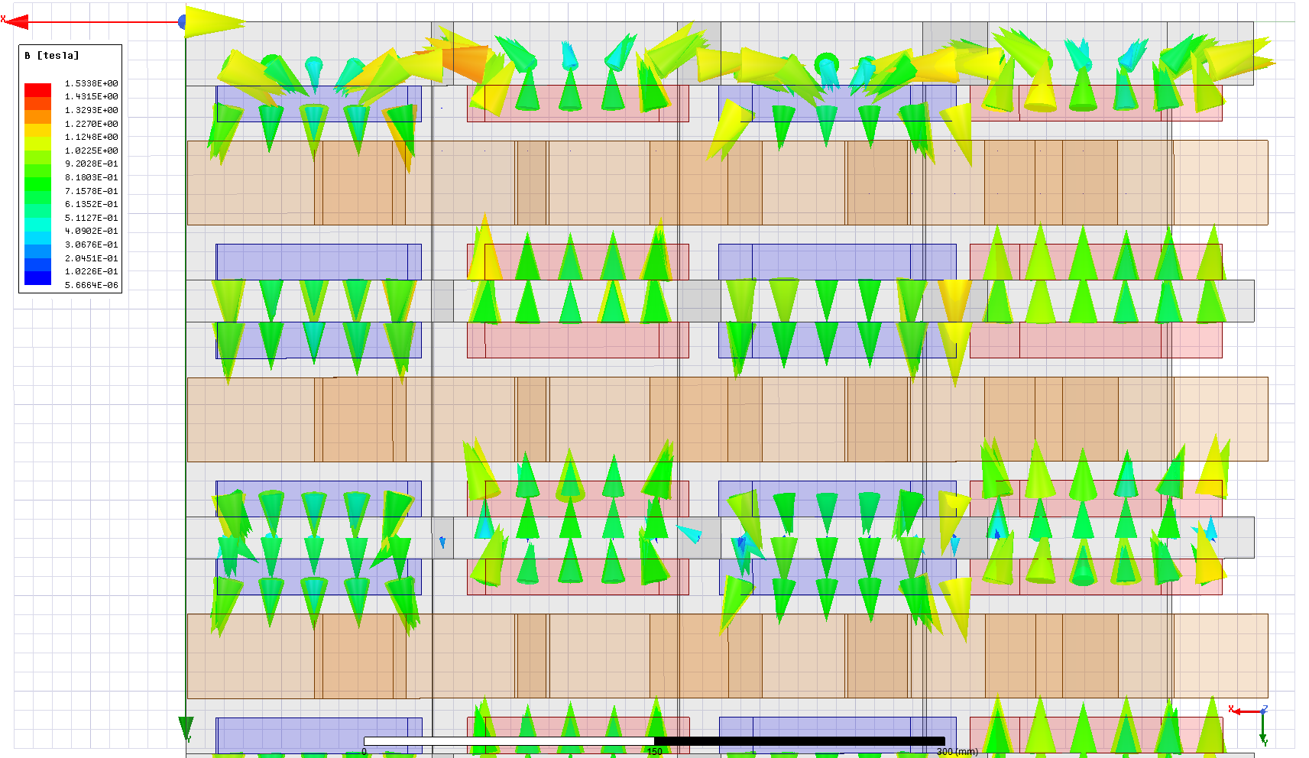

Fig. 5-4. Airgap flux density vectors for the 5 MW proposed design.

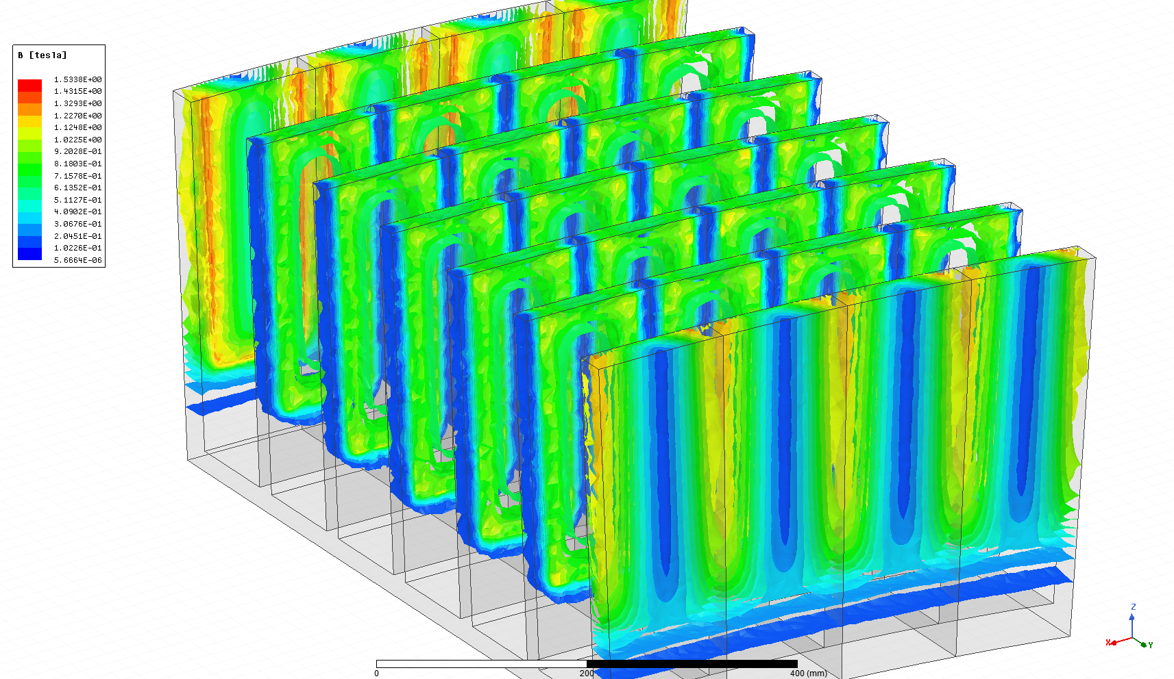

Fig. 5-5. Flux density distribution over the steel cores of the proposed 5MW design.

## Transient Analysis

## Transient FEA Configurations

## No-load Model

## Induced emf verification

## Full-load Model

## Phase Voltage verification

## Eddy loss coefficient estimation

## Proposed model comparison

## Conclusion

**References**

[1] N. Rostami, M. R. Feyzi, J. Pyrhonen, A. Parviainen, and V. Behjat, “Genetic Algorithm Approach for Improved Design of a Variable Speed Axial-Flux Permanent-Magnet Synchronous Generator,” *IEEE Trans. Magn.*, vol. 48, no. 12, pp. 4860–4865, 2012.

[2] J. F. Gieras, R.-J. Wang, and M. J. Kamper, *Axial Flux Permanent Magnet Brushless Machines*, vol. 3 ed. Dordrecht: Springer Netherlands, 2008.