|  |
| --- |
| **PROJECT PLANNING & MANAGEMENT FORM**  **CMPE 405 or 406**  **PROJECT NO :**  **PROJECT NAME :**  **PROJECT START DATE :**  **PROJECT END DATE :**  **SUPERVISOR :**  **SEMESTER TERM :**  Project Type: Hardware Design & Development Project  Template updated: 20.11.2017 |

A.1. Preliminary Project Information

# A.1.1

|  |  |
| --- | --- |
| **Project No** |  |
| **Project Name** |  |
| **Start Date** |  |
| **End Date** |  |
| **Time** |  |

# A.1.2

|  |  |  |  |
| --- | --- | --- | --- |
| **Project Manager** | | | |
| **Name Surname** |  | **ID No** |  |
| **Title/Role** |  | | |
| **Address** |  | | |
| **Phone** |  | | |
| **Email** |  | | |

A.2 Group Information

# A.2.1

|  |  |  |  |
| --- | --- | --- | --- |
| **Student 1** | | | |
| **Name Surname** |  | **ID No** |  |
| **Title/Role** |  | | |
| **Address** |  | | |
| **Phone** |  | | |
| **Email** |  | | |

|  |  |  |  |
| --- | --- | --- | --- |
| **Student 2** | | | |
| **Name Surname** |  | **ID No** |  |
| **Title/Role** |  | | |
| **Address** |  | | |
| **Phone** |  | | |
| **Email** |  | | |

# A.2.2

|  |
| --- |
| **List of Completed / Ongoing Projects of Team** |
|  |

B.1 Introduction to Project

# B.1.1

|  |
| --- |
| **Summary of Project** |
|  |

# B.1.2

|  |
| --- |
| **Key Words** |
|  |

# B.1.3

|  |
| --- |
| **Aim of Project** |
|  |

# B.1.4

|  |
| --- |
| **Innovative Aspects/Contributions of Project** |
|  |

# B.1.5

|  |
| --- |
| **Methods to be Applied** |
|  |

# B.1.6

|  |
| --- |
| **Economic and National Outcomes** |
|  |

B.2 Reason of Starting the Project, Methods and R&D Stages

# B.2.1

|  |
| --- |
| **1- Explain the reason of starting this project. (Max 500 charachter)** |
|  |

|  |
| --- |
| **2- Explain the purpose of this project.** |
|  |

|  |
| --- |
| **3- Explain**   * **output of project** * **national / international standards if exist** * **the specific objectives of the project** * **success criterias** * **realistic constraints** |
|  |
| **4- Explain**   * **the methods to be applied during R&D activities** * **applications** * **technics and tools to be used** * **standards to be followed under the workflow** |
| **Explain, Project Workflow:**   1. **Feasibility and Pre-research:** 2. **System Design:** 3. **Software development:** 4. **Prototype implementation and testing work:** 5. **Maintenance:** |
| **5- Explain**   * **the contribution of national/international technological development if exist** * **starting a new research and development projects within or outside the team** * **launch new applications or research studies in different technology areas**   **With whom we can cooperate?**  **Expectations:**  **Published work:**  **Can your output be an input for other similar national/international projects?** |
|  |

B.3 Innovative and Unique Aspects

# B.3.1

|  |
| --- |
| **1- Describe**   * **differences** * **advantages** * **superiority**   **compared to other similar projects.** |
|  |

# B.4.1

|  |
| --- |
| **2- Who can contribute to this project in your team?** |
| Example:   * Project Manager * System Designer * ..... |

C.1 Gantt Chart and Work Packages

# C.1.1 Gantt Chart

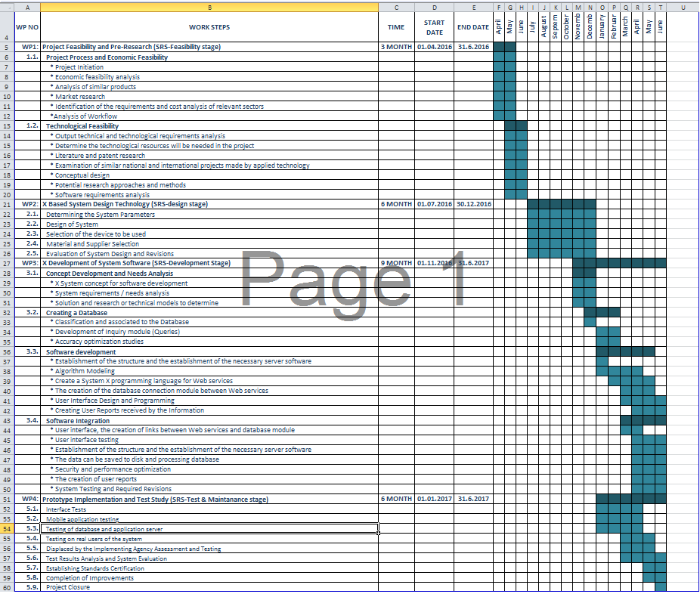

# C.1.2 List of Work Packages

|  |  |
| --- | --- |
| **Work Package No** | 1 |
| **Work Package Name** | **Project Feasibility and Pre-Research (Feasibility Analysis)** |
| **Start-End Date and Time** |  |
| **Related Organizations** |  |

|  |
| --- |
| **1- List the activities of work packages.** |
| **1.1 Project Process and Economic Feasibility:**  **1.2 Technological Feasibility:** |
| **2- Describe the methods and parameters that will be used for work package.** |
|  |
| **3- List the experiments, tests and analysis in the work package.** |
|  |
| **4- List the output of work package and its success criterias.** |
| **Outputs:**  **Success Criterias:** |
| **5- Explain the relation of output with other work packages** |
|  |

|  |  |
| --- | --- |
| **Work Package No** | 2 |
| **Work Package Name** | **X Based System Design Technology (Design Stage)** |
| **Start-End Date and Time** |  |
| **Related Organizations** |  |

|  |
| --- |
| **1- List the activities of work packages.** |
|  |
| **2- Describe the methods and parameters that will be used for work package.** |
|  |
| **3- List the experiments, tests and analysis in the work package.** |
|  |
| **4- List the output of work package and its success criterias.** |
| **Outputs:**  **Success Criterias:** |
| **5- Explain the relation of output with other work packages** |
|  |

|  |  |
| --- | --- |
| **Work Package No** | 3 |
| **Work Package Name** | **X Development of System (Development Stage)** |
| **Start-End Date and Time** |  |
| **Related Organizations** |  |

|  |
| --- |
| **1- List the activities of work packages.** |
|  |
| **2- Describe the methods and parameters that will be used for work package.** |
|  |
| **3- List the experiments, tests and analysis in the work package.** |
|  |
| **4- List the output of work package and its success criterias.** |
| **Outputs:**  **Success Criterias:** |
| **5- Explain the relation of output with other work packages** |
|  |

|  |  |
| --- | --- |
| **Work Package No** | 4 |
| **Work Package Name** | **Prototype Implementation and Test Study and Maintenance (Test & Maintenance stage)** |
| **Start-End Date and Time** |  |
| **Related Organizations** |  |

|  |
| --- |
| **1- List the activities of work packages.** |
|  |
| **2- Describe the methods and parameters that will be used for work package.** |
|  |
| **3- List the experiments, tests and analysis in the work package.** |
|  |
| **4- List the output of work package and its success criterias.** |
| **Outputs:**  **Success Criterias:** |
| **5- Explain the relation of output with other work packages** |
|  |

# C.1.3 List of Milestones (should be matched in the Gantt chart)

|  |  |  |
| --- | --- | --- |
|  | **Description of Output** | **Expected Time Interval** |
| ***Example:*** | ***Feasibility Studies*** | ***01.07.2014 – 30.09.2014*** |
| 1 |  |  |
| 2 |  |  |
| 3 |  |  |
| 4 |  |  |
| 5 |  |  |
| 6 |  |  |
| 7 |  |  |

# C.1.4 List of Risks (see following example, find other risks of your Project!)

|  |  |  |  |
| --- | --- | --- | --- |
| Risk | Probability | Effects | Your Strategy |
| The time required to develop the software is underestimated. | High | Serious | ? |
| Software tools cannot work together in an integrated way. | High | Tolerable | ? |
| Customers fail to understand the impact of requirements changes. | Moderate | Tolerable | ? |
| The rate of defect repair is underestimated. | Moderate | Tolerable | Replace potentially defective components with more reliable bought-in components. |
| The size of the HW/SW is underestimated. | High | Serious | Investigate buying new HW or SW components; or ?? |
| Code generated by code generation tools is inefficient. | Moderate | Insignificant |  |
| Key staff are ill at critical times in the project. | Moderate | Serious | Reorganize team so that there is more overlap of work and people therefore understand each other’s jobs. |
| The database used in the system cannot process as many transactions per second as expected. | Moderate | Serious | Investigate the possibility of buying a higher-performance database. |

C.2 Project Management and Organization

# C.2.1 Project Team

|  |  |  |  |  |  |  |
| --- | --- | --- | --- | --- | --- | --- |
| **Personnel Name** | **Title** | **ID** | **Education Status** | **Graduation Date** | **Date of Starting Work** | **Idea Owner** |
|  |  |  |  |  |  |  |
|  |  |  |  |  |  |  |
|  |  |  |  |  |  |  |
|  |  |  |  |  |  |  |
|  |  |  |  |  |  |  |
|  |  |  |  |  |  |  |

# C.2.2 Organization Scheme (an example is given below!)

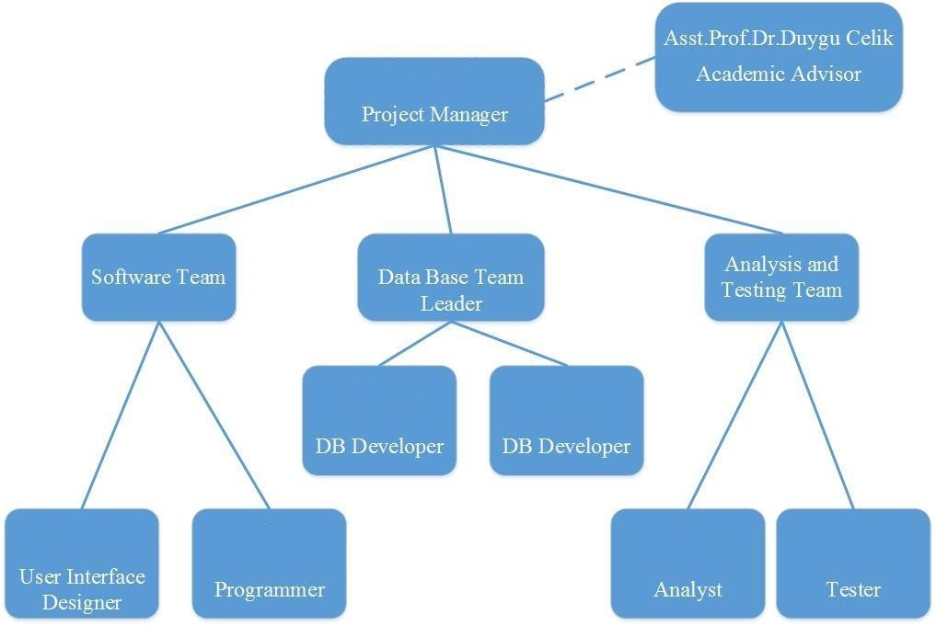

D.1 Economic Forecasts

|  |
| --- |
| **1- Evaluate the commercialization potential of project outcomes. List possible risks here?** |
|  |

|  |  |
| --- | --- |
| **2- List your expectations to your team which are come by your project (if available)** | |
| Time-to-market (month): |  |
| The expected increase in sales revenue (%): |  |
| The expected increase in market share (%): |  |
| Time to start to gain: |  |

D.2 National Outcomes

|  |
| --- |
| **1- Specify the output that may be subject to patent, utility model and industrial design registration in the project.** |
|  |
| **2- Explain the potential of project and its outputs that may have an effect on social life, education, health and etc.** |
|  |
| **3- Explain the positive and negative effects of project outputs for environment and human being.** |
|  |

(M013) Instrument / Equipment / Software / RELEASE PURCHASES

|  |  |  |  |  |  |  |  |  |  |  |  |
| --- | --- | --- | --- | --- | --- | --- | --- | --- | --- | --- | --- |
| **Project Name** | |  | | | | | | | | | |
| **Line no** | **Instrument / Equipment / Software / Publication Name** | | **No. of Item** | **Capacity** | **Technical specification** | **Purpose of Project Activities** | **Post-Project Place of Use / Purpose** | | **Unit Price (USD)** | **Unit Price (TL)** | **Total Amount (TL)** |
| **R & D** | **Production** |
| **1** |  | |  |  |  |  |  |  |  |  |  |
| **2** |  | |  |  |  |  |  |  |  |  |  |
| **3** |  | |  |  |  |  |  |  |  |  |  |
| **4** |  | |  |  |  |  |  |  |  |  |  |
| **5** |  | |  |  |  |  |  |  |  |  |  |
| **6** |  | |  |  |  |  |  |  |  |  |  |
| **7** |  | |  |  |  |  |  |  |  |  |  |
| **8** |  | |  |  |  |  |  |  |  |  |  |
| **9** |  | |  |  |  |  |  |  |  |  |  |
| **10** |  | |  |  |  |  |  |  |  |  |  |
|  |  | |  |  |  |  |  |  |  | **TOTAL** | **TL** |

(M030) Quarterly Estimated Cost Form (TL)

|  |  |  |  |  |
| --- | --- | --- | --- | --- |
| **Project Name :** | | | | |
| **Cost Item** | **2017** | | **TOTAL**  **(TL)** | **TOTAL COST RATE OF CONTENTS (%)** |
| **I** | **II** |
| **Personnel** |  |  |  |  |
| **Travel** |  |  |  |  |
| **Instrument / Equipment / Software / Publications** |  |  |  |  |
| **Domestic Works Made By R & D and Testing Institutions** |  |  |  |  |
| **International Works Made By R & D and Testing Institutions** |  |  |  |  |
| **Domestic Services Procurement** |  |  |  |  |
| **Overseas Service Procurement** |  |  |  |  |
| **Material** |  |  |  |  |
| **TOTAL COST** |  |  |  | 100 |
| **CUMULATIVE COST** |  |  |  | 100 |
| **IN THE PROJECT TOTAL MAN-MONTH** | | |  | |

APPENDIX