|  |
| --- |
| **PROJECT PLANNING & MANAGEMENT FORM**  **CMSE-406**  **GRADUATION PROJECT-II**  **PROJECT NO: 1**  **PROJECT NAME: A Web Based Document Management System**  **PROJECT START DATE: 16 November, 2020**  **PROJECT END DATE : 29 January, 2021**  **SUPERVISOR: Assoc. Prof. Dr. Gürcü Öz**  **SEMESTER TERM: 2020/2021 FALL** |

**A.1. Preliminary Project Information**

# A.1.1

|  |  |
| --- | --- |
| **Project No** | 1 |
| **Project Name** | **A Web Based Document Management System Evaluating Graduation Projects Suitable for ABET Accreditation** |
| **Start Date** | 16 Nov, 2020 |
| **End Date** | 29 Jan, 2021 |
| **Time** | 55 Days |

# A.1.2

|  |  |  |  |
| --- | --- | --- | --- |
| **Project Manager** | | | |
| **Name Surname** | Çağrıhan Aydın Tarım | **ID No** | 16002478 |
| **Title/Role** | Project Manager /Lead Programmer/Analyst | | |
| **Address** | Şeyhhamit Mahallesi 3320.sokak Huzur Apt. NO:5 Merkez/Aksaray | | |
| **Phone** | 0552 685 00 68 | | |
| **Email** | cagrihanaydin@gmail.com | | |

**A.2 Group Information**

# A.2.1

|  |  |  |  |
| --- | --- | --- | --- |
| **Student 2** | | | |
| **Name Surname** | Ali Barış Ayten | **ID No** | 15000086 |
| **Title/Role** | UI Designer/Programmer | | |
| **Address** | Gaziemir/İzmir | | |
| **Phone** | 0552 720 4211 | | |
| **Email** | alibrs15@hotmail.com | | |

# A.2.2

|  |
| --- |
| **List of Completed / Ongoing Projects of Team** |
| Real Time System Design-PD Control of a Pendulum in the Upper State  Software Project Management-A Web Based Discussion Forum  Web based Chat System based on NTRU-Encrypt Crypto System |

**B.1 Introduction to Project**

# B.1.1

|  |
| --- |
| **Summary of Project** |
| A Web-based Document Management System. This system creates the necessary documentation drafts for Student Graduation Projects Evaluation Form and enables editing. This system also prints or records these results. |

# B.1.2

|  |
| --- |
| **Key Words** |
| Web based, Document, ABET, Evaluating, Graduation Project, Graduation, Project, Teacher, Student, |

# B.1.3

|  |
| --- |
| **Aim of Project** |
| ABET require that programs show student achievement and certain course outcomes. Documentation of this requirement is particularly burdensome. A software tool is need that facilitates this collection of the data and automatically generates the required reports would save time and paper. |

# B.1.4

|  |
| --- |
| **Innovative Aspects/Contributions of Project** |
| As a web-based application, the keyword "convenience" is no longer just a dream, but a true possibility. With real-time updates, cross-platform compatibility and support, continuous availability and customization options, users will experience real-life convenience in our system. |

# B.1.5

|  |
| --- |
| **Methods to be Applied** |
| - Object Oriented System Development  - Web Development  - User Interface Design  - UML Diagrams  - Unit Testing  - Interview and Research on Internet (Data Collection) |

# B.1.6

|  |
| --- |
| **Economic and National Outcomes** |
| The economic and national outcomes of this project will benefit us primarily by saving paper and time and secondly by the user's ability to work more easily and efficiently. |

**B.2 Reason of Starting the Project, Methods and R&D Stages**

# B.2.1

|  |
| --- |
| **1- Explain the reason of starting this project.** |
| This project will enable assessments to be made more easly and quickly. And also, this project will save from paper and will provide to see and edit documents from internet so it will be easy to reach student graduation project. |

|  |
| --- |
| **2- Explain the purpose of this project.** |
| The Graduation Evaluating System will make full automated to evaluating the student's graduation projects. The users will able to use the system from web and this will be make evaluating and uploading the graduation projects easier. |

|  |
| --- |
| **3- Explain**   * **output of project** * **national / international standards if exist** * **the specific objectives of the project** * **success criterias** * **realistic constraints** |
| The output of this project is going to be **A Web Based Document Management System for graduate projects.** The standard we are going to be basing the project on is the World Web Consortium(W3C) it is the main international standards widely used to enable Web access anywhere, anytime, using any device. The specific objective of this project is to that make users (admin, advisor, students etc.), project presentation and evaluation phases are faster and more effective.  **Success criteria**:  1.Project is completed on time  2.Projects budget is realistic.  3.Projects should be able to output all functionalities  4.Project should meet the proper quality targets  5.Project should be able to meet non-behavioral or non-functional requirements e.g. maintainability, scalability, testability, usability etc.  6.Project team expectation on the target achieved  7.Project design uses approved technology  8.Project meets all internal information security policies.  9.Projects should be user friendly |
| **4- Explain**   * **the methods to be applied during R&D activities** * **applications** * **technics and tools to be used** * **standards to be followed under the workflow** |
| We would employ the Iterative and Incremental Development Model. This is a combination of the iterative development; the breaking of the application into smaller chunks and the incremental development; implementing and testing the application after every milestone of progress achieved.   1. **Feasibility and Pre-research:**   This is the preliminary stage of our project; we shall take the time to undergo quality research and information gathering to ensure the possibility and success of the system with the available resources. Research shall include an analysis of similar and preexisting systems to gain information on how to make ours intuitive and reliable.   1. **System Design:**   This phase contains all the decision making about parts of the system This includes all modules to be implemented, suitable techniques/algorithms to be employed, thorough documentation of proposed deliverables containing all entities, as well as design diagrams to be used in the project ranging from Use Cases, Dataflow diagrams, to Database ER diagrams and others.   1. **Software development:**   The system will be implemented using (mostly) the “HTML”, “CSS(Bootstrap)” and “JavaScript (NodeJS, Typescript), C#” languages. In addition, we used .NET CORE and Entity Framework tools as widely used web technologies today. The MySQL database where data can be stored and manipulated by the system in real-time would also be implemented in this phase.   1. **Prototype implementation and testing work:**   In the course of implementing the incremental development model, we would put out small releases (in the form of updated system functions) until we get a working prototype to be tested. If successful, the next prototype implementation phase shall commence.   1. **Maintenance:**   The system will be maintained using the results obtained from the performance of the “prototypes” created. All issues would be documented and fixed while simultaneously modifying the system making it more attractive, intuitive and responsive. |
| **5- Explain**   * **the contribution of national/international technological development if exist** * **starting a new research and development projects within or outside the team** * **launch new applications or research studies in different technology areas**   **With whom we can cooperate?**  **Expectations:**  **Published work:**  **Can your output be an input for other similar national/international projects?** |
| The existence of this system, especially in this form and at this level, will be very important in companies where documentation works are very intense and that want to save time and paper. Collaborations with many such establishments would not only benefit them but benefit us and the university in the process. In the near future, a global market based on our design could be implemented. |

**B.3 Innovative and Unique Aspects**

# B.3.1

|  |
| --- |
| **1- Describe**   * **differences** * **advantages** * **superiority**   **compared to other similar projects.** |
| With this system, student outcomes describe what students are expected to know and be able to do by the time of graduation. These relate to the skills, knowledge, and behaviors that students acquire as they progress through the program. Advantage of this system is do to things better for instructor and students with making outcomes of students easy to fill and easy to evaluate. Superiority of this project is the students know what will be the draft of their projects and it will be easy to modify their project reports. |

# B.4.1

|  |
| --- |
| **2- Who can contribute to this project in your team?** |
| Project Manager  Database Developer  System Designer  Inteface Designer  System Tester  Lead Programmer  All stakeholders |

C.1 Gantt Chart and Work Packages

# C.1.1 Gantt Chart

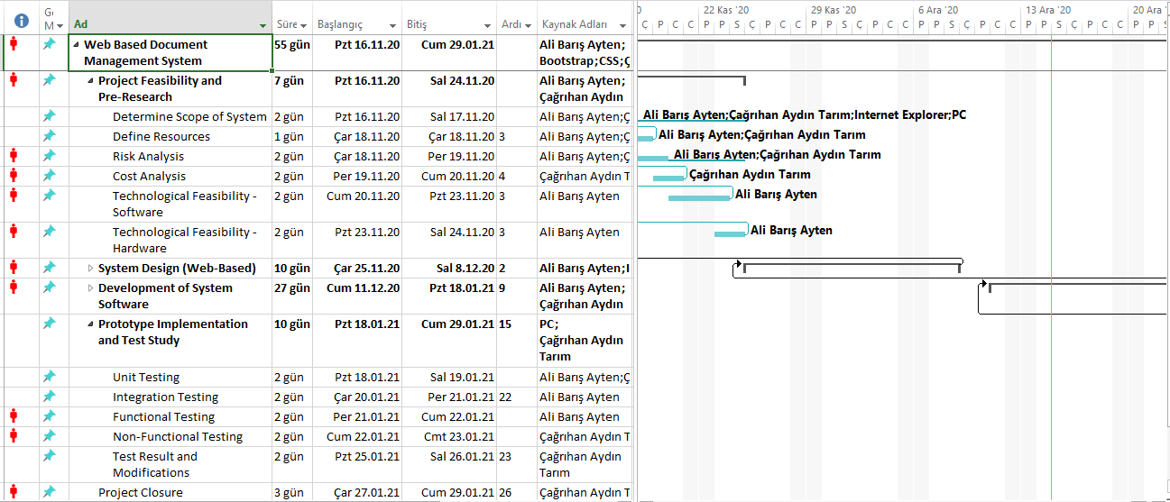

# C.1.2 List of Work Packages

|  |  |
| --- | --- |
| **Work Package No** | 1 |
| **Work Package Name** | **Project Feasibility and Pre-Research (Feasibility Analysis)** |
| **Start-End Date and Time** | 16.11.2020-24.11.2020 |
| **Related Organizations** |  |

|  |
| --- |
| **1- List the activities of work packages.** |
| **1.1 Project Process and Economic Feasibility:**   |  | | --- | | * Project initiation * Determine the system parameters * Analysis of workflow * Market research |   **1.2 Technological Feasibility:**   |  | | --- | | * Determine the technological resources will be needed in the Project * Potential research approaches and methods | |
| **2- Describe the methods and parameters that will be used for work package.** |
| Technical, legal, operational and schedule feasibility techniques will be used in this work package. |
| **3- List the experiments, tests and analysis in the work package.** |
| |  | | --- | | * Project process flow test * Economic market and outcomes test * Technological requirements and users’ needs test | |
| **4- List the output of work package and its success criterias.** |
| **Outputs:**   |  | | --- | | The output of feasibility study will show similar projects’ marketspace and missing features |   **Success Criterias:**   |  | | --- | | If current systems have little usability and features, our project will deserves to work on it. | |
| **5- Explain the relation of output with other work packages** |
| |  | | --- | | Other work packages prerequisite to this feasibility work package. So, only after this work package successfully end, we can start to work on other work packages. | |

|  |  |
| --- | --- |
| **Work Package No** | 2 |
| **Work Package Name** | **Web Based System Design Technology (Design stage)** |
| **Start-End Date and Time** | 25.11.2020 - 08.12.2020 |
| **Related Organizations** |  |

|  |
| --- |
| **1- List the activities of work packages.** |
| |  | | --- | | * Design of System. * Evaluation of system design and revisions. | |
| **2- Describe the methods and parameters that will be used for work package.** |
| |  | | --- | | * Figuring out system architecture with this work package * Research about the most useful methodologies for project | |
| **3- List the experiments, tests and analysis in the work package.** |
| |  | | --- | | * Research about convenient development interface * Research about coding language * Research about application of system architecture to Project * Time Analysis * Risk Management | |
| **4- List the output of work package and its success criterias.** |
| **Outputs:**   |  | | --- | | The most important output is fully ready system architecture for development stage. |   **Success Criterias:**   |  | | --- | | Convenient models and methodologies.(Dataflow,Sequence,Use Case diagrams etc) | |
| **5- Explain the relation of output with other work packages** |
| Before starting development and implementation steps, the most important thing is system design/architecture to reach success at next steps of project |

|  |  |
| --- | --- |
| **Work Package No** | 3 |
| **Work Package Name** | **Development of System Software (Development Stage)** |
| **Start-End Date and Time** | 11.12.2020 - 18.01.2021 |
| **Related Organizations** |  |

|  |
| --- |
| **1- List the activities of work packages.** |
| |  | | --- | | * Concept development and needs analysis * Creating database * Software development * Software integration | |
| **2- Describe the methods and parameters that will be used for work package.** |
| |  | | --- | | * Creating relational database with ER and different diagrams * Using pre-desired software language and platform. | |
| **3- List the experiments, tests and analysis in the work package.** |
| |  | | --- | | * Start time for coding * Little unit tests for strong codes * Integration with IDE, DB * Interface design with professional tools | |
| **4- List the output of work package and its success criterias.** |
| **Outputs:**   * Running sample application of project * Ready to test codes   **Success Criterias:**   * Low error rate in coding step * Effective database design and implementation |
| **5- Explain the relation of output with other work packages** |
| The project is fully connected this work package because other work packages are preparatory for this step. After this work package there will be only testing and releasing steps. |

|  |  |
| --- | --- |
| **Work Package No** | 4 |
| **Work Package Name** | **Prototype Implementation and Test Study and Maintenance (Test & Maintenance stage)** |
| **Start-End Date and Time** | 18.01.2021-29.01.2021 |
| **Related Organizations** |  |

|  |
| --- |
| **1- List the activities of work packages.** |
| * Interface tests * Web application testing * Testing of database and application server * Testing on real users of the system * Test results analysis and system evaluation * Completion of improvements * Project closure |
| **2- Describe the methods and parameters that will be used for work package.** |
| * Database testing * User experience measurement * Interface testing by all team members * Testing real users’ opinions about project and usability |
| **3- List the experiments, tests and analysis in the work package.** |
| * Unit test will be completed and correcting errors if there exist. Unit test is the most important test for project release step. * Web application test. |
| **4- List the output of work package and its success criterias.** |
| **Outputs:**   * Reporting test results * Ready to release project * Verification results.   **Success Criterias:**   * The application should be passed from all test perfectly |
| **5- Explain the relation of output with other work packages** |
| This work package is last one. So, if this work package’s steps will be perfectly completed, our project will be done. It means, the project is ready to release market and gain. |

# C.1.3 List of Milestones

|  |  |  |
| --- | --- | --- |
|  |  |  |
| **1** | **Project Initialization/ Feasibility Studies** | 16.11.2020 – 24.11.2020 |
| **2** | **Team Development/Scheduling** | 25.11.2020 – 26.11.2020 |
| **3** | **Requirements Analysis and Development** | 27.11.2020 – 01.12.2020 |
| **4** | **Resources Procurement/Allocation** | 01.12.2020 – 02.12.2020 |
| **5** | **Development of System Model(s)** | 02.12.2020 – 08.12.2020 |
| **6** | **UI and Database Development** | 11.12.2020 – 18.12.2020 |
| **7** | **Coding and Implementation of Functionalities** | 10.12.2020 – 12.01.2021 |
| **8** | **Prototyping and Design Synthesis** | 12.01.2021 – 17.01.2021 |
| **9** | **Testing Activities and Modifications** | 18.01.2021 – 26.01.2021 |
| **10** | **Project Closure** | 27.01.2021 – 29.01.2021 |

# C.1.4 List of Risks

|  |  |  |  |
| --- | --- | --- | --- |
| Risk | Probability | Effects | Your Strategy |
| Poor communication | Low | Serious | We will inform each other at every step we take. |
| Lack of resources | Moderate | Serious | Looking for other alternative suppliers. |
| Customers fail to understand the impact of requirements changes | Moderate | Tolerable | Creating the user interface simple as possible. |
| Insufficient programmer for some parts. | High | Serious | Assign other programmers or train the team member. |
| The size of the software is underestimated. | High | Serious | Investigate buying software components;  Investigate use of a program generator. |
| Low working speed | Moderate | Serious | Progressing in a planned way |
| The database used in the system cannot process as many transactions per second as expected. | Moderate | Serious | Investigate the possibility of buying a higher-performance database. |

**C.2 Project Management and Organization**

# C.2.1 Project Team

|  |  |  |  |  |  |
| --- | --- | --- | --- | --- | --- |
| **Personnel Name** | **Title** | **ID** | **Grad. Date** | **Date of Starting Work** | **Idea Owner** |
| Çağrıhan Aydın TARIM | Project Manager/Lead Programmer/ System Tester | 16002478 | 2021 | 26/03/2020 | Yes |
| Ali Barış AYTEN | Administrator/  Web Developer/  User Interface Developer | 15000086 | 2021 | 26/03/2020 | Yes |
|  |  |  |  |  |  |

# C.2.2 Organization Scheme

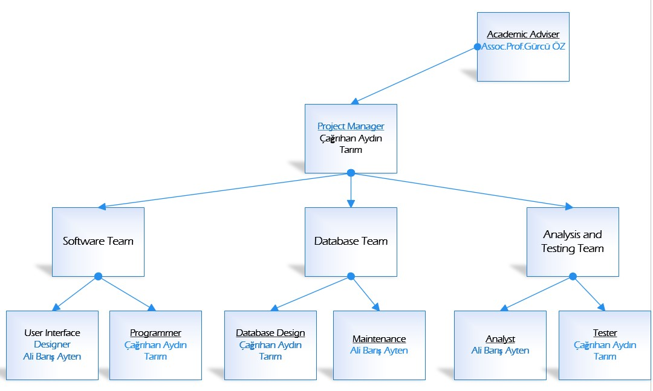

**D.1 Economic Forecasts**

|  |
| --- |
| **1- Evaluate the commercialization potential of project outcomes. List possible risks here?** |
| In our system, we aimed to shorten the graduation project evaluation process for instructors and enable the student to access report formats and upload their reports.  We plan to market this system to universities. The risk here, most universities can have similar type of system. |

|  |  |
| --- | --- |
| **2- List your expectations to your team which are come by your project** | |
| Time-to-market (month): | 2 months |
| The expected increase in sales revenue (%): | 45% |
| The expected increase in market share (%): | 75% |
| Time to start to gain: | 4 months |

**D.2 National Outcomes**

|  |
| --- |
| **1- Specify the output that may be subject to patent, utility model and industrial design registration in the project.** |
| We can adapt our project differently for each school/university. According to incoming requests, we can create different industrial designs for each school/university. |
| **2- Explain the potential of project and its outputs that may have an effect on social life, education, health and etc.** |
| This project will have an effect on education. Because the project is aimed at students and teachers, it is linked to education. In addition, the impact of the project on the students is directly proportional to the effect on the education. |
| **3- Explain the positive and negative effects of project outputs for environment and human being.** |
| There is no expected negative effect. This project will help to save forests with less usage of paper. In EMU, every documentation was creating on papers and on every update they were printing out. |

**(M013) Instrument / Equipment / Software / RELEASE PURCHASES**

|  |  |  |  |  |  |  |  |  |  |  |  |
| --- | --- | --- | --- | --- | --- | --- | --- | --- | --- | --- | --- |
| **Project Name** | | **A Web Based Document Management System** | | | | | | | | | |
| **Line no** | **Instrument / Equipment / Software / Publication Name** | | **No. of Item** | **Capacity** | **Technical specification** | **Purpose of Project Activities** | **Post-Project Place of Use / Purpose** | | **Unit Price (USD)** | **Unit Price (TL)** | **Total Amount (TL)** |
| **R & D** | **Production** |
| **1** | **Laptop** | | **2** |  | **Core i7 – 8gb** | **Visual Studio –Brackets,** |  | **Coding** | **1000** | **8000TL** | **16000TL** |
| **2** | **MS Office** | | **2** |  | **An office suite of applications, servers, and services** | **Used in many areas of the project such as documentation** |  | **Documentation** | **200** | **1600TL** | **3200TL** |
| **3** | **MS Project** | | **1** |  | **Project Management Software** | **We will use this application to plan and schedule our project** |  |  | **400** | **3200TL** | **3200TL** |
| **4** | **Team Services& Github** | |  |  |  | **Team Working** |  | **Communication** | **Free** |  |  |
| **5** | **Drawio** | |  |  | **Design** | **Used to draw software design diagrams** | **System Design** | **Management** | **Free** |  |  |
| **6** | **Internet Connection** | | **2** |  | **8Mbit** | **Connection** | **Research** | **Communication** | **100** | **800TL** | **1600TL** |
|  |  | |  |  |  |  |  |  |  | **TOTAL** | **24000TL** |

**(M030) Quarterly Estimated Cost Form (TL)**

|  |  |  |  |  |
| --- | --- | --- | --- | --- |
| **Project Name: A Web Based Document Management System** | | | | |
| **Cost Item** | **2020** | | **TOTAL**  **(TL)** | **TOTAL COST RATE OF CONTENTS (%)** |
| **I** | **II** |
| **Personnel** | 36000 | 45000 | 81000 | 72.6% |
| **Travel** | 6500 | 8000 | 14500 | 13% |
| **Instrument / Equipment / Software / Publications** | 5000 | 7000 | 12000 | 11.6% |
| **Domestic Works Made By R & D and Testing Institutions** |  |  |  |  |
| **International Works Made By R & D and Testing Institutions** |  |  |  |  |
| **Domestic Services Procurement** |  |  |  |  |
| **Overseas Service Procurement** |  |  |  |  |
| **Material** | 1500 | 2500 | 4000 | 2.8% |
| **TOTAL COST** | 49000 | 62500 | 111500 | 100% |
| **CUMULATIVE COST** |  |  | 111500 | 100% |
| **IN THE PROJECT TOTAL MAN-MONTH** | | | 3600TL | |

|  |  |  |  |
| --- | --- | --- | --- |
| **Task ID** | **Task Name** | **Duration** | **Dependency** |
| A | Project Initialization/ Feasibility Studies | 7 |  |
| B | Team Development/Scheduling | 4 | A |
| C | Requirements Analysis and Development | 3 | B |
| D | Resources Procurement/Allocation | 5 | B |
| E | Development of System Model(s) | 5 | C, D |
| F | UI and Database Development | 9 | E |
| G | Coding and Implementation of Functionalities | 20 | F |
| H | Prototyping and Design Synthesis | 5 | G |
| I | Testing Activities and Modifications | 8 | H |
| J | Project Closure | 1 | I |

Critical Path Management

|  |  |
| --- | --- |
| Paths | Duration |
| A B C E F G H I J | 62 |
| **A B D E F G H I J** | **64** |

Network Diagram (w/durations)

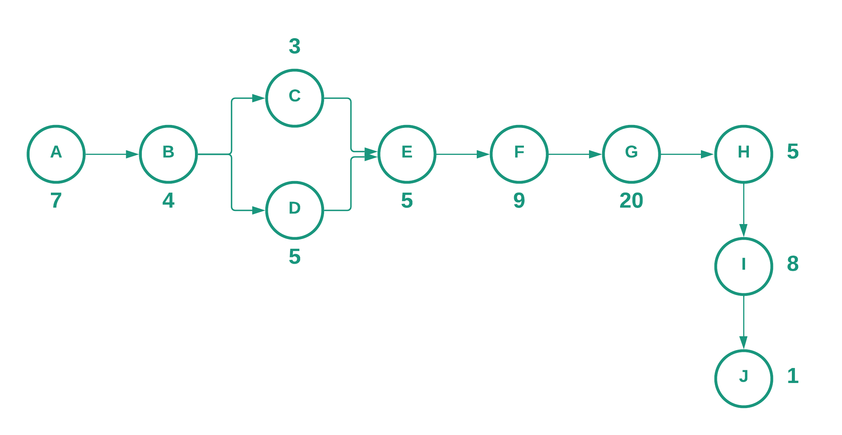

Network Diagram(Critical Path)

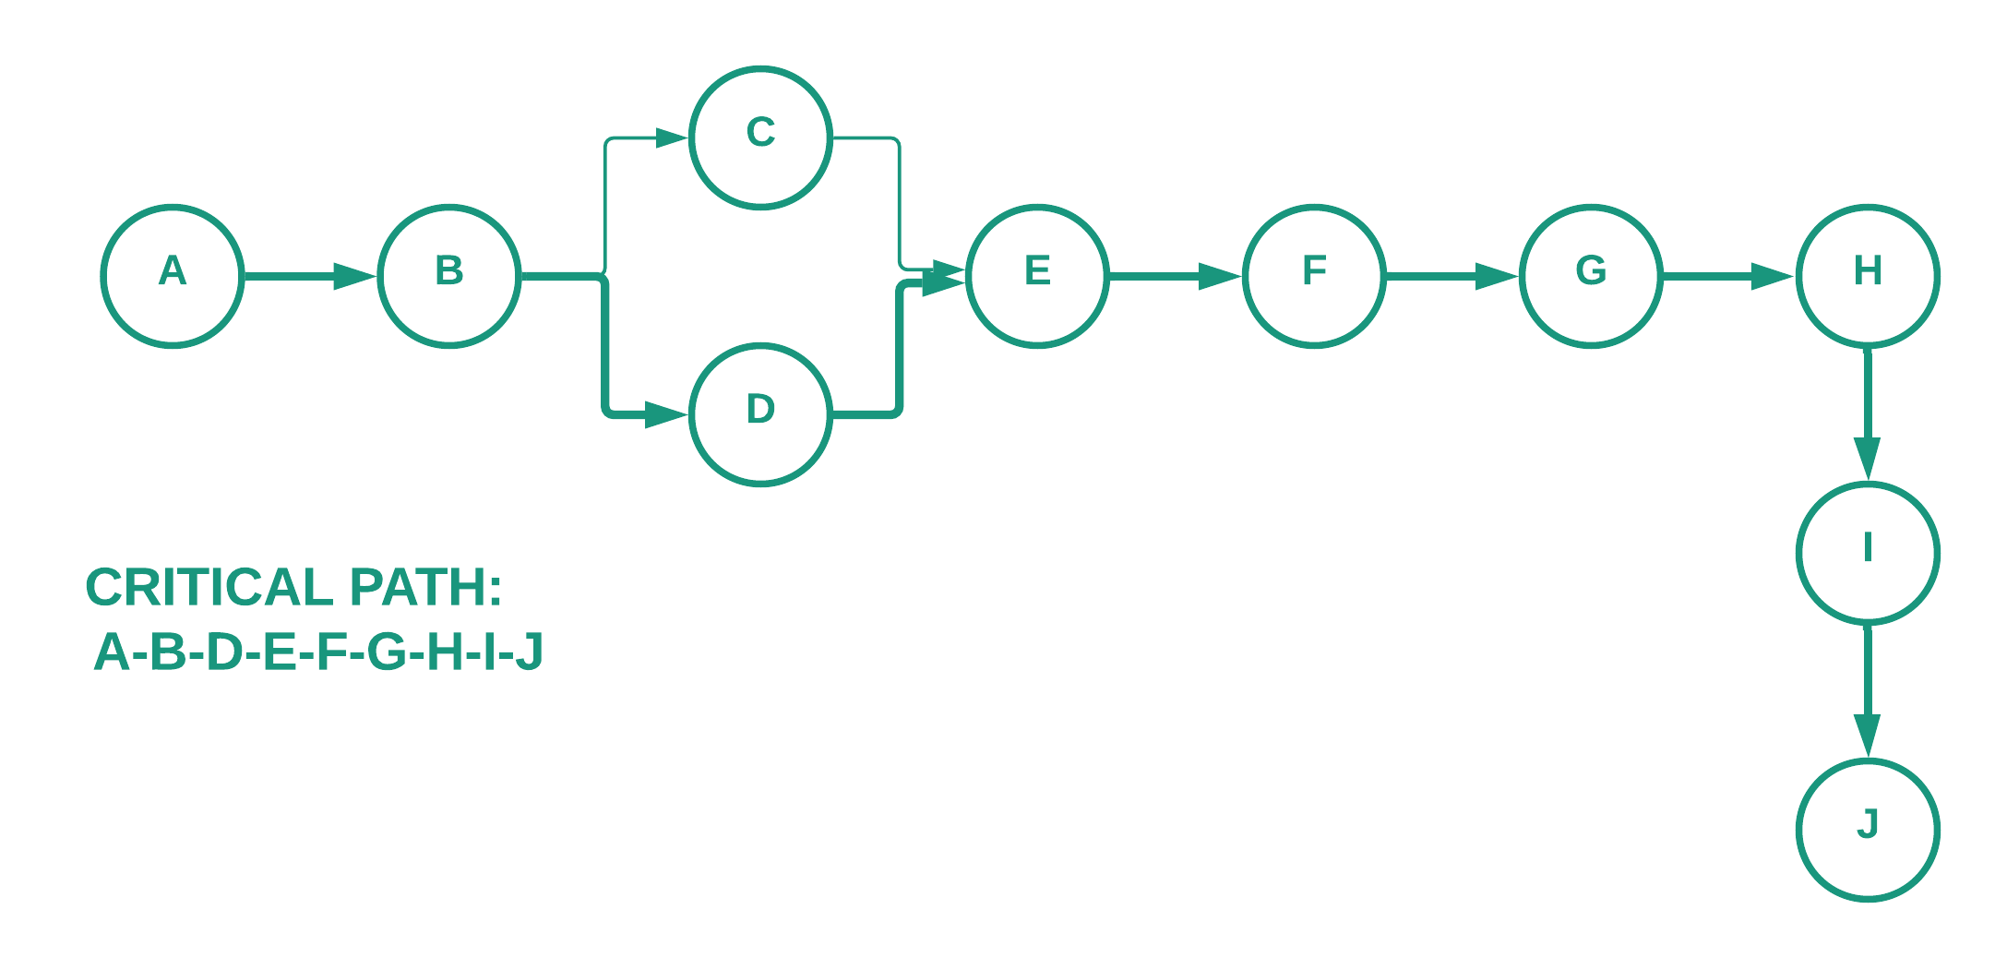

**COCOMO**

We used the Intermediate COCOMO approach for the project. We defined project characteristics Semi-Detached because we did not be in such a web project before and also, we are not a quite experienced developer.

* From other related projects we defined the line of codes as **18 000**.
* KLOC/KDSI, this is in DSI, we need KDSI. 5 000 / 1000 = 5.

**Effort applied by per person per month (E)**

E = $a×{\left(KLOC\right)}^{b}×EAF$,

and Semi-Detached Coefficients are a = 3.0 and b = 1.12

For Effort Adjustment Factor (EAF),

* Application Experience (AEXP) is low = 1.13
* Programmer Capability (PCAP) is low = 1.17
* Programming Language Experience (LEXP) is low = 1.07

Then, EAF is equal:

$EAF=AEXP×PCAP×LEXP$

$$EAF=1,13×1,17×1,07=1,41467$$

Finally, E is equal,

E = $3×{\left(5000\right)}^{1,12}×1,41467$

E = 58,97 PM

**For development time (D)**,

$D=c×{\left(E\right)}^{d}$ and Semi-Detached Coefficients are c = 2.5 and d = 0.35

$$D=2,5×{\left(58,97\right)}^{0,35}$$

$$D=10,41$$

**For number of people required for the project (SS)**

$$SS=E/D$$

$$SS=58,97/10,41$$

$$SS=5,66$$