**Yellow HRM**

1)toplu əməlliyatlar => Toplu məzuniyyət => + => dövr inputlari ashagi dushməsi

GroupVacationModal(72 toplu mezuniyyet) 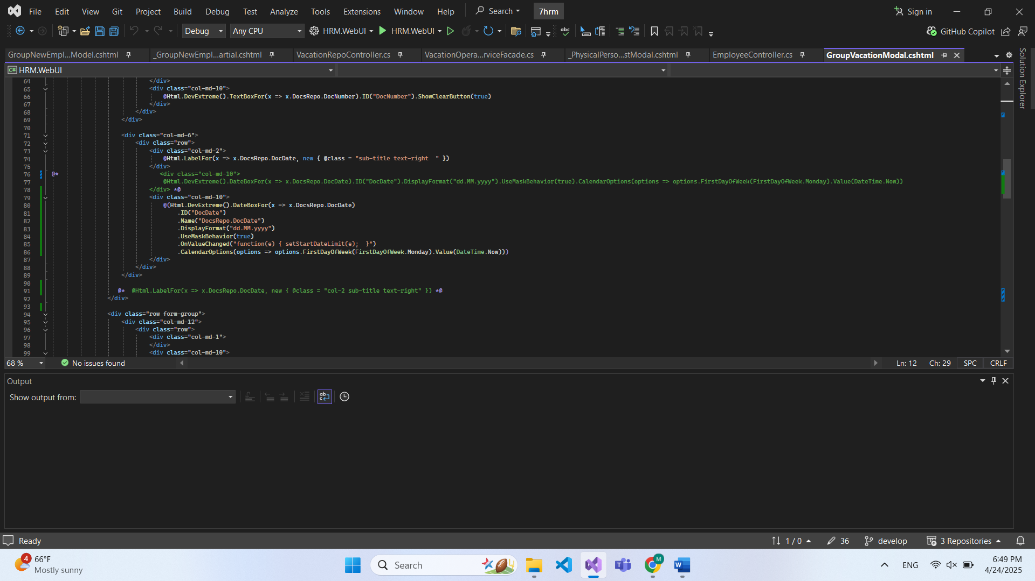

_LaborVacationPartial(function successPeriodForm)-+

2) toplu məzuniyyət => məzuniyyətlərdə calendar

_LaborVacationPartial(function setStartDateLimit и фунция над ним)

$(document).ready(function() {

var docDateBox = $("#DocDate").dxDateBox("instance");

if (docDateBox) {

var docDateValue = docDateBox.option('value');

if (docDateValue) {

var generatorId = '@ids';

var startDateId = "#_StartDate" + generatorId;

var startDateBox = $(startDateId).dxDateBox("instance");

if (startDateBox) {

var currentValue = startDateBox.option('value');

if (currentValue && currentValue < docDateValue) {

startDateBox.option('value', docDateValue);

}

startDateBox.option("min", docDateValue);

startDateBox.option("disabledDates", function(date) {

return date < docDateValue;

});

}

}

}

});

function setStartDateLimit(e) {

let minDate = e.value;

console.log("minDate", minDate)

$(".startDate").each(function() {

let dateBoxElem = $(this).find(".dx-datebox");

if (dateBoxElem.length > 0) {

let dateBoxId = dateBoxElem.attr('id');

if (dateBoxId) {

let startDateBox = $("#" + dateBoxId).dxDateBox("instance");

if (startDateBox) {

startDateBox.option("disabledDates", null);

startDateBox.option("min", minDate);

startDateBox.option("disabledDates", function(date) {

return date < minDate;

});

let currentValue = startDateBox.option('value');

if (currentValue && currentValue < minDate) {

startDateBox.option('value', minDate);

}

}

}

}

});

}

3) İşçi seçilmədikdə xəbərdarlıq mesajının görünməsi

_LaborVacationPartial( function onEmployeeChanged(e) )

function onEmployeeChanged(e){

var employee = e.value;

console.log("employee", employee)

if(employee != null){

$("#@submitId").prop('disabled', false);

}

else{

$("#@submitId").prop('disabled', true);

}

} .OnValueChanged("onEmployeeChanged") + button disabled

4) Toplu emelliyatlar => vezife deyishdirilmesi her hansi bir data seçilmədikdə xəbərdarlıq mesajının görünməs i

_GroupChangePostionPartial

GroupChangePositionModal(button) disabled

5)Ishden azad etmede tarixler ishlemir(Bayram gunlerini)

_GroupDismissalPartial

GroupDismissalModel

6) Toplu ezamiyyet her hansi bir data seçilmədikdə xəbərdarlıq mesajının görünməsi

GroupBusinessTripModal(button)

_ GroupBusinessTripPartial

7) Toplu ishe gebul tarix

_GroupNewEmployeePartial

VacatinRepoController

VacationOperationServiceFacade

8)toplu mukafatlandirma(teze) dolgo I mnogo

9)kabinetde Ezamiyyet telebnamesi **_BusinessTripModal.cshtml**

Qeyri ish gune chixma **_UnWorkHoursModal.cshtm**

Ish saatlarin qisadilmasi **_WorkingHoursReductionModal.cshtml**

**10) printpage employeerelocationprintpage**

**11) seferberlik (mobilization printpage + deyishilik)**

**MEDICOM**

Hospital, ProductType,ProductGroup,Doctor,Product,Unit,Customer, TechPerson, Agent,CashOutCome,Stock

1)field dobavlat vezde(7core)

Release download I dobavit v proekt v core(ne v custom)

2)

1. Model/Setting/ bool?
2. View/ gridpartial + form dobavlaem
3. Workflow/modelconverter/+isdeleted
4. Services/settings/fascade
5. Migration cerez core

3)

1. Controller
2. GetData rename GetActive
3. +Getdata snova menau tam reference

4) v kajdoy modele sozdat generate constructor

public CashOutcomeTypeModel()

{

IsDeleted = false;

}

4)database

SELECT * FROM "SEPTEM"."CashOutcomeTypes"

UPDATE "SEPTEM"."CashOutcomeTypes"

SET "IsDeleted" = FALSE

WHERE "IsDeleted" IS NULL;

SELECT * FROM "SEPTEM"."Hospitals"

UPDATE "SEPTEM"."Hospitals"

SET "IsDeleted" = FALSE

WHERE "IsDeleted" IS NULL;

SELECT * FROM "SEPTEM"."ProductType"

UPDATE "SEPTEM"."ProductType"

SET "IsDeleted" = FALSE

WHERE "IsDeleted" IS NULL;

SELECT * FROM "SEPTEM"."ProductGroup"

UPDATE "SEPTEM"."ProductGroup"

SET "IsDeleted" = FALSE

WHERE "IsDeleted" IS NULL;

SELECT * FROM "SEPTEM"."Doctors"

UPDATE "SEPTEM"."Doctors"

SET "IsDeleted" = FALSE

WHERE "IsDeleted" IS NULL;

SELECT * FROM "SEPTEM"."Products"

UPDATE "SEPTEM"."Products"

SET "IsDeleted" = FALSE

WHERE "IsDeleted" IS NULL;

SELECT * FROM "SEPTEM"."Units"

UPDATE "SEPTEM"."Units"

SET "IsDeleted" = FALSE

WHERE "IsDeleted" IS NULL;

SELECT * FROM "SEPTEM"."Customers"

UPDATE "SEPTEM"."Customers"

SET "IsDeleted" = FALSE

WHERE "IsDeleted" IS NULL;

SELECT * FROM "SEPTEM"."TechPersons"

UPDATE "SEPTEM"."TechPersons"

SET "IsDeleted" = FALSE

WHERE "IsDeleted" IS NULL;

SELECT * FROM "SEPTEM"."Agents"

UPDATE "SEPTEM"."Agents"

SET "IsDeleted" = FALSE

WHERE "IsDeleted" IS NULL;

SELECT * FROM "SEPTEM"."Stocks"

UPDATE "SEPTEM"."Stocks"

SET "IsDeleted" = FALSE

WHERE "IsDeleted" IS NULL;

5) ubrat barcodi v anbare

SELECT * FROM "SEPTEM"."Stocks"

ORDER BY "Id" ASC

UPDATE "SEPTEM"."Stocks"

SET "Code" = NULL;

6)dobavit v techcizatci borcu noviy stolbik (valyuta)

1.stockincome dobavlaem field currency(7core)

2.view dobavlaem tak je currency (potom puslaem migration)

3. v model stockincome dobavil

4. v viewdto dobavil I v grippartial.

5. bazada view code obnovlaem