CALCULATING OVERDRAFT INTEREST FROM BANK STATEMENT WITH SQL

1. INTRODUCTION

When I started to create reports on Qlik Sense after completing the training, I experienced that just completing training is not enough, and the main driving force for learning was hidden in finding solutions to problems encountered in real data. While looking for a solution to a problem, I was learning more than necessary to solve the problem, and as I gained experience, I found solutions that could work more efficiently and faster.

I created this project with interesting problems to increase my SQL experience by applying the learning-by-doing method in SQL.

1. RULES OF CALCULATING OVERDRAFT INTEREST \*

* The money withdrawn from the account is withdrawn on the current day. If the current day is a holiday, it is considered to withdraw on the previous business day.
* The money deposited into the account is considered to be deposited on the next business day.
* It is assumed that 12-18-23 and 24 of the month are holidays in addition to Saturday-Sunday days in November, to avoid a regular holiday pattern.
* Interest is charged on the last day of the month, and the last day of the month is not included in the calculation.

1. CHALLENGES

* Bank statements do not show the starting balance for each day. Some days, even if there is no account activity, the account may be in a negative balance. To calculate how much overdraft limit is used in a day, the initial balance of that day must also be taken into account.
* Since the money withdrawn from the account is the same day and the deposited money is the next day, the holidays should be calculated by grouping them with the last business day before a holiday. For example, if 12-13-14 November are holidays, then the calculation should be made by assuming that 11 November, which precedes the holidays, is a day with a power of 4 days lasting 96 hours. To group the holidays, it is necessary to include a pattern that can recognize the business day before the holiday and holidays.

0.STAGE

Balance sheet and calendar tables are created.



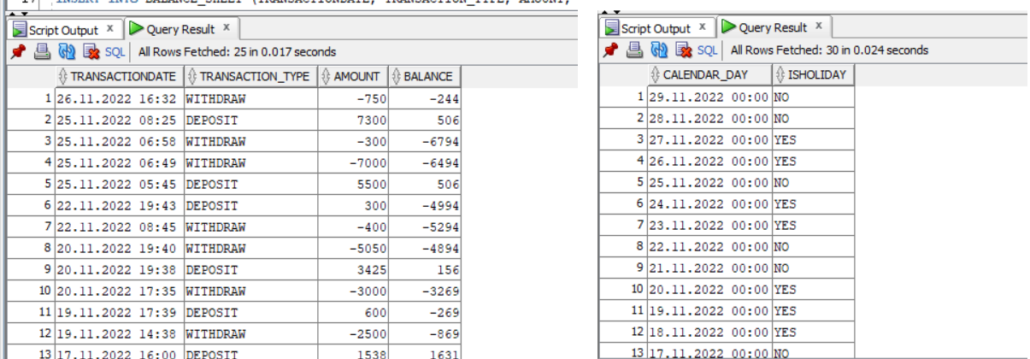

1. STAGE

Before finding the starting balance for each day, the previous day before the last day of the month and the last day of the previous month will be added to the balance sheet table.



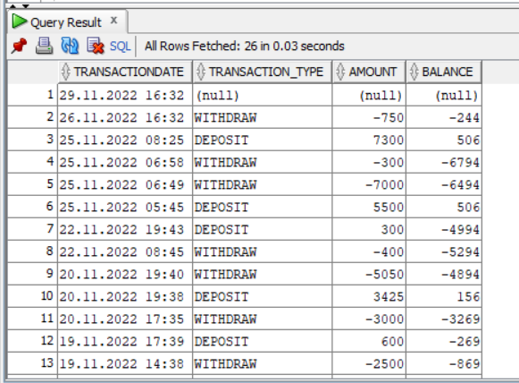

1. STAGE

To find the starting balances of each day, it is necessary to multiply the last balance during the day until the first balance of the next day. For example, to copy the balance at 26.11.2022 16:32 into the balance fields of 27.11.2022 00:00 - 28.11.2022 00:00 -29.11.2022 00:00, we should create a GAP field by checking the date and the leading date.



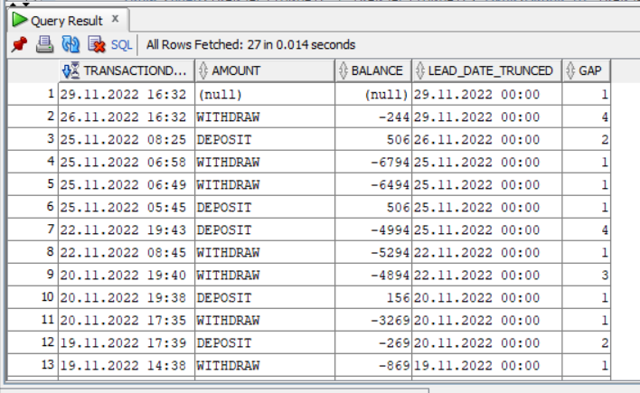

1. STAGE

In the previous stage, we calculated GAP. At this stage, we create levels depending on GAP. IF LEVELL = GAP the record stays the same, if LEVELL <> GAP records will be altered by adding a level to the transaction date until reaching the ceil of the GAP.



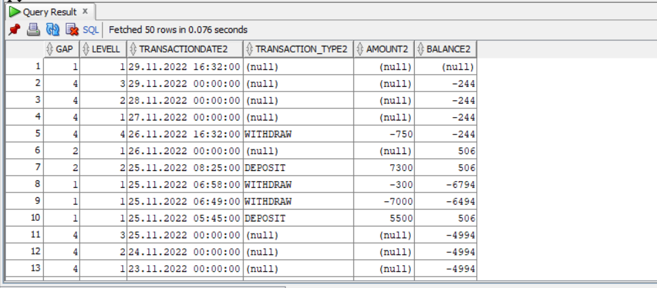

1. STAGE

The amount and balance will not be enough to calculate the interest base of the overdraft limit. If the previous balance is positive, the withdrawal from the account may not necessarily mean that the overdraft limit has been used, but if the previous balance is negative, it is necessary to use the overdraft limit for the withdrawal from the account. The previous balance is added to the table to calculate the interest base.



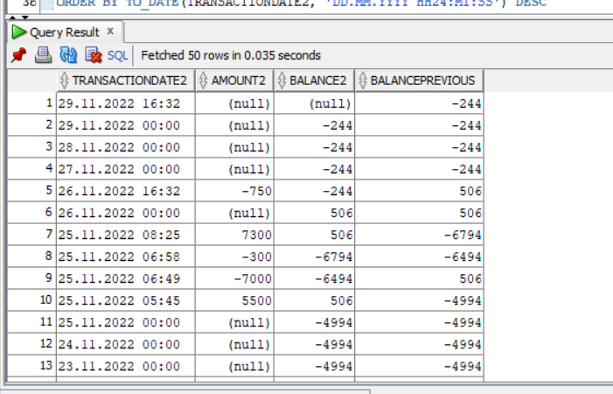

1. STAGE

The amount, balance, and previous balance are compared for calculating the interest base amount.



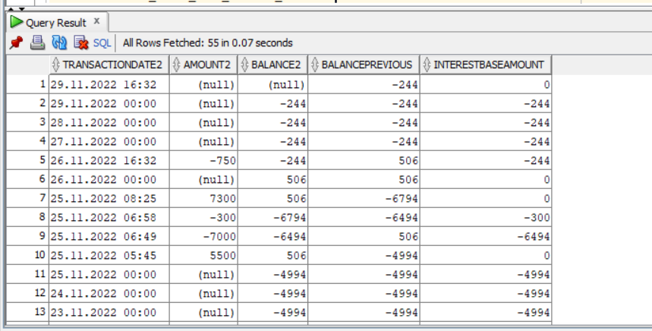

1. STAGE

Before joining the balance sheet with the calendar table, the matching pattern should be calculated to recognize holidays with the previous business day. When we look at our calendar, it can be seen that the pattern will be like a business day + any number of holidays or independent business days [ PATTERN(NO YES+ | NO ) ].



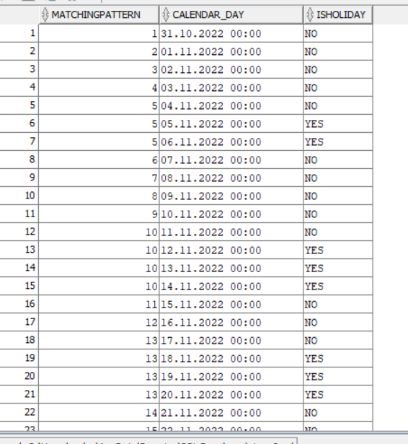

1. STAGE

Two tables are joined.



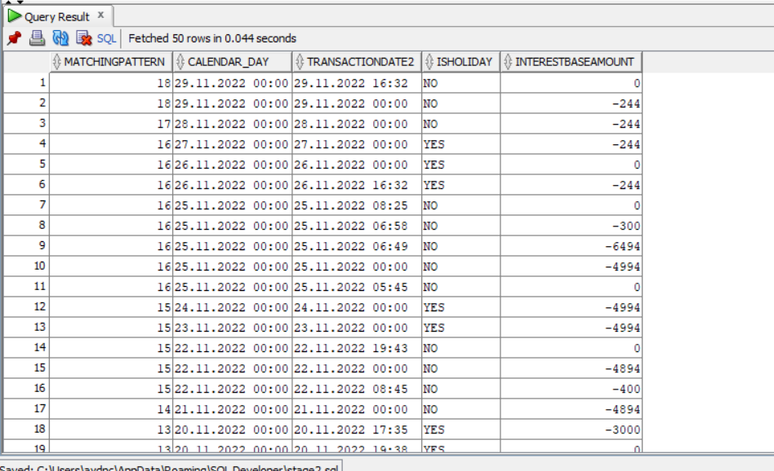

1. STAGE

To calculate the negative starting balances for the day + how much overdraft limit is used during the day, we need to group each day in itself. But before we do this, there is something we must consider. If 12-13-14 November are holidays, we said that the calculation should be made by assuming that November 11, which precedes the holidays, is a day with a power of 4 days lasting 96 hours. While doing this, we need to ignore the starting balances for days 12-13-14 to be consistent and consider only the transactions during the day for these days. At this stage, the starting balances for the days, which should be ignored, are deleted.



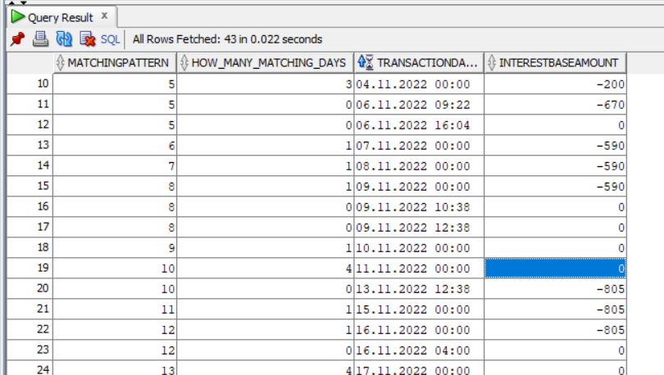

1. STAGE

Cleaned data are grouped based on the matching pattern.



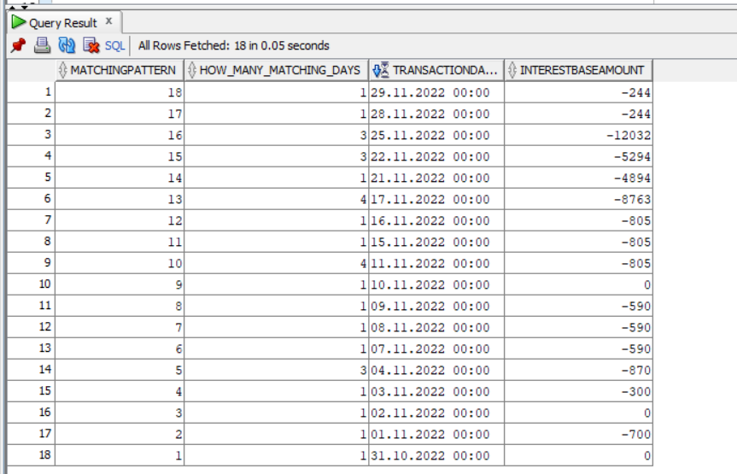

1. STAGE

At the final stage, overdraft interest is calculated. Changing interest rate within the month or reading it from a table is not interesting enough to be considered. Thus monthly interest rate is assumed to be 2 % per month.



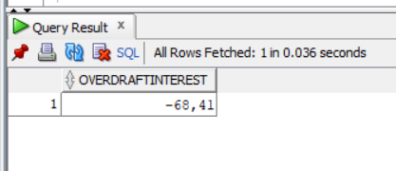

NOTE: Oracle version: Oracle Database 21c Enterprise Realese 21.0.0.0.0 – Production

National Language Support Parameters

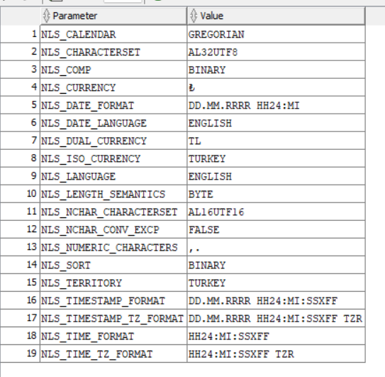

\*These overdraft rules do not merely represent the real rules of the Banks. They are made up for educational purposes.

https://www.linkedin.com/in/aydincoskun/