**HW#5 Fall 2018**

**EE475**

**Noisy Edge Detection:** Consider the Circles image, which is centered at (101, 101) and the radii are 20, 40, 60 and 80 pixels. Use an edge detector performance measure, EP; where $δ(e_{grt},e_{exp})$ means that there is an edge found on the ground-truth location, and $I(edge distance≤2)$ signifies that the edge experimental is offset by at most two pixels from the corresponding ground-truth edge location. $N_{grt}$ is the number of ground-truth edge pixels:

EP=

* 1. Compare the performances of the (a) Sobel, (b) Laplacian of Gaussian (LoG), (c) Canny edge detectors.
  2. Add Gaussian noise *N(0, 484)* to the Circles image and compare edge detectors



**Edge Linking and Completion**

Consider the Building image:

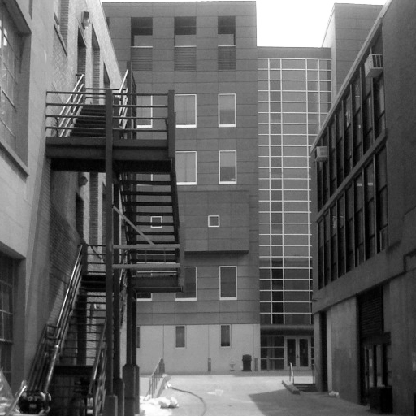

1. Filter the image with a small Gaussian filter, e.g.,  = 1. Find the gradient field and obtain its histogram. Establish the 95, 80 and 70 percentile points for high-thresholding and two low-thresholding cases, respectively.
2. Find first the edge candidates using the high-threshold, which will hopefully yield strong edges.
3. Use low-thresholding output to continue these edges, that is, apply hysteresis thresholding to connect the edges. Simply continue edges in the high-threshold image if there are overlapping or 8-neighbor edges in the low-threshold image. Discard all other low-threshold edge candidates (Read the textbook!).

**Note**: The resulting edges are thick. Normally you would have followed the step above with a thinning algorithms, e.g., using some morphological operator.

**Segmentation by Region Growing**:

Consider the Berkeley\_Deer image. The original contour images and their contour maps are given. You can access the ground-truth boundary images by using the following Matlab codes.

 load 113016  
ground1=groundTruth{1,1}.Boundaries;  
figure,imshow(ground1)

ground1=groundTruth{1,2}.Boundaries;  
figure,imshow(ground1)

Use the simpler boundary map.

|  |  |
| --- | --- |
| C:\Users\Bulent Sankur\Dropbox\DROP_EE475_2018\HW#5 Edges and Segmentation\Berkeley_Deer.jpg |  |

1. Use seeded region growing on these images; in other words, you plant region seeds appropriately, say two on the background, one on the deer. Label each seed with a different (positive) number (this will be the label of the corresponding regions). Apply the procedure to Berkeley\_deer image for N=3.
2. Centroidal growing: Let the regions grow according to the color predicate. For each unlabeled pixel p, use Euclidean distance from the test pixel to the region centroid. The distance must be compared with the threshold Th. The centroid is simply the average of the region pixels, that is, $c= \frac{1}{\left|Reg\right|}\sum_{(i,j)ϵReg}{\left[\begin{matrix}R(i,j) \\ G(i,j) \\ B(i,j)\end{matrix}\right]}$, where $\left|Reg\right|$ is the cardinal of Reg, the number of pixels in a region at that stage of growth and the predicate is: $\sqrt{{\left(R\left(p\right)-c_{R}\right)}^{2}+{\left(G\left(p\right)-c_{G}\right)}^{2}+{\left(B\left(p\right)-c_{B}\right)}^{2}}<Th$. If the pixel does not satisfy the predicate, then leave p unlabeled.
3. Recursively repeat b) until no change occurs in the labels (i.e. regions do not grow further).
4. Use the threshold Th = Th + t, repeat b-c until no pixels are left unlabeled. You have to decide for the threshold: Try thresholds starting with Th = 10 and t = 10
5. Finally, compare the resulting segmentation map with the ground truth map. One goodness criterion could be (G: ground-truth region set, S: segmented region set) $g= \frac{\left|G∩S\right|}{\left|G∪S\right|}$, one for each region. For example, obtain the goodness of segmentation score for the raindeer.

**Segmentation by Clustering**:

Consider the Gauss\_rgb1 128x128 image painted by three noisy color tones. Try the two feature vectors: $f_{1}=\left[R G B \right]$ and $f_{2}=\left[R(x) G(x) B(x) x y σ_{R(x)} σ_{G(x)} σ_{B(x)}\right]$, where (x,y) are the relative coordinates vis-à-vis the image center, and $\left[ σ_{R} σ_{G} σ_{B}\right]$ are the respective variances computed from a 3x3 neighborhood, e.g., $σ_{R(x)}= \frac{1}{9}\sum_{-1}^{1}{\sum_{-1}^{1}{{\left(f\left(x,y\right)-μ_{R}\right)}^{2}}}$.

* Randomly select C seed points from the image within what you judge to be a potential segment, consider their intensity values as the initial region centroids (means)  n=1,2,…C.
* Label each pixel in the image with the index of the center to which it is closer to:
  + - ), where L = 1, ... C is the label of the pixel at coordinates (i,j)
* Compute new means M(c) from the intensity values of the pixels labeled with L = c, for each one of the segments.
* Repeat (ii) and (iii) until M(c)’s start to remain constant, e.g., $\max_{c}\left\{\left|M_{t+1}\left(c\right)-M_{t}(c)\right|\right\}<ε$ or $\sum_{c=1}^{C}{{\left\|M_{t+1}\left(c\right)-M_{t}(c)\right\|}^{2}}<ε$

1. Obtain the image , which is the segmented image and plot it.
2. To compare the resulting segmentation map with the ground truth map, use the goodness criterion $g= \frac{\left|G∩S\right|}{\left|G∪S\right|}$, where G: ground-truth region set, S: segmented region set, for each region. The weighted sum of g scores, where the weight is the percentage of the ground truth area, is the goodness score for the whole image.
3. Compare the performances of the two feature vectors. How much improvement does the choice of the ***f2*** feature vector bring with respect to ***f1***?