**EE475 Compression**

**Fall 2012**

|  |  |  |  |  |  |  |
| --- | --- | --- | --- | --- | --- | --- |
| **SUB-SAMPLING** | **PCM** | **DPCM** | **VQ** | **DCT** | **JPEG** | **Total** |
|  |  |  |  |  |  | **/200** |

1. **Try to give concise one or two sentence answers, explanations**
2. **I suggest you copy and past images from the VC Demo program to enhance your answers**

**IMAGE COMPRESSION SOFTWARE**

In the following, study the image processing function experimenting with various parameters, report your experience briefly in a few sentences. Copy and paste the images and graphs to accompany your commentaries.

**SUBSAMPLING**

* Inspect the spectrum of the image Build512B.bmp. The DC component is in the center. Give explanations for the observed line structures, that is identify the image structures to which the spectral line structures correspond to. Note: *SS Button 🡪 Spectrum 🡪 Apply*
* Subsample by a factor of 2, once without anti-aliasing filter and then with 17-tap aliasing filter. Can you pinpoint the aliasing events in the subsampled image without anti-aliasing filtering? Does anti-aliasing filter improve it? In turn, does the anti-aliasing filter cause any distortions? Explain the difference in the spectra of the subsampled images with and without anti-aliasing filters. .

Note: *SS 🡪 Factor 🡪 2 , check Apply Subsampling box, check Blow-up Subsampled Image box*

*SS 🡪 Filter 🡪 Check or uncheck Apply anti-alias filter, Set the number of taps to 17.*

**PCM**

* Study the images Lena256B, Clown256B, Odie256B. At which rate do the artifacts become objectionable? At this rate how many gray values are available to represent the image?

Note: *PCM button 🡪 Select bitrate 🡪 Apply. Do for bit rates 7 to 1.*

|  |  |  |
| --- | --- | --- |
|  | Bit-rate at which artifacts become objectionable | Gray values at this rate |
| Lena256B |  |  |
| Clown256B |  |  |
| Odie256B |  |  |

For Lena256B, Fill in the table.

|  |  |
| --- | --- |
| Bit rate | SNR (dB) |
| 1 |  |
| 2 |  |
| 3 |  |
| 4 |  |
| 5 |  |
| 6 |  |
| 7 |  |

* Draw an SNR-versus-bit-rate plot for Lena256B. Explain the reason why you are getting such a slope for this curve.

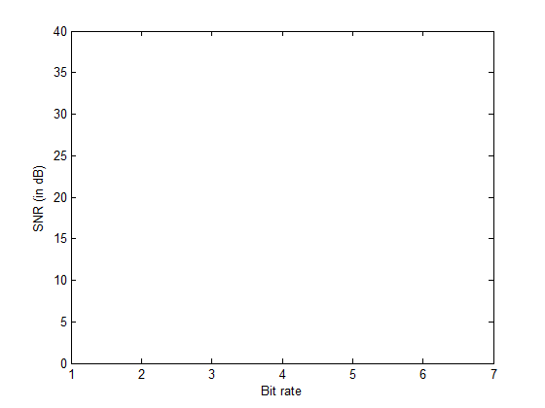

* Explain the behavior of Odie under PCM, which is quite different than that of Lena. What distortions occur in Odie? What distortions occur in Lena?

**DPCM**

* Select the Lena256B image and the 1-D predictor. Carry out compression at bit rates 6 to 1 bpp and obtain the SNR – Observe the gain over PCM.

Note: *DPCM button 🡪 Model 🡪 Select the first prediction model. Select Bit Rate from 1 to 6.*

For Lena256B, Fill in the table.

|  |  |  |
| --- | --- | --- |
| Bit rate | DPCM SNR (dB) | PCM SNR (dB)  Copy from previous table |
| 1 |  |  |
| 2 |  |  |
| 3 |  |  |
| 4 |  |  |
| 5 |  |  |
| 6 |  |  |
| 7 |  |  |

* Compare visually the images with their PCM version and state at what rate DPCM achieves a performance equal to that of PCM?
* Use four types of prediction region for DPCM at bit rate level 5 and comment on the performance differences. Sketch the prediction context.
* Observe the correlation matrix. What is the theoretical gain over PCM in terms of bit rate reduction at the same quality? Does the experimental result match the theory? Recall the prediction gain for one-tap predictor:  where r(1) is the normalized correlation coefficient.

**VQ**

Load the predesigned codebook Standard_4x4_min1-max12.cbk. This codebook has been designed on 4 other images other than Lena.

Note: *VQ button 🡪 Codebook 🡪 Load codebook 🡪 Select Standard_4x4_min1-max12.cbk 🡪 Open*

*Bits 🡪 Select*

* Make an SNR-bit rate plot on the same curve as PCM/DPCM. Note: Be careful to first calculate the VQ bit rate (bits/pixel) before you plot.



**Start this curve from 0.**

* What type distortion do you observe .at low bit rates? Does it appear to be additive white Gaussian noise?
* Can you use codebooks obtained by Lena-type images on cartoons and maps? If yes, how? If not, why not?

**JPEG**

* Use the Lena256B image and the standard luminance normalization matrix. Fill the SNR-bit rate tables, one for each entropy coding choice. At the same time, write down the corresponding QF: Quality Factors. How much additional SNR does entropy-coding give?

Note: *JPEG button 🡪 Huffman tab 🡪 Select FLC, Standard VLC, Optimal VLC in turn*

*JPEG button 🡪 Bit rate tab 🡪 Bitrate 🡪 Select bit rate as 0.5, 0.8, 1.0, 1.5, 2.0, 2.5, 3.0 in turn 🡪 Apply*

Write down the Encoded Bit Rate in bpp, Optimized Quality Factor and the corresponding SNR. (FLC: Fixed Length Coding, VLC: Variable Length Coding)

|  |  |  |  |  |  |  |
| --- | --- | --- | --- | --- | --- | --- |
| Bit rate | FLC | | | Standard VLC | | |
|  | Encoded Bit Rate | Quality factor | SNR (dB) | Encoded Bit Rate | Quality factor | SNR |
| 0.5 |  |  |  |  |  |  |
| 0.8 |  |  |  |  |  |  |
| 1.0 |  |  |  |  |  |  |
| 1.5 |  |  |  |  |  |  |
| 2.0 |  |  |  |  |  |  |
| 2.5 |  |  |  |  |  |  |
| 3.0 |  |  |  |  |  |  |

* Compare the resulting SNRs from a “flat normalization matrix” against that of the “standard luminance normalization” and comment.

Note: *Repeat above selecting: Quant 🡪 Choose Flat*

|  |  |  |  |  |  |  |
| --- | --- | --- | --- | --- | --- | --- |
| Bit rate | Fixed weighting | | | Standard weighting (psychovisual) | | |
|  | Encoded Bit Rate (b | Quality factor | SNR (dB) | Encoded Bit Rate | Quality factor | SNR |
| 0.5 |  |  |  |  |  |  |
| 0.8 |  |  |  |  |  |  |
| 1.0 |  |  |  |  |  |  |
| 1.5 |  |  |  |  |  |  |
| 2.0 |  |  |  |  |  |  |
| 2.5 |  |  |  |  |  |  |
| 3.0 |  |  |  |  |  |  |

Draw the four bit rate-SNR curves on the same plot:

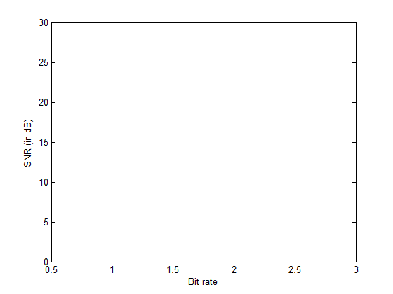

* Observe the images with flat versus standard normalization matrix at 0.5 bpp. Their SNRs are equal, yet one looks better than the other one. Explain this dilemma.

**DCT**

Select the Lena256B image. Study the block sizes of 2x2, 4x4 and 8x8. Explain what you observe in the “DCT: Original Coefficients” window. Explain what you observe in the “DCT: Coded Coefficients” window. Select PCM compression for all DCT coefficients. Pick c = 0.75 as the exponent power of the generalized Gaussian distribution.

Note: *DCT button 🡪 Size tab 🡪 Check encoding of DCT coefficients 🡪 Set transform size as 2x2, 4x4 and 8x8 in turn and press apply*

*Coefs tab 🡪 Select PCM for First and Others, Select C value as 0.75*

*Bitrate 🡪 Check the entropy coding. Select each of the bit rates in turn.*