**WEBSITE IMPROVEMENTS**

**Color Scheme:**

* **Primary Colors**:
  + Navy Blue



* + Steel Gray



* **Secondary Colors**:
  + Light Gray

* **Accent Colors**:
  + Bright Orange



* + White

**Top Bar:**

* **Logo**: Move the logo to the left, increase its size for better visibility.
* **Navigation Bar**: Fill the bar with "Home", "About", "Services", and "Contact" sections.



**Fonts:**

* Use **Roboto** font for a modern and clean look.



**Layout and Design Enhancements:**

-change the our solution layout to this

1. **Scroll to Discover and Services**:
   * Add a horizontal white bubble around these sections for emphasis.
2. **Our Solutions Section**:
   * Reduce the space between "Our Solutions" and the text on the right.
   * Move the text under "Our Solutions" to the left side.

* + Add relevant images on the right side.
  + Ensure all images are of equal size.
  + Add arrow buttons on the right and left for navigation.
  + In services

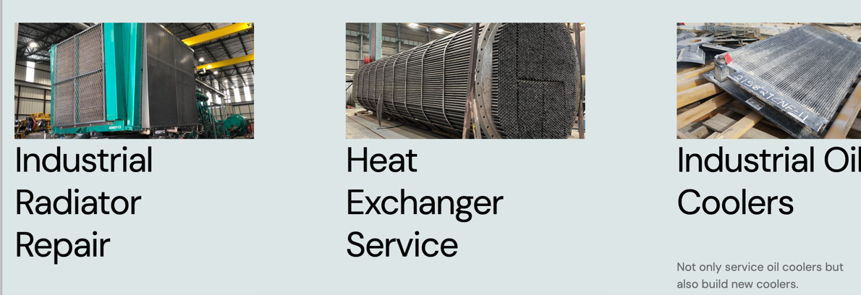

In home:

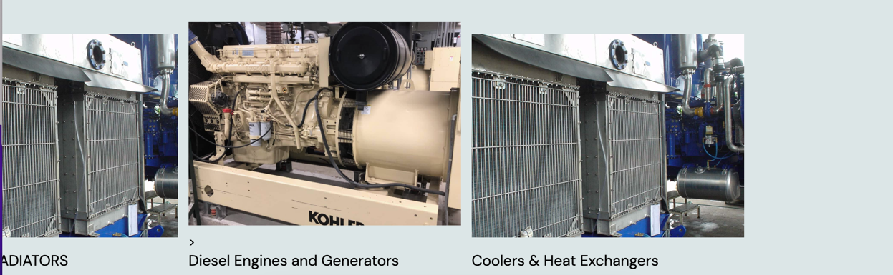

* + Make the service layout as this

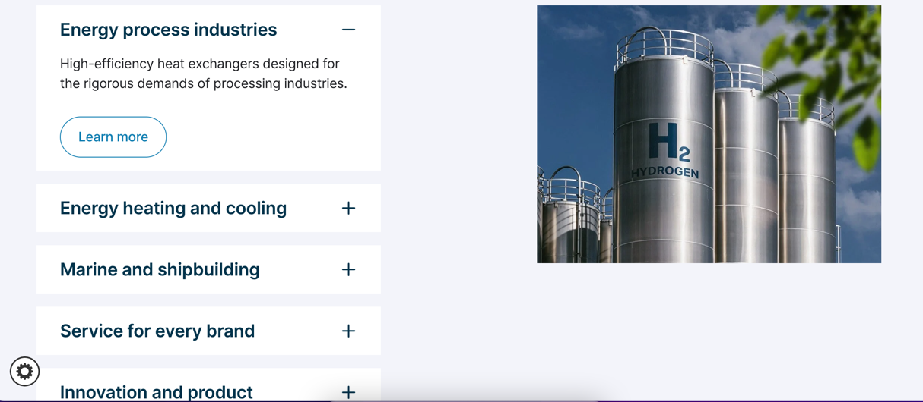

1. **Image Adjustments**:
   * Ensure all images are unique and not AI-generated.
   * Remove the arrow from "Diesel Engines and Generators".
   * Replace any repetitive or AI-generated images.
2. **Text Adjustments:**

Text on the right seems to be placed only that can also be made better

1. **Referece:**

For refence please look up

<https://www.tranter.com/>

https://naylahtml.pethemes.com/home-corporate.html