***Documentation of “PIGEON”***

***Title and Aim of PIGEON....***

The title of our website is "Pigeon". It is named by referring to the homing pigeons which were used to transfer letters from one place to another long time ago.

According to the title of the website, our website has the main aim to get touched from the people to the community among the world wide news.

***The working system of the website***

This website is the news reporting website. The categories are " General, Technology, Health, Educational and Celebrity Gossip" and each type of news have their contents uploaded by the admins. The head of admins checks the details of the news reported to him by the reporters. Other admins get the source of the news and general content by the freelance

and stable news reporters working under them.

***The purpose of our website***

The purpose of our website is dealing with the following features.

1. The news will be reported by freelance reporters who are working in local and foreign countries. (We find the foreign news reporters from our website "contact"Section)

2. The news will be bought by these freelance reporters and we also have targets on the time reported to us to get up to date news.

***The USP (unique selling point) of our website***

The users will be interested to use our website for the following reason.

Our reporters are asked to report not only the popular news but also the news from their surroundings which should be known by the users.

Thus, users will be able to read both the famous news and unknown ones in the community.

And this is the reason why the website helps in the community and this is the USP of our website.

The users do not need to have an account to read our news. Even when they want to contact us, they only need to fill the email and the message so the privacy is really secured while using our website.

Also, the freelance reporters are always welcomed so our website can also provide freelance jobs for everyone who is interested.

***How our website supports the community***

Our website is the news portal which always upload latest news up to date with many different categories.

Our website will help the community by letting know which is happening in which field around the world .

The security of all people is secured so that it is convenient for all kinds of users to use our website.

The website is not a very modern style and easy to use so this is a news portal website aimed for all ages of group.

***The features of each page***

Home page

The home page design is simple and includes features which support the interactivity of the website. It has a section about the most news-uploaded admins.

The admins with the target of their reported news might manage the reporters for each of their categories.

The home page also has a "contact" section which is really caring the users' problems and also finding new reporters for the business.

The Contact page

For the problems faced by the users, the contact page asks the brief problems from the users and the head of admin will handle them. This page is for reporting the problems from the users. Contact page contains the information about all of the admins and two developers of our website.

Contact page can be entered from all of the other pages and also the categories pages.

Categories page

Categories page include a set of information on the news report which is under the respective title of the dropdown menu.

There are five categories pages.

Latest news page

Latest news page contains the news which are up to date and displayed latest.

The latest news page can be displayed from the categories page.

***Customization and interactivity of first version***

Home page and contact page

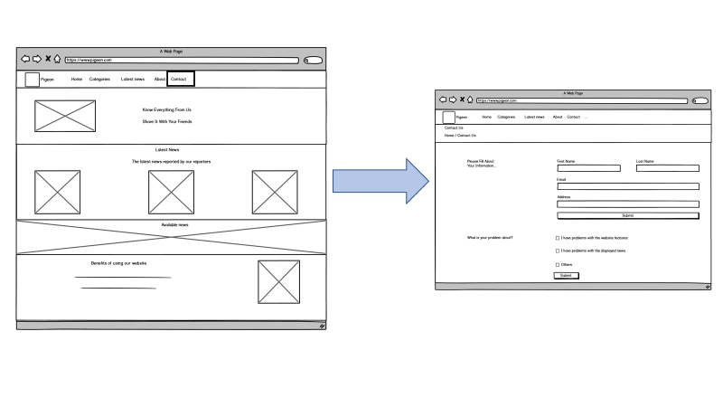Home page and about page

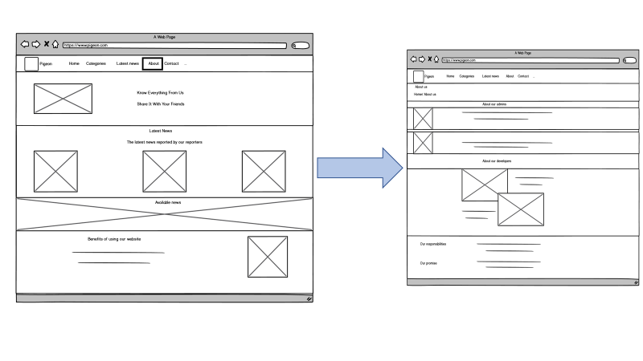

Home page and Health (categories) page

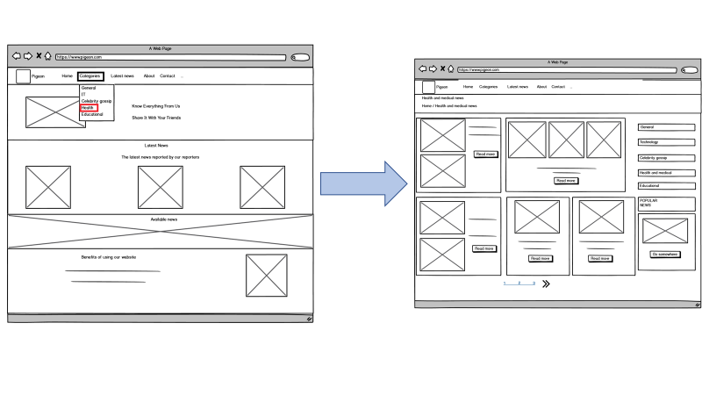

Home page and Learn more link to contact page

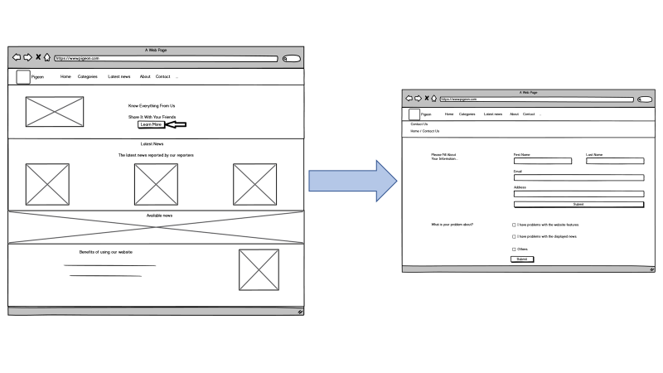

The home page has links under the dropdown of “categories” for all categories.

Contact us and about us page link by the report a problem link

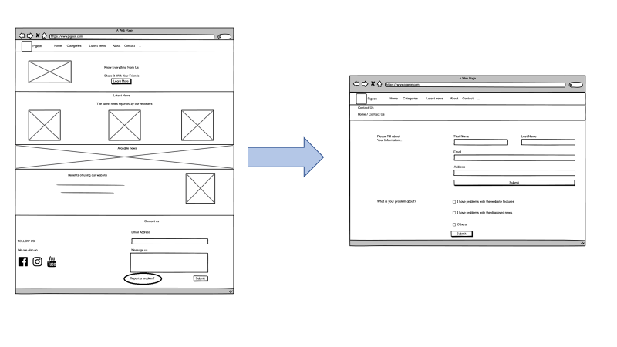

There are additional links and interactivities in our final website.