**Overview:**

This is web based application built in React to display Weather data .

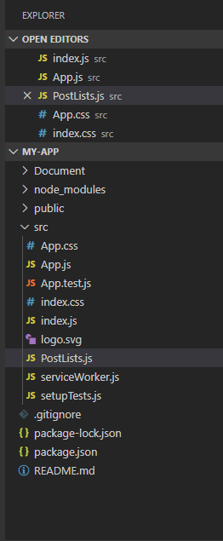

The weather data is consumed from an existing API https://ws.weatherzone.com.au/?lt=aploc&lc=<LOCATION-CODE>&locdet=1&latlon=1&pdf=twc(period=48,detail=2)&u=1&format=json

**Achieved UI Requirements,**

1. A dropdown containing the locations to be displayed.

2. The table should contain the following weather data: precipitation probability (chance),temperature, wind speed and wind direction.

3. The date and time should be shown. Think about how dates and times should be displayed,

including time zones.

4. Add toggles to the meteogram to show/hide weather data

**How it works:**

1. Select a Location from Location dropdown.

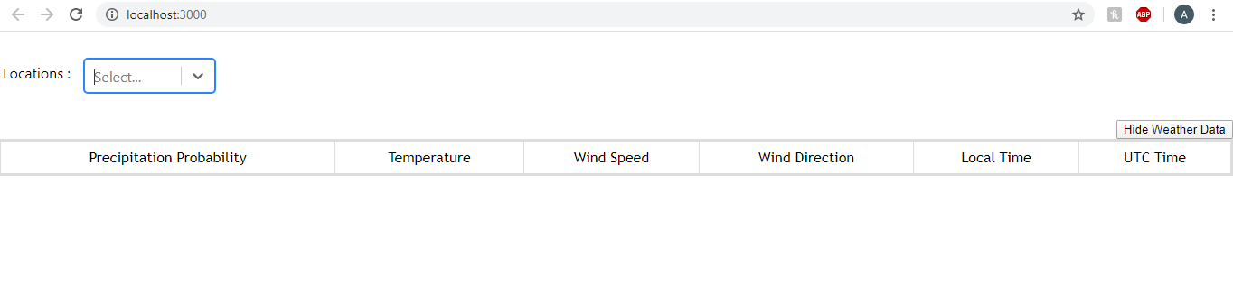2. Based on selected location, it displays the weather data from the API endpoint.

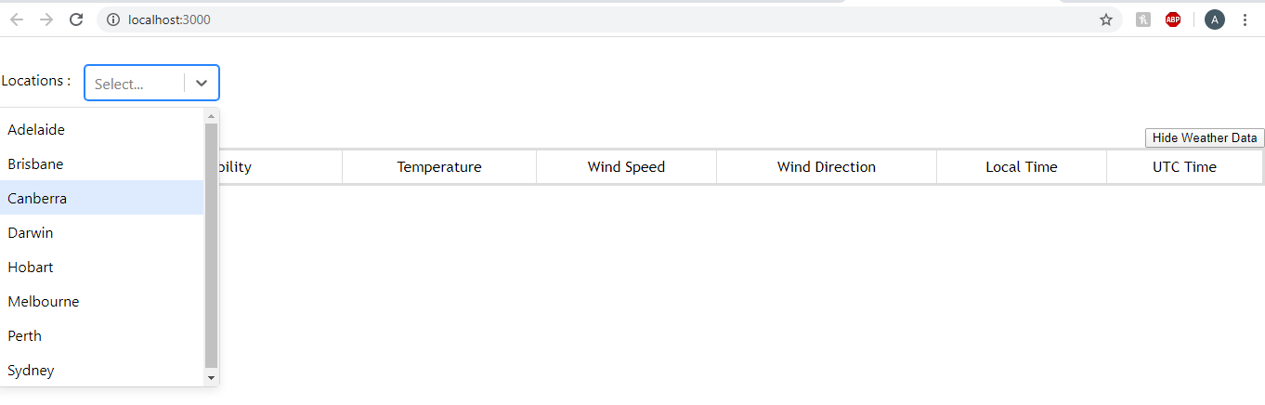

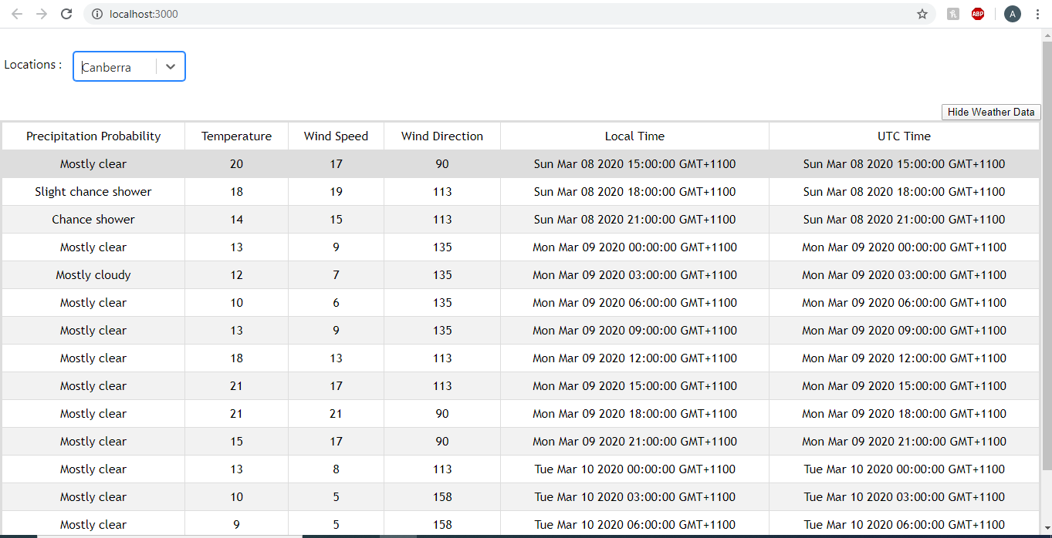

3. Show/Hide Weather data button used as toggle to show or hide weather data .

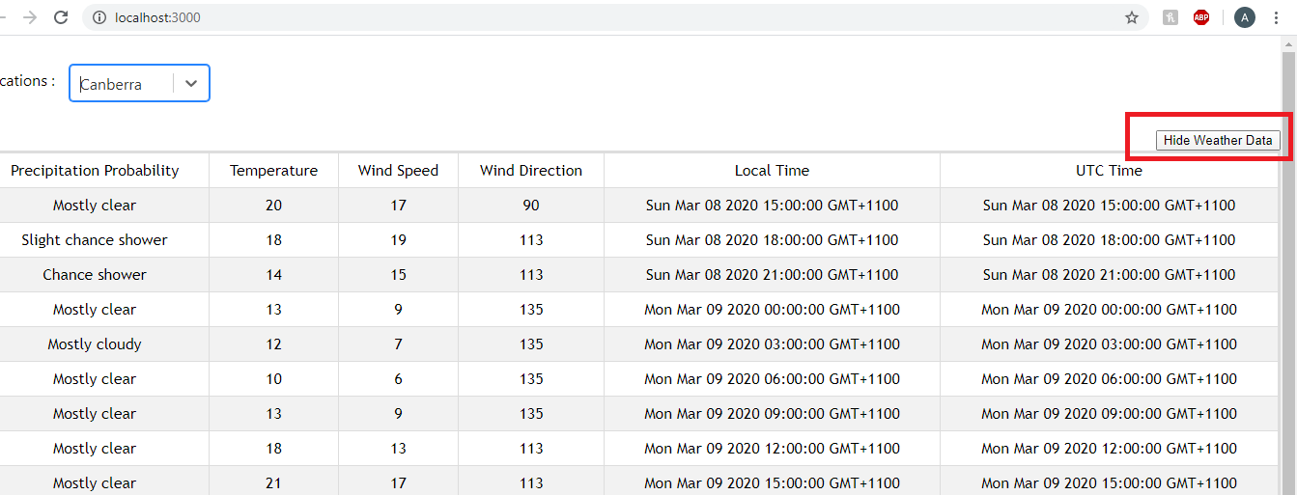

Select Hide Weather Data as shown in above screen , to hide weather details.

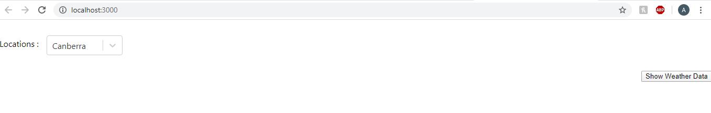

Select Show Weather data button to show weather data,

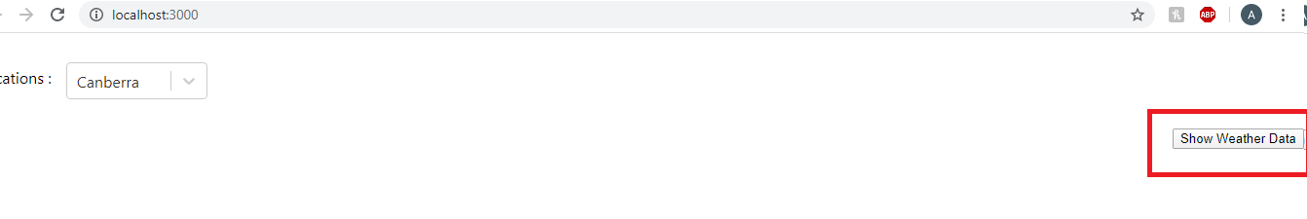

**Note : If you run/debug the application , please install below libraries from Node.js ,**

**1. react-select**

**2. moment-timezone**

**3. react-moment**

**4. axios**