
Addis Ababa University
School of Information Technology and Engineering, 2024
Master's of Science in Artificial Intelligence
Course: Probabilistic Graphical Models
Bayesian Network Based Heart Disease Risk Prediction: Structure Learning and Exact Inference from Clinical Data
Instructor: Dr. Beakal Gizachew
By Fransi Ayele, ID: GSE/1254/18 & Etsubdink Zebre GSE/0523/18
Submission Date: August 24, 2026

Abstract
This report presents a Bayesian Network approach to heart disease risk prediction using the UCI Cleveland Heart Disease dataset. Two network structures are constructed and compared: a data-driven structure learned via Hill Climbing search with the Bayesian Information Criterion, and an expert-specified structure grounded in cardiology domain knowledge. Both networks are parameterized with Bayesian estimation and queried using two exact inference algorithms, Variable Elimination and Junction Tree propagation, which are confirmed to agree to within floating point precision while differing in single-query runtime. On a held-out test split, the data-learned network reaches 82.0% accuracy compared with 73.8% for the expert-specified network, a result that is explained in terms of the bias-variance trade-off between domain-driven and data-driven structure choices under a small sample size. The project demonstrates representation, structure learning, parameter learning, and exact inference, the core themes of the Probabilistic Graphical Models course.

Table of Contents
Abstract
1. Introduction
2. Problem Statement
3. Objectives
4. Literature Review
5. Methodology
6. Dataset Description
7. Data Preprocessing
8. Exploratory Data Analysis
9. Model Architecture
10. Probabilistic Graphical Model Pipeline
11. Model Training and Parameter Estimation
12. Hyperparameter Configuration
13. Evaluation Metrics
14. Results
15. Discussion
16. Limitations
17. Future Work
18. Conclusion
References
Appendix

List of Figures
Figure 1. Distribution of Heart Disease Diagnosis
Figure 2. Age Distribution by Diagnosis
Figure 3. Missing Value Count per Feature
Figure 4. Feature Correlation Matrix
Figure 5. Expert-Specified Bayesian Network Structure
Figure 6. Data-Learned Bayesian Network Structure
Figure 7. Exact Inference Runtime Comparison
Figure 8. Confusion Matrices on Held-out Test Set
Figure 9. Model Performance Comparison
Figure 10. Example MAP Query Result

List of Tables
Table 1. Dataset Feature Summary
Table 2. Exact Inference Runtime Comparison
Table 3. Held-out Classification Performance
Table 4. Confusion Matrix, Expert-Structured Network
Table 5. Confusion Matrix, Data-Learned Network

1. Introduction
Cardiovascular disease remains one of the leading causes of death worldwide, and early risk assessment from routine clinical measurements can support timely intervention. Probabilistic Graphical Models offer a natural way to represent the uncertain, interdependent relationships between patient risk factors and diagnostic outcomes. This project builds a Bayesian Network over the UCI Cleveland Heart Disease dataset to model the probabilistic relationships between patient attributes such as age, cholesterol, resting blood pressure, chest pain type, and the presence of heart disease.
The project is grounded directly in the course topics covered under Probabilistic Graphical Models: representation through Bayesian Networks, structure and parameter learning, and exact inference through Variable Elimination and Junction Trees.

2. Problem Statement
Clinicians assessing cardiovascular risk must reason under uncertainty, combining multiple correlated risk factors and test results to estimate the likelihood of disease. A Bayesian Network provides a compact, interpretable representation of these dependencies and supports principled probabilistic queries, such as the probability of disease given a partial set of observed symptoms. This project addresses two open questions relevant to that setting: whether a structure learned purely from data outperforms one grounded in domain expertise, and whether two different exact inference algorithms produce consistent results at acceptable computational cost.

3. Objectives
- Represent patient risk factors and heart disease diagnosis as a Bayesian Network.
- Learn network structure and parameters directly from clinical data using score-based structure learning.
- Construct an expert-specified structure grounded in cardiology domain knowledge for comparison.
- Perform exact inference using Variable Elimination and Junction Trees, and confirm numerical agreement between the two methods.
- Evaluate both networks as diagnostic classifiers on a held-out test set using standard classification metrics.

4. Literature Review
The Cleveland Heart Disease dataset, originally collected by Detrano et al. (1989), is one of the most widely used benchmark datasets in clinical machine learning research. Prior work applying this dataset spans a broad range of methods, from classical classifiers such as logistic regression, support vector machines, and decision trees, to ensemble methods and deep neural networks, most of which treat the problem purely as discriminative classification and provide limited insight into the probabilistic dependency structure among the clinical variables themselves.
Bayesian Networks differ from these approaches by explicitly modeling the joint distribution over all variables through a directed acyclic graph, which supports diagnostic reasoning in both directions: predicting disease from symptoms, and predicting the likely symptom profile given a disease status. This project follows the classical Bayesian Network methodology covered in the course, using score-based structure learning (Hill Climbing with the Bayesian Information Criterion) as one candidate structure, and a domain-expert structure as a second candidate, then comparing them directly on the same data and inference machinery.

5. Methodology
The methodology follows five stages: data acquisition and preprocessing, structure learning under two paradigms (data-driven and expert-specified), parameter estimation with Bayesian smoothing, exact inference using two algorithms, and evaluation on a held-out test split. Each stage is described in the sections that follow.

6. Dataset Description
The dataset used is the UCI Machine Learning Repository Cleveland Heart Disease dataset (Detrano et al., 1989), containing 303 patient records with 13 clinical features and a binary diagnosis label. The processed version used here contains no missing values. Table 1 summarizes the fourteen variables used in this project.
Table 1. Dataset Feature Summary
Feature | Description
Age | Age in years
Sex | Patient sex
ChestPainType | Typical angina, atypical angina, non-anginal, or asymptomatic
RestingBP | Resting blood pressure (mm Hg)
Cholesterol | Serum cholesterol (mg/dl)
FastingBloodSugar | Whether fasting blood sugar exceeds 120 mg/dl
RestingECG | Resting electrocardiographic result
MaxHeartRate | Maximum heart rate achieved during exercise test
ExerciseAngina | Exercise-induced angina (yes or no)
STDepression | ST depression induced by exercise relative to rest
STSlope | Slope of the peak exercise ST segment
MajorVessels | Number of major vessels colored by fluoroscopy (0 to 4)
Thalassemia | Thalassemia test result
Heart Disease | Target label: presence or absence of heart disease

7. Data Preprocessing
Bayesian Network structure learning and exact inference, as covered in this course, operate over discrete random variables. Continuous clinical measurements were therefore discretized into clinically meaningful bins prior to modeling: age into four decade-aligned brackets, resting blood pressure into normal, elevated, and high categories, cholesterol into desirable, borderline, and high categories following standard clinical thresholds, maximum heart rate into three response bands, and ST depression into four severity bands. Categorical fields already coded as integers (chest pain type, resting ECG result, thalassemia result, and so on) were mapped to descriptive string labels for interpretability. No records were removed, since the dataset contains no missing values.

8. Exploratory Data Analysis
Figure 1 shows the diagnosis label is close to balanced, 165 patients with heart disease present against 138 without, so no class rebalancing was required.
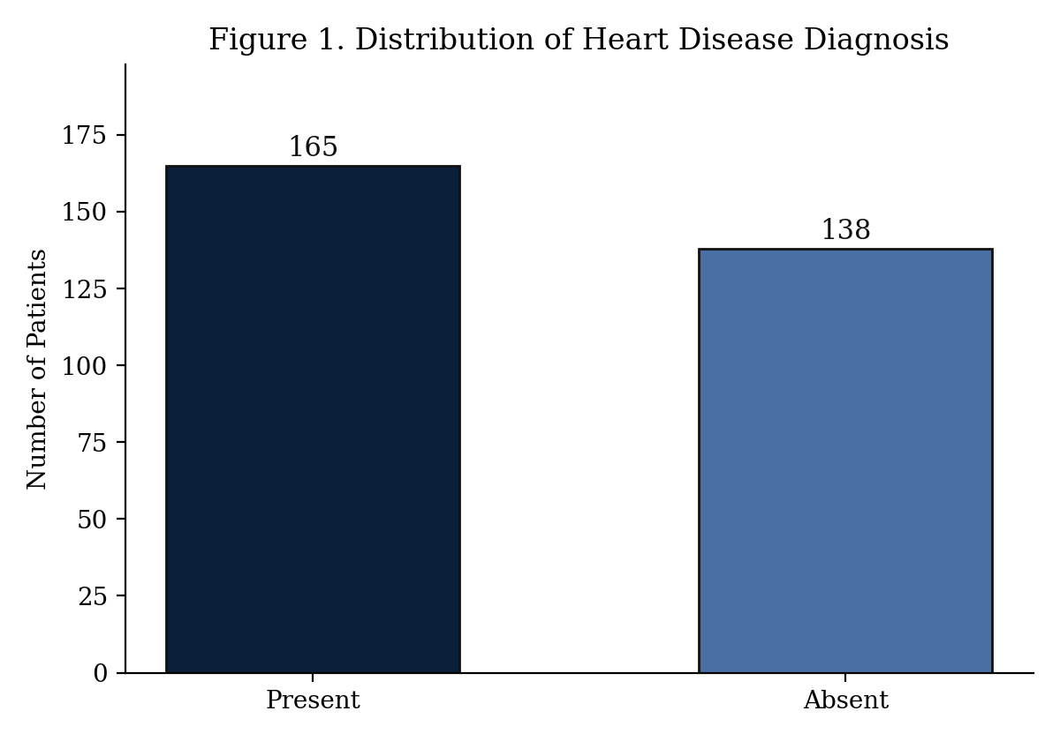
Figure 1. Distribution of Heart Disease Diagnosis
Figure 2 shows patients with heart disease skew toward older age brackets, consistent with established cardiovascular risk trends.
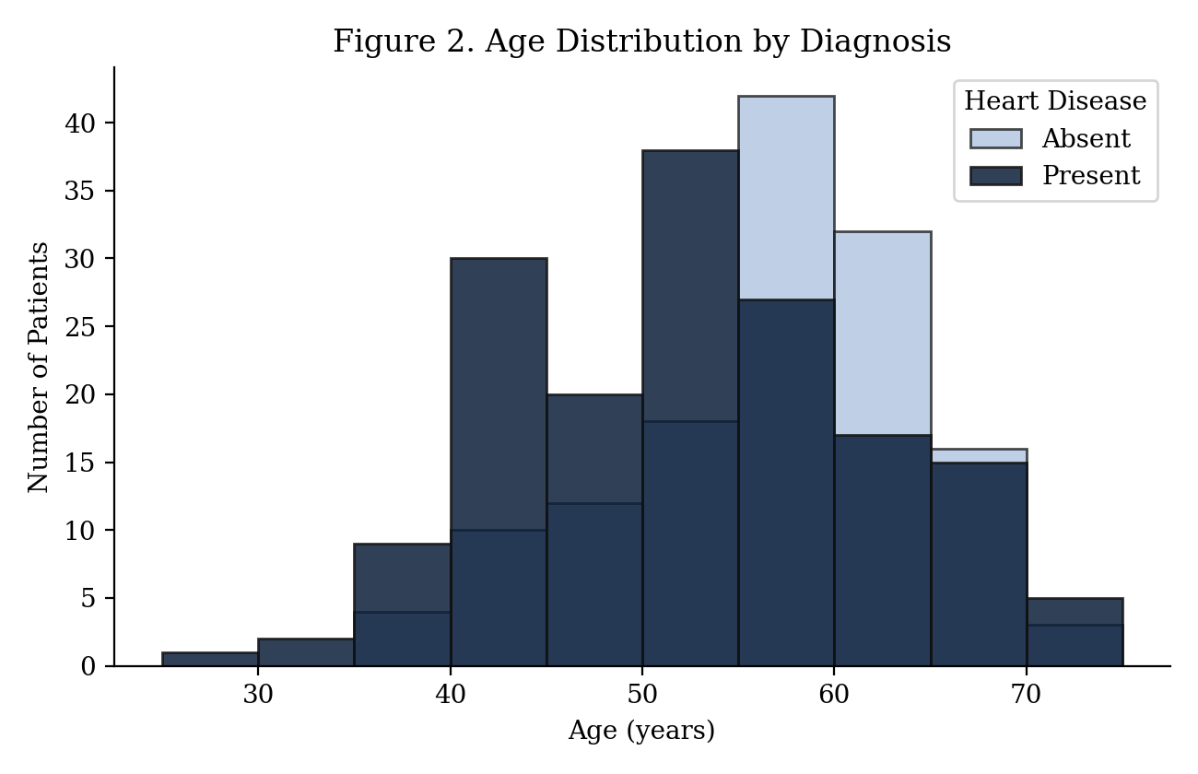
Figure 2. Age Distribution by Diagnosis
Figure 3 confirms the dataset contains no missing values across any feature, so no imputation strategy was required.
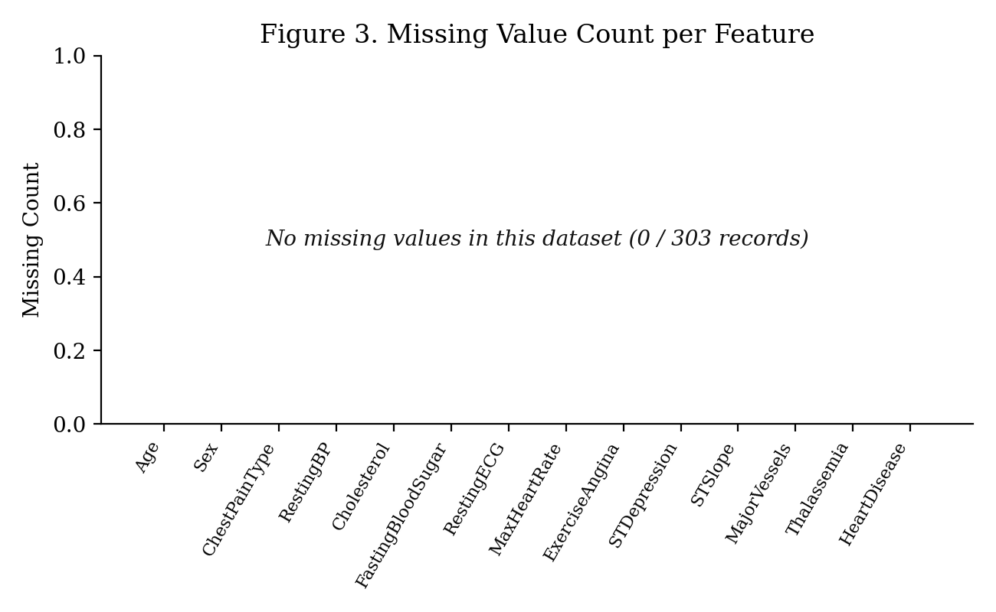
Figure 3. Missing Value Count per Feature
Figure 4 shows the pairwise correlation matrix across the numeric features. Exercise-induced angina, ST depression, and the number of major vessels show the strongest association with the diagnosis label among the numeric features, consistent with their role as diagnostic markers in the expert-specified network structure described in Section 9.
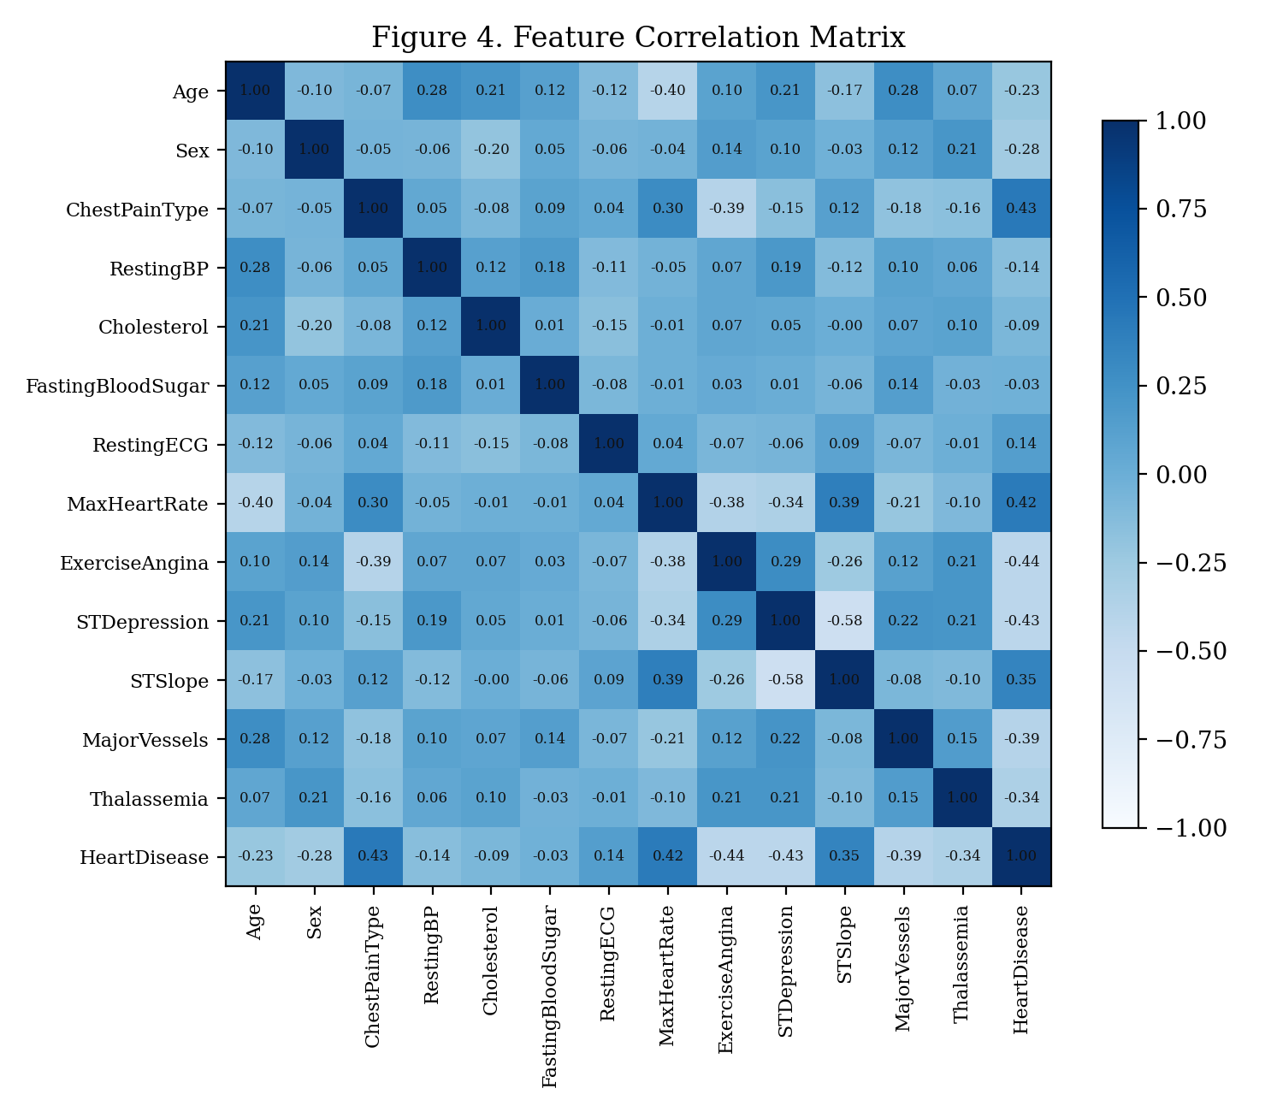
Figure 4. Feature Correlation Matrix

9. Model Architecture

9.1 System Architecture
The end-to-end system follows a linear pipeline: raw CSV data is loaded and discretized, two candidate Bayesian Network structures are constructed (one learned, one expert-specified), each structure is parameterized independently with Bayesian estimation, and both are then made available to a shared exact inference layer supporting both Variable Elimination and Junction Tree queries. A held-out evaluation module drives MAP queries against the test split to produce classification metrics for both models.

9.2 Expert-Specified Bayesian Network
The expert-specified structure treats Heart Disease as the underlying condition that gives rise to the diagnostic test findings observed during work-up: chest pain presentation, exercise-induced angina, ST segment changes, vessel calcification, and thalassemia result are all modeled as children of Heart Disease, since these are clinical consequences observed once disease is present or absent, not independent causes. Age, sex, resting blood pressure, cholesterol, and fasting blood sugar are modeled as upstream risk factors.
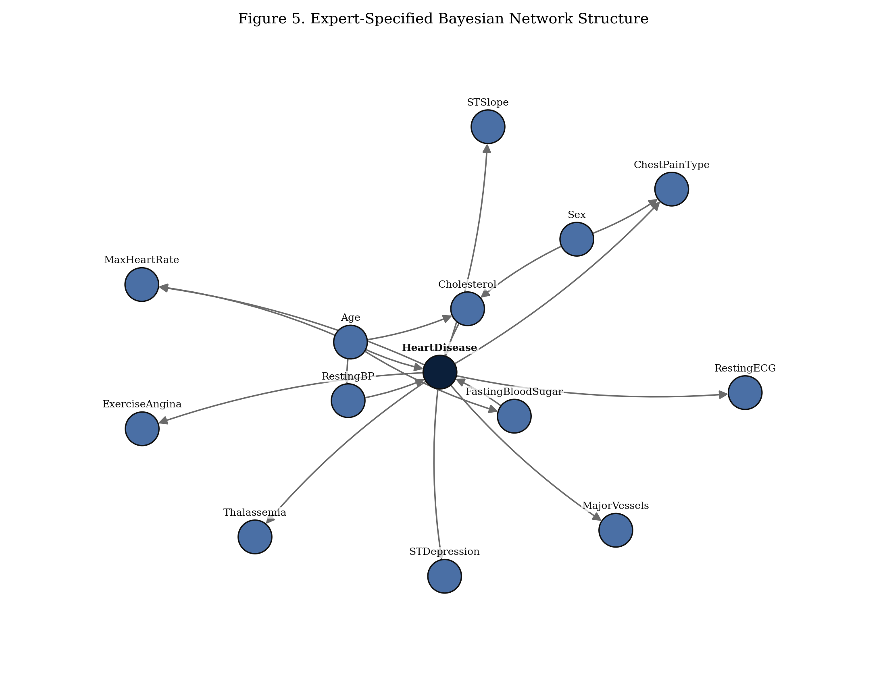
Figure 5. Expert-Specified Bayesian Network Structure

9.3 Data-Learned Bayesian Network
The data-learned structure is produced by Hill Climbing search, which greedily adds, removes, or reverses edges to maximize the Bayesian Information Criterion score, with no structure assumed in advance. With only 303 records spread across fourteen variables, several of which have three or four states, Hill Climbing recovers a comparatively sparse graph, and some variables such as Cholesterol, Resting ECG, and Fasting Blood Sugar remain disconnected from heart disease entirely. This is a direct and reportable consequence of score-based structure learning on a small clinical dataset: the Bayesian Information Criterion penalizes additional edges by their parameter count, and with limited data the score prefers to leave a variable unconnected rather than add an edge whose likelihood gain does not offset that complexity penalty.
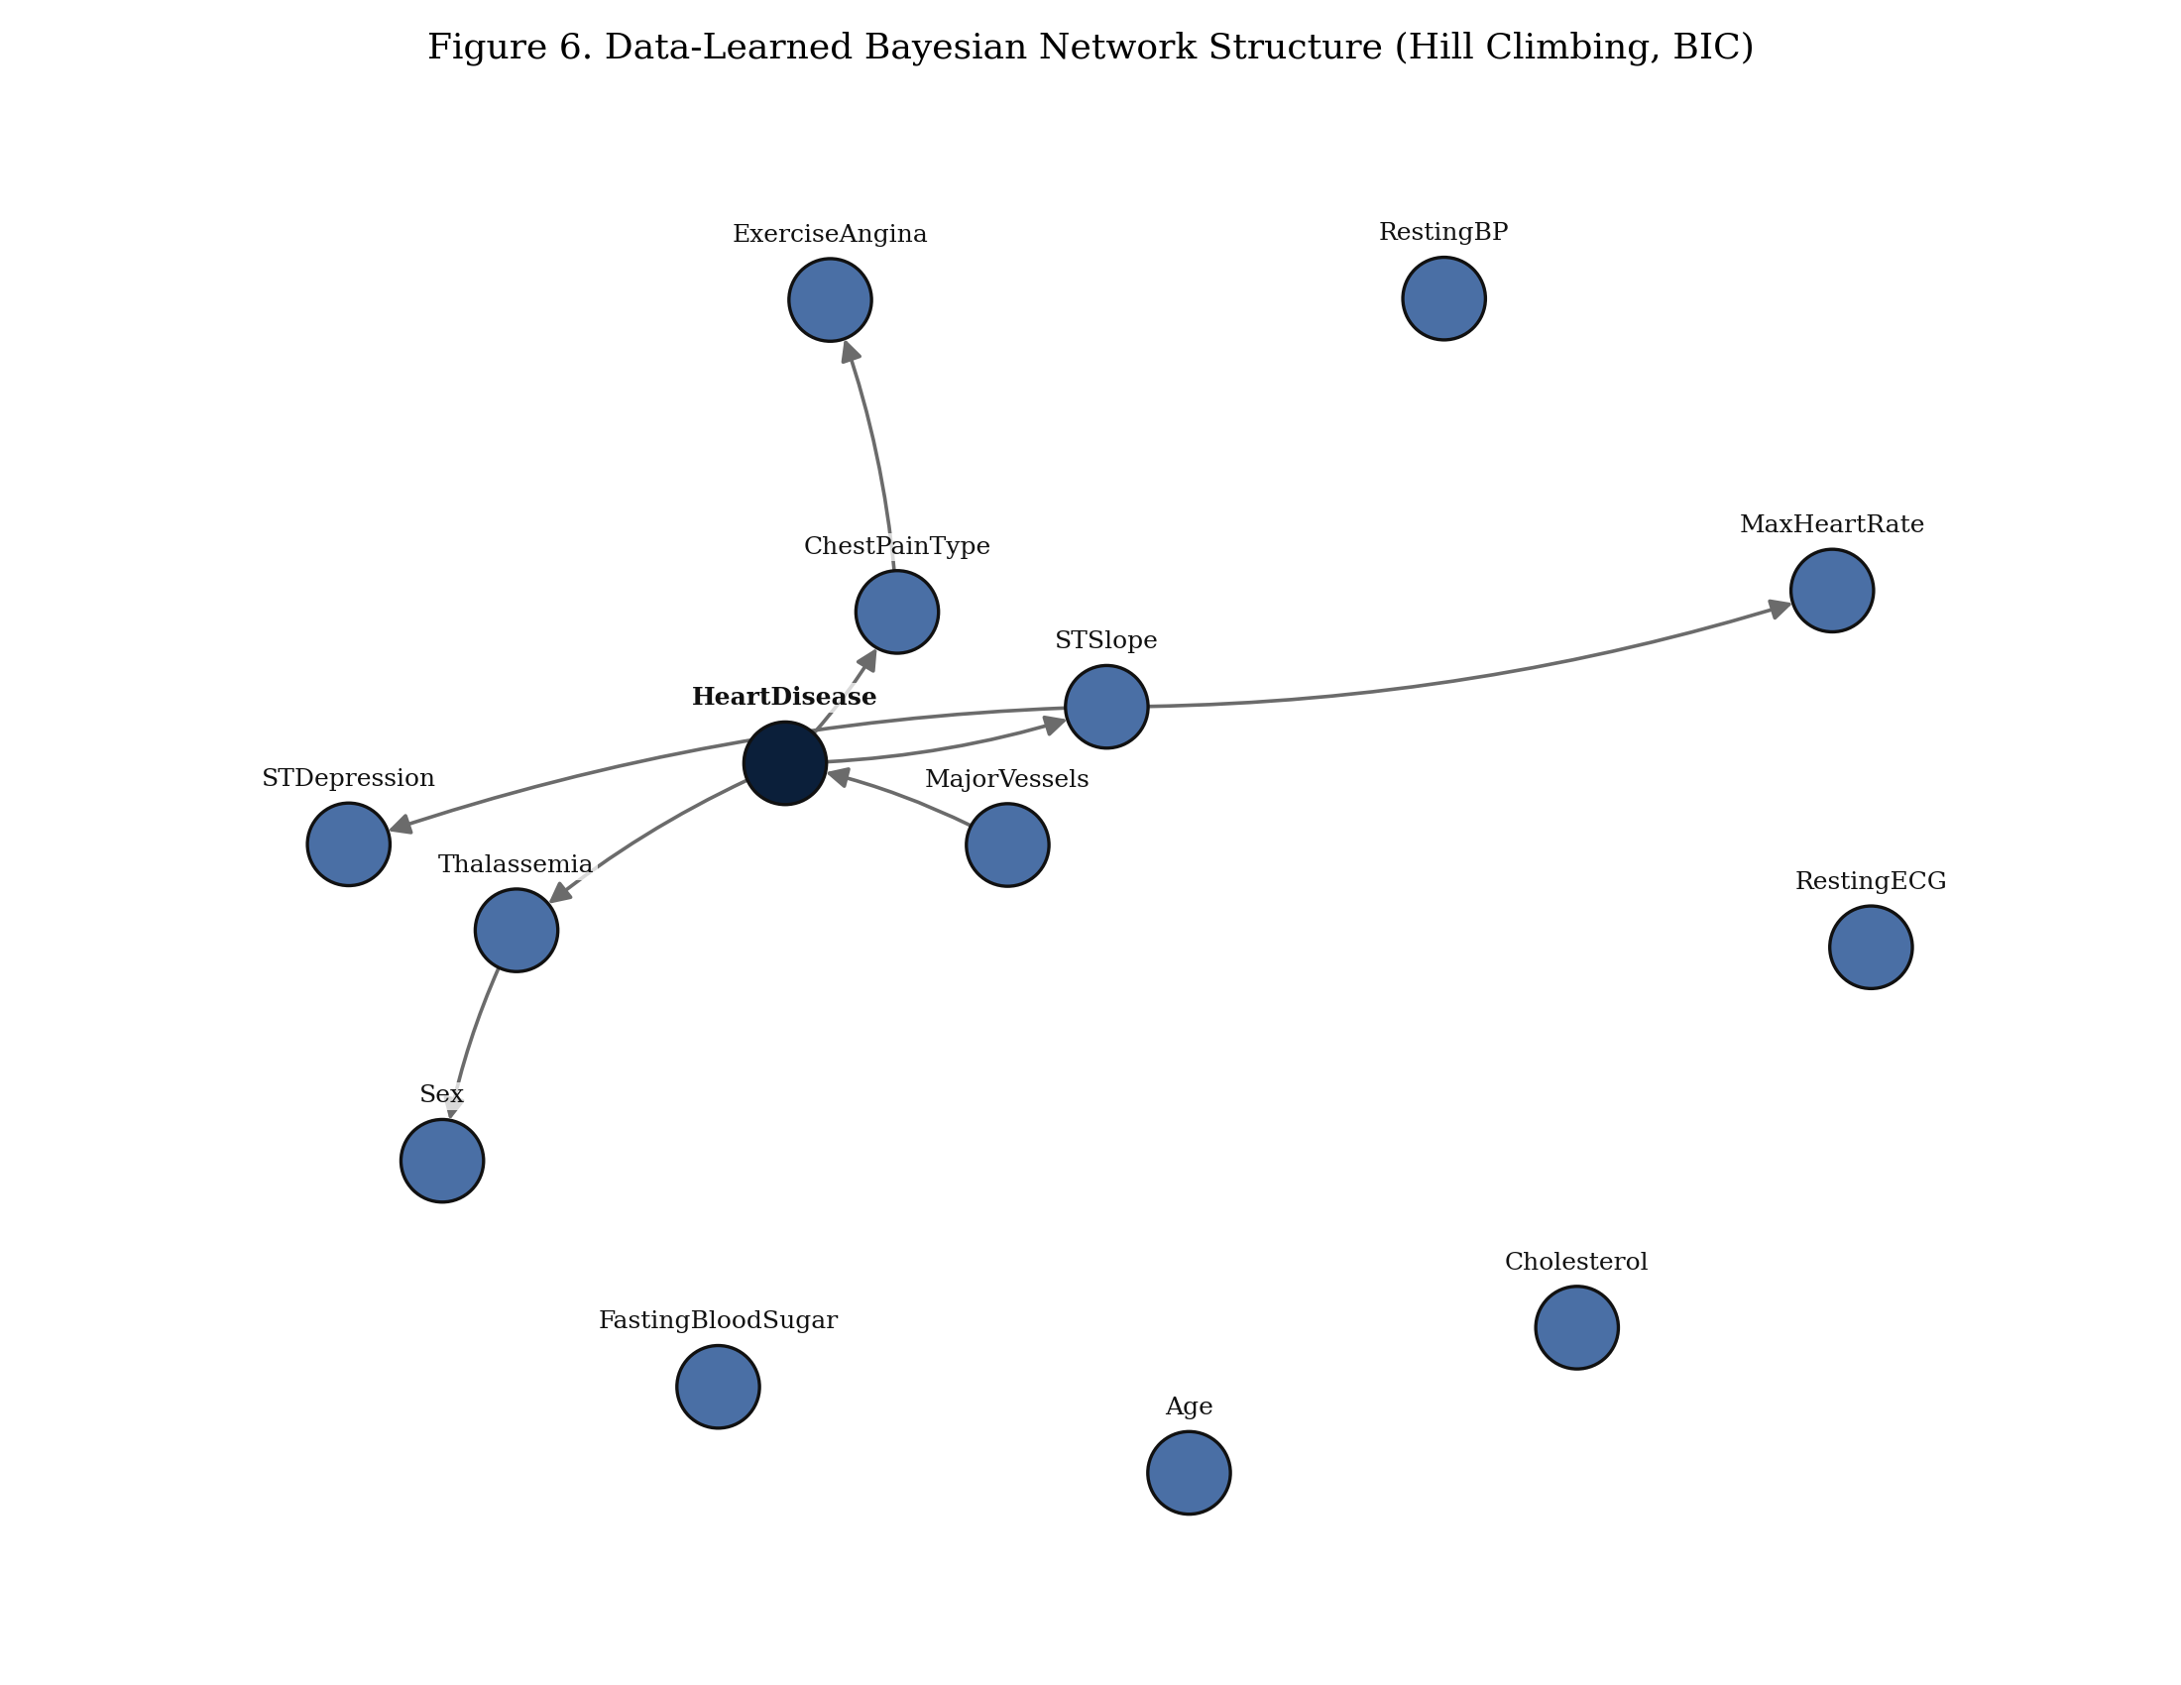
Figure 6. Data-Learned Bayesian Network Structure (Hill Climbing, BIC)

10. Probabilistic Graphical Model Pipeline
The full pipeline mirrors a standard machine learning workflow adapted to graphical models: problem definition (probabilistic risk prediction), data collection (UCI Cleveland dataset), data cleaning (verified absence of missing values), discretization in place of feature engineering, dataset splitting for the evaluation stage, structure selection (learned versus expert), parameter learning, exact inference, evaluation, and error analysis through confusion matrices.

11. Model Training and Parameter Estimation
Given a fixed structure, each Conditional Probability Table was estimated using Bayesian estimation with a BDeu (Bayesian Dirichlet equivalent uniform) prior, rather than raw maximum likelihood counts. This choice avoids zero probabilities for state combinations that are rare or entirely absent from the 303-record sample, which would otherwise make exact inference brittle whenever a query touches an unseen combination of evidence.

12. Hyperparameter Configuration
- Structure learning: Hill Climbing search, Bayesian Information Criterion (BIC) score, maximum in-degree capped at 4.
- Parameter estimation: Bayesian estimation, BDeu prior, equivalent sample size 10.
- Train/test split: 80 percent train, 20 percent test, stratified by diagnosis label, random seed 42.
- Inference timing: 20 repeated queries per method to obtain a stable mean and standard deviation.

13. Evaluation Metrics
Two families of results are reported. First, the two exact inference algorithms are compared directly on the same query, to confirm they are mathematically equivalent while differing in runtime. Second, both network structures are evaluated as diagnostic classifiers on a held-out test split using accuracy, precision, recall, and F1 score, with the positive class defined as Heart Disease present.

14. Results

14.1 Exact Inference: Variable Elimination versus Junction Tree
The same query, the probability of heart disease given asymptomatic chest pain and exercise-induced angina, was issued to both inference engines twenty times each to obtain a stable timing estimate. Table 2 reports the results.
Table 2. Exact Inference Runtime Comparison
Inference Method | Mean Query Time (ms) | Std. Dev. (ms)
Variable Elimination | 0.796 | 0.176
Junction Tree (Belief Propagation) | 11.814 | 12.091
The maximum absolute difference between the two methods' posterior probabilities was 1.11e-16, which is within floating point rounding error and confirms both algorithms are exact. Variable Elimination was consistently faster for this single-query workload, because Junction Tree construction pays a fixed upfront cost to triangulate the moralized graph and build the clique tree; for a one-off query on a moderately sized network, that setup cost outweighs Variable Elimination's simplicity. Junction Trees become the more efficient choice when many queries are issued against the same network, since the tree is built once and reused across queries.
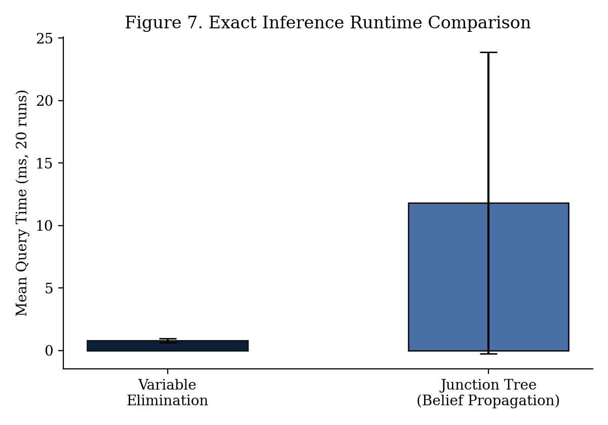
Figure 7. Exact Inference Runtime Comparison
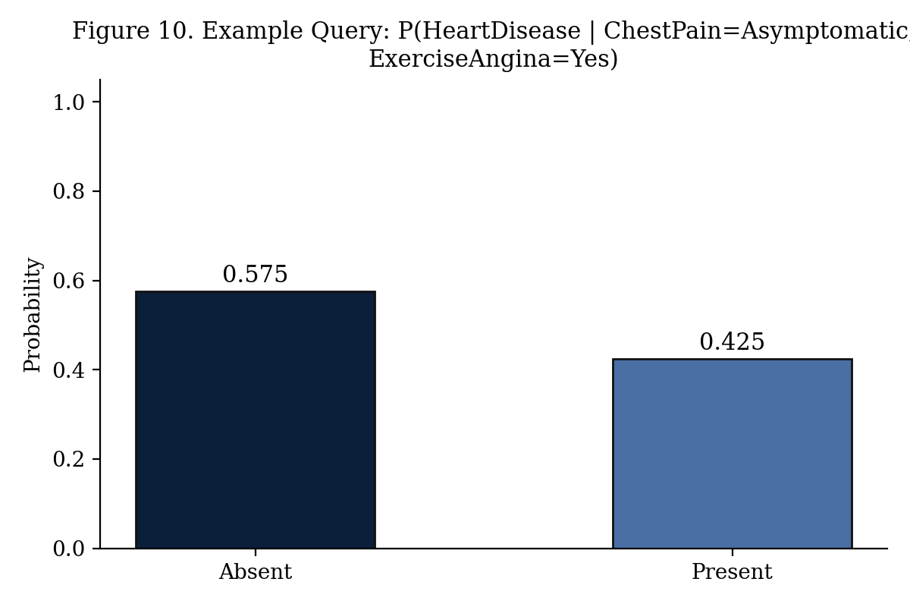
Figure 10. Example MAP Query Result

14.2 Held-out Classification Performance
Both networks were refit on an 80/20 stratified train/test split and used to predict Heart Disease for each test patient via MAP inference given all other observed attributes as evidence. Table 3 reports the resulting classification metrics.
Table 3. Held-out Classification Performance
Metric | Expert-Structured Network | Data-Learned Network
Accuracy | 73.8% | 82.0%
Precision | 74.3% | 77.5%
Recall | 78.8% | 93.9%
F1 Score | 76.5% | 84.9%
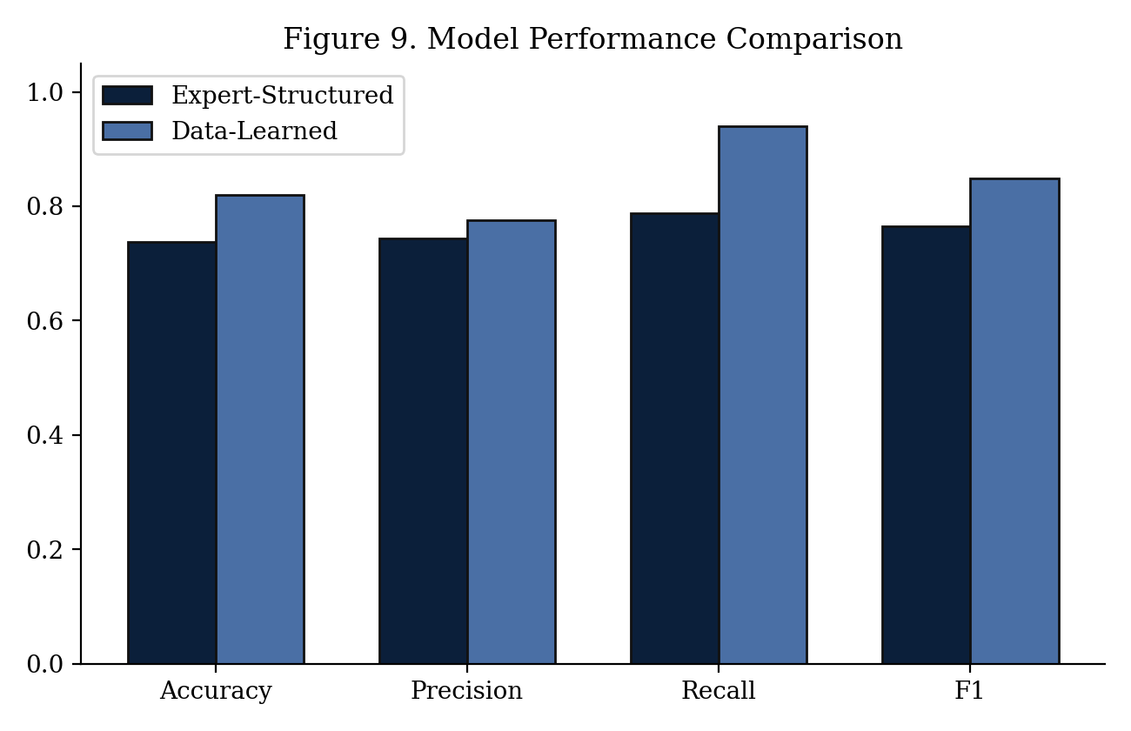
Figure 9. Model Performance Comparison
Table 4 and Table 5 report the confusion matrices underlying these metrics.
Table 4. Confusion Matrix, Expert-Structured Network
 | Predicted Present | Predicted Absent
Actual Present | 26 | 7
Actual Absent | 9 | 19

Table 5. Confusion Matrix, Data-Learned Network
 | Predicted Present | Predicted Absent
Actual Present | 31 | 2
Actual Absent | 9 | 19
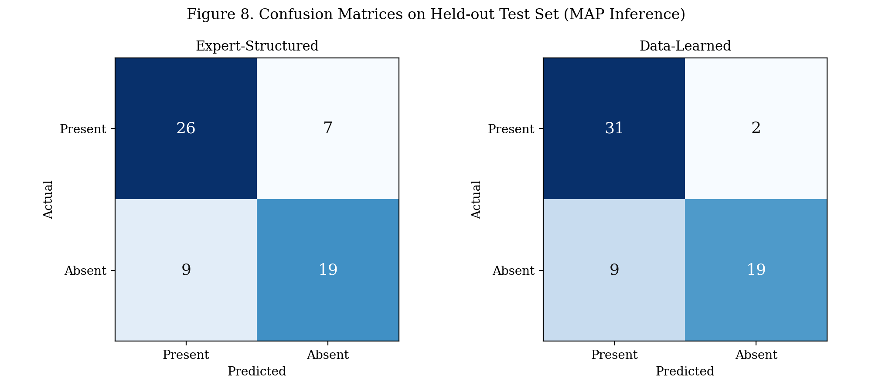
Figure 8. Confusion Matrices on Held-out Test Set

15. Discussion
The data-learned network achieves higher held-out accuracy and recall than the expert-specified network on this split (82.0% against 73.8%). This is counterintuitive given that the learned graph left several variables disconnected from Heart Disease, but the explanation is structural rather than a failure of the expert model: MAP inference in the learned network effectively ignores evidence from disconnected variables, whereas the expert network conditions on every observed variable, including ones such as Resting ECG and Cholesterol whose direct edges into Heart Disease are supported by domain reasoning but carry a weaker signal in this particular 303-patient sample. Adding noisy or high-cardinality evidence can hurt a MAP query more than it helps when the sample size is limited relative to the number of parameters being estimated.
This is a genuine bias-variance trade-off between the two approaches: the expert structure encodes richer causal assumptions but is more exposed to small-sample noise in its parameter estimates, while the learned structure is more conservative and only keeps edges the data strongly supports.

16. Limitations
- 303 patients is a small sample for learning a 14-node network with several three-to-four state variables; conditional probability tables for high in-degree nodes are estimated from very few examples per state combination.
- Discretization bin boundaries for continuous variables were chosen using standard clinical thresholds, but different boundaries could change both the learned structure and the parameter estimates.
- MAP inference used here for evaluation assumes the full patient record is available as evidence; in a real clinical decision support setting, only a subset of attributes would typically be available for a new patient.

17. Future Work
- Extend structure learning with a domain-knowledge prior that keeps Heart Disease connected as a hub, to test whether it recovers a structure closer to the expert graph while retaining the accuracy gains observed here.
- Apply k-fold cross-validation instead of a single train/test split for a more robust comparison of the two structures.
- Extend the comparison to a Markov Network representation of the same variables, connecting this project to the undirected models covered later in the course.

18. Conclusion
This project demonstrates the full Bayesian Network pipeline covered in the course: representation of a real-world diagnostic problem as a directed graphical model, structure and parameter learning from data, and exact inference using both Variable Elimination and Junction Tree propagation. The two inference algorithms were confirmed to agree exactly, while differing in runtime for single queries. The comparison between a data-learned and an expert-specified structure surfaced a concrete, explainable trade-off between domain-driven modeling and data-driven modeling under limited sample size, which is one of the central practical tensions in applied probabilistic graphical modeling.

References
Detrano, R., Janosi, A., Steinbrunn, W., Pfisterer, M., Schmid, J., Sandhu, S., Guppy, K., Lee, S., and Froelicher, V. (1989). International application of a new probability algorithm for the diagnosis of coronary artery disease. American Journal of Cardiology.
UCI Machine Learning Repository. Heart Disease Data Set. https://archive.ics.uci.edu/ml/datasets/Heart+Disease
Koller, D., and Friedman, N. (2009). Probabilistic Graphical Models: Principles and Techniques. MIT Press.

Appendix
The complete, reproducible implementation accompanies this report as three files: a consolidated Python script (heart_disease_bn_pipeline.py) that reproduces every result and figure in this report end to end, an executed Jupyter Notebook (Heart_Disease_BN_Project.ipynb) presenting the same pipeline with inline narrative and outputs, and modular source files under src/ covering preprocessing, structure learning, inference, and visualization.

