NICHOLE RM DENGA
COMPUTER ENGINEERING STUDENT
2025
ONLINE STORE DATABASE APPLICATION WITH DIAGRAMS AND DOCUMENTATION IN A PROJECT FORMAT
TOOLS USED: Microsoft Visio(erd diagrams, flowcharts,etc)
Microsoft SQL Server Management Studio
Microsoft Office

TABLE OF CONTENTS
TABLE OF CONTENTS 1
DATABASE TOPIC 3
DATABASE ASSUMPTIONS 3
DATABASE STRUCTURE 4
PROCEDURES 5
FLOWCHART 8
TRIGGERS OR PROCEDURES 11
SAMPLE DATA 13
SUMMARY 22

DATABASE TOPIC

This project is based on an online store for clothes. The project is supported by a relational database developed in SQL Server. The database was designed using normalization principles up to the Third Normal Form (3NF) to ensure data integrity, avoid redundancy, and maintain scalability. I also tried to ensure the following:

Efficient storage of products, customers, orders, payments, and shipping details.

Support secure transaction recording and reporting.

Facilitate easy querying for both business and customer activities.

Enforce data consistency through appropriate primary and foreign key relationships.
The database consists of 20 interrelated tables representing core business entities such as:
- Product Management: Products, Product Description, Promotion.
- Customer Management: Customer, Customer Address, Orders.
- Payment and Shipping: Payment, Shipping Method, Card Details.
- Data Integrity is maintained using primary and foreign key constraints.

Sample Data of 10 records per table has been inserted for testing, reporting, and demonstration.

I used the following tools as well:
- Microsoft SQL Server Management Studio (SSMS) for database design and scripting.
- Microsoft Visio for ERD design.

SQL Scripts for table creation, data insertion, and testing.

DATABASE ASSUMPTIONS
- Payment Method – only online card payments were taken into account such as Visa, PayPal etc. Assumption was all customers would only use such payment options, hence the database design.
- Shipping Method- the shipping methods are also limited to specific service providers which are partnered with the online store.
- Customer Details- Customers must provide a valid email and a single phone number during registration. Multiple emails or phone numbers per customer are not supported to avoid complexity and prevent nullable columns. This also simplifies order tracking and communication.
- No Product Variants (e.g., sizes, colors)- products are treated as unique items; variations are stored as separate products. This keeps product table structure simple while allowing for core e-commerce features.
- Single Currency Support- the system will only support transactions in one currency (e.g. USD). This simplifies pricing, invoicing, and accounting logic.
- One Address Per Customer- each customer can save one shipping address. The online store only ships to Poland hence no “country” table. This is to reduce complexity in the schema and application logic for early development.
- Orders Cannot Be Edited After Submission- once an order is placed, it cannot be modified. This ensures data integrity and prevents inconsistencies in inventory and transaction logs.
- No User Roles Beyond Admin and Customer -The system supports only two user roles: admin and customer. This simplifies access control and security policies in the early version.

NB: These assumptions are made to ensure a clean, maintainable 3NF- compliant database with minimal complexity.

DATABASE STRUCTURE

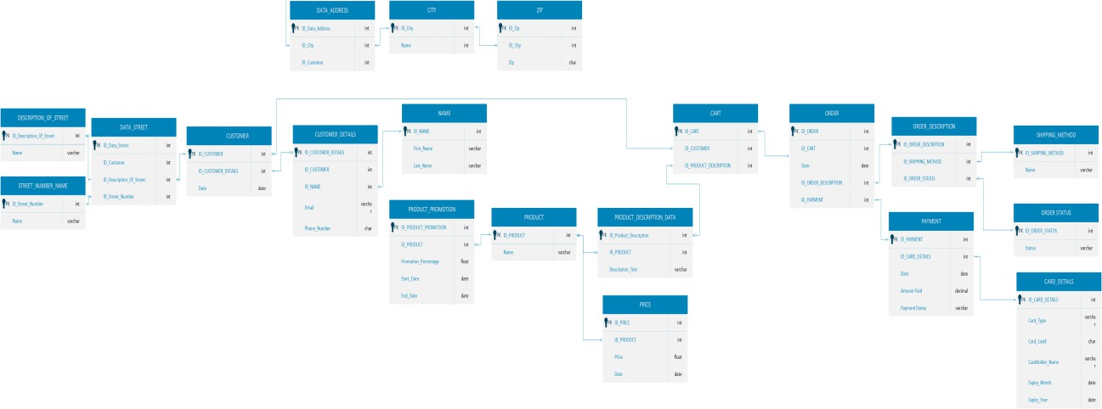

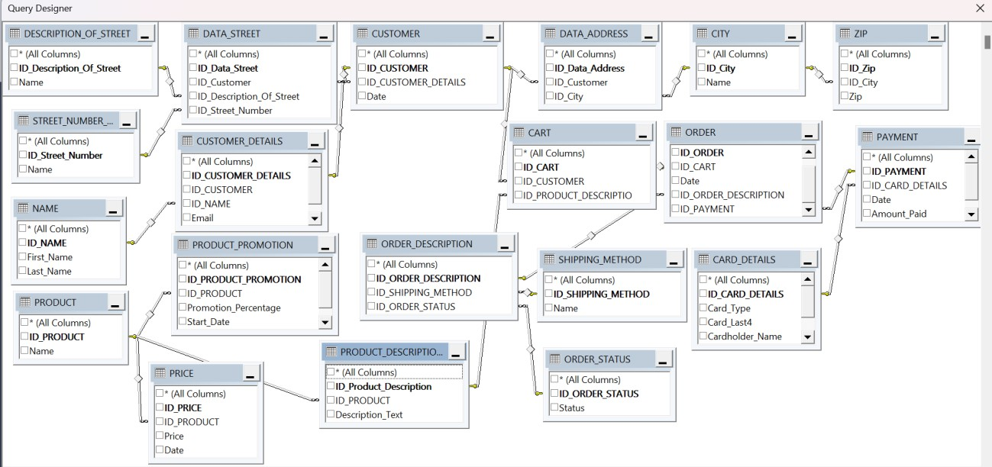

PROCEDURES

---Procedure to Add a New Product----
CREATE PROCEDURE AddProduct @ID_PRODUCT INT, @Name VARCHAR(100)

AS BEGIN
INSERT INTO PRODUCT (ID_PRODUCT, Name) VALUES (@ID_PRODUCT, @Name); END;

GO

-----Procedure to Update a Product-----
CREATE PROCEDURE UpdateProduct @ID_PRODUCT INT, @Name Varchar(100) AS

BEGIN
UPDATE PRODUCT SET Name = @Name WHERE ID_PRODUCT = @ID_PRODUCT; END; GO

----Procedure to Delete a Product-----
CREATE PROCEDURE DeleteProduct @ID_PRODUCT INT AS

BEGIN

DELETE FROM PRODUCT WHERE ID_PRODUCT = @ID_PRODUCT; END; GO

---Procedure to Add a Customer---
CREATE PROCEDURE AddCustomer @ID_CUSTOMER INT,
@ID_CUSTOMER_DETAILS INT, @Date date AS

BEGIN I
NSERT INTO CUSTOMER (ID_CUSTOMER, ID_CUSTOMER_DETAILS, Date) VALUES (@ID_CUSTOMER, @ID_CUSTOMER_DETAILS, @Date);

END; GO

----Procedure to Update a Customer---
CREATE PROCEDURE UpdateCustomer @ID_CUSTOMER INT, @ID_CUSTOMER_DETAILS INT, @Date date AS BEGIN UPDATE CUSTOMER SET ID_CUSTOMER_DETAILS = @ID_CUSTOMER_DETAILS

WHERE ID_CUSTOMER = @ID_CUSTOMER;

END; GO

---Procedure to Delete a Customer---
CREATE PROCEDURE DeleteCustomer @ID_CUSTOMER INT AS BEGIN DELETE FROM CUSTOMER WHERE ID_CUSTOMER = @ID_CUSTOMER; END; GO

---Procedure to Add an Order---
CREATE PROCEDURE AddOrder @ID_ORDER INT, @ID_CART INT, @Date DATE, @ID_ORDER_DESCRIPTION INT, @ID_PAYMENT INT

AS
BEGIN INSERT INTO [ORDER] (ID_ORDER, ID_CART, Date, ID_ORDER_DESCRIPTION, ID_PAYMENT) VALUES (@ID_ORDER, @ID_CART, @Date, @ID_ORDER_DESCRIPTION, @ID_PAYMENT); END; GO

---Procedure to Update an Order---
CREATE PROCEDURE UpdateOrder @ID_ORDER INT, @ID_CART INT, @Date date, @ID_ORDER_DESCRIPTION INT, @ID_PAYMENT INT AS BEGIN UPDATE [ORDER] SET ID_CART = @ID_CART SET ID_ORDER_DESCRIPTION = @ID_ORDER_DESCRIPTION SET ID_PAYMENT = @ID_PAYMENT

WHERE ID_ORDER = @ID_ORDER;

END; GO
---Procedure to Delete an Order---
CREATE PROCEDURE DeleteOrder @ID_ORDER INT AS

BEGIN

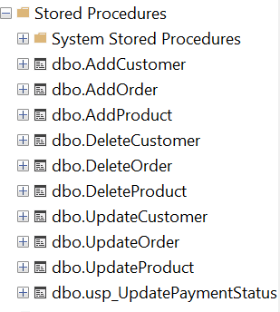
DELETE FROM [ORDER] WHERE ID_ORDER = @ID_ORDER; END; GO

FLOWCHART
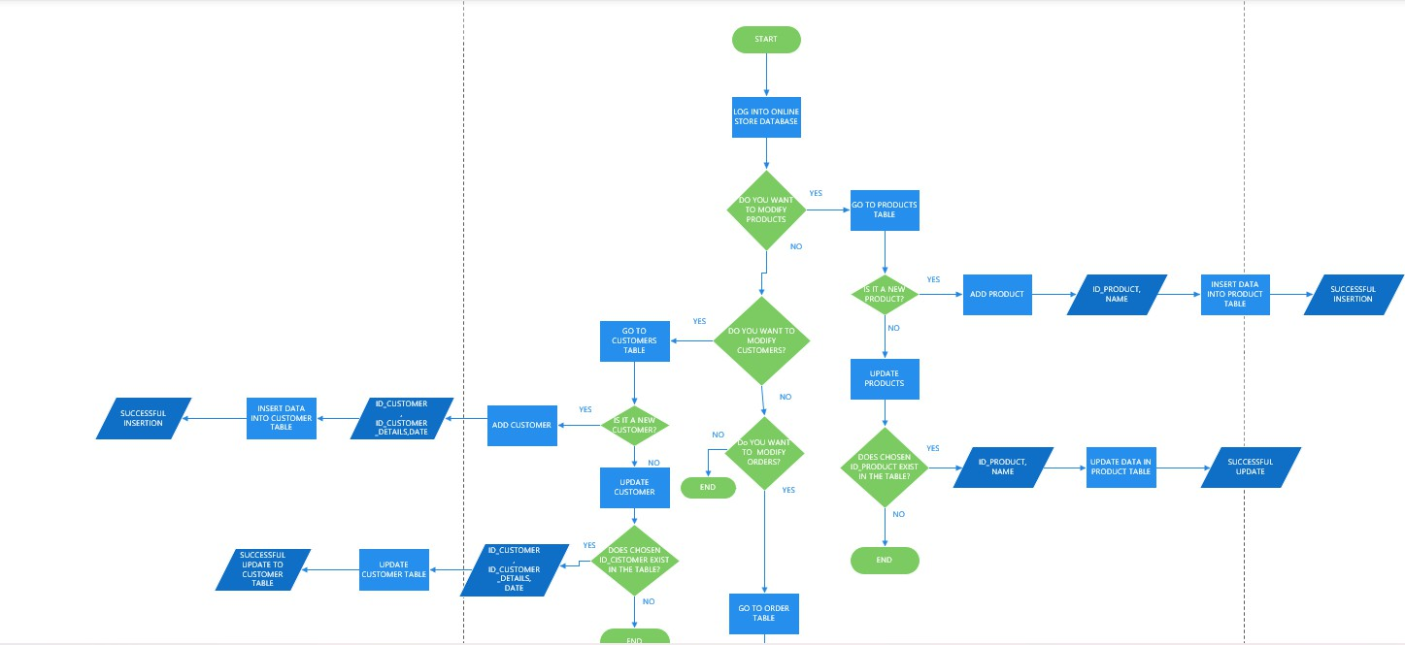
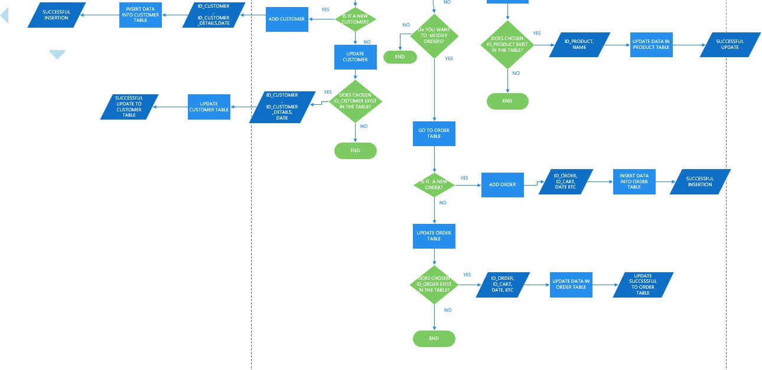

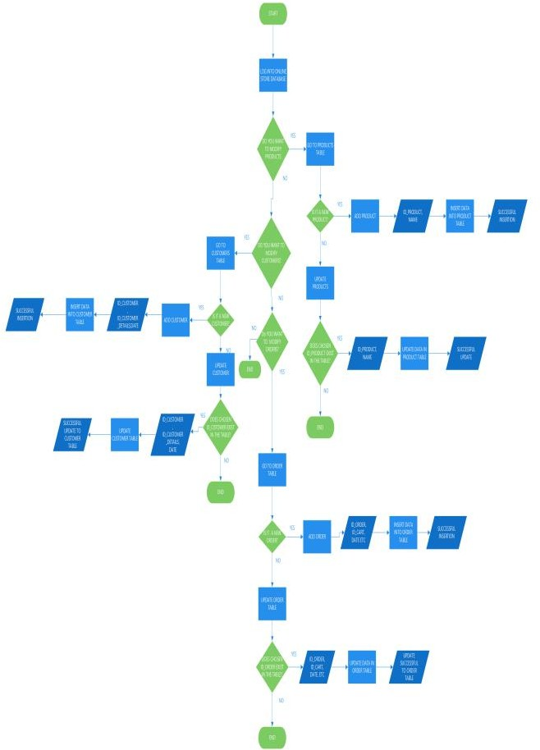

TRIGGERS OR PROCEDURES

For my online database project, I have decided to use a balanced approach which consists of both Procedures and Triggers. This is because procedures are better for explicit business actions, reports and bulk operations which may be monotonous to do manually like adding customers, updating products etc. In this way procedures are better for maintainability, clarity and control from the application layer.

In the same breath, triggers help to enforce automatic business rules in an application for audit and security reasons at the database level, independent of the application. Such as the trigger I created below for order status updates upon successful payment to ensure data integrity and security even in the case of direct table manipulation outside the application.

The below Procedure is for handling payment updates by customers.
CREATE PROCEDURE usp_UpdatePaymentStatus @PaymentID INT,
@NewStatus VARCHAR(20) AS

BEGIN

UPDATE PAYMENT
SET Payment_Status = @NewStatus WHERE ID_PAYMENT = @PaymentID;

END;

The Trigger below is created to ensure that whenever the Payment table is updated to 'Accepted', the Order is also updated automatically, even if done outside the procedure (directly in SQL).
CREATE TRIGGER UpdateOrderStatus_AfterPayment ON PAYMENT AFTER UPDATE AS BEGIN SET NOCOUNT ON;

UPDATE OD

SET OD.ID_ORDER_STATUS = (

SELECT TOP 1 OS.ID_ORDER_STATUS FROM ORDER_STATUS OS
WHERE OS.Status = 'Paid'
)

FROM ORDER_DESCRIPTION OD

INNER JOIN [ORDER] O ON O.ID_ORDER_DESCRIPTION = OD.ID_ORDER_DESCRIPTION

INNER JOIN INSERTED I ON O.ID_PAYMENT = I.ID_PAYMENT
WHERE I.Payment_Status = 'Accepted';

END;

The following is a Test of the above trigger to ensure that the trigger works correctly. This ensures data consistency between payments and orders without manual intervention. It demonstrates the automation of business rules at the database level, which prevents inconsistencies, especially if someone updates the payment status directly through SQL or an external application.

SELECT * FROM PAYMENT WHERE ID_PAYMENT = 1; SELECT OD.* FROM ORDER_DESCRIPTION OD JOIN [ORDER] O ON OD.ID_ORDER_DESCRIPTION = O.ID_ORDER_DESCRIPTION WHERE O.ID_PAYMENT = 1;
UPDATE PAYMENT SET Payment_Status = 'Accepted' WHERE ID_PAYMENT = 1;

SELECT OD.* FROM ORDER_DESCRIPTION OD JOIN [ORDER] O ON OD.ID_ORDER_DESCRIPTION = O.ID_ORDER_DESCRIPTION WHERE O.ID_PAYMENT = 1;

This trigger below will prevent the deletion of any order where the related order status is 'Paid' (assuming ID_ORDER_STATUS = 2 is 'Paid' in your system)
CREATE TRIGGER trg_PreventDeletePaidOrder ON [ORDER] INSTEAD OF DELETE AS BEGIN -- Check if the order(s) being deleted have status 'Paid' IF EXISTS ( SELECT 1 FROM deleted d JOIN ORDER_DESCRIPTION od ON d.ID_ORDER_DESCRIPTION = od.ID_ORDER_DESCRIPTION WHERE od.ID_ORDER_STATUS = 2 -- 'Paid' status )
BEGIN -- Prevent the delete by raising an error RAISERROR ('Cannot delete orders with Paid status.', 16, 1); ROLLBACK TRANSACTION; END ELSE BEGIN -- Allow delete for non-paid orders DELETE FROM [ORDER] WHERE ID_ORDER = (SELECT ID_ORDER FROM
deleted); END END; GO

The following code tests the above trigger
DELETE FROM [ORDER] WHERE ID_ORDER = 1; -- If this order is 'Paid'
DELETE FROM [ORDER] WHERE ID_ORDER = 2; -- If this order is not 'Paid'

SAMPLE DATA

The following screenshots are of sample data from the 20 tables I created for my Online Store.
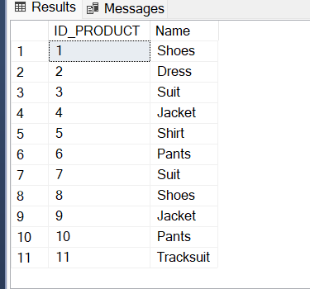
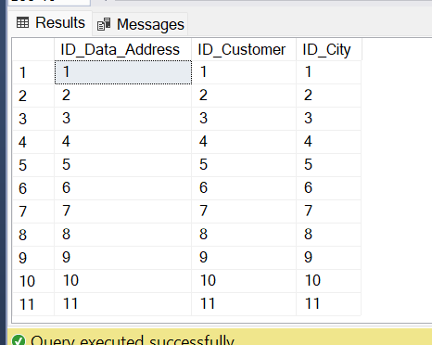
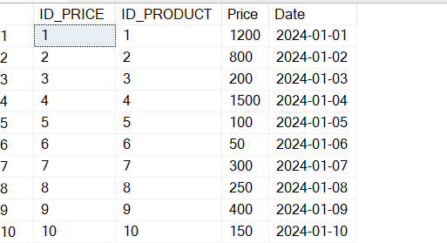

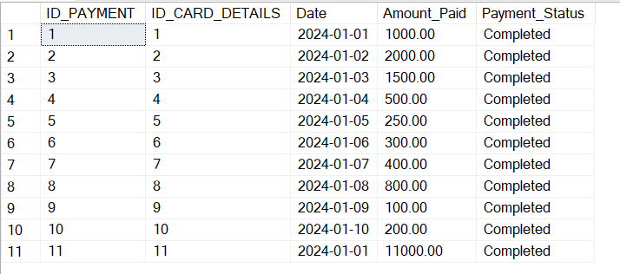
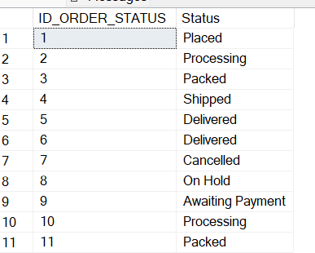

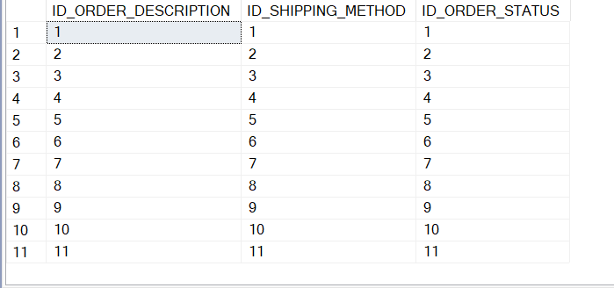
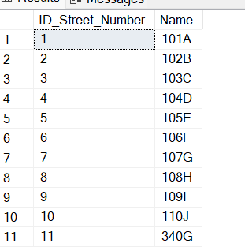
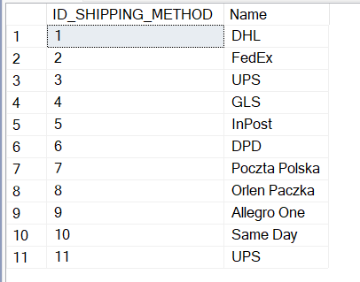
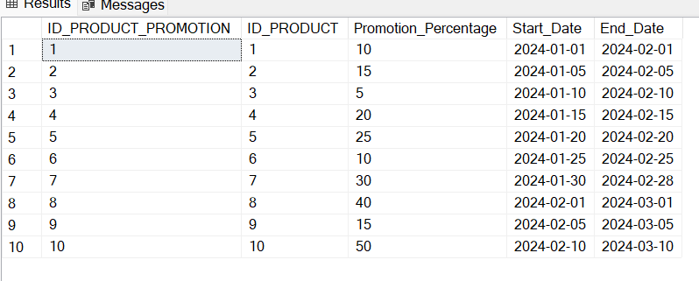
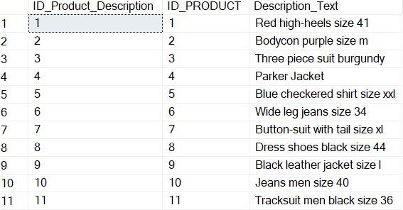
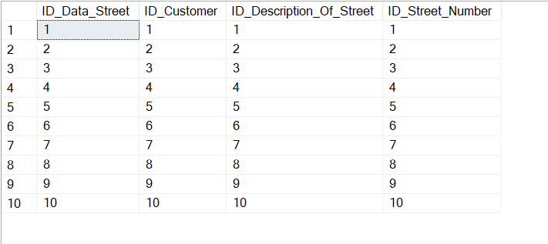

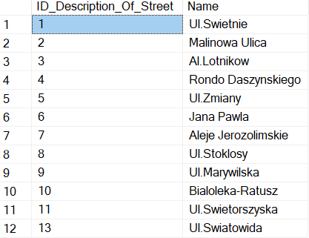
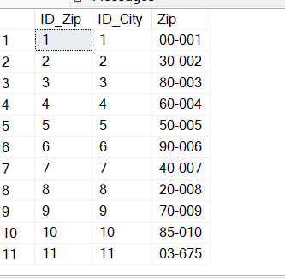
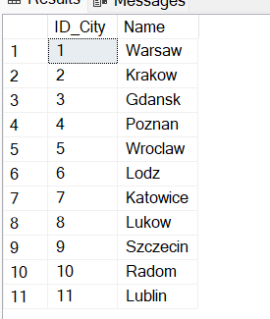
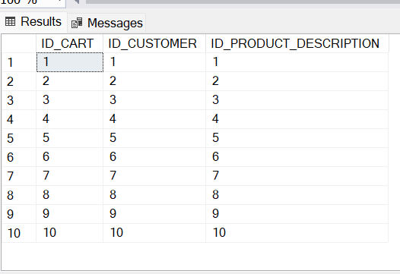
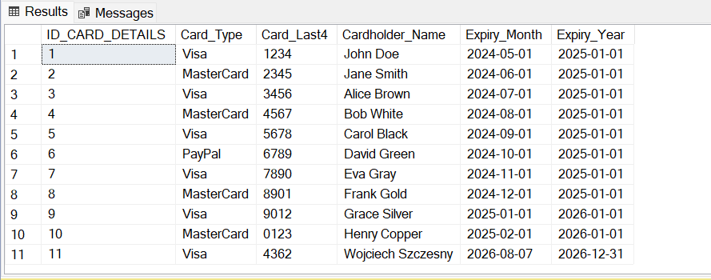
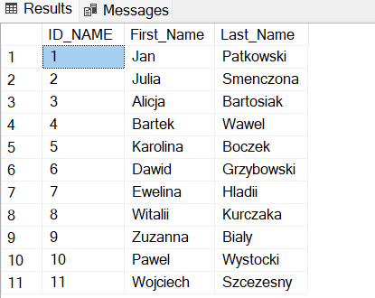
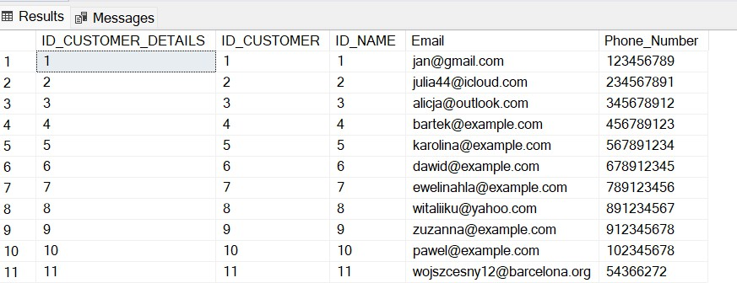

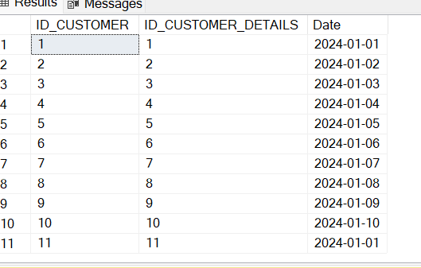

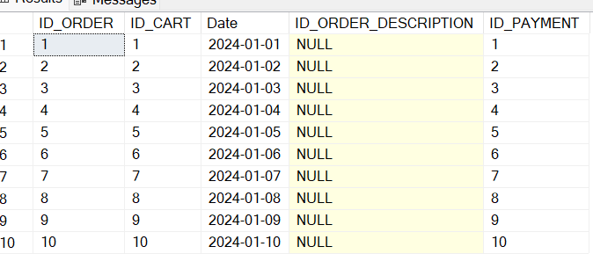

SUMMARY
In this project, I developed a simple but functional Online Store Database System designed to manage key operations such as customer management, order processing, payments, and product management. The project started with the design and creation of the database structure, ensuring that the system followed normalization principles in particular third normal form and proper entity relationships to maintain data integrity and avoid redundancy. As well as the creation of procedures for adding and updating data and a flow chart to illustrate how these procedures work as well as triggers to ensure data integrity and security. Lastly, I captured sample data of my tables for my online store. Some challenges I faced included data complexity and data duplication in some instances which are bound to occur.

