IMDb Review Sentiment Classification: A Deep CNN Based LSTM with Combined Kernels Approach

Alec Yenter
College of Engineering and Computer Science
California State University
Fullerton, California
alecyenter@csu.fullerton.edu
Abhishek Verma, Ph.D.
College of Engineering and Computer Science
California State University
Fullerton, California
averma@fullerton.edu

Abstract—Deep learning neural networks have made significant progress in the area of image and video analysis. This success of neural networks can be directed towards improvements in textual sentiment classification. In this paper, we describe an approach to sentiment analysis through the use of a multi-kernel convolutional neural network (CNN) with Long Short-term Memory (LSTM) layers. The combination of these two neural network schemes produces a model with the highest reported accuracy on the Internet Movie Database (IMDb) Review Sentiment dataset.
Additionally, we present multiple architecture variations of our proposed model to illustrate our attempts to increase accuracy while minimizing overfitting. We experiment with numerous regularization techniques, network structures, and kernel sizes to create 5 high-performing models for comparison. These models are capable of predicting the sentiment polarity of reviews from the IMDb dataset with an accuracy above 89%. The capability of the Combined-Kernel CNN based LSTM architecture could also be lucrative towards other datasets for sentiment analysis or simply text classification. Furthermore, the proposed model may have potential in machine learning in video and audio.
Keywords—IMDb; sentiment analysis; text classification; neural network; CNN; LSTM;

Introduction
With an ever increasing production of films, there is an excess of reviews and opinions of movies. Analysis of these sentiments becomes extremely useful to helping people organize and choose movies. Classification of review sentiment helps extract meaningful information from opinions and is a critical portion of analysis.
There are three different levels to sentiment analysis: document level, sentence level, and aspect level [9]. This paper focuses on document level where the entirety of each review is classified as positive or negative. Additionally, learning can be supervised or unsupervised. Since our chosen IMDb review sentiment dataset has labels, this paper utilizes supervised machine learning.
Neural networks have become a popular approach to a variety of problems that require a complex solution, such as computer vision and speech recognition. GoogLeNet [10], ResNet [12], and VGG-16 [13] are all powerful networks that have made leaps of progress in image/video classification. The further advancement of the aforementioned models in [14], [15], and [16] prove that there is still improvement possible in neural networks. This paper builds a simpler neural network towards text classification in sentiment analysis. While textual classification can be processed on a letter level [4], our proposed model centers on word level learning.
Our network combines ides from multiple networks. A portion of the proposed network resembles a single module from the GoogLeNet Inception model in [10]. This portion uses multiple branches of convolution. The network also incorporates recurrent neural layers. The resulting model outperforms other machine learning models on the same movie dataset.
The rest of this paper is organized into six main parts. Section II presents the basic sections of the network and reviews related literature in the field of text classification. Section III defines the details of the IMDb review sentiment dataset. Section IV presents the detailed structure of the model layer by layer. Section V describes the specific configuration of the model that results in the highest accuracy. Section VI discusses the results and challenges. Section VII concludes the paper.

Background
To build a context to the paper, the following sections review related literature of neural networks and text classification.

Neural Networks (NN)
Groundbreaking progress in machine learning has been made through the use of neural networks. The ability for a neural network to imitate the brain’s processes is a valuable method for problems in textual, visual, and other signals. The basics for neural networks are layers each with a specific number of nodes. Input data is the first layer and connections are given to the next layer. This is repeated until the final layer, where the output is produced. There are multiple types of networks and layers; in this paper, we will specifically use three layers: Fully-Connected Layers, Convolutional Layers, and LSTM layers.

Fully-Connected (Dense) Layers are simple layers where every neuron from the previous layer is connected to every neuron in the dense layer [11]. These layers can do basic learning while reshaping the input data, for instance reducing the output to one neuron.

Convolutional Neural Networks (CNN) are a specific type of neural network that can work well with spatial data. CNNs are particularly useful with images for tasks such as classification. Convolutional layers use only certain connections from previous layer; specifically, local neurons are connected to the neurons of the next layer [11]. This method causes the layer to gain more of an understanding of the genreal view of the inputs.

Long Short-Term Memory (LSTM) is a type of Recurrent Neural Network (RNN). RNN neurons have a connection to the previous neuron state in addition to the layer inputs. RNNs are particularly benefitial to data that is sequential or that can value a contextual view; therefore, RNNs can be impressive in text classification [19]. LSTMs are a form of RNNs where newer information in the neurons is more critical than older information [12]. LSTMs have been useful in deep learning on video footage in [17] and [18] because of films sequential nature. Similarly, they are useful on sequential text data, because, while LSTM can incorporate the context of a parargraph and/or a sentence, the most recent words hold the most weight on the current neuron state.

Neural Network Text Classification
When given textual data, a typical objective is to classify the information for analytical or statistical purposes. Reference [20] categorize text, while [21] and [22] performed sentiment classification, all on social media datasets using neural networks. References [2] and [23] used and compared multiple machine learning techniques on the sentiment analysis of movie review. [2] compared multiple n-gram machine learning approaches on the same IMDb review sentiment dataset used in this paper. The data was preprocessed before being vectorized and fed into various configuration of machine learning algorithms. Many of these techniques in [2] reached high accuracies in the 80% with the best configuration “Unigram + Bigram + Trigram” reaching the maximum accuracy of 88.94%.
While there are many useful mathematical algorithms, this paper focuses on neural network approaches to textual classification. These approaches have been split into character-level classification and word-level classification for the following discussion.

Character-Level Text Classification is a newer approach that focuses on the letters of the text. This approach has the benefit of avoiding the need for a dictionary or an understanding of the language, but instead defines an albhabet for the data. [4] explored the use of charater-level convolutional networks for classification of textual documents. The use of the sequence of letters as a signal sequence produced comparable results to other methods such as word-level classification. [4] developed a neural network of nine layers: six convolutional layers followed by three fully-connected layers. These layers were accompanied my max-pooling layers to help the nework handle the nine-layered depth.
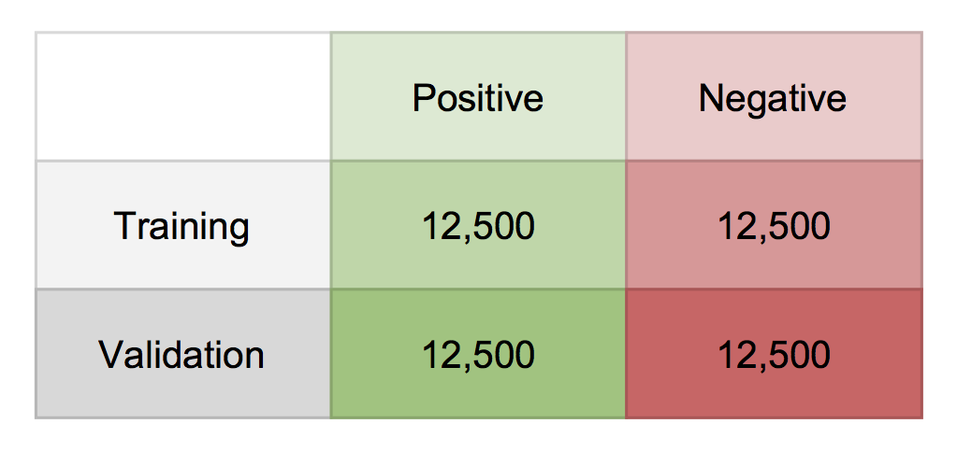

[6] built onto character-level text classification by using a CNN to produce a form of word embedding from the character inputs of a word. For each word, letter embeddings are concatenated along axis 1, convoluted through multiple kernels, and finally pooled and concatenated into a flat layer. The last layer produces a representation of the word that is fed through a highway network to a LSTM network for classification. The benefit of this hybrid method is that no dictionary is needed, yet the network learns on a word-level basis that shows a human-like understanding of the language.

Word-Level Text Classification is a more traditional method to text classfication with neural networks. [5] created a shallow CNN that classifies using multiple different kernels. In this network, a convolutional layer will look at n words at a time when applying the filters and pooling-over-time. The network would use multiple kernel sizes and concatenate the results; therefore, the network finds context from the n number of words nearby the word. The final connected layer uses this information for classification. This network is simple but effective in textual classification.
[1] uses IMDb review data with a new LSTM neural network to classify sentiment of the review. The review data contained no neutral data. The dictionary was limited to the top 2000 most used words and each review sequence was capped at 100 words and padded with zeros if less than the max. The proposed LSTM layer is a biologically-inspired additive version of a traditional LSTM that produced higher loss stability, but lower accuracy. The best accuracy achieved between both LSTM models was still under 85%. The use of an LSTM on textual data gives better contextual view of words than a CNN.

Description of Dataset
The ACL Internet Movie Database (IMDb) dataset used was created in [3] for learning word vectors. The dataset consists of 100,000 textual reviews of movies; half (50,000) of the reviews are for testing and have no label. The other (50,000) reviews are paired with a label of 0 or 1 to represent negative and positive sentiment, respectively. These labels were linearly mapped from the IMDb’s star rating system where reviewers can rate a movie a certain number of stars from 1 to 10. The labeled reviews are split 50/50 into training and validation data. Each set has 12,500 positive reviews and 12,500 negative reviews to keep the data balanced.
There is at most 30 reviews for any one movie. Each review can have anywhere from min to max number of words. The mean number of words is 234.76 with a standard deviation of 172.911495 words. Certain punctuation and symbols are included, such as “?”, “!”, and “:(“. Collectively, the dataset contained 88,585 different words across all reviews.
The deep learning library Keras provides a simple import method to retrieve these reviews in a preprocessed format. The function grabs the reviews and encodes them into a sequence of word indices according to a dictionary of the D most frequently used words in the dataset, where D is given. For further flexibility, the indices are ordered by the frequency of the words, such that the word mapped to index 2 is the 2nd most common word in the dataset. Index 0 is reserved for unknown words that are not in the dictionary. The reviews are then padded to fit a desired maximum sequence length; longer reviews are truncated and shorter reviews are padded with zeros. As a final step, the first layer of the neural network converts the indices to embeddings of E dimension.
For this paper’s experiments, the dictionary was capped at 5,000 words with a maximum padded sequence length of 500 words. The indices were embedded into 32 dimensions.

Methodology
The proposed method in this paper utilizes a CNN and a LSTM on word-level classification of the IMDb review sentiment dataset. The method combines versions of the networks from [5] and [1]; the proposed network has multiple branches that accept the data and perform convolution. The output of the CNN layers is fed into an LSTM similarly to the method proposed in [6] before being concatenated and sent to a fully-connected layer in order to produce a single, final output. The network is trained and tested in mini-batches between 16 and 128. The network is largely inspired by the Keras’s own text classification example.

Embedding
Positive Example:
Although this was obviously a low-budget production, the performances and the songs in this movie are worth seeing. One of Walken's few musical roles to date. (he is a marvelous dancer and singer and he demonstrates his acrobatic skills as well - watch for the cartwheel!) Also starring Jason Connery. A great children's story and very likable characters.

Negative Example:
Not only is it a disgustingly made low-budget bad-acted movie, but the plot itself is just STUPID!!!
A mystic man that eats women? (And by the looks, not virgin ones)
Ridiculous!!! If you´ve got nothing better to do (like sleeping) you should watch this. Yeah right.

The first layer of the network accepts the input reviews as a sequence of indices and embeds each word into a vector of a specific size e. (e.g. a vector of 500 word indices embedded at 32 becomes 500 vectors of length 32). The embedding layer is a matrix of trainable weights that, through matrix multiplication, produce the vectors for each word index. Therefore, during training, the embedding layer improves on the embeddings of each word.

Convolution
The output of the embedding layer is given to each branch of b branches. Each branch starts with a 1-dimensional convolution layer of kernel size c specific to that branch. The kernel during 1-dimensional convolution is of shape kernel size by embedding size (c x e). The kernel will then preform convolution on whole words instead of the typical 2-dimensional convolution that would filter partial widths and cut words into pieces. The layer produces multiple outputs with the use of multiple filters f.
The purpose of the CNN layer is to view word combinations of the kernel size c. The result is an understanding of words when used with other words. For example, when c=3, the layer views 3 words at a time and, therefore, establishing a sense of 3-word combinations. This layer’s output has a shape of input height by filters (words by f).

Activation
Each branch applies a rectified linear unit (ReLU) activation of the CNN layer’s output; this layer replaces any negative outputs with zero. The ReLU layer is used in order to introduce non-linearity into the network. The output of this layer is the same shape as the input shape.

Max Pooling
Each branch undergoes 1-dimensional max pooling following ReLU activation; this layer converts each kernel size of the input into a single output of the maximum observed number. The result is a reduced, down-sampled version of the input. The purpose of the layer is to reduce overfitting, while allowing for further processing. Similarly to the CNN layer, the 1-dimensional max pooling kernel shape is fit to the width of the data, so that the parameter kernel size p implies a kernel shape of p by data width. This technique allows pooling to be applied with the understanding that data is composed of whole words. The output of this layer is a reduction in height according to kernel size p (input height ÷ p) .

Dropout
After max pooling, each branch goes through a dropout layer; this layer randomly sets a portion of the inputs to 0. The dropout is applied to specified d fraction of the inputs. This layer serves to prevent overfitting and generalize the network to not focus on specific pieces of input. The output shape is equivalent to the input shape.

Batch Normalization
The next layer for each branch is batch normalization; this layer simply normalizes the distribution for each batch after dropout. The purpose of batch normalization is to reduce internal covariate shift and therefore lead to convergence at a faster rate. The output of this layer holds the same shape as the input.

LSTM
The final layer for each branch is a LSTM layer with a specified number of units l. The LSTM is used because of the nature of sequential data. The layer’s persistence allows knowledge of previous input (convoluted word combinations) to influence subsequent input. The output has a length of the number of units l.

Concatenation
The branches are finally merged together through concatenation. The LSTM layers’ outputs are combined together in an array. The output shape of this layer is equal to the summation of the output of all the branches (l x b) .

Dense
The last layer is a fully-connected layer from the concatenated input to a single output. The layer is followed by a simple sigmoid activation function to conform the output between 0 and 1. The final yield is a single output.

Loss Function and Optimizer
The network is compiled with a binary crossentropy loss function; this loss calculates loss with two classes (0 and 1). For this paper’s purposes, 0 represents negative sentiment and 1 represents positive sentiment. The loss is calculated on the single and final output of the dense layer.
The network is also compiled with an optimizer; Adam, RMSprop, and SGD were the optimizers used for testing during the experiments. Each optimizer was used with varying learning rates and learning rate decay parameters.
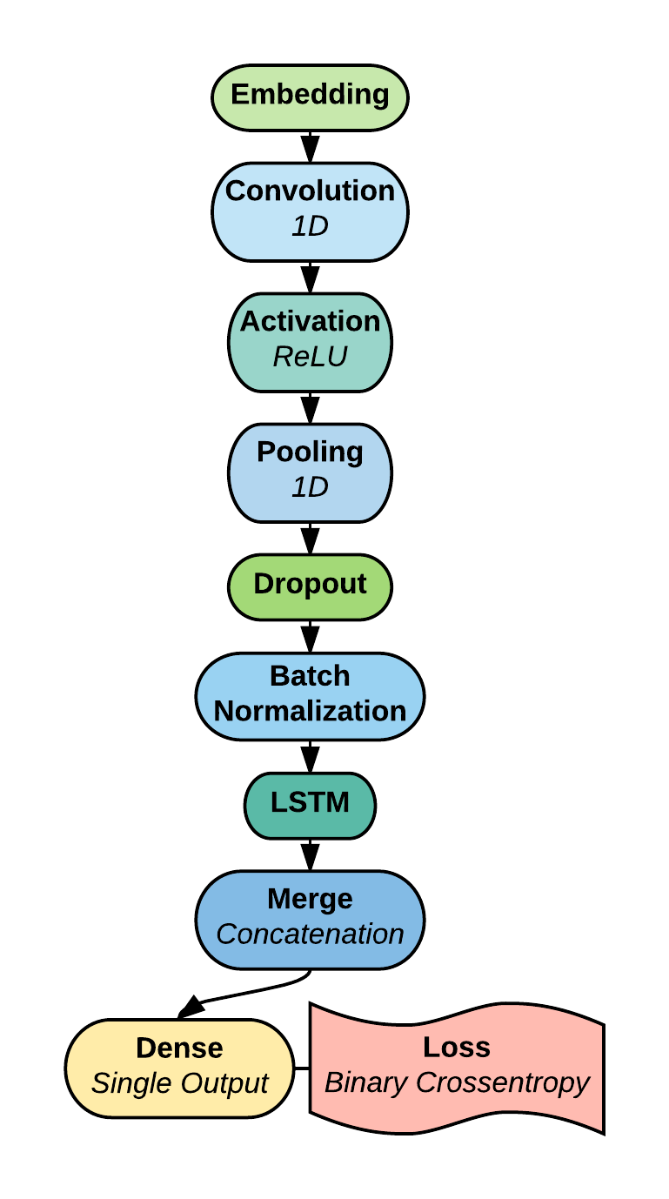

Experimental Setup
The hardware used for experimenting different networks was a dual Intel Xeon E5-2690 v3 2.60GHz processors (24 physical cores / 48 logical cores) with a single NVIDIA GeForce GTX TITAN X GPU with 12 GB of VRAM and a 256 GB SSD hard drive. The machine ran Keras 2.0.4 on Ubuntu 14.04.5 using TensorFlow 1.1.0 backend on the GPU. The network was constructed and compiled using the Keras sequential model.
Many experiments were attempted to determine the appropriate parameters and network structure. The IMDb review sentiment dataset was used for all experiments. The dataset was preprocessed to a dictionary size of 5,000 words with a zero-padded maximum sequence of 500 words per a review; anymore data became insignificant to the networks objective. The best network used a batch size of 128. The following sections establish the best parameters approximated by the experiments.

Embedding
An embedding size of 32 best fit the dataset. Attempts to use GoogleNews word2vec pre-trained embeddings from [7] and Wikipedia fastText pre-trained embeddings from [8] (as untrainable word embeddings) proved to have no positive effect.

Convolution / Activation
The largest alterations where determined by the number of branches to be used; this was directly tied to the kernel sizes used. The optimal 1-dimensional kernel sizes where three, five, seven, and nine; therefore, four branches. Viewing words in these kernel sizes proved to extract the most critical information and produce higher accuracy. The optimal number of filters was found to be 128. Additionally, the convolutional layer was accompanied by a ridge regression (l2) kernel regularizer to help prevent overfitting. The l2 parameter was set to 0.01.
The ReLU activation layer proved crucial to reaching a higher accuracy. This layer has no parameters.

Max Pooling / Dropout / Batch Normalization
Although max pooling assisted with the chief issue, overfitting, large pooling sizes proved to decrease accuracy. The optimum kernel size during the experiments was 2; reducing the height of the input by half.
The dropout layer was recognized to be the best option to reduce overfitting. The dropout was set at a rate of 0.5 to force other weights to help generalize the network. While slowing convergence, this method led to higher accuracy and a better understanding of the data.
Batch normalization was added to the network to help with overfitting with the LSTM network. This layer has no parameters.
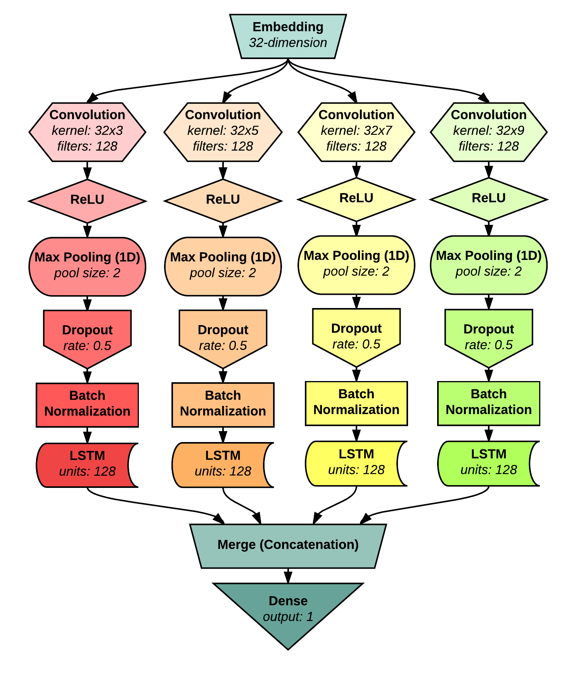

LSTM / Concatentaion / Dense / Optimizer
Each branch’s LSTM layer has 128 units. Any less or more units reduce accuracy or increase overfitting. The merging layer and dense layer have no tuning parameters. While the optimizer did not have a profound effect, RMSprop showed the best results. The learning rate was increased to 0.01 and the learning rate decay was set to 0.1. These parameters reached the highest overall accuracy.
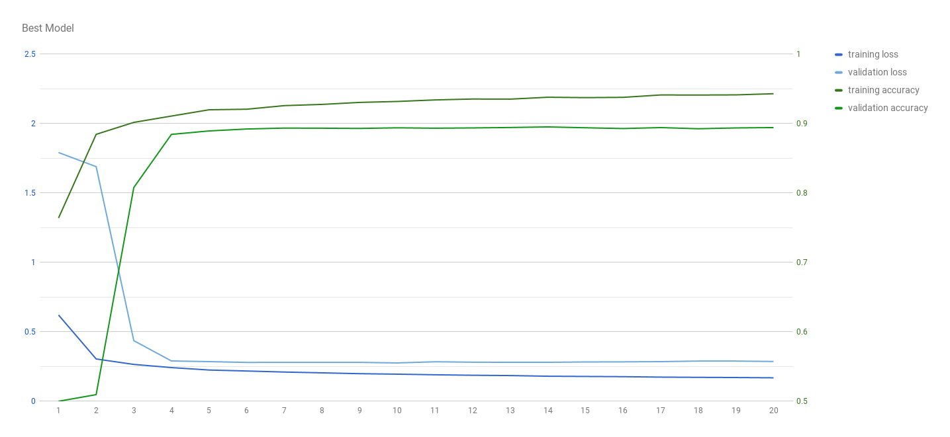

Results and Analysis
The proposed network and parameters reached just over 89.5% accuracy. This accuracy was achieved despite the main challenge of overfitting. Many models and variations were tested to attempt to reduce overfitting and generalize the learning.

Accuracy
The achieved accuracy of 89.5% surpassed other models’ results on the same IMDb review sentiment dataset. Both the traditional and the proposed LSTM models in [1] plateaued at an accuracy just over 80%, with a maximum under 85%. The accuracy in [1] was used as a baseline accuracy for a simple, lone LSTM model. Our model’s performance can also be compared to other machine learning methods. Reference [3] proposed a hybrid supervised-unsupervised model when they created the IMDb review sentiment dataset. Their highest reported accuracy was 88.89% from their full model with additional unlabeled reviews and bag of words vectors. Reference [2] experimented with multiple variation of machine learning models on the IMDb dataset. The best accuracy achieved in [2] was 88.94% from their combined Unigram-Bigram-Trigram model. From reviewing these other machine learning models, it is clear that our proposed method is comparable and effective.

Overfitting
During the experiments, overfitting became the primary issue. Within a few epochs, 80% was easily achieved in most networks. However, the networks would begin to memorize the data and overfit. Graph X shows the accuracy comparison of multiple tested networks from epoch 3 to epoch 10 and overfitting is obvious of most models after epoch 4.

Layers were able to help recude overfitting; these included Max Pooling, Dropout, and Normalization. By rducing dimensionality, max pooling assisted with generalizing the learning process; max pooling performed best at a size of 2 (1-dimensionally) across all networks. Dropout layers were assessed at different locations in the network. They were found to be most helpful after max pooling and before batch normalization or, in some cases, after concatenation of all the layers. Dropout was typically found to be helpful at a rate higher than or equal to 0.5. Batch normalization was found to always be helpful in both increasing accuracy and reducing overfitting.

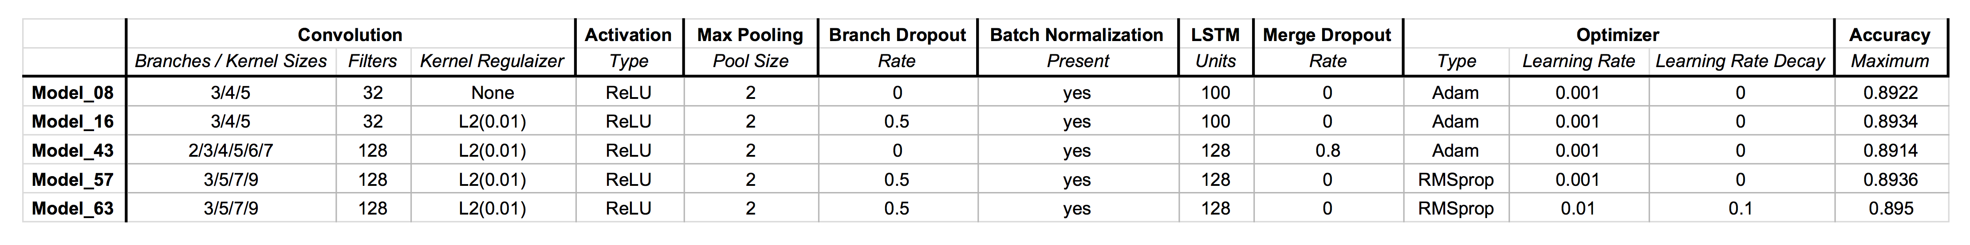

Parameters of regularization, learning rate, and decay played a large part in reducing overfitting. Although any activity regularizer reduced accuracy with no other benefit, a ridge regression regularizer of the kernel decreased overfitting. The optimal kernel regularizer was L2(0.01). Chaning the learning rate from its default did not typicallly help unless accompanied by a learning rate decay. The best performing model utilized a higher learning rate of 0.01 with a learning rate decay of 0.1. As shown in Graph X, this combination caused the accuracy percent to jump to the high 80’s and then stay there with little alterations. Without the decay, the training accuracy would drop down to below 85% because of overfitting. The loss also did not fluctuate too much after reaching its lowest.
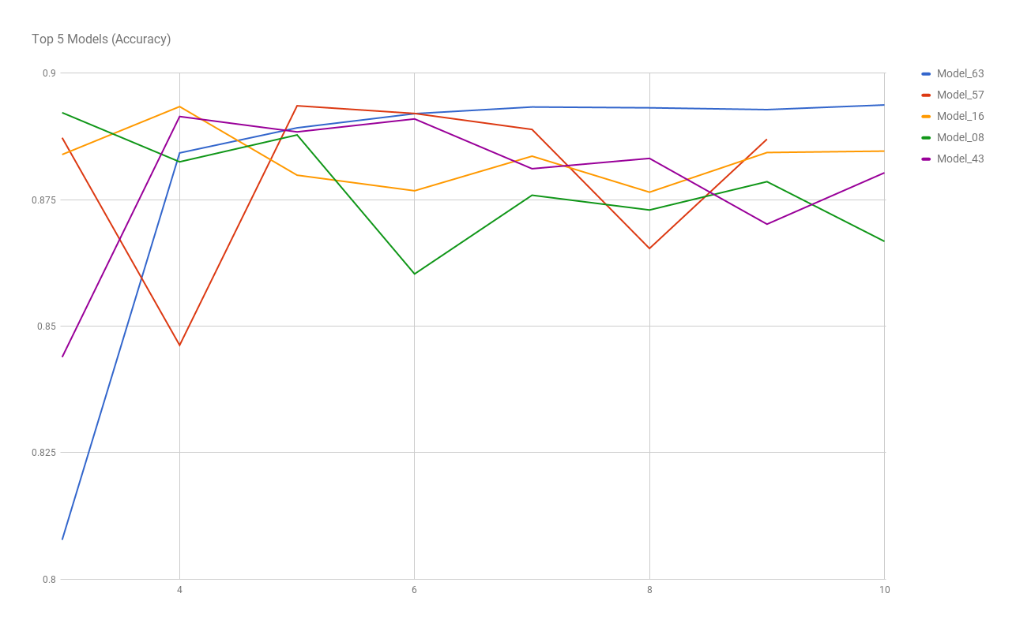

Depth had to be kept low in order to keep the network from decaying. The deeper the network, the more likely of overfitting. Since the data was more simple than images, deeper networks were not able to extract anymore useful information. Attempts to add additional dense or convolutional layers were fruitless.

Comparison of Other Experimented Models
Table X shows the comparisons between the 5 top networks structure and parameters. Graph X compares the accuracy of the top 5 models. Model_63 is the best performing network; its use of learning rate decay resulted in the least overfitting.

Conclusion
This paper shows the effectiveness of the multi-branch convolution to LSTM network on the IMDb review sentiment dataset. It is evident that different convolution branches are able to pull significant information from textual information in a shallow network. Additionally, LSTM layers are able to use the information to dig deeper into classifying the reviews. While overfitting was a challenge for most versions of the model, proper layers and parameters were able to reduce the deterioration and reach new accuracy highs on the dataset.
Although the model was used on only the IMDb dataset, other textual classification data may benefit from the network. While the tuned parameters worked well for our data, other datasets may need to have the network tuned slightly differently.
One area of investigating that could be beneficial is the use of different types of word representations. While the embedding was used, other methods, such as bag of words and TF-IDF, could be mixed in to produce different results. While it was established that GoogleNews embeddings from [7] and Wiki FastText embeddings from [8] did not add to the accuracy, other pre-trained models may have better effect. There may also be other pre-processing techniques that could raise the efficacy of the model.

References
- G. Eason, B. Noble, and I.N. Sneddon, “On certain integrals of Lipschitz-Hankel type involving products of Bessel functions,” Phil. Trans. Roy. Soc. London, vol. A247, pp. 529-551, April 1955. (references)
- J. Clerk Maxwell, A Treatise on Electricity and Magnetism, 3rd ed., vol. 2. Oxford: Clarendon, 1892, pp.68-73.
- I.S. Jacobs and C.P. Bean, “Fine particles, thin films and exchange anisotropy,” in Magnetism, vol. III, G.T. Rado and H. Suhl, Eds. New York: Academic, 1963, pp. 271-350.
- K. Elissa, “Title of paper if known,” unpublished.
- R. Nicole, “Title of paper with only first word capitalized,” J. Name Stand. Abbrev., in press.
- Y. Yorozu, M. Hirano, K. Oka, and Y. Tagawa, “Electron spectroscopy studies on magneto-optical media and plastic substrate interface,” IEEE Transl. J. Magn. Japan, vol. 2, pp. 740-741, August 1987 [Digests 9th Annual Conf. Magnetics Japan, p. 301, 1982].
- M. Young, The Technical Writer’s Handbook. Mill Valley, CA: University Science, 1989.

? The textual dataset is made available at: http://ai.stanford.edu/~amaas/data/sentiment/
? Example of Keras Text Classification available online at: https://github.com/fchollet/keras/blob/master/examples/imdb_cnn_lstm.py

