**CAPSTONE-4**

**Name-Satyam Parida**

**Regd_no-2141016403**

PYTHON LOCAL CODE -

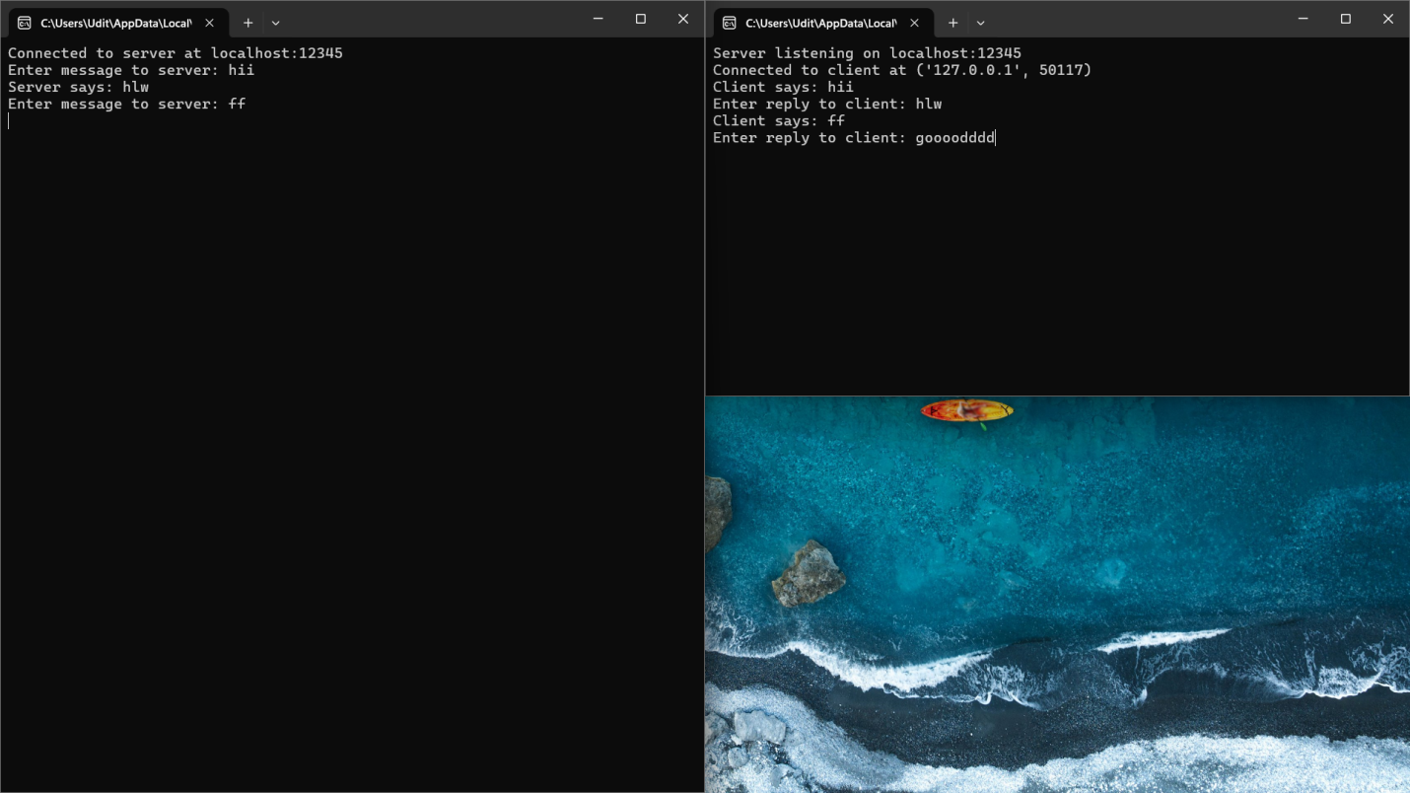

PYTHON DOCKER CODE –

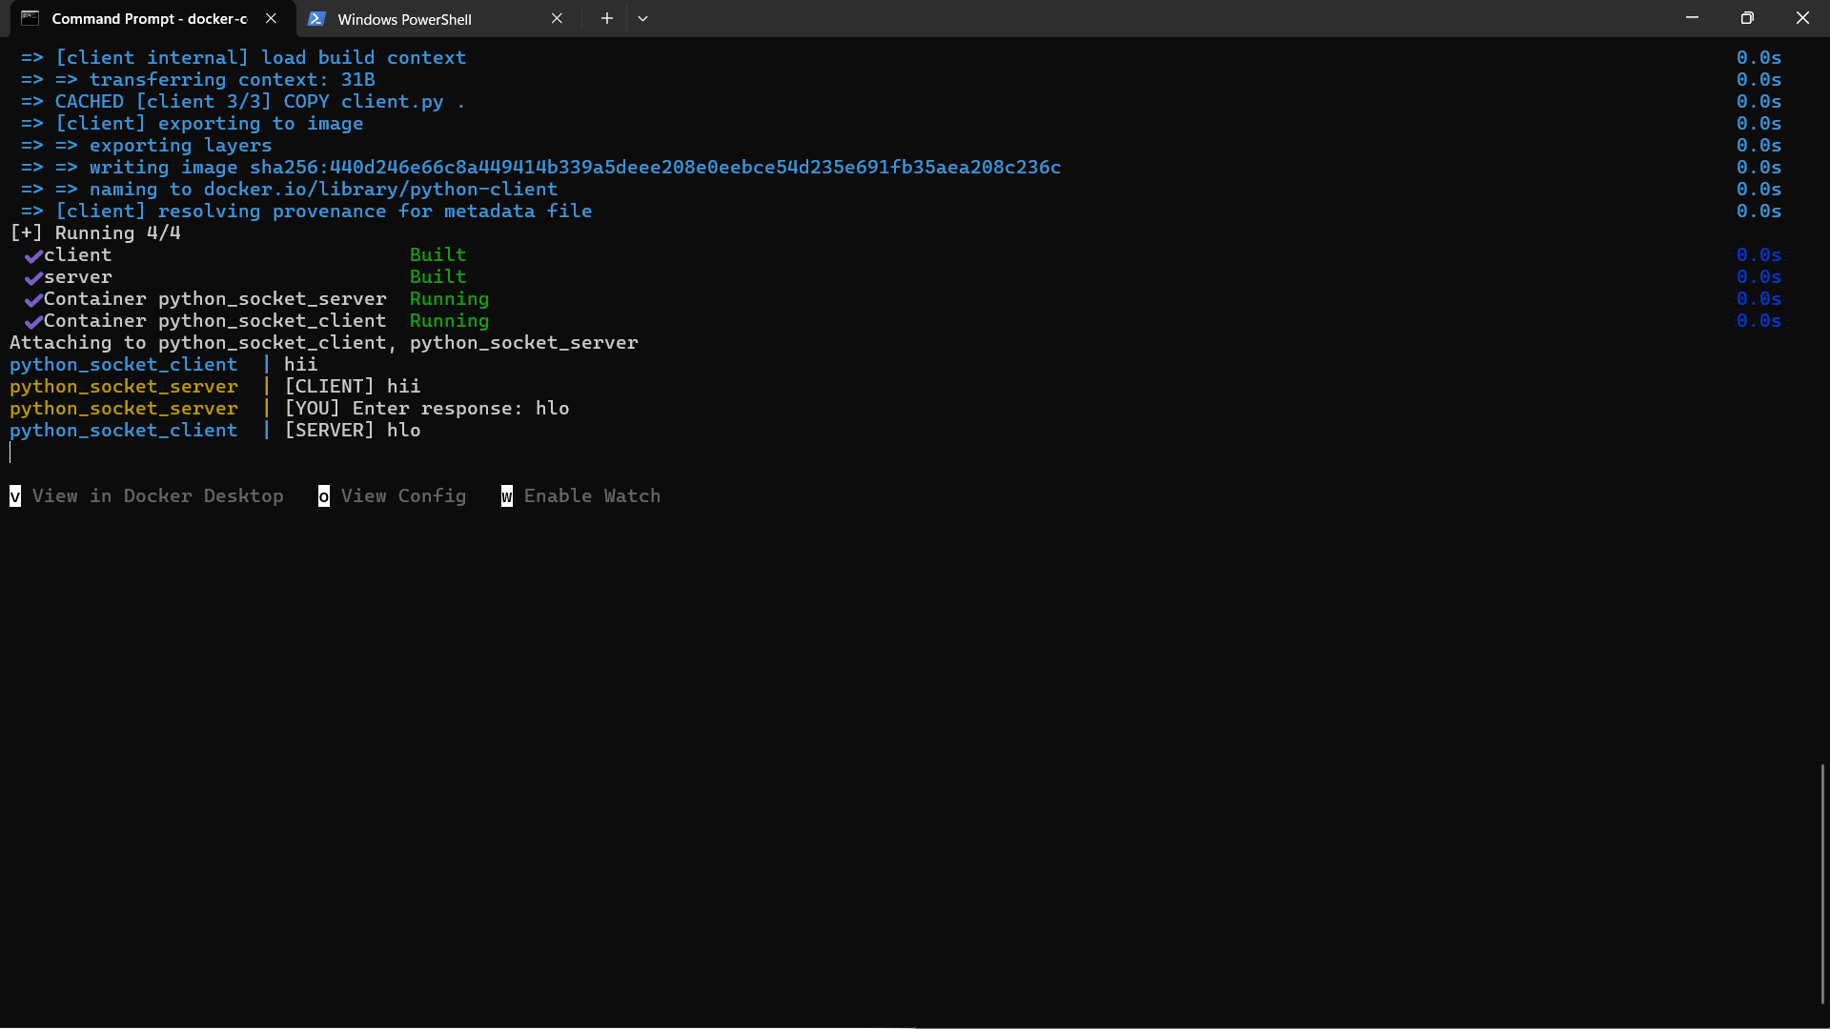

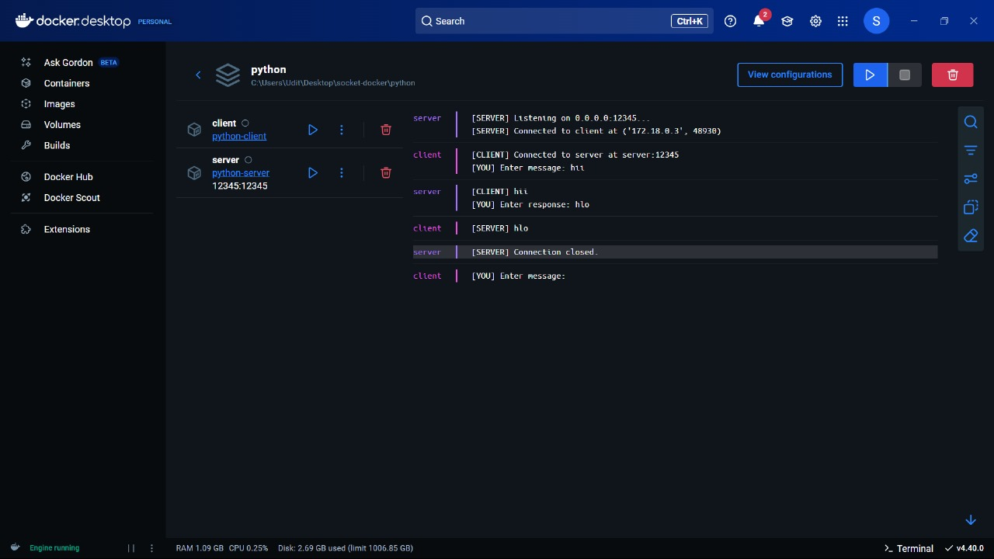

C LOCAL CODE -

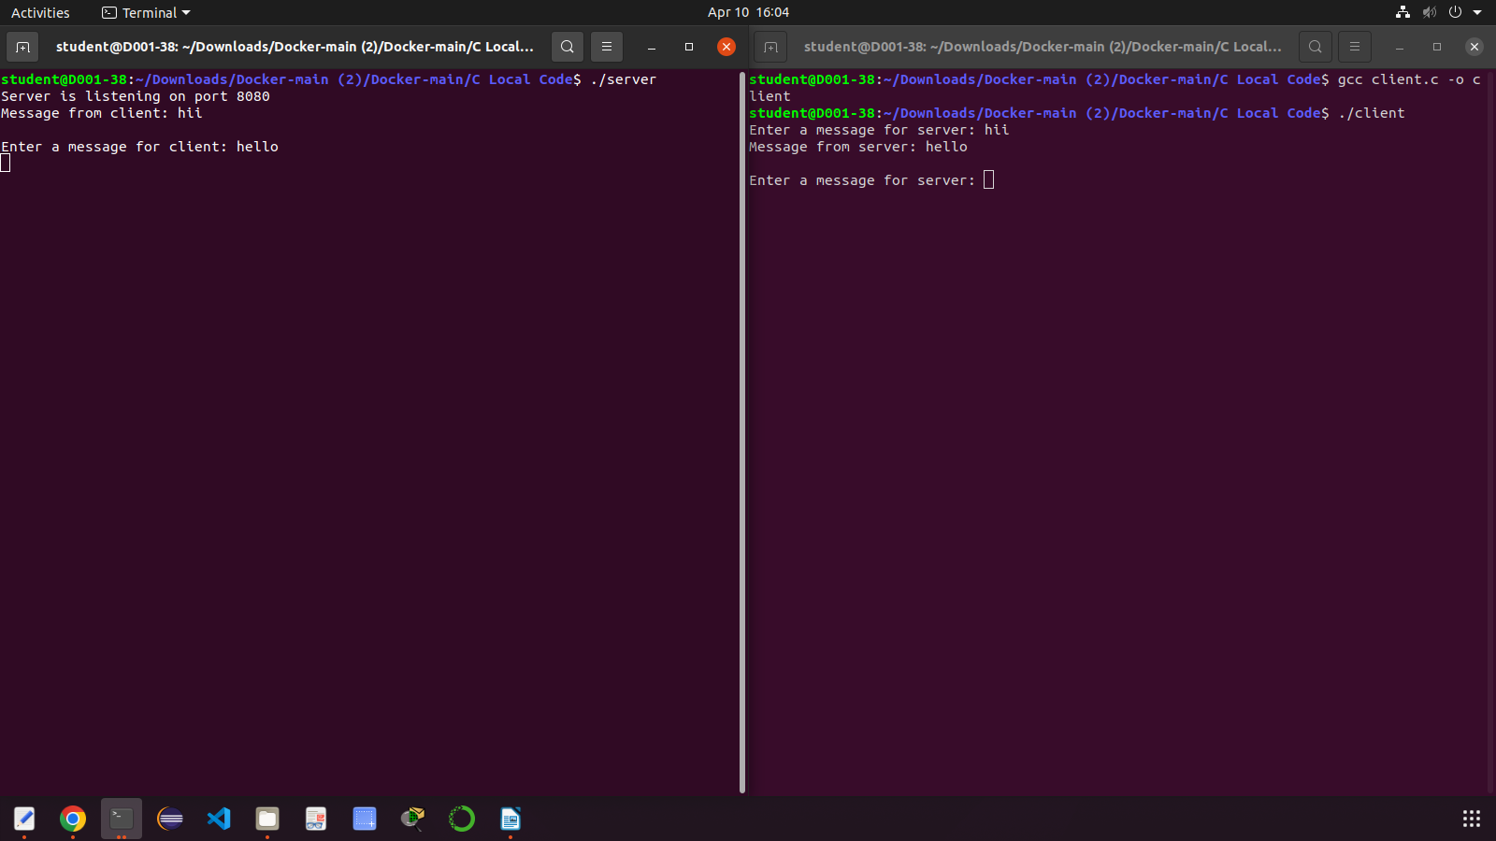

C DOCKER CODE –

