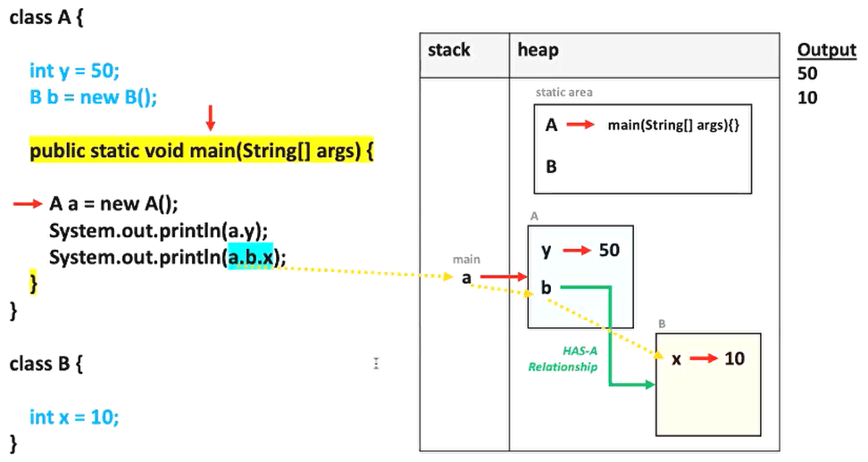

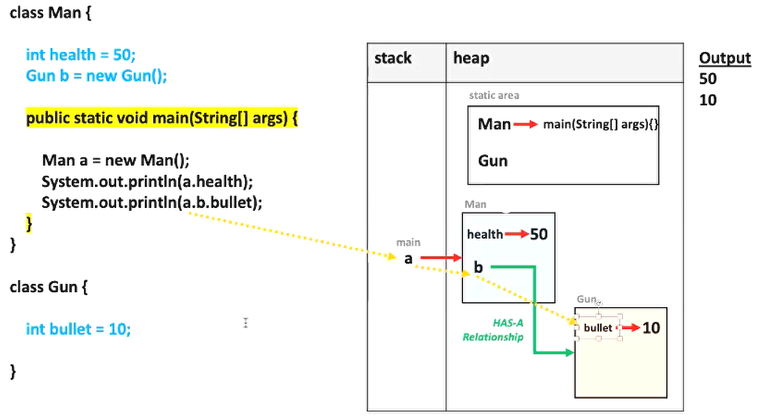

package package1;

class Man {

int health = 50;

Gun b = new Gun();

public static void main(String[] args) {

Man a = new Man();

System.out.println(a.health);

System.out.println(a.b.bullet);

a.shoot();

a.shoot();

a.shoot();

}

public void shoot(){

System.out.println("Shoot");

b.bullet = b.bullet - 1;

System.out.println(b.bullet);

}

}

class Gun {

int bullet = 10;

}