package package1;

public class A {

public static void main(String[] args) {

int x = m();

System.out.println(x);

}

public static int m(){

int x = 10;

System.out.println(x);

return x;

}

}

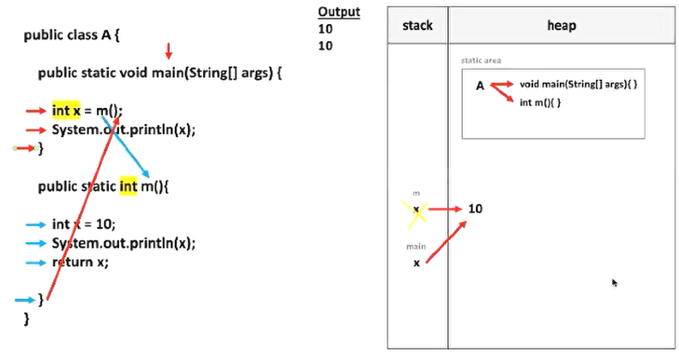

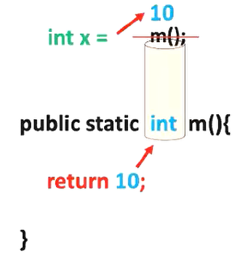

//---------------------------------------------------------------------

package package1;

public class A {

public static void main(String[] args) {

int x = m();

System.out.println(x);

}

public static int m(){

if(10<5){

return 10;

}else {

return 5;

}

}

}

//---------------------------------------------------------------------

package package1;

public class A {

public static void main(String[] args) {

int x = 10;

System.out.println(m(x));

}

public static int m(int x){

return x+5;

}

}

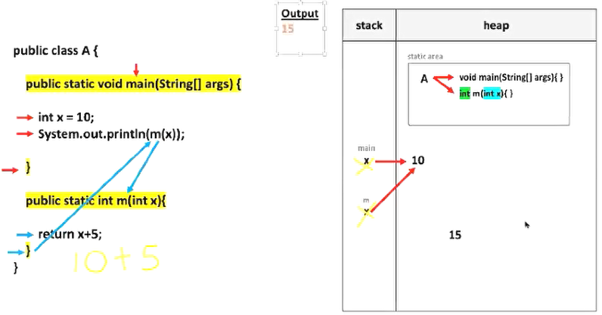

//---------------------------------------------------------------------

package package1;

public class A {

public static void main(String[] args) {

int x = 10;

System.out.println(x);

x = m(x);

System.out.println(x);

}

public static int m(int x){

return x+5;

}

}



