**Complex Engineering Problem**

**Phase 2**

**Ayesha Ishaq  
18I-0772**





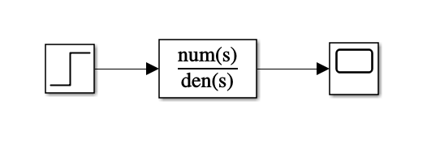

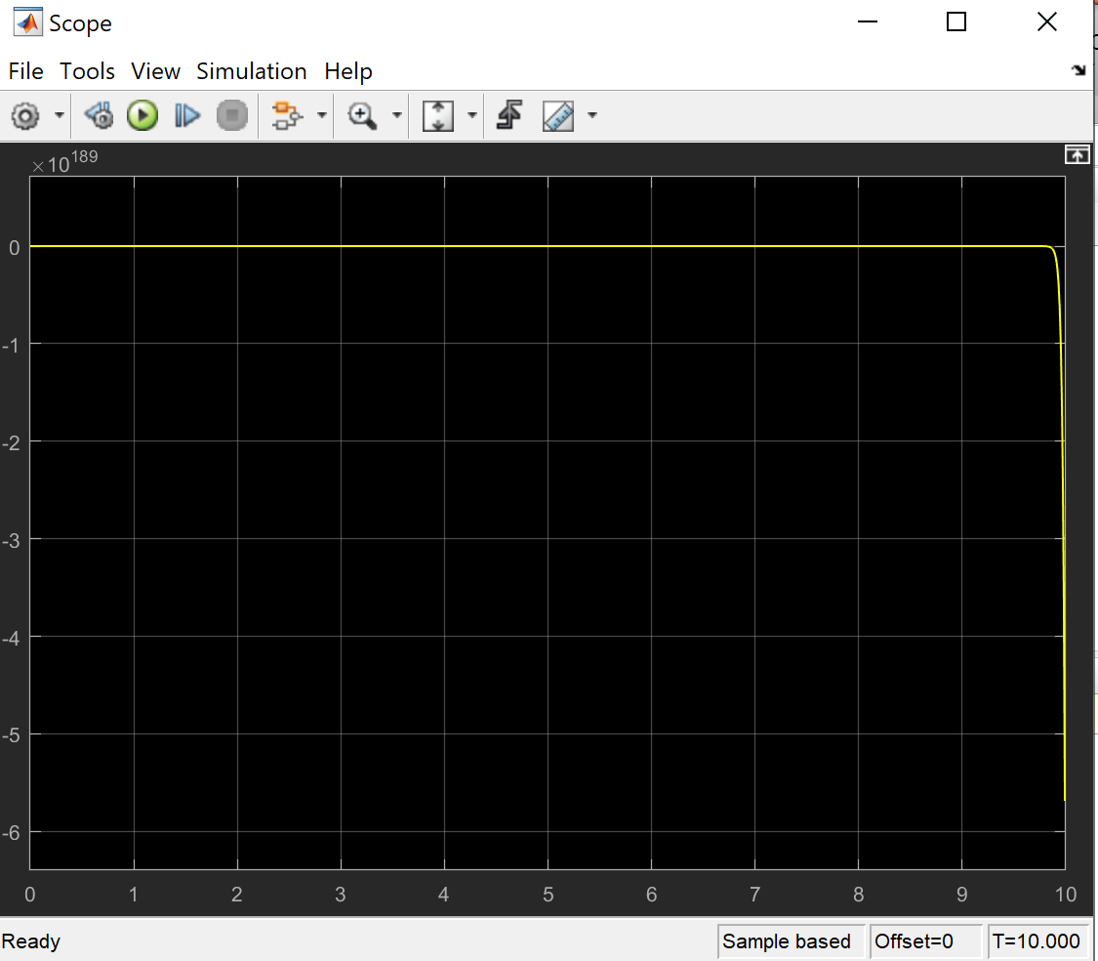





**Please Note: The double point is in the RHP not at the origin.**



**Comments and Summary of Plots**

In the **pole zero map**, we can right away identify the pole in the RHP that will cause the system response to be unstable. In the next plot, the **step response** of the open loop system can be seen to go to negative infinity with time, this is due to the pole in the RHP. The third plot is the closed loop **Root Locus** for values of K (gain) from 0 to infinity and the fourth plot is for values of K (gain) from zero to negative infinity. In either case, for no value of K will the system become stable, as one or two of the poles will remain in the right hand plane. The **Bode plot** also highlights their being a pole in the RHP therefore also pointing to unstable system. In the magnitude plot, a slope of -40dB appears first around 44Hz, and the final slope is -60dB, indicating three poles. However, the phase plot only goes from 0 to -90. This means the poles at 44 were of opposite signs and thus the phases were subtracted to 0.

**Reference for Phase 1**

**Designing Two Dimensional Magnetic Levitation Control System  
Section 2.3: One Dimensional Magnetic Ball Levitation State Equations**

[**https://iugspace.iugaza.edu.ps/bitstream/handle/20.500.12358/18856/file_1.pdf?sequence=1&isAllowed=y**](https://iugspace.iugaza.edu.ps/bitstream/handle/20.500.12358/18856/file_1.pdf?sequence=1&isAllowed=y)