**Complex Engineering Problem**

**Phase 3**

**Ayesha Ishaq  
18I-0772**

**P Controller**



**Just P controller will not suffice as for no value of Kp will the poles be on the LHS.**

**PI Controller**

pidtune(G,'PI')

with Kp = -274, Ki = -236



**Unable to tune a PI controller to give a stable system response, closed loop poles in RHP**



**Closed Loop Poles and Zeros (R->Y)**





**PID Controller**

pidtune(G,'PID')

with Kp = -197, Ki = -1.19e+03, Kd = -8.11

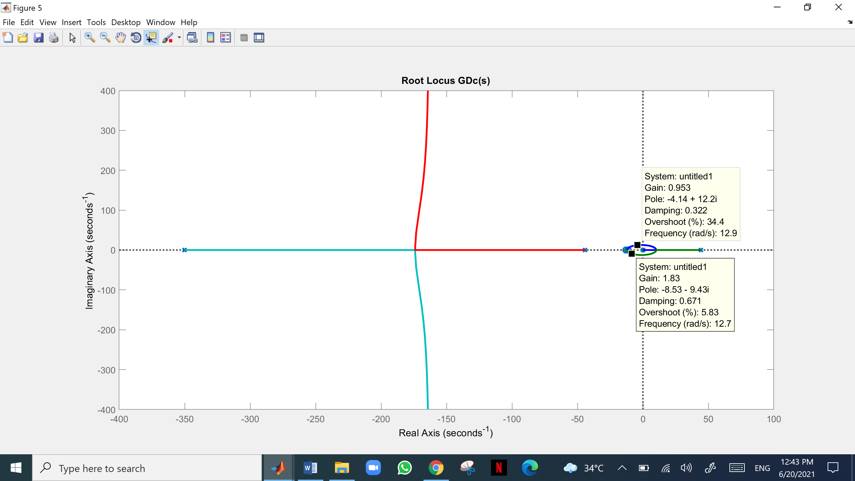

**For given PID controller and gain K=1**



**Closed Loop Poles and Zeros (R->Y)**







**For given PID controller and gain K=2**



**Closed Loop Poles and Zeros (R->Y)**







**For given PID controller and gain K=20**



**Closed Loop Poles and Zeros (R->Y)**







**PID Controller with Simulink Auto Tuning**

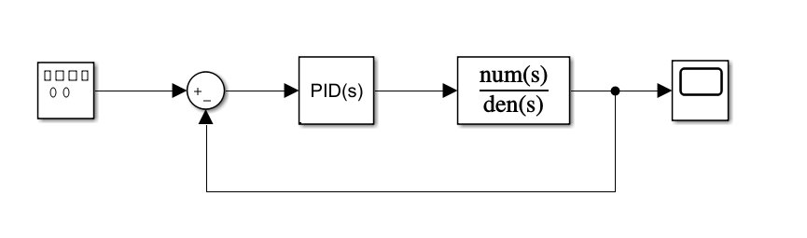

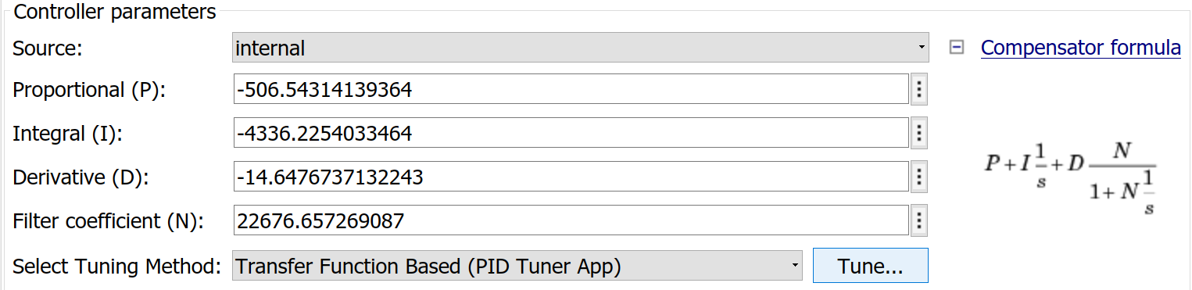

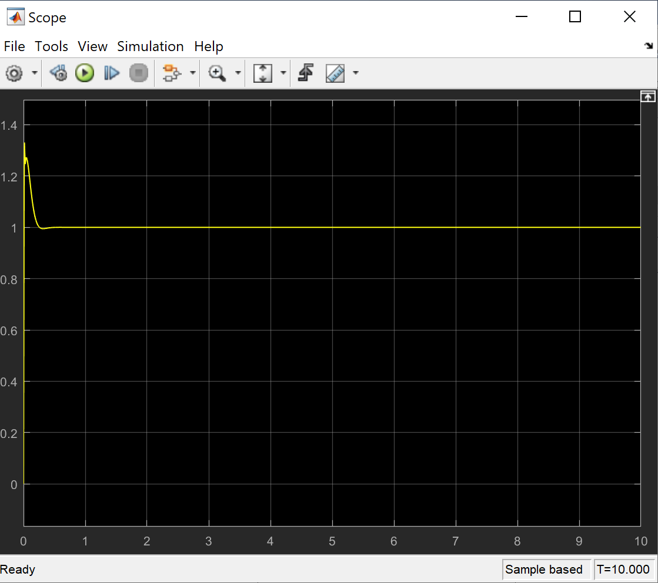

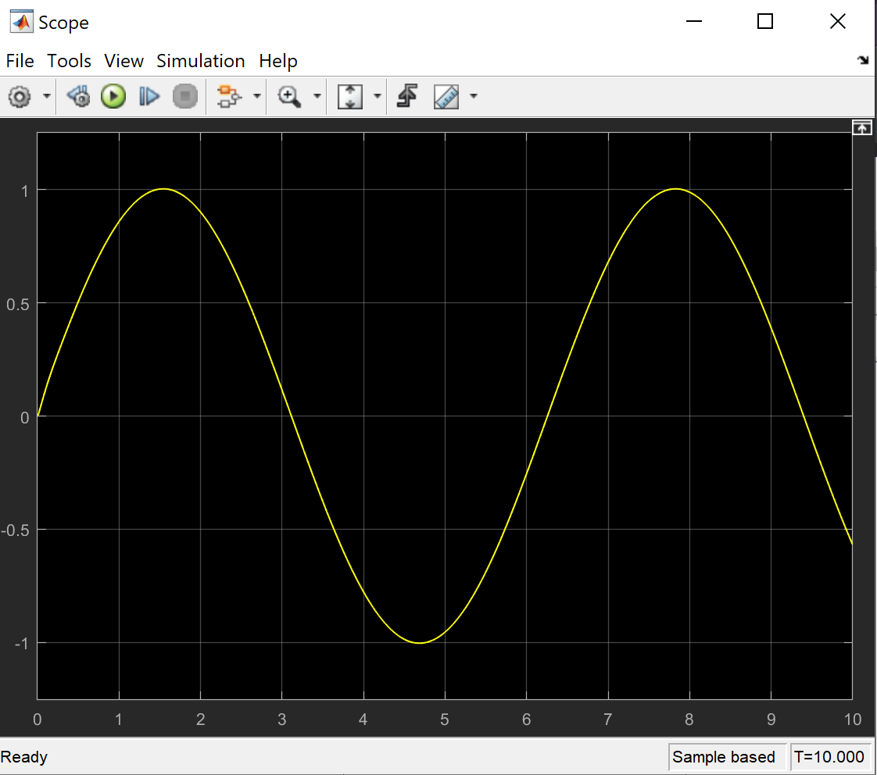

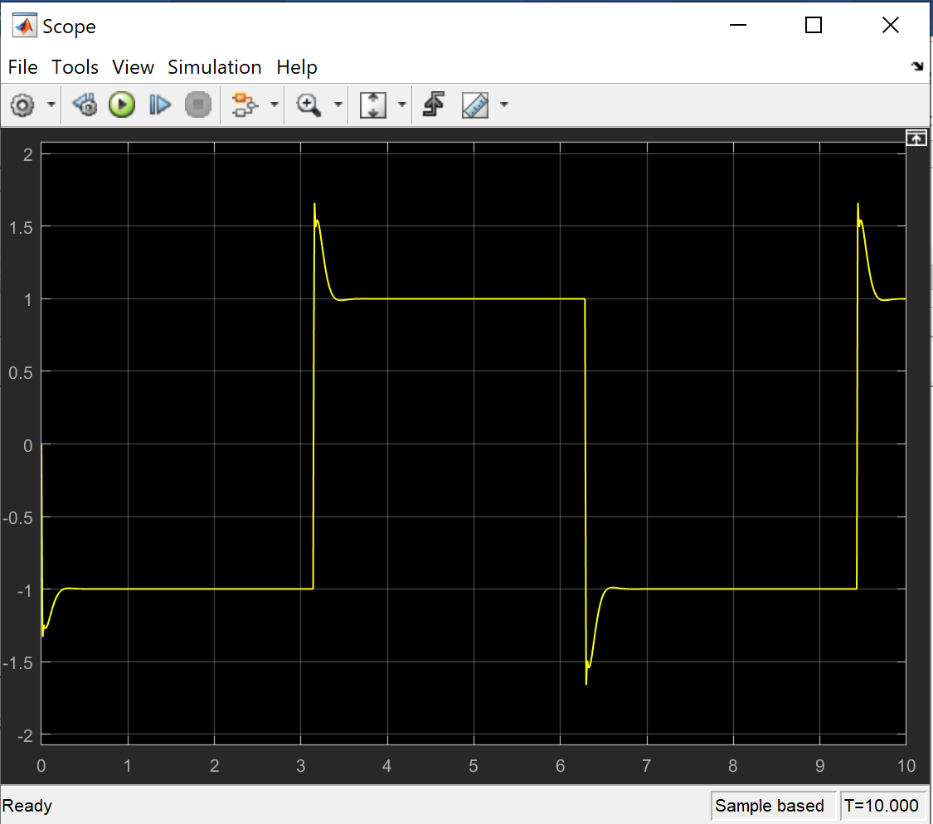

**Summary and Design Analysis**

Our plant was modeled as an open loop unstable system. To begin with we applied root locus technique to evaluate if changing the gain would change the pole locations and bring them to the LHP. We found a simple P controller would not work in this case. We next made an attempt with a PI controller. Since our open loop system was unstable (not even marginally stable for any value of K), we could not use Zeigler Nicholas process reaction curve or ultimate gain method. We then attempted hit and trial at PI and PID controllers. To begin with, we used MATLAB’s ‘pidtune’ function to get some optimum values for PI, and then used root locus on the TF to check for any workable value of gain that might make our PI controller work. We found that PI, just as P was unstable for all values of K as well. Using ‘pidtune’ for PID controller we found some values for Ki, Kd and Kp that when plotted with root locus, shifted the poles to the LHP for a range of K values. From the root locus, we used various values of K to tune our controller and found that with increasing values of K our controller tracked reference much better. This is due to the fact that increasing K allows for T to approach 1, and minimize error. Lastly, we used Simulink’s auto tune and were able to get a controller that successfully tracked each reference too.